Michael Deveau

IFT 458: Middleware Programming

Joseph Kuitche

January 22, 2018

Project Deliverable 1

**Introduction:**

The class was given an assignment of creating an imaginary main page for a website. The students had a choice of either a main page for a solar research laboratory or a charity organization. The project called for a responsive webpage that can take input from the user and process that data. The website includes a login page, registration form, and a simple and inviting user interface. The website was to be created using proficient skills in HTML, CSS, and JavaScript.

**Description:**

The project consists of three files, a HTML page, a CSS file, and a JavaScript file. The HTML was used to create the base code of the page and the objects that the user interacts with. The CSS file adds the formatting and design to the page. This allows for responsiveness such as the dropdown hover menu, the registration and log in form, and most importantly the layout and design of the page. The first step in starting the webpage was creating the header bar and the logo. These elements were separated into separate divs and were formatted to allow for social media links as well as a search bar. The logo is simple text redesigned with fancy font and spacing.

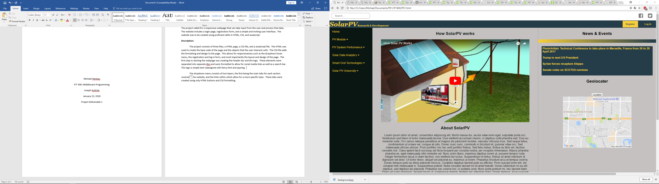

Next step was creating the dropdown menu. The dropdown menu consists of two layers, the first being the main tabs for each section covered in the website, and the links within which allow for a more specific topic. These tabs were created using only HTML buttons and CSS formatting.

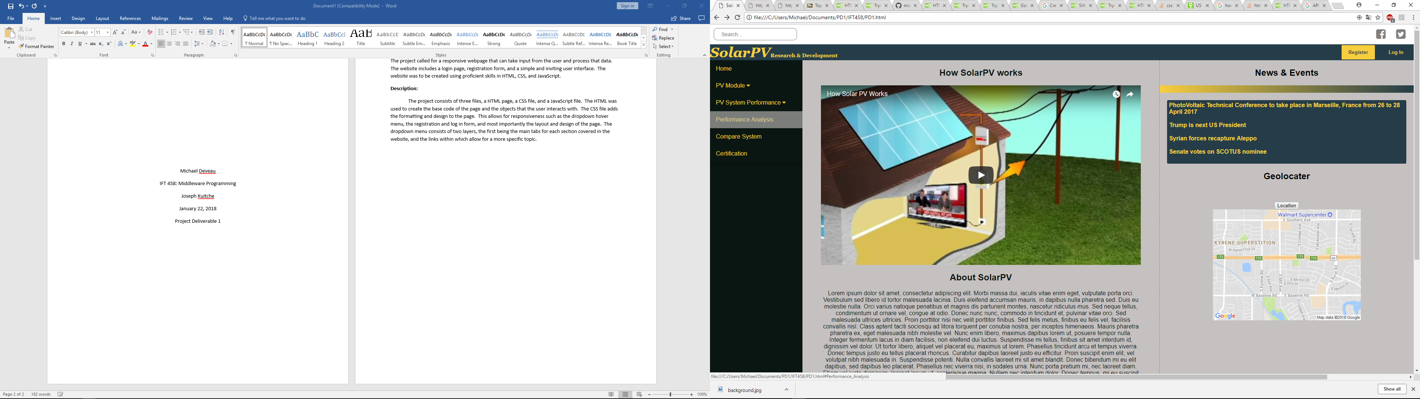

The registration and login form were the next step in creating a functional and responsive website. The registration section of the website includes the “Register” button and the “Log In” button.

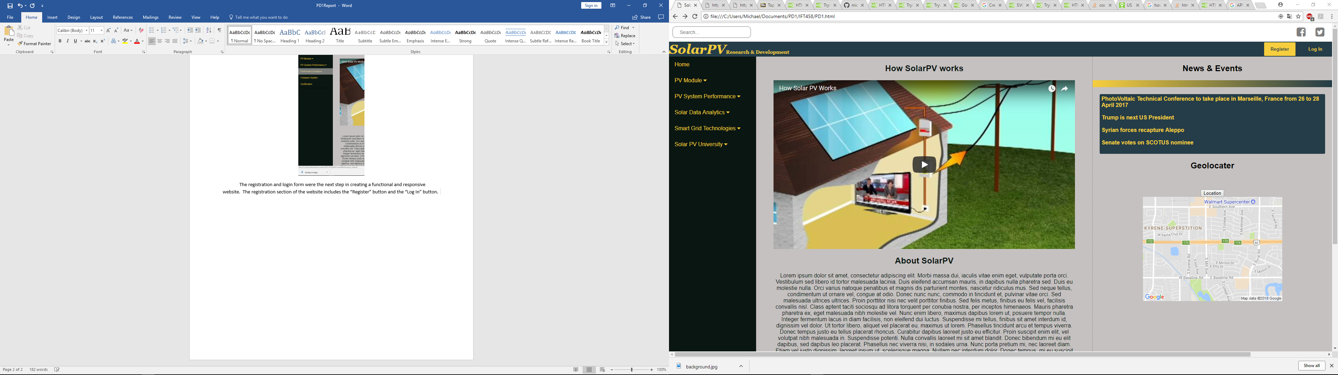

The directions provided the required fields of the registration form. The form must collect the username, password, first name, middle name, last name, gender, address, city, state, zipcode, email, phone number, and company from the user. The base of this form was created using the form tag in HTML, then using CSS to overlay the form itself of the base webpage. This style of form allows for quick response and removes the need of having to load another page. This eliminates the need for another file within the zip, thus limiting the size of the file. The submit button at the bottom of the form stores the data and updates the UI to show that the new user is signed in.

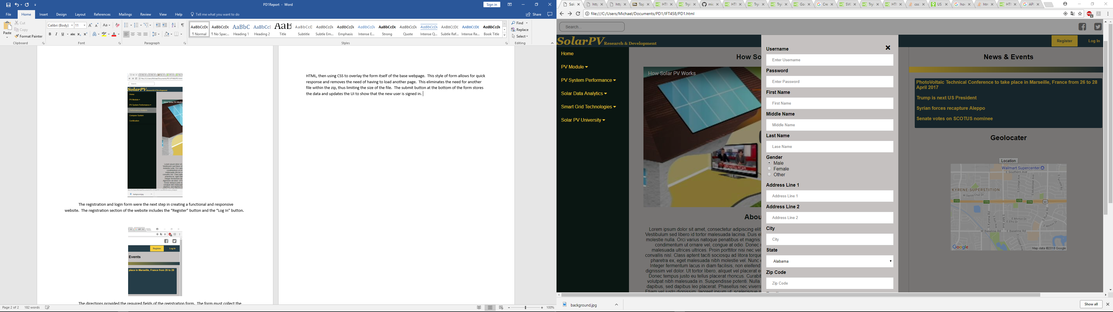

The part in the registration section was the login page. The log in page is similar in format to the register page, however instead of having to enter a large amount of data, the user can enter their credentials and successfully log into the page. The log in form includes the normal username and password along with a “remember me” checkbox and a “forgot password” link. When the user enters their information the form will update the UI in the registration section to show that they are logged in.

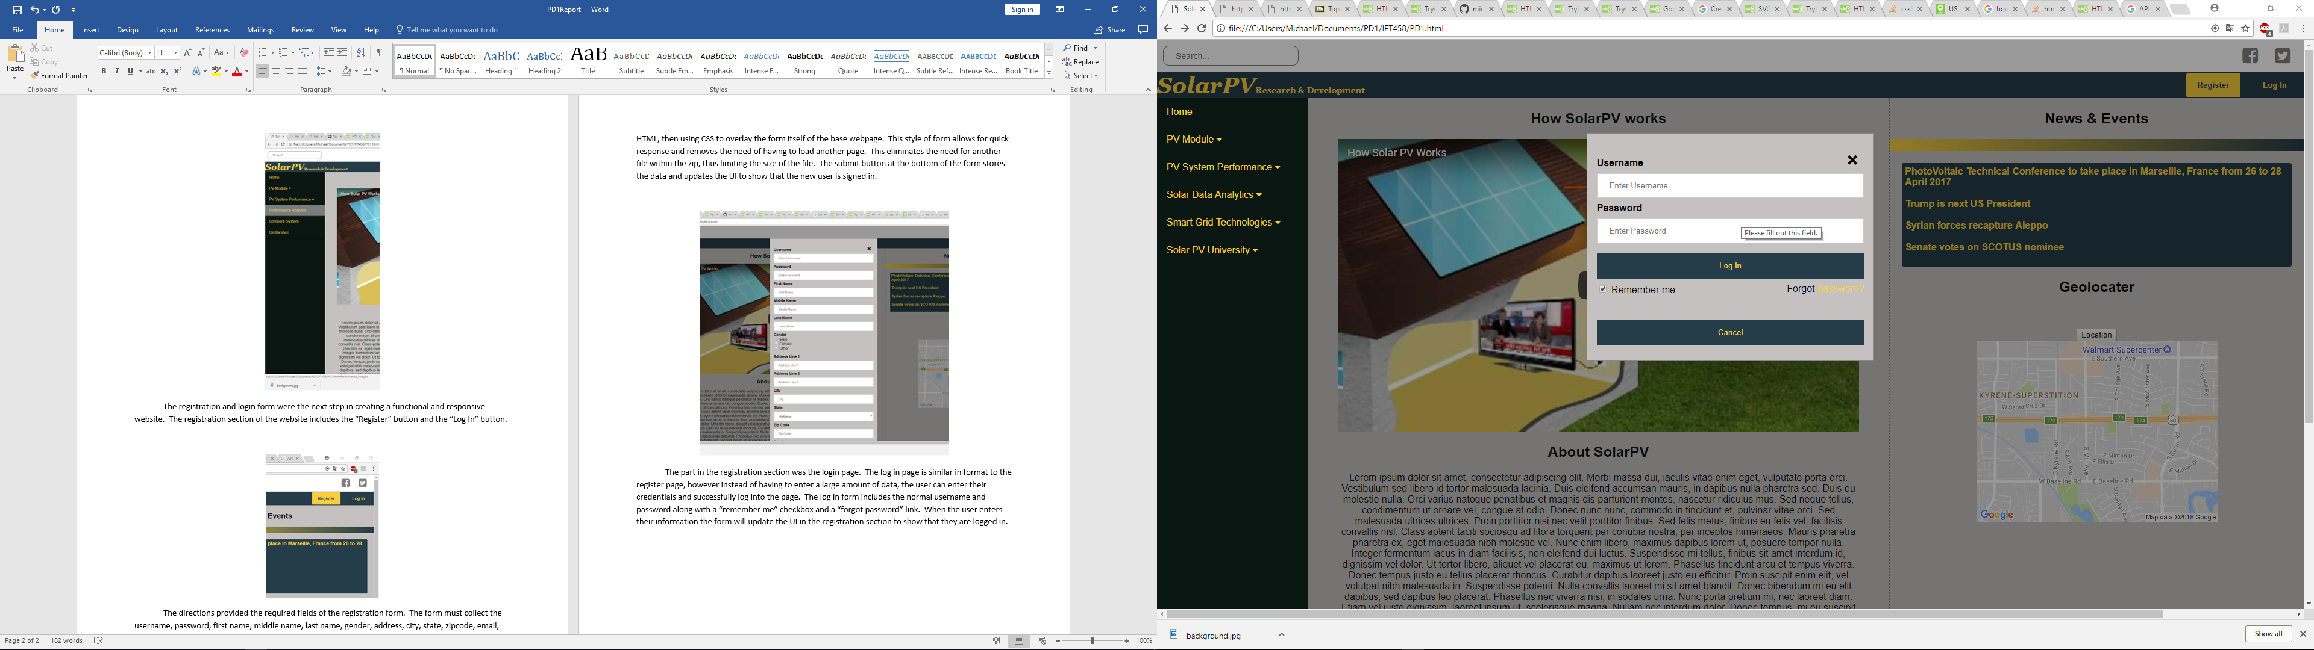

The remaining steps in creating the webpage were providing an educational video in the content section of the page, the news and events section, and the footer. This was accomplished by a simple iframe that linked to a YouTube video. The user can click on the play button and enjoy the video within the webpage and not have to travel to an external link. The news and events section was created using a simple list tag and linking the page with articles about current events in the world. Lastly, the footer is a simple div with information about the location of the laboratory and contact information.

**User Manual:**

1. Start by downloading the zip file with the required file.
2. Next open up the zip file and running the “PD1.html” file. This will launch the webpage.
3. Log into or register with the site.
4. Navigate through the side menu bar to familiarize yourself with the content of the webpage.
5. Lastly, watch the instructional video provided on the homepage to learn what SolarPV is.

**Conclusion:**

This project called for proficient skills in the HTML, CSS, and JavaScript. It tested on whether or not I was capable of creating a responsive and professional website. The project emphasized the need for responsiveness by requiring certain aspects that are found within all modern webpages. The aspects learned from this project were the advancement in knowledge of JavaScript and CSS. Although I am very familiar with JavaScript and CSS this project allowed me to investigate advanced ways of webpage creation. This advancement was not without challenges however. The challenges of sizing the page and form submission were the main obstacles that I had to overcome. Making sure the page would resize correctly in a smaller browser window was one the main focuses. The form submission and ensure that the user stayed logged in was the hardest challenge in creating this webpage. I struggled with grabbing the data and updating it to the UI. So aspects of the website that could be improved is the news and events page. I would like to make it into an image carousel where the images are links to the articles.