Michael Deveau

IFT 458: Middleware Programming

Joseph Kuitche

February 5, 2018

Project Deliverable 2

**Introduction:**

The class was given an assignment of creating a backend database for the imaginary website that was created in the previous assignment. The students were instructed to create a ER diagram of the different entities and the corresponding attributes. Next was to add the relationships of one entity to another, creating the Relational diagram along with the tables organized to show their data types. Lastly, was to implement the Relational diagram into a SQL database. The database was created using Microsoft SQL Server Management Studio.

**Description:**

This project was started by identifying the situation given for the imaginary website database. Each of the entities shown in Figure 1, are represented by the rectangle. Each entity is described by attributes which are represented by the elipses. Attributes of the entities can categorized as either unique, mulitvalued, optional, composite, or derived. The unique attributes are represented with an underline which usually is reserved for the keys of the entity. Figure 1 displays the ER diagram without the relationships added.

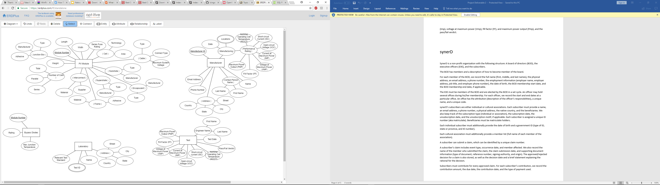

Figure 1

The next step was the ER to Relational mapping. This process includes developing the relations that entity has with another entity. This includes relationships such as 1 to 1, 1 to many, and many to many. The first step in the relational mapping algorithm is the mapping of regular entity types. This includes the identification of all entities within the database. Step two is the mapping of weak entity types. Weak entities are entities that contain no key. Step three begins the mapping of the relationships starting with the 1 to 1 relationships. These relationships are represented by the diamond symbol and the corresponding “1” on the connecting line. Step four is the mapping of the 1 to N relationship types. These relationships are previlent in this database, for example the relationship of manufacturers manufacturing the PV Modules is a 1 to N relationship. This is because one manufacturer produces many different PV Modules. Step five is the mapping of the M:N relationships. This database does not contain any M to N relationships. Step six is identifiing the multivalued attributes. In Figure 1 these can be identified by the double outlined elipses. Lastly, step seven is the mapping of N-ary relationship type. No N-ary relationships were found in this database. The final Relational Diagram can be viewed in Figure 2.

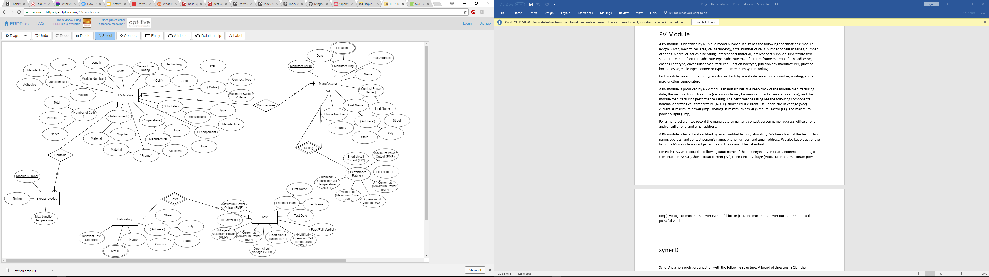

Figure 2

After creating the relational diagram, the table diagram was the next step. This diagram, as seen in Figure 3, gives a graphical view of the different tables within the database. This diagram provides the entity names, attributes, datatypes, and the primary and foreign key constraints. 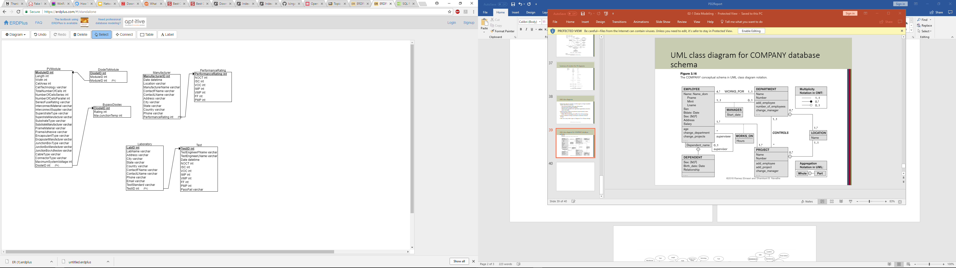

Figure 3

The final portion of this project was to develop the database in MySQL and create a functional database. This involved creating a database, creating the individual tables and the many attributes within them, and relating the data through constraints and intersection tables. The final database creation in SQL can be seen below in Figure 4.

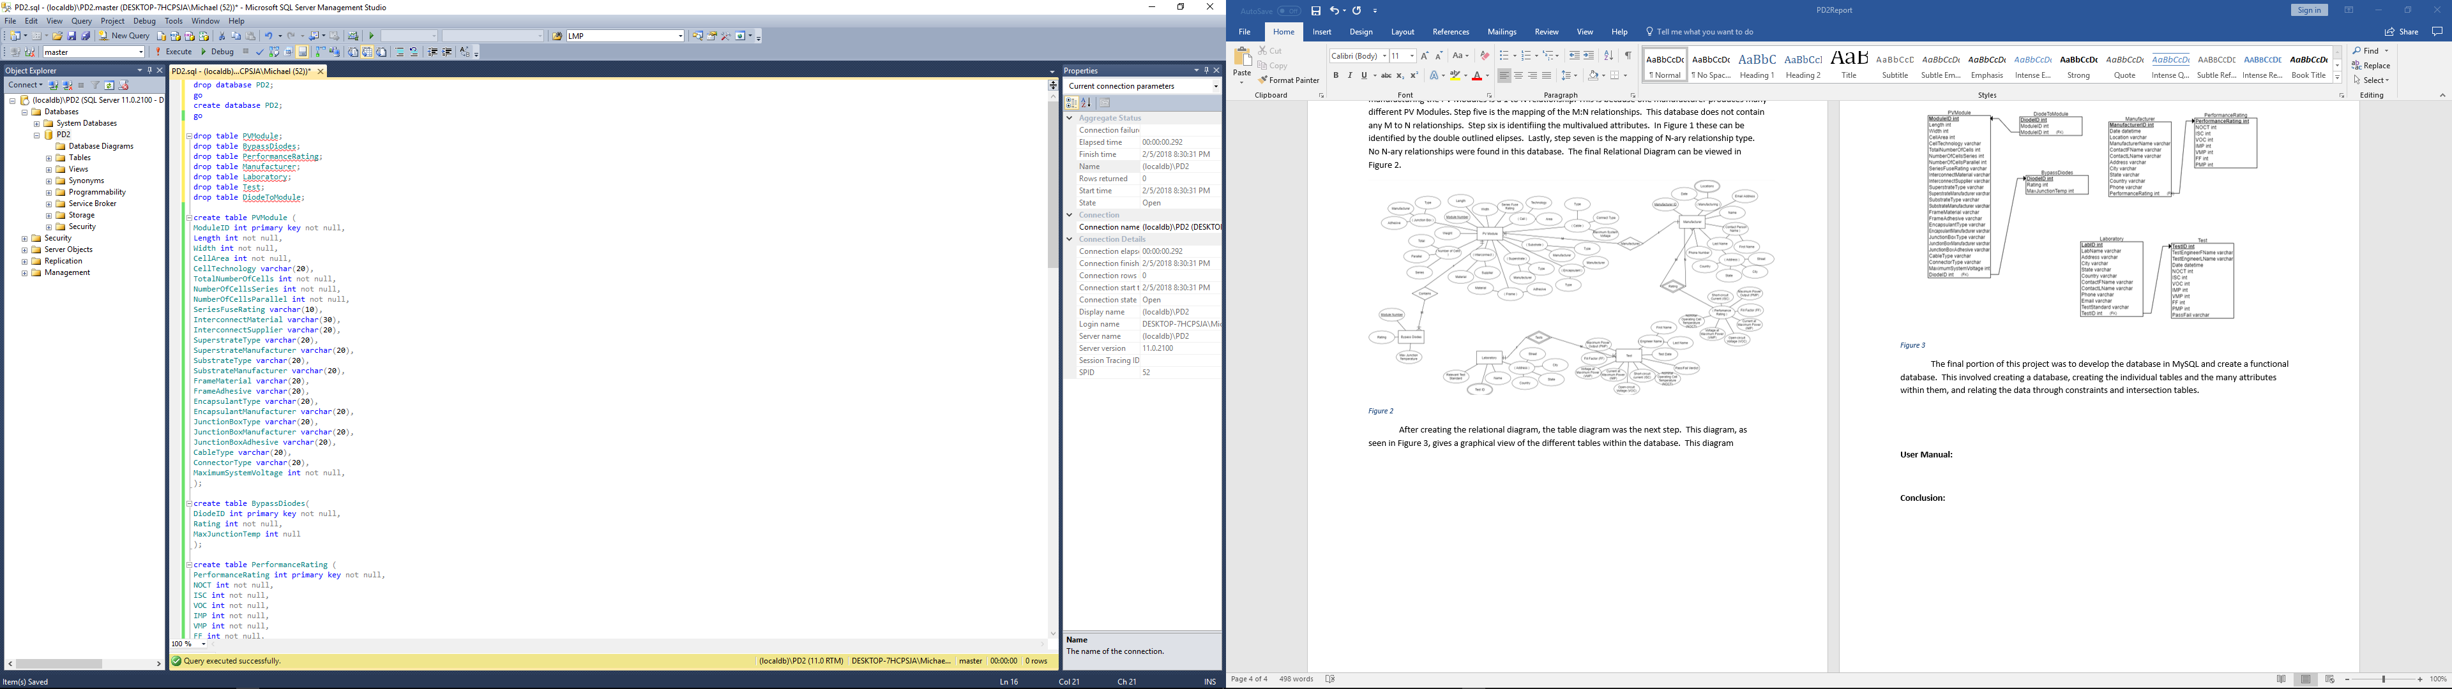 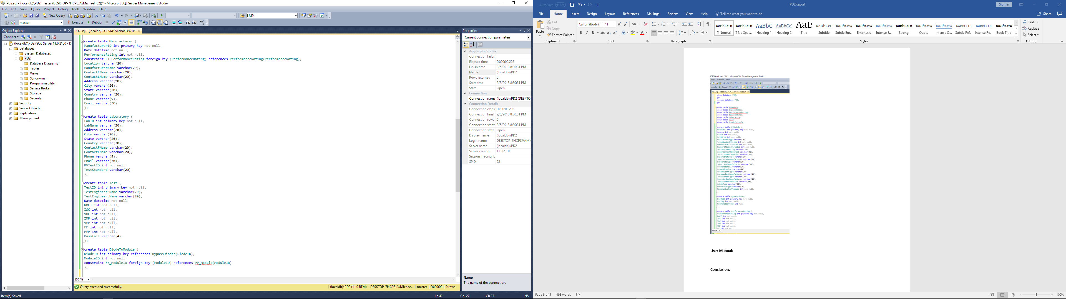

*Figure 4*

**User Manual:**

1. Start by downloading the PD2.zip file.
2. Next open the PD2.sql file with Microsoft SQL Server Management Studio. (If installation of SSMS is needed, visit <https://docs.microsoft.com/en-us/sql/ssms/download-sql-server-management-studio-ssms> for download.
3. Click execute in the menu bar and the query should create the database and tables.
4. To verify that the database was created correctly, execute the select commands located at the button of the query to view the tables.

**Conclusion:**

This project tested the skills learned in lecture on how to create a ER diagram, relate the entities within that ER diagram, and develop a working SQL server database for the imaginary website of our choosing. This project solidified my understanding of ER to Relational mapping and my proficiency with SQL. The main challenge faced in this project was implementing the ER to Relational mapping algorithm provided in class. Ensuring that every step was taken and that the diagram was in normal form caused many delays. This project could be improved by creating a more organized ER and Relational diagram.