GHS Markdown Editor
User Guide

Version 1.0.0
Windows & macOS
Part of the GHS Markdown Ecosystem

Contents
This guide covers everything you need to know to get the most out of GHS Markdown Editor.
1. Introduction ............................................ 3
2. Getting Started .......................................... 3
3. Interface Overview ....................................... 4
4. The Editor ............................................... 5
5. The Preview Pane ......................................... 6
6. Formatting Toolbar ....................................... 7
7. Document Topology & Outline .............................. 8
8. Snippet Studio ........................................... 9
9. Version Timeline ........................................ 10
10. Export .................................................. 11
11. Focus Mode .............................................. 12
12. Detached Preview (Dual Monitor) ......................... 13
13. AI Assist Panel .......................................... 14
14. Command Palette .......................................... 15
15. Settings ................................................ 15
16. File Operations .......................................... 17
17. Keyboard Shortcuts Reference ............................ 18

1. Introduction
GHS Markdown Editor is a feature-rich Markdown editor for Windows and macOS, built for writers, developers, and content creators who want the clarity of plain text with the power of a professional editing environment.
The app offers a live split-pane view — you write Markdown on the left and see beautifully formatted output on the right, updating as you type. It is part of the GHS Markdown Ecosystem, alongside the GHS Markdown web app and the GHS Markdown for Windows (WPF) companion app.

What Makes GHS Markdown Editor Different
- Bidirectional editing — click the preview to move the editor cursor, double-click to edit a block inline, or select text in the preview and press formatting shortcuts to apply them directly to the source.
- AI Assist — Claude-powered writing assistant built into the right panel. Summarize, rewrite, brainstorm — all without leaving the app.
- Smart document tools — Document Topology, Snippet Studio, Version Timeline, and a Command Palette give you a power-user workflow without a steep learning curve.
- Three themes — GHS Dark, GHS Light, and a fully customizable GHS Custom theme where you pick every color.

2. Getting Started

Installation

Windows
Download GHSMarkdownEditor-Setup-1.0.0.exe from the Releases page on GitHub and run the installer. The installer registers the .md file type with the app, enabling the Windows Jump List (recent files in the taskbar right-click menu).
- Accept the license agreement.
- Choose your install location (default is recommended).
- Optionally create a desktop shortcut.
- Launch GHS Markdown Editor from the Start Menu or the desktop shortcut.

macOS
Download GHSMarkdownEditor-1.0.0.dmg from the Releases page, open the disk image, and drag GHS Markdown Editor to your Applications folder. Launch it from Launchpad or Spotlight.
💡 Tip: On macOS, you may see a security prompt on first launch. Right-click the app and choose Open to bypass Gatekeeper on the first run.

First Launch
When you first open GHS Markdown Editor, you will see the main window in Split view with a blank document. The editor pane is on the left and the preview pane is on the right.
To open an existing file, press Ctrl+O (Windows) or drag and drop a .md file onto the app window. To start a new document, press Ctrl+N.
💡 Tip: GHS Markdown Editor auto-saves a draft every 60 seconds. If the app closes unexpectedly, it will offer to restore your unsaved work the next time you open the file.

3. Interface Overview
The app window is divided into several key areas. Understanding the layout helps you get to features quickly.
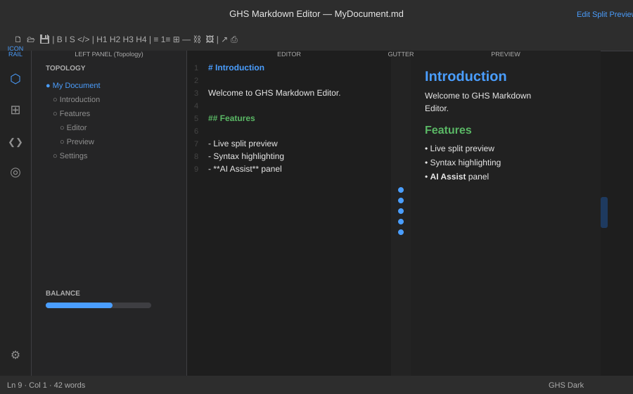
Figure 1 — The GHS Markdown Editor main window in Split view

Layout Areas

Titlebar
The top bar shows the current filename and gives you quick access to view modes (Edit, Split, Preview), the Export panel, Print, and Focus Mode. The formatting toolbar toggle (≡) and Detach Preview button (⧉) are also here.

Formatting Toolbar
The icon toolbar below the titlebar provides one-click access to all formatting commands. It can be shown or hidden with the ≡ button or Ctrl+Shift+B.

Icon Rail
The narrow vertical strip on the far left switches the Left Panel between Document Topology (⬡), Files (⊞), Snippet Studio (❮❯), and Search (◎). The gear icon (⚙) at the bottom opens Settings. Clicking an active icon closes the panel.

Left Panel
The collapsible left panel shows the active view — Document Topology, File Browser, or Snippet Studio. It slides in and out smoothly and remembers its open/closed state across restarts.

Editor Pane
The Markdown source editor. Syntax highlighting colors headings, bold, italic, code, links, and more. Line numbers are shown in the gutter. The active line is highlighted.

Smart Gutter
The 28-pixel strip between the editor and preview panes. You can drag it to adjust the split ratio. The chain of colored dots shows scroll sync state: blue = synced, amber = drifted, green = just saved. A small word count for the active section is shown vertically.

Preview Pane
Live rendered HTML preview, styled with the current theme. Supports click-to-sync, double-click inline editing, and selection-based formatting shortcuts.

Right Panel
A collapsible right panel with three tabs at the bottom: Outline (heading navigator), Snippets (quick-insert templates), and AI Assist (Claude-powered writing help). Open it using the pull tab on the right edge.

Status Bar
The bottom strip shows cursor position (line and column), total word count, and the active theme name. The Version Timeline scrubber sits on the right end.

4. The Editor
The editor is built on AvaloniaEdit, a powerful code editor engine. It has been customized specifically for Markdown writing.

Typing Markdown
Just start typing. GHS Markdown Editor uses standard Markdown syntax. Headings start with #, bold uses **double asterisks**, italic uses *single asterisks*, and so on.
The preview updates as you type, with a short debounce to avoid flickering while you are mid-word.

Syntax Highlighting
The editor colorizes your Markdown as you write:
- Headings — H1 in blue, H2 in green, H3 in amber, H4–H6 in progressively lighter grays
- Bold — white with bold weight
- Italic — light gray with italic style
- Inline code — purple with monospace font
- Links and images — blue
- Blockquotes — gray italic
- List bullet markers — blue
- Horizontal rules — gray
Note: Syntax highlighting in the editor is fixed to the GHS Dark color palette regardless of the active theme. The preview pane is fully theme-aware.

Formatting Shortcuts
Most formatting shortcuts work from anywhere in the app — even when the preview pane has focus. Press Ctrl+B for bold, Ctrl+I for italic, Ctrl+1 through Ctrl+6 for headings, and so on. See the Keyboard Shortcuts Reference for a complete list.

Applying Headings
Position your cursor on any line and press Ctrl+1 to Ctrl+6 to apply that heading level. Any existing heading markers on the line are replaced automatically. For example, pressing Ctrl+2 on a line that starts with # Title will change it to ## Title.

Wrapping Selections
Select text and press a formatting shortcut to wrap the selection. For example, select the word "important" and press Ctrl+B to produce **important**. If no text is selected, the markers are inserted at the cursor.

View Modes
Edit Only (Ctrl+Shift+E) — full-width editor, preview hidden. Split (Ctrl+Shift+T) — editor and preview side by side. Preview Only (Ctrl+Shift+W) — full-width preview, editor hidden.

5. The Preview Pane
The preview pane renders your Markdown as styled HTML in real time. It is more than a passive viewer — you can interact with it in several ways.

Click-to-Sync
Click anywhere in the preview and the editor cursor jumps to the corresponding source line. The gutter dots turn blue to confirm the two panes are in sync. This is the fastest way to navigate to a specific part of your document.

Double-Click Inline Edit
Double-click any paragraph, heading, list item, or blockquote in the preview to open a floating edit overlay for that block. The raw Markdown appears in a small popup directly over the element. Edit the text and press Enter to commit, or Escape to cancel.
💡 Tip: Inline edit is perfect for quick corrections when you are reading the preview. You do not need to switch to the editor or scroll to find the line.

Selection-Based Formatting
Select text in the preview pane and press a formatting shortcut (Ctrl+B, Ctrl+I, etc.). The app finds the corresponding text in the editor source, selects it there, and applies the formatting. The preview updates immediately.
This means you can work entirely in the preview — read, select text you want to change, and format it without ever clicking into the editor.

Scroll Sync
When you scroll the editor, the preview follows proportionally, and vice versa. The gutter dots show the sync state:
- Blue — editor and preview are in sync
- Amber — you have manually scrolled one pane; they have drifted apart
- Green — the file was just saved (reverts to blue after 3 seconds)
If the panes have drifted, click anywhere in the preview to re-sync them.

Active Block Highlight
The preview highlights the block that matches your editor cursor position with a blue outline. As you move your cursor through the document, the highlighted block follows. This makes it easy to see where you are in the rendered output.

6. Formatting Toolbar
The formatting icon toolbar sits below the titlebar and provides one-click access to all common Markdown formatting operations.
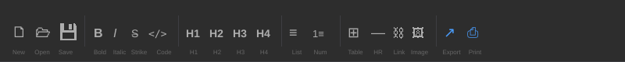
Figure 2 — The formatting toolbar

Showing and Hiding the Toolbar
Click the ≡ button in the titlebar, or press Ctrl+Shift+B. The toolbar state is remembered across restarts — if you close the app with the toolbar hidden, it stays hidden on the next launch.

Toolbar Buttons

File Operations
- New (🗋) — create a new blank document
- Open (🗁) — open a file picker dialog
- Save (💾) — save the current document

Text Formatting
- B — bold (wraps selection or inserts markers at cursor)
- I — italic
- S — strikethrough
- </> — inline code

Headings
- H1 through H4 — applies the heading level to the current line

Lists and Blocks
- ≡ — unordered list (prefixes line with "- ")
- 1≡ — ordered list (prefixes line with "1. ")
- ⊞ — insert a 3-column table template
- — — horizontal rule
- ⛓ — insert link template
- 🖼 — insert image template

Actions
- ↗ — open the Export panel
- ⎙ — print the current document
💡 Tip: All toolbar buttons work even when the preview pane has focus. Formatting buttons also return focus to the editor so you can keep typing immediately after clicking.

7. Document Topology & Outline

Document Topology
The Document Topology view (⬡ icon in the icon rail) shows a navigable heading tree for your document — a visual map of your document structure.

Reading the Topology
- Each heading appears as a node in the tree, indented by level.
- The currently active heading (matching your cursor position) is highlighted in blue.
- Click any node to jump directly to that heading in both the editor and preview.

Balance Chart
At the bottom of the Topology panel is the Balance Chart — a horizontal bar showing how much content is in each top-level section. A balanced bar means your sections are roughly equal in length. A very short or very long section is immediately visible.
💡 Tip: Use the Balance Chart when editing long documents to make sure no single section has grown too large or been left too thin.

Document Outline
The Outline view lives in the right panel (OUTLINE tab at the bottom). It shows a flat list of all headings in the document, making it easy to navigate quickly without expanding the left panel.
Click any heading in the Outline to scroll both the editor and preview to that section.

8. Snippet Studio
Snippet Studio is a template system for text you type repeatedly. Snippets can include tab stops — placeholders you jump between with the Tab key.

Using Snippets
- Open Snippet Studio by clicking the ❮❯ icon in the icon rail, or open the right panel and click the SNIPPETS tab.
- Find the snippet you want by scrolling or typing to filter.
- Click Insert to insert it at the editor cursor.
- The first tab stop is automatically selected. Type your content, then press Tab to advance to the next placeholder.
- Press Escape at any time to exit snippet mode and return to normal editing.

Creating and Editing Snippets
- Click the + button in Snippet Studio to create a new snippet.
- Give it a name and write the body text.
- Add tab stops using ${1:placeholder} syntax. ${1:name} creates the first tab stop with the default text "name".
- Example: **${1:bold text}** and *${2:italic text}* creates a snippet with two tab stops.
- Click Save to add the snippet to your library.

Snippet Library Path
By default, snippets are stored in the app data folder. You can point to a shared snippet library (for example, a folder in your cloud storage) via Settings → Snippet Library Path. This is useful for syncing snippets across machines.

9. Version Timeline
The Version Timeline automatically saves snapshots of your document as you work, giving you a full version history without any manual effort.

How It Works
Two auto-save systems run independently:
- Draft sidecar — saves a .draft file alongside your document every 60 seconds (configurable). Discarded when you manually save. Protects against crashes.
- Version snapshots — saves a timestamped snapshot every 2 minutes and on every manual save. Kept for 7 days, up to 200 snapshots per file. These form your version history.

Using the Timeline Scrubber
The scrubber is the thin bar at the right end of the status bar. Each dot on the scrubber represents a saved snapshot.
- Hover over a dot to see the timestamp of that snapshot.
- Click a dot to preview that snapshot in the preview pane (the editor is not affected).
- While previewing, a Restore button appears. Click it to replace the current document content with that snapshot.
- Click away from the scrubber to dismiss the preview and return to live editing.

Draft Restore
If the app closes unexpectedly while you have unsaved changes, the next time you open that file a dialog will appear offering to restore the auto-saved draft or discard it.

10. Export
Click Export… in the titlebar or press Ctrl+Shift+P to open the Export panel. The panel slides in from the right and the editor expands to full width automatically.

Export Formats
- HTML (Styled) — full HTML document with the GHS theme CSS embedded. Ready to share or publish.
- HTML (Clean) — HTML without any styling, just the structure. Useful for pasting into a CMS.
- Word Document (.docx) — exports with proper heading styles (Heading 1 through Heading 6), bold, italic, code, blockquotes, and lists. Opens correctly in Microsoft Word and LibreOffice.
- Plain Text — strips all Markdown formatting and exports pure text.
- PDF — exports via the preview pane's print engine. Renders exactly as the preview looks.

Suggested Filename
The save dialog suggests a filename automatically. If the file has already been saved, it uses the current filename. If the document is unsaved (Untitled), it reads the first # Heading from your document and uses that as the filename.
💡 Tip: To export as PDF, choose "PDF (via Print)" from the export options or use Ctrl+Shift+P to open the print dialog directly. The PDF will match what you see in the preview, including your active theme colors.

11. Focus Mode
Focus Mode is designed for distraction-free writing. Press Ctrl+Shift+F or click the Focus button in the titlebar to activate it.
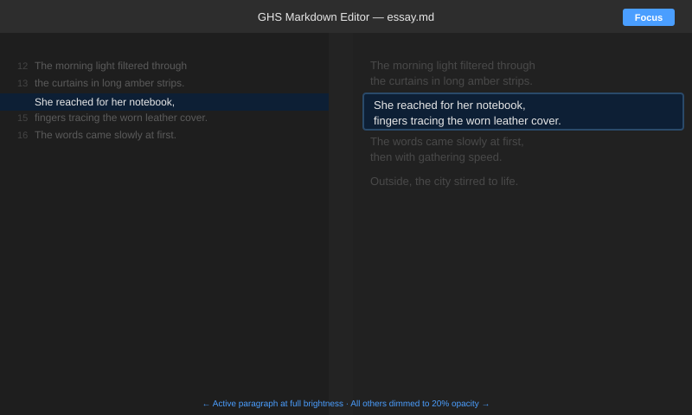
Figure 3 — Focus Mode with active paragraph at full brightness, others dimmed

Prose Dimming
When Focus Mode is active, the preview pane dims all content except the block your cursor is in. The active block stays at full brightness with a subtle blue outline. All other paragraphs, headings, and lists fade to 20% opacity.
As you move your cursor to a different paragraph, the highlight follows smoothly with a 0.3-second fade transition. This keeps your attention on the sentence or paragraph you are writing without hiding the surrounding context entirely.

Toggling Focus Mode
Focus Mode can be toggled from anywhere in the app — including when the preview pane has focus. Press Ctrl+Shift+F, click the Focus button in the titlebar, or search "Focus Mode" in the Command Palette.
Focus Mode state is remembered across restarts. If you close the app with Focus Mode active, it will be active when you reopen the app.

12. Detached Preview (Dual Monitor)
Press Ctrl+D or click the ⧉ button in the titlebar to detach the preview into a separate window. This is designed for dual-monitor setups where you write on one screen and see the live rendered output on the other.

How It Works
- The main window automatically switches to Edit-only mode when the preview detaches, giving you the full width of the screen for writing.
- The detached preview window shows the live document, updating in real time as you type.
- Scroll sync works between the editor and the detached window — scrolling the editor scrolls the preview proportionally.
- Closing the detached preview window returns the main window to Split mode automatically.
- The detached window remembers its position and size. The next time you detach, it reopens in the same location.

Notes
Note: The detached preview state is not persisted across restarts. You will need to press Ctrl+D again after relaunching the app. This is by design — it avoids confusion if you launch the app on a single monitor.

13. AI Assist Panel
The AI Assist panel brings Claude — Anthropic's AI assistant — directly into the right panel slot. Ask it to summarize your document, suggest improvements, rewrite a section, answer questions about your content, and more.
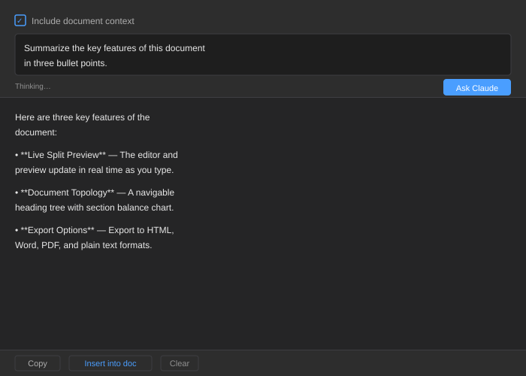
Figure 4 — The AI Assist panel with a streaming response

Setting Up Your API Key
AI Assist requires an Anthropic API key. This is separate from a Claude.ai or Claude Pro subscription. Get your key at console.anthropic.com.
- Open Settings (⚙ icon in the icon rail)
- Scroll to the AI Assist section
- Paste your API key into the field (it is masked for security)
- Click Test Connection to verify the key works
Note: Your API key is stored locally in the app settings file on your machine. It is never sent anywhere except Anthropic's API endpoint. API usage is billed directly to your Anthropic account.

Using AI Assist
- Open the right panel using the pull tab on the right edge, then click AI ASSIST at the bottom of the panel.
- Check Include document context to send your full document along with your prompt. Uncheck it for general questions that do not relate to your document.
- Type your prompt in the text box and click Ask Claude (or press Enter).
- The response streams in token by token. You can click Stop at any time to cancel.
- When the response is complete, use the Copy button to copy it to the clipboard, Insert into doc to append it to your document, or Clear to reset.

Example Prompts
- "Summarize the key points of this document in three bullet points."
- "Rewrite the introduction to be more engaging and concise."
- "What are the weak points in this argument?"
- "Suggest a better title for this document based on its content."
- "Check this document for logical inconsistencies."

14. Command Palette
The Command Palette is the fastest way to run any action in the app. Press Ctrl+P to open it from anywhere — including when the preview pane has focus.
Start typing to fuzzy-search all available commands. The palette shows the command name, its category, and its keyboard shortcut if one is assigned. Click a command or press Enter to execute it.

What Can You Do From the Palette?
- Switch themes (GHS Dark, GHS Light, GHS Custom)
- Open export formats directly (Export as PDF, Export as Word, etc.)
- Toggle Focus Mode, formatting toolbar, right panel, left panel
- Apply heading levels and formatting to the current line
- Navigate to the Outline or Snippet Studio panel
- Open Settings, print, or create a new file
The palette is especially useful if you cannot remember a keyboard shortcut — just type what you want to do and the matching command will appear.

15. Settings
Click the ⚙ icon at the bottom of the icon rail to open the Settings panel in the left slot.

Theme
Choose from three theme options:
- GHS Dark — near-black shell with blue accent. The default. Best for low-light environments.
- GHS Light — warm cream/off-white tones. Best for bright environments or print-like reading.
- GHS Custom — create your own color scheme by editing 10 key color tokens.
- Auto (OS) — follows your operating system appearance setting, switching between Dark and Light automatically.

Custom Theme Editor
Selecting GHS Custom reveals the Custom Colors section with 10 color pickers:
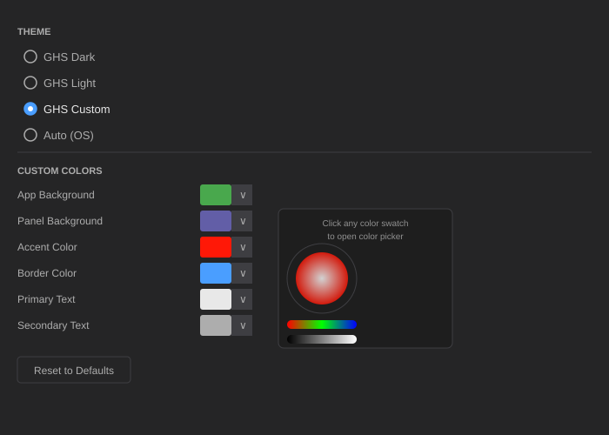
Figure 5 — The custom theme editor with color picker controls
- App Background — the overall window background
- Panel Background — the left and right panel areas
- Toolbar Background — the titlebar and formatting toolbar
- Editor Background — the text editor area
- Preview Background — the preview pane background
- Accent Color — links, active states, and highlights
- Border Color — panel dividers and table borders
- Primary Text — the main body text color
- Secondary Text — muted labels and secondary information
- Hint / Icon Color — icon glyphs and placeholder text
Click the color swatch next to any token to open the color picker. Your selections apply to the app and preview immediately. Click Reset to Defaults to return all colors to the GHS Dark baseline.
Custom colors are saved automatically and restored on every launch.

Editor Font
- Font Family — type any font name installed on your system. The editor accepts comma-separated fallback lists, e.g. "Cascadia Code, Consolas, monospace".
- Font Size — use the up/down buttons to adjust. Range: 10pt to 24pt.

Auto-Save
The Draft interval setting controls how often the auto-save draft is written. Default is 60 seconds. Range: 30 to 3600 seconds.

Snippet Library Path
By default, snippets are stored in the app data folder. Enter a custom path here to point to a shared snippet library — useful for syncing snippets across devices via cloud storage.

AI Assist
Enter your Anthropic API key here. Click Test Connection to verify it works. See the AI Assist Panel section for full setup instructions.

Keyboard Shortcuts Reference
A full table of all registered commands and their shortcuts appears at the bottom of the Settings panel for quick reference.

16. File Operations

Creating, Opening, and Saving
- New file — Ctrl+N. Prompts to save if the current document has unsaved changes.
- Open file — Ctrl+O. Opens a file picker dialog filtered to .md files. You can also drag and drop a .md file anywhere onto the app window.
- Save — Ctrl+S. Saves to the current path. Triggers a snapshot and discards the draft sidecar.
- Save As — Ctrl+Shift+S. Opens a save dialog to choose a new location or filename.

Recent Files
The File Browser (⊞ icon in the icon rail) shows your last 20 opened files. Click any file to open it immediately.
On Windows, after installing via the Inno Setup installer, your recent files also appear in the Windows taskbar Jump List — right-click the pinned app icon to see them.

Draft Auto-Save and Recovery
A .draft file is written alongside your document every 60 seconds (configurable in Settings). If the app closes without saving:
- The draft file remains on disk.
- The next time you open the same file, a dialog appears asking whether to Restore the draft or Discard it.
- Restoring loads the unsaved content. Discarding removes the draft and opens the last saved version.
Note: Draft files are deleted automatically when you save manually. They are purely a crash recovery mechanism.

Drag and Drop
Drag any .md file from Windows Explorer or macOS Finder and drop it onto the GHS Markdown Editor window to open it. If the current document has unsaved changes, you will be prompted before the new file loads.

17. Keyboard Shortcuts Reference
All shortcuts work from anywhere in the app, including when the preview pane has focus.
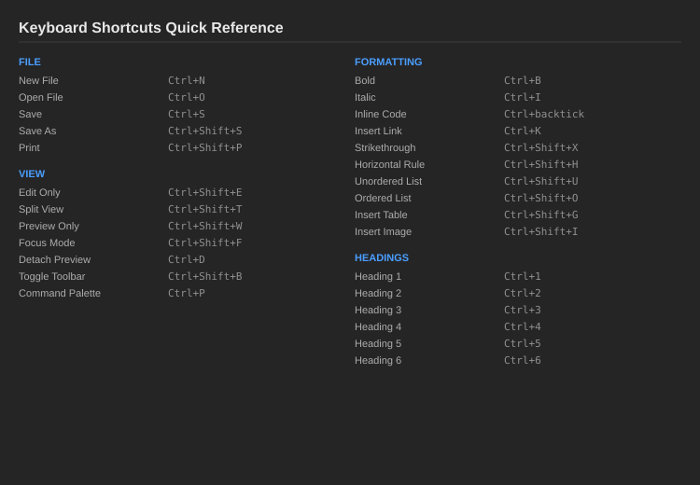
Figure 6 — Keyboard shortcuts quick reference

File
Action | Shortcut
New File | Ctrl+N
Open File | Ctrl+O
Save | Ctrl+S
Save As | Ctrl+Shift+S
Print | Ctrl+Shift+P

View
Action | Shortcut
Edit Only | Ctrl+Shift+E
Split View | Ctrl+Shift+T
Preview Only | Ctrl+Shift+W
Focus Mode toggle | Ctrl+Shift+F
Detach Preview Window | Ctrl+D
Toggle Formatting Toolbar | Ctrl+Shift+B
Command Palette | Ctrl+P

Formatting
Action | Shortcut
Bold | Ctrl+B
Italic | Ctrl+I
Inline Code | Ctrl+` (backtick)
Insert Link | Ctrl+K
Strikethrough | Ctrl+Shift+X
Horizontal Rule | Ctrl+Shift+H
Unordered List | Ctrl+Shift+U
Ordered List | Ctrl+Shift+O
Insert Table | Ctrl+Shift+G
Insert Image | Ctrl+Shift+I

Headings
Action | Shortcut
Heading 1 | Ctrl+1
Heading 2 | Ctrl+2
Heading 3 | Ctrl+3
Heading 4 | Ctrl+4
Heading 5 | Ctrl+5
Heading 6 | Ctrl+6

18. Right-Click Context Menu
Right-clicking anywhere in the editor opens a context menu with quick access to formatting, editor options, clipboard operations, and file actions — all without leaving the keyboard home position.

Formatting commands (top group):
Bold, Italic, Strikethrough, Inline Code
Heading submenu — H1, H2, H3 with keyboard shortcuts shown
Link, Image

Editor toggle options (middle group — each shows a checkmark when active):
Word Wrap — toggles soft line wrapping on and off
Show Line Numbers — toggles the line number gutter
Highlight Current Line — toggles the active line background highlight

These toggle settings are persisted — they survive app restart.

Clipboard operations:
Cut, Copy, Paste, Select All

File:
Save (Ctrl+S)

Tip: The toggle options in the context menu are the only way to change Word Wrap and Line Numbers at runtime. They are remembered between sessions.

19. Inserting Code Blocks
The {} button in the formatting toolbar opens the Code Block Language Picker. This dialog lets you choose the programming language for syntax highlighting before inserting the fenced code block.

How to insert a code block:
Place your cursor where you want the block
Click {} in the toolbar (or right-click → Code Block...)
Type to search for a language, or click a pill to select it
The fenced block is inserted with your cursor positioned inside, ready to type

Supported languages (28):
plaintext, csharp, javascript, typescript, python, html, css, sql, bash, json, xml, yaml, markdown, powershell, rust, go, java, cpp, c, ruby, php, swift, kotlin, r, scala, dockerfile, toml, ini, graphql

Changing the language on an existing code block:
Double-click on the opening fence line (the line that starts with three backticks) to reopen the language picker. Select a new language to update the fence tag. You can also right-click on the fence line and choose Change Language...

Tip: The search box filters languages as you type. Typing "sc" will show both "scala" and "typescript".

20. Git Diff Margin
When you open a file that is tracked in a git repository, the editor shows a thin colored bar to the left of the line numbers indicating what has changed since your last commit.

Color guide:
Green bar — line was added (not in the last commit)
Amber bar — line was modified (changed from the last commit)
Red triangle — lines were deleted at this point

The margin appears automatically when a tracked file has uncommitted changes. It updates when you save the file. If the file is clean (matches the last commit), the margin is invisible.

The margin does not appear if:
The file is outside a git repository
Git is not installed on your machine
The file has no changes since the last commit

In all these cases the app behaves normally — there are no errors or warnings.

Using git for document version control:
Writers can use git to version their documents folder just like developers version code. Create a git repository in your documents folder, add your files, and commit. After that, any file you open from that folder will show diff indicators as you write. Green bars show new content. Amber bars show revised sentences. This gives you a live view of everything you have changed since your last checkpoint — without leaving the editor.

Use git commit whenever you want to save a checkpoint. The diff margin resets after each commit, giving you a clean view of your next round of changes.

Tip: Combine the Git Diff Margin with the Version Timeline (the scrubber in the status bar) for two complementary views of your document history — the timeline shows auto-saved snapshots, the diff margin shows changes since your last git commit.

21. Theme Improvements
Several visual refinements were made to the editor themes.

Light theme italic text:
In GHS Light theme, italic text is now displayed in a readable dark blue-gray (#555566) instead of the previous near-white color. All italic Markdown syntax is clearly visible on the cream background.

Right panel pull tab:
The pull tab on the right edge of the window now shows a clear chevron indicator — ‹ when the panel is open, › when it is closed. The tab is 16px wide and uses the accent color for visibility.

Custom theme Reset to Light:
The custom theme editor now has two reset buttons:
Reset to Dark — restores the GHS Dark color palette as the custom baseline
Reset to Light — restores the GHS Light (cream) color palette as the custom baseline

This makes it easier to start a custom theme from either the dark or light palette without manually entering color values.
GHS Markdown Editor v1.0.0 · github.com/michaeldhead/MarkDown-CrossPlatform

