The Newcastle Audio Ranking test
User manual
Michael Drinnan
Original Windows edition, 2010-2012
Web edition, October 2026

With great thanks due (in alphabetical order) to:

Meike Brockmann
Paul Carding
Jim Gould
Jessie Waugh

We hope you find NeAR useful.

The original manuscript describing a simple validation is at:

https://doi.org/10.1016/j.jvoice.2011.07.011

The app is at:

https://michaeldrinnan.github.io/NeAR/

For advice, improvements, bug reports or anything else, please use the project page:

https://github.com/michaeldrinnan/NeAR/issues

Contents
Getting started and preparing the audio files 2
Opening the app 2
Try it out with the example files 2
Getting the file format right 2
Put together the rating folder 2
Optionally, put together a reference folder 2
Preparing the rating session 3
Select the files for rating 3
If necessary, select your reference files 3
Choose a name to identify the rating session 3
Tick the rating options you want to use 3
Starting the rating session 4
Performing the rating 5
And then… 7
End the rating session 7
Look at the results 7
Finer details 7
How does the program deal with the results file NeAR.csv? 7
Loading the data into Excel 8
The file format 9
Using reference files 9
Analysing the data 10
Measures of agreement 10
Unrated samples 10
Using reference files 10
What’s different from the 2012 Windows version 11
References 11
Acknowledgements 11

Getting started and preparing the audio files
The Newcastle audio ranking test (NeAR) is a mini-application for sorting and rating audio clips by repeated comparison. It is very simple to use. This edition of the manual describes the web version, which runs in your web browser. It replaces the 2012 Windows program and reads and writes the same results files.

Opening the app
There is nothing to install. Open https://michaeldrinnan.github.io/NeAR/ in a web browser. The program runs entirely on your own computer: your audio files are never uploaded anywhere, and once the page has been opened it carries on working without an internet connection.
Which browser? If you can, use Google Chrome or Microsoft Edge on a Windows, Mac or Linux computer. These can open a folder on your disk and write the results file NeAR.csv straight into it, just like the old Windows program. Other browsers (Safari, Firefox, and the browsers on iPads and phones) work too, but they can’t save into folders. Instead the results are kept inside the browser, and you download NeAR.csv when you need it; see Look at the results below.
If you’d like NeAR to behave like an ordinary program, with its own icon and window, you can install it. In Chrome or Edge (and on Android), click the Install app button at the top of the NeAR window; once installed, NeAR appears with your other programs and the button disappears. On an iPad or iPhone, use Share then Add to Home Screen. This is optional. When a new version is published, an Update available button appears at the top of the window; click it when you’re ready.

Try it out with the example files
NeAR comes with a set of example files, so you can try it before preparing your own. They are synthetic recordings of a sustained “ah”, made with increasing amounts of hoarseness, so there is a right answer: 8 samples to rate (sample-A … sample-H) and 5 references, from ref-1 (the clearest) to ref-5 (the roughest).
Click Try with example files at the top of the start screen. The samples and references are loaded, the reference box is ticked and the session is named Demo: just click Start. The results of example sessions are kept in the browser under “Example files”, so they never mix with your own studies.
To practise the full routine with real folders instead, use the download them (.zip) link next to the button. Unzip the file, then choose its TestItems and RefItems folders. The file ANSWER-KEY.txt in the zip gives the correct order, so you can check your ranking.

Getting the file format right
NeAR needs to have your audio files in .WAV format. This is pretty much the standard for uncompressed audio; if your software doesn’t create WAV files already, then it will almost certainly have an option to do so. If not, then there are many software applications that will convert between a bewildering array of different formats. I’d recommend the free audio editor Audacity (https://www.audacityteam.org), which will do the job, and will also let you edit down the audio files to the right size for your rating tasks.
NOTE: If you’ve got an over-riding reason to need to use wma or mp3 and you really can’t convert them to WAVs, then it would be fairly straightforward to adapt the software – I just didn’t do it yet.

Put together the rating folder
Create a folder on your hard disk. Put there a copy of all the WAV files you want to be rated. Any WAV file in this folder will be included in the rating task; files in sub-folders are ignored. The results file NeAR.csv is kept in this folder too, so use one folder for each rating study.

Optionally, put together a reference folder
You only need to do this if you want to rate the samples against some reference files you have already created. Create a different folder on your hard disk. Put there a copy of all the WAV files you want to use as references. They will always be displayed in ascending alphanumeric order: 0…9, then A…Z (capital and small letters are treated alike).
When you come to do the rating, you won’t be able to move the reference files around. Therefore they need to be named correctly from the start. For example, if you’ve got 12 reference files you could name them: 01.wav … 12.wav, or A.wav … L.wav. The lowest number or letter will appear to the left on the screen, and should correspond to the ‘best’ sample – however you choose to interpret ‘best’.

Preparing the rating session

Select the files for rating
Open NeAR, and use the Choose folder… button at the top to pick out the folder you just created. Underneath, NeAR shows the name of the folder and the number of WAV files found there to rate.
In Chrome and Edge, the browser asks whether NeAR may view the files in the folder, and then whether it may save changes there. Allow both: NeAR needs to read the audio files and to write NeAR.csv. It never changes or deletes your audio files.
NeAR remembers the folders you used last time. When you come back, a button such as Use “TestItems” again appears; click it and confirm, rather than finding the folder again.
In other browsers there are two buttons, Choose folder… and Choose files…. On an iPad or phone, use Choose files… and select all the WAV files at once.

If necessary, select your reference files
If you want to use some reference files, tick the box and pick the relevant folder with the Choose folder… button in the next box down.

Choose a name to identify the rating session
To make the analysis easier, all the results go into the same file. The name you type here will help you identify this rating session. You can use the same name twice, but you’ll get a warning. The name can’t contain a comma, because that would upset the columns of the results file. The date and time of the session will also be saved, which might let you figure out which rater was which if you’ve forgotten.

Tick the rating options you want to use
Most of these are self–explanatory. It’s probably easier to have a trial run and just watch what happens when you pick the various options, but here is a short explanation of each (on the next page is a picture that might help guide you). NeAR remembers your choices for next time.
- If you tick the first box, then the audio samples are presented in a different random order each time you run the rating test. This would be useful if you are giving the same test to the same person on multiple occasions to assess test-retest agreement, for example. Otherwise, the audio samples are presented in alphabetical order by file name. This means that every rater gets the samples in the same order.
- If you tick the second box, then the samples will be labelled from 1 upwards. This isn’t very helpful.
- If you tick the third box, then the samples will be labelled with their file name. For example, you could deliberately label the samples with the patient’s age to see whether that affects the ranking process. Be careful using this option; it’s quite likely you used meaningful file names for the original audio samples. For example, they might give away the fact that two samples came from the same patient.
- The fourth tick box indicates how many times each sample has been played. Initially, it was in mind to restrict the users to playing the samples only a fixed number of times but this hasn’t proven necessary. If it would be useful then it would be a reasonably easy change.
NOTE: the count only goes up when the sample’s own Play button is clicked. If the rater replays a sample using the player bar at the bottom of the window, that isn’t counted.
- The fifth tick box allows the user to leave some samples unrated. This can make statistical analysis of your data more difficult. Before you do this, read the discussion of statistics at the end of the manual.

Starting the rating session
If you’ve done everything correctly, it should look a bit like this:
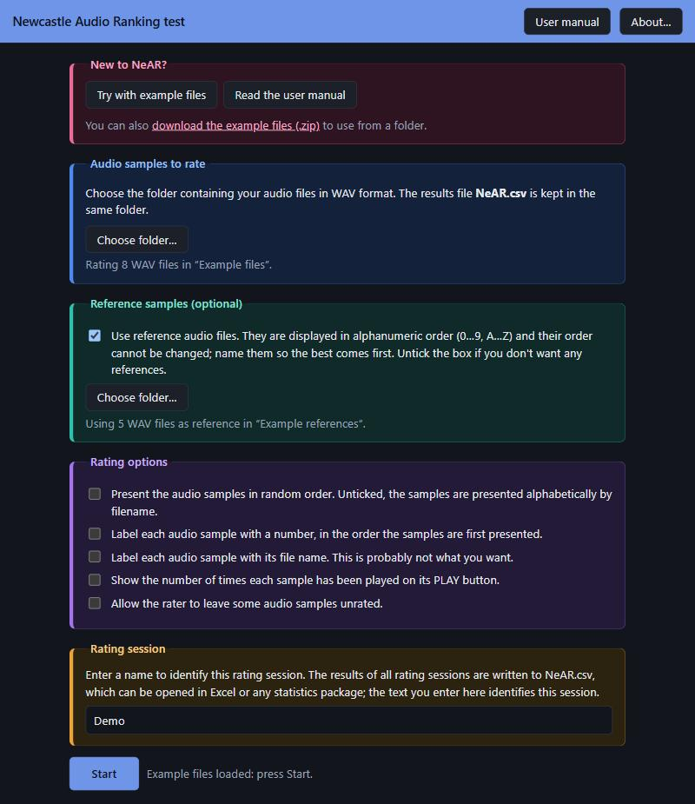
Click the Start button, and the rating screen appears like in the picture below. On a computer you can make the browser window bigger, or press F11 for full screen, to fit more samples on the screen.
- The unrated audio samples appear at the bottom of the screen. Each one is coloured differently, so that you can recognise which sample is which.
- If you specified reference files they appear at the top of the screen in plain blue, as in the example below.

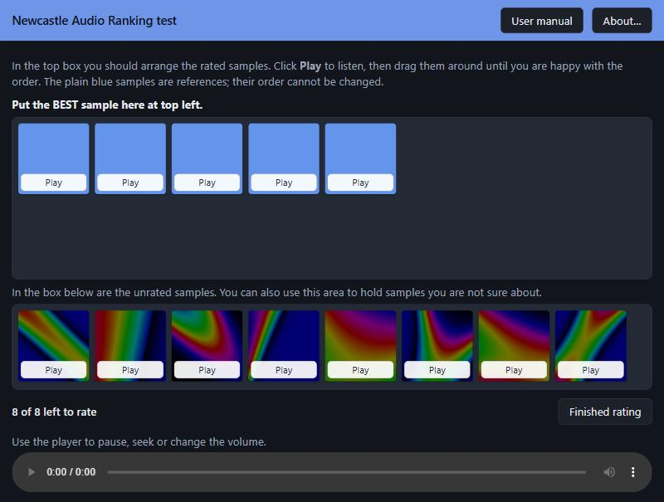

Performing the rating
The rating process is easy, but here are the steps:
- Make the browser window as large as is comfortable, so that you can see all the samples.
- Click the Play button on any audio sample to hear it. Clicking Play on another sample stops the first one.
- Then, drag it up to the top box using the mouse (or your finger, on a touchscreen). It will turn bright-coloured when you drop it, to indicate that it has been rated.
- Repeat for the second audio sample. Drop it to the left or right of the first sample, according to whether you think it was better or worse. Dragging a sample over another one moves it into that place and shuffles the others along; dragging it into empty space puts it at the end. And so on.
- You can play and move the audio samples as often as you like, until you are happy with the order.
- If you are not sure about a sample, drag it back to the bottom of the screen where it joins the unrated samples.
- Note that you can’t change the order of the blue reference samples.
- Use the player bar at the bottom of the window to pause, skip forward or back, or change the volume.

Here is a rating session after five of the eight samples have been rated:
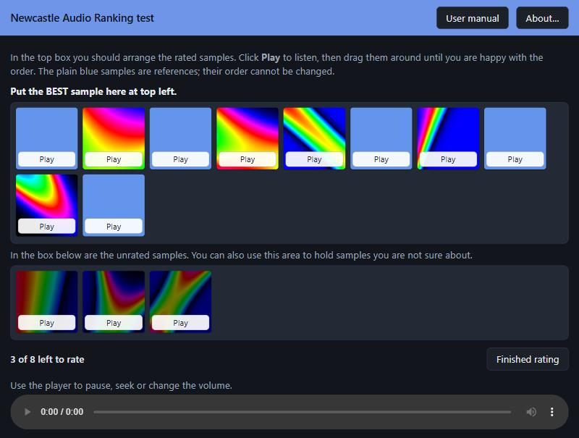

And then…

End the rating session
When you are happy, click the Finished rating button and confirm. That’s it – the results are saved automatically, and you can start another rating session. The folders, options and session name stay filled in, so for the next rater you only need to change the name.
NOTE: If you want to abandon a rating session without rating all the samples, but you forgot to tick the box on the front page, then hold down the CTRL key (or ⌘ on a Mac) as you click the Finished rating button. This feature isn’t advertised to the user in the software.

Look at the results
In Chrome and Edge, the results are saved in a file called NeAR.csv in the same folder as your WAV files. The file can be opened straight into Microsoft Excel, or just about any text editor or statistics package. There is some more detail about the intricacies of the file format on the next pages.
In other browsers, the results are kept inside the browser, separately for each samples folder, and after each session NeAR offers to download an up-to-date copy of NeAR.csv. You can also use the Download NeAR.csv button on the start screen at any time. Download a copy regularly: clearing the browser’s history or site data deletes the results kept in it. To carry on a study begun elsewhere, choose the samples first, then use Import NeAR.csv… to load the existing results file.

Finer details
There might be odd occasions when the program does something unexpected. The error messages are quite informative, but the detail here might help explain what is going on.

How does the program deal with the results file NeAR.csv?
- First, the program checks to see if the results file NeAR.csv already exists in the same folder as your test samples (or, in browsers that can’t use folders, inside the browser). If not, it is created new.
- If NeAR.csv DOES exist, the program reads the file names from the first line of the file. These would have been created the first time you tried to rate the files in this folder. It then compares these file names with the WAV files that are currently in the folder. If the files have been changed, then the results file must be cleared; this is a precaution to make sure a single results file always relates to the same set of voices.
- If the audio samples have changed, the program will give you the opportunity to save the existing results under a different name before it starts a new file.
- Then you perform the rating task.
- After the rating task, the program will add the new results to the end of the file NeAR.csv as a new row.
- Normally, that’s the end of the story but occasionally the program fails to write the new results. This is probably because you’ve got the file open in another program. For example, Excel will lock the file and stop any other program from accessing it. In this case, you can close the other program and try again, or save the results as a new file. Be aware this is a one-off; the next set of results will go back to NeAR.csv. So - if you have a problem, you need to sort it out immediately. Otherwise, you will have some results in one file, and some in another.

Loading the data into Excel
Your results are stored in a file NeAR.csv. The CSV (comma separated value) file is in a text format and can be read by any text editor, word processor, spreadsheet or statistics package. However, it is probably best suited to Microsoft Excel for initial viewing. Here’s how:

If you use the point (.) as your decimal separator (99.9)
This applies in most English-speaking countries. You should just be able to double-click on the file in Windows Explorer (or the Finder on a Mac) and it will open properly in Excel.

If you use the comma (,) as your decimal separator (99,9)
This is the case in some European countries: Germany, the Netherlands, Italy, parts of Scandinavia, etc. If so, then the comma might be misinterpreted if you open the file directly. It seems to depend on how you have your regional and Language settings in the control panel.

If the import doesn’t work as you expect, you will need to import the data with explicit settings to use a comma delimiter. In current versions of Excel use Data -> From Text/CSV, pick the file and set the delimiter to Comma. In Excel 2007 and 2010 you do it using the Data -> From Text command like this:

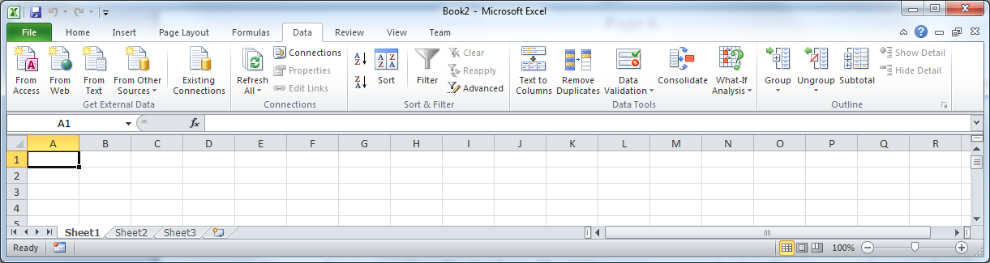

Select the file you want to import, then pick a Delimited file, and a Comma delimiter like this:

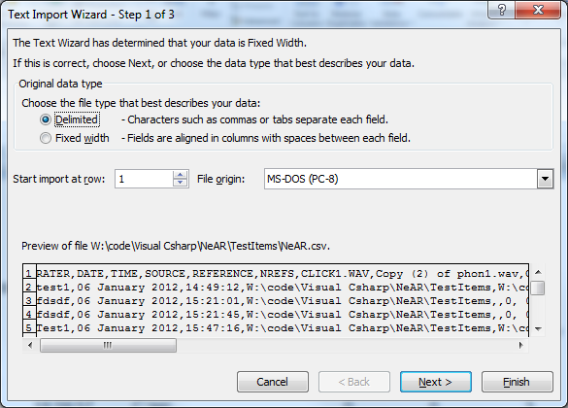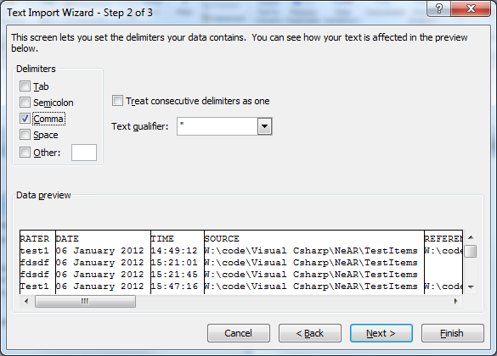

Notice that in the second box you can see how Excel has parsed your data into columns. This should give you a good idea whether it is going to work or not. If so, the other settings can all be left as they are.

The file format
Here’s how your data might look in Excel:
RATER | DATE | TIME | SOURCE | REFERENCE | NREFS | zz10.wav | zz24.wav | zz89.wav | zz90.wav
Anne | 2008-07-25 | 18:59:12 | src |  | 0 | 4 | 3 | 2 | 1
Brian | 2008-07-25 | 18:59:37 | src |  | 0 | 1 | 4 | 3 | 2
Claire | 2008-07-25 | 18:59:57 | src |  | 0 | 0 | 3 | 2 | 1

- The folder src contained 4 WAV files, named zz10, zz24, zz89 and zz90.wav respectively.
- Three rating sessions had been conducted to date, with the dates and times as shown. Dates are written year-month-day, and times use the 24-hour clock.
- Anne thought zz90 was the best audio sample, and zz10 was the worst.
- Brian thought zz10 was best, but the others were in the same order as before.
- Claire was unable to rate zz10, but had the other three samples in the same order as before.

Claire was only able to leave a sample unrated because the corresponding option was ticked on the front page. If it wasn’t ticked, then she would have been obliged to rate all the audio samples to complete the task. See the discussion of unrated samples below.
SOURCE and REFERENCE give the name of the folder, because web browsers can’t see the full path. Rows written by the 2012 Windows version show the full path instead (C:\src), and dates in the style 25-Jul-08; old and new rows can sit in the same file without any problem.

Using reference files
If you’ve used 10 reference samples stored in a folder called ref, the file might look like this:

RATER | DATE | TIME | SOURCE | REFERENCE | NREFS | zz10.wav | zz24.wav | zz89.wav | zz90.wav
Anne | 2008-07-25 | 18:59:12 | src | ref | 10 | 14 | 7 | 2 | 1
Brian | 2008-07-25 | 18:59:37 | src | ref | 10 | 1 | 11 | 10 | 9
Claire | 2008-07-25 | 18:59:57 | src | ref | 10 | 0 | 10 | 7 | 3

The results for the reference samples aren’t included in the table because they always stay in the same order. Therefore there are still only 4 rankings. However, the rankings will now be in the range 1… 14. So for example, Ann thought that sample zz90 was better than all the reference samples, and sample zz10 was worse than all of them.

Analysing the data

Measures of agreement
The results of the ranking test have some special properties that make them amenable to some simple statistical measures of agreement. Consider a group of 10 audio samples in a rating task. Each rank from 1 to 10 will appear just once. Thus each set of rankings will have the same mean (5.5) and the same standard deviation (3.0). Therefore there can no systematic bias between raters. Under these circumstances many coefficients of agreement, such as Pearson’s and Spearman’s correlation, intra-class correlation and quadratic weighted kappa become equivalent.

Unrated samples
The biggest potential stumbling block to analysis is where you allow the raters to leave some audio samples unrated. Think carefully whether this is really what you want. Here are issues to think about:
- First, the unrated samples will all be given the value zero. For most analysis, this is NOT the same as missing data. The zeros might be useful in some circumstances, for example to create a histogram showing missing data. HOWEVER in most cases you will need to replace the zeros with a blank, or whatever your own software uses to indicate missing data.
- Second, ranks always start at 1 so it is the higher ranks that will be missing. Some statistical tests (Spearman’s rank correlation, for example) are relatively insensitive to this problem, but others are not. Even a simple mean score for each audio sample is probably wrong if you have missing data.

Using reference files
For similar reasons, if you’re using reference audio samples these special properties don’t hold true because the ranks of the reference files are not included in the results. Therefore one rater might rank all the samples as better than the reference samples, while the next rater ranks them all as worse.

What’s different from the 2012 Windows version?
The web version is intended as a drop-in replacement. The ranking task, the reference files and the results file all work as before, so existing NeAR.csv files can be carried on. The differences are:
- It runs in a web browser, on Windows, Mac, Linux or an iPad. There is nothing to install, and it doesn’t need .NET or Windows Media Player.
- Windows Media Player is replaced by a simple player bar, so the option to run a stand-alone Windows Media Player has gone.
- DATE and TIME are written as 2026-10-01 and 15:22:15, whatever the computer’s regional settings.
- SOURCE and REFERENCE contain the name of the folder rather than its full path.
- The random order is now properly random; the 2012 version shuffled the samples unevenly.
- The warning about a session name that has already been used now only appears for an exact match. Previously, for example, 1 was mistaken for test1.
- Reference samples no longer show the number 0 when the samples are labelled with numbers.
- Without Chrome or Edge, the results are kept in the browser and downloaded, rather than written into the folder.

References
Clopper CG. Auditory free classification: Methods and analysis. Behavior Research Methods 2008; 40: 575-581.
Granqvist S. The visual sort and rate method of perceptual evaluation in listening tests. Logopedics Phoniatrics Vocology 2003; 28: 109-116.
Imai S, Garner WR. Discriminability and preference for attributes in free and constrained classification. Journal of Experimental Psychology 1965; 69: 596-608.
Rae G. The equivalence of multiple rater kappa statistics and intraclass correlation coefficients. Educational and psychological measurement 1988; 48: 367-374.

Citation for this work
Gould J, Waugh J, Carding P, Drinnan M. A new voice rating tool for clinical practice. Journal of Voice 2012; 26(4): e163-70. DOI: 10.1016/j.jvoice.2011.07.011

Acknowledgements
Thanks to the following people for helping with the development, finding bugs or suggesting improvements:
Ben Barsties; Paul Carding; Jim Gould; Meike Brockmann; Jess Waugh.

Thanks also to Claude for help with the translation from C# to TypeScript.

