Assignment 1
Michael Wu 71163091

from PIL import Image
import numpy as np
import math
from scipy import signal

def boxfilter(n):
assert n%2!=0 # make sure it's odd
value = 1.0/(n*n) # normalized values
filter = np.zeros(shape=(n,n), dtype='d')
filter.fill(value) # fill matrix with normalized values
assert np.round(np.sum(filter))==1.0 # make sure it adds to 1
return filter

def gauss1d(sigma):
length = int(np.ceil(6*sigma))
if (length%2==0): # if its even, make it odd
length += 1
values = np.array([x for x in xrange((-length/2)+1,(length/2)+1)], dtype='d')
# create np array with doubles , deal with the integer roundoff
values = np.exp(-(values**2)/(2*(sigma**2)))
values = (1/np.sum(values))*values
return values

def gauss2d(sigma):
x = gauss1d(sigma) # retrieve the 1d gaussian
x = x[np.newaxis] # create new axis

y = gauss1d(sigma) # retrieve the 1d guassian
y = y[np.newaxis] # create a new axis
y = y.transpose() # take the transpose

return signal.convolve2d(x,y) # return the convolution of the two

def gaussconvolve2d(image, sigma):
i = Image.open(image)
i = i.convert('L')

i = np.asarray(i)
f = gauss2d(sigma)
i_filtered = signal.convolve2d(i, f, 'same')

new_image = Image.fromarray(i_filtered.astype('uint8'), 'L')
new_image.save('/home/i/i7f7/cs425/a1/new.png','PNG')

### TESTS ###

def testBoxFilter():
# check that our boxfilter works correctly for n=3,4,5...
for n in [3,4,5]:
try:
print 'Boxfilter with n =', n
print boxfilter(n)
except AssertionError:
# catch where it doesn't work
print 'Couldnt generate boxfilter of size ',n,'x',n

def testGauss1D():
for n in [0.3,0.5,1.0,2.0]:
try :
val = gauss1d(n)
assert np.round(np.sum(val))==1 # check that it is normalized
print '1D Gauss filter with sigma = ',n, 'length', val.size, np.sum(val), '\n', val
except AssertionError:
print 'Did not correctly generate a 1D Gaussian filter!', np.sum(val), val.size

def testGauss2D():
for n in [0.5,1.0]:
try :
val = gauss2d(n)
assert np.round(np.sum(val))==1 # check that it is normalized
print '2D Gauss filter with sigma = ',n, 'length', val.size, np.sum(val), '\n', val
except AssertionError:
print 'Did not correctly generate a 2D Gaussian filter!', np.sum(val), val.size

def testGaussFilter():
gaussconvolve2d('/home/i/i7f7/cs425/a1/lena.bmp',3)

### MAIN ###
if __name__=="__main__":
testBoxFilter()
testGauss1D()
testGauss2D()
testGaussFilter()

### RESULTS ###

1.) Boxfilter with n = 3
[[ 0.11111111 0.11111111 0.11111111]
[ 0.11111111 0.11111111 0.11111111]
[ 0.11111111 0.11111111 0.11111111]]
Boxfilter with n = 4
Couldnt generate boxfilter of size 4 x 4
Boxfilter with n = 5
[[ 0.04 0.04 0.04 0.04 0.04]
[ 0.04 0.04 0.04 0.04 0.04]
[ 0.04 0.04 0.04 0.04 0.04]
[ 0.04 0.04 0.04 0.04 0.04]
[ 0.04 0.04 0.04 0.04 0.04]]

2.) 1D Gauss filter with sigma = 0.3 length 3 1.0
[ 0.00383626 0.99232748 0.00383626]
1D Gauss filter with sigma = 0.5 length 3 1.0
[ 0.10650698 0.78698604 0.10650698]
1D Gauss filter with sigma = 1.0 length 7 1.0
[ 0.00443305 0.05400558 0.24203623 0.39905028 0.24203623 0.05400558
0.00443305]
1D Gauss filter with sigma = 2.0 length 13 1.0
[ 0.0022182 0.00877313 0.02702316 0.06482519 0.12110939 0.17621312
0.19967563 0.17621312 0.12110939 0.06482519 0.02702316 0.00877313
0.0022182 ]

3.) 2D Gauss filter with sigma = 0.5 length 9 1.0
[[ 0.01134374 0.08381951 0.01134374]
[ 0.08381951 0.61934703 0.08381951]
[ 0.01134374 0.08381951 0.01134374]]
2D Gauss filter with sigma = 1.0 length 49 1.0
[[ 1.96519161e-05 2.39409349e-04 1.07295826e-03 1.76900911e-03
1.07295826e-03 2.39409349e-04 1.96519161e-05]
[ 2.39409349e-04 2.91660295e-03 1.30713076e-02 2.15509428e-02
1.30713076e-02 2.91660295e-03 2.39409349e-04]
[ 1.07295826e-03 1.30713076e-02 5.85815363e-02 9.65846250e-02
5.85815363e-02 1.30713076e-02 1.07295826e-03]
[ 1.76900911e-03 2.15509428e-02 9.65846250e-02 1.59241126e-01
9.65846250e-02 2.15509428e-02 1.76900911e-03]
[ 1.07295826e-03 1.30713076e-02 5.85815363e-02 9.65846250e-02
5.85815363e-02 1.30713076e-02 1.07295826e-03]
[ 2.39409349e-04 2.91660295e-03 1.30713076e-02 2.15509428e-02
1.30713076e-02 2.91660295e-03 2.39409349e-04]
[ 1.96519161e-05 2.39409349e-04 1.07295826e-03 1.76900911e-03
1.07295826e-03 2.39409349e-04 1.96519161e-05]]
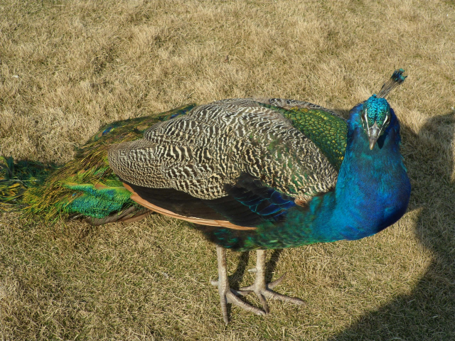
4.) The same peacock image used in assignment 0 was used here for demonstration of the filter.
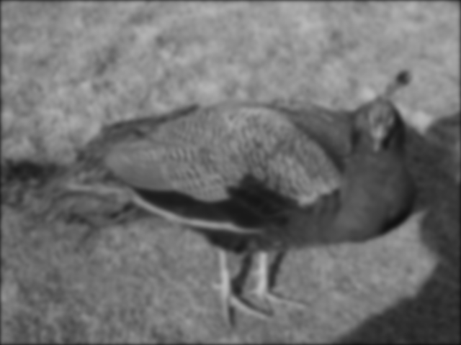
5.) This operation can performed in parallel for each dimension, since convolution with a ND Gaussian filter is the product of convolutions on N different dimensions. The other fashion which this could be done would be iterative, discarding the gains achievable by vectorized operations.

