Documentation for the Buhooro Website build January 2025

AirBnB account sign-in
The Airbnb sign-in for Buhooro seems to have the email address buhooro_wr@gmail.com
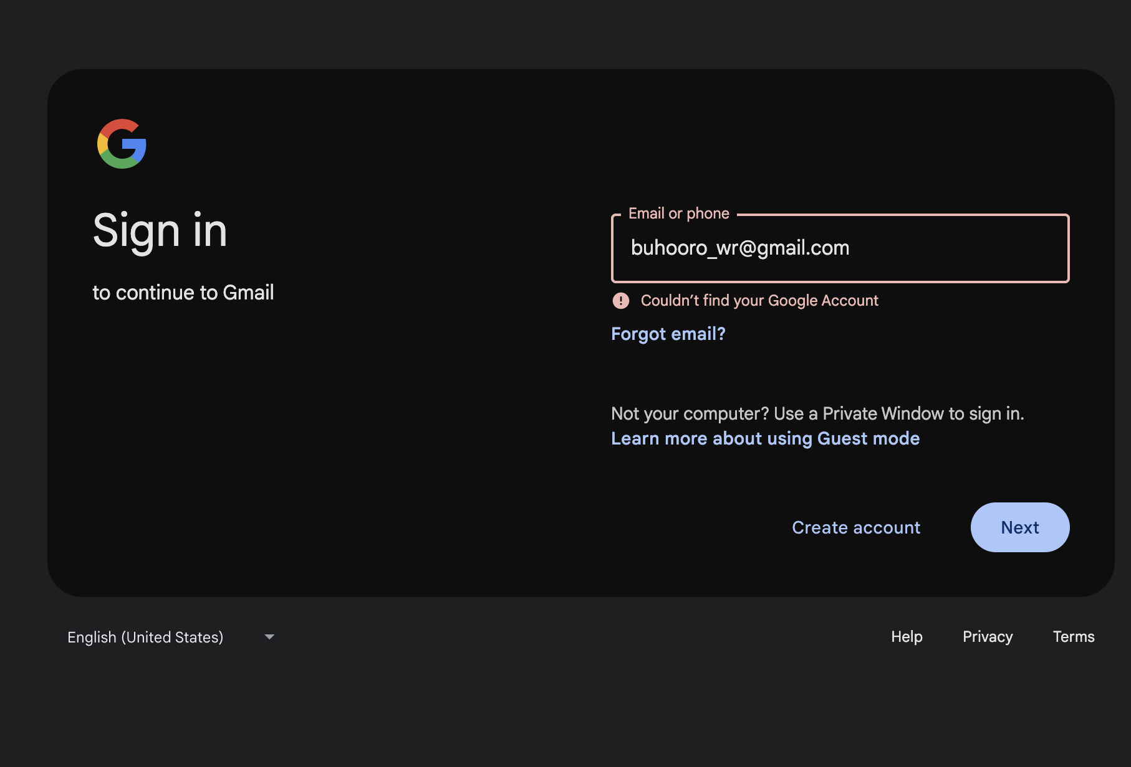
Google does not have an account buhooro_wr@gmail.com as of 5th January 2025, see above.
To be checked: What is the AirBnB sign-in for Buhooro then?
It cannot be buhooro_wr@gmail.com

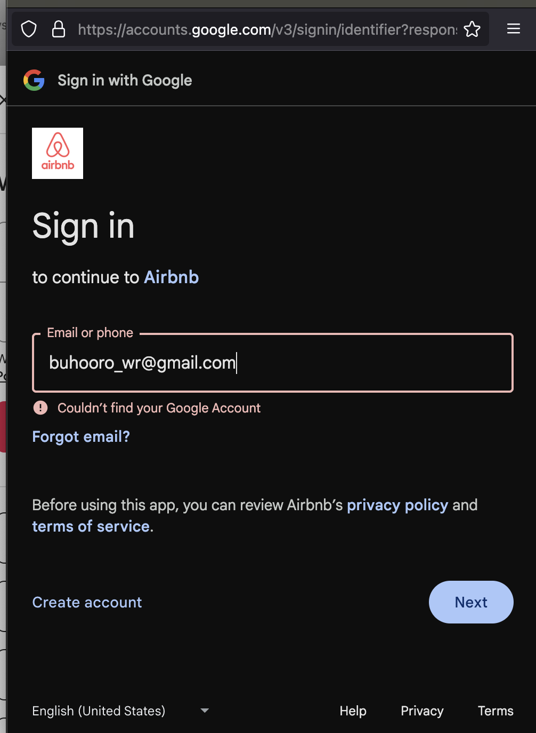

Pages to be on the site

- Home
  - Pic of the house and beach sunrise with minimal text, and contact info, and roughly j
- Stay
  - Pics of accommodation, and verandah, plus beach. Text on facilities locally and wider, shops etc, range of churches mosques. Staff to look after you. Our pets, Why there is no television. Our own eggs and fish caught locally
- Gallery
  - Pics of the grounds and wildlif
- Events
  - Wedding pics and other functions on-site.
- Videography
  - Bamatunde video – text of

