**DNF – The Next Generation Package Management Utility for RPM Based Distributions**

A recent news draw the attention of many Linux users, professionals and learners that “**DNF**” (stands for nothing officially) is going to replace “**YUM**” package management utility in distributions viz., Fedora, CentOS, RedHat, etc. that are using RPM Package Manager.

The news was quite surprising and more or less a packager manager is attached to the identity of a Linux distribution which is responsible for installing, updating and removing packages.

[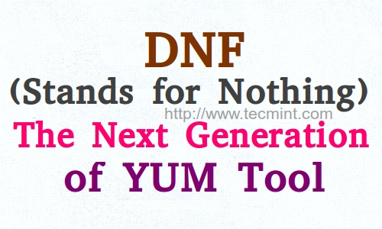](https://www.tecmint.com/wp-content/uploads/2014/08/dnf-command.jpeg)DNF: Next Generatin Yum Tool

**YUM** (stands for **Yellowdog Updater, Modified**) is a free and open-source command-line based utility released under GNU General Public License and is primarily written in Python Programming language. YUM was developed to manage and update RedHat Linux at Duke University, later it got wide recognition and become the package manager of RedHat Enterprise Linux, Fedora, CentOS and other RPM based Linux distribution. It is often called as “**Your Package Manager**”, unofficially frequently by Linux Professionals.

**Read Also**

**The Idea to Replace Yum With DNF**

**Ale¨ Kozumplík**, the developer of DNF project is a RedHat Employee. He says:

“For the first time in the year 2009 while working on ‘**Anaconda**‘ – The System Installer, he had an insight working of Linux. He wanted to work on a totally different project which let him exploring packaging tool of Fedora.”

Ale¨ Kozumplík said – he has been tired of explaining that DNF stands for nothing, it is a package manager name answer so it is, nothing else. It has to be named something that don’t conflicts with **YUM** and hence it was named **DNF**.

Short comings of Yum that led to the foundation of DNF:

1. Dependency resolution of YUM is a nightmare and was resolved in DNF with SUSE library ‘libsolv’ and Python wrapper along with C Hawkey.
2. YUM don’t have a documented API.
3. Building new features are difficult.
4. No support for extensions other than Python.
5. Lower memory reduction and less automatic synchronization of metadata – a time taking process.

Ale¨ Kozumplík, says he has no choice other than forking YUM and develop DNF. The YUM package maintainer were not ready to implement these changes. YUM has about **59000** LOC whereas DNF has **29000** LOC (Lines of Code).

**The DNF Development**

DNF showed its presence in Fedora 18 for the first time. Fedora 20 was the first Linux distribution that welcome users to utilise the functionality of DNF in place of YUM.

The technical challenges DNF is facing as now are – to implement all the functions of YUM. For a normal user DNF provides package download, install, update, downgrade and delete. However, still there are little or no support for features like – skipping broken package during install, debug, verbose output, enable repo, exclude packages during install, etc.

DNF and its predecessor’s comparison:

1. No effect of **–skip-broken** switch.
2. Command Update = Upgrade
3. The command **resolvedep** unavailable
4. The option **skip_if_unavailable** is ON by default
5. Dependency resolving process is not visible in Command Line.
6. Parallel downloads in future release.
7. Undo History
8. Delta RPM
9. Bash completion
10. Auto-remove, etc.

DNF integration with fedora and later in commercial environment is questioned from time-to-time by RHEL. The latest version is **DNF 0.6.0** was released on August 12, 2014.

**Testing DNF Commands**

Install dnf on fedora or later on RHEL/CentOS using yum command.

# yum install dnf

Usages Synopsis.

dnf [options] <command> [<argument>]

Install a Package.

# dnf install <name_of_package>

Delete a Package.

# dnf remove <name_of_package>

Update and Upgrade the System.

# dnf update

# dnf upgrade

**Note**: As said above update=upgrade. So. is this package going to implement something like rolling release? – A future question.

The default location of dnf configuration file: **/etc/dnf/dnf.conf**.

**Future of Project**

This project aims at bringing more transparency as well as document the project fully. The project is a very infant and the support of community is required to integrate the project. A lot of functions still needs to be ported and it will take time. DNF will be officially released with Fedora 22.

That’s all for now. I’ll be here again with another interesting article soon. Till then stay tuned and connected. Don’t forget to provide us with your valuable feedback in the comments below.