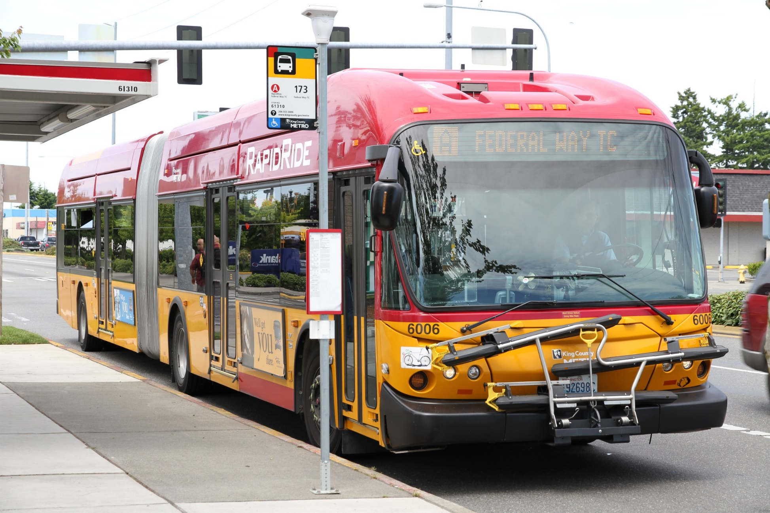A picture containing drawing

Description generated with very high confidenceFront Cover Image

[](https://www.google.com/url?sa=i&url=https://www.portseattle.org/transportation/king-county-metro-bus&psig=AOvVaw0i_oGLNmnktbOKhgziAPog&ust=1598467276872000&source=images&cd=vfe&ved=0CAIQjRxqFwoTCOisheWAt-sCFQAAAAAdAAAAABAZ)

**Useful Life Assessment of Inventoried Assets**

Recommendations Report

DRAFT | May 19th, 2021

# Release Details

## This Document

|  |  |  |  |  |
| --- | --- | --- | --- | --- |
| Release Date | | May 19th, 2021 | | |
| Filename | | 20210519_KCMetroTAMPlanRedev_UsefulLifeAssessment (v1-ISSUED) | | |
| Author | Name | Doris Lee | Nicholas Richter | Michael Gaunt |
| Title | Manager, West Region Asset Management and Business Advisory | Lead Systems Analyst (former) | Data Analyst |
| Reviewed and Approved By | Name | Doris Lee | Dr. Christian Roberts | |
| Title | Manager, West Region Asset Management and Business Advisory | Senior Vice President, Asset Management and Business Advisory | |

## Version History

|  |  |  |  |  |  |
| --- | --- | --- | --- | --- | --- |
| Rev | Author | Reviewer | Comment | Status | Date |
| 1 | Doris Lee, Nicholas Richter, Michael Gaunt | Doris Lee, Christian Roberts | Initial Draft | Issued to Client | 05/19/2021 |
|  |  |  |  |  |  |
|  |  |  |  |  |  |



# Contents

1 Introduction 5

2 Current Useful Life Benchmarks 7

3 Summary of Findings 10

3.1 Key Observations 10

3.2 Staff Input 10

3.3 Analysis of Maintenance Records 14

3.4 Review of Best Practice 27

4 Recommendations 29

4.1 Recommended Useful Life Benchmarks 29

5 Next Steps 30

Appendix A: Analysis Methodology 31

Analysis Methodology 31

Appendix B: Glossary of Acronyms 32

# Introduction

This document presents findings of an assessment of King County Metro’s (Metro) vehicle useful life benchmarks.

King County Metro (Metro) has retained WSP to redevelop its Transit Asset Management (TAM) Plan. As part of this effort, WSP assessed Metro’s vehicle useful life benchmarks (ULBs) and developed recommendations for the appropriateness of current ULBs, based on Metro staff feedback and input on the considerations being used to decide whether to replace assets, a review of maintenance records to identify key trends, and industry best practice.

*The Federal Transit Administration (FTA) defines ULB as the expected lifecycle of a capital asset for a particular transit provider’s operating environment, or the acceptable period of use in service for a particular transit provider’s operating environment. Each vehicle type’s ULB estimates how many years that vehicle can be in service and still be in a state of good repair.*

The Federal Transit Administration (FTA) defines ULB as the expected lifecycle of a capital asset for an individual transit provider’s operating environment, or the acceptable period of use in service for a particular transit provider’s operating environment. Each vehicle type’s ULB estimates how many years that vehicle can be in service and still be in a state of good repair (SGR). The ULB considers how long it is cost effective to operate an asset before ongoing maintenance costs outweigh replacement costs. ULBs are derived from FTA’s Transit Economic Requirements Model (TERM). TERM estimates the age at which each of the vehicle types would enter the SGR backlog, or have a rating of 2.5 or below on the TERM scale. ULB is the measure agencies will use to track the performance of revenue vehicles (i.e., what FTA refers to as rolling stock) and service vehicles (i.e., what FTA refers to as equipment) to set their performance measure targets.

TAM ULBs are not the same as the useful life definitions used in FTA’s grant programs (FTA Circular 5010.1E), which outlines the minimum useful life and mileage for rolling stock and ferries purchased with federal assistance. For example, a bus may have a useful life of 12 years and at this point is eligible for replacement according to FTA Circular 5010.1E, but the actual point of replacement and ULB may be 14 years.

This task is a continuation of an ongoing effort by Metro to take a more data driven approach to determining the optimal age at which its vehicles should be replaced. Prior King County Auditor reports recommended leveraging an economic replacement analysis to determine when its bus fleets should be replaced and inform cost-effective decision-making. The 2009 report defines the optimal vehicle replacement point as at the lowest point of the total cost, before increased operations and maintenance costs force the total line to rise again (**Figure 1‑1**).

Figure 1‑1: Optimal Vehicle Replacement Point

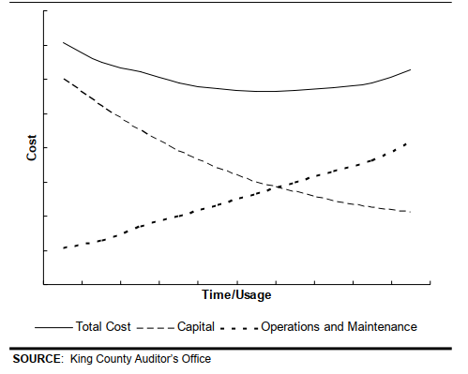

Currently, Metro does not leverage any type of economic replacement analysis across any of its fleet. There is a lack of standardization and consistency in determining replacement as practices vary across bases.

The scope of this document includes only those vehicles that Metro has capital responsibility for (i.e., vehicles that Metro owns and not vehicles that Metro operates on behalf of Sound Transit and the Seattle Department of Transportation).

# Current Useful Life Benchmarks

King County Metro began documenting its ULBs for the first time in its 2018 Transit Asset Management Manual (TAMM). Metro monitors the condition of its vehicles against its ULBs to facilitate financial planning and replacement, and ensure adequate lead times for replacements.

Metro uses age (and how age compares against ULBs) as benchmarks for asset replacements. However, while age is used as a consideration for retirement, it is not the only factor, as Metro needs to balance retirements with the phasing of new procurements and new vehicles being put in service. Since there can be long lead times to procure new vehicles, it can take many years to phase out an entire fleet, which can result in many vehicles being kept in service beyond their useful life, and beyond what may be economical for the agency. Replacement of vehicles is not only dependent on age but is also tied to available funding to purchase replacement vehicles.

There is some variation between the ULBs documented in Metro’s 2018 TAMM and the ULBs used in Metro’s 2019 National Transit Database (NTD) reports, as illustrated in **Table 2‑1**.[1] ULBs can vary across different fleets; they do not need to be the same for a given vehicle type. Discussions with staff identified that not all the ULBs listed in **Table 2‑1** accurately reflect when vehicles are actually being retired; the decision whether to retire a vehicle is often made on a vehicle by vehicle basis, taking into consideration a range of factors (e.g., age, mileage, condition, major incidents or breakdowns, etc.).

Table 2‑1: 2019 TAMM vs. NTD ULBs

| **Vehicle Class** | **Vehicle Type** | **Mileage ULB**  **(2018 TAMM)** | **Age ULB**  **(2018 TAMM)** | **Age ULB**  **(2019 NTD Report)** |
| --- | --- | --- | --- | --- |
| Revenue Vehicles | Articulated Bus | -- | 12 | 12 |
| Automobile | -- | 8 | -- |
| Over-the-road-Bus | -- | 12 | -- |
| Bus (Diesel) | -- | 12 | 14 |
| Bus (Hybrid) | -- | 12 | 12 |
| Battery Bus | -- | 12 | 12 |
| Trolleybus | -- | 15 | 18 |
| Ferryboat[2] | -- | 42 | 42 |
| Minibus | -- | 10 | -- |
| Minivan | -- | 8 | 8 |
| Sport Utility Vehicle | -- | 8 | 8 |
| Van | -- | 8 | 8 |
| Vintage Trolley | -- | 58 | -- |
| Paratransit | Passenger Van | 125,000 | 7 | 8 |
| Minibus (Gasoline) | 250,000 | 10 | -- |
| Minibus (Diesel) | 350,000 | 10 | -- |
| Cutaway | -- | -- | 10 |
| Non-Revenue Vehicles[3] | Automobile | 85,000 | 8 | 4, 8, 10 |
| Trucks and other rubber tire vehicles | -- | -- | 4, 5, 10, 12, 15 |
| Pickups | 100,000 | 8 | -- |
| Vans | 100,000 | 8 | -- |
| ~~Supervisor Vans[4]~~ | ~~250,000~~ | ~~6~~ | ~~--~~ |
| Police Pursuit Vehicles | 110,000 | 4 | -- |
| Air Compressors | -- | 12 | -- |
| Backhoe | -- | 12 | -- |
| Forklift | -- | 15 | -- |
| Manlift | -- | 15 | -- |
| Mower | -- | 12 | -- |
| Pressure Washer | -- | 8 | -- |
| Street Sweeper | -- | 10 | -- |
| Medium Duty Trucks | 250,000 | 15 | -- |
| Wreckers | 250,000 | 15 | -- |
| Trailers | -- | 15 | -- |
| Utility Vehicles | -- | 12 | -- |
| Tractors | -- | 15 | -- |
| Sanders | -- | 15 | -- |

According to Metro’s *2009 Performance Audit of Transit*, although replacement criteria are primarily age based, the basis for the criteria varies across Metro’s five different fleet types, and none of the fleet types deploy an analytical approach to determining optimal replacement, as illustrated in **Figure 2‑1**.

Figure 2‑1: Metro’s Replacement Criteria for Transit Fleets

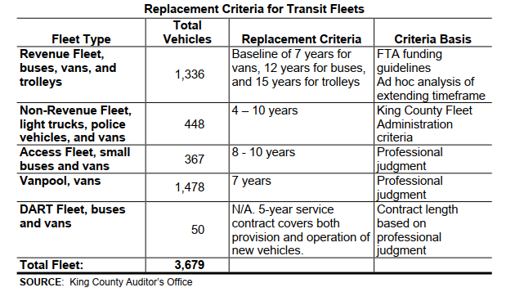

# Summary of Findings

This section presents findings of an assessment of King County Metro’s (Metro) vehicle useful life benchmarks, based on discussions with staff and an analysis of Metro’s maintenance records.

To inform the appropriateness of current ULBs, WSP conducted a workshop with key staff across the agency responsible for maintaining assets (Vehicle Maintenance, Marine, Mobility Divisions) and making decisions about assets (Capital Planning, Finance) to understand how the agency is currently making decisions about asset replacements and the factors that affect the useful life of vehicle assets.

The following factors were considered and discussed:

* Operating conditions that impact useful life (e.g., snow events, road conditions)
* Historical knowledge of assets (including usage, any major issues/repairs, etc.)
* Condition assessment of vehicles (visual or tear-down assessments)
* Maintenance and overhaul programs to extend the useful life
* Lifecycle costs (ongoing maintenance costs vs. replacement costs)
* Additional considerations

In addition, WSP also conducted an analysis of Metro’s work order records to determine whether any key trends emerged between age, cost, and the number of work orders conducted, and consulted best practice for vehicle replacements.

Finally, WSP talked to industry experts and consulted best practice to determine how the industry is determining useful life of vehicles and key factors for consideration.

## Key Observations

Metro does not currently have a consistent approach for how vehicle replacement is being determined. While age is a major driver for replacement, it is not the only consideration. Replacement decisions are not data-driven, but rely on ad-hoc analyses, observations and intuition. Practices also vary across vehicle type and different bus bases. Metro could introduce more informed decisions as information on maintenance history and lifecycle cost data are collected.

Replacement of paratransit vehicles is fairly predictable and consistent, whereas the replacement of coaches is least predictable, especially for hybrid and battery-electric buses. There are uncertainties surrounding how long hybrid and battery-electric vehicles (and the technology of the propulsion systems) can be kept in service, especially since existing fleets are relatively young and therefore Metro has limited historical knowledge to inform replacement decisions.

Detailed findings are described in the sections that follow.

## Staff Input

### Operating Conditions

The primary operating conditions that affect asset performance are poor road conditions (particularly in more rural areas where roads are not maintained), and wet weather that can cause leaks, rust, and rot. Staff maintaining coaches cited that they are constantly chasing and addressing leaks. Most bus fleets have a water intrusion problem, but these issues are usually addressed during the first few years of the bus’s service life.

Since Metro does not have a lot of experience with battery-electric buses, there is a lot of uncertainty regarding how operating conditions may affect performance. Metro has observed that battery-electric buses do not perform well in cold weather; they expend a lot of battery life to heat the vehicle and utilize the defroster, wipers, and lights (to navigate darkness). In addition, the hilly terrain of Seattle can also affect the battery life.

For vanpool and cutaway vehicles, commute conditions result in a lot of stop and go traffic, which can be detrimental to vehicle brakes and transmissions. Transmissions can fail around year 7, which can affect residual value. Paratransit vehicles (used for non-profit agencies to provide transportation for schools, etc.) are not used as often, which can result in molding due to condensation.

### Asset Maintenance History

A detailed database of repair history is maintained for coaches and is used extensively to inform the replacement of coaches (more so than vehicle condition), along with mileage. The decision to retire coaches is based on an individual vehicle by vehicle basis, rather than by fleet.

Paratransit vehicles (providing Access service) are maintained by contractors and are generally not retired early, unless there is a major engine issue that occurs near its replacement age.

Dial-A-Ride (DART) and Community Connection vehicles are rarely replaced early unless there are major component failures (i.e., engine, transmission) near the end of life (e.g., 6 months to 1 year), in which case the vehicle is retired. Otherwise, rebuild activities and replacements are conducted according to manufacturers’ guidelines.

Replacement decisions for Vanpool and Community Van vehicles are based on a similar approach to what insurance companies use. The salvage value of the vehicle is compared against the repair cost and the cost to providing service. The cost per mile is also a metric that is taken into consideration.

For non-revenue vehicles, staff look at the vehicle’s lifetime cost (i.e., the cost to replace vs. repair) and any significant problems throughout the fleet’s lifetime (e.g., transmission issues with the entire fleet). Most non-revenue vehicles either reach their age threshold, mileage threshold, or are totaled.

### Asset Condition Information

The way in which asset condition information is used to inform vehicle replacement varies across bus bases. When coaches are planned for replacement, mechanics typically have a good handle on coach conditions, which helps to prioritize repairs (generally based on how many times they are coming in for repairs or major work). While mechanics have access to condition reports and life to date costs (based on data stored in FleetFocus M5, Metro’s fleet enterprise asset management [EAM]), it is unclear as to how the data are being used, if at all. The condition of a vehicle’s parts (e.g., engine, transmission, battery) is also taken into consideration. Metro maintains a high condition standard; however, once a fleet is in its last few months of its service life, the maintenance effort may begin to wind down as further investment is not cost effective.

Access vehicles (which are operated and maintained by a contractor) follow a preventive maintenance (PM) schedule and undergo random inspections.

DART vehicles also undergo random inspections either on the road or at the base. The contractor’s maintenance practices are reviewed and audited to ensure they comply with manufacturer recommendations. While there have been Covid-19 related enhancements, there have not been many safety inspections. Audits are typically conducted every 6 months and random inspections are conducted every quarter.

For Vanpool and Community Vans, the PM schedule is derived from the manufacturer’s recommendations and historical knowledge (i.e., 6 months, 6,000 mileage cycle).

Marine assets also undergo a regular PM schedule (e.g., monthly, quarterly, annual, and bi-annual check lists). In addition, an ultrasonic (UT) scan is conducted on the vessel skin every 5, 10, and 15 years to determine if there are any hulls, interior piping, or other deterioration. Repairs are conducted to extend the useful life.

Non-revenue vehicles are on a PM schedule that includes 12-month inspections for most vehicles (and four-month inspections for police pursuit vehicles). Some vehicles that have their chassis rusting out are replaced sooner (and are inspected every year).

### Maintenance and Overhaul Programs

There is some rotation that is being done to the coaches to even out buses at different bases (to achieve a consistent average age over time), although the Covid-19 pandemic has upended rotation practices and it may take years to reinstate the lifecycle balance. An oil analysis is conducted on vehicles to determine engine performance. For hybrid vehicles, Metro takes a proactive approach to maintaining the fleet. Energy storage systems (ESS) are replaced in order to avoid premature failure in related systems, such as the drive system. Failure of the energy storage system is often predicted by issues in related systems.

Overhauls are conducted on trolley buses to extend the life by an additional 10 years. In the past, Metro would replace the transmission and engines of revenue coaches and repaint at a certain age, but it now replaces components on an as-fail (rather than scheduled) basis. This decision was primarily cost-driven, especially given the cost to conduct these activities on the newer hybrid coaches is so much more expensive.

Access vehicles normally average 30,000-35,000 miles per year. Vehicles are rotated across bases to even out the mileage.

Community Access vehicles are also rotated to even out usage. Of the 190 vehicles in the fleet, less than five vehicles reach 20,000 miles/year.

Vanpool vehicles undergo normal preventive maintenance activities. An internal report is generated to look at to-date operating costs and daily usage. Vehicles need to run every day in order for them to run efficiently, otherwise there is a high cost to maintain.

The Marine Division conducts major engine rebuilds following manufacturer recommendations, based on load and fuel going through the engine. The engine is replaced at midlife.

For non-revenue vehicles, most of the vehicles used for base operations undergo an analysis of the mileage and vehicles are swapped among bases to even out the usage. Heavy duty vehicles undergo engine swaps and midlife hydraulic and boom overhauls.

### Lifecycle Costs

All maintenance costs for buses are tracked in FleetFocus M5 and discussions with Contract Procurement help identify whether there are any significant cost deviations. The cost per fleet is monitored and factors into the decision to retire a fleet, but costs are not directly compared to replacement costs. The Vehicle Maintenance – Technical Services (VMDM) group tracks lifecycle costs at all bases.

For Access vehicles, lifecycle costs are not tracked since the service is contracted out. Lifecycle maintenance costs are only reviewed if the contractor mentions significant issues with the vehicles.

Community Access practices right sizing of its fleet; vehicles are provided to agencies and if the usage is not sufficient (in terms of the number of users), then there will be a switch to smaller vehicles.

Vanpool tracks and reports on operations and maintenance (O&M) costs per mile in FleetFocus M5. While it tracks maintenance expenses, it was uncertain at the time of this analysis whether and how these expenses inform key decisions.

Lifecycle costs for water taxis are not being tracked, given replacements are a large cost (~$20 million) and it is unlikely maintenance costs will exceed replacement costs. The current program within the Marine Division has the capability to track lifecycle costs, but resources are limited to conduct such an analysis.

For non-revenue vehicles, staff analyze the cost to repair versus the cost to replace analysis on major vehicles, based on current age.

#### Additional Considerations

Additional consideration that Metro staff identified include:

* The optimal replacement of hybrid and battery-electric bus fleets is largely unknown given there is no historical knowledge to inform the replacement of either; the oldest hybrid and battery-electric fleets are 12 years old and 5 years old, respectively. There are uncertainties surrounding how the technology of the propulsion system will ultimately affect the useful life. In particular, advances in replacement components make failure of older, original components a less reliable predictor of future useful life.
* Due to budget constraints, Metro will need to keep buses longer—while approximately 144 buses will be retired due to a decrease in service resulting in the Covid-19 pandemic, only 53 buses are planned for replacement between now and 2025. Hybrid buses will be kept longer due to these budget constraints but as Metro holds onto older fleet for longer, it will be important to look to the data to inform how best to phase retirements.
* Bus retirements are phased over a number of years. A large fleet, for example, can be phased out over the course of 4 to 6 years. That can translate to keeping buses between 12 to 16 years before they are retired.
* The Covid-19 pandemic has resulted in numerous revisions to Metro’s fleet replacement plan (16 times at the time of this study), having to balance planned replacements with which buses to take out of service first. The pandemic has made it difficult to plan for the future, as its full impact is still unknown.
* Metro’s zero emission (by 2035) and climate goals will supersede lifecycle cost goals, which will require Metro to find ways to maintain its zero-emission fleet cost effectively and maintain a balance between keeping vehicles in service that are aging out, and retiring them before they are no longer economical to keep in service.

## Analysis of Maintenance Records

WSP conducted multiple analyses to inform the useful life benchmark recommendations and better understand factors impacting costs of ownership. The analyses were performed using ten years of data exported by Metro from the FleetFocus M5 system, including an asset inventory, work order details, job details, and domain lists for decoding values in the maintenance records. The data includes information from both current and retired buses across all bus fuel type and length combination.

The results of the analyses are presented in this section.

* **Analysis of maintenance costs per year** to determine whether costs were significantly increasing over the life of the asset measured using mileage instead of asset age.
* **Analysis of frequency of service needs** to determine whether there are any key trends or patterns between vehicle age and the number of preventive maintenance and corrective maintenance work orders conducted across Metro’s fleets (i.e., whether there is any correlation between age and the number of corrective maintenance work orders, maintenance costs, number of trouble calls, and downtime).
* **Analysis of total cost of ownership** to determine when or if there is a point where costs are minimized on a per mile basis.

Each analysis is described in more detail in the sections that follow.

### Analysis of Maintenance Costs per Year

In May 2020, as part of a separate initiative from this project, WSP conducted an analysis of maintenance costs on two hybrid fleets (26-New Flyer Hybrid and 68-New Flyer Hybrid) and found that the annual cost per fleet remains relatively constant after the initial ten years of service (**Figure 3‑1**). For the 26 fleet, the median cost per mile increases steadily during the first 8 years and thereafter remains relatively unchanged. For the 68 fleet, the median annual cost per bus decreases after 8 years in service, however this may be the result of a smaller sample size (N = 24 with 12 years of service versus N = 187 with 8 years of service).

Figure 3‑1: Total Cost per Vehicle, May Analysis (Fleet 26 and 68 only)

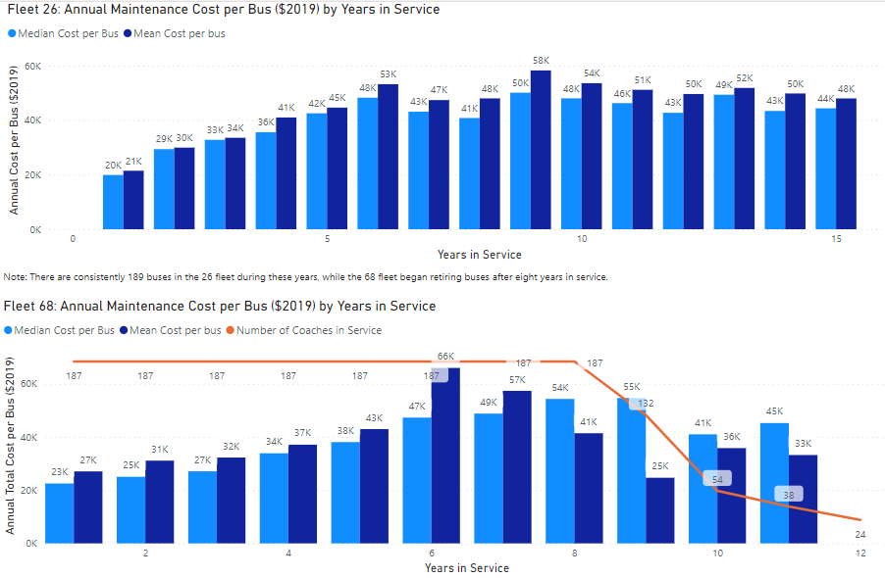

Using the new information provided by Metro, the information was reanalyzed to expand the analysis to additional fleets and fuel types in late 2020. The following subsections contain the expanded analysis results for transit buses, paratransit vehicles, and non-revenue vehicles.

#### Transit Bus Revenue Vehicles Maintenance Costs Per Year

The new analysis mirrors the findings of the smaller analysis of the two fleets. A similar plateau of maintenance costs occurs on a per coach basis when analyzing the new dataset.

After year eight, certain component repairs and replacements become recurring and common jobs. The energy storage system and propulsion for hybrid vehicles are notable for their high cost in later years. Despite these high dollar repairs and replacement, the overall cost per vehicle does not dramatically change.

The analysis is limited by the data available. Most records in the job set that was analyzed occurred within the first 8 years, with fewer records being generated between years 9 and 16. The sample size of vehicles lasting past 16 years is small and has limited predictive power. This analysis did not include other factors, such as fuel consumption, rider experience, technology obsolescence, or other factors that are required to identify optimal replacement timing.

Section 3.3.3 contextualizes this information on a per mile cost basis and incorporates capital costs into the analysis. The result of this analysis does not provide a clear point in time where replacement is economically optimal. Minimizing maintenance costs for hybrid buses and the future electric-battery buses will be heavily influenced by minimizing the number of energy storage system replacements. Since these systems typically last between five to six years, the useful life of an individual bus may be extended when a replacement is performed in the later years of the vehicle.

Figure 3‑2: Total Costs per Vehicle by Age (Bus Fleet)

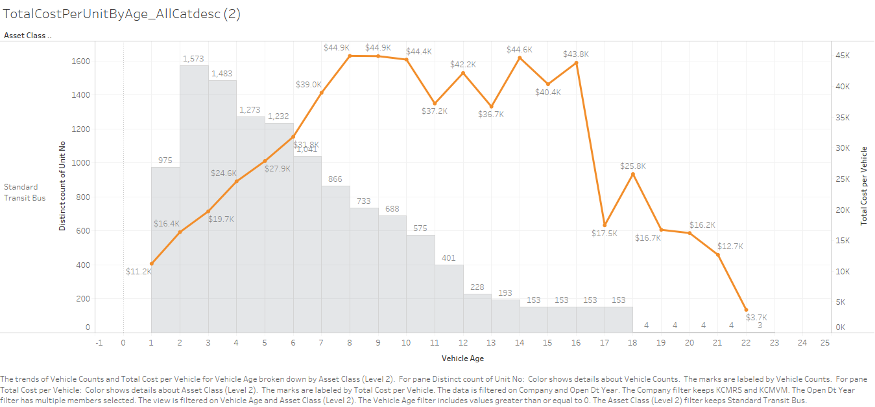

#### Paratransit Vehicles Maintenance Costs Per Year

The job records used to calculate total maintenance costs did not have cost data or downtime information (likely due to the fact that paratransit and vanpool services are provided by a contractor). Work order count by age of vehicle remained nearly unchanged between years 1 and 6, with a slight decrease in the number of work orders generated after year 6 (**Figure 3‑3**). Due to a lack of cost information, this analysis did not suggest an optimal useful life for targeting replacement.

Figure 3‑3: Total Costs per Vehicle by Age (Paratransit)

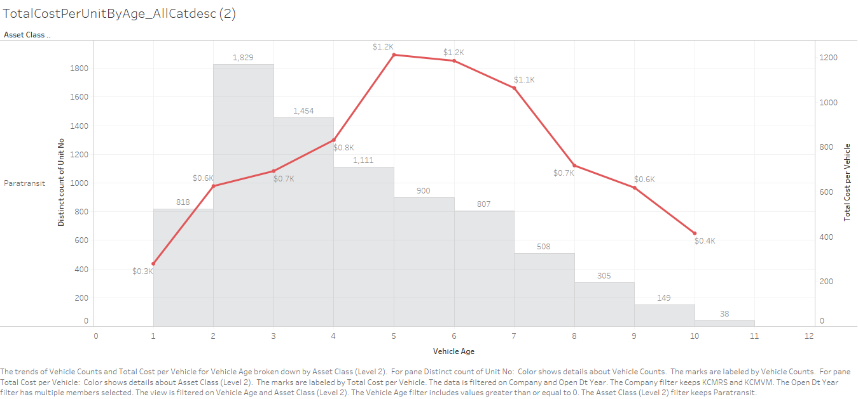

#### Non-Revenue Vehicles Maintenance Costs Per Year

Maintenance costs for non-revenue vehicles remained consistent over the first 12 years of vehicle life (**Figure 3‑4**). Few vehicles are kept past twelve years. Exceptions include specialized heavier vehicles, based on asset record descriptions. Based on conversations with asset owners at Metro, non-revenue vehicles often have a wide range of usage patterns. Similar vehicles can have major differences in the number of miles accumulated per year, which makes it difficult to set a specific point in time for replacement. Metro staff indicated that there is limited ability to rotate vehicles to balance the mileage accumulation per year.

Figure 3‑4: Total Costs per Vehicle by Age (Non-Revenue Vehicles)

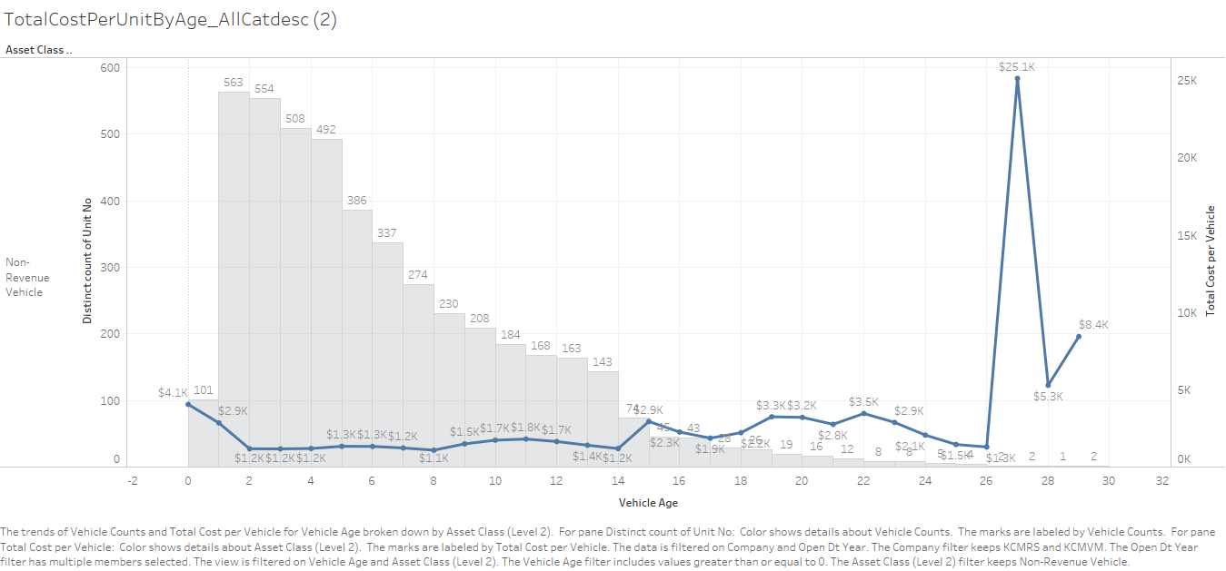

### Analysis of Frequency of Service Needs

For this analysis, four metrics were reviewed: overall number of work orders per vehicle (**Figure 3‑5**), number of trouble-calls and yard truck jobs per vehicle (**Figure 3‑6**), number of towing jobs per vehicle (**Figure 3‑7**), and downtime per vehicle (**Figure 3‑8**). In each of the metrics, a bow shaped trendline appeared (with the exception of towing calls for non-revenue vehicles, which increases over time).

The approximate age when the peaks occurred are outlined in **Table 3‑1**.

Table 3‑1: Frequency of Service Needs – Peaks of Key Metrics

|  |  |  |
| --- | --- | --- |
| **Vehicle Type** | **Metric** | **Approximate Age of Peak** |
| **Revenue Vehicles** | Total work orders per vehicle | 11 years |
| All trouble-calls/yard truck jobs per vehicle | 11 years |
| Towing jobs per vehicle | 8 years |
| Downtime per vehicle | 8 years |
| **Paratransit** | Total work orders per vehicle | 5 yeas |
| All trouble-calls/yard truck jobs per vehicle | N/A, no observations |
| Towing jobs per vehicle | N/A, no observations |
| Downtime per vehicle | N/A, no observations |
| **Non-Revenue Vehicles** | Total work orders per vehicle | 12 years |
| All trouble-calls/yard truck jobs per vehicle | N/A, increases with age |
| Towing jobs per vehicle | N/A, stable over time |
| Downtime per vehicle | 12 years |

Figure 3‑5: Total Work Orders per Vehicle, by Age

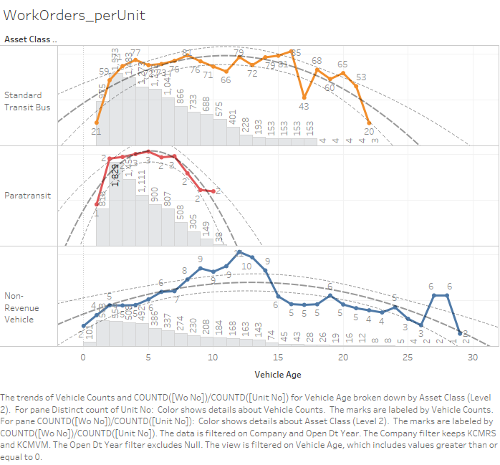

Figure 3‑6: Total Trouble-Calls/Yard Truck per Vehicle, by Age

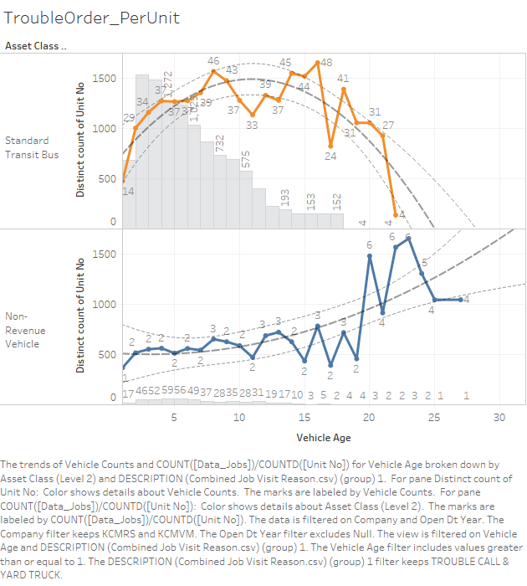

Figure 3‑7: Towing Jobs per Vehicle, by Age

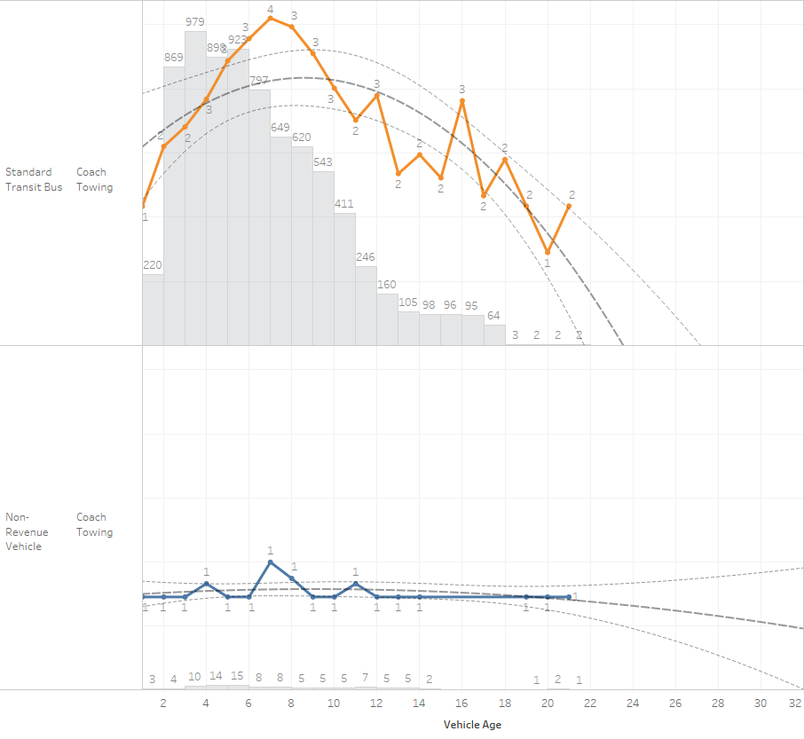

Figure 3‑8: Downtime (Hours per Year) per Vehicle, by Age

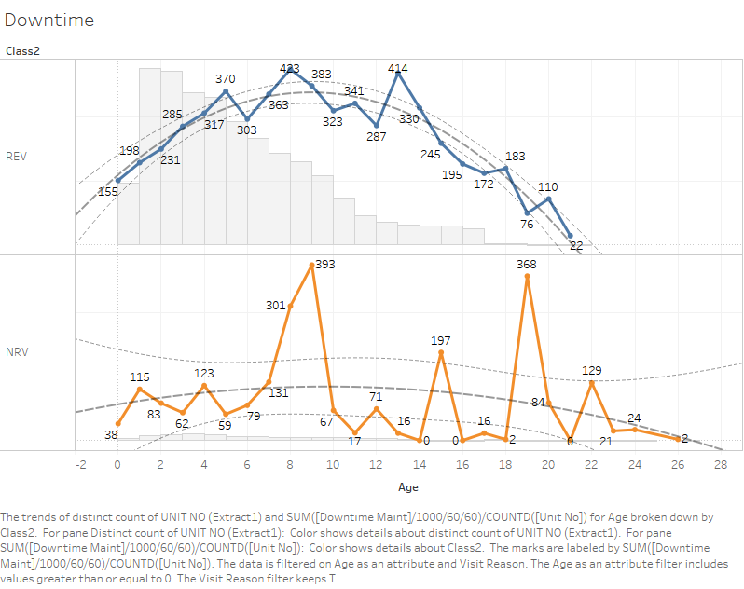

### Analysis of Total Cost of Ownership per Mile

The total cost of ownership was calculated on a per mile basis by combining the acquisition cost of the asset and the cumulative cost of maintenance (i.e., parts, labor, and fluid costs) incurred by that asset. The economic optimal point of replacement is where this total cost is minimized, although this measure does not include other factors that weigh in on replacement and vehicle selection decisions.

A full description of the analysis methodology can be found in **Appendix A.**

The data contains cost and mileage information in each record, shown below in **Figure 3‑9**.

Figure 3‑9: Mileage vs Cumulative Maintenance Costs, All Individual Vehicles (Hybrid, Diesel, Trolley)

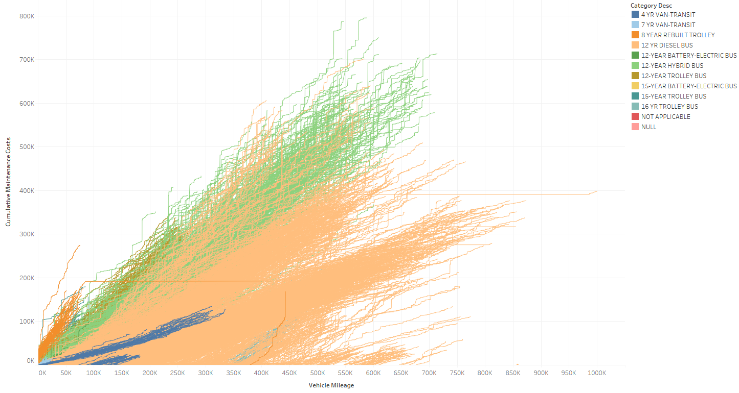

#### Hybrid Buses

While maintenance costs accumulate and increase during the first half of the life of a typical bus, the high capital cost of replacing the bus resulted in a consistently decreasing cost per mile. The result is that the accumulating maintenance costs on a per mile basis do not exceed the capital costs on a per mile basis at any point within the data range. **Figure 3‑10** shows the resulting average curve for all 12-Year Hybrid Buses. This data is also represented in **Table 3‑2**. The vehicle age has been calculated using the date of work performed.

Figure 3‑10: Average Total Cost of Ownership per Mile, All Hybrid Buses

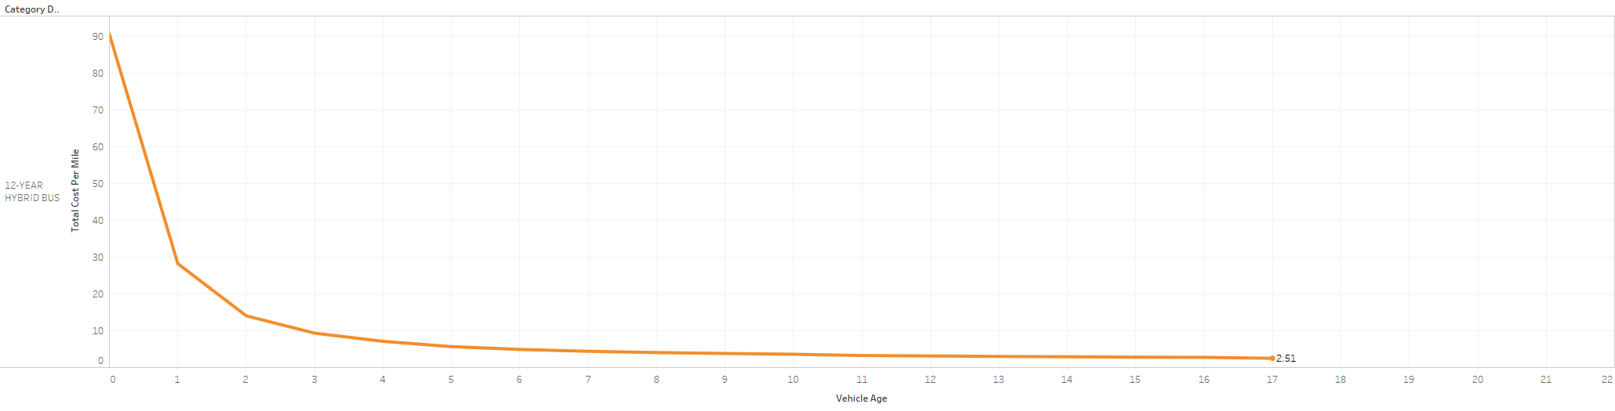

This pattern was consistent for most individual vehicles and combined vehicle classes. Exceptions to this rule exist, where high costs and lower than typical utilization result in an economic optimal point less than the maximum. **Figure 3‑11** highlights the hybrid bus unit number 11064 and the resulting economic optimal point of replacement in year 12. The vehicle is unusual in that it is one of the first hybrids to enter service with Metro (Fleet 2600 from 2004) and has had an atypical combination of maintenance costs and usage.

Figure 3‑11: Outlier Example, Unit No 11064

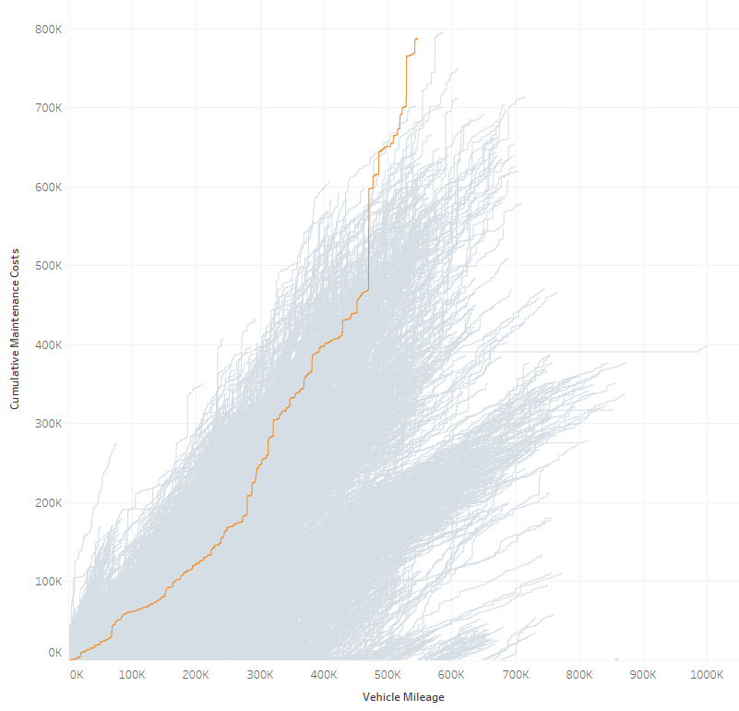 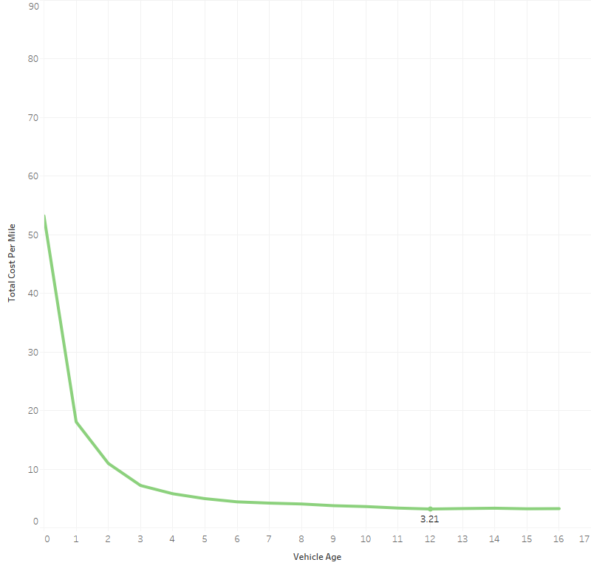

As a rule, the economic optimal point of replacement is obtained at the maximum extent of available data. The data also indicates that new vehicle models (XDE60 vs. DE60LF/A) are generally incurring lower maintenance costs at the same age as older vehicles. **Figure 3‑12** showscurrent generation vehicles highlighted in darker colors while color type indicates length. Blue indicates 60-foot articulated buses, while orange indicates 40-foot or less buses.

Figure 3‑12: Hybrid Bus Maintenance Costs vs. Mileage by Model

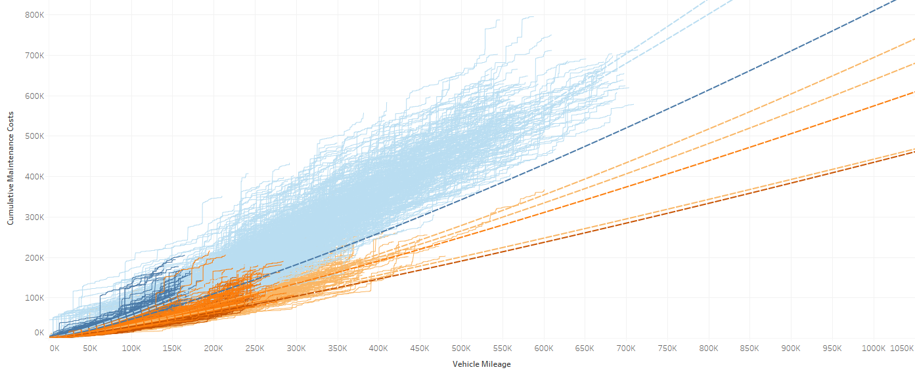

The mileage-based analysis of the economic optimal replacement point indicates that replacement decisions must include other factors outside of maintenance costs in determining when replacement is justified. The decision about when to replace buses and what type of buses to procure relies on agency policy goals, such as environmental and equity issues, as well as other non-economic based factors such as obsolescence or general condition.

Table 3‑2: Total Cost per Mile, Hybrid Buses

|  |  |  |  |  |  |  |  |  |  |  |  |  |  |  |  |
| --- | --- | --- | --- | --- | --- | --- | --- | --- | --- | --- | --- | --- | --- | --- | --- |
| Vehicle Age | 0 | | 1 | | 2 | | 3 | | 4 | 5 | 6 | 7 | 8 | 9 | 10 |
| Cost per Mile, Total | $90.50 | | $28.20 | | $14.10 | | $9.30 | | $7.10 | $5.70 | $4.90 | $4.40 | $4.10 | $3.80 | $3.60 |
|  | 11 | 12 | | 13 | | 14 | | 15 | | 16 | 17 |
|  | $3.30 | $3.20 | | $3.00 | | $2.90 | | $2.80 | | $2.80 | $2.50 |

#### Diesel Buses

Diesel buses are no longer in consideration at Metro for future purchases due to advances in clean technologies, including hybrid and electric battery buses. Overall, diesel buses provide service at a lower per mile cost than alternatives, but this type of analysis does not include outside non-economic factors that determine bus fuel type choices (such as greenhouse gas reduction policies). **Figure 3‑14** shows the total cost per mile data in **Table 3‑3** visually.

Figure 3‑13: Average Total Cost of Ownership per Mile, All Diesel Buses

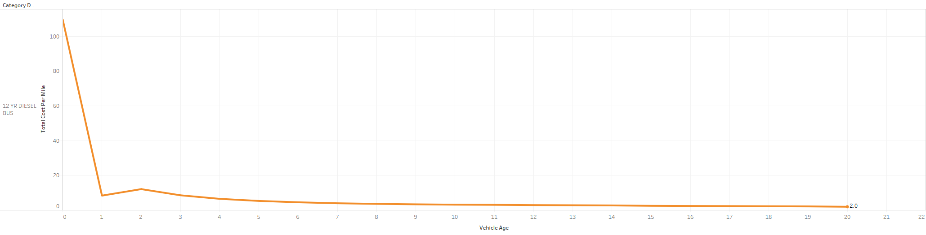

Table 3‑3: Total Cost per Mile, Diesel Buses

|  |  |  |  |  |  |  |  |  |  |  |  |  |
| --- | --- | --- | --- | --- | --- | --- | --- | --- | --- | --- | --- | --- |
| Vehicle Age | 0 | | 1 | 2 | 3 | 4 | 5 | 6 | 7 | 8 | 9 | 10 |
| Cost per Mile, Total | $109.60 | | $8.40 | $12.10 | $8.60 | $6.50 | $5.30 | $4.50 | $4.00 | $3.60 | $3.40 | $3.20 |
|  | 11 | 12 | | 13 | 14 | 15 | 16 | 17 | 18 | 19 | 20 |
|  | $3.10 | $2.90 | | $2.80 | $2.70 | $2.50 | $2.40 | $2.30 | $2.20 | $2.20 | $2.00 |

#### Trolley Buses

There are four classifications of trolley buses: 8-year rebuilt, 12-year, 15-year, and 16-year. The 12-year is presented as representative for this bus type as the other three have incomplete records and signs of assets being recoded over time. This evidence includes significant changes in the number of buses included in a category and vehicles where the first record is from year 15 of the vehicle life. The 12-year category provides the best available information for evaluating useful life.

**Figure 3‑15** shows the total cost per mile data in **Table 3‑4** visually.

Figure 3‑14: Average Total Cost of Ownership per Mile, 12-Year Trolley Buses

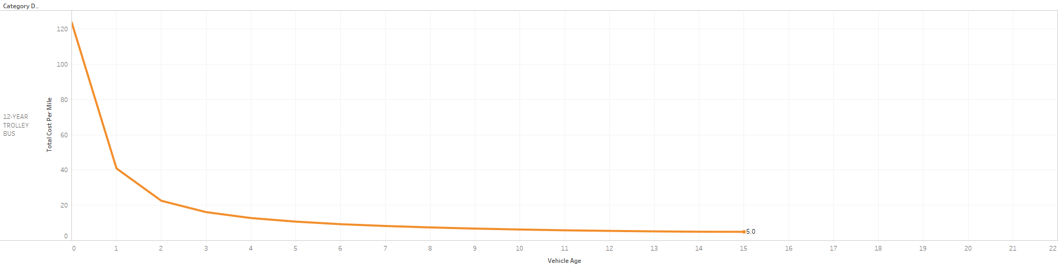

Table 3‑4: Total Cost per Mile, 12-Year Trolley Buses

|  |  |  |  |  |  |  |  |  |  |  |  |
| --- | --- | --- | --- | --- | --- | --- | --- | --- | --- | --- | --- |
| Vehicle Age | 0 | 1 | 2 | 3 | 4 | 5 | 6 | 7 | 8 | 9 | 10 |
| Cost per Mile, Total | $123.80 | $40.90 | $22.60 | $16.10 | $12.80 | $10.70 | $9.30 | $8.30 | $7.50 | $6.80 | $6.30 |
|  | 11 | 12 | 13 | 14 | 15 | 16 | 17 | 18 | 19 | 20 |
|  | $5.80 | $5.50 | $5.20 | $5.00 | $5.00 | $2.50 | $2.40 | $2.30 | $2.20 | $2.20 |

#### Transit Vans

Cumulative maintenance costs (**Figure 3‑15**) were calculated for individual vehicles by dividing the sum of the total maintenance cost (i.e., preventative and corrective maintenance costs) by their respective cumulative miles driven. Vehicles appear to exhibit a constant rise in cumulative maintenance costs indicating that monthly maintenance costs are contestant or rise very little over its operational lifetime. It should be noted that some vehicles display extremely costly maintenance events (vertical portions of cumulative cost curves); given the extreme nature of these events, it is reasonable to consider these costs as outliers. In any event, these events occur so infrequently that they do not impact the rest of the study.

Figure 3‑15: Cumulative Maintenance Costs for Individual Vehicles

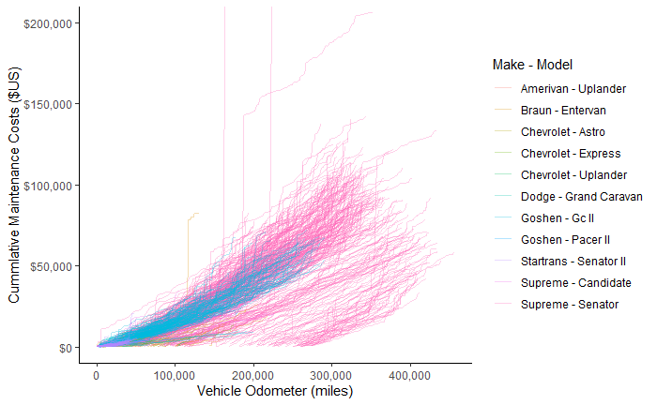

The plot below, **Figure 3-16**, depicts the cumulative maintenance costs divided by the cumulative miles driven for unique vehicles. Costs are initially very high in the lower mileage ranges, drop precipitously, and then gradually rise and stabilize. The high initial costs are likely caused by costs associated with bringing a vehicle into operation, newer vehicles will have fewer miles driven and therefor produce higher maintenance costs per miles driven. Costs grow very slowly and stabilize around $0.25 cents per mile.

Figure ‑: Cumulative Maintenance Costs per Cumulative Miles

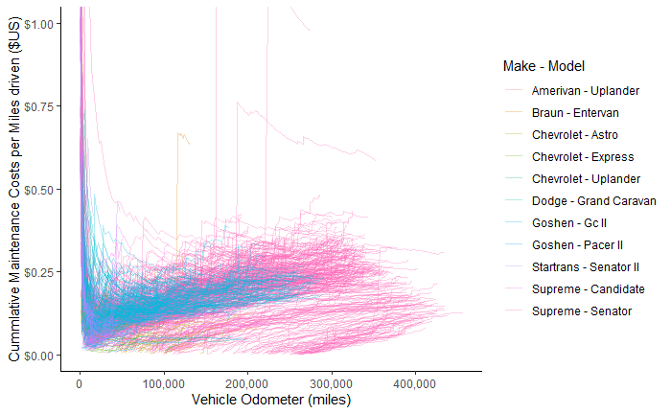

**Figure 3‑17** illustrates the total cost of ownership per cumulative miles driven for all unique vehicles analyzed in the transit van analysis. Curves for the total cost of ownership per vehicle make/model class were constructed by median cost values calculated from samples contained within 1k mileage bin increments. The cost curves in **Figure 3‑17** illustrate the underlying cost behavior for each make/model class.

Most vehicles exhibit the same general behavior; initially, total cost of ownership is high, fall rapidly,[5] and then begins to flatten. Total cost of ownership closely follows replacement costs in the lower mileage ranges. Maintenance costs per cumulative mile (**Figure 3‑16**) begin to influence total cost of ownership once the replacement value of the vehicle approaches and lowers below $1.00. At this point, total cost of ownership begins to flatten and asymptotically approaches maintenance costs (~$0.25-$0.50). The flattest parts of these curves, where total costs of ownership are defined by maintenance costs rather than negligible replacement costs, can be considered the economic optimum. So long as total costs of replacement fall, a vehicle will operate at its economic optimum. No vehicle experiences a rise in total cost of ownership.

Figure 3‑17: Total Cost of Ownership Curves by Make/Model 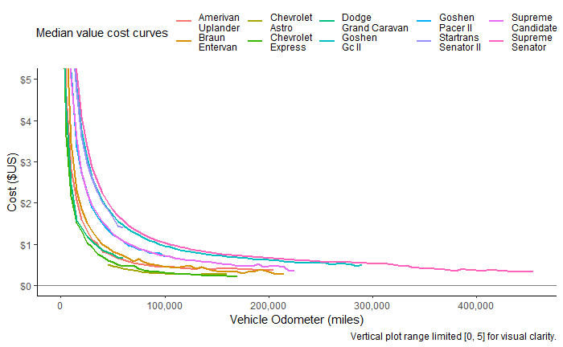

## Review of Best Practice

In 2007, the FTA released *Useful Life of Transit Buses and Vans*, a report that aims to reassess the FTA’s minimum-life policy, considering experience and input from transit operators and vehicle manufacturers. Although the report was developed 13 years ago, many of its findings still ring true. The report found that while buses become less reliable with age, the extent of unreliability and deterioration could be controlled and/or mitigated with improved maintenance (assuming agencies have the funds necessary to conduct the appropriate maintenance activities). Agencies that conducted only corrective maintenance on their buses reported that older buses became more unreliable and more expensive to maintain.

The report also considers how alternative fuels and hybrid propulsion systems could impact useful life of hybrid electric buses:

*“The first issue is the life expectancy of the batteries. There are currently two battery types being used on transit buses—lead-acid and nickel metal hydrides. Neither is capable of meeting the minimum life expectancy of a transit bus; both will need to be replaced one or more times throughout the vehicle life cycle. Transit authorities will have to decide whether it makes economic sense to install new batteries at a significant expense into an older bus or retire and buy new. The second issue deals with weight. The weight of the batteries and associated components is approximately 1,500 pounds. While not as significant as the weight with CNG buses, the additional weight increases roof loads onto the structure and may impact useful life. Here again, the actual impact on vehicle useful life will not be known until these buses begin to reach their mid and later service years.”*

In addition, the increase of new electronic technologies to bus vehicles, including automatic vehicle location (AVL), automatic passenger counters, on-board cameras, vehicle diagnostics, adaptive signal timing, and communication control, voice annunciation, and others, can also lead to increased fleet reliability issues.

The report included two other sections of interest for current recommendations: a transit operator survey and an economic analysis of optimal bus replacement timing.

Nine different transit operators provided information on their experiences operating buses in Northern America. Representing a combined fleet of over 12,000 buses and 1,400 vans, the average age of replacement for buses was 15.1 years instead of the 12-year useful life standard. While five of the nine operators had 12-year bus replacement policies, only one of them reported partially adhering to the policy due to either lack of funding or delayed in the procurement process.

In the economic analysis section of the report, the age of the asset when the cost is minimized to the agency was found to vary based on the average mileage of the vehicles. Higher annual mileage vehicles had shorter lifespans than those with lower annual miles. Forty-foot buses were given the most detailed analysis, which is summarized in **Table 3‑7**. Differences between propulsion types or manufacturer were not included.

Table 3‑7: Age and Mileage at Which Lifecycle Cost is Minimized

|  |  |  |  |  |  |  |  |  |  |  |  |
| --- | --- | --- | --- | --- | --- | --- | --- | --- | --- | --- | --- |
| Average Annual Mileage | 20K | 25k | 30k | 35k | 40k | 45k | 50k | 55k | 60k | 65k | 70k |
| Vehicle Age Lifecycle Cost is Minimized (in Years) | 19 | 17 | 15 | 14 | 13 | 12 | 11 | 11 | 10 | 10 | 9 |

Other bus types were also included with three average annual mile values. **Table 3‑8** is a combination of tables, representing the “continuous vehicle rehabilitation” values provided. Forty-foot and 60-foot buses both had the same lowest cost age and mileage, while each of the lighter/smaller buses varied. The general observation is that buses with an average annual mileage utilization of 45,000 miles had lost cost of ownership where retirement occurred at the stated minimum useful life measured by age.

The study found that replacing assets sooner yielded a net cost of $3,600 if vehicles were replaced on a 10-year cycle instead of a 12-year cycle. It also found a net savings of $2,800 if vehicles were replaced at 14 years instead of 12 years. This was based on a 40-foot bus with 35,000 average miles per year (ibid. p. 102).

Table 3‑8: Minimum Lifecycle Cost Replacement Age

|  |  |  |  |  |  |  |
| --- | --- | --- | --- | --- | --- | --- |
|  | **25,000 Average Annual Miles** | | **35,000 Average Annual Miles** | | **45,000 Average Annual Miles** | |
| **Bus Type** | **Age** | **Mileage** | **Age** | **Mileage** | **Age** | **Mileage** |
| **40-Foot, 12-Yr/500,000-Mile Bus** | 17 | 425k | 14 | 490k | 12 | 540k |
| **Articulated Bus (60 Foot)** | 17 | 425k | 14 | 490k | 12 | 540k |
| **10-Yr, Heavy-Duty, Small Bus** | 12 | 300k | 11 | 385k | 11 | 495k |
| **7-Year, Medium Duty, Small Bus** | 9 | 225k | 8 | 280k | 7 | 315k |
| **5-Yr, Light-Duty, Mid-Size Buses/Vans** | 7 | 140k | 6 | 180k | 5 | 200k |
| **4-Yr, Light-Duty, Mid-Size Buses/Vans** | 6 | 120k | 5 | 150k | 4 | 160k |

Discussions with WSP’s transit fleet experts found that components other than the propulsion system must also be monitored when determining replacement. In addition to the propulsion system deteriorating, 70 percent of the bus is comprised of non-propulsion systems (e.g., suspension, brakes, seats, windows, flooring, etc.) and most of these systems wear out equally regardless of vehicle type.

Previous studies have shown that there is typically a progressive increase in vehicle operating costs after year 9, regardless of the bus type (e.g., if the hybrid propulsion system is still in good condition at year 12, the non-propulsion systems are still going to have the same issues as a non-hybrid bus).

# Recommendations

The recommendations set forth in this section reflect findings from interviews with Metro staff, an analysis of maintenance records, and best practice.

## Recommended Useful Life Benchmarks

Based on the findings described in this report, WSP recommends the following:

* **Revenue buses** – Optimizing costs will depend on avoiding energy storage system replacements late in the life of the vehicle and ensuring that when they are conducted, they will achieve a reasonable extension of the useful life. If the vehicle is 12 years old and has not undergone an energy storage system replacement, the risk of incurring the major cost of replacing the energy storage system will likely justify replacing the entire vehicle. However, if an energy storage replacement occurs in years 9-11, then retaining the vehicle will provide a better return on that additional investment and the vehicle should be replaced when it reaches obsolescence or when another major system fails. The data supports a general useful life target between 12 and 14 years.
* **Water taxis** – The 2018 TAMM incorrectly stated the ULB for water taxis as 42 years (the 2018 TAMM was written before the Marine Division was incorporated into Metro). Water taxis are being retired at 25 years, which is in line with best practice. The FTA’s recommended useful life benchmark of 42 years assumes steel vessels (whereas Metro’s vessels are aluminum).
* **Paratransit vehicles** –Metro should consider using another metric other than cumulative maintenance cost to determine a suitable replacement schedule for the vehicles analyzed in the transit van analysis. The analysis did not support the idea that maintenance costs should be considered in determining when a vehicle should be scheduled for replacement.
* **Non-revenue vehicles** – Since maintenance cost increases significantly after 12 years, vehicles should not be kept longer unless Metro is able to demonstrate that holding onto a vehicle beyond 12 years avoids a major capital replacement cost.

These recommendations are limited by the input received and the analyses the WSP team was able to conduct based on available data.

# Next Steps

The next tasks will focus on redefining the approach for assessing fixed assets, selecting a decision support tool, and conducting an analysis with the selected tool:

* *Task 1.3: Criticality of Assets (Risk of Failure)* will involve an assessment of Metro’s approach for assessing the condition of its fixed assets, and developing a risk and criticality framework to assess the probability and consequence of failure. The approach will include conducting workshops to gather feedback from staff and incorporating best practice to develop a framework that Metro can leverage for its investment prioritization process.
* *Task 2.1: Decision Support Tool* will focus on selecting a decision support tool based on Metro’s unique needs and the capabilities of proposed tools, including FTA’s TERM Lite, and **am2p**, WSP’s proprietary asset management planning tool.

The findings from these tasks will be incorporated in Metro’s final TAM Plan.

# Appendix A: Analysis Methodology

## Analysis Methodology

The scope of the analyses described in Section 3.3.3 was to investigate the existence of an economically optimal point of replacement for bus and van types and vehicle make/model classes. All analyses in Section 3.3.3 followed the same fundamental process; total cost of ownership for bus types and transit van types were calculated by combining cumulative maintenance and replacement costs together. This process is explained in greater detail in the subsections below.

The analyses described in Sections 3.3.3.1 to 3.3.3.3 were performed using Tableau software and the analysis described in Section 3.3.3.4 was performed using the R statistical programming language. The use of different software did not impact the results in any way.

### Calculating Vehicle Age and Maintenance Event Costs

Vehicle age was calculated using the year of the open date data value from the job record entry and the install year data value found in the inventory dataset. Using this age, the costs and other data points were grouped by the age of the asset when the job occurred. The total cost ([Total Cost]) of a job was calculated as a combination of fields [Act Comm Cost Do] + [Act Labor Cost Do], [Act Part Cost Do] found in the job record. Every record (in the jobs dataset) represented a unique maintenance event for a given vehicle that recorded the total cost of that event, the vehicle’s odometer reading, and the age of the vehicle. A complete maintenance history and operation profile was constructed for each vehicle.

### Calculating Maintenance Costs

Maintenance costs were required to determine the total cost of ownership for individual vehicles and vehicle make/model classes. The analyses described in Sections 3.3.3.1 to 3.3.3.3 were performed using exports from FleetFocus M5, provided by Metro staff. Data from each of the individual extracts were combined, normalizing the vehicle ID to “UNIT NO,” and exported into a Tableau hyper database. The transit vans analysis described in Section 3.3.3.4 used two datasets: vehicle type (UNIT_DEPT_COMP_MAIN.csv) and vehicle work order (O_WO.csv). The datasets include only data that was available through Fall 2019.

The vehicle history data was transformed and aggregated to calculate monthly maintenance costs per vehicle and vehicle type. As described above, total monthly maintenance costs were calculated for each calendar month for every vehicle. This metric was divided by the monthly maximum odometer reading to calculate monthly maintenance costs per miles driven – resulting in maintenance costs associated with every vehicle per calendar month.

### Total Costs Analysis

For every month of operation, a vehicle’s replacement cost was divided by the vehicle’s cumulative miles driven. This resulted in every vehicle having a maintenance cost and replacement cost per miles driven cost for every month of its operation. These two metrics were summed together to create a total cost of ownership per month for every vehicle. The total cost of ownership was aggregated per vehicle type and by operation metric – by age (years old) for the analyses in Sections 3.3.3.1 to 3.3.3.3 and by cumulative mileage (1k mile bins) in the transit vans analysis Section 3.3.3.4) (see **Figure 3‑17** as an example). As mentioned earlier, the bus analyses used Tableau to perform this task while the transit vans analysis utilized the R programming language.

# Appendix B: Glossary of Acronyms

AVL Automatic Vehicle Location

DART Dial-A-Ride Transit

EAM Enterprise Asset Management

ESS Energy Storage System

FTA Federal Transit Administration

Metro King County Metro

NTD National Transit Database

O&M Operations and Maintenance

PM Preventive Maintenance

SGR State of Good Repair

TAM Transit Asset Management

TAMM Transit Asset Management Manual

TERM Transit Economic Requirements Model

UT Ultrasonic

ULB Useful Life Benchmark

VMDM Vehicle Maintenance – Technical Services

[](https://www.google.com/url?sa=i&url=https://www.portseattle.org/transportation/king-county-metro-bus&psig=AOvVaw0i_oGLNmnktbOKhgziAPog&ust=1598467276872000&source=images&cd=vfe&ved=0CAIQjRxqFwoTCOisheWAt-sCFQAAAAAdAAAAABAZ)

1. ULBs that differ between the 2018 TAMM and 2019 NTD report are highlighted in yellow.
2. While the ULB for ferryboats is listed as 42 years in the 2018 TAMM and the 2019 NTD report, the ULB for ferryboats is actually 25 years based on discussions with Marine Division staff
3. Discussions with NRV staff identified several corrections with ULBs stated in this table: automobiles are retired at 12 years (or when vehicles reach 110,000 miles, pick-up trucks are retired at 12 years, vans are retired at 12 years, and police pursuit vehicles are retired at 10 years or 110,000 miles (although these vehicles usually reach 110,000 miles before they reach 10 years).
4. Supervisor vans are no longer in operation.
5. Replacement costs fall sharply initially because the replacement value of a vehicle is divided by cumulative miles driven.