Schema2Script Milestone1
Project Design Document
G7
Michael Geljić mg3578@rit.edu
Luka Boban lb1097@rit.edu
Žarko Žižić zz6085@rit.edu
Helana Markulin hm8843@rit.edu
Felicio Orlandini fo4324@rit.edu

Project Summary
The Schema2Script project provides functionality to parse schema definitions in JSON and XML formats and generate corresponding SQL CREATE TABLE statements. The application is designed following the Model-View-Controller (MVC) pattern to ensure modularity, high cohesion, and low coupling. It addresses the need for a flexible and extensible system capable of supporting multiple database management systems (DBMS) in the future.
The system allows developers to upload schema files, validate their structure, and generate SQL statements in a DBMS-specific format. It is designed to handle errors gracefully using custom exception handling, and validation rules are enforced to ensure future DBMS compatibility.

Design Overview
The project design evolved from a simple parser prototype into a structured MVC system. Initially, parsing logic was handled directly in the main class, but this created tight coupling. By introducing a dedicated controller and separating model and view concerns, the system became easier to test, extend, and maintain.
The design emphasizes separation of concerns, with clear boundaries between parsing, validation, SQL generation, and user interaction. High cohesion is achieved by ensuring each class has a single, well-defined responsibility. Low coupling is achieved through the use of interfaces (SchemaParser, ISqlGenerator) and a factory pattern (ParserFactory).
Validation rules were defined early to ensure extendibility for multiple DBMS systems. Rejected alternatives include embedding validation directly inside parsers (this would have created duplication) and having Main handle error handling (which breaks MVC). These were replaced with SchemaValidator and centralized exception handling in SchemaController.

Overall System Structure

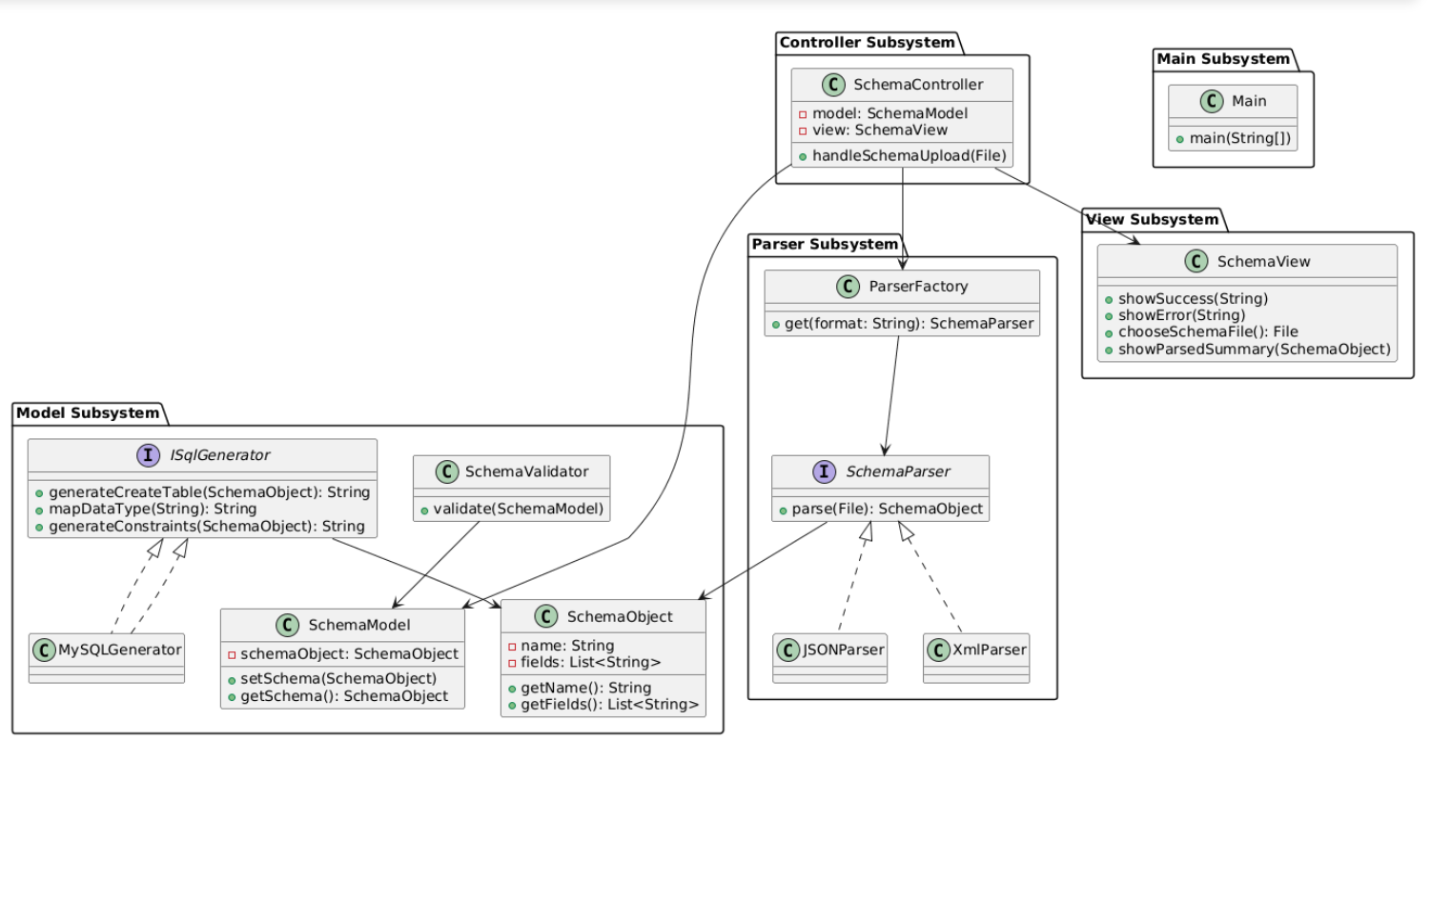

The system is organized into the following subsystems:
- Parser subsystem (JSONParser, XmlParser, ParserFactory)
- Model subsystem (SchemaObject, SchemaModel, SchemaValidator, ISqlGenerator, MySQLGenerator)
- Controller subsystem (SchemaController)
- View subsystem (SchemaView)
- Main subsystem (Main entry point)
Each subsystem is cohesive in purpose, and interactions occur through defined interfaces to minimize coupling.

Subsystems

Subsystem Parser Subsystem
Classes: JSONParser, XmlParser, ParserFactory.
- JSONParser: Parses JSON schema files into SchemaObject.
- XmlParser: Parses XML schema files into SchemaObject.
- ParserFactory: Returns the appropriate parser implementation based on file format.
Pattern: Factory Pattern is used to decouple controller from parser implementations.

Subsystem Model Subsystem
Classes: SchemaObject, SchemaModel, SchemaValidator, ISqlGenerator, MySQLGenerator.
- SchemaObject: Represents a schema with name and fields.
- SchemaModel: Stores the current schema state.
- SchemaValidator: Enforces validation rules to ensure schema compatibility across DBMS.
- ISqlGenerator: Interface for SQL generation.
- MySQLGenerator: Concrete implementation for MySQL.
Validation Rules:
1. Schema name must not be null or empty and should follow identifier conventions.
2. At least one unique field must be present.
3. Reserved SQL keywords must not be used as schema or field names.
4. Generic data types are mapped through ISqlGenerator for DBMS compatibility.
Pattern: Validation logic is centralized; ISqlGenerator supports future DBMS extensions.

Subsystem Controller Subsystem
Class: SchemaController.
- Coordinates file upload, parser selection, schema parsing, validation, and error handling.
- Catches exceptions and communicates outcomes to the view.
Pattern: Controller in MVC.

Subsystem View Subsystem
Class: SchemaView.
- Displays success and error messages to the user.
- Provides file chooser functionality.
Pattern: View in MVC.

Subsystem Main Subsystem

Class: Main.
- Entry point for the application.
- Initializes MVC components and delegates to controller.

Sequence Diagrams

5.1 Upload and Parse JSON Schema
Scenario: A user uploads a JSON schema file.
- Main creates MVC components.
- Controller validates the file and requests parser from ParserFactory.
- JSONParser parses the schema and returns a SchemaObject.
- Controller updates SchemaModel and notifies SchemaView.
Pattern: Factory Pattern is applied when selecting the parser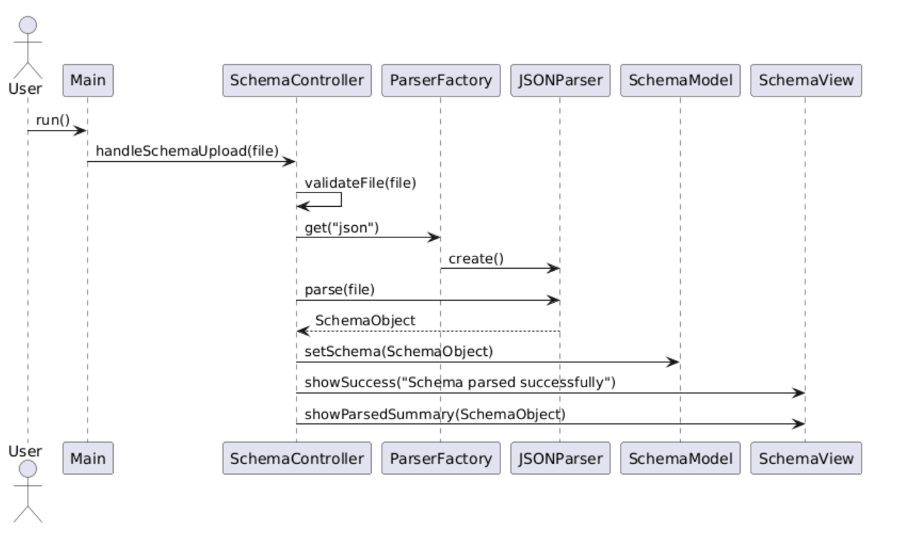.

5.2 Validate Schema and Generate SQL
Scenario: SQL generation after schema upload.
- Controller passes SchemaObject to SchemaValidator.
- If validation succeeds, ISqlGenerator (MySQLGenerator) generates SQL.
- Errors are handled through exceptions and reported via SchemaView.
Pattern: Strategy Pattern could be applied when extending ISqlGenerator for multiple DBMS.


