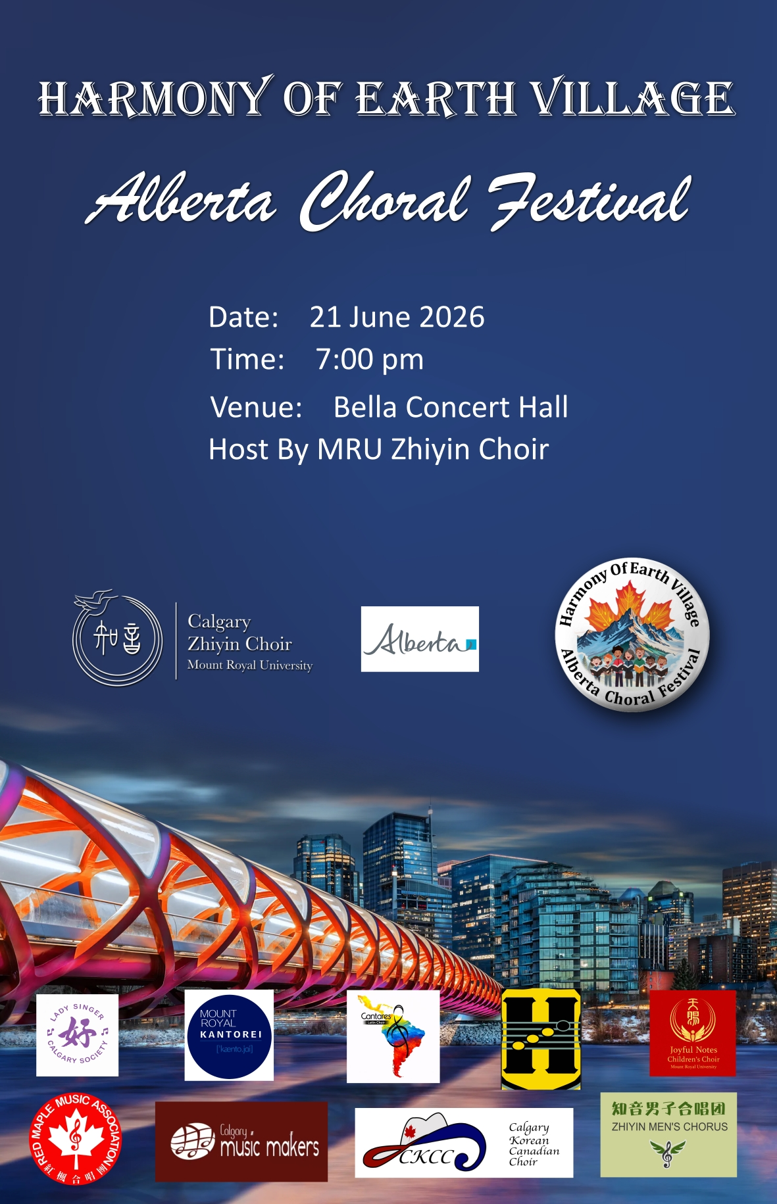



HARMONY OF EARTH VILLAGE
Alberta Choral Festival
Concert Program
Sunday, June 21, 2026 · 7:00 PM · Bella Concert Hall
Dion Simon Traditional Indigenous Blessing Ceremony
Jesse Pelletier Traditional Indigenous Dance
Joyful Notes Children's Choir 天赐之音少儿合唱团
♪ Solfege Symphony
♪ Heartbeat Rhythm
Red Maple Choir 红枫合唱团
♪ 我有一个装满星星的口袋
♪ 锦瑟
♪ Happy Together
Zhiyin Men's Choir 知音男子合唱团
♪ 同桌的你 My Old Deskmate
♪ 莫尼山 Mount Moni
Calgary Music Makers
♪ My Favorite Things
♪ Skyfall
♪ Fix You
♪ Something to Sing About
Calgary Lady Singers 卡尔加里女子合唱团
♪ 萱草花 Daylily
♪ Amani
♪ 立春 Beginning of Spring
INTERMISSION
Calgary Korean Canadian Choir
♪ Song of the Birds
♪ Spring in My Hometown
♪ Go Classic
Cantares Latin Choir
♪ La Chaparrita Golpe Larense
♪ Juana y José Merengue
♪ El Alcaraván Pasaje
♪ Bésame Mucho Bolero
♪ Quitapesares Joropo
Heebee-jeebees
Zhiyin Choir 知音合唱团
♪ 敕勒歌 Chi Le Ge · Song of the Nomads
♪ 城南送别 Farewell
♪ 人世间 A Life Journey
Heebee-jeebees
Mount Royal Kantorei
♪ Dies Irae Mozart
♪ May It Be Enya
♪ Sogno di Volare Tin
♪ Joyful Joyful We Adore Thee Beethoven, arr. M. Warren

感谢岁月 · 请你做我的知音

PERFORMER & CHOIR INTRODUCTIONS
About Our Guests & Ensembles
Dion Simon Traditional Indigenous Blessing Ceremony
Dion is of the Cree Nation, Treaty 6 territory — a father, leader, and teacher who serves as Naato'ohsokay, Medicine Trail Program Coordinator. For 15 years, Dion has provided cultural support to staff and students of the Iniskim Centre and throughout the Mount Royal University campus, working continuously toward education and Indigenization at MRU. A “compassionate and humbling energy” comes from his work — the creativity he experiences as a visual artist gives him a calming, thankful outlook that deepens his appreciation for the gifts and challenges around him, and inspires his optimism about Indigenization at Mount Royal and helping students succeed.
Jesse Pelletier Traditional Indigenous Dance
Jesse Pelletier is from Siksika Nation, Treaty 7. He has been a traditional singer for many years, performing at Powwows, Round Dances, and singing at public gatherings throughout the community.
Calgary Zhiyin Choir 知音合唱团 · Host
Founded in 2004 as a non-profit organization in Alberta, the Calgary Zhi-Yin Choir plays an important role in Calgary, especially among the local Chinese community. Led by its founder and conductor Shana Yang, the choir is made up of diverse adults from different backgrounds and professions who share a passion for music. Focusing on both popular and classical music, the name “Zhi-Yin” means friends in music — reflecting its goal to build musical connections and promote multiculturalism in Canada. Under the guidance of Shana Yang and with input from guest speakers, the choir provides valuable vocal coaching to its members, enhancing their skills and contributing to overall excellence. The choir connects with audiences through annual concerts in Calgary and performances in Edmonton, Vancouver, New York, Taipei, Sardinia, Prague, and Barcelona — symbolizing unity, cultural exchange, and artistic accomplishment.
Red Maple Music Association 红枫合唱团
Established in August 2004 and registered as a non-profit in Edmonton, Red Maple Music Association is an amateur chorus of Chinese individuals from around the world. Their mission: to promote Chinese culture, foster community harmony, and prove that music enriches life. They have toured three cities in Heilongjiang, China, participated in earthquake and flood relief fundraisers, and regularly perform charity concerts at nursing homes. Over the past two decades, the chorus has grown with the love, support, and encouragement of devoted audiences.
Calgary Music Makers
For over four decades, the Calgary Music Makers Sr's Choir has been singing, performing, and creating shared laughter and fellowship. They rehearse Thursday mornings and perform on Thursday afternoons — a choir that balances beautiful music with a rich community life. New members are always welcome to drop by in September.
Calgary Korean Canadian Choir CKCC
Founded in 2009 by artistic director Hana Kyung-Hui Kim, the CKCC carries Korean culture into Calgary's multicultural mosaic through choral music and the performing arts. Notable highlights include performing at Korea's 70th Annual Liberation Day Festival at the Seoul Arts Centre, Beethoven's 9th Symphony with the Calgary Philharmonic Orchestra, a 2024 finalist spot at the YYC Music Awards, and a scheduled performance at Carnegie Hall in New York City in April 2027.
Cantares Latin Choir
A proud member of the Cantares Venezuelan Cultural Foundation, Cantares Latin Choir has been celebrating Latin American culture — particularly Venezuelan folklore — since June 2010. Under the direction of Juan Sosa, they have participated in every Calgary CarolFest since 2010, competed at the XV International Choral Kathaumixw in BC, and most recently earned a “Distinction” rating at the 2026 Airdrie Rotary Festival for Performing Arts. Everyone is welcome — contact conductor Juan Sosa at 587-989-6290.
Joyful Notes Children's Choir 天赐之音少儿合唱团
Founded by Ms. Xuejia Yang, Joyful Notes Children's Choir is the only children's choir under the Mount Royal University Conservatory that specializes in Chinese song pedagogy and the promotion of Chinese culture. The choir nurtures children's musical literacy, vocal capabilities, and teamwork through systematic vocal training, a diverse repertoire, and extensive stage experience. Featuring both a Main Choir and a Preparatory Choir, it provides a personalized development path for every child — allowing the seeds of art to take root and blossom in their hearts.
Lady Singer Calgary Society 卡尔加里女子合唱团
Lady Singer Calgary Society is composed of women who are passionate about music and dedicated to cultural promotion — a mix of professional musicians and talented enthusiasts with rich choral experience. Through rehearsals, stage performances, and community cultural activities, the choir showcases the charm of Chinese music to Calgary's multicultural communities. By integrating Chinese dance, traditional attire, language, and cultural history, they help broader audiences understand and appreciate Chinese culture, connecting different cultures through their voices and fostering mutual understanding through music.
Zhiyin Men's Choir 知音男子合唱团
The Zhiyin Men's Choir is composed of men who share a deep love for music and passion for the arts, drawn from diverse professional and cultural backgrounds. Through systematic vocal training, a rich repertoire, and high-quality stage performances, the choir continuously elevates its musical expressiveness and artistic excellence. Their repertoire spans Chinese and international choral classics, conveying emotions and connecting cultures through deep, powerful, and warm male harmonies — committed to promoting Chinese musical culture and enriching Canada's diverse artistic landscape.
Mount Royal Kantorei
Based in Calgary, Alberta, Mount Royal Kantorei is a 90-voice auditioned ensemble known for its rich choral sound, artistic excellence, and innovative programming. Founded in 1994, it is the flagship chorus of Mount Royal Conservatory, united by values of diversity, inclusivity, and compassion. Under the direction of John Morgan, the choir performs a wide range of repertoire — from classical masterworks to contemporary compositions and Indigenous collaborations — and frequently partners with the Calgary Philharmonic, Calgary Youth Choir, Calgary Civic Symphony, and many community choirs. In May 2025, the choir made its international competition debut at the prestigious Cork International Choral Festival in Ireland, where it was awarded the P.E.A.C.E. Trophy, recognizing excellence in choral performance and intercultural understanding. The ensemble recently released its latest album Witness, now available on all major streaming platforms, featuring powerful works that speak to justice, remembrance, and the human spirit. A key initiative is the Kantorei Choral Festival, a multi-year project bringing together choirs, clinicians, and composers for shared learning and exceptional performances. With a passionate membership and bold artistic vision, Mount Royal Kantorei continues to inspire audiences locally and internationally.
The Heebee-jeebees
The Heebee-jeebees are a 4-man Canadian comic a cappella quartet formed in 1993 who have, over 30+ years, sung thousands of performances and appeared on local, national, and international radio, television, and print. Known for being hilarious, entertaining, and extremely talented, they have released nine recordings to international recognition — including 4 CARA nominations and 2 CARA Awards (the Grammy's of a cappella). They have won the Canadian Championships of Harmony twice, as well as multiple Championships in the USA, and were inducted into the Canadian A Cappella Hall of Fame. In 2024, they were honoured by their alma mater UCalgary with a commemorative sign where they sang their first notes together. The Heebee-jeebees continue to impress audiences across North America and are considered the very best of comedic a cappella entertainment.

