FR-UBM-3.3.2.1/R0

|  |  |  |  |
| --- | --- | --- | --- |
| □ **UTS** ☑ **UAS** | **NASKAH UJIAN**  □**Susulan UTS/ UAS** □ **Lain-lain : ………………………….… [ ~~Ganjil~~/ Genap] 2020/2021** | | |
| **KMK - Mata Kuliah** | **:** TIB04 – Pemrograman Berorientasi Objek | | **NIM : 32200040** |
| **Kelas** | **:** 2MTI1 | | **NamaMahasiswa : MICHAEL HUNG** |
| **Hari /Tanggal** | **:** Senin/ 7 Juni 2021 | |
| **Waktu Ujian** | **:** 45 Menit (17:30-18:15) | |
| **Sifat Ujian** | **:** ~~Buka~~/ ~~Tutup Buku~~/ ~~Kamus~~/ Take Home | Diperiksaoleh: | **TandaTangan :** |
| **Lembar Jawaban** | **:** Ya / ~~Tidak~~ |  |  |
| **Laptop** | **:** Ya / ~~Tidak~~ |
| (Lukman Hakim) |  |
| **Kalkulator** | **:** Ya ~~/Tidak~~ |
| Tanggal :6/5/2021 |  |

Naskah ujian harap dimasukkan kedalam lembar jawaban dan dikumpulkan kembali !!!

|  |  |  |
| --- | --- | --- |
| **No** | **Jawablah Pertanyaan dibawah ini pada Lembar Jawaban Yang telah disediakan**  **Untuk kendala Ujian dapat kirimkan ke email prodi:**  [**teknikinformatika.uas@ubm.ac.id**](mailto:teknikinformatika.uas@ubm.ac.id) | **Bobot**  **%** |
|  | **Petunjuk mengerjakan soal:**  Soal akan dibedakan menjadi kelompok **A** dan **B**, silahkan pilih salah satu dari kelompok A atau B. Bila memilih soal kelompok A maka kerjakan soal dari kelompok A, jika memilih kelompok B maka kerjakan soal kelompok B. Tidak diperkenankan mengerjakan soal dari kelompok A dan mengerjakan juga soal  kelompk B. Pilih salah satu kelompok A atau B. |  |
|  |  |  |
| **1** | Buatlah aplikasi dengan menggunakan Bahasa Pemrograman JAVA GUI dari daftar studi kasus dibawah ini (pilih salah satu):   1. Rental Alat-Alat Berat 2. Sistem Hotel Terms and Conditions: 3. Memiliki form Menus, Login Proccess and Create New Account 4. Form CRUD (Create, Read, Update dan Delete)+Master Data+ 5. Transaction Data 6. File Report 7. Using MySQL Databases 8. User Validation and user friendly | **100** |
|  | **20** |
|  | **20** |
|  | **20** |
|  | **15** |
|  | **10** |
|  | **15** |
|  |  |  |
|  | **Ketentuan.**  Berkas yang di upload adalah:   * Source code (program) di copy ke MS-Word, dibagian bawah source code isi dengan tampilan keluaran program. * Kemudian file Ms-word yang berisi source program dan tampilan program dijadikan dokumen PDF. Sebaiknya file PDF yang diupload kecuali ukuran file besar boleh di ZIP atau RAR. * Bila menggunakan GoogleDrive, sertakan linknya, dan pastikan GoogleDrive bisa diakses. |  |
|  |  | **100** |

halaman1dari1

LAPORAN

UAS PEMROGRAMAN BERORIENTASI OBJEK

PEMBUATAN PROGRAM SISTEM HOTEL



DOSEN PEMBIMBING

**I Gusti Ngurah Suryantara, S.Kom, M.Kom**

Disusun Oleh

**Michael Hung**

**32200040**

PROGRAM STUDI TEKNIK INFORMATIKA

FAKULTAS TEKNOLOGI DAN DESAIN

UNIVERSITAS BUNDA MULIA

JAKARTA

JFrame Login :

import java.sql.Connection;

import java.sql.DriverManager;

import java.sql.ResultSet;

import java.sql.Statement;

import javax.swing.JOptionPane;

public class Login extends javax.swing.JFrame {

public home home;

public Connection cons;

public Statement stat;

public String Username;

public Login() {

initComponents();

try{

Class.forName("com.mysql.jdbc.Driver");

cons = DriverManager.getConnection("jdbc:mysql://localhost:3306/crud","root",""); //connection

stat = cons.createStatement();

}

catch (Exception E) {

JOptionPane.showMessageDialog(null,"Program Can't Connect To Database!");

System.exit(0);

}

}

@SuppressWarnings("unchecked")

// <editor-fold defaultstate="collapsed" desc="Generated Code">

private void initComponents() {

jLabel1 = new javax.swing.JLabel();

jLabel2 = new javax.swing.JLabel();

login = new java.awt.Button();

signupbutton = new java.awt.Button();

exit = new java.awt.Button();

username = new javax.swing.JTextField();

password = new javax.swing.JPasswordField();

jLabel3 = new javax.swing.JLabel();

jLabel4 = new javax.swing.JLabel();

warning = new javax.swing.JLabel();

setDefaultCloseOperation(javax.swing.WindowConstants.EXIT_ON_CLOSE);

setBackground(new java.awt.Color(153, 204, 255));

setCursor(new java.awt.Cursor(java.awt.Cursor.DEFAULT_CURSOR));

jLabel1.setText("Username : ");

jLabel2.setText("Password : ");

login.setLabel("Login");

login.addActionListener(new java.awt.event.ActionListener() {

public void actionPerformed(java.awt.event.ActionEvent evt) {

loginActionPerformed(evt);

}

});

signupbutton.setLabel("Sign Up");

signupbutton.addActionListener(new java.awt.event.ActionListener() {

public void actionPerformed(java.awt.event.ActionEvent evt) {

signupbuttonActionPerformed(evt);

}

});

exit.setLabel("Exit");

exit.addActionListener(new java.awt.event.ActionListener() {

public void actionPerformed(java.awt.event.ActionEvent evt) {

exitActionPerformed(evt);

}

});

password.addActionListener(new java.awt.event.ActionListener() {

public void actionPerformed(java.awt.event.ActionEvent evt) {

passwordActionPerformed(evt);

}

});

jLabel3.setFont(new java.awt.Font("Dialog", 1, 36)); // NOI18N

jLabel3.setText("LOGIN FORM");

jLabel4.setFont(new java.awt.Font("Dialog", 1, 18)); // NOI18N

jLabel4.setText("HOTEL SEMUA BAHAGIA ");

warning.setForeground(new java.awt.Color(255, 51, 0));

javax.swing.GroupLayout layout = new javax.swing.GroupLayout(getContentPane());

getContentPane().setLayout(layout);

layout.setHorizontalGroup(

layout.createParallelGroup(javax.swing.GroupLayout.Alignment.LEADING)

.addGroup(layout.createSequentialGroup()

.addContainerGap(66, Short.MAX_VALUE)

.addGroup(layout.createParallelGroup(javax.swing.GroupLayout.Alignment.LEADING)

.addGroup(javax.swing.GroupLayout.Alignment.TRAILING, layout.createSequentialGroup()

.addGroup(layout.createParallelGroup(javax.swing.GroupLayout.Alignment.LEADING)

.addComponent(jLabel1)

.addComponent(jLabel2))

.addGap(47, 47, 47)

.addGroup(layout.createParallelGroup(javax.swing.GroupLayout.Alignment.LEADING, false)

.addComponent(username)

.addComponent(password, javax.swing.GroupLayout.PREFERRED_SIZE, 201, javax.swing.GroupLayout.PREFERRED_SIZE))

.addGap(49, 49, 49))

.addGroup(javax.swing.GroupLayout.Alignment.TRAILING, layout.createSequentialGroup()

.addGroup(layout.createParallelGroup(javax.swing.GroupLayout.Alignment.TRAILING)

.addComponent(jLabel4)

.addComponent(jLabel3))

.addGap(99, 99, 99))

.addGroup(javax.swing.GroupLayout.Alignment.TRAILING, layout.createSequentialGroup()

.addComponent(login, javax.swing.GroupLayout.PREFERRED_SIZE, 75, javax.swing.GroupLayout.PREFERRED_SIZE)

.addGap(27, 27, 27)

.addComponent(signupbutton, javax.swing.GroupLayout.PREFERRED_SIZE, 75, javax.swing.GroupLayout.PREFERRED_SIZE)

.addGap(28, 28, 28)

.addComponent(exit, javax.swing.GroupLayout.PREFERRED_SIZE, 75, javax.swing.GroupLayout.PREFERRED_SIZE)

.addGap(63, 63, 63))

.addGroup(javax.swing.GroupLayout.Alignment.TRAILING, layout.createSequentialGroup()

.addComponent(warning)

.addGap(128, 128, 128))))

);

layout.setVerticalGroup(

layout.createParallelGroup(javax.swing.GroupLayout.Alignment.LEADING)

.addGroup(javax.swing.GroupLayout.Alignment.TRAILING, layout.createSequentialGroup()

.addContainerGap(51, Short.MAX_VALUE)

.addComponent(jLabel4)

.addPreferredGap(javax.swing.LayoutStyle.ComponentPlacement.RELATED)

.addComponent(jLabel3)

.addPreferredGap(javax.swing.LayoutStyle.ComponentPlacement.UNRELATED)

.addGroup(layout.createParallelGroup(javax.swing.GroupLayout.Alignment.BASELINE)

.addComponent(jLabel1)

.addComponent(username, javax.swing.GroupLayout.PREFERRED_SIZE, javax.swing.GroupLayout.DEFAULT_SIZE, javax.swing.GroupLayout.PREFERRED_SIZE))

.addGap(33, 33, 33)

.addGroup(layout.createParallelGroup(javax.swing.GroupLayout.Alignment.BASELINE)

.addComponent(jLabel2)

.addComponent(password, javax.swing.GroupLayout.PREFERRED_SIZE, javax.swing.GroupLayout.DEFAULT_SIZE, javax.swing.GroupLayout.PREFERRED_SIZE))

.addGap(18, 18, 18)

.addComponent(warning)

.addPreferredGap(javax.swing.LayoutStyle.ComponentPlacement.RELATED)

.addGroup(layout.createParallelGroup(javax.swing.GroupLayout.Alignment.LEADING, false)

.addComponent(login, javax.swing.GroupLayout.DEFAULT_SIZE, javax.swing.GroupLayout.DEFAULT_SIZE, Short.MAX_VALUE)

.addComponent(exit, javax.swing.GroupLayout.DEFAULT_SIZE, javax.swing.GroupLayout.DEFAULT_SIZE, Short.MAX_VALUE)

.addComponent(signupbutton, javax.swing.GroupLayout.PREFERRED_SIZE, 52, javax.swing.GroupLayout.PREFERRED_SIZE))

.addGap(25, 25, 25))

);

login.getAccessibleContext().setAccessibleDescription("");

pack();

setLocationRelativeTo(null);

}// </editor-fold>

private void loginActionPerformed(java.awt.event.ActionEvent evt) {

int value;

String nama = username.getText();

String pass = String.valueOf(password.getPassword());

if(username.getText().trim().isEmpty() && pass.trim().isEmpty()){

warning.setText("Kolom Tidak Boleh Kosong!");

value = -1;

}

else if (username.getText().trim().isEmpty()){

warning.setText("Username Tidak Boleh Kosong!");

value = -1;

}

else if (pass.trim().isEmpty()){

warning.setText("Password Tidak Boleh Kosong!");

value = -1;

}

else{

value = 1;

}

try{

Username = username.getText();

if (value>0){

String db = "select *from login where Username = '"+username.getText() + "'and Password = '" +String.valueOf(password.getPassword()) + "'";

ResultSet result = stat.executeQuery(db);

if (result.next()){

JOptionPane.showMessageDialog(null , "Login Berhasil!");

home = new home();

home.setVisible(false);

new home(nama).setVisible(true);

this.dispose();

}

else{

JOptionPane.showMessageDialog(null, "Mohon Maaf , Username / Password Salah! ");

}

}

}

catch (Exception E){

JOptionPane.showMessageDialog(null, "Terjadi Sebuah Kesalahan!");

}

}

public void setNama(String value){

JOptionPane.showMessageDialog(null,value);

this.Username = value;

}

private void passwordActionPerformed(java.awt.event.ActionEvent evt) {

// TODO add your handling code here:

}

private void exitActionPerformed(java.awt.event.ActionEvent evt) {

System.exit(0);

}

private void signupbuttonActionPerformed(java.awt.event.ActionEvent evt) {

signup signup = new signup();

signup.setVisible(true);

this.dispose();

}

/**

* @param args the command line arguments

*/

public static void main(String args[]) {

/* Set the Nimbus look and feel */

//<editor-fold defaultstate="collapsed" desc=" Look and feel setting code (optional) ">

/* If Nimbus (introduced in Java SE 6) is not available, stay with the default look and feel.

* For details see http://download.oracle.com/javase/tutorial/uiswing/lookandfeel/plaf.html

*/

try {

for (javax.swing.UIManager.LookAndFeelInfo info : javax.swing.UIManager.getInstalledLookAndFeels()) {

if ("Nimbus".equals(info.getName())) {

javax.swing.UIManager.setLookAndFeel(info.getClassName());

break;

}

}

} catch (ClassNotFoundException ex) {

java.util.logging.Logger.getLogger(Login.class.getName()).log(java.util.logging.Level.SEVERE, null, ex);

} catch (InstantiationException ex) {

java.util.logging.Logger.getLogger(Login.class.getName()).log(java.util.logging.Level.SEVERE, null, ex);

} catch (IllegalAccessException ex) {

java.util.logging.Logger.getLogger(Login.class.getName()).log(java.util.logging.Level.SEVERE, null, ex);

} catch (javax.swing.UnsupportedLookAndFeelException ex) {

java.util.logging.Logger.getLogger(Login.class.getName()).log(java.util.logging.Level.SEVERE, null, ex);

}

//</editor-fold>

//</editor-fold>

/* Create and display the form */

java.awt.EventQueue.invokeLater(new Runnable() {

public void run() {

new Login().setVisible(true);

}

});

}

// Variables declaration - do not modify

private java.awt.Button exit;

private javax.swing.JLabel jLabel1;

private javax.swing.JLabel jLabel2;

private javax.swing.JLabel jLabel3;

private javax.swing.JLabel jLabel4;

private java.awt.Button login;

private javax.swing.JPasswordField password;

private java.awt.Button signupbutton;

private javax.swing.JTextField username;

private javax.swing.JLabel warning;

// End of variables declaration

}

JFrame Signup :

import java.sql.Connection;

import java.sql.DriverManager;

import java.sql.Statement;

import java.sql.PreparedStatement;

import javax.swing.JOptionPane;

public class signup extends javax.swing.JFrame {

public Login login;

public Connection cons;

public Statement stat;

public signup() {

initComponents();

try{

Class.forName("com.mysql.jdbc.Driver");

cons = DriverManager.getConnection("jdbc:mysql://localhost:3306/crud","root",""); //connection

stat = cons.createStatement();

}

catch (Exception E) {

JOptionPane.showMessageDialog(null,"Program Can't Connect To Database!");

System.exit(0);

}

}

/**

* This method is called from within the constructor to initialize the form.

* WARNING: Do NOT modify this code. The content of this method is always

* regenerated by the Form Editor.

*/

@SuppressWarnings("unchecked")

// <editor-fold defaultstate="collapsed" desc="Generated Code">

private void initComponents() {

jLabel1 = new javax.swing.JLabel();

jLabel2 = new javax.swing.JLabel();

jLabel3 = new javax.swing.JLabel();

jLabel4 = new javax.swing.JLabel();

jLabel5 = new javax.swing.JLabel();

ID = new javax.swing.JTextField();

username = new javax.swing.JTextField();

jButton1 = new javax.swing.JButton();

jButton2 = new javax.swing.JButton();

password = new javax.swing.JPasswordField();

warning = new javax.swing.JLabel();

jButton3 = new javax.swing.JButton();

setDefaultCloseOperation(javax.swing.WindowConstants.EXIT_ON_CLOSE);

jLabel1.setFont(new java.awt.Font("Dialog", 1, 36)); // NOI18N

jLabel1.setText("SIGN UP");

jLabel2.setText("ID :");

jLabel3.setText("Username : ");

jLabel4.setText("Password : ");

jButton1.setText("Sign Up");

jButton1.addActionListener(new java.awt.event.ActionListener() {

public void actionPerformed(java.awt.event.ActionEvent evt) {

jButton1ActionPerformed(evt);

}

});

jButton2.setText("Back");

jButton2.addActionListener(new java.awt.event.ActionListener() {

public void actionPerformed(java.awt.event.ActionEvent evt) {

jButton2ActionPerformed(evt);

}

});

warning.setForeground(new java.awt.Color(255, 0, 51));

jButton3.setText("Exit");

jButton3.addActionListener(new java.awt.event.ActionListener() {

public void actionPerformed(java.awt.event.ActionEvent evt) {

jButton3ActionPerformed(evt);

}

});

javax.swing.GroupLayout layout = new javax.swing.GroupLayout(getContentPane());

getContentPane().setLayout(layout);

layout.setHorizontalGroup(

layout.createParallelGroup(javax.swing.GroupLayout.Alignment.LEADING)

.addGroup(layout.createSequentialGroup()

.addGap(33, 33, 33)

.addGroup(layout.createParallelGroup(javax.swing.GroupLayout.Alignment.LEADING)

.addGroup(layout.createSequentialGroup()

.addGroup(layout.createParallelGroup(javax.swing.GroupLayout.Alignment.LEADING)

.addComponent(jLabel2)

.addComponent(jLabel3)

.addComponent(jLabel4))

.addGap(56, 56, 56)

.addGroup(layout.createParallelGroup(javax.swing.GroupLayout.Alignment.LEADING, false)

.addComponent(password, javax.swing.GroupLayout.DEFAULT_SIZE, 190, Short.MAX_VALUE)

.addComponent(username)

.addComponent(ID))

.addContainerGap(javax.swing.GroupLayout.DEFAULT_SIZE, Short.MAX_VALUE))

.addGroup(layout.createSequentialGroup()

.addComponent(jLabel5)

.addPreferredGap(javax.swing.LayoutStyle.ComponentPlacement.RELATED)

.addGroup(layout.createParallelGroup(javax.swing.GroupLayout.Alignment.LEADING)

.addGroup(layout.createSequentialGroup()

.addComponent(jButton1, javax.swing.GroupLayout.PREFERRED_SIZE, 85, javax.swing.GroupLayout.PREFERRED_SIZE)

.addPreferredGap(javax.swing.LayoutStyle.ComponentPlacement.RELATED, javax.swing.GroupLayout.DEFAULT_SIZE, Short.MAX_VALUE)

.addComponent(jButton2, javax.swing.GroupLayout.PREFERRED_SIZE, 85, javax.swing.GroupLayout.PREFERRED_SIZE)

.addGap(112, 112, 112))

.addGroup(javax.swing.GroupLayout.Alignment.TRAILING, layout.createSequentialGroup()

.addPreferredGap(javax.swing.LayoutStyle.ComponentPlacement.RELATED, 226, javax.swing.GroupLayout.PREFERRED_SIZE)

.addComponent(jButton3, javax.swing.GroupLayout.PREFERRED_SIZE, 85, javax.swing.GroupLayout.PREFERRED_SIZE)))

.addGap(35, 35, 35))))

.addGroup(layout.createSequentialGroup()

.addGap(119, 119, 119)

.addComponent(jLabel1)

.addContainerGap(javax.swing.GroupLayout.DEFAULT_SIZE, Short.MAX_VALUE))

.addGroup(javax.swing.GroupLayout.Alignment.TRAILING, layout.createSequentialGroup()

.addContainerGap(javax.swing.GroupLayout.DEFAULT_SIZE, Short.MAX_VALUE)

.addComponent(warning)

.addGap(120, 120, 120))

);

layout.setVerticalGroup(

layout.createParallelGroup(javax.swing.GroupLayout.Alignment.LEADING)

.addGroup(layout.createSequentialGroup()

.addGap(17, 17, 17)

.addComponent(jLabel1)

.addGap(27, 27, 27)

.addGroup(layout.createParallelGroup(javax.swing.GroupLayout.Alignment.BASELINE)

.addComponent(jLabel2)

.addComponent(ID, javax.swing.GroupLayout.PREFERRED_SIZE, javax.swing.GroupLayout.DEFAULT_SIZE, javax.swing.GroupLayout.PREFERRED_SIZE))

.addGap(22, 22, 22)

.addGroup(layout.createParallelGroup(javax.swing.GroupLayout.Alignment.BASELINE)

.addComponent(jLabel3)

.addComponent(username, javax.swing.GroupLayout.PREFERRED_SIZE, javax.swing.GroupLayout.DEFAULT_SIZE, javax.swing.GroupLayout.PREFERRED_SIZE))

.addGap(22, 22, 22)

.addGroup(layout.createParallelGroup(javax.swing.GroupLayout.Alignment.BASELINE)

.addComponent(jLabel4)

.addComponent(password, javax.swing.GroupLayout.PREFERRED_SIZE, javax.swing.GroupLayout.DEFAULT_SIZE, javax.swing.GroupLayout.PREFERRED_SIZE))

.addGroup(layout.createParallelGroup(javax.swing.GroupLayout.Alignment.LEADING)

.addGroup(layout.createSequentialGroup()

.addGap(65, 65, 65)

.addComponent(jLabel5)

.addContainerGap(59, Short.MAX_VALUE))

.addGroup(layout.createSequentialGroup()

.addPreferredGap(javax.swing.LayoutStyle.ComponentPlacement.UNRELATED)

.addComponent(warning)

.addPreferredGap(javax.swing.LayoutStyle.ComponentPlacement.RELATED, javax.swing.GroupLayout.DEFAULT_SIZE, Short.MAX_VALUE)

.addGroup(layout.createParallelGroup(javax.swing.GroupLayout.Alignment.BASELINE)

.addComponent(jButton1, javax.swing.GroupLayout.PREFERRED_SIZE, 45, javax.swing.GroupLayout.PREFERRED_SIZE)

.addComponent(jButton2, javax.swing.GroupLayout.PREFERRED_SIZE, 45, javax.swing.GroupLayout.PREFERRED_SIZE)

.addComponent(jButton3, javax.swing.GroupLayout.PREFERRED_SIZE, 45, javax.swing.GroupLayout.PREFERRED_SIZE))

.addGap(26, 26, 26))))

);

pack();

setLocationRelativeTo(null);

}// </editor-fold>

private void jButton2ActionPerformed(java.awt.event.ActionEvent evt) {

Login Login = new Login();

Login.setVisible(true);

this.dispose();

}

private void jButton1ActionPerformed(java.awt.event.ActionEvent evt) {

int value;

String pass = String.valueOf(password.getPassword());

if(ID.getText().trim().isEmpty() && username.getText().trim().isEmpty() && pass.trim().isEmpty()){

warning.setText("Kolom Tidak Boleh Kosong!");

value = -1;

}

else if(ID.getText().trim().isEmpty()){

warning.setText("ID Tidak Boleh Kosong!");

value = -1;

}

else if(username.getText().trim().isEmpty()){

warning.setText("Username Tidak Boleh Kosong!");

value = -1;

}

else if(pass.trim().isEmpty()){

warning.setText("Password Tidak Boleh Kosong!");

value = -1;

}

else {

value = 1;

}

String db = "insert into login values (?,?,?)";

try{

if (value>0){

PreparedStatement statement = cons.prepareStatement(db);

statement.setString(1,ID.getText());

statement.setString(2,username.getText());

statement.setString(3,String.valueOf(password.getPassword()));

statement.executeUpdate();

JOptionPane.showMessageDialog(null,"Sign Up Complete! You Will Be Directed Back To The Login Form!");

Login Login = new Login();

Login.setVisible(true);

this.dispose();

}

}

catch (Exception E){

JOptionPane.showMessageDialog(null, "Register Gagal!");

}

}

private void jButton3ActionPerformed(java.awt.event.ActionEvent evt) {

System.exit(0);

}

/**

* @param args the command line arguments

*/

public static void main(String args[]) {

/* Set the Nimbus look and feel */

//<editor-fold defaultstate="collapsed" desc=" Look and feel setting code (optional) ">

/* If Nimbus (introduced in Java SE 6) is not available, stay with the default look and feel.

* For details see http://download.oracle.com/javase/tutorial/uiswing/lookandfeel/plaf.html

*/

try {

for (javax.swing.UIManager.LookAndFeelInfo info : javax.swing.UIManager.getInstalledLookAndFeels()) {

if ("Nimbus".equals(info.getName())) {

javax.swing.UIManager.setLookAndFeel(info.getClassName());

break;

}

}

} catch (ClassNotFoundException ex) {

java.util.logging.Logger.getLogger(signup.class.getName()).log(java.util.logging.Level.SEVERE, null, ex);

} catch (InstantiationException ex) {

java.util.logging.Logger.getLogger(signup.class.getName()).log(java.util.logging.Level.SEVERE, null, ex);

} catch (IllegalAccessException ex) {

java.util.logging.Logger.getLogger(signup.class.getName()).log(java.util.logging.Level.SEVERE, null, ex);

} catch (javax.swing.UnsupportedLookAndFeelException ex) {

java.util.logging.Logger.getLogger(signup.class.getName()).log(java.util.logging.Level.SEVERE, null, ex);

}

//</editor-fold>

/* Create and display the form */

java.awt.EventQueue.invokeLater(new Runnable() {

public void run() {

new signup().setVisible(true);

}

});

}

// Variables declaration - do not modify

private javax.swing.JTextField ID;

private javax.swing.JButton jButton1;

private javax.swing.JButton jButton2;

private javax.swing.JButton jButton3;

private javax.swing.JLabel jLabel1;

private javax.swing.JLabel jLabel2;

private javax.swing.JLabel jLabel3;

private javax.swing.JLabel jLabel4;

private javax.swing.JLabel jLabel5;

private javax.swing.JPasswordField password;

private javax.swing.JTextField username;

private javax.swing.JLabel warning;

// End of variables declaration

}

JFrame Home

import java.awt.event.ActionEvent;

import java.util.Date;

import java.text.SimpleDateFormat;

import javax.swing.Timer;

import java.awt.event.ActionListener;

public class home extends javax.swing.JFrame {

public reservation reservation;

public home(String value) {

initComponents();

welcomemsg.setText("Welcome , " +value + "!");

showTime();

showDate();

}

public home(){

initComponents();

welcomemsg.setText("HOTEL SEMUA BAHAGIA");

showTime();

showDate();

}

public void showDate(){

Date tanggal = new Date();

SimpleDateFormat f_tanggal = new SimpleDateFormat("dd-MM-yyyy");

date.setText(f_tanggal.format(tanggal));

}

Timer tm;

SimpleDateFormat sdf;

public void showTime(){

tm = new Timer (0, new ActionListener() {

@Override

public void actionPerformed(ActionEvent ae) {

Date dt = new Date();

sdf = new SimpleDateFormat("hh:mm:ss a");

String time = sdf.format(dt);

jam.setText(time);

}

});

tm.start();

}

@SuppressWarnings("unchecked")

// <editor-fold defaultstate="collapsed" desc="Generated Code">

private void initComponents() {

jButton1 = new javax.swing.JButton();

jButton2 = new javax.swing.JButton();

exit = new javax.swing.JButton();

jButton5 = new javax.swing.JButton();

jButton6 = new javax.swing.JButton();

welcomemsg = new javax.swing.JLabel();

jam = new javax.swing.JLabel();

date = new javax.swing.JLabel();

setDefaultCloseOperation(javax.swing.WindowConstants.EXIT_ON_CLOSE);

jButton1.setText("Check In");

jButton1.addActionListener(new java.awt.event.ActionListener() {

public void actionPerformed(java.awt.event.ActionEvent evt) {

jButton1ActionPerformed(evt);

}

});

jButton2.setText("Check Out");

jButton2.addActionListener(new java.awt.event.ActionListener() {

public void actionPerformed(java.awt.event.ActionEvent evt) {

jButton2ActionPerformed(evt);

}

});

exit.setBackground(new java.awt.Color(255, 0, 0));

exit.setForeground(new java.awt.Color(255, 255, 255));

exit.setText("Exit");

exit.addActionListener(new java.awt.event.ActionListener() {

public void actionPerformed(java.awt.event.ActionEvent evt) {

exitActionPerformed(evt);

}

});

jButton5.setText("Reservation");

jButton5.addActionListener(new java.awt.event.ActionListener() {

public void actionPerformed(java.awt.event.ActionEvent evt) {

jButton5ActionPerformed(evt);

}

});

jButton6.setText("Database (Only Admin)");

jButton6.addActionListener(new java.awt.event.ActionListener() {

public void actionPerformed(java.awt.event.ActionEvent evt) {

jButton6ActionPerformed(evt);

}

});

welcomemsg.setFont(new java.awt.Font("Dialog", 1, 24)); // NOI18N

welcomemsg.setText("Welcome , !");

jam.setText("JAM");

date.setText("TANGGAL");

javax.swing.GroupLayout layout = new javax.swing.GroupLayout(getContentPane());

getContentPane().setLayout(layout);

layout.setHorizontalGroup(

layout.createParallelGroup(javax.swing.GroupLayout.Alignment.LEADING)

.addGroup(layout.createSequentialGroup()

.addGap(26, 26, 26)

.addGroup(layout.createParallelGroup(javax.swing.GroupLayout.Alignment.LEADING)

.addGroup(layout.createSequentialGroup()

.addComponent(welcomemsg)

.addContainerGap(javax.swing.GroupLayout.DEFAULT_SIZE, Short.MAX_VALUE))

.addGroup(layout.createSequentialGroup()

.addGroup(layout.createParallelGroup(javax.swing.GroupLayout.Alignment.LEADING)

.addComponent(date)

.addComponent(jam))

.addPreferredGap(javax.swing.LayoutStyle.ComponentPlacement.RELATED, javax.swing.GroupLayout.DEFAULT_SIZE, Short.MAX_VALUE)

.addComponent(exit, javax.swing.GroupLayout.PREFERRED_SIZE, 77, javax.swing.GroupLayout.PREFERRED_SIZE)

.addGap(15, 15, 15))))

.addGroup(javax.swing.GroupLayout.Alignment.TRAILING, layout.createSequentialGroup()

.addGap(0, 143, Short.MAX_VALUE)

.addGroup(layout.createParallelGroup(javax.swing.GroupLayout.Alignment.LEADING, false)

.addComponent(jButton6, javax.swing.GroupLayout.Alignment.TRAILING, javax.swing.GroupLayout.DEFAULT_SIZE, 181, Short.MAX_VALUE)

.addComponent(jButton1, javax.swing.GroupLayout.Alignment.TRAILING, javax.swing.GroupLayout.DEFAULT_SIZE, javax.swing.GroupLayout.DEFAULT_SIZE, Short.MAX_VALUE)

.addComponent(jButton2, javax.swing.GroupLayout.Alignment.TRAILING, javax.swing.GroupLayout.DEFAULT_SIZE, javax.swing.GroupLayout.DEFAULT_SIZE, Short.MAX_VALUE)

.addComponent(jButton5, javax.swing.GroupLayout.DEFAULT_SIZE, javax.swing.GroupLayout.DEFAULT_SIZE, Short.MAX_VALUE))

.addGap(125, 125, 125))

);

layout.setVerticalGroup(

layout.createParallelGroup(javax.swing.GroupLayout.Alignment.LEADING)

.addGroup(javax.swing.GroupLayout.Alignment.TRAILING, layout.createSequentialGroup()

.addGap(25, 25, 25)

.addComponent(welcomemsg)

.addGap(54, 54, 54)

.addComponent(jButton5, javax.swing.GroupLayout.PREFERRED_SIZE, 51, javax.swing.GroupLayout.PREFERRED_SIZE)

.addGap(37, 37, 37)

.addComponent(jButton1, javax.swing.GroupLayout.PREFERRED_SIZE, 51, javax.swing.GroupLayout.PREFERRED_SIZE)

.addGap(49, 49, 49)

.addComponent(jButton2, javax.swing.GroupLayout.PREFERRED_SIZE, 51, javax.swing.GroupLayout.PREFERRED_SIZE)

.addGap(49, 49, 49)

.addComponent(jButton6, javax.swing.GroupLayout.PREFERRED_SIZE, 55, javax.swing.GroupLayout.PREFERRED_SIZE)

.addPreferredGap(javax.swing.LayoutStyle.ComponentPlacement.RELATED, 82, Short.MAX_VALUE)

.addGroup(layout.createParallelGroup(javax.swing.GroupLayout.Alignment.LEADING)

.addComponent(exit, javax.swing.GroupLayout.Alignment.TRAILING)

.addGroup(javax.swing.GroupLayout.Alignment.TRAILING, layout.createSequentialGroup()

.addComponent(jam)

.addPreferredGap(javax.swing.LayoutStyle.ComponentPlacement.UNRELATED)

.addComponent(date)))

.addGap(15, 15, 15))

);

pack();

setLocationRelativeTo(null);

}// </editor-fold>

private void exitActionPerformed(java.awt.event.ActionEvent evt) {

System.exit(0);

}

private void jButton5ActionPerformed(java.awt.event.ActionEvent evt) {

reservation = new reservation();

reservation.setVisible(true);

this.dispose();

}

private void jButton1ActionPerformed(java.awt.event.ActionEvent evt) {

checkin checkin = new checkin();

checkin.setVisible(true);

this.dispose();

}

private void jButton2ActionPerformed(java.awt.event.ActionEvent evt) {

checkout checkout = new checkout();

checkout.setVisible(true);

this.dispose();

}

private void jButton6ActionPerformed(java.awt.event.ActionEvent evt) {

verify verify = new verify();

verify.setVisible(true);

this.dispose();

}

/**

* @param args the command line arguments

*/

public static void main(String args[]) {

java.awt.EventQueue.invokeLater(new Runnable() {

public void run() {

new home().setVisible(true);

}

});

}

// Variables declaration - do not modify

private javax.swing.JLabel date;

private javax.swing.JButton exit;

private javax.swing.JButton jButton1;

private javax.swing.JButton jButton2;

private javax.swing.JButton jButton5;

private javax.swing.JButton jButton6;

private javax.swing.JLabel jam;

private javax.swing.JLabel welcomemsg;

// End of variables declaration

}

JFrame Reservation

import java.util.Random;

import java.sql.Connection;

import java.sql.DriverManager;

import java.sql.ResultSet;

import java.sql.Statement;

import java.sql.PreparedStatement;

import javax.swing.JOptionPane;

public class reservation extends javax.swing.JFrame {

public home home;

public Connection cons;

public Statement stat;

public reservation() {

initComponents();

try{

Class.forName("com.mysql.jdbc.Driver");

cons = DriverManager.getConnection("jdbc:mysql://localhost:3306/crud","root",""); //connection

stat = cons.createStatement();

}

catch (Exception E) {

JOptionPane.showMessageDialog(null,"Program Can't Connect To Database!");

System.exit(0);

}

Random rand = new Random();

int RandNumb = rand.nextInt(1000);

kodeBooking.setEditable(false);

kodeBooking.setText("HSB-" +RandNumb);

harga.setEditable(false);

}

@SuppressWarnings("unchecked")

// <editor-fold defaultstate="collapsed" desc="Generated Code">

private void initComponents() {

jLabel1 = new javax.swing.JLabel();

jLabel2 = new javax.swing.JLabel();

jLabel3 = new javax.swing.JLabel();

jLabel4 = new javax.swing.JLabel();

jLabel5 = new javax.swing.JLabel();

jLabel7 = new javax.swing.JLabel();

jLabel9 = new javax.swing.JLabel();

kodeBooking = new javax.swing.JTextField();

nama = new javax.swing.JTextField();

alamat = new javax.swing.JTextField();

noHp = new javax.swing.JTextField();

tipekamar = new javax.swing.JComboBox<>();

jButton1 = new javax.swing.JButton();

jButton2 = new javax.swing.JButton();

jLabel6 = new javax.swing.JLabel();

harga = new javax.swing.JTextField();

jLabel10 = new javax.swing.JLabel();

cLamainap = new javax.swing.JComboBox<>();

check = new javax.swing.JButton();

readykamar = new javax.swing.JLabel();

warning = new javax.swing.JLabel();

jLabel8 = new javax.swing.JLabel();

jLabel11 = new javax.swing.JLabel();

tglCheckin = new javax.swing.JTextField();

jLabel12 = new javax.swing.JLabel();

setDefaultCloseOperation(javax.swing.WindowConstants.EXIT_ON_CLOSE);

jLabel1.setFont(new java.awt.Font("Dialog", 1, 36)); // NOI18N

jLabel1.setText("RESERVATION");

jLabel2.setText("KODE BOOKING");

jLabel3.setText("NAMA");

jLabel4.setText("ALAMAT");

jLabel5.setText("NO HP");

jLabel7.setText("TANGGAL CHECK IN ");

jLabel9.setText("TIPE KAMAR");

kodeBooking.addActionListener(new java.awt.event.ActionListener() {

public void actionPerformed(java.awt.event.ActionEvent evt) {

kodeBookingActionPerformed(evt);

}

});

nama.addActionListener(new java.awt.event.ActionListener() {

public void actionPerformed(java.awt.event.ActionEvent evt) {

namaActionPerformed(evt);

}

});

tipekamar.setModel(new javax.swing.DefaultComboBoxModel<>(new String[] { "Standard", "Family", "Deluxe", "Suite" }));

tipekamar.addActionListener(new java.awt.event.ActionListener() {

public void actionPerformed(java.awt.event.ActionEvent evt) {

tipekamarActionPerformed(evt);

}

});

jButton1.setText("Back");

jButton1.addActionListener(new java.awt.event.ActionListener() {

public void actionPerformed(java.awt.event.ActionEvent evt) {

jButton1ActionPerformed(evt);

}

});

jButton2.setText("Reserve");

jButton2.addActionListener(new java.awt.event.ActionListener() {

public void actionPerformed(java.awt.event.ActionEvent evt) {

jButton2ActionPerformed(evt);

}

});

jLabel6.setText("HARGA");

harga.addActionListener(new java.awt.event.ActionListener() {

public void actionPerformed(java.awt.event.ActionEvent evt) {

hargaActionPerformed(evt);

}

});

jLabel10.setText("LAMA INAP");

cLamainap.setModel(new javax.swing.DefaultComboBoxModel<>(new String[] { "1", "2", "3", "4", "5", "6", "7" }));

cLamainap.addActionListener(new java.awt.event.ActionListener() {

public void actionPerformed(java.awt.event.ActionEvent evt) {

cLamainapActionPerformed(evt);

}

});

check.setText("Check");

check.addActionListener(new java.awt.event.ActionListener() {

public void actionPerformed(java.awt.event.ActionEvent evt) {

checkActionPerformed(evt);

}

});

readykamar.setForeground(new java.awt.Color(255, 0, 0));

warning.setForeground(new java.awt.Color(255, 0, 0));

jLabel8.setText("Rp. ");

jLabel11.setText("HARI");

tglCheckin.addActionListener(new java.awt.event.ActionListener() {

public void actionPerformed(java.awt.event.ActionEvent evt) {

tglCheckinActionPerformed(evt);

}

});

jLabel12.setFont(new java.awt.Font("Dialog", 1, 10)); // NOI18N

jLabel12.setForeground(new java.awt.Color(255, 0, 0));

jLabel12.setText("NB : Dengan Format mm/dd/yyyy (cth : 12/31/2000)");

javax.swing.GroupLayout layout = new javax.swing.GroupLayout(getContentPane());

getContentPane().setLayout(layout);

layout.setHorizontalGroup(

layout.createParallelGroup(javax.swing.GroupLayout.Alignment.LEADING)

.addGroup(layout.createSequentialGroup()

.addGap(35, 35, 35)

.addGroup(layout.createParallelGroup(javax.swing.GroupLayout.Alignment.TRAILING)

.addGroup(layout.createParallelGroup(javax.swing.GroupLayout.Alignment.TRAILING)

.addComponent(jButton1, javax.swing.GroupLayout.Alignment.LEADING, javax.swing.GroupLayout.PREFERRED_SIZE, 85, javax.swing.GroupLayout.PREFERRED_SIZE)

.addGroup(layout.createSequentialGroup()

.addGap(35, 35, 35)

.addGroup(layout.createParallelGroup(javax.swing.GroupLayout.Alignment.TRAILING)

.addComponent(jLabel9)

.addComponent(jLabel3)

.addComponent(jLabel2)

.addComponent(jLabel4)

.addComponent(jLabel5))))

.addComponent(jLabel7))

.addGroup(layout.createParallelGroup(javax.swing.GroupLayout.Alignment.LEADING)

.addGroup(javax.swing.GroupLayout.Alignment.TRAILING, layout.createSequentialGroup()

.addPreferredGap(javax.swing.LayoutStyle.ComponentPlacement.RELATED, javax.swing.GroupLayout.DEFAULT_SIZE, Short.MAX_VALUE)

.addComponent(jButton2, javax.swing.GroupLayout.PREFERRED_SIZE, 85, javax.swing.GroupLayout.PREFERRED_SIZE)

.addGap(35, 35, 35))

.addGroup(layout.createSequentialGroup()

.addGap(13, 13, 13)

.addGroup(layout.createParallelGroup(javax.swing.GroupLayout.Alignment.TRAILING)

.addComponent(jLabel12)

.addGroup(layout.createParallelGroup(javax.swing.GroupLayout.Alignment.LEADING, false)

.addComponent(kodeBooking)

.addComponent(nama)

.addComponent(alamat)

.addComponent(noHp)

.addComponent(tipekamar, 0, 220, Short.MAX_VALUE)

.addComponent(tglCheckin)))

.addContainerGap(66, Short.MAX_VALUE))))

.addGroup(javax.swing.GroupLayout.Alignment.TRAILING, layout.createSequentialGroup()

.addContainerGap(javax.swing.GroupLayout.DEFAULT_SIZE, Short.MAX_VALUE)

.addGroup(layout.createParallelGroup(javax.swing.GroupLayout.Alignment.LEADING)

.addGroup(javax.swing.GroupLayout.Alignment.TRAILING, layout.createSequentialGroup()

.addComponent(jLabel1)

.addGap(104, 104, 104))

.addGroup(javax.swing.GroupLayout.Alignment.TRAILING, layout.createSequentialGroup()

.addComponent(readykamar, javax.swing.GroupLayout.PREFERRED_SIZE, 358, javax.swing.GroupLayout.PREFERRED_SIZE)

.addGap(14, 14, 14))

.addGroup(javax.swing.GroupLayout.Alignment.TRAILING, layout.createSequentialGroup()

.addComponent(warning)

.addGap(171, 171, 171))

.addGroup(javax.swing.GroupLayout.Alignment.TRAILING, layout.createSequentialGroup()

.addGroup(layout.createParallelGroup(javax.swing.GroupLayout.Alignment.TRAILING)

.addComponent(jLabel10)

.addComponent(jLabel6))

.addGap(36, 36, 36)

.addGroup(layout.createParallelGroup(javax.swing.GroupLayout.Alignment.LEADING, false)

.addGroup(layout.createSequentialGroup()

.addGap(2, 2, 2)

.addComponent(jLabel8)

.addPreferredGap(javax.swing.LayoutStyle.ComponentPlacement.UNRELATED)

.addComponent(harga, javax.swing.GroupLayout.PREFERRED_SIZE, 104, javax.swing.GroupLayout.PREFERRED_SIZE)

.addPreferredGap(javax.swing.LayoutStyle.ComponentPlacement.UNRELATED)

.addComponent(check, javax.swing.GroupLayout.DEFAULT_SIZE, 69, Short.MAX_VALUE))

.addGroup(layout.createSequentialGroup()

.addComponent(cLamainap, javax.swing.GroupLayout.PREFERRED_SIZE, 121, javax.swing.GroupLayout.PREFERRED_SIZE)

.addGap(18, 18, 18)

.addComponent(jLabel11)))

.addGap(61, 61, 61))))

);

layout.setVerticalGroup(

layout.createParallelGroup(javax.swing.GroupLayout.Alignment.LEADING)

.addGroup(layout.createSequentialGroup()

.addGap(17, 17, 17)

.addComponent(jLabel1)

.addGap(29, 29, 29)

.addGroup(layout.createParallelGroup(javax.swing.GroupLayout.Alignment.BASELINE)

.addComponent(jLabel2)

.addComponent(kodeBooking, javax.swing.GroupLayout.PREFERRED_SIZE, javax.swing.GroupLayout.DEFAULT_SIZE, javax.swing.GroupLayout.PREFERRED_SIZE))

.addGap(21, 21, 21)

.addGroup(layout.createParallelGroup(javax.swing.GroupLayout.Alignment.BASELINE)

.addComponent(jLabel3)

.addComponent(nama, javax.swing.GroupLayout.PREFERRED_SIZE, javax.swing.GroupLayout.DEFAULT_SIZE, javax.swing.GroupLayout.PREFERRED_SIZE))

.addGap(18, 18, 18)

.addGroup(layout.createParallelGroup(javax.swing.GroupLayout.Alignment.LEADING)

.addComponent(jLabel4)

.addComponent(alamat, javax.swing.GroupLayout.PREFERRED_SIZE, 99, javax.swing.GroupLayout.PREFERRED_SIZE))

.addGap(18, 18, 18)

.addGroup(layout.createParallelGroup(javax.swing.GroupLayout.Alignment.BASELINE)

.addComponent(jLabel5)

.addComponent(noHp, javax.swing.GroupLayout.PREFERRED_SIZE, javax.swing.GroupLayout.DEFAULT_SIZE, javax.swing.GroupLayout.PREFERRED_SIZE))

.addGap(26, 26, 26)

.addGroup(layout.createParallelGroup(javax.swing.GroupLayout.Alignment.BASELINE)

.addComponent(jLabel9)

.addComponent(tipekamar, javax.swing.GroupLayout.PREFERRED_SIZE, javax.swing.GroupLayout.DEFAULT_SIZE, javax.swing.GroupLayout.PREFERRED_SIZE))

.addGap(37, 37, 37)

.addGroup(layout.createParallelGroup(javax.swing.GroupLayout.Alignment.BASELINE)

.addComponent(jLabel7)

.addComponent(tglCheckin, javax.swing.GroupLayout.PREFERRED_SIZE, javax.swing.GroupLayout.DEFAULT_SIZE, javax.swing.GroupLayout.PREFERRED_SIZE))

.addGap(7, 7, 7)

.addComponent(jLabel12)

.addGap(18, 18, 18)

.addGroup(layout.createParallelGroup(javax.swing.GroupLayout.Alignment.BASELINE)

.addComponent(jLabel10)

.addComponent(cLamainap, javax.swing.GroupLayout.PREFERRED_SIZE, javax.swing.GroupLayout.DEFAULT_SIZE, javax.swing.GroupLayout.PREFERRED_SIZE)

.addComponent(jLabel11))

.addGap(30, 30, 30)

.addGroup(layout.createParallelGroup(javax.swing.GroupLayout.Alignment.BASELINE)

.addComponent(jLabel6)

.addComponent(harga, javax.swing.GroupLayout.PREFERRED_SIZE, javax.swing.GroupLayout.DEFAULT_SIZE, javax.swing.GroupLayout.PREFERRED_SIZE)

.addComponent(check)

.addComponent(jLabel8))

.addPreferredGap(javax.swing.LayoutStyle.ComponentPlacement.RELATED)

.addComponent(readykamar)

.addPreferredGap(javax.swing.LayoutStyle.ComponentPlacement.RELATED, 38, Short.MAX_VALUE)

.addComponent(warning)

.addPreferredGap(javax.swing.LayoutStyle.ComponentPlacement.RELATED)

.addGroup(layout.createParallelGroup(javax.swing.GroupLayout.Alignment.BASELINE)

.addComponent(jButton1, javax.swing.GroupLayout.PREFERRED_SIZE, 40, javax.swing.GroupLayout.PREFERRED_SIZE)

.addComponent(jButton2, javax.swing.GroupLayout.PREFERRED_SIZE, 40, javax.swing.GroupLayout.PREFERRED_SIZE))

.addGap(15, 15, 15))

);

pack();

setLocationRelativeTo(null);

}// </editor-fold>

private void kodeBookingActionPerformed(java.awt.event.ActionEvent evt) {

}

private void namaActionPerformed(java.awt.event.ActionEvent evt) {

// TODO add your handling code here:

}

private void tipekamarActionPerformed(java.awt.event.ActionEvent evt) {

}

private void jButton1ActionPerformed(java.awt.event.ActionEvent evt) {

home = new home();

home.setVisible(true);

this.dispose();

}

private void hargaActionPerformed(java.awt.event.ActionEvent evt) {

}

private void cLamainapActionPerformed(java.awt.event.ActionEvent evt) {

// TODO add your handling code here:

}

private void checkActionPerformed(java.awt.event.ActionEvent evt) {

String tkamar = tipekamar.getSelectedItem().toString();

int lamamenginap = Integer.parseInt(cLamainap.getSelectedItem().toString());

int hargakamar;

int total;

try{

if (tkamar.equals("Standard")){

hargakamar = 250000;

total = hargakamar * lamamenginap;

harga.setText(String.valueOf(total));

String db = "select count(*) as jmlh from standard";

ResultSet result = stat.executeQuery(db);

result.next();

int hasil = result.getInt(1);

readykamar.setText("Terdapat " +hasil + " Kamar Kosong Untuk Tipe Kamar Standard");

}

else if (tkamar.equals("Family")){

hargakamar = 500000;

total = hargakamar * lamamenginap;

harga.setText(String.valueOf(total));

String db = "select count(*) as jmlh from family";

ResultSet result = stat.executeQuery(db);

result.next();

int hasil = result.getInt(1);

readykamar.setText("Terdapat " +hasil + " Kamar Kosong Untuk Tipe Kamar Family");

}

else if (tkamar.equals("Deluxe")){

hargakamar = 750000;

total = hargakamar * lamamenginap;

harga.setText(String.valueOf(total));

String db = "select count(*) as jmlh from Deluxe";

ResultSet result = stat.executeQuery(db);

result.next();

int hasil = result.getInt(1);

readykamar.setText("Terdapat " +hasil + " Kamar Kosong Untuk Tipe Kamar Deluxe");

}

else if(tkamar.equals("Suite")){

hargakamar = 1000000;

total = hargakamar * lamamenginap;

harga.setText(String.valueOf(total));

String db = "select count(*) as jmlh from Suite";

ResultSet result = stat.executeQuery(db);

result.next();

int hasil = result.getInt(1);

readykamar.setText("Terdapat " +hasil + " Kamar Kosong Untuk Tipe Kamar Suite");

}

}

catch(Exception E){

JOptionPane.showMessageDialog(null, "Terjadi Sebuah Kesalahan!");

}

}

private void jButton2ActionPerformed(java.awt.event.ActionEvent evt) {

int value;

String type = tipekamar.getSelectedItem().toString();

String lama = cLamainap.getSelectedItem().toString();

// Date day = new Date();

// SimpleDateFormat sdf = new SimpleDateFormat("dd-MM-yyyy");

// Date date = tglCheckin.getDate();

// String tanggal = DateFormat.getDateInstance().format(date);

if(nama.getText().trim().isEmpty() && alamat.getText().trim().isEmpty() && noHp.getText().trim().isEmpty() && tglCheckin.getText().trim().isEmpty() ){

warning.setText("Kolom Tidak Boleh Kosong!");

value = -1;

}

else if(nama.getText().trim().isEmpty()){

warning.setText("Nama Tidak Boleh Kosong!");

value = -1;

}

else if(alamat.getText().trim().isEmpty()){

warning.setText("Alamat Tidak Boleh Kosong!");

value = -1;

}

else if(noHp.getText().trim().isEmpty()){

warning.setText("No HP Tidak Boleh Kosong!");

value = -1;

}

else if (tglCheckin.getText().trim().isEmpty()) {

warning.setText("Tanggal Check In Tidak Boleh Kosong!!");

value = -1;

}

else if (harga.getText().trim().isEmpty()) {

warning.setText("Mohon Click Tombol Check Untuk Menampilkan Harga Sewa!");

value = -1;

}

else{

value = 1;

}

String db = "insert into reservation values (?,?,?,?,?,?,?,?)";

try{

if (value>0){

PreparedStatement statement = cons.prepareStatement(db);

statement.setString(1,kodeBooking.getText());

statement.setString(2,nama.getText());

statement.setString(3,alamat.getText());

statement.setString(4,noHp.getText());

statement.setString(5,type);

statement.setString(6,tglCheckin.getText());

statement.setString(7,lama);

statement.setString(8,harga.getText());

statement.executeUpdate();

JOptionPane.showMessageDialog(null,"Reservation Complete! You will be directed back to home page");

home home = new home();

home.setVisible(true);

this.dispose();

}

}

catch (Exception E){

JOptionPane.showMessageDialog(null, "Register Gagal!");

}

}

private void tglCheckinActionPerformed(java.awt.event.ActionEvent evt) {

// TODO add your handling code here:

}

/**

* @param args the command line arguments

*/

public static void main(String args[]) {

java.awt.EventQueue.invokeLater(new Runnable() {

public void run() {

new reservation().setVisible(true);

}

});

}

// Variables declaration - do not modify

private javax.swing.JTextField alamat;

private javax.swing.JComboBox<String> cLamainap;

private javax.swing.JButton check;

private javax.swing.JTextField harga;

private javax.swing.JButton jButton1;

private javax.swing.JButton jButton2;

private javax.swing.JLabel jLabel1;

private javax.swing.JLabel jLabel10;

private javax.swing.JLabel jLabel11;

private javax.swing.JLabel jLabel12;

private javax.swing.JLabel jLabel2;

private javax.swing.JLabel jLabel3;

private javax.swing.JLabel jLabel4;

private javax.swing.JLabel jLabel5;

private javax.swing.JLabel jLabel6;

private javax.swing.JLabel jLabel7;

private javax.swing.JLabel jLabel8;

private javax.swing.JLabel jLabel9;

private javax.swing.JTextField kodeBooking;

private javax.swing.JTextField nama;

private javax.swing.JTextField noHp;

private javax.swing.JLabel readykamar;

private javax.swing.JTextField tglCheckin;

private javax.swing.JComboBox<String> tipekamar;

private javax.swing.JLabel warning;

// End of variables declaration

}

JFrame Checkin

import java.util.Random;

import java.sql.Connection;

import java.sql.DriverManager;

import java.sql.PreparedStatement;

import java.sql.ResultSet;

import java.sql.Statement;

import javax.swing.JOptionPane;

/*

* To change this license header, choose License Headers in Project Properties.

* To change this template file, choose Tools | Templates

* and open the template in the editor.

*/

/**

*

* @author Michael

*/

public class checkin extends javax.swing.JFrame {

public Connection cons;

public Statement stat;

int value;

public checkin() {

initComponents();

try{

Class.forName("com.mysql.jdbc.Driver");

cons = DriverManager.getConnection("jdbc:mysql://localhost:3306/crud","root",""); //connection

stat = cons.createStatement();

}

catch (Exception E) {

JOptionPane.showMessageDialog(null,"Program Can't Connect To Database!");

System.exit(0);

}

kodebook.setEditable(false);

name.setEditable(false);

alamat.setEditable(false);

nohp.setEditable(false);

tipekamar.setEditable(false);

tglcheck.setEditable(false);

lamainap.setEditable(false);

harga.setEditable(false);

}

/**

* This method is called from within the constructor to initialize the form.

* WARNING: Do NOT modify this code. The content of this method is always

* regenerated by the Form Editor.

*/

@SuppressWarnings("unchecked")

// <editor-fold defaultstate="collapsed" desc="Generated Code">

private void initComponents() {

jLabel1 = new javax.swing.JLabel();

checkkodebooking = new javax.swing.JTextField();

jButton1 = new javax.swing.JButton();

jLabel2 = new javax.swing.JLabel();

jLabel3 = new javax.swing.JLabel();

jLabel4 = new javax.swing.JLabel();

jLabel5 = new javax.swing.JLabel();

jLabel6 = new javax.swing.JLabel();

jLabel7 = new javax.swing.JLabel();

jLabel8 = new javax.swing.JLabel();

name = new javax.swing.JTextField();

kodebook = new javax.swing.JTextField();

alamat = new javax.swing.JTextField();

nohp = new javax.swing.JTextField();

tipekamar = new javax.swing.JTextField();

lamainap = new javax.swing.JTextField();

harga = new javax.swing.JTextField();

info = new javax.swing.JLabel();

jLabel9 = new javax.swing.JLabel();

jLabel10 = new javax.swing.JLabel();

jLabel11 = new javax.swing.JLabel();

jButton2 = new javax.swing.JButton();

jButton3 = new javax.swing.JButton();

jButton4 = new javax.swing.JButton();

warning = new javax.swing.JLabel();

jLabel12 = new javax.swing.JLabel();

tglcheck = new javax.swing.JTextField();

setDefaultCloseOperation(javax.swing.WindowConstants.EXIT_ON_CLOSE);

jLabel1.setFont(new java.awt.Font("Dialog", 1, 14)); // NOI18N

jLabel1.setText("Masukkan Kode Booking Yang Didapat : ");

checkkodebooking.addActionListener(new java.awt.event.ActionListener() {

public void actionPerformed(java.awt.event.ActionEvent evt) {

checkkodebookingActionPerformed(evt);

}

});

jButton1.setText("OK");

jButton1.addActionListener(new java.awt.event.ActionListener() {

public void actionPerformed(java.awt.event.ActionEvent evt) {

jButton1ActionPerformed(evt);

}

});

jLabel2.setText("KODE BOOKING :");

jLabel3.setText("NAMA : ");

jLabel4.setText("ALAMAT : ");

jLabel5.setText("NOMOR HP :");

jLabel6.setText("TIPE KAMAR :");

jLabel7.setText("LAMA INAP :");

jLabel8.setText("HARGA : ");

tipekamar.addActionListener(new java.awt.event.ActionListener() {

public void actionPerformed(java.awt.event.ActionEvent evt) {

tipekamarActionPerformed(evt);

}

});

info.setBackground(new java.awt.Color(0, 0, 0));

info.setFont(new java.awt.Font("Dialog", 1, 14)); // NOI18N

info.setForeground(new java.awt.Color(255, 0, 0));

jLabel9.setForeground(new java.awt.Color(204, 0, 0));

jLabel9.setText("NB : Mohon Dicek Kembali Apakah Data Yang Muncul Sudah Sesuai / Belum");

jLabel10.setText("Rp.");

jLabel11.setText("HARI");

jButton2.setText("Check In");

jButton2.addActionListener(new java.awt.event.ActionListener() {

public void actionPerformed(java.awt.event.ActionEvent evt) {

jButton2ActionPerformed(evt);

}

});

jButton3.setText("BACK");

jButton3.addActionListener(new java.awt.event.ActionListener() {

public void actionPerformed(java.awt.event.ActionEvent evt) {

jButton3ActionPerformed(evt);

}

});

jButton4.setBackground(new java.awt.Color(255, 0, 0));

jButton4.setForeground(new java.awt.Color(255, 255, 255));

jButton4.setText("EXIT");

jButton4.addActionListener(new java.awt.event.ActionListener() {

public void actionPerformed(java.awt.event.ActionEvent evt) {

jButton4ActionPerformed(evt);

}

});

warning.setForeground(new java.awt.Color(204, 51, 0));

warning.setText(" ");

jLabel12.setText("TGL CHECK IN :");

javax.swing.GroupLayout layout = new javax.swing.GroupLayout(getContentPane());

getContentPane().setLayout(layout);

layout.setHorizontalGroup(

layout.createParallelGroup(javax.swing.GroupLayout.Alignment.LEADING)

.addGroup(javax.swing.GroupLayout.Alignment.TRAILING, layout.createSequentialGroup()

.addContainerGap(javax.swing.GroupLayout.DEFAULT_SIZE, Short.MAX_VALUE)

.addComponent(info, javax.swing.GroupLayout.PREFERRED_SIZE, 219, javax.swing.GroupLayout.PREFERRED_SIZE)

.addGap(100, 100, 100))

.addGroup(layout.createSequentialGroup()

.addGap(20, 20, 20)

.addGroup(layout.createParallelGroup(javax.swing.GroupLayout.Alignment.LEADING)

.addGroup(layout.createSequentialGroup()

.addGroup(layout.createParallelGroup(javax.swing.GroupLayout.Alignment.LEADING)

.addComponent(jLabel9)

.addGroup(layout.createSequentialGroup()

.addGap(75, 75, 75)

.addComponent(warning)))

.addContainerGap(javax.swing.GroupLayout.DEFAULT_SIZE, Short.MAX_VALUE))

.addGroup(layout.createSequentialGroup()

.addGroup(layout.createParallelGroup(javax.swing.GroupLayout.Alignment.LEADING)

.addGroup(layout.createSequentialGroup()

.addComponent(jLabel1, javax.swing.GroupLayout.PREFERRED_SIZE, 295, javax.swing.GroupLayout.PREFERRED_SIZE)

.addGap(18, 18, 18)

.addComponent(checkkodebooking, javax.swing.GroupLayout.PREFERRED_SIZE, 96, javax.swing.GroupLayout.PREFERRED_SIZE)

.addGap(18, 18, 18)

.addComponent(jButton1)

.addGap(0, 0, Short.MAX_VALUE))

.addGroup(layout.createSequentialGroup()

.addComponent(jButton3, javax.swing.GroupLayout.PREFERRED_SIZE, 80, javax.swing.GroupLayout.PREFERRED_SIZE)

.addGap(126, 126, 126)

.addComponent(jButton2, javax.swing.GroupLayout.PREFERRED_SIZE, 93, javax.swing.GroupLayout.PREFERRED_SIZE)

.addPreferredGap(javax.swing.LayoutStyle.ComponentPlacement.RELATED, javax.swing.GroupLayout.DEFAULT_SIZE, Short.MAX_VALUE)

.addComponent(jButton4, javax.swing.GroupLayout.PREFERRED_SIZE, 80, javax.swing.GroupLayout.PREFERRED_SIZE)))

.addContainerGap())))

.addGroup(layout.createSequentialGroup()

.addGap(88, 88, 88)

.addGroup(layout.createParallelGroup(javax.swing.GroupLayout.Alignment.TRAILING)

.addComponent(jLabel12)

.addComponent(jLabel3)

.addComponent(jLabel2)

.addComponent(jLabel4)

.addComponent(jLabel5)

.addComponent(jLabel6)

.addComponent(jLabel7)

.addComponent(jLabel8))

.addGap(27, 27, 27)

.addGroup(layout.createParallelGroup(javax.swing.GroupLayout.Alignment.LEADING)

.addComponent(alamat)

.addComponent(name)

.addComponent(kodebook)

.addComponent(nohp, javax.swing.GroupLayout.Alignment.TRAILING)

.addComponent(tipekamar)

.addGroup(javax.swing.GroupLayout.Alignment.TRAILING, layout.createSequentialGroup()

.addGap(0, 0, Short.MAX_VALUE)

.addComponent(jLabel10)

.addPreferredGap(javax.swing.LayoutStyle.ComponentPlacement.UNRELATED)

.addComponent(harga, javax.swing.GroupLayout.PREFERRED_SIZE, 250, javax.swing.GroupLayout.PREFERRED_SIZE))

.addGroup(layout.createSequentialGroup()

.addComponent(lamainap, javax.swing.GroupLayout.PREFERRED_SIZE, 195, javax.swing.GroupLayout.PREFERRED_SIZE)

.addGap(18, 18, 18)

.addComponent(jLabel11)

.addGap(0, 0, Short.MAX_VALUE))

.addComponent(tglcheck))

.addGap(50, 50, 50))

);

layout.setVerticalGroup(

layout.createParallelGroup(javax.swing.GroupLayout.Alignment.LEADING)

.addGroup(layout.createSequentialGroup()

.addGap(61, 61, 61)

.addGroup(layout.createParallelGroup(javax.swing.GroupLayout.Alignment.BASELINE)

.addComponent(jLabel1, javax.swing.GroupLayout.PREFERRED_SIZE, 45, javax.swing.GroupLayout.PREFERRED_SIZE)

.addComponent(checkkodebooking, javax.swing.GroupLayout.PREFERRED_SIZE, 45, javax.swing.GroupLayout.PREFERRED_SIZE)

.addComponent(jButton1))

.addPreferredGap(javax.swing.LayoutStyle.ComponentPlacement.RELATED)

.addComponent(info)

.addGap(25, 25, 25)

.addGroup(layout.createParallelGroup(javax.swing.GroupLayout.Alignment.BASELINE)

.addComponent(jLabel2)

.addComponent(kodebook, javax.swing.GroupLayout.PREFERRED_SIZE, 33, javax.swing.GroupLayout.PREFERRED_SIZE))

.addGap(21, 21, 21)

.addGroup(layout.createParallelGroup(javax.swing.GroupLayout.Alignment.BASELINE)

.addComponent(jLabel3)

.addComponent(name, javax.swing.GroupLayout.PREFERRED_SIZE, 33, javax.swing.GroupLayout.PREFERRED_SIZE))

.addGroup(layout.createParallelGroup(javax.swing.GroupLayout.Alignment.LEADING)

.addGroup(layout.createSequentialGroup()

.addGap(35, 35, 35)

.addComponent(jLabel4))

.addGroup(javax.swing.GroupLayout.Alignment.TRAILING, layout.createSequentialGroup()

.addGap(27, 27, 27)

.addComponent(alamat, javax.swing.GroupLayout.PREFERRED_SIZE, 80, javax.swing.GroupLayout.PREFERRED_SIZE)))

.addPreferredGap(javax.swing.LayoutStyle.ComponentPlacement.RELATED, 39, Short.MAX_VALUE)

.addGroup(layout.createParallelGroup(javax.swing.GroupLayout.Alignment.BASELINE)

.addComponent(jLabel5)

.addComponent(nohp, javax.swing.GroupLayout.PREFERRED_SIZE, 33, javax.swing.GroupLayout.PREFERRED_SIZE))

.addGap(18, 18, 18)

.addGroup(layout.createParallelGroup(javax.swing.GroupLayout.Alignment.BASELINE)

.addComponent(jLabel6)

.addComponent(tipekamar, javax.swing.GroupLayout.PREFERRED_SIZE, 33, javax.swing.GroupLayout.PREFERRED_SIZE))

.addGap(18, 18, 18)

.addGroup(layout.createParallelGroup(javax.swing.GroupLayout.Alignment.BASELINE)

.addComponent(jLabel12)

.addComponent(tglcheck, javax.swing.GroupLayout.PREFERRED_SIZE, 32, javax.swing.GroupLayout.PREFERRED_SIZE))

.addGap(18, 18, 18)

.addGroup(layout.createParallelGroup(javax.swing.GroupLayout.Alignment.BASELINE)

.addComponent(jLabel7)

.addComponent(lamainap, javax.swing.GroupLayout.PREFERRED_SIZE, 33, javax.swing.GroupLayout.PREFERRED_SIZE)

.addComponent(jLabel11))

.addGap(27, 27, 27)

.addGroup(layout.createParallelGroup(javax.swing.GroupLayout.Alignment.BASELINE)

.addComponent(jLabel8)

.addComponent(harga, javax.swing.GroupLayout.PREFERRED_SIZE, 33, javax.swing.GroupLayout.PREFERRED_SIZE)

.addComponent(jLabel10))

.addGap(37, 37, 37)

.addComponent(jLabel9)

.addPreferredGap(javax.swing.LayoutStyle.ComponentPlacement.RELATED)

.addComponent(warning)

.addGroup(layout.createParallelGroup(javax.swing.GroupLayout.Alignment.LEADING)

.addGroup(layout.createSequentialGroup()

.addGap(58, 58, 58)

.addGroup(layout.createParallelGroup(javax.swing.GroupLayout.Alignment.LEADING, false)

.addComponent(jButton3, javax.swing.GroupLayout.DEFAULT_SIZE, javax.swing.GroupLayout.DEFAULT_SIZE, Short.MAX_VALUE)

.addComponent(jButton4, javax.swing.GroupLayout.PREFERRED_SIZE, 45, javax.swing.GroupLayout.PREFERRED_SIZE)))

.addGroup(layout.createSequentialGroup()

.addGap(17, 17, 17)

.addComponent(jButton2, javax.swing.GroupLayout.PREFERRED_SIZE, 44, javax.swing.GroupLayout.PREFERRED_SIZE)))

.addGap(26, 26, 26))

);

pack();

setLocationRelativeTo(null);

}// </editor-fold>

private void checkkodebookingActionPerformed(java.awt.event.ActionEvent evt) {

}

private void jButton1ActionPerformed(java.awt.event.ActionEvent evt) {

try{

String db = "select *from reservation where KodeBooking = '" +checkkodebooking.getText() + "'";

ResultSet result = stat.executeQuery(db);

if(result.next()){

info.setText("Data Ditemukan!");

String kode = result.getString("KodeBooking");

kodebook.setText(kode);

String getnama = result.getString("Nama");

name.setText(getnama);

String address = result.getString("Alamat");

alamat.setText(address);

String number = result.getString("No HP");

nohp.setText(number);

String Type = result.getString("TipeKamar");

tipekamar.setText(Type);

String tgl = result.getString("TglCheckIn");

tglcheck.setText(tgl);

String lama = result.getString("LamaInap");

lamainap.setText(lama);

String price = result.getString("Harga");

harga.setText(price);

}

else{

info.setText("Data Tidak Ditemukan!");

kodebook.setText(null);

name.setText(null);

alamat.setText(null);

nohp.setText(null);

tipekamar.setText(null);

tglcheck.setText(null);

lamainap.setText(null);

harga.setText(null);

}

}

catch(Exception E){

JOptionPane.showMessageDialog(null, "Terjadi Sebuah Kesalahan!");

}

}

private void jButton2ActionPerformed(java.awt.event.ActionEvent evt) {

if(kodebook.getText().trim().isEmpty() && name.getText().trim().isEmpty() && alamat.getText().trim().isEmpty() && nohp.getText().trim().isEmpty()

&& tipekamar.getText().trim().isEmpty() && lamainap.getText().trim().isEmpty() && harga.getText().trim().isEmpty()){

warning.setText("Data Tidak Ditemukan! Mohon Masukkan Kode Booking Yang Sesuai!");

value = -1;

}

else{

value = 1;

}

if (value > 0){

int decision = JOptionPane.showConfirmDialog(null, "Apakah data yang ditampilkan sudah sesuai ?","WARNING!" ,JOptionPane.YES_NO_OPTION , JOptionPane.QUESTION_MESSAGE);

if (decision == JOptionPane.YES_OPTION){

Random rand = new Random();

int RandomNumb = rand.nextInt(10);

int kamar;

int pembayaran;

int intharga;

int kembalian;

String room =tipekamar.getText();

try{

String data = "insert into checkin values (?,?,?,?,?,?,?,?,?,?,?);";

if (room.equals("Standard")){

kamar = 100+RandomNumb;

String dbase = "select *from " +room + " where NoKamar = '" + String.valueOf(kamar) + "'";

String hapuskamar = "delete from standard where NoKamar = '" + String.valueOf(kamar) + "'";

ResultSet hasil = stat.executeQuery(dbase);

if(hasil.next()){

String nokamar= hasil.getString("NoKamar");

String lantai = hasil.getString("LantaiKamar");

do{

pembayaran = Integer.parseInt(JOptionPane.showInputDialog("Harga Kamar : Rp. " +harga.getText() + "\nMasukkan Jumlah Uang : "));

intharga = Integer.valueOf(harga.getText());

if(pembayaran >= intharga){

kembalian = pembayaran - intharga;

JOptionPane.showMessageDialog(null,"Pembayaran Berhasil! Jumlah Kembalian : Rp. " +kembalian);

JOptionPane.showMessageDialog(null,"Selamat Anda BERHASIL Check In!" + " Kamar Anda Ada Di Lantai "+lantai + "\nDengan Nomor Kamar : " +nokamar);

PreparedStatement statement = cons.prepareStatement(data);

PreparedStatement statement2 = cons.prepareStatement(hapuskamar);

statement.setString(1, kodebook.getText());

statement.setString(2, name.getText());

statement.setString(3, alamat.getText());

statement.setString(4, nohp.getText());

statement.setString(5, tipekamar.getText());

statement.setString(6, nokamar);

statement.setString(7, lamainap.getText());

statement.setString(8, tglcheck.getText());

statement.setString(9, harga.getText());

statement.setString(10, String.valueOf(pembayaran));

statement.setString(11, String.valueOf(kembalian));

statement.executeUpdate();

statement2.executeUpdate();

home home = new home();

home.setVisible(true);

this.dispose();

}

else{

JOptionPane.showMessageDialog(null, "Pembayaran Kurang! Masukkan Jumlah Uang Kembali!");

}

}while(pembayaran < intharga);

}

}

else if (room.equals("Family")){

kamar = 200+RandomNumb;

String dbase = "select *from " +room + " where NoKamar = '" + String.valueOf(kamar) + "'";

String hapuskamar = "delete from Family where NoKamar = '" + String.valueOf(kamar) + "'";

ResultSet hasil = stat.executeQuery(dbase);

if(hasil.next()){

String nokamar= hasil.getString("NoKamar");

String lantai = hasil.getString("LantaiKamar");

do{

pembayaran = Integer.parseInt(JOptionPane.showInputDialog("Harga Kamar : Rp. " +harga.getText() + "\nMasukkan Jumlah Uang : "));

intharga = Integer.valueOf(harga.getText());

if(pembayaran >= intharga){

kembalian = pembayaran - intharga;

JOptionPane.showMessageDialog(null,"Pembayaran Berhasil! Jumlah Kembalian : Rp. " +kembalian);

JOptionPane.showMessageDialog(null,"Selamat Anda BERHASIL Check In!" + " Kamar Anda Ada Di Lantai "+lantai + "\nDengan Nomor Kamar : " +nokamar);

PreparedStatement statement = cons.prepareStatement(data);

PreparedStatement statement2 = cons.prepareStatement(hapuskamar);

statement.setString(1, kodebook.getText());

statement.setString(2, name.getText());

statement.setString(3, alamat.getText());

statement.setString(4, nohp.getText());

statement.setString(5, tipekamar.getText());

statement.setString(6, nokamar);

statement.setString(7, lamainap.getText());

statement.setString(8, tglcheck.getText());

statement.setString(9, harga.getText());

statement.setString(10, String.valueOf(pembayaran));

statement.setString(11, String.valueOf(kembalian));

statement.executeUpdate();

statement2.executeUpdate();

home home = new home();

home.setVisible(true);

this.dispose();

}

else{

JOptionPane.showMessageDialog(null, "Pembayaran Kurang! Masukkan Jumlah Uang Kembali!");

}

}while(pembayaran < intharga);

}

}

else if (room.equals("Deluxe")){

kamar = 300+RandomNumb;

String dbase = "select *from " +room + " where NoKamar = '" + String.valueOf(kamar) + "'";

String hapuskamar = "delete from Deluxe where NoKamar = '" + String.valueOf(kamar) + "'";

ResultSet hasil = stat.executeQuery(dbase);

if(hasil.next()){

String nokamar= hasil.getString("NoKamar");

String lantai = hasil.getString("LantaiKamar");

do{

pembayaran = Integer.parseInt(JOptionPane.showInputDialog("Harga Kamar : Rp. " +harga.getText() + "\nMasukkan Jumlah Uang : "));

intharga = Integer.valueOf(harga.getText());

if(pembayaran >= intharga){

kembalian = pembayaran - intharga;

JOptionPane.showMessageDialog(null,"Pembayaran Berhasil! Jumlah Kembalian : Rp. " +kembalian);

JOptionPane.showMessageDialog(null,"Selamat Anda BERHASIL Check In!" + " Kamar Anda Ada Di Lantai "+lantai + "\nDengan Nomor Kamar : " +nokamar);

PreparedStatement statement = cons.prepareStatement(data);

PreparedStatement statement2 = cons.prepareStatement(hapuskamar);

statement.setString(1, kodebook.getText());

statement.setString(2, name.getText());

statement.setString(3, alamat.getText());

statement.setString(4, nohp.getText());

statement.setString(5, tipekamar.getText());

statement.setString(6, nokamar);

statement.setString(7, lamainap.getText());

statement.setString(8, tglcheck.getText());

statement.setString(9, harga.getText());

statement.setString(10, String.valueOf(pembayaran));

statement.setString(11, String.valueOf(kembalian));

statement.executeUpdate();

statement2.executeUpdate();

home home = new home();

home.setVisible(true);

this.dispose();

}

else{

JOptionPane.showMessageDialog(null, "Pembayaran Kurang! Masukkan Jumlah Uang Kembali!");

}

}while(pembayaran < intharga);

}

}

else if (room.equals("Suite")){

kamar = 400+RandomNumb;

String dbase = "select *from " +room + " where NoKamar = '" + String.valueOf(kamar) + "'";

String hapuskamar = "delete from Suite where NoKamar = '" + String.valueOf(kamar) + "'";

ResultSet hasil = stat.executeQuery(dbase);

if(hasil.next()){

String nokamar= hasil.getString("NoKamar");

String lantai = hasil.getString("LantaiKamar");

do{

pembayaran = Integer.parseInt(JOptionPane.showInputDialog("Harga Kamar : Rp. " +harga.getText() + "\nMasukkan Jumlah Uang : "));

intharga = Integer.valueOf(harga.getText());

if(pembayaran >= intharga){

kembalian = pembayaran - intharga;

JOptionPane.showMessageDialog(null,"Pembayaran Berhasil! Jumlah Kembalian : Rp. " +kembalian);

JOptionPane.showMessageDialog(null,"Selamat Anda BERHASIL Check In!" + " Kamar Anda Ada Di Lantai "+lantai + "\nDengan Nomor Kamar : " +nokamar);

PreparedStatement statement = cons.prepareStatement(data);

PreparedStatement statement2 = cons.prepareStatement(hapuskamar);

statement.setString(1, kodebook.getText());

statement.setString(2, name.getText());

statement.setString(3, alamat.getText());

statement.setString(4, nohp.getText());

statement.setString(5, tipekamar.getText());

statement.setString(6, nokamar);

statement.setString(7, lamainap.getText());

statement.setString(8, tglcheck.getText());

statement.setString(9, harga.getText());

statement.setString(10, String.valueOf(pembayaran));

statement.setString(11, String.valueOf(kembalian));

statement.executeUpdate();

statement2.executeUpdate();

home home = new home();

home.setVisible(true);

this.dispose();

}

else{

JOptionPane.showMessageDialog(null, "Pembayaran Kurang! Masukkan Jumlah Uang Kembali!");

}

}while(pembayaran < intharga);

}

}

}

catch (Exception E){

JOptionPane.showMessageDialog(null, "Mohon Maaf! Kode Booking Yang Dimasukkan Sudah Pernah Dilakukan Check In!");

}

}

}

}

private void jButton3ActionPerformed(java.awt.event.ActionEvent evt) {

home home = new home();

home.setVisible(true);

this.dispose();

}

private void jButton4ActionPerformed(java.awt.event.ActionEvent evt) {

System.exit(0);

}

private void tipekamarActionPerformed(java.awt.event.ActionEvent evt) {

// TODO add your handling code here:

}

/**

* @param args the command line arguments

*/

public static void main(String args[]) {

/* Set the Nimbus look and feel */

//<editor-fold defaultstate="collapsed" desc=" Look and feel setting code (optional) ">

/* If Nimbus (introduced in Java SE 6) is not available, stay with the default look and feel.

* For details see http://download.oracle.com/javase/tutorial/uiswing/lookandfeel/plaf.html

*/

try {

for (javax.swing.UIManager.LookAndFeelInfo info : javax.swing.UIManager.getInstalledLookAndFeels()) {

if ("Nimbus".equals(info.getName())) {

javax.swing.UIManager.setLookAndFeel(info.getClassName());

break;

}

}

} catch (ClassNotFoundException ex) {

java.util.logging.Logger.getLogger(checkin.class.getName()).log(java.util.logging.Level.SEVERE, null, ex);

} catch (InstantiationException ex) {

java.util.logging.Logger.getLogger(checkin.class.getName()).log(java.util.logging.Level.SEVERE, null, ex);

} catch (IllegalAccessException ex) {

java.util.logging.Logger.getLogger(checkin.class.getName()).log(java.util.logging.Level.SEVERE, null, ex);

} catch (javax.swing.UnsupportedLookAndFeelException ex) {

java.util.logging.Logger.getLogger(checkin.class.getName()).log(java.util.logging.Level.SEVERE, null, ex);

}

//</editor-fold>

/* Create and display the form */

java.awt.EventQueue.invokeLater(new Runnable() {

public void run() {

new checkin().setVisible(true);

}

});

}

// Variables declaration - do not modify

private javax.swing.JTextField alamat;

private javax.swing.JTextField checkkodebooking;

private javax.swing.JTextField harga;

private javax.swing.JLabel info;

private javax.swing.JButton jButton1;

private javax.swing.JButton jButton2;

private javax.swing.JButton jButton3;

private javax.swing.JButton jButton4;

private javax.swing.JLabel jLabel1;

private javax.swing.JLabel jLabel10;

private javax.swing.JLabel jLabel11;

private javax.swing.JLabel jLabel12;

private javax.swing.JLabel jLabel2;

private javax.swing.JLabel jLabel3;

private javax.swing.JLabel jLabel4;

private javax.swing.JLabel jLabel5;

private javax.swing.JLabel jLabel6;

private javax.swing.JLabel jLabel7;

private javax.swing.JLabel jLabel8;

private javax.swing.JLabel jLabel9;

private javax.swing.JTextField kodebook;

private javax.swing.JTextField lamainap;

private javax.swing.JTextField name;

private javax.swing.JTextField nohp;

private javax.swing.JTextField tglcheck;

private javax.swing.JTextField tipekamar;

private javax.swing.JLabel warning;

// End of variables declaration

}

JFrame Checkout

import java.sql.Connection;

import java.sql.DriverManager;

import java.sql.PreparedStatement;

import java.sql.ResultSet;

import java.sql.Statement;

import java.text.SimpleDateFormat;

import java.util.Calendar;

import java.util.Date;

import javax.swing.JOptionPane;

public class checkout extends javax.swing.JFrame {

public Connection cons;

public Statement stat;

int value;

public checkout() {

initComponents();

try{

Class.forName("com.mysql.jdbc.Driver");

cons = DriverManager.getConnection("jdbc:mysql://localhost:3306/crud","root",""); //connection

stat = cons.createStatement();

}

catch (Exception E) {

JOptionPane.showMessageDialog(null,"Program Can't Connect To Database!");

System.exit(0);

}

nama.setEditable(false);

alamat.setEditable(false);

nohp.setEditable(false);

tipekamar.setEditable(false);

lamainap.setEditable(false);

tglcheckin.setEditable(false);

tglcheckout.setEditable(false);

}

@SuppressWarnings("unchecked")

// <editor-fold defaultstate="collapsed" desc="Generated Code">

private void initComponents() {

jSeparator1 = new javax.swing.JSeparator();

jLabel1 = new javax.swing.JLabel();

jLabel2 = new javax.swing.JLabel();

kodebook = new javax.swing.JTextField();

nokamar = new javax.swing.JTextField();

jButton1 = new javax.swing.JButton();

search = new javax.swing.JLabel();

jLabel4 = new javax.swing.JLabel();

jLabel5 = new javax.swing.JLabel();

jLabel6 = new javax.swing.JLabel();

jLabel7 = new javax.swing.JLabel();

jLabel8 = new javax.swing.JLabel();

jLabel3 = new javax.swing.JLabel();

nama = new javax.swing.JTextField();

alamat = new javax.swing.JTextField();

nohp = new javax.swing.JTextField();

tipekamar = new javax.swing.JTextField();

tglcheckin = new javax.swing.JTextField();

jButton2 = new javax.swing.JButton();

jButton3 = new javax.swing.JButton();

jButton4 = new javax.swing.JButton();

search2 = new javax.swing.JLabel();

tglcheckout = new javax.swing.JTextField();

jLabel9 = new javax.swing.JLabel();

lamainap = new javax.swing.JTextField();

jLabel10 = new javax.swing.JLabel();

setDefaultCloseOperation(javax.swing.WindowConstants.EXIT_ON_CLOSE);

jLabel1.setText("KODE BOOKING :");

jLabel2.setText("NO KAMAR :");

kodebook.addActionListener(new java.awt.event.ActionListener() {

public void actionPerformed(java.awt.event.ActionEvent evt) {

kodebookActionPerformed(evt);

}

});

nokamar.addActionListener(new java.awt.event.ActionListener() {

public void actionPerformed(java.awt.event.ActionEvent evt) {

nokamarActionPerformed(evt);

}

});

jButton1.setText("CHECK");

jButton1.addActionListener(new java.awt.event.ActionListener() {

public void actionPerformed(java.awt.event.ActionEvent evt) {

jButton1ActionPerformed(evt);

}

});

search.setForeground(new java.awt.Color(255, 0, 0));

jLabel4.setText("NAMA :");

jLabel5.setText("ALAMAT :");

jLabel6.setText("NO HP :");

jLabel7.setText("TIPE KAMAR :");

jLabel8.setText("TANGGAL CHECK IN :");

jLabel3.setText("TANGGAL CHECK OUT :");

jButton2.setBackground(new java.awt.Color(255, 0, 0));

jButton2.setForeground(new java.awt.Color(255, 255, 255));

jButton2.setText("EXIT");

jButton2.addActionListener(new java.awt.event.ActionListener() {

public void actionPerformed(java.awt.event.ActionEvent evt) {

jButton2ActionPerformed(evt);

}

});

jButton3.setText("BACK");

jButton3.addActionListener(new java.awt.event.ActionListener() {

public void actionPerformed(java.awt.event.ActionEvent evt) {

jButton3ActionPerformed(evt);

}

});

jButton4.setText("CHECK OUT");

jButton4.addActionListener(new java.awt.event.ActionListener() {

public void actionPerformed(java.awt.event.ActionEvent evt) {

jButton4ActionPerformed(evt);

}

});

search2.setForeground(new java.awt.Color(255, 0, 51));

jLabel9.setText("LAMA INAP :");

jLabel10.setText("HARI");

javax.swing.GroupLayout layout = new javax.swing.GroupLayout(getContentPane());

getContentPane().setLayout(layout);

layout.setHorizontalGroup(

layout.createParallelGroup(javax.swing.GroupLayout.Alignment.LEADING)

.addGroup(layout.createSequentialGroup()

.addGroup(layout.createParallelGroup(javax.swing.GroupLayout.Alignment.LEADING)

.addGroup(layout.createSequentialGroup()

.addGap(70, 70, 70)

.addGroup(layout.createParallelGroup(javax.swing.GroupLayout.Alignment.TRAILING)

.addGroup(layout.createSequentialGroup()

.addComponent(jLabel2)

.addPreferredGap(javax.swing.LayoutStyle.ComponentPlacement.UNRELATED)

.addComponent(nokamar, javax.swing.GroupLayout.PREFERRED_SIZE, 161, javax.swing.GroupLayout.PREFERRED_SIZE))

.addGroup(layout.createSequentialGroup()

.addComponent(jLabel1)

.addPreferredGap(javax.swing.LayoutStyle.ComponentPlacement.UNRELATED)

.addComponent(kodebook, javax.swing.GroupLayout.PREFERRED_SIZE, 161, javax.swing.GroupLayout.PREFERRED_SIZE)))

.addGap(47, 47, 47)

.addComponent(jButton1)

.addGap(0, 36, Short.MAX_VALUE))

.addGroup(layout.createSequentialGroup()

.addContainerGap()

.addComponent(jSeparator1)))

.addContainerGap())

.addGroup(javax.swing.GroupLayout.Alignment.TRAILING, layout.createSequentialGroup()

.addContainerGap()

.addComponent(jButton3, javax.swing.GroupLayout.PREFERRED_SIZE, 70, javax.swing.GroupLayout.PREFERRED_SIZE)

.addPreferredGap(javax.swing.LayoutStyle.ComponentPlacement.RELATED, javax.swing.GroupLayout.DEFAULT_SIZE, Short.MAX_VALUE)

.addComponent(jButton2, javax.swing.GroupLayout.PREFERRED_SIZE, 70, javax.swing.GroupLayout.PREFERRED_SIZE)

.addContainerGap())

.addGroup(layout.createSequentialGroup()

.addGap(49, 49, 49)

.addGroup(layout.createParallelGroup(javax.swing.GroupLayout.Alignment.TRAILING)

.addComponent(jLabel4)

.addGroup(layout.createParallelGroup(javax.swing.GroupLayout.Alignment.LEADING)

.addComponent(jLabel6)

.addComponent(jLabel5))

.addGroup(layout.createSequentialGroup()

.addGroup(layout.createParallelGroup(javax.swing.GroupLayout.Alignment.TRAILING)

.addComponent(jLabel8)

.addComponent(jLabel3)

.addComponent(jLabel7)

.addComponent(jLabel9))

.addGap(6, 6, 6)))

.addGap(27, 27, 27)

.addGroup(layout.createParallelGroup(javax.swing.GroupLayout.Alignment.LEADING)

.addGroup(layout.createParallelGroup(javax.swing.GroupLayout.Alignment.LEADING, false)

.addComponent(alamat, javax.swing.GroupLayout.DEFAULT_SIZE, 204, Short.MAX_VALUE)

.addComponent(nama)

.addComponent(nohp)

.addComponent(tipekamar)

.addComponent(tglcheckin)

.addComponent(tglcheckout))

.addGroup(layout.createSequentialGroup()

.addComponent(lamainap, javax.swing.GroupLayout.PREFERRED_SIZE, 131, javax.swing.GroupLayout.PREFERRED_SIZE)

.addGap(18, 18, 18)

.addComponent(jLabel10)))

.addContainerGap(javax.swing.GroupLayout.DEFAULT_SIZE, Short.MAX_VALUE))

.addGroup(javax.swing.GroupLayout.Alignment.TRAILING, layout.createSequentialGroup()

.addGap(0, 0, Short.MAX_VALUE)

.addComponent(jButton4)

.addGap(196, 196, 196))

.addGroup(javax.swing.GroupLayout.Alignment.TRAILING, layout.createSequentialGroup()

.addContainerGap(javax.swing.GroupLayout.DEFAULT_SIZE, Short.MAX_VALUE)

.addGroup(layout.createParallelGroup(javax.swing.GroupLayout.Alignment.LEADING)

.addGroup(javax.swing.GroupLayout.Alignment.TRAILING, layout.createSequentialGroup()

.addComponent(search, javax.swing.GroupLayout.PREFERRED_SIZE, 234, javax.swing.GroupLayout.PREFERRED_SIZE)

.addGap(68, 68, 68))

.addGroup(javax.swing.GroupLayout.Alignment.TRAILING, layout.createSequentialGroup()

.addComponent(search2, javax.swing.GroupLayout.PREFERRED_SIZE, 383, javax.swing.GroupLayout.PREFERRED_SIZE)

.addGap(37, 37, 37))))

);

layout.setVerticalGroup(

layout.createParallelGroup(javax.swing.GroupLayout.Alignment.LEADING)

.addGroup(layout.createSequentialGroup()

.addGroup(layout.createParallelGroup(javax.swing.GroupLayout.Alignment.LEADING)

.addGroup(layout.createSequentialGroup()

.addGap(31, 31, 31)

.addGroup(layout.createParallelGroup(javax.swing.GroupLayout.Alignment.BASELINE)

.addComponent(jLabel1)

.addComponent(kodebook, javax.swing.GroupLayout.PREFERRED_SIZE, javax.swing.GroupLayout.DEFAULT_SIZE, javax.swing.GroupLayout.PREFERRED_SIZE))

.addGap(37, 37, 37)

.addGroup(layout.createParallelGroup(javax.swing.GroupLayout.Alignment.BASELINE)

.addComponent(jLabel2)

.addComponent(nokamar, javax.swing.GroupLayout.PREFERRED_SIZE, javax.swing.GroupLayout.DEFAULT_SIZE, javax.swing.GroupLayout.PREFERRED_SIZE)))

.addGroup(layout.createSequentialGroup()

.addGap(39, 39, 39)

.addComponent(jButton1, javax.swing.GroupLayout.PREFERRED_SIZE, 68, javax.swing.GroupLayout.PREFERRED_SIZE)))

.addGap(39, 39, 39)

.addComponent(jSeparator1, javax.swing.GroupLayout.PREFERRED_SIZE, 10, javax.swing.GroupLayout.PREFERRED_SIZE)

.addPreferredGap(javax.swing.LayoutStyle.ComponentPlacement.RELATED)

.addComponent(search)

.addPreferredGap(javax.swing.LayoutStyle.ComponentPlacement.UNRELATED)

.addComponent(search2)

.addPreferredGap(javax.swing.LayoutStyle.ComponentPlacement.UNRELATED)

.addGroup(layout.createParallelGroup(javax.swing.GroupLayout.Alignment.BASELINE)

.addComponent(jLabel4)

.addComponent(nama, javax.swing.GroupLayout.PREFERRED_SIZE, javax.swing.GroupLayout.DEFAULT_SIZE, javax.swing.GroupLayout.PREFERRED_SIZE))

.addGap(24, 24, 24)

.addGroup(layout.createParallelGroup(javax.swing.GroupLayout.Alignment.BASELINE)

.addComponent(alamat, javax.swing.GroupLayout.PREFERRED_SIZE, 90, javax.swing.GroupLayout.PREFERRED_SIZE)

.addComponent(jLabel5))

.addGap(42, 42, 42)

.addGroup(layout.createParallelGroup(javax.swing.GroupLayout.Alignment.BASELINE)

.addComponent(jLabel6)

.addComponent(nohp, javax.swing.GroupLayout.PREFERRED_SIZE, javax.swing.GroupLayout.DEFAULT_SIZE, javax.swing.GroupLayout.PREFERRED_SIZE))

.addGap(29, 29, 29)

.addGroup(layout.createParallelGroup(javax.swing.GroupLayout.Alignment.BASELINE)

.addComponent(jLabel7)

.addComponent(tipekamar, javax.swing.GroupLayout.PREFERRED_SIZE, javax.swing.GroupLayout.DEFAULT_SIZE, javax.swing.GroupLayout.PREFERRED_SIZE))

.addPreferredGap(javax.swing.LayoutStyle.ComponentPlacement.RELATED, 35, Short.MAX_VALUE)

.addGroup(layout.createParallelGroup(javax.swing.GroupLayout.Alignment.BASELINE)

.addComponent(jLabel9)

.addComponent(lamainap, javax.swing.GroupLayout.PREFERRED_SIZE, javax.swing.GroupLayout.DEFAULT_SIZE, javax.swing.GroupLayout.PREFERRED_SIZE)

.addComponent(jLabel10))

.addGap(31, 31, 31)

.addGroup(layout.createParallelGroup(javax.swing.GroupLayout.Alignment.BASELINE)

.addComponent(tglcheckin, javax.swing.GroupLayout.PREFERRED_SIZE, javax.swing.GroupLayout.DEFAULT_SIZE, javax.swing.GroupLayout.PREFERRED_SIZE)

.addComponent(jLabel8))

.addGap(35, 35, 35)

.addGroup(layout.createParallelGroup(javax.swing.GroupLayout.Alignment.BASELINE)

.addComponent(jLabel3)

.addComponent(tglcheckout, javax.swing.GroupLayout.PREFERRED_SIZE, javax.swing.GroupLayout.DEFAULT_SIZE, javax.swing.GroupLayout.PREFERRED_SIZE))

.addGap(41, 41, 41)

.addComponent(jButton4, javax.swing.GroupLayout.PREFERRED_SIZE, 44, javax.swing.GroupLayout.PREFERRED_SIZE)

.addPreferredGap(javax.swing.LayoutStyle.ComponentPlacement.UNRELATED)

.addGroup(layout.createParallelGroup(javax.swing.GroupLayout.Alignment.BASELINE)

.addComponent(jButton2, javax.swing.GroupLayout.PREFERRED_SIZE, 46, javax.swing.GroupLayout.PREFERRED_SIZE)

.addComponent(jButton3, javax.swing.GroupLayout.PREFERRED_SIZE, 46, javax.swing.GroupLayout.PREFERRED_SIZE))

.addContainerGap())

);

pack();

setLocationRelativeTo(null);

}// </editor-fold>

private void kodebookActionPerformed(java.awt.event.ActionEvent evt) {

// TODO add your handling code here:

}

private void nokamarActionPerformed(java.awt.event.ActionEvent evt) {

// TODO add your handling code here:

}

private void jButton1ActionPerformed(java.awt.event.ActionEvent evt) {

try{

String db = "select *from checkin where KodeBooking = '" +kodebook.getText() + "'and NoKamar = '" +nokamar.getText() + "'";

ResultSet result = stat.executeQuery(db);

if(result.next()){

search2.setText(null);

search.setText("Data Ditemukan!");

String name = result.getString("Nama");

nama.setText(name);

String address = result.getString("Alamat");

alamat.setText(address);

String phone = result.getString("No HP");

nohp.setText(phone);

String type = result.getString("TipeKamar");

tipekamar.setText(type);

String lama = result.getString("Lamainap");

lamainap.setText(lama);

String tgl = result.getString("tglCheckin");

tglcheckin.setText(tgl);

SimpleDateFormat sdf = new SimpleDateFormat("MM/dd/yyyy");

Date datee = new Date(tgl);

Calendar clr = Calendar.getInstance();

clr.setTime(datee);

clr.add(Calendar.DATE, Integer.valueOf(lamainap.getText()));

Date hasil = clr.getTime();

String hasilcheckout = sdf.format(hasil);

tglcheckout.setText(hasilcheckout);

}

else{

search.setText("Data Tidak Ditemukan!");

nama.setText(null);

alamat.setText(null);

nohp.setText(null);

tipekamar.setText(null);

tglcheckin.setText(null);

tglcheckout.setText(null);

}

}

catch(Exception E){

JOptionPane.showMessageDialog(null, "Terjadi Sebuah Kesalahan!");

}

}

private void jButton2ActionPerformed(java.awt.event.ActionEvent evt) {

System.exit(0);

}

private void jButton3ActionPerformed(java.awt.event.ActionEvent evt) {

home home = new home();

home.setVisible(true);

this.dispose();

}

private void jButton4ActionPerformed(java.awt.event.ActionEvent evt) {

if(nama.getText().trim().isEmpty() && alamat.getText().trim().isEmpty() && nohp.getText().trim().isEmpty() && tipekamar.getText().trim().isEmpty() && tglcheckin.getText().trim().isEmpty()){

search2.setText("Data Tidak Ditemukan! Mohon Masukkan Kode Booking Yang Sesuai!");

value = -1;

}

else{

value = 1;

}

if (value > 0){

int decision = JOptionPane.showConfirmDialog(null, "Apakah data yang ditampilkan sudah sesuai ?","WARNING!" ,JOptionPane.YES_NO_OPTION , JOptionPane.QUESTION_MESSAGE);

if (decision == JOptionPane.YES_OPTION){

try{

String data = "insert into checkout values (?,?,?,?,?,?,?,?,?);";

PreparedStatement statement = cons.prepareStatement(data);

statement.setString(1, kodebook.getText());

statement.setString(2, nama.getText());

statement.setString(3, alamat.getText());

statement.setString(4, nohp.getText());

statement.setString(5, tipekamar.getText());

statement.setString(6, nokamar.getText());

statement.setString(7, lamainap.getText());

statement.setString(8, tglcheckin.getText());

statement.setString(9, tglcheckout.getText());

statement.executeUpdate();

JOptionPane.showMessageDialog(null, "Selamat! Anda berhasil CHECKOUT! \nTerima Kasih Sudah Menginap Di Hotel Semua Bahagia!");

if (tipekamar.getText().equals("Standard")){

String add = "insert into standard values (?,?)";

String lt = "1";

PreparedStatement stat = cons.prepareStatement(add);

stat.setString(1, nokamar.getText());

stat.setString(2, lt);

stat.executeUpdate();

}

else if (tipekamar.getText().equals("Family")){

String add = "insert into Family values (?,?)";

String lt = "2";

PreparedStatement stat = cons.prepareStatement(add);

stat.setString(1, nokamar.getText());

stat.setString(2, lt);

stat.executeUpdate();

}

else if (tipekamar.getText().equals("Deluxe")){

String add = "insert into Deluxe values (?,?)";

String lt = "3";

PreparedStatement stat = cons.prepareStatement(add);

stat.setString(1, nokamar.getText());

stat.setString(2, lt);

stat.executeUpdate();

}

else if (tipekamar.getText().equals("Suite")){

String add = "insert into Family values (?,?)";

String lt = "4";

PreparedStatement stat = cons.prepareStatement(add);

stat.setString(1, nokamar.getText());

stat.setString(2, lt);

stat.executeUpdate();

}

home home = new home();

home.setVisible(true);

this.dispose();

}

catch(Exception E){

JOptionPane.showMessageDialog(null, "Terjadi Sebuah Kesalahan!");

}

}

}

}

public static void main(String args[]) {

/* Set the Nimbus look and feel */

//<editor-fold defaultstate="collapsed" desc=" Look and feel setting code (optional) ">

/* If Nimbus (introduced in Java SE 6) is not available, stay with the default look and feel.

* For details see http://download.oracle.com/javase/tutorial/uiswing/lookandfeel/plaf.html

*/

try {

for (javax.swing.UIManager.LookAndFeelInfo info : javax.swing.UIManager.getInstalledLookAndFeels()) {

if ("Nimbus".equals(info.getName())) {

javax.swing.UIManager.setLookAndFeel(info.getClassName());

break;

}

}

} catch (ClassNotFoundException ex) {

java.util.logging.Logger.getLogger(checkout.class.getName()).log(java.util.logging.Level.SEVERE, null, ex);

} catch (InstantiationException ex) {

java.util.logging.Logger.getLogger(checkout.class.getName()).log(java.util.logging.Level.SEVERE, null, ex);

} catch (IllegalAccessException ex) {

java.util.logging.Logger.getLogger(checkout.class.getName()).log(java.util.logging.Level.SEVERE, null, ex);

} catch (javax.swing.UnsupportedLookAndFeelException ex) {

java.util.logging.Logger.getLogger(checkout.class.getName()).log(java.util.logging.Level.SEVERE, null, ex);

}

//</editor-fold>

/* Create and display the form */

java.awt.EventQueue.invokeLater(new Runnable() {

public void run() {

new checkout().setVisible(true);

}

});

}

// Variables declaration - do not modify

private javax.swing.JTextField alamat;

private javax.swing.JButton jButton1;

private javax.swing.JButton jButton2;

private javax.swing.JButton jButton3;

private javax.swing.JButton jButton4;

private javax.swing.JLabel jLabel1;

private javax.swing.JLabel jLabel10;

private javax.swing.JLabel jLabel2;

private javax.swing.JLabel jLabel3;

private javax.swing.JLabel jLabel4;

private javax.swing.JLabel jLabel5;

private javax.swing.JLabel jLabel6;

private javax.swing.JLabel jLabel7;

private javax.swing.JLabel jLabel8;

private javax.swing.JLabel jLabel9;

private javax.swing.JSeparator jSeparator1;

private javax.swing.JTextField kodebook;

private javax.swing.JTextField lamainap;

private javax.swing.JTextField nama;

private javax.swing.JTextField nohp;

private javax.swing.JTextField nokamar;

private javax.swing.JLabel search;

private javax.swing.JLabel search2;

private javax.swing.JTextField tglcheckin;

private javax.swing.JTextField tglcheckout;

private javax.swing.JTextField tipekamar;

// End of variables declaration

}

JFrame Verify

import java.sql.Connection;

import java.sql.DriverManager;

import java.sql.ResultSet;

import java.sql.Statement;

import javax.swing.JOptionPane;

public class verify extends javax.swing.JFrame {

public Connection cons;

public Statement stat;

public verify() {

initComponents();

try{

Class.forName("com.mysql.jdbc.Driver");

cons = DriverManager.getConnection("jdbc:mysql://localhost:3306/crud","root",""); //connection

stat = cons.createStatement();

}

catch (Exception E) {

JOptionPane.showMessageDialog(null,"Program Can't Connect To Database!");

System.exit(0);

}

}

/**

* This method is called from within the constructor to initialize the form.

* WARNING: Do NOT modify this code. The content of this method is always

* regenerated by the Form Editor.

*/

@SuppressWarnings("unchecked")

// <editor-fold defaultstate="collapsed" desc="Generated Code">

private void initComponents() {

jLabel1 = new javax.swing.JLabel();

jLabel2 = new javax.swing.JLabel();

jLabel3 = new javax.swing.JLabel();

username = new javax.swing.JTextField();

jButton1 = new javax.swing.JButton();

jButton2 = new javax.swing.JButton();

warning = new javax.swing.JLabel();

password = new javax.swing.JPasswordField();

setDefaultCloseOperation(javax.swing.WindowConstants.EXIT_ON_CLOSE);

jLabel1.setFont(new java.awt.Font("Dialog", 3, 12)); // NOI18N

jLabel1.setText("MASUKKAN USERNAME DAN PASSWORD YANG MEMILIKI AKSES!");

jLabel2.setText("USERNAME : ");

jLabel3.setText("PASSWORD : ");

jButton1.setText("LOGIN");

jButton1.addActionListener(new java.awt.event.ActionListener() {

public void actionPerformed(java.awt.event.ActionEvent evt) {

jButton1ActionPerformed(evt);

}

});

jButton2.setText("BACK");

jButton2.addActionListener(new java.awt.event.ActionListener() {

public void actionPerformed(java.awt.event.ActionEvent evt) {

jButton2ActionPerformed(evt);

}

});

warning.setForeground(new java.awt.Color(204, 0, 0));

javax.swing.GroupLayout layout = new javax.swing.GroupLayout(getContentPane());

getContentPane().setLayout(layout);

layout.setHorizontalGroup(

layout.createParallelGroup(javax.swing.GroupLayout.Alignment.LEADING)

.addGroup(layout.createSequentialGroup()

.addGap(15, 15, 15)

.addComponent(jLabel1, javax.swing.GroupLayout.DEFAULT_SIZE, 407, Short.MAX_VALUE)

.addContainerGap())

.addGroup(layout.createSequentialGroup()

.addGap(83, 83, 83)

.addGroup(layout.createParallelGroup(javax.swing.GroupLayout.Alignment.TRAILING)

.addComponent(jLabel3)

.addComponent(jLabel2)

.addComponent(jButton1, javax.swing.GroupLayout.PREFERRED_SIZE, 78, javax.swing.GroupLayout.PREFERRED_SIZE))

.addGroup(layout.createParallelGroup(javax.swing.GroupLayout.Alignment.LEADING)

.addGroup(javax.swing.GroupLayout.Alignment.TRAILING, layout.createSequentialGroup()

.addPreferredGap(javax.swing.LayoutStyle.ComponentPlacement.RELATED, javax.swing.GroupLayout.DEFAULT_SIZE, Short.MAX_VALUE)

.addComponent(jButton2, javax.swing.GroupLayout.PREFERRED_SIZE, 78, javax.swing.GroupLayout.PREFERRED_SIZE)

.addGap(53, 53, 53))

.addGroup(layout.createSequentialGroup()

.addGap(18, 18, 18)

.addGroup(layout.createParallelGroup(javax.swing.GroupLayout.Alignment.LEADING, false)

.addComponent(username)

.addComponent(password, javax.swing.GroupLayout.DEFAULT_SIZE, 168, Short.MAX_VALUE))

.addContainerGap(javax.swing.GroupLayout.DEFAULT_SIZE, Short.MAX_VALUE))))

.addGroup(javax.swing.GroupLayout.Alignment.TRAILING, layout.createSequentialGroup()

.addContainerGap(javax.swing.GroupLayout.DEFAULT_SIZE, Short.MAX_VALUE)

.addComponent(warning)

.addGap(184, 184, 184))

);

layout.setVerticalGroup(

layout.createParallelGroup(javax.swing.GroupLayout.Alignment.LEADING)

.addGroup(layout.createSequentialGroup()

.addGap(28, 28, 28)

.addComponent(jLabel1, javax.swing.GroupLayout.PREFERRED_SIZE, 38, javax.swing.GroupLayout.PREFERRED_SIZE)

.addGap(28, 28, 28)

.addGroup(layout.createParallelGroup(javax.swing.GroupLayout.Alignment.BASELINE)

.addComponent(jLabel2)

.addComponent(username, javax.swing.GroupLayout.PREFERRED_SIZE, javax.swing.GroupLayout.DEFAULT_SIZE, javax.swing.GroupLayout.PREFERRED_SIZE))

.addGap(24, 24, 24)

.addGroup(layout.createParallelGroup(javax.swing.GroupLayout.Alignment.BASELINE)

.addComponent(jLabel3)

.addComponent(password, javax.swing.GroupLayout.PREFERRED_SIZE, javax.swing.GroupLayout.DEFAULT_SIZE, javax.swing.GroupLayout.PREFERRED_SIZE))

.addPreferredGap(javax.swing.LayoutStyle.ComponentPlacement.UNRELATED)

.addComponent(warning)

.addPreferredGap(javax.swing.LayoutStyle.ComponentPlacement.RELATED, 24, Short.MAX_VALUE)

.addGroup(layout.createParallelGroup(javax.swing.GroupLayout.Alignment.BASELINE)

.addComponent(jButton1)

.addComponent(jButton2))

.addGap(31, 31, 31))

);

pack();

setLocationRelativeTo(null);

}// </editor-fold>

private void jButton2ActionPerformed(java.awt.event.ActionEvent evt) {

this.dispose();

}

private void jButton1ActionPerformed(java.awt.event.ActionEvent evt) {

int value;

String pass = String.valueOf(password.getPassword());

if (username.getText().trim().isEmpty() && pass.isEmpty()){

warning.setText("Kolom Tidak Boleh Kosong!");

value = -1;

}

else if (username.getText().trim().isEmpty()){

warning.setText("Username Tidak Boleh Kosong!");

value = -1;

}

else if (pass.isEmpty()){

warning.setText("Password Tidak Boleh Kosong!");

value = -1;

}

else{

value = 1;

}

try{

if (value>0){

String db = "select *from administrator where Nama = '" +username.getText() + "'and Password = '" +pass + "'";

ResultSet result = stat.executeQuery(db);

if (result.next()){

home home = new home();

choose choose = new choose();

choose.setVisible(true);

this.dispose();

}

else{

JOptionPane.showMessageDialog(null, "Mohon Maaf , Username / Password Salah / Bukan Admin! ");

}

}

}

catch (Exception E){

JOptionPane.showMessageDialog(null, "Terjadi Sebuah Kesalahan!");

}

}

/**

* @param args the command line arguments

*/

public static void main(String args[]) {

/* Set the Nimbus look and feel */

//<editor-fold defaultstate="collapsed" desc=" Look and feel setting code (optional) ">

/* If Nimbus (introduced in Java SE 6) is not available, stay with the default look and feel.

* For details see http://download.oracle.com/javase/tutorial/uiswing/lookandfeel/plaf.html

*/

try {

for (javax.swing.UIManager.LookAndFeelInfo info : javax.swing.UIManager.getInstalledLookAndFeels()) {

if ("Nimbus".equals(info.getName())) {

javax.swing.UIManager.setLookAndFeel(info.getClassName());

break;

}

}

} catch (ClassNotFoundException ex) {

java.util.logging.Logger.getLogger(verify.class.getName()).log(java.util.logging.Level.SEVERE, null, ex);

} catch (InstantiationException ex) {

java.util.logging.Logger.getLogger(verify.class.getName()).log(java.util.logging.Level.SEVERE, null, ex);

} catch (IllegalAccessException ex) {

java.util.logging.Logger.getLogger(verify.class.getName()).log(java.util.logging.Level.SEVERE, null, ex);

} catch (javax.swing.UnsupportedLookAndFeelException ex) {

java.util.logging.Logger.getLogger(verify.class.getName()).log(java.util.logging.Level.SEVERE, null, ex);

}

//</editor-fold>

/* Create and display the form */

java.awt.EventQueue.invokeLater(new Runnable() {

public void run() {

new verify().setVisible(true);

}

});

}

// Variables declaration - do not modify

private javax.swing.JButton jButton1;

private javax.swing.JButton jButton2;

private javax.swing.JLabel jLabel1;

private javax.swing.JLabel jLabel2;

private javax.swing.JLabel jLabel3;

private javax.swing.JPasswordField password;

private javax.swing.JTextField username;

private javax.swing.JLabel warning;

// End of variables declaration

}

JFrame Choose

import java.sql.Connection;

import java.sql.DriverManager;

import java.sql.ResultSet;

import java.sql.Statement;

import javax.swing.JOptionPane;

import javax.swing.table.DefaultTableModel;

import net.sf.jasperreports.engine.JasperFillManager;

import net.sf.jasperreports.engine.JasperPrint;

import net.sf.jasperreports.view.JasperViewer;

public class choose extends javax.swing.JFrame {

public Connection cons;

public Statement stat;

public choose() {

initComponents();

try{

Class.forName("com.mysql.jdbc.Driver");

cons = DriverManager.getConnection("jdbc:mysql://localhost:3306/crud","root",""); //connection

stat = cons.createStatement();

}

catch (Exception E) {

JOptionPane.showMessageDialog(null,"Program Can't Connect To Database!");

System.exit(0);

}

}

@SuppressWarnings("unchecked")

// <editor-fold defaultstate="collapsed" desc="Generated Code">

private void initComponents() {

pilihan = new javax.swing.JComboBox<>();

jLabel1 = new javax.swing.JLabel();

jSeparator1 = new javax.swing.JSeparator();

jButton1 = new javax.swing.JButton();

jScrollPane1 = new javax.swing.JScrollPane();

tabel = new javax.swing.JTable();

cetak = new javax.swing.JButton();

back = new javax.swing.JButton();

setDefaultCloseOperation(javax.swing.WindowConstants.EXIT_ON_CLOSE);

pilihan.setModel(new javax.swing.DefaultComboBoxModel<>(new String[] { "Login", "Reservation", "Checkin", "Checkout" }));

jLabel1.setText("PILIH DATA : ");

jButton1.setText("OK");

jButton1.addActionListener(new java.awt.event.ActionListener() {

public void actionPerformed(java.awt.event.ActionEvent evt) {

jButton1ActionPerformed(evt);

}

});

tabel.setModel(new javax.swing.table.DefaultTableModel(

new Object [][] {

},

new String [] {

}

));

jScrollPane1.setViewportView(tabel);

cetak.setText("CETAK");

cetak.addActionListener(new java.awt.event.ActionListener() {

public void actionPerformed(java.awt.event.ActionEvent evt) {

cetakActionPerformed(evt);

}

});

back.setText("BACK");

back.addActionListener(new java.awt.event.ActionListener() {

public void actionPerformed(java.awt.event.ActionEvent evt) {

backActionPerformed(evt);

}

});

javax.swing.GroupLayout layout = new javax.swing.GroupLayout(getContentPane());

getContentPane().setLayout(layout);

layout.setHorizontalGroup(

layout.createParallelGroup(javax.swing.GroupLayout.Alignment.LEADING)

.addComponent(jSeparator1, javax.swing.GroupLayout.Alignment.TRAILING)

.addGroup(javax.swing.GroupLayout.Alignment.TRAILING, layout.createSequentialGroup()

.addContainerGap(javax.swing.GroupLayout.DEFAULT_SIZE, Short.MAX_VALUE)

.addComponent(jLabel1)

.addGap(31, 31, 31)

.addComponent(pilihan, javax.swing.GroupLayout.PREFERRED_SIZE, 146, javax.swing.GroupLayout.PREFERRED_SIZE)

.addGap(59, 59, 59)

.addComponent(jButton1)

.addGap(169, 169, 169))

.addGroup(layout.createSequentialGroup()

.addGap(27, 27, 27)

.addGroup(layout.createParallelGroup(javax.swing.GroupLayout.Alignment.LEADING)

.addGroup(layout.createSequentialGroup()

.addComponent(back)

.addPreferredGap(javax.swing.LayoutStyle.ComponentPlacement.RELATED, javax.swing.GroupLayout.DEFAULT_SIZE, Short.MAX_VALUE)

.addComponent(cetak)

.addGap(43, 43, 43))

.addGroup(layout.createSequentialGroup()

.addComponent(jScrollPane1, javax.swing.GroupLayout.PREFERRED_SIZE, 653, javax.swing.GroupLayout.PREFERRED_SIZE)

.addContainerGap(22, Short.MAX_VALUE))))

);

layout.setVerticalGroup(

layout.createParallelGroup(javax.swing.GroupLayout.Alignment.LEADING)

.addGroup(layout.createSequentialGroup()

.addGap(26, 26, 26)

.addGroup(layout.createParallelGroup(javax.swing.GroupLayout.Alignment.BASELINE)

.addComponent(pilihan, javax.swing.GroupLayout.PREFERRED_SIZE, javax.swing.GroupLayout.DEFAULT_SIZE, javax.swing.GroupLayout.PREFERRED_SIZE)

.addComponent(jLabel1)

.addComponent(jButton1))

.addPreferredGap(javax.swing.LayoutStyle.ComponentPlacement.UNRELATED)

.addComponent(jSeparator1, javax.swing.GroupLayout.PREFERRED_SIZE, 10, javax.swing.GroupLayout.PREFERRED_SIZE)

.addGap(18, 18, 18)

.addComponent(jScrollPane1, javax.swing.GroupLayout.PREFERRED_SIZE, 366, javax.swing.GroupLayout.PREFERRED_SIZE)

.addPreferredGap(javax.swing.LayoutStyle.ComponentPlacement.RELATED, 48, Short.MAX_VALUE)

.addGroup(layout.createParallelGroup(javax.swing.GroupLayout.Alignment.BASELINE)

.addComponent(cetak)

.addComponent(back))

.addGap(26, 26, 26))

);

pack();

setLocationRelativeTo(null);

}// </editor-fold>

private void jButton1ActionPerformed(java.awt.event.ActionEvent evt) {

String choose = pilihan.getSelectedItem().toString();

DefaultTableModel tb = new DefaultTableModel();

if(choose.equals("Login")){

tb.addColumn("ID");

tb.addColumn("Username");

tb.addColumn("Password");

tabel.setModel(tb);

try{

String db = "select * from " +choose;

ResultSet result = stat.executeQuery(db);

while (result.next()){

tb.addRow(new Object[]{

result.getString("ID"),

result.getString("Username"),

result.getString("Password"),

});

}

}

catch(Exception E){

JOptionPane.showMessageDialog(null, "Terjadi Sebuah Kesalahan!");

}

}

else if(choose.equals("Reservation")){

tb.addColumn("Kode Booking");

tb.addColumn("Nama");

tb.addColumn("Alamat");

tb.addColumn("No HP");

tb.addColumn("Tipe Kamar");

tb.addColumn("Tgl Check In");

tb.addColumn("Lama Inap");

tb.addColumn("Harga");

tabel.setModel(tb);

try{

String db = "select * from " +choose;

ResultSet result = stat.executeQuery(db);

while (result.next()){

tb.addRow(new Object[]{

result.getString("KodeBooking"),

result.getString("Nama"),

result.getString("Alamat"),

result.getString("No HP"),

result.getString("TipeKamar"),

result.getString("TglCheckin"),

result.getString("LamaInap"),

result.getString("Harga"),

});

}

}

catch(Exception E){

JOptionPane.showMessageDialog(null, "Terjadi Sebuah Kesalahan!");

}

}

else if(choose.equals("Checkin")){

tb.addColumn("Kode Booking");

tb.addColumn("Nama");

tb.addColumn("Alamat");

tb.addColumn("No HP");

tb.addColumn("Tipe Kamar");

tb.addColumn("Nomor Kamar");

tb.addColumn("Lama Inap");

tb.addColumn("Tgl Check In");

tb.addColumn("Harga");

tb.addColumn("Pembayaran");

tabel.setModel(tb);

try{

String db = "select * from " +choose;

ResultSet result = stat.executeQuery(db);

while (result.next()){

tb.addRow(new Object[]{

result.getString("KodeBooking"),

result.getString("Nama"),

result.getString("Alamat"),

result.getString("No HP"),

result.getString("TipeKamar"),

result.getString("NoKamar"),

result.getString("LamaInap"),

result.getString("tglCheckin"),

result.getString("Harga"),

result.getString("Pembayaran"),

});

}

}

catch(Exception E){

JOptionPane.showMessageDialog(null, "Terjadi Sebuah Kesalahan!");

}

}

else if(choose.equals("Checkout")){

tb.addColumn("Kode Booking");

tb.addColumn("Nama");

tb.addColumn("Alamat");

tb.addColumn("No HP");

tb.addColumn("Tipe Kamar");

tb.addColumn("Nomor Kamar");

tb.addColumn("Lama Inap");

tb.addColumn("Tgl Check In");

tb.addColumn("Tgl Check Out");

tabel.setModel(tb);

try{

String db = "select * from " +choose;

ResultSet result = stat.executeQuery(db);

while (result.next()){

tb.addRow(new Object[]{

result.getString("KodeBooking"),

result.getString("Nama"),

result.getString("Alamat"),

result.getString("NoHP"),

result.getString("TipeKamar"),

result.getString("NoKamar"),

result.getString("LamaInap"),

result.getString("TglCheckin"),

result.getString("TglCheckout"),

});

}

}

catch(Exception E){

JOptionPane.showMessageDialog(null, "Terjadi Sebuah Kesalahan!");

}

}

}

private void cetakActionPerformed(java.awt.event.ActionEvent evt) {

String choose = pilihan.getSelectedItem().toString();

if(choose.equals("Login")){

try{

JasperPrint jp = JasperFillManager.fillReport(getClass().getResourceAsStream("reportlogin.jasper"), null, cons);

JasperViewer.viewReport(jp, false);

}

catch (Exception E){

JOptionPane.showMessageDialog(null, "Terjadi Sebuah Kesalahan!");

}

}

else if(choose.equals("Reservation")){

try{

JasperPrint jp = JasperFillManager.fillReport(getClass().getResourceAsStream("reportreservation.jasper"), null, cons);

JasperViewer.viewReport(jp, false);

}

catch (Exception E){

JOptionPane.showMessageDialog(null, "Terjadi Sebuah Kesalahan!");

}

}

else if(choose.equals("Checkin")){

try{

JasperPrint jp = JasperFillManager.fillReport(getClass().getResourceAsStream("reportcheckin.jasper"), null, cons);

JasperViewer.viewReport(jp, false);

}

catch (Exception E){

JOptionPane.showMessageDialog(null, "Terjadi Sebuah Kesalahan!");

}

}

else if(choose.equals("Checkout")){

try{

JasperPrint jp = JasperFillManager.fillReport(getClass().getResourceAsStream("reportcheckout.jasper"), null, cons);

JasperViewer.viewReport(jp, false);

}

catch (Exception E){

JOptionPane.showMessageDialog(null, "Terjadi Sebuah Kesalahan!");

}

}

}

private void backActionPerformed(java.awt.event.ActionEvent evt) {

home home = new home();

home.setVisible(true);

this.dispose();

}

/**

* @param args the command line arguments

*/

public static void main(String args[]) {

/* Set the Nimbus look and feel */

//<editor-fold defaultstate="collapsed" desc=" Look and feel setting code (optional) ">

/* If Nimbus (introduced in Java SE 6) is not available, stay with the default look and feel.

* For details see http://download.oracle.com/javase/tutorial/uiswing/lookandfeel/plaf.html

*/

try {

for (javax.swing.UIManager.LookAndFeelInfo info : javax.swing.UIManager.getInstalledLookAndFeels()) {

if ("Nimbus".equals(info.getName())) {

javax.swing.UIManager.setLookAndFeel(info.getClassName());

break;

}

}

} catch (ClassNotFoundException ex) {

java.util.logging.Logger.getLogger(choose.class.getName()).log(java.util.logging.Level.SEVERE, null, ex);

} catch (InstantiationException ex) {

java.util.logging.Logger.getLogger(choose.class.getName()).log(java.util.logging.Level.SEVERE, null, ex);

} catch (IllegalAccessException ex) {

java.util.logging.Logger.getLogger(choose.class.getName()).log(java.util.logging.Level.SEVERE, null, ex);

} catch (javax.swing.UnsupportedLookAndFeelException ex) {

java.util.logging.Logger.getLogger(choose.class.getName()).log(java.util.logging.Level.SEVERE, null, ex);

}

//</editor-fold>

/* Create and display the form */

java.awt.EventQueue.invokeLater(new Runnable() {

public void run() {

new choose().setVisible(true);

}

});

}

// Variables declaration - do not modify

private javax.swing.JButton back;

private javax.swing.JButton cetak;

private javax.swing.JButton jButton1;

private javax.swing.JLabel jLabel1;

private javax.swing.JScrollPane jScrollPane1;

private javax.swing.JSeparator jSeparator1;

private javax.swing.JComboBox<String> pilihan;

private javax.swing.JTable tabel;

// End of variables declaration

}

**OUTPUT PROGRAM :**

**Login :**

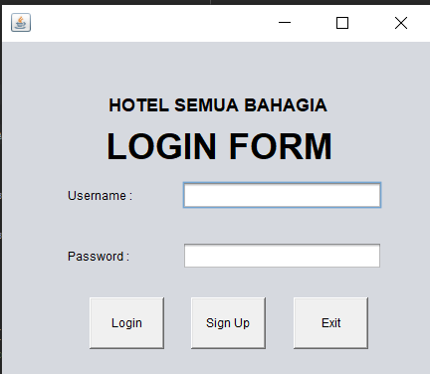 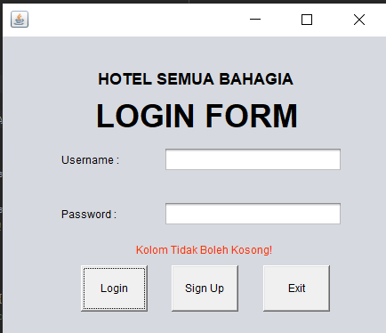

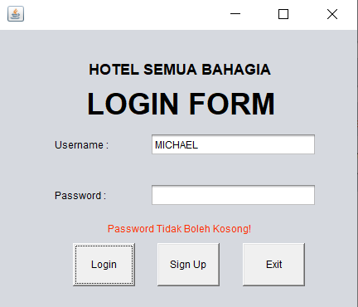 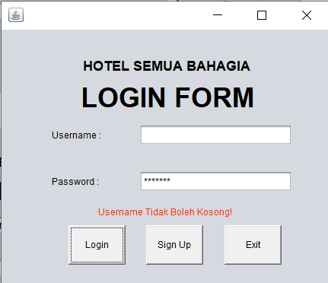

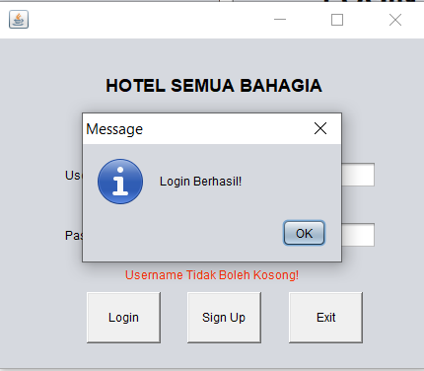

**SIGNUP :**

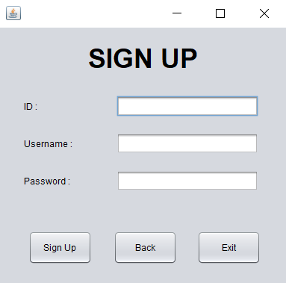 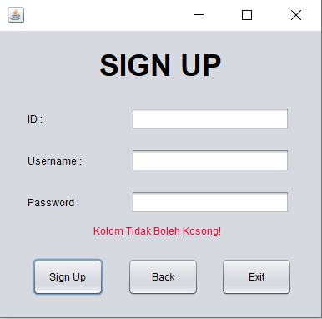

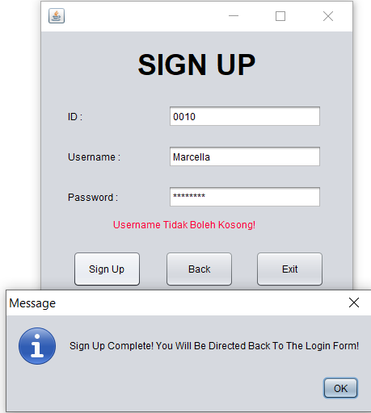

**HOME :**

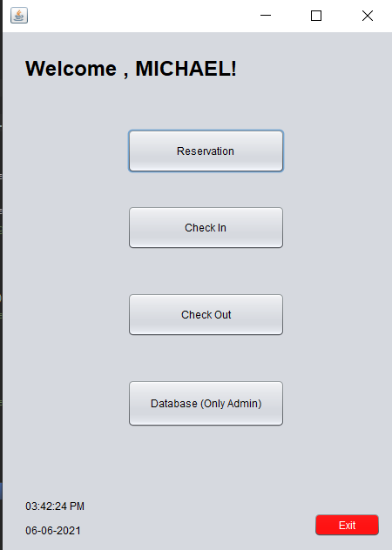

**Reservation :**

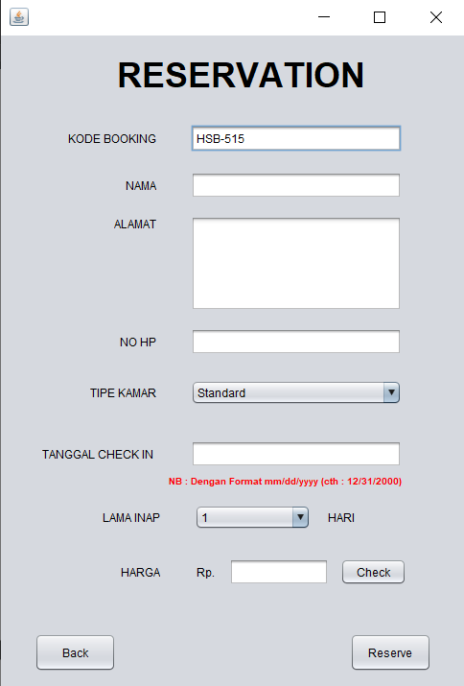 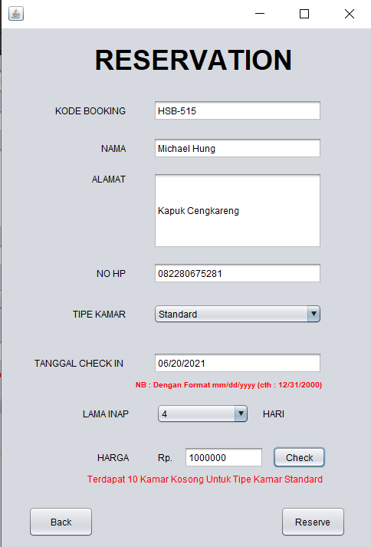

Auto Generated Kode Booking

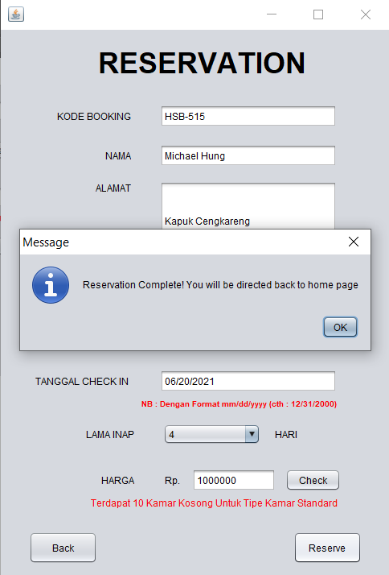

**Checkin :**

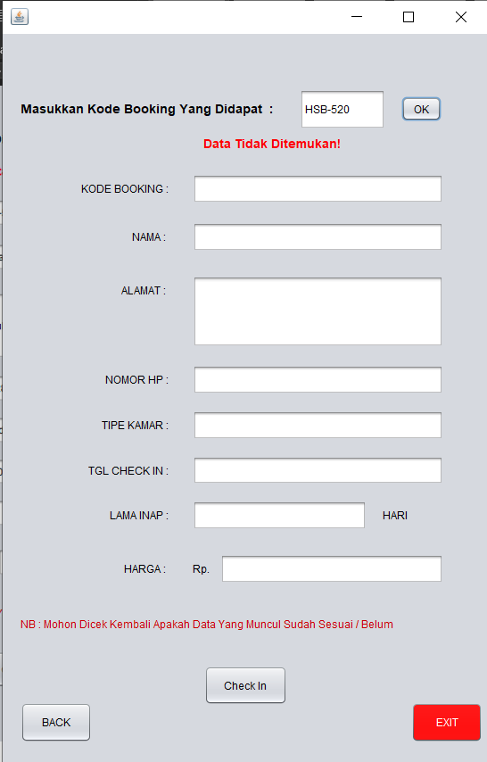 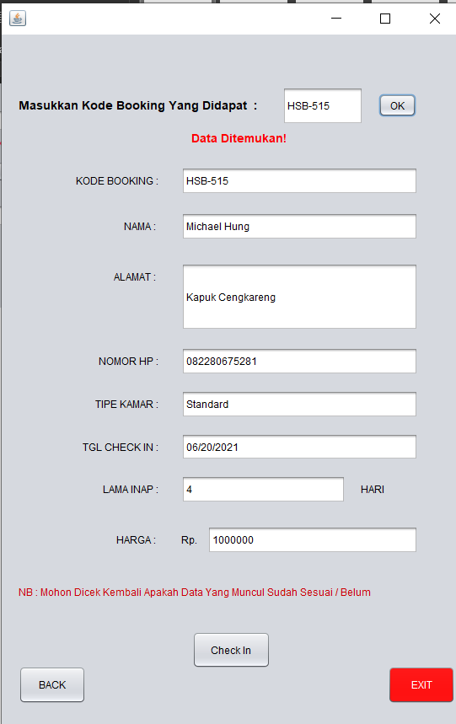

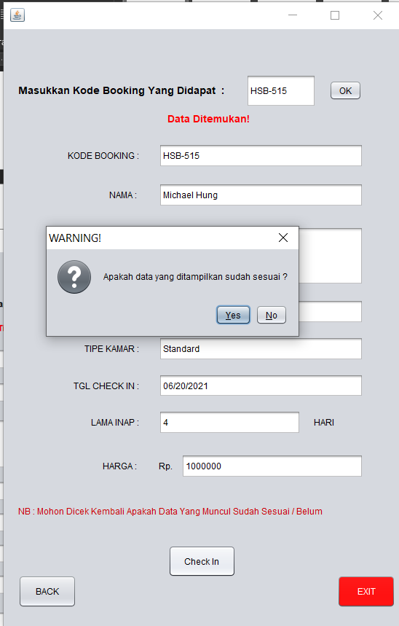 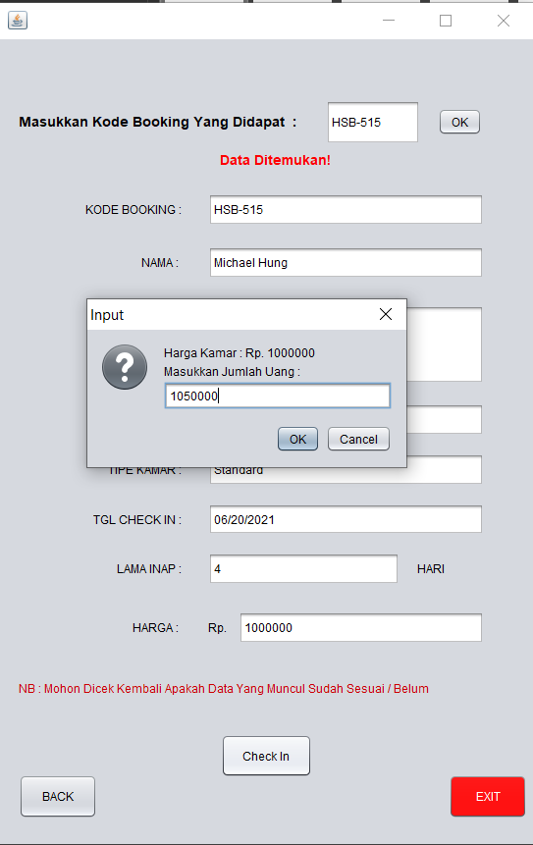

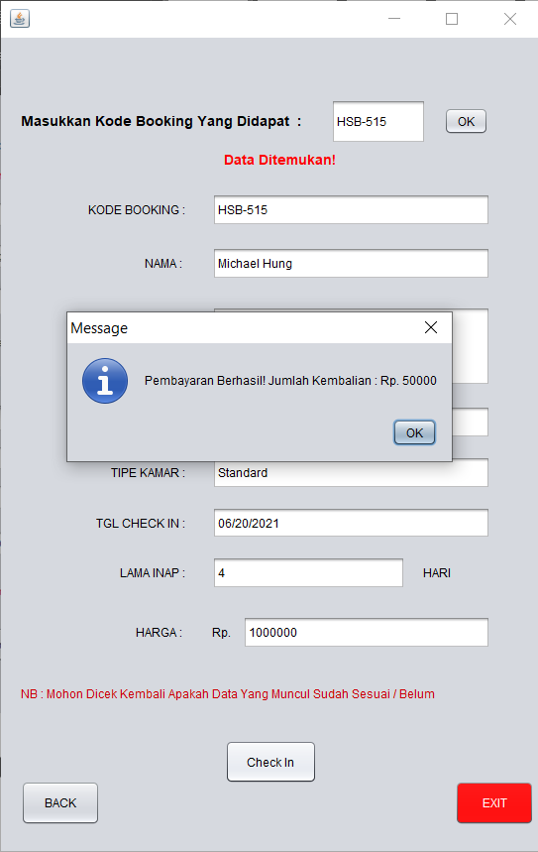 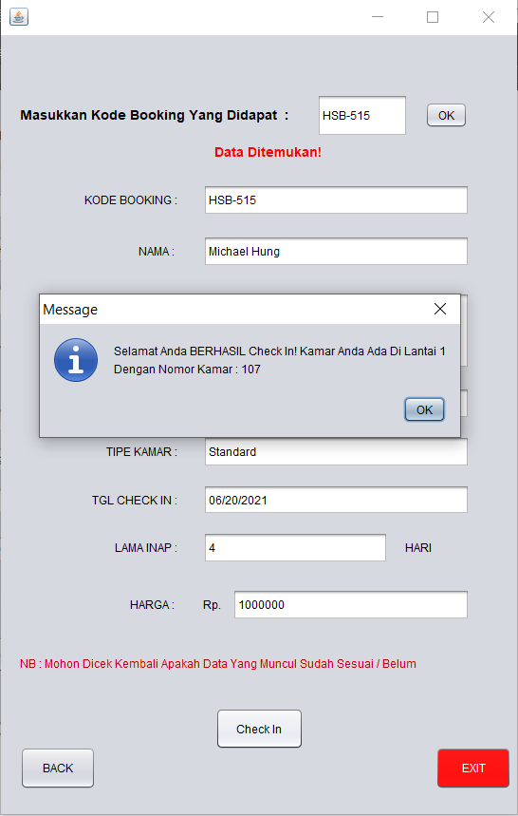

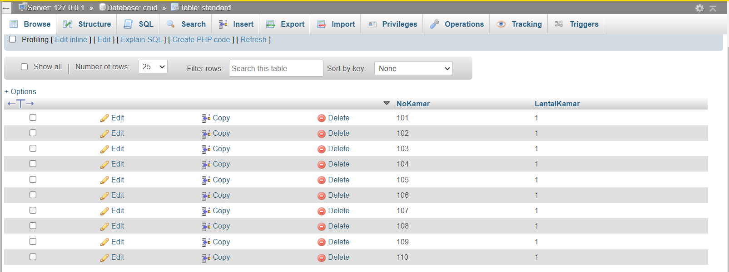

Sebelum Klik OK , No Kamar 107 Masih Ada

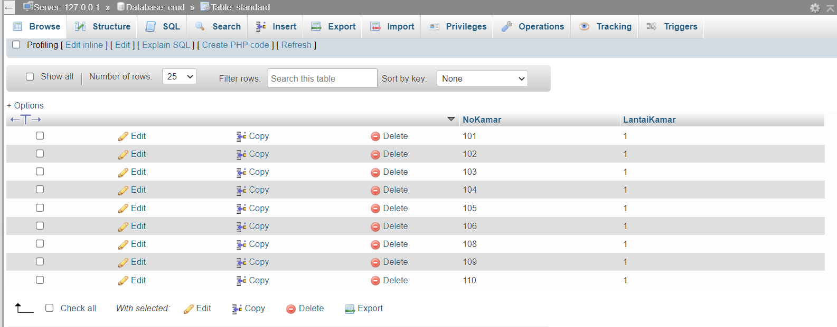

Setelah klik OK , No Kamar 107 Di Delete Di Tabel Tersedianya Kamar Standard

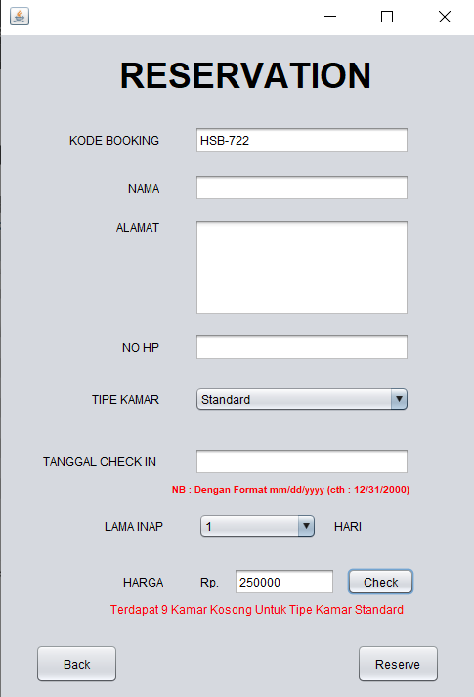

Informasi mengenai Jumlah kamar standard yang kosong langsung berkurang pada

bagian reservation

**Checkout :**

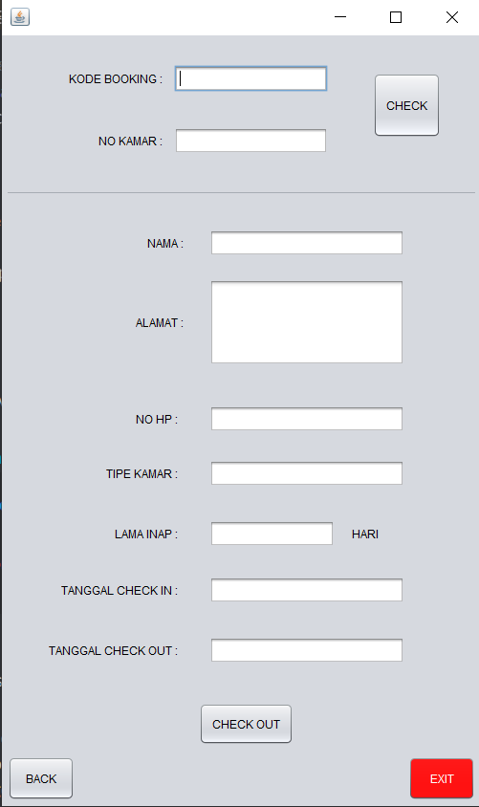 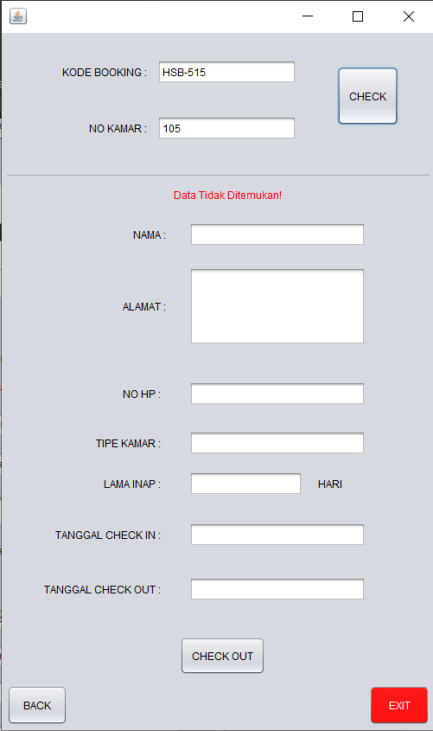

Data Tidak Akan Muncul Jika Kode Booking / No

Kamar salah

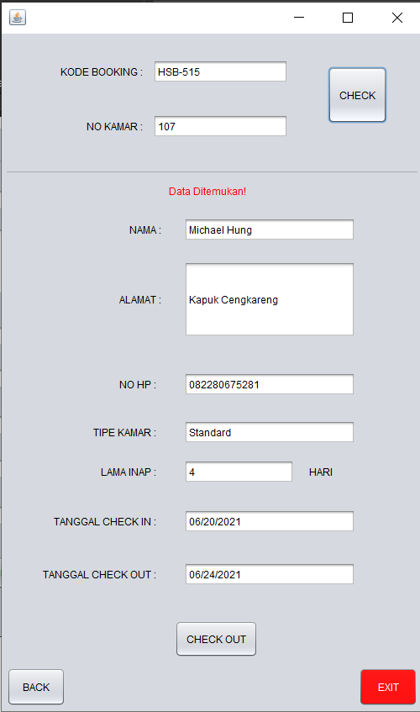 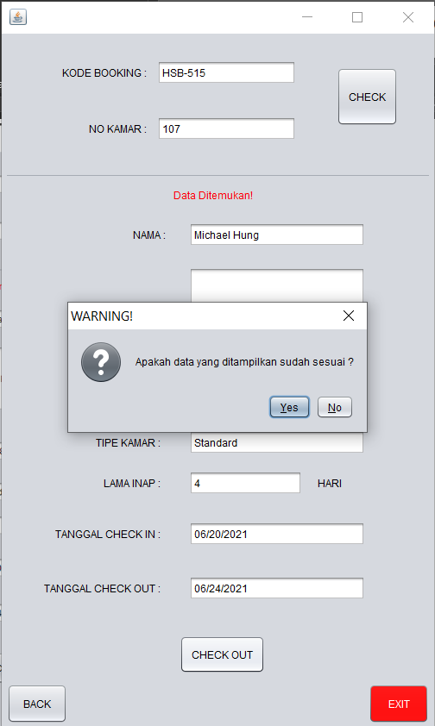

Auto Generated Tanggal Checkout

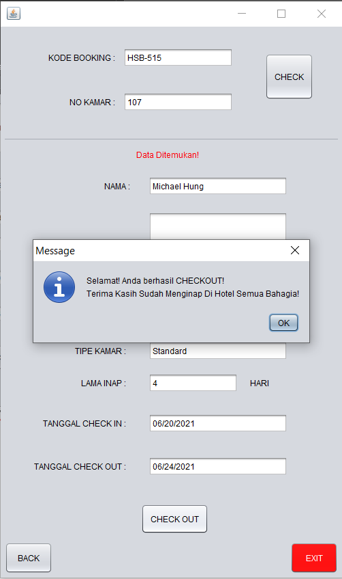 Jika klik ok , maka no kamar akan di kembalikan ke table tipe kamar

**Database :**

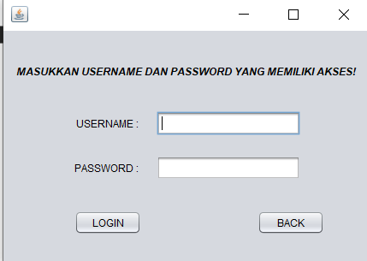 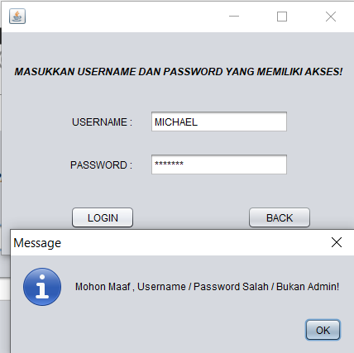

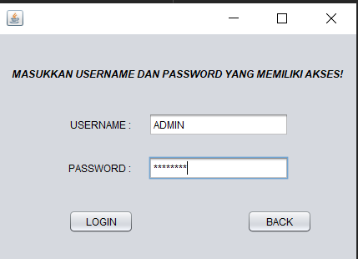 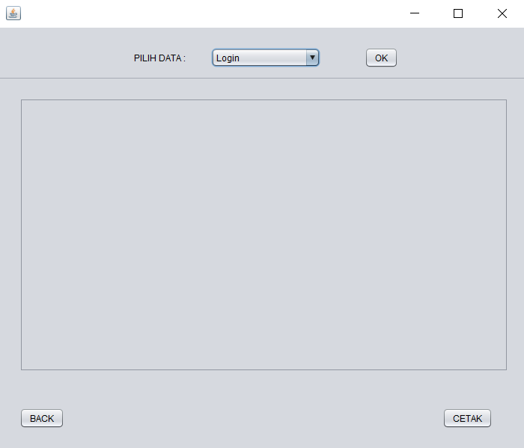

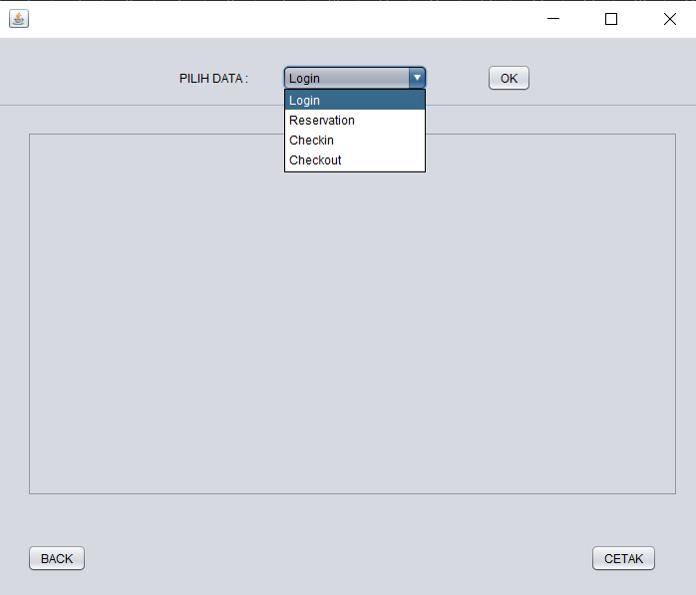

Dapat memilih table mana yang ingin diakses , jika sudah

Klik ok

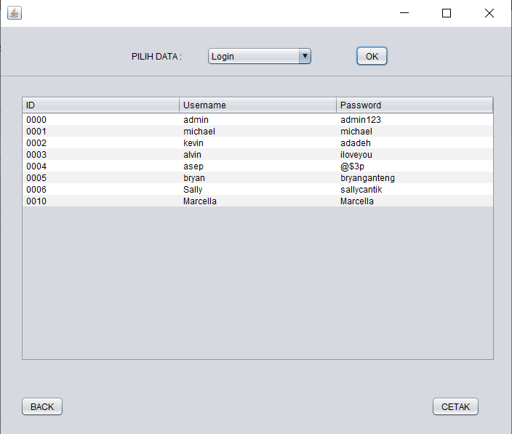

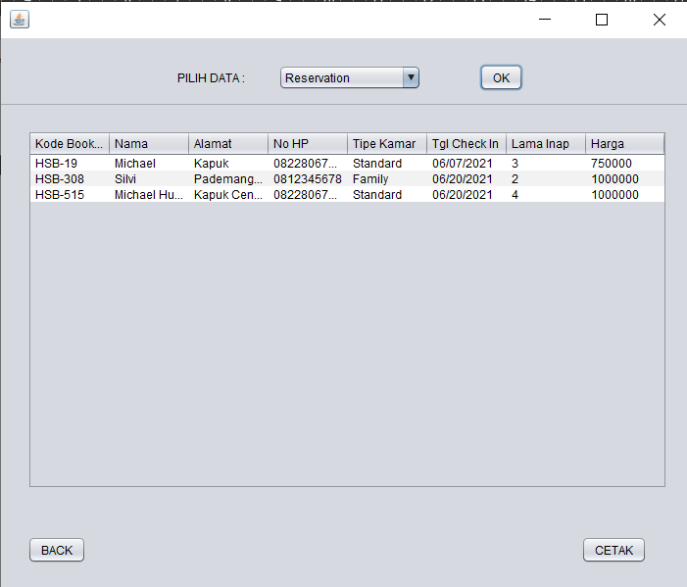

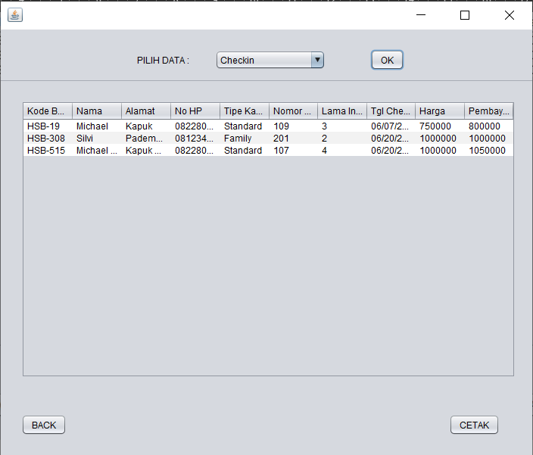

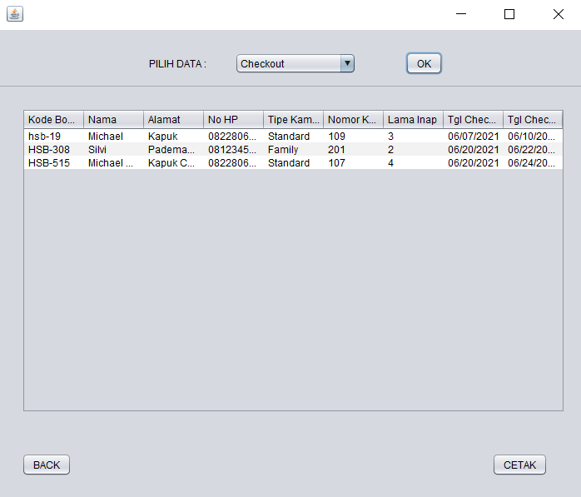

**Semua Table Terhubung Dengan Database**

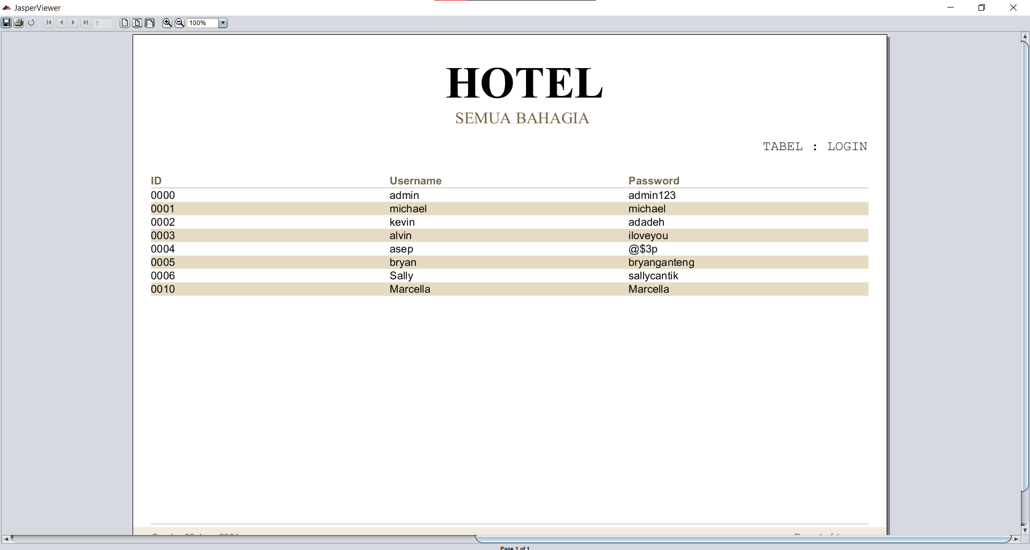

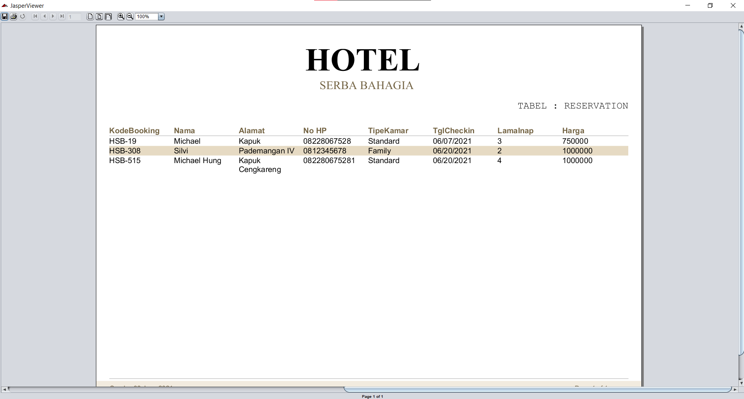

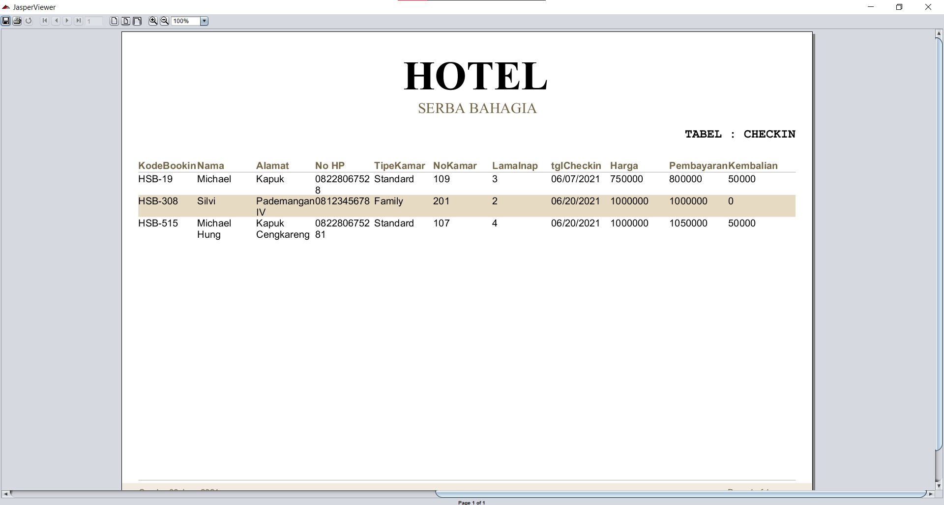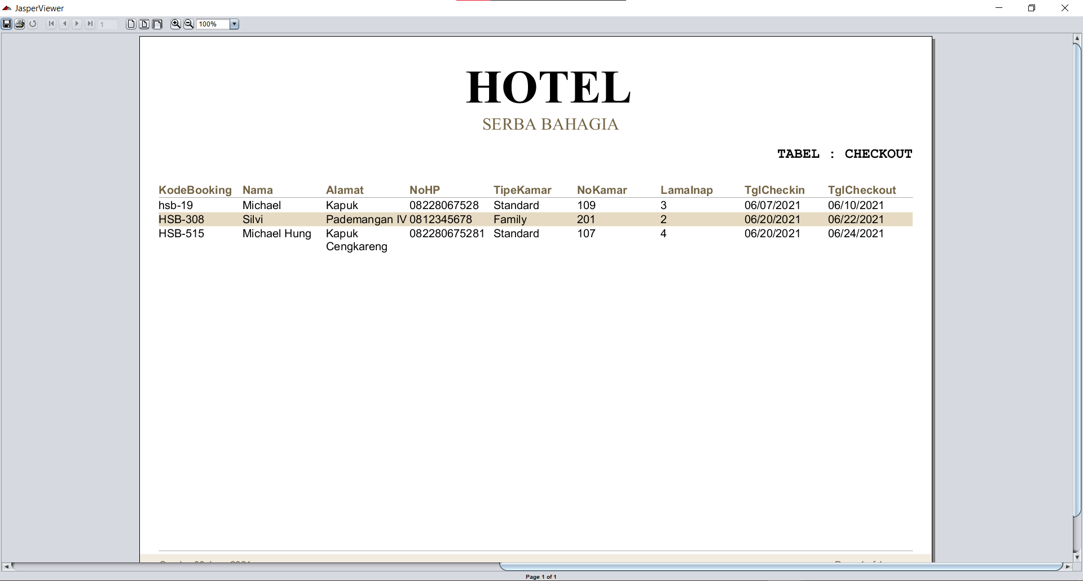

Tampilan File Report Dari Table Yang Dipilih