Sampling and Quantization

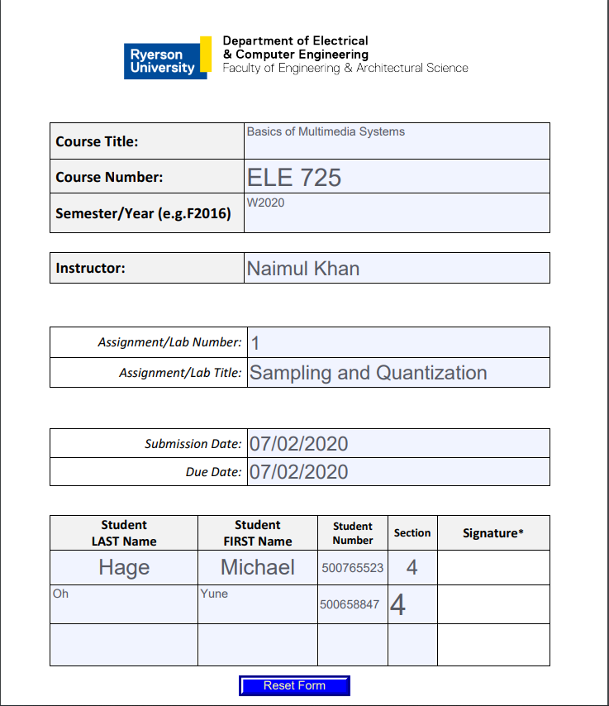

Lab 1 - Audio

Michael Hage *(Author)*

500765523

Ryerson University

michael.hage@ryerson.ca

Yune Gyo Oh *(Author)*

5007658847

Ryerson University

yune.oh@ryerson.ca

***Abstract—*This report introduces practical use of digital**

**processing signal theories through analysis of audio file and**

**provides result for comparison of audio file at different sampling**

**rate in order to see effect of down sampling, uniform**

**quantization of audio signal and mu-law companding technique.**

**This report aims to enhance understand of sampling and**

**quantization using digital audio signal.**

# Introduction

The purpose of this lab is to understand theories behind audio signal through comparison of quality of the sound with different sampling rates, filters, and quantization techniques by implementing and testing an audio file using MATLAB software. The audio signal is a representation of sound using binaries or electrical voltage depending on type of audio signal. Audio files contains several properties such as number of audio channels, sampling rate, bits per sample, and bit rate. Sample rate is a number of samples per unit time. Each sample is a measurement of signal amplitude and contains signal amplitude of the signal waveform over time. Higher sample rate implies higher quality signal as it uses more samples to create signal close to original audio signal. The size of audio file can be calculated using these properties obtained through MATLAB.

# Theory

## Quantization

The Lab uses uniform quantization technique and μ-Law companding technique for audio analysis. Quantization is the process of converting a continuous range of values into a finite range of discrete values. It functions as analog-to-digital conversion which creates a series of digital values to represent original analog signal. Accuracy and quality of the quantized values depends on bit depth. Bit depth refers to the number of bits of information in each sample.

## Uniform Quantization

Uniform quantization is a type of quantization where quantization levels are equally spaced within amplitude range of signal. The space between each level is referred as step size which implies that uniform quantization has equal step size. If there are N bits, number of levels can be determined by doing 2^N with N being number of bits. There are two types of uniform quantization called Mid-Rise type and Mid-Tread type. The following figures represent the two types of uniform quantization.

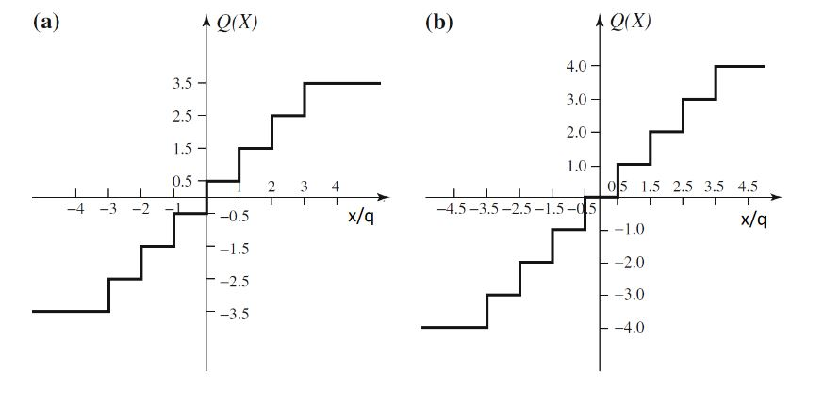

*Figure 1 – (a) Mid-Rise (b) Mid-Tread*

Identify applicable sponsor/s here. *(sponsors)*

Mid-Rise is a type of uniform quantization where origin lies in between of two quantization level which can be described as middle of a raising part of the stair-case like graph. On the other hand, Mid-Tread type is where origin lies in the middle of a tread of the stair-case like graph, in other words origin is located in the middle of quantization level. Quantization levels are even numbered for Mid-Rise and odd numbered for Mid-Tread type quantization.

## μ-Law Quantization

Companding technique is a method of compressing a digital signal by reducing the bit depth before its transmitted and then expanding it upon receiving the signal. Mu-law companding technique is a non-linear companding method that is widely used in telecommunications. This method allows signal to preserve some of signal range which would be lost with use of linear companding method. Mu-law companding technique assigns more levels to low amplitude samples to protect them from quantization error. The following figure represents the equation used to transform signal using Mu-law.

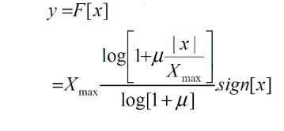

*Figure 2: Equation for Mu-law companding*

Equation can be used to transform the signal and quantize signal using a uniform quantizer. By doing so It will compress signal before transmitting signal and doing opposite operation will expand the signal once receiver accepts signal.

# Methodology

During the investigation, the bulk of the work was conducted in making the script components in Matlab. Each script file was tested with the same reference audio file to highlight the nature of each method used in this experiment.

## Downsample Script

## The downsample script file adjusts the sampling rate of the audio file that is passed through the function. Firstly, the function downsamples the function according to the downsampling factor. There is also an option to prefilter the audio before downsampling the audio array. After the signal is adjusted, the signal is then interpolated to the original size of the audio signal. Then the spectra of the original, downsampled and interpolated signals are then graphed. The audio of all three signals are then played as well and the interpolated signal is stored in a file.

## Uniform Quantization

This function quantizes an input sequence with a user specified number of levels, which are described by a number of bits decided by the user. The value of stepsize, is found by using the formula above. The signal is quantized using the midrise method, described in the theory section above. The signal is then reconstructed by multiplying the quantized array by the stepsize, as this will give an approximation of the original array. The Mean Square Error is then calculated to check the accuracy of the method used to quantize the signal.

## μ – Law Quantization

This function is the same as the previous quantization function, however, there is a form of pre-processing that is utilized, shown in Figure 2, to distribute more levels towards the lower values of the signal. Then the signal is passed onto the midrise Uniform Quantizer, and the output of the function is then expanded by the formula shown in Figure 3. Like the previous function, the Mean Squared Error is then computed and passed as an output along with the newly constructed signal.

# Results

## Audio File Properties

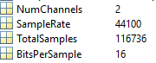

*Figure 3: Audio File Info*

## Sampling

|  |
| --- |
| *(a)* |
| *(b)* |
| *(c)* |
| *(d)* |
| (e) |

*Figure 4: Audio Signal Spectrograms (a) Original Audio (b) Downsampled, no filter, (c) Downsampled, with filter, (d) Reconstructed, no filter, (e) Reconstructed, with filter*

## Uniform Quantization

|  |
| --- |
| *(a)* |
| *(b)* |
| *(c)* |
| *(d)* |

*Figure 5: Uniform Quantization Signals with Various Bit Levels; (a) Original, 16-bit, (b) Quantized, 2-bit, (c) Quantized, 4-bit, (d) Quantized, 8-bit*

## μ-Law Quantization

|  |
| --- |
| *(a)* |
| *(b)* |
| *(c)* |

*Figure 6: μ-Law Quantization Signals with Various Bit Levels; Quantized, 2-bit, (b) Quantized, 4-bit, (c) Quantized, 8-bit*

## Comparison

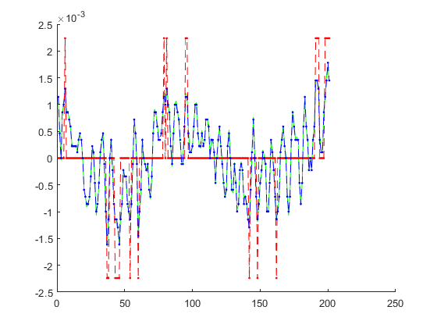

*Figure 7: Comparison between Uniform(red), μ-Law(blue), and Original signal(green)*

# Discussion

## Audio File Properties

The file size of the audio file can be approximated by the values that were given by the Matlab command audioinfo. The important details of the file are shown in the figure 3 above.

The file size can be approximated by multiplying the Number of Channels by the Total Samples and also the Number of Bits per Sample and then dividing by 1024 and then 8, which are respectively the amount of bits in a kilobyte and the number of bits in a byte, to give the file size in kilobytes. In addition, another 16 bits, or 2 Bytes can be added to the file size as the sampling rate is also stored in the file. This will yield approximately 456KB, which is close to the actual value of the file size.

## Sampling

When the audio signal is downsampled, the ambient noise is lost, however, the overall quality of the speaker is retained. There are signs of aliasing as the downsampling rate is increased, as shown in the spectra above in Figure 4 (b) and (c). Prefiltering the signal provides a much clearer and better approximation of the original signal as shown in Figure 4 (d) and (e). The recreation with filtering gets a sharper spectrum around the lower frequency range.

## Comparison

When observing the differences between Uniform and μ-Law, the μ-Law Quantization method appears to be better as it allows lower values to have more level depth. When observing the comparison figure, the μ-Law recreates the original signal better than the Uniform as the signal follows the signal much more clearly, as opposed to the levels that the Uniform Quantized Signal follows. Also, the μ-Law signal has smoother transitions between sampled values as opposed to the sharp transitions between the Uniform sampled values. Smaller values tend to favor μ-Law Quantization as it provides more levels towards those values and Uniform Quantization performs better with larger values due to the μ-Law allocating less levels towards large values.

# Conclusion

Overall, this lab is successful in demonstrating the functions of down sampling, uniform quantizer, Mu-law companding method in MATLAB language. By implementing these functions, we can observe how these methods affect quality of audio signal.

From the results, we can see that quality of audio signal depends on down sampling factor. Quality of audio signal increases with more sampling factor. More bits result in higher quality of signal when we use uniform quantization. Higher quantization level meant it is close original sequence level.