Plots and Code
Code for the image and distribution of pixel channel values

Image Properties
clc
clear
% load image and display
I = imread('house.tiff');
figure
imshow(I);
% reshape image
dim = size(I);
X = reshape(I, dim(1) * dim(2), dim(3));
X = double(X);
% calcultate mean of cluster
mn = mean( X(:,:));
% plot colorspace
figure
plot3(X(:,1), X(:,2), X(:,3),'.', 'Color','b');
hold on;
plot3(mn(1), mn(2), mn(3), '*', 'Color', 'r')
xlabel("Red Channel")
ylabel("Green Channel")
zlabel("Blue Channel")
title("Distribution of Image")
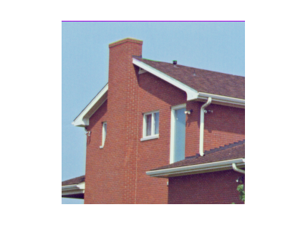
Figure 1: Image used throughout the Investigation
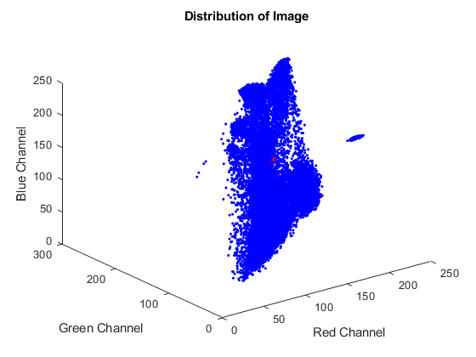
Figure 2: Distribution of pixel channel values
Code for Question A
clc
% initialize number of classes
c = 2;
% use algorithm
[mu, idx, error] = kmeans(X, c, 1);
% select two iterations
n = size(idx,2);
iter = ceil((n-1) * rand(1,2));
% earliest iteration portrayed
figure
plot3(X(idx(:,min(iter)) == 1,1), X(idx(:,min(iter)) == 1,2), X(idx(:,min(iter)) == 1,3),'.', 'Color',mu(:,1)/255);
hold on
plot3(X( idx(:,min(iter)) == 2 ,1), X(idx(:,min(iter)) == 2,2), X(idx(:,min(iter)) == 2,3),'.', 'Color',mu(:,2)/255)
hold on
plot3(mu(1,:), mu(2,:), mu(3,:), '*', 'Color', 'r')
xlabel("Red Channel")
ylabel("Green Channel")
zlabel("Blue Channel")
title("Iteration " + min(iter))
% middle iteration portrayed
figure
plot3(X(idx(:,max(iter)) == 1,1), X(idx(:,max(iter)) == 1,2), X(idx(:,max(iter)) == 1,3),'.', 'Color',mu(:,1)/255);
hold on
plot3(X( idx(:,max(iter)) == 2 ,1), X(idx(:,max(iter)) == 2,2), X(idx(:,max(iter)) == 2,3),'.', 'Color',mu(:,2)/255)
hold on
plot3(mu(1,:), mu(2,:), mu(3,:), '*', 'Color', 'r')
xlabel("Red Channel")
ylabel("Green Channel")
zlabel("Blue Channel")
title("Iteration " + max(iter))
% final iteration portrayed
figure
plot3(X(idx(:,n) == 1,1), X(idx(:,n) == 1,2), X(idx(:,n) == 1,3),'.', 'Color',mu(:,1)/255);
hold on
plot3(X( idx(:,n) == 2 ,1), X(idx(:,n) == 2,2), X(idx(:,n) == 2,3),'.', 'Color',mu(:,2)/255)
hold on
plot3(mu(1,:), mu(2,:), mu(3,:), '*', 'Color', 'r')
xlabel("Red Channel")
ylabel("Green Channel")
zlabel("Blue Channel")
title("Final Iteration - Iteration " + n)
% convert to unsigned 8-bit integer
mu = uint8(mu);
% reshape index vector to index matrix
[x,y,z] = size(I);
M = reshape(idx(:,n),x,y);
% create new image
img = uint8(zeros(size(I)));
% map each pixel to their domain counterpart
for i = 1:x
for j = 1:y
img(i,j,:) = mu(:,M(i,j)).';
end
end
figure, imshow(img);
% plot error
figure
plot(error, '.-')
title("Error Across Iterations")
xlabel("Iterations")
ylabel("Error")
Initial Values
mu =
205.3998 61.1827
147.0640 226.0605
46.6452 7.3119
number of iterations: 9

Plots for Part A
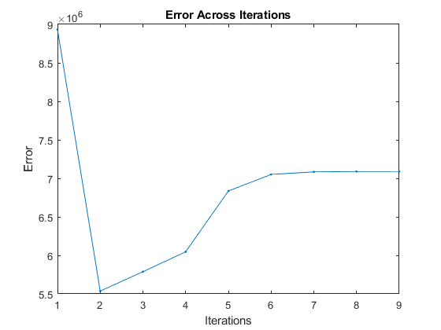
Figure 3: Question 1.1 Plots the Error across the Iterations of the Algorithm

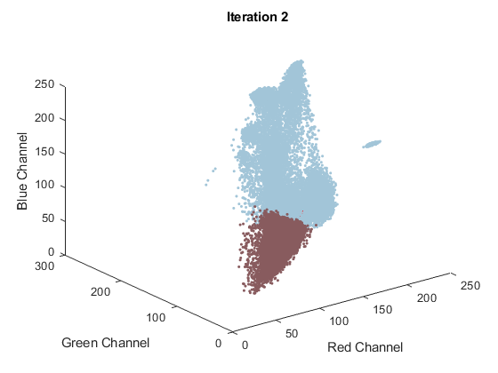
Figure 4: Used for Question 1.2 to represent one of the stages during the iteration of the algorithm
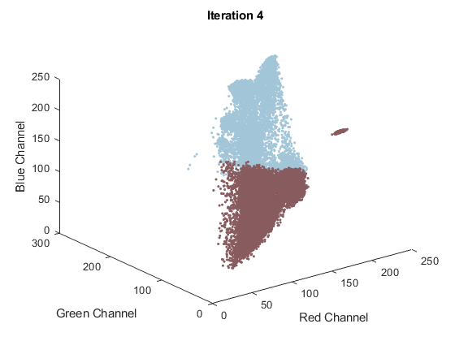
Figure 5: Used for Question 1.2 to represent another stage during the iteration of the algorithm
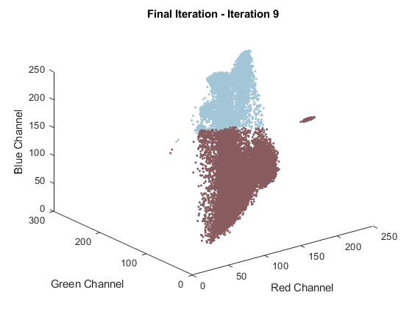
Figure 6: Used for Question 1.3, plots the clustered pixels with the color corespondance to the cluster

Figure 7: Question 1.4, Plots the Image with the Clustered Pixel values
Code for Question B and C
clc
% use kmeans algorithm
c = 5;
[mu1, idx1, error1] = kmeans(X, c);
[mu2, idx2, error2] = kmeans(X, c);
% plot domain RGB plot
figure
for i = 1:c
plot3(X(idx1(:) == i,1), X(idx1(:) == i,2), X(idx1(:) == i,3),'.', 'Color',mu1(:,i)/255);
hold on
end
plot3(mu1(1,:), mu1(2,:), mu1(3,:), '*', 'Color', 'r')
xlabel("Red Channel")
ylabel("Green Channel")
zlabel("Blue Channel")
title("First Run of Algorithm")
figure
for i = 1:c
plot3(X(idx2(:) == i,1), X(idx2(:) == i,2), X(idx2(:) == i,3),'.', 'Color',mu2(:,i)/255);
hold on
end
plot3(mu2(1,:), mu2(2,:), mu2(3,:), '*', 'Color', 'r')
xlabel("Red Channel")
ylabel("Green Channel")
zlabel("Blue Channel")
title("Second Run of Algorithm")
hold off
% Question C
% Compute Xie-Beni algorithm
Y1 = xiebeni(idx1, X, mu1, c);
Y2 = xiebeni(idx2, X, mu2, c);
disp("The Xie-Beni Difference for the first cluster is: " + Y1);
disp("The Xie-Beni Difference for the second cluster is: " + Y2);
% cluster 1
% create domain image
mu1 = uint8(mu1);
[x,y,z] = size(I);
M = reshape(idx1(:),x,y);
img = uint8(zeros(size(I)));
% map each pixel to its colour space
for i = 1:x
for j = 1:y
img(i,j,:) = mu1(:,M(i,j)).';
end
end
figure, imshow(img);
% cluster 2
% create domain image
mu2 = uint8(mu2);
[x,y,z] = size(I);
M = reshape(idx2(:),x,y);
img = uint8(zeros(size(I)));
% map each pixel to its colour space
for i = 1:x
for j = 1:y
img(i,j,:) = mu2(:,M(i,j)).';
end
end
figure, imshow(img);
% plot error
figure
plot(error1, '.-')
title("Error Across Iterations")
xlabel("Iterations")
ylabel("Error")
% plot error
figure
plot(error2, '.-')
title("Error Across Iterations")
xlabel("Iterations")
ylabel("Error")
Initial Values
mu =
249.5636 120.1275 10.8199 24.6662 184.2221
181.7371 15.2028 18.2186 208.6279 38.2157
127.6203 173.9028 133.0207 208.4745 168.1993
number of iterations: 21
Initial Values
mu =
132.2417 204.0843 210.4550 44.2141 204.8579
248.1085 115.7184 21.2848 99.6891 15.4202
165.4928 110.2598 33.9586 212.0018 101.8107
number of iterations: 29
The Xie-Beni Difference for the first cluster is: 9.7967
The Xie-Beni Difference for the second cluster is: 7.6133
Plots for Part B
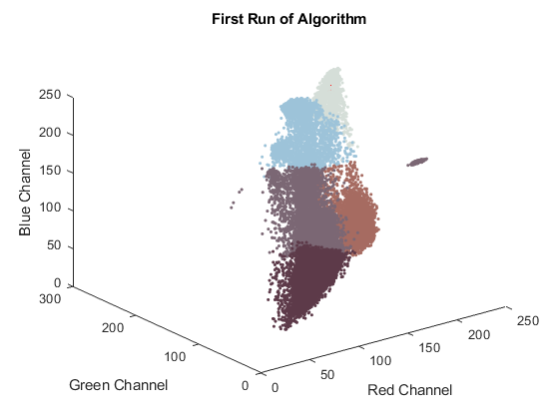
Figure 8: First Run of Part B

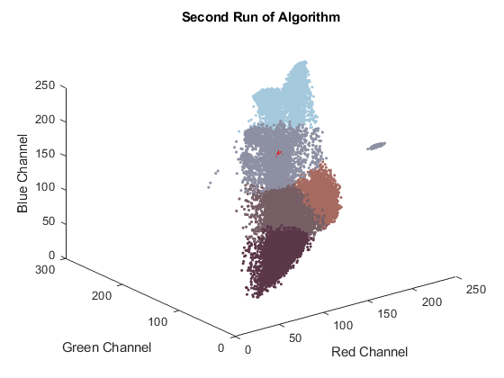
Figure 9: Second Run of Part B
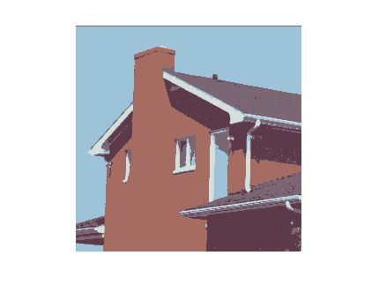
Figure 10: Image of the First Run of the Algorithm (note the top part isnt purple)
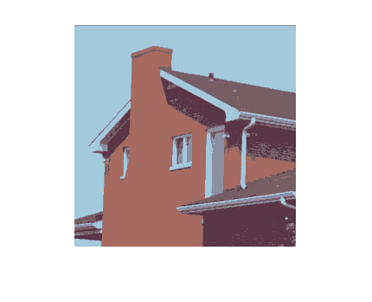
Figure 11: Image of the Second Run of the Algorithm
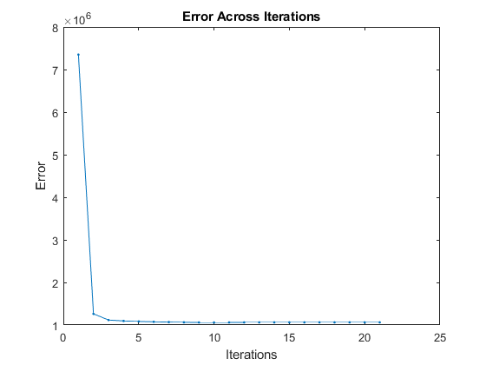
Figure 12: Error of First Run of the Algorithm
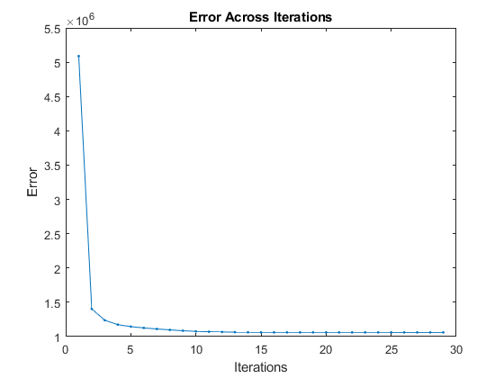
Figure 13: Error of Second Run of the Algorithm
Answers for Part C
The Xie-Beni Difference for the first cluster is: 9.7967
The Xie-Beni Difference for the second cluster is: 7.6133
Observations for Part A
- By observing the plots as the it goes through the iterations, it was quite clear that the values for the red channel get bigger and bigger and the distribution ends up being mostly red pixels.
- Due to this, the image of the house ends up being predominantly a shade of brown.
- The error also goes up as the number of iterations goes on until iteration 6 where the number of errors per iteration stay constant.
Observations for Part B and C
- Since c=5, both of these runs provide a much better output than the one in part A.
- The first cluster took less iterations than the second cluster but ended up having a higher error in the begginning. However, it ended up converging faster than the second cluster and ahs a much steeper curve.
- A major disrepency in the two photos is that in the first run, the part on the roof that is supposd to be white is indeed white, but the second cluster has a purple shade on that part of the roof.
- However, even though the first cluster may look closer to the actual image by the eye, according to the Xie-bine difference, the second cluster is closer to the original image. This is due to some specific shades being more accurate that may not be visible when first looking at the image.
Conclusions
The purpose of this lab was to implement the kmeans algoriithm for clustering unlabelled data, in other words, it is called unsupervised learning. By comparing Part A and B, it was quite clear that Part A had much greater error due there being only two classes used in the algorithm while in part B, five classes were used. In part B, two different clusters were meant to be generated and it was found that the second cluster provides more accurated results. This is evident when comparing the Xie-Beni difference as it is much lower for the second cluster comapred to the first cluster. In conclusion, the unsupervised learning algorithm was performed to completion and a better understanding of it was gained.

