**German University in Cairo**

**Mechatronics Lab (MCTR704)**

**Automated Garbage Bin**

**Project No. [4]**

Name: Michael Hany /Khaled Hussien

I.D #: 55-23395 /55-6752

Tutorial No.: 28

Table of Contents

|  |  |  |
| --- | --- | --- |
| **Milestone No./**  **Submission Date** | **Content** | **Page** |
| Milestone 1  23/09/2024 | Project Description……………………………………………………………….. | x-x |
| Milestone 1  23/09/2024 | SolidWorks Design: 3D Schematic Diagram………...................... | x-x |
| Milestone 2  14/10/2024 | Mechanical Components in 2D with Dimensions…………………… | x-x |
| Milestone 2  14/10/2024 | Mechanical Components List………………………………………………… | x-x |
| Milestone 3  11/11/2024 | Pneumatic Step Diagram………………………………………………………. | x-x |
| Milestone 3  11/11/2024 | Electro-Pneumatic Circuit……………………………………………………… | x-x |
| Milestone 4  09/12/2024 | Hardware Model (Electrical + Mechanical)……………………………. | x-x |
| Milestone 4  xx/12/2024 | Fully Operating Hardware (Final Evaluation)…………………………. | x-x |

Project Description:

Dimensions:

Frame 90cm X 70cm X 90cm

Workpiece is a paper cup diameter 6.5cm and height 10cm

Project Idea:

The **Automated Garbage Bin** consists of a compact machine with a sturdy, ground-seated frame that supports three hydraulic cylinders and integrated sensors. The frame holds all the necessary mechanical components, and the system is designed to manage garbage collection and compaction efficiently. Various actuators and sensors are used to automate the entire operation.

Objective:

This project aims to collect and compress garbage, reducing its volume for more efficient storage and disposal and save more space also for the environment

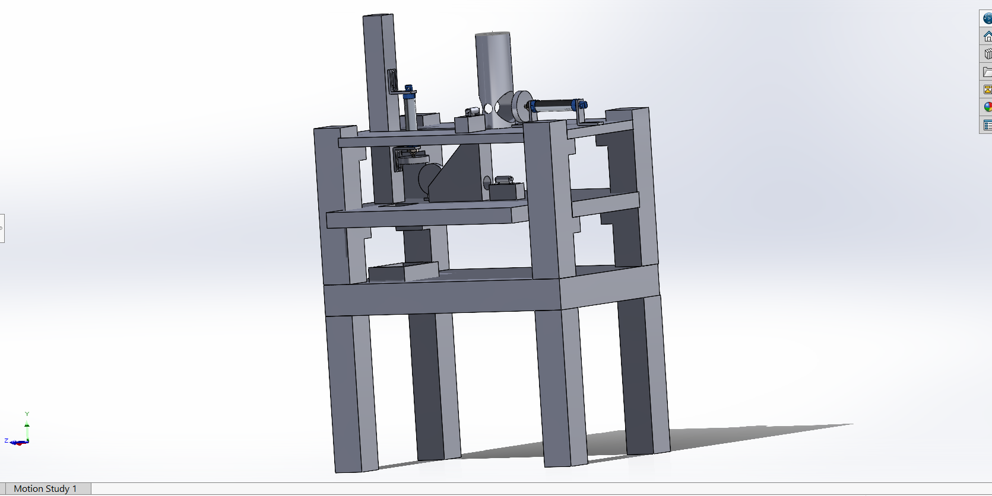

Process:

This machine features a ground-level frame that supports all mechanical components, including three hydraulic cylinders and various sensors. Here's how it works:

1. Garbage is placed into a container.
2. First, the garbage is dropped into the receiving container.
3. When the sensors sense the garbage the first cylinder [A] moves the garbage from the bin into a compression chamber.
4. The second cylinder [B] which is in a vertical mode, compresses the garbage.
5. Once compressed, the third cylinder ejects the compacted garbage from the machine to the trash.

SolidWorks Design: 3D Schematic Diagram

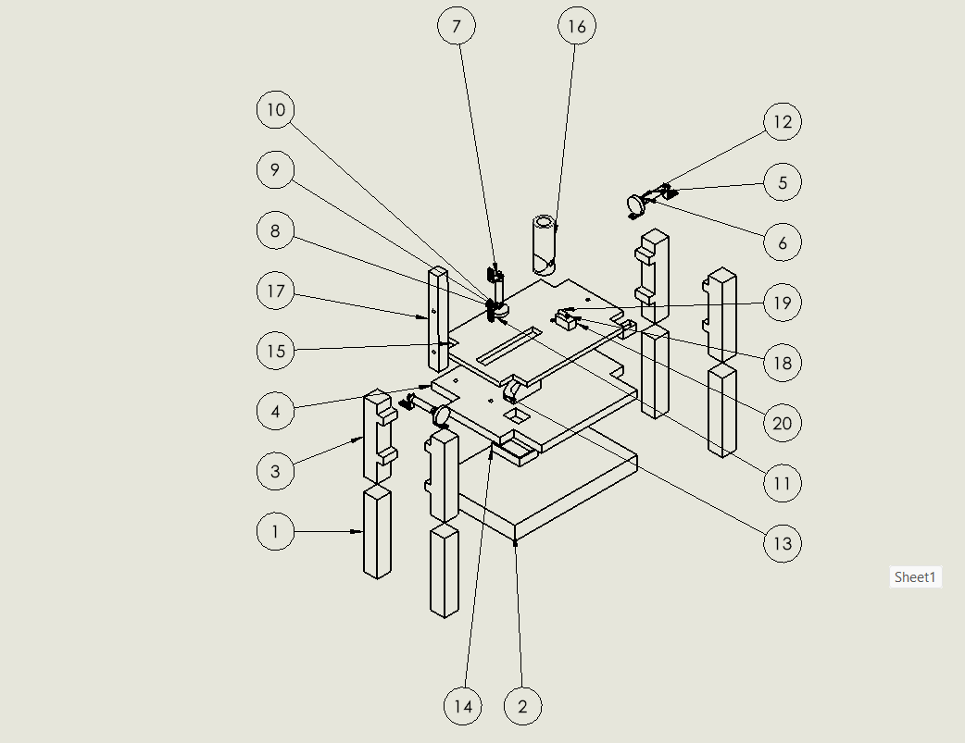

|  |  |  |
| --- | --- | --- |
| **Part Number** | **Name** | **Quantity** |
| 1 | Table leg | 4 |
| 2 | Ground base | 1 |
| 3 | Support bar | 4 |
| 4 | First level base | 1 |
| 5 | Cylinder A | 1 |
| 6 | bracket | 2 |
| 7 | Cylinder B | 1 |
| 8 | bracket | 6 |
|  |  |  |
| 9 | washer | 1 |
| 10 | End effector B | 1 |
| 11 | Nut | 1 |
| 12 | End effector A | 1 |
| 13 | Ramp | 1 |
| 14 | Garbage basket | 1 |
| 15 | Level 2 base | 1 |
| 16 | magazine | 1 |
| 17 | Cylinder B supporter | 1 |
| 18 | Sensor bracket | 4 |
| 19 | Sensor | 2 |
| 20 | Sensor Holder | 2 |

## Mechanical Components 2D Projections with Dimensions

|  |
| --- |
| **Ramp**    **Supporter**      **Tablet:**    **Cylinder Hold**    **Base el Base**    **End Effector** |
| **Pneumatic Air Cylinder Double Acting** |

|  |
| --- |
| **Base el Base** |

|  |
| --- |
| **Bracket**        **Magazine**          **Sensor**   |

+

**Component’s List:**

|  |  |  |
| --- | --- | --- |
| **Component’s Name** | **Picture** | **Quantity And Functions** |
| Photoelectric Sensor (ben5m-mfr) |  | 2  Function: To detect the garbage and send electrical signal to the cylinder to function it |
| Pneumatic air cylinder double action |  | 3  Function : Are used to transport and compress the gargbage |
| 5/2 pneumatic valves | A close-up of a machine | 3  Function : restore the pulses and make it continues |

Pneumatic step diagram and description

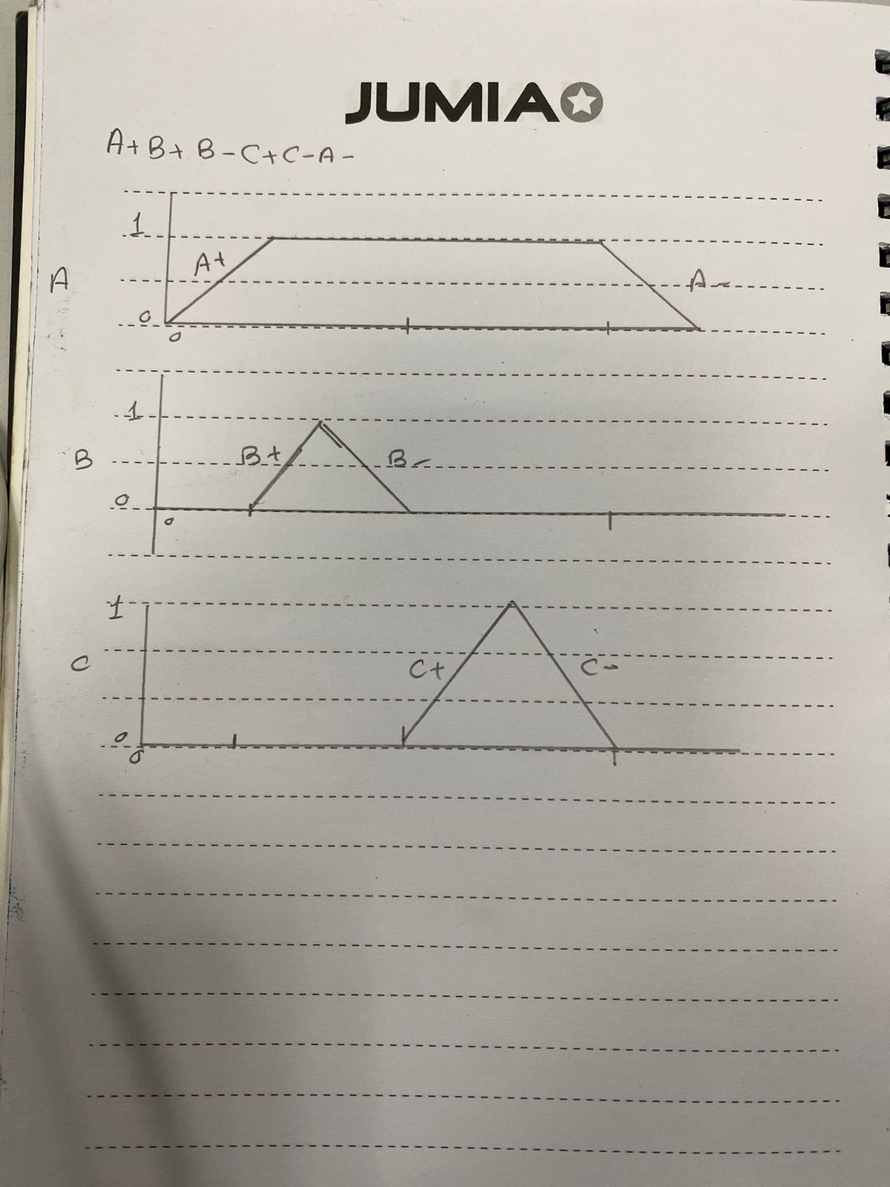

As shown in figure the operation will start with Cylinder A extend

Then cylinder B will crash the object by extending then retracting

And Cylinder C will get rid of the object by extending

Then Cylinder A will retract after it ,Cylinder C will retract to start again the sequence

Electro pneumatic circuit

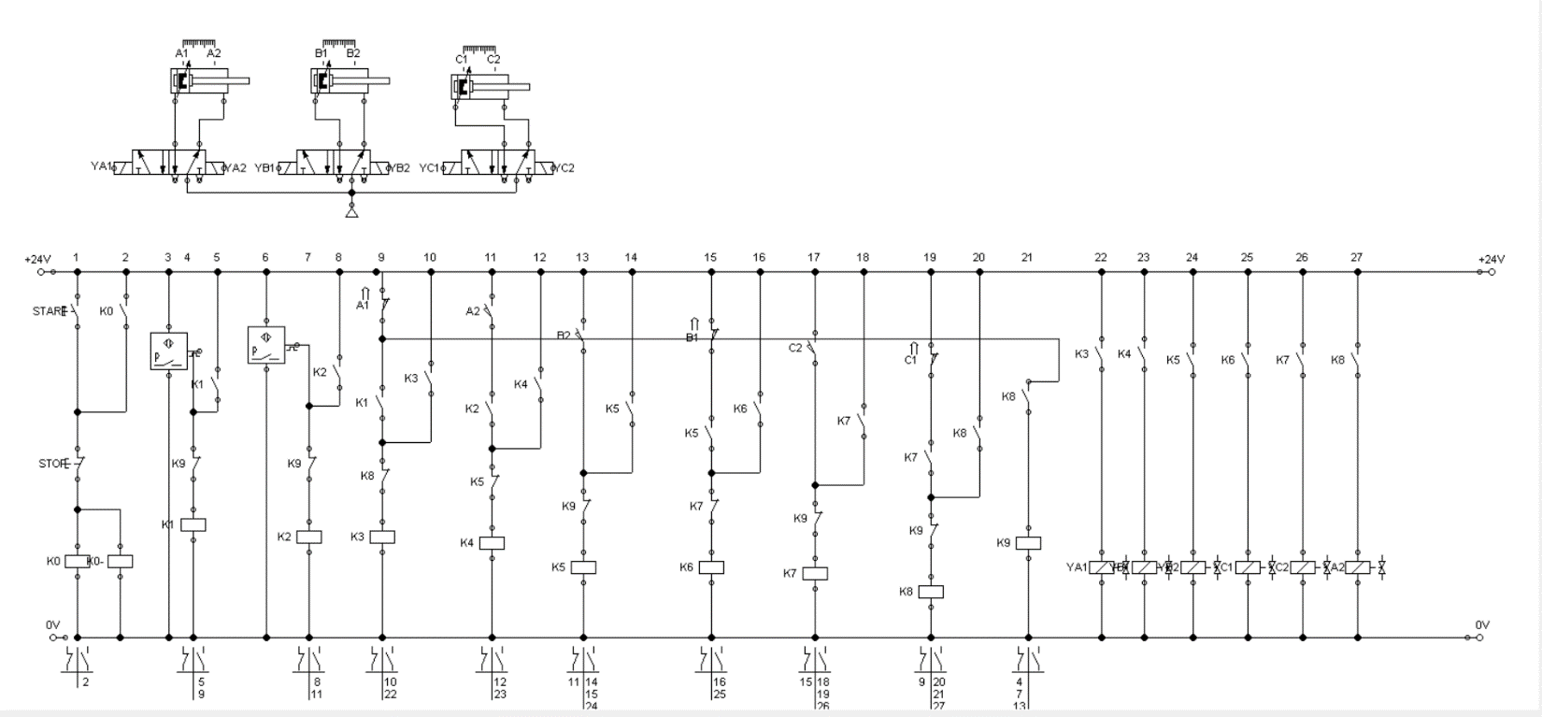

.

Hardware Model (Electrical + Mechanical):

Frame:

Control panel:

Final hardware:

