**German University in Cairo**

**Mechatronics Lab (MCTR704)**

**Automated Garbage Bin**

**Project No. [4]**

Name: Michael Hany /Khaled Hussien

I.D #: 55-23395 /55-6752

Tutorial No.: 28

Table of Contents

|  |  |  |
| --- | --- | --- |
| **Milestone No./**  **Submission Date** | **Content** | **Page** |
| Milestone 1  23/09/2024 | Project Description……………………………………………………………….. | x-x |
| Milestone 1  23/09/2024 | SolidWorks Design: 3D Schematic Diagram………...................... | x-x |
| Milestone 2  14/10/2024 | Mechanical Components in 2D with Dimensions…………………… | x-x |
| Milestone 2  14/10/2024 | Mechanical Components List………………………………………………… | x-x |
| Milestone 3  11/11/2024 | Pneumatic Step Diagram………………………………………………………. | x-x |
| Milestone 3  11/11/2024 | Electro-Pneumatic Circuit……………………………………………………… | x-x |
| Milestone 4  09/12/2024 | Hardware Model (Electrical + Mechanical)……………………………. | x-x |
| Milestone 4  xx/12/2024 | Fully Operating Hardware (Final Evaluation)…………………………. | x-x |

Project Description:

Dimensions:

Frame 90cm X 70cm X 90cm

Project Idea:

The **Automated Garbage Bin** consists of a compact machine with a sturdy, ground-seated frame that supports three hydraulic cylinders and integrated sensors. The frame holds all the necessary mechanical components, and the system is designed to manage garbage collection and compaction efficiently. Various actuators and sensors are used to automate the entire operation.

Objective:

This project aims to collect and compress garbage, reducing its volume for more efficient storage and disposal and save more space also for the environment

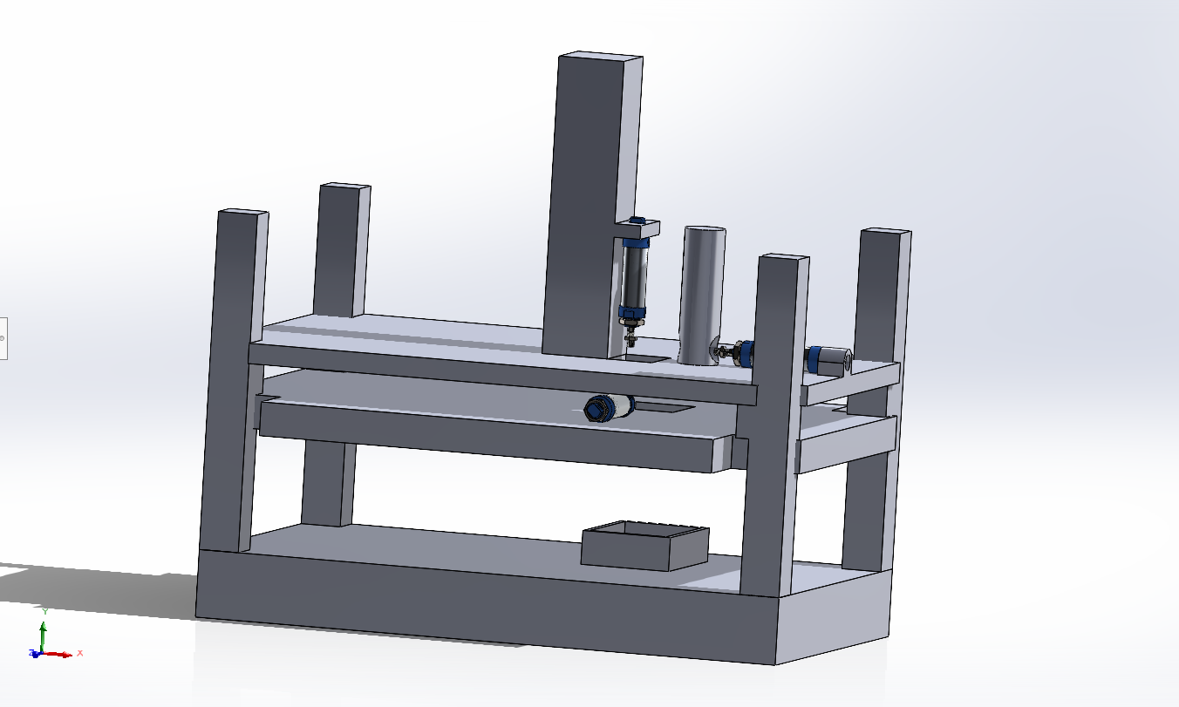

Process:

This machine features a ground-level frame that supports all mechanical components, including three hydraulic cylinders and various sensors. Here's how it works:

1. Garbage is placed into a container.
2. First, the garbage is dropped into the receiving container.
3. When the sensors sense the garbage the first cylinder [A] moves the garbage from the bin into a compression chamber.
4. The second cylinder [B] which is in a vertical mode, compresses the garbage.
5. Once compressed, the third cylinder ejects the compacted garbage from the machine to the trash.

SolidWorks Design: 3D Schematic Diagram

|  |  |  |
| --- | --- | --- |
| **Part Number** | **Name** | **Quantity** |
| 1 | Ground base | 1 |
| 2 | Support Bar | 4 |
| 3 | Level 2 base | 3 |
| 4 | Cylinder A Piston | 1 |
| 5 | Cylinder C | 1 |
| 6 | Cylinder A | 1 |
| 7 | Cylinder B piston | 1 |
| 8 | Cylinder B | 1 |
| 9 | Cup Cylinder | 1 |
| 10 | Cylinder A nut | 1 |
| 11 | Cylinder B Holder | 1 |
| 12 | Level 1 base | 1 |
| 13 | Garbage basket | 1 |