Michael Jones

Final Class Project. CS494

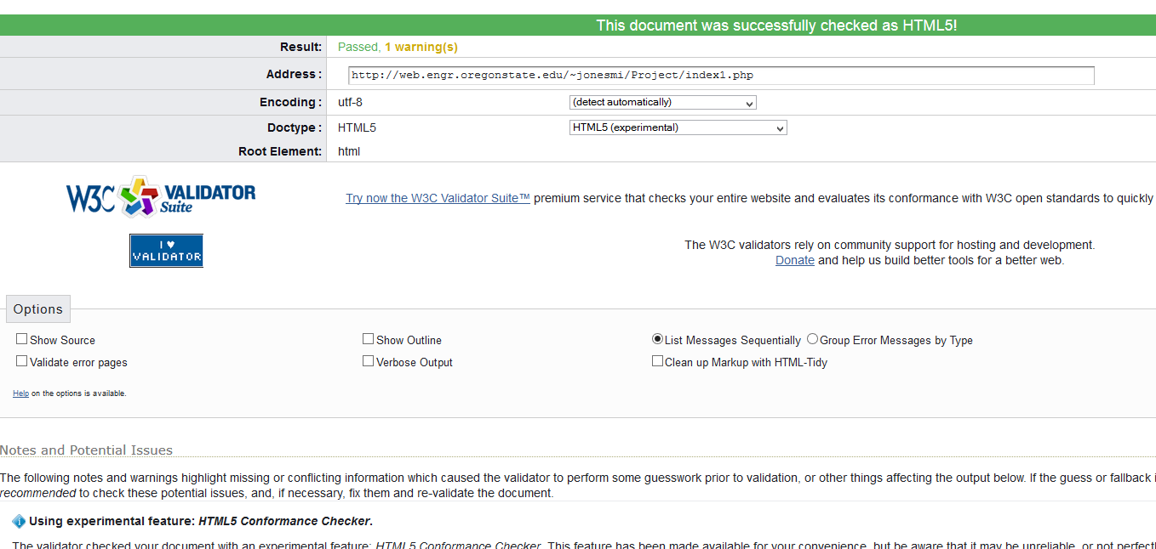

Index1.php passing validation

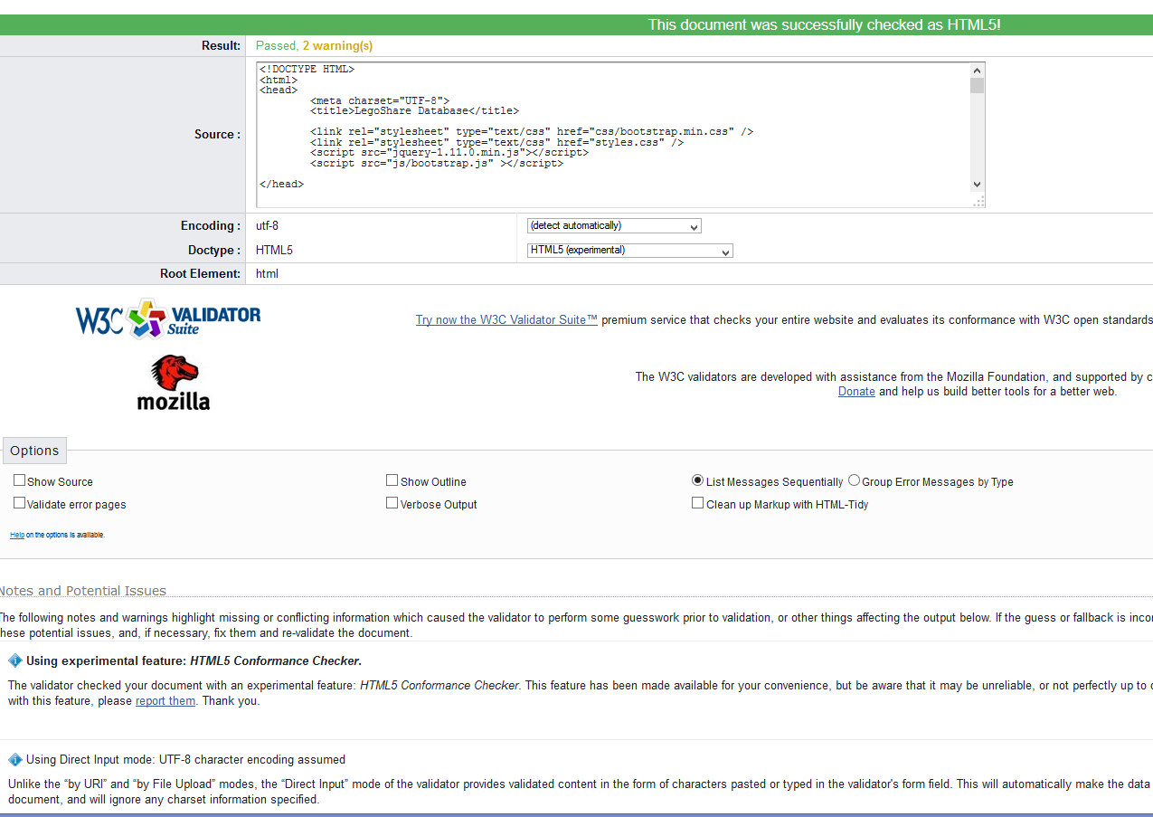

Database_Page.php passing direct input validation. I do get an warning for UTF-8 but that is because I have to use direct input. 4th line is <meta> tag to address warning.

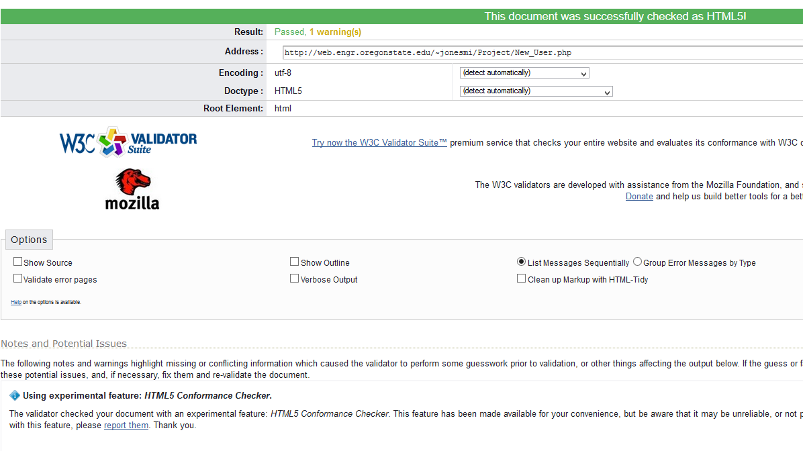

New_User.php passing validation.

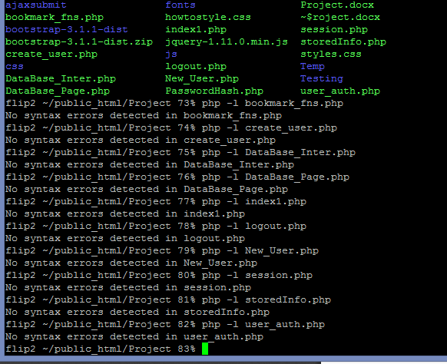.

All files in project directory with no errors.

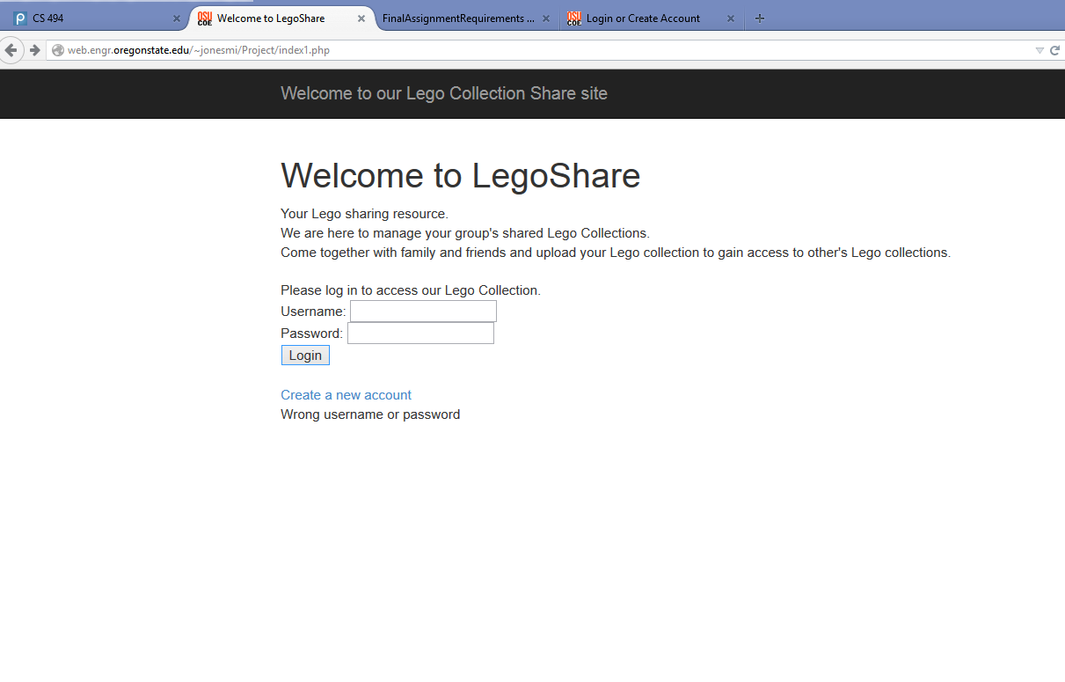

Main Page showing ajax wrong username and password.

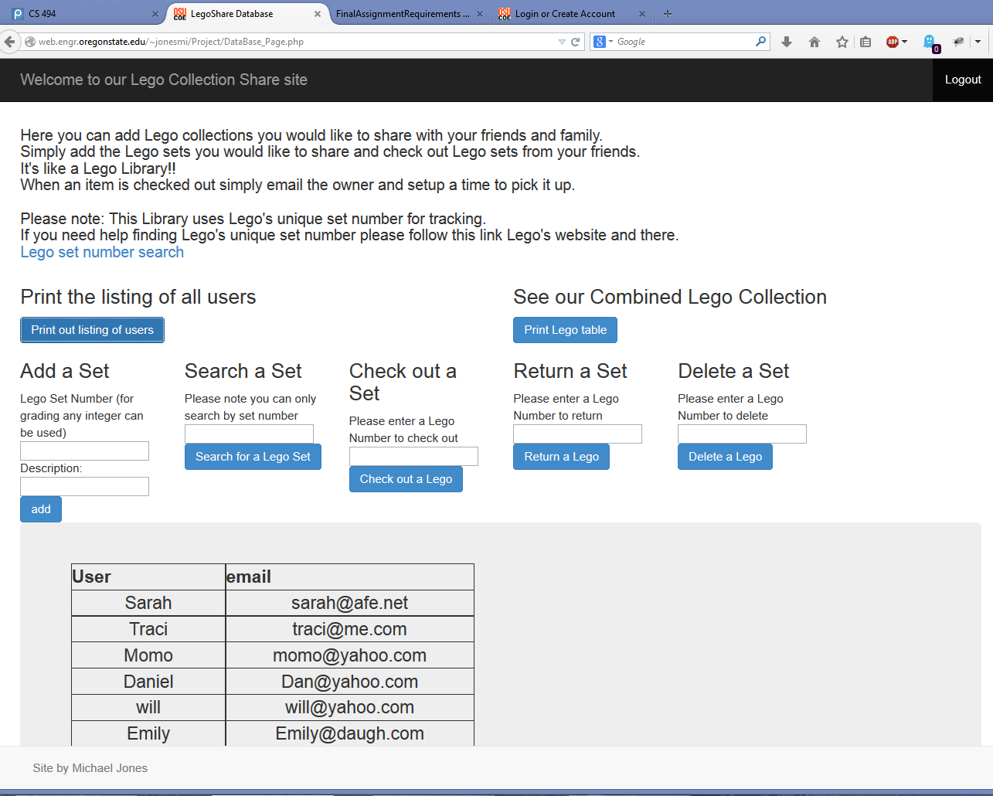

Main site showing LegoShare’s main page. Shows a table created in php and displayed with ajax call.

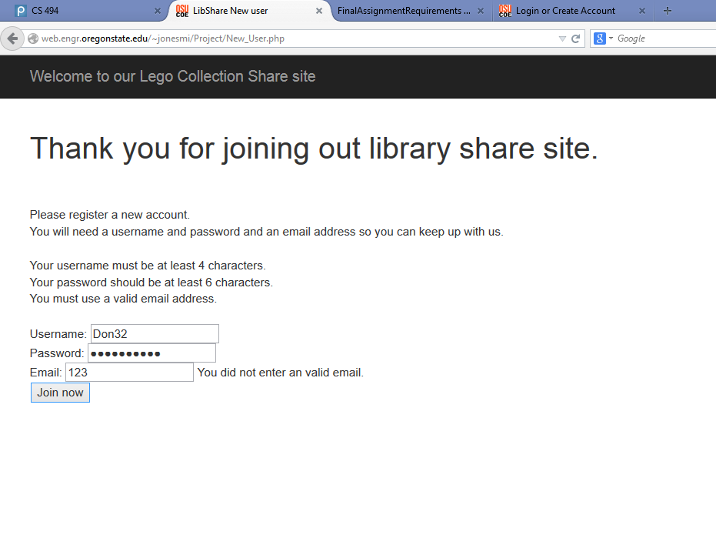

Create account page showing ajax error on email.

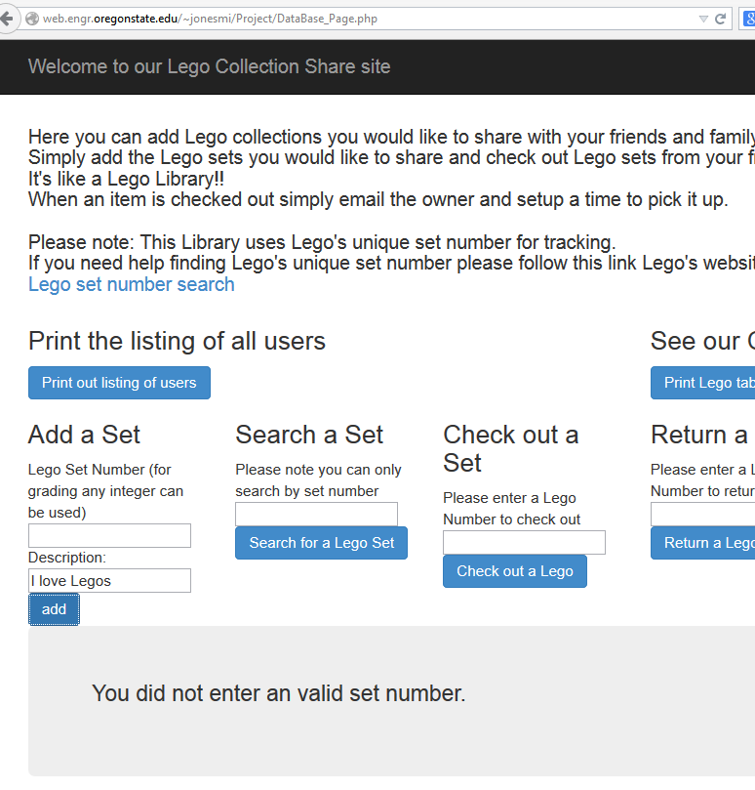

Here is a code example of an ajax fail for no set number.

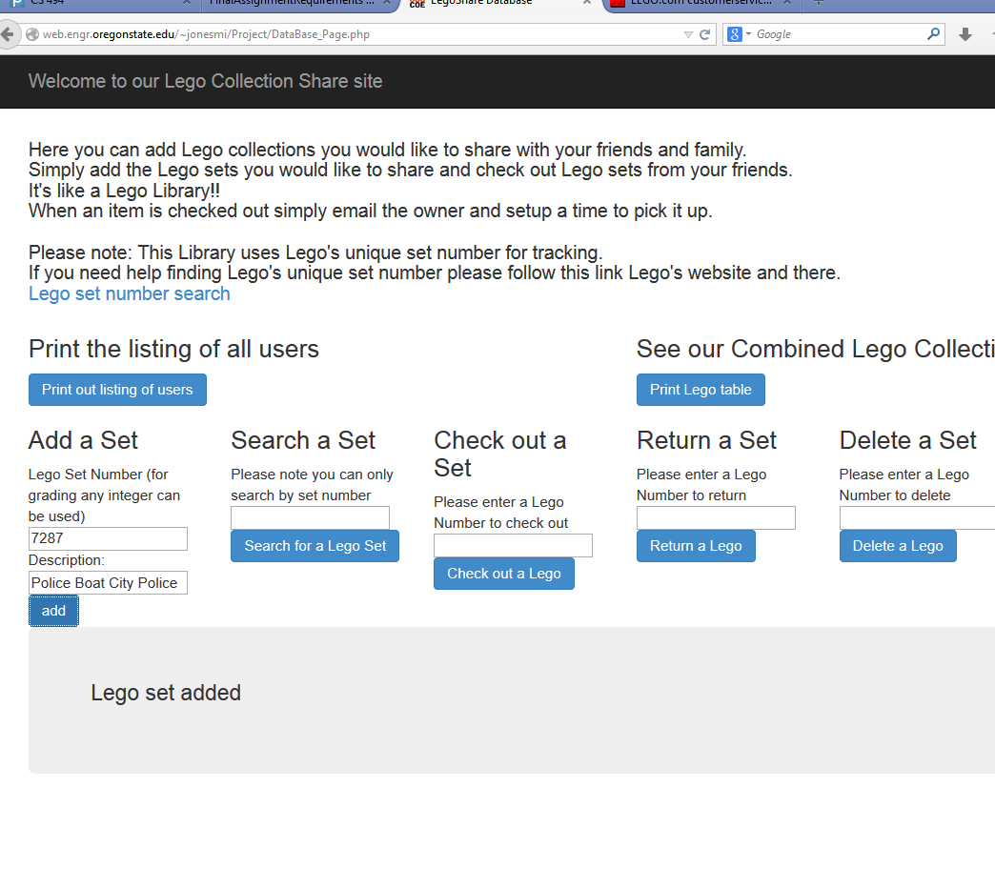

Here I have now added values for both fields and ajax responded with success.

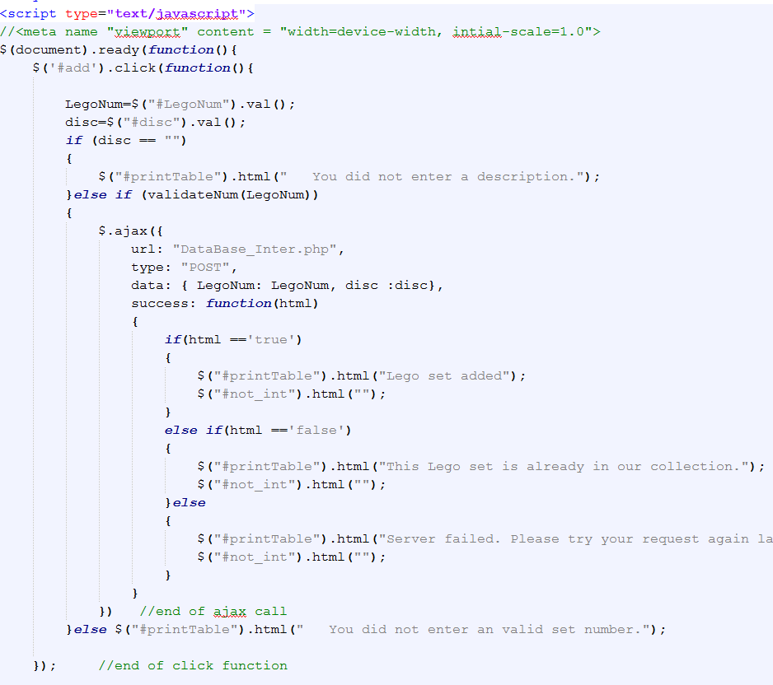

Here is the ajax code for that click of add. This is for the requirement of one code example.

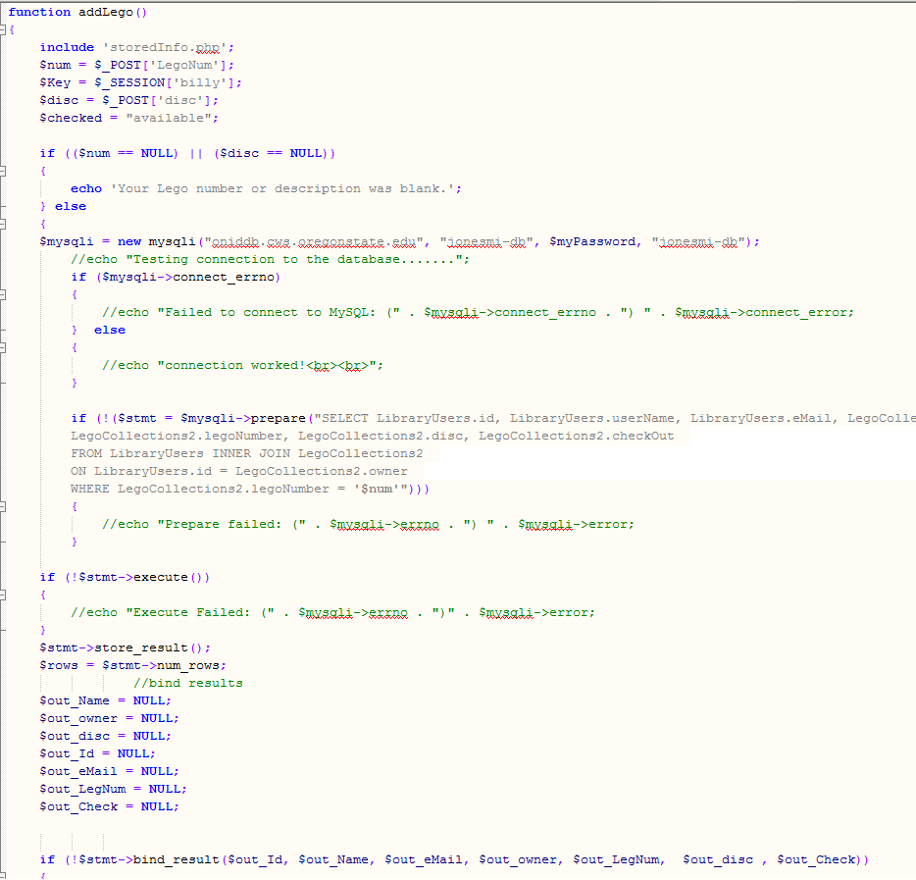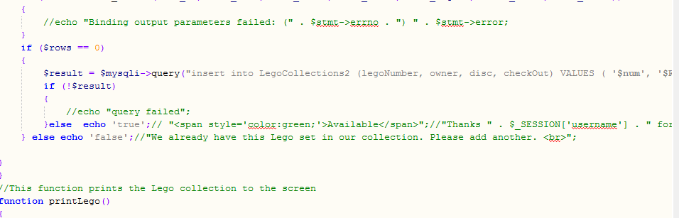

Sorry add function is very long, but this is the php side of the add function.

Outside the class.

For my outside the class requirement I used three things. PHPass, Bootstrap and joining two tables with a foreign key. I haven’t taken CS275 so I had to figure that out.

Phpass was the major implementation so I will describe that. I used phpass to hash my password on creation of the account. The database stores the hashed password. On login the user enters their password as normal. Phpass uses a specialized function to see if the user’s password hashes to the hash in the database. If it does success. If not failure. Thanks to Maria De Bruyn and her wonderful how to guide for help finding this feature.

Bootstrap is really cool and pretty easy to use with tons of documentation on it. Really cool feature. This was my first “real” website and it made it look great.