Michael Camara

Honor Code Pledge: This work is mine unless otherwise cited

CMPSC 382

Due Date: 10/20/15

Lab 5: Image Manipulation

The convolution filter that I ultimately created for this lab was the product of much trial and error. From the outset I wanted to produce a picture with a high level of detail, and so I searched for source images that were naturally textured, like fur and feathers. I eventually found a picture of an owl’s face, taken by Allard Schager (https://www.flickr.com/photos/allard1/3807655054/), and I really wanted to accentuate the already fine features of this bird. I also wanted to think outside of the box, and so I tried creating a number of filters that eschewed the formats of conventional filters. I tried matrices with only values along a diagonal, or that had an “X” pattern connecting all corners, or even some that had “zig-zags” along the columns:

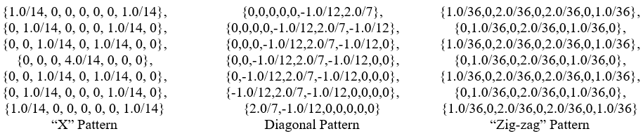

Most of my early attempts did not produce the kind of image I had envisioned, often blurring some of the features I wanted to highlight. I then studied the standard convolution filters and realized that the edge detection and sharpen filters used a combination of negative and positive values, which seemed to accentuate features like I desired. I realized that my previous attempts mimicked the average or blur filters, containing positive fractional values that summed to a value of one. So, I tried altering some of my previous patterns by incorporating negative values and sticking with integers for simplicity. I also realized that extending the convolution filter bounds from 3x3, to 5x5, and onward increased the contrast I saw between features (up to a certain point). I eventually created this 9x9 filter, keeping the original diagonal pattern I created earlier:

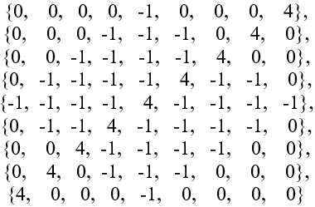

This created an interesting cross-hatched look for the owl’s face, which was visually interesting; but the overall image seemed too flat and some of the fine details were lost.

Finally, after reviewing the standard convolution filters again, I tried to create a hybrid between the sharpen and Laplacian edge detection filters. These filters seemed to evince the greatest amount of detail from the image I was manipulating, and I wondered what effect combining them would have. I again tried a number of different configurations, and ultimately created this 11x11 filter, which I used in my final version:

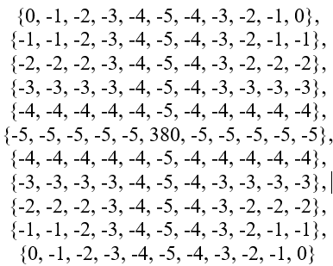

This filter captures what I envisioned from the beginning, highlighting every tiny feather of the owl’s face with great detail and creating a surreal representation of the original. It further adds some blue and yellow highlights in certain areas, which was an unintended but interesting side effect!