VanGo Testing
December 8, 2015
Herbie Torrance (Tester)

In order to provide the highest quality tool available to our customer, manual testing was chosen as the preferred method of testing. The reason for this is because manual testing is much quicker and more efficient than automated testing to perform on a small scale system. Also, much of the system deals with human interaction and outputs which needed to be checked by a human to ensure quality and consistency.
Manual testing is characterized by the evaluation of program behavior by a person. The knowledgeable manual tester compares expected output with actual output while attempting to exploit any potential flaws with the system.

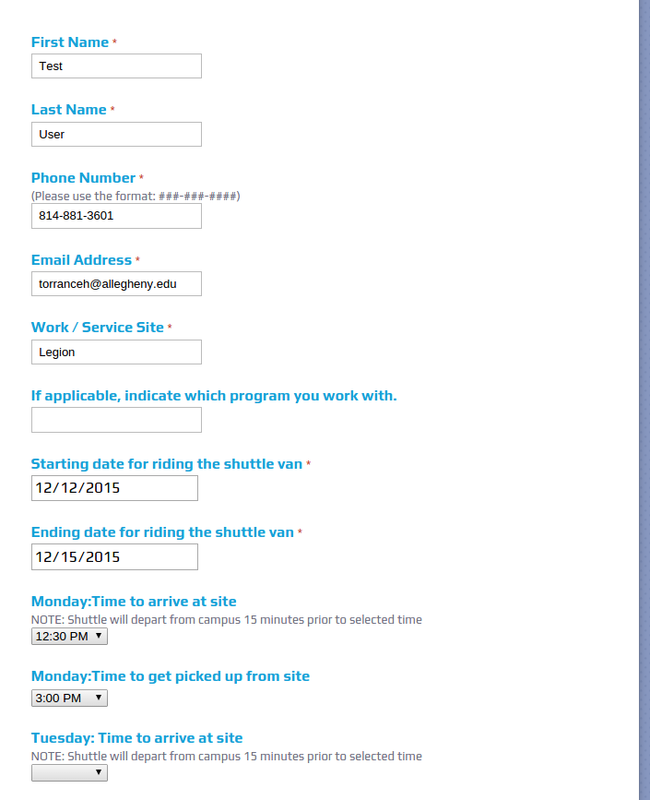
The first test initiated was proof of correctness for a forum entered with correct information.

As shown in the figure to the left, the forum should create data as shown. The output of the forum and calendar matches the expected output, as shown below, therefore showing this case to be true for both the forum and calendar.
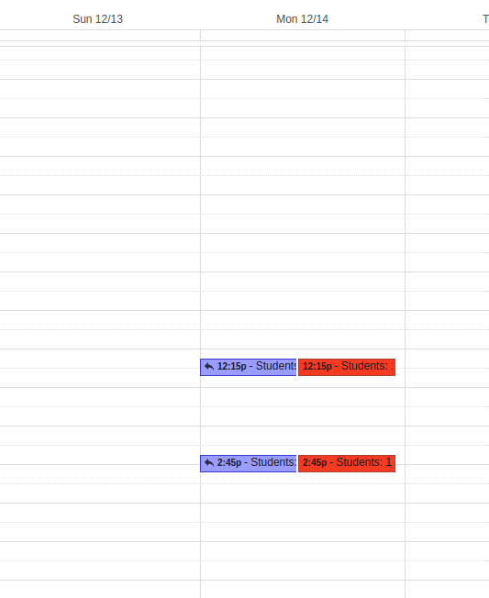

The second test initiated was proof of correctness for a forum entered incorrectly with multiple dates in a single week. The incorrectness of the forum is related to the start and end times. For example arrival time cannot occur after or match departure time. Therefore for any time this occurs the output should not be added to the calender. The figure on the left shows incorrect timing occurring.

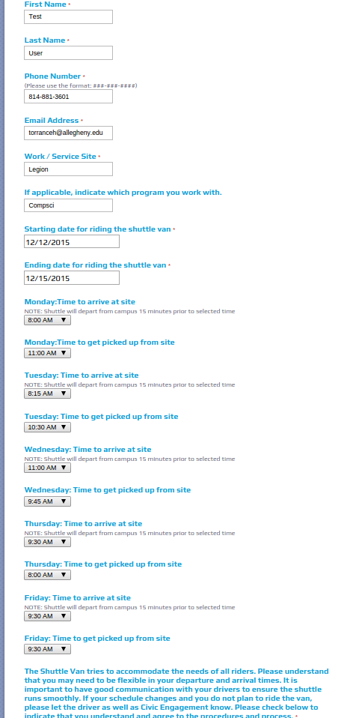
As shown by the figures below, the incorrect time was added into the forum, but not into the calender, as expected.

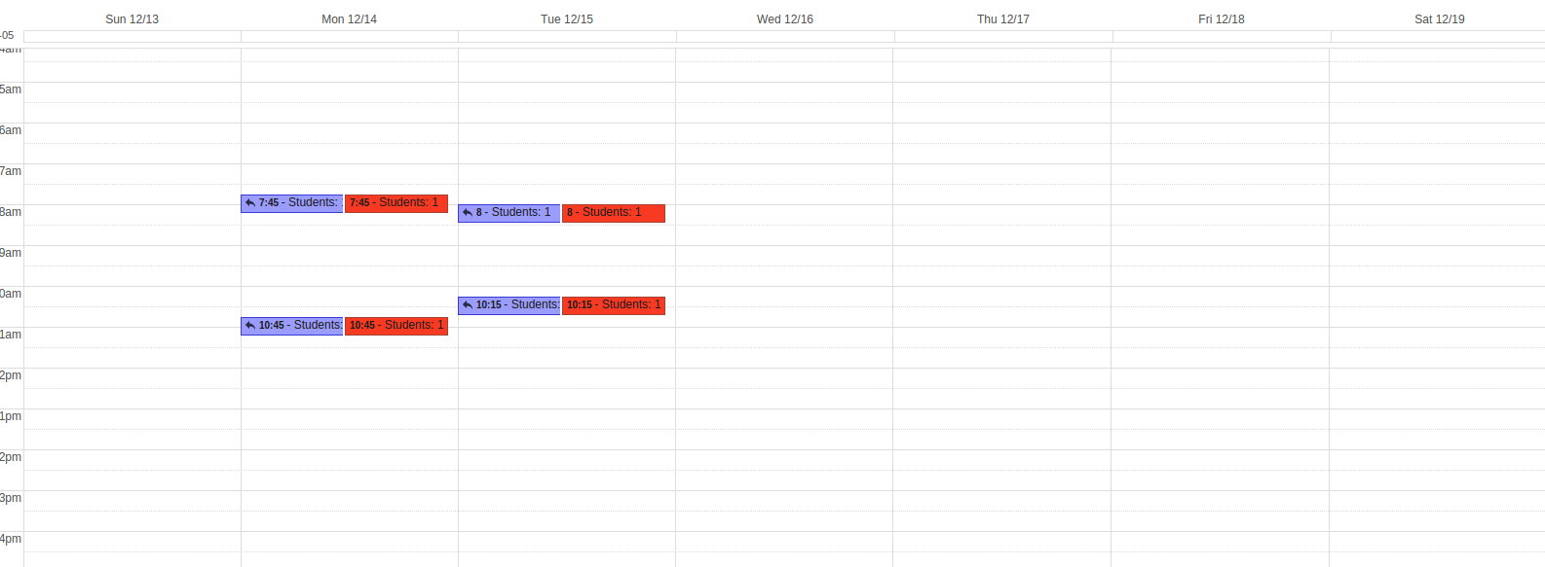

These two tests were run numerous times by our tester to ensure correctness in these cases. Note a feature may be added in the future to remove incorrect times from the forum or even set restrictions on the forum so that arrival time can not exist after departure time.

Struggles with testing revolved around time to implement automated testing. This product was implemented in Javascript and Appscript which meant that in order to provide an automated test suite for the product much time and effort would have been expended on learning new testing programs. Originally the program was to be implemented in Java which was the tester's specialty. However, upon changing the language of the program, the tester was at a disadvantage and under a very strict time constraint for automated testing. This is a risk taken when certain aspects of the program change throughout time and it is not easily avoided. To counter this, the tester took a more direct approach to testing and ensured quality through manual testing which is statistically very effective for small systems. Overall testing was limited to these two cases above because the forum limits the input of the user so that conformity is met. Therefore all variations of possible outcomes were covered by these manual test cases which ensured that the product was of the highest quality.

