COIT11238 – Networked Infrastructure Foundations

Term 1, 2022

**Assessment 3 Portfolio Draft 2**

**Version 2**

Name: Michael Clark

ID: 12188698

Lecturer / Tutor: Zhenglin Wang  
Course Coordinator: Yufeng Lin  
Due Date: 6/5/2022

Table of Contents

**Week 43**

**Week 55**

**Week 67**

**Week 711**

Week 04

**Part 1:**

**Q1:**

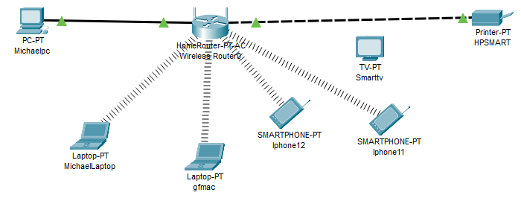

* In my Cisco Diagram I used logical and Physical Star topology to outline my home network setup with devices such as my PC and Printer achieving data transfer via Ethernet and my Laptops and phones achieving through Wi-Fi.
* The differences between Physical and Logical topologies are Physical Topologies demonstrate the arrangement of cables that make up the devices in the network, whereas Logical Topologies describe the method of which data exchanges occur within the network devices.

**Q2:**

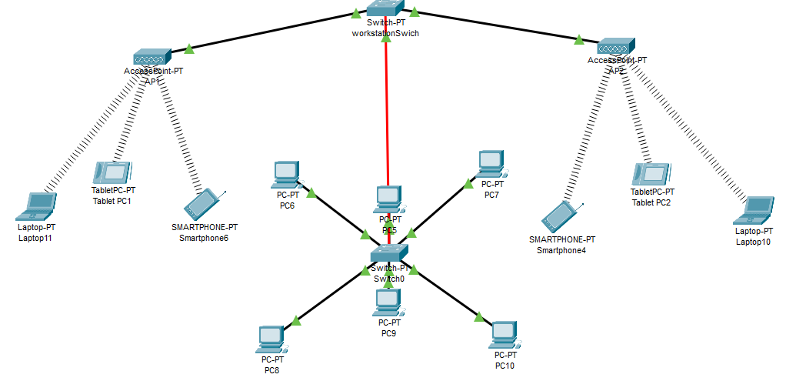

The advantages of Star topology are its Centralized nature, its reliability, extendibility, and its manageability as well as its user friendliness. Some disadvantages include its high price point and maintenance and up-keep as well as immobility. Also noted that its Wireless components can prove slower transfer speeds.

**Q3:**

**The supported standards of the FS S3900-24T4S are:**

* 128Gbps/176Gbps switching capacity
* IEEE 802.1D, IEEE 802.1w,

Its number of ports are:

* 24 1G downlink ports and 4 10G uplinks.

**The supported standards of the TL-SF1005D are:**

* IEEE 802.3, IEEE 802.3u, IEEE 802.3x, IEEE 802.1s,
* BPDU Guard/filtering/transparent
* Root Guard
* Loopback Detection

Its number of ports are:

* 5 port 10/100mb.

**Q4:**

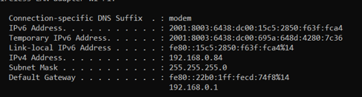

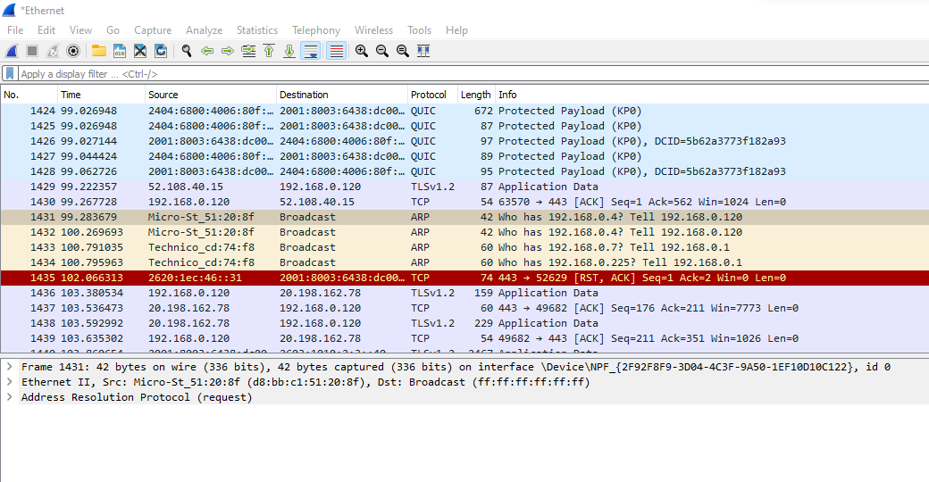

Ethernet II, Src: Micro-St_51:20:8f (d8:bb:c1:51:20:8f), Dst: Broadcast (ff:ff:ff:ff:ff:ff)



This frame has a length pf 42 Bytes:





The data in an IMCP message consists of:

Address, IG bit, Hardware type, Protocol type, Hardware size, Protocol size, OP Code, Sender MAC address, Target MAC address, Target IP Adress.

**Part 2:**

For a brief reflection of this week, I implemented network topologies to represent my current home network as well as designing a Star topology for a hypothetical office scenario. I also described the difference between logical and physical topologies and outlined some advantages and disadvantages of Star topology implementation. From there I captured packets using Wireshark and outlined the frame and IMCP continents. There were no technical issues in this week’s ongoings.

Week 05

**Q1:** *Find made CAT5e/CAT6 cables for sale online, check the prices.*

The cheapest [CAT5e](https://www.inkstation.com.au/rj45-cat5e-patch-ethernet-networking-cable-05m-1m-15m-2m-3m-5m-10m-p-17440.html?17446&gclid=Cj0KCQjwl7qSBhD-ARIsACvV1X21fkZ5eLy5W262k_J94gTxmnj_sg00fQtdAwrBoqyOL8__eGWTqg8aAud8EALw_wcB) Pre made cables can be acquired at Inkstation for $2.98, that is for half a meter, meter prices cost ~$5.00. For [CAT6](https://www.officeworks.com.au/shop/officeworks/p/comsol-rj45-cat-6-patch-cable-1m-black-coutp016bb) the cheapest I can find per m for premade is at Officeworks, which will set you back $6.98 per meter.

*Select different cables (UTP/STP), RJ45 connectors and needed tools in an online*

*store if you want to make a CAT5e/CAT6 by yourself.* Will need the Cable, I have selected UTP, RJ45 connectors suit CAT6E and the cable crimpers and strippers.

$1.98 p/m $14.95 (10pk) $22.95 $18.95

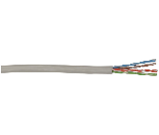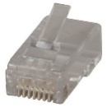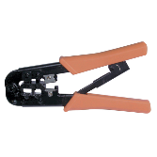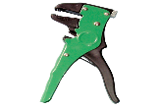

**Q2:**

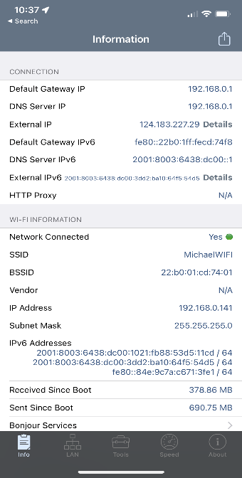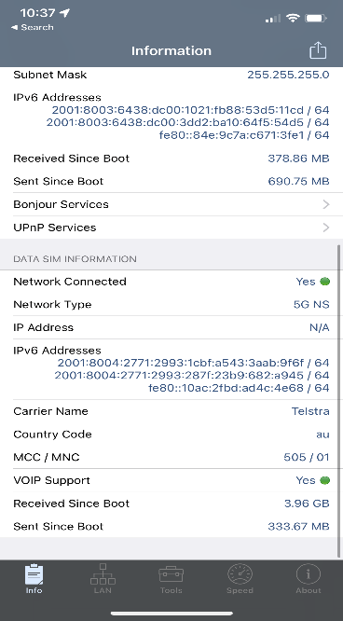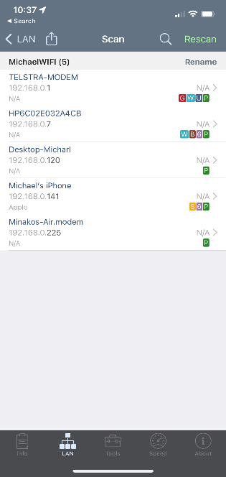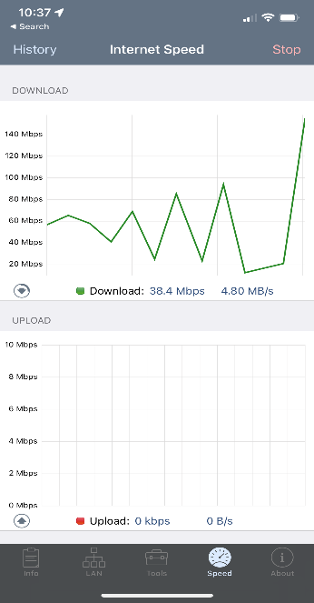

* The SSID of my current network is called MichaelWiFi.
* iPhone Net analyser does not contain other AP’s or signal strength but according to my settings I have 5 other connectable AP’s and my signal strength is very good.
* The other information in the App shows my Default Gateway, DNS IP, my ipv4 and ipv6 as well as my SSID and Carrier details. This app can also do Graphed network speed tests.

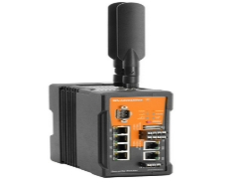**Q3:**

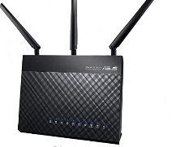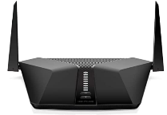1

|  |  |  |
| --- | --- | --- |
| Name | Price | Specifications/Standards |
| 1. Netgear Nighthawk AX4/4-Stream AX3000 | $399.00 | 3Gbps with 4-stream connectivity, IEEE 802.3, IEEE 802.3u, IEEE 802.3x, IEEE 802.1s, |
| 1. ASUS RT-AC68U | $189.00 | 1900Mbps, IEEE 802.1D, IEEE 802.1w |
| 1. SECURITY/NAT/VPN/U-LINK ROUTER | $2,995.52 | 100mbps 3g/4g (But it can survive extreme weather conditions) |

**Part 2:**

In summary of week 5’s activities I Learned how to create rj45 cat5e/cat6 ethernet cables and included the tools needed for such an activity, these include cable strippers and crimpers and connectors themselves. Later in the tutorial I purchased a WIFI Analyser application for my iPhone. This app allows me to analyse my local network connection, and gives me other information such as address details, signal strengths and other Access Points. The only technical difficulty of this week was the lack of support for proper analyser applications on iPhone’s resulting in me having to purchase the application.

Week 06: **Lab exercise report: To Build a Simple Network with Two Computers**

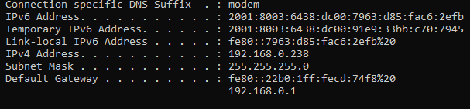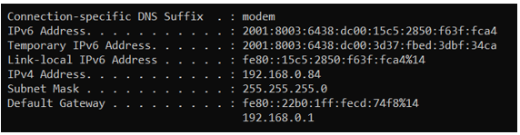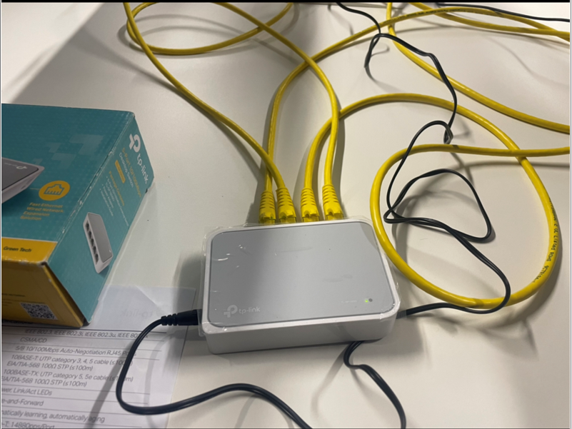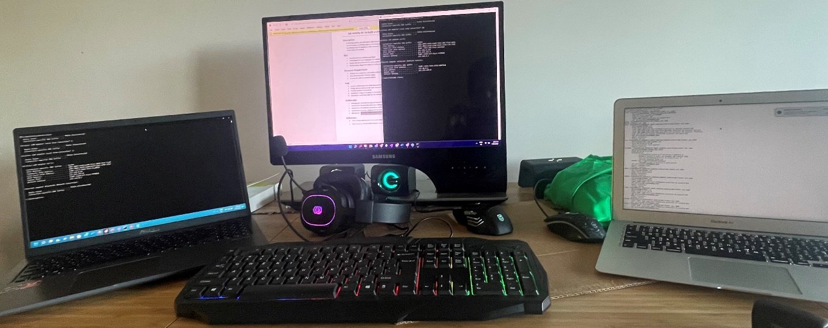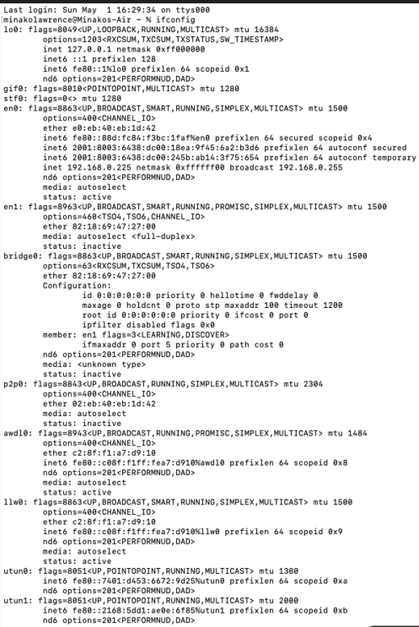

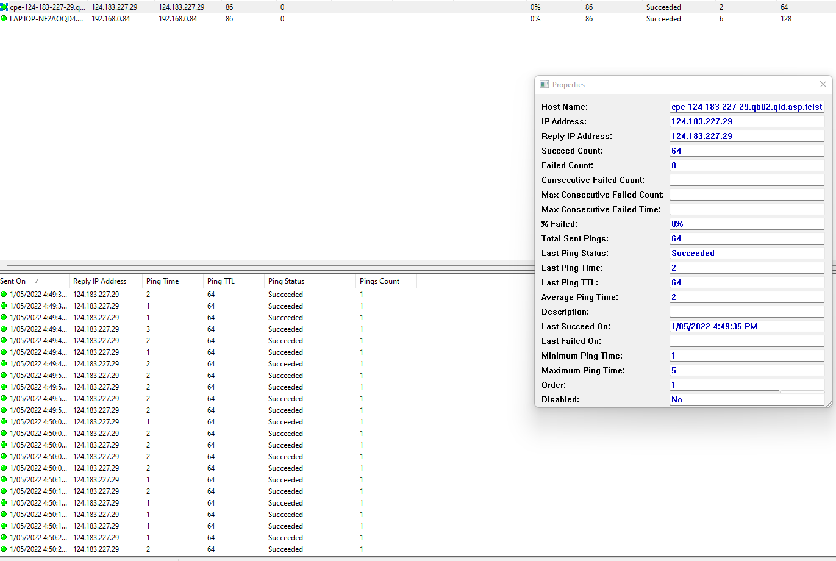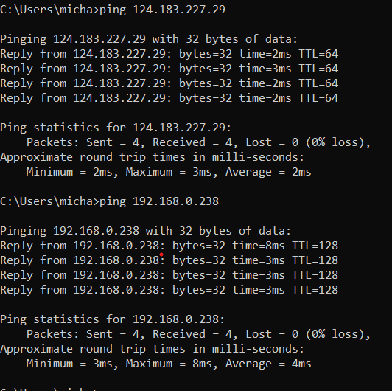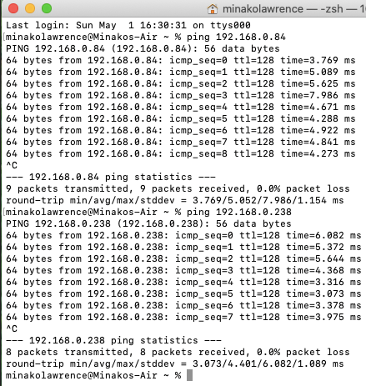

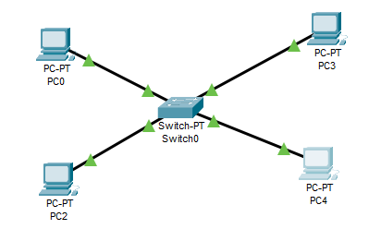

|  |  |
| --- | --- |
| Mac Address | Port Number |
| 00:66:c6:b6:ed:73 | P1 |
| 69:b1:97:a1:1e:63 | P2 |
| 29:b3:53:fd:f4:9d | P3 |
| 80:a5:47:a5:82:0a | P4 |

Week 7:

**Q1:**

* Ipconfig
* My ipv4 address: 10.200.0.130 Binary: 00001010.11001000.00000000.10000010
* My IP address belongs to class A. Private IPs as opposed to public are regarded as better mainly because of their boasted security aspects and the lack of visibility to the broader aspects of the internet.

**Q2:**

* 
* The 0’s in my IPv4 Address represent the host’s portion.
* Subnetting is splitting a single network into multiple, some advantages include routing efficiency enhancement, security benefits and proper management

**Q3:**

* Use tracert (or a similar command, e.g., traceroute in macOS or trace path in Linux) to find

the path from your computer to a web server, e.g., google.com. From the output:

* [www.google.com](http://www.google.com) server IP address: [142.250.71.68]
* The default gateway is 10.200.0.1

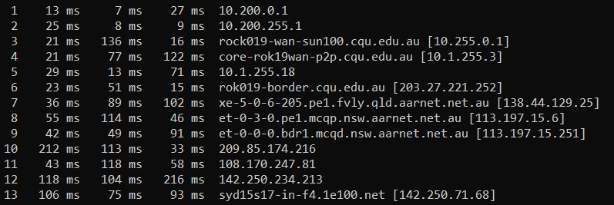

* Draw a diagram to show the path.
* Tracert also gives other information such as [-d] [-h maximum hops] [-j host-list] [-w timeout] [-R] [-S srcaddr] [-4] [-6] target name.

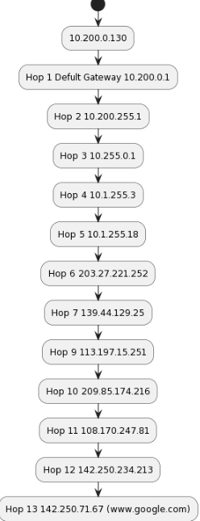  
**Q4:** Ipv6:

* Ipv-4 is limited by its smaller address size, Ipv-4 does not have built in IP security, it is not as efficient in the managing of data packets. Ipv-6 has optimization to extend the lifetime of bandwidth and other services. Ipv-6 has also brought the simplification of network administration as well as its reliability is far higher than Ipv-4. Some disadvantages of Ipv-6 however include Its amount of incompatibility with devices still running Ipv-4, as well as investment costs as it is more expensive to make the switch.
* Coexistence of both Ipv4 and Ipv6’s compatibility can be made via three methods, Dual stacking, as well as tunnelling either protocol through another or there is also the usage of NAP-PT (Network Address Translation-Protocol Translation (NAT-PT)) This is when a translation of Ipv-6 packets into Ipv-4 Packets takes place.

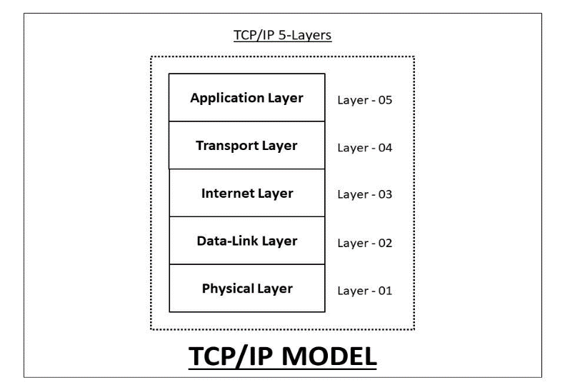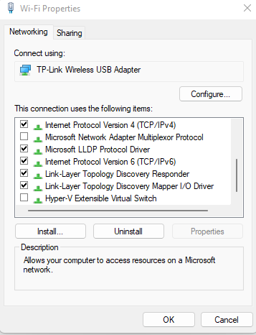**Q5:**











**Part 2:**

To conclude this week’s work; in summary I converted my Ip address to binary, I used the command ‘tracert’ to track the path from my pc to accessing google. From there I developed a UML Diagram to outline the path of the hops. I made definitive comparisons between Ipv4 and Ipv6 and discussed how they can co-exist. Wrapping this week up I Identified 5 Layers of Tcp/Ip within my Wifi Properties, *// note I only had access to a wifi adaptor at home for my pc and due to time constraints I missed documenting it in the tutorial.