COIT11238 – Networked Infrastructure Foundations

Term 1, 2022

**Assessment 3 Portfolio Draft 1 Version 2**

Michael Clark

12188698

Lecturer / Tutor:

Course Coordinator: Yufeng Lin

Due Date: 01/04/2022

# Table of Contents

**Type chapter title (level 1)** ..................................................................................................................... **1**

Type chapter title (level 2) .................................................................................................................. 2

Portfolio Questions weeks 1-3 ........................................................................................................ 3

Questions cont. ....................................................................................................................................... **4**

Personal network details .................................................................................................................... 5

Creating a shared File .............................................................................................................. 6

Week 01

**Part 1:**

**Q1:** The fundamental difference between bits and Bytes is the quantity of the data. A Byte is 8 bits, and a bit is equal to .125 Bytes. Furthermore, a bit is represented with a lowercase ‘b’ whereas a Byte is represented with an uppercase ‘B’.

**Q2:** There are 3 main counting methods that are used in almost all situations of computer calculation. They are hexadecimal, binary and decimal. These differ significantly, as a base-2 system binary is represented as 0’s and 1’s. decimal is determined based on its position relevant to the decimal point and the code is formulated by the specific placement of each digit. Hexadecimal is a base-16 numbering system which would be made up of 16 unique variables which are between 1-9 and A-F.

**Q3:** The conversion of 12,345,678 Bytes to MB can be done by 12345678/10^6 with the incorporation of scientific notation or by adding a decimal after the first two digits. The conversion of 0.04567s into ms can be done by multiplying the initial value by 1000 to achieve 45.67

**Q4:** My PC’s CPU manufacturer is Intel, specifically an Intel Core i3-10105f. It’s a 4 core 8 thread CPU with a base clock speed of 3700000000hz with an overclockable speed of 4400000000hz.

**Q5:** When storing 10TB of data and investigating different storage methods you could expect to pay (on average):

* For a Hard Drive (HDD) ~$350.
* To supplement the same amount of storage with SSD a greater option would be to use multiple as there are no commercially developed SSD’s with that much storage capacity. The closest you could get are 2x5TB with the price totalling ~$564.
* The best I could find for 10TB cloud storage is subscription based in Google Drive totalling ~$68.10 per month.

The (HDD) sacrifices quality for quantity as with the development of faster technologies like the (SSD). The user may experience cheaper storage but slower transfer speeds and could also fall victim to malfunctions and data loss as the device ages. The SSD is an appropriate go to but has a noticeably higher price point, however, this price is justifiable based on the transfer speeds and compact nature of the product. The cloud storage like GD is also a worthy contender as it boasts large storage amounts and lacks mechanical components on the user’s side, although the price point for repeated transactions and lack of offline access when permanent data solutions are available is a downside.

**Q6:**

**(Q7):** By pressing ctrl+shift+esc I can quickly access the task manager and see the performance of my pc under various stresses. Now the most demanding constraint on my RAM is the amount of Chrome tabs that are open. My CPU is a performance one and wont really experience any load unless a video game or a million programs are open. You can stop a program or process that is unresponsive by clicking the item in the list and pressing the end task button.

**Part 2:**

No technical issues thus far however I will need to practise the mathematical side of the unit conversions and incorporate new learning strategies as I get more exposure to complex methods.

Week 02(the same style of summary as Week01)

**Q1:** My home internet is a Telstra Smart modem, which achieves connection via NBN or (Hybrid Fibre Coaxial) My PC connects to the router via Ethernet Cable and my laptop and phone connect via Wi-Fi.

**Q2:**

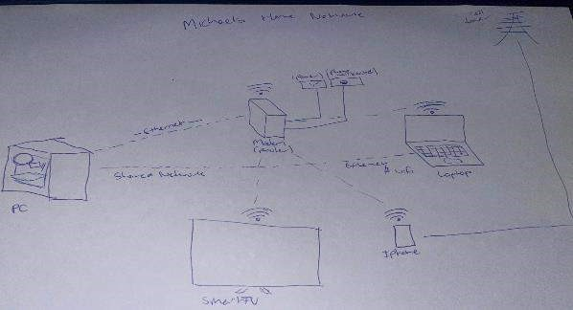

**Q3:** Using ipconfig in the command prompt I identified the following:

* My Ip: 2001:8003:6438:dc00:c00c:8fa4:4ca3:6da4
* My MAC/Eth address: fe80::22b0:1ff:fecd:74f8%6

The addresses listed on my other computer are similar but hold different values.

**Q4:** By Pinging my other PC (2001:8003:6438:dc00:15c5:2850:f63f:fca4) There was 4 packets sent with 0% loss.

**Q5:** Upon running an internet speed test my download speed was 52.1 mb/s and my upload was 18.7mb/s. The university’s speed earlier was around triple my value. This is because my internet is not very cheap, and I chose to have it capped at 50 mb/s.

**Part 2:**

The only technical issue I experienced was when trying to set up remote desktop on my home laptop to control from my pc. The reason for this was Windows does not support RD in Home edition, the remedy for this was acquiring and upgrading to a professional copy of windows; however, I could’ve used a program such as Team Viewer.

Week 03

**Lab exercise report: To Build a Simple Network with Two Computers**

Based on the “Deliverable” to draft a report.

Deliverable

It should be noted that there was only 2 laptops available on the day of the lab exercise that had ethernet ports/had administrator privileges. However, everyone did have a go on pictured pc’s

* Photographs showing the physical connection of the two computers.

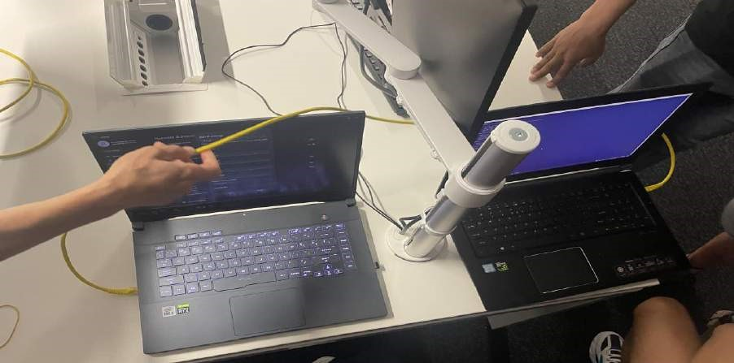

Screenshots showing the connection tests.

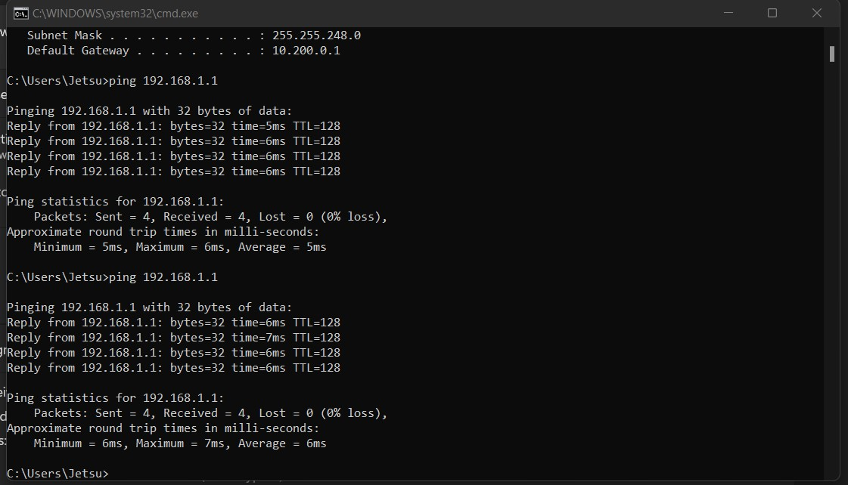

* Table the MAC and IP addresses details of the two computers (table will be my home pc and laptop as I did not grab other details

|  |  |  |
| --- | --- | --- |
| Computer | MAC | IPv4 |
| PC | D8-BB-C1-51-20-8F | 192.168.0.120 |
| Laptop | D8-F3-BC-76-93-BF | 192.168.0.1 |

* Record the steps of creating a file sharing service on the built network.

1. Right click on folder you wish to share:



1. Select properties:

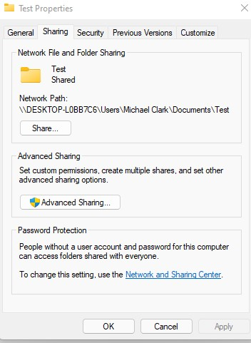 3. Select Share…:

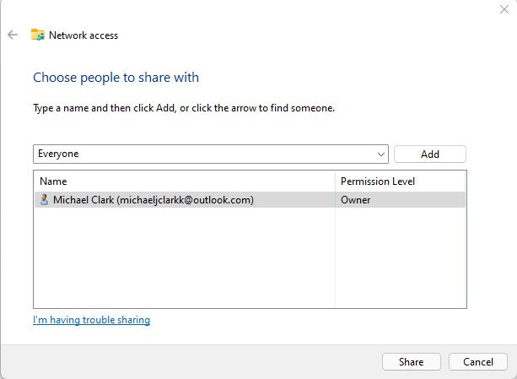

1. Click on drop down bar and select everyone:
2. Select Share:

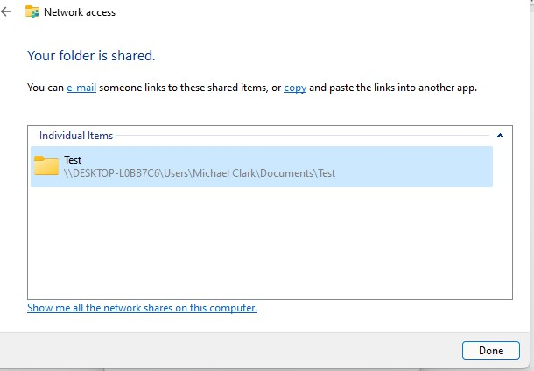

1. On other networked computer open File explorer:



1. Make sure file sharing is turned on:
2. Select Network at the bottom left:

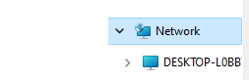

1. Select the PC that is established in the network containing the shared folder:
2. Follow the address to desired folder:



1. Open Shared folder:



• Summary with reflection

In summary thus far, I have learned new definitions and gained some fundamental knowledge of the concepts implemented in this in this portfolio; this includes mapping out my home network and various commands from LAN and Wifi to reach and share data between multiple computers. I have also learned how to Investigate the costs of items for data storage.