# COIT11222 Assessment 1 Part A (Programming Assignment)

# Report

|  |  |
| --- | --- |
| Student ID | 12188698 |
| Student Name | Michael Clark |

This coversheet **must** be completed with your submission.

Please check (X) to indicate that you have satisfied these requirements

This work and my programming submission are my original work and no part of it has been copied from any other student’s work or any other source.

No part of this work or my code has been written for me by any other person/student.

I have taken proper and reasonable care to prevent this work and my code from being copied by another student.

I acknowledge that it is my responsibility to check that the file submitted is readable and complete and that the code submitted can be uploaded in NetBeans and will compile and run correctly.

I understand that plagiarism also includes the act of assisting or allowing another person to plagiarise or to copy my own work.

# **Instructions**

# **A description of what is required in each section is shown in italics. Please remove all the instructions from your final report.**

# Description of the Phase Completed

***Phase 1*** *has been completed.*

***Phase 2*** *has been completed.*

***Phase 3*** *has been completed.*

***Phase 4*** *has been completed.*

***Phase 5*** *has been completed*

# Testing

***Phase 1:***

|  |  |  |  |
| --- | --- | --- | --- |
| **Inputs** | **Expected Output** | **Actual Output** | **Pass/Fail** |
| **Height= 95 Weight = 1.9** | **29.4** | 29.4 | pass |

Phase one tests if the scanner will scan for user input and do a simple calculation to output the BMI.

***Phase 2:***

|  |  |  |  |
| --- | --- | --- | --- |
| **Inputs** | **Expected Output** | **Actual Output** | **Pass/Fail** |
| **Height= 95 Weight = 1.9** | **29.4** | error | Fail |

Adding a BMI calculator class and testing if it returns the bmi and outputs it. It *Failed* to output.

***Phase 3:***

Added the Classification methods to attempt to output BMI . Test Project still didn’t initialize getting the BMI from the calculator class.

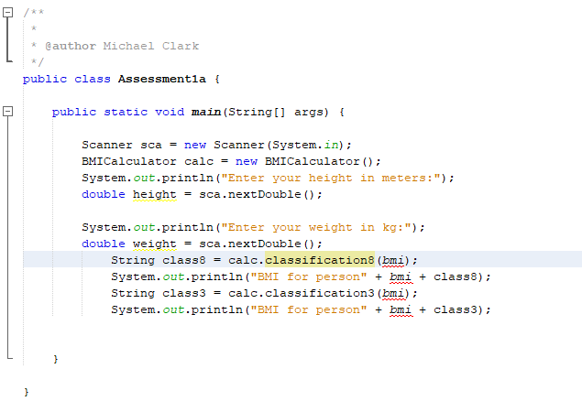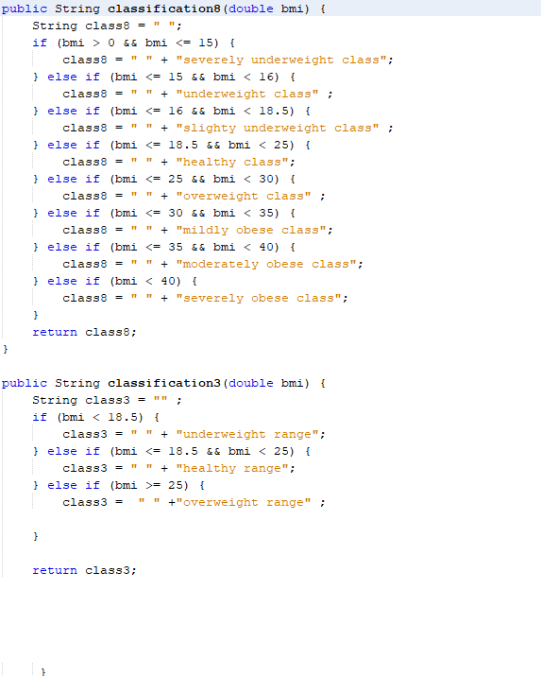



|  |  |  |  |
| --- | --- | --- | --- |
| **Inputs** | **Expected Output** | **Actual Output** | **Pass/Fail** |
| **Height= 95 Weight = 1.9** | **29.4** | Error // removed unused variable | Fail |
| **Height= 95 Weight = 1.9** | **29.4** | 29.3545498 | Pass |
| **Height= 0 Weight = 0** | **Invalid input** | Error | Fail |

*Phase 4:*

Adding a ‘for’ loop to Get the number of BMI calculations to be made. It should output person 1 person 2 height eight bmi etc. however the counter works for the correct number of times it doesn’t add the number next to the Person.

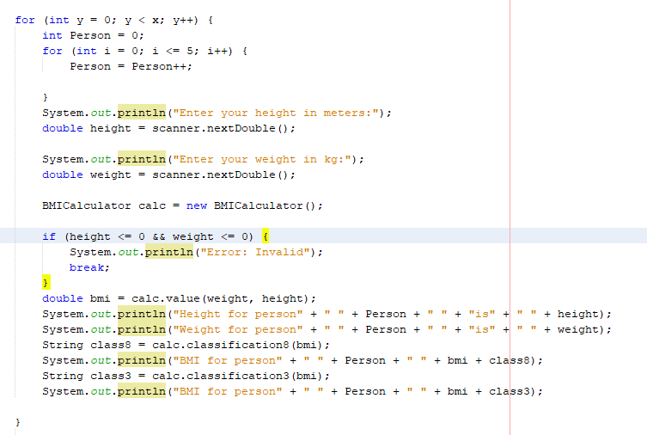

|  |  |  |  |
| --- | --- | --- | --- |
| **Inputs** | **Expected Output** | **Actual Output** | **Pass/Fail** |
| **Height= 95 Weight = 1.9** | **29.4** | Error // removed unused variable | Fail |
| **Height= 95 Weight = 1.9** | **29.4** | 29.4 | Pass |
| **Height= 0 Weight = 0** | **Error: Invalid** | **Error: Invalid** | Pass |
| **Calculations to perform: 3** |  |  | Fail |
| **Height= 95 Weight = 1.9** | **Person 1** | **Person 0** | Fail |
| **Height= 95 Weight = 1.9** | **Person 2** | **Person 0** | Fail |
| **Height= 95 Weight = 1.9** | **Person 3** | **Person 0** | Fail |

*Phase 5 Completed:*

*Summary has been added by implementing class3 Method. Statements have been formatted to PrintF.*

|  |  |  |  |
| --- | --- | --- | --- |
| **Inputs** | **Expected Output** | **Actual Output** | **Pass/Fail** |
|  |  |  |  |
| **Height= 95 Weight = 1.9** | **29.4** | 29.4 | Pass |
| **Height= 0 Weight = 0** | **Error: Invalid** | **Error: Invalid** | Pass |
| **Calculations to perform: 3** |  |  | Pass |
| **Height= 95 Weight = 1.9** | **Number with** | **Number with** | Pass |
| **Height= 95 Weight = 1.9** | **Number with** | **Number with** | Pass |
| **Height= 95 Weight = 1.9** | **Number with** | **Number with** | Pass |
|  |  |  |  |
| **Height = 1.82 Weight = 80** | **Bmi for person 1** | **Bmi for person 1** | Pass |
| **Height = 1.82 Weight = 100** | **Bmi for person 2** | **Bmi for person 2** | Pass |
| **Height = 1.82 Weight = 60** | **Bmi for person 3** | **Bmi for person 3** | Pass |
| **Height = 1.82 Weight = 80** | **24.2** | **24.2** | Pass |
| **Height = 1.82 Weight = 100** | **30.2** | **30.2** | Pass |
| **Height = 1.82 Weight = 60** | **18.1** | **18.1** | Pass |
| **0,0,0,0** | **Error message** | **Error message** | Pass |
| **Height= 2.xxxx Weight=200+** | **47 (which is Severely Overweight)** | **47 Which is “ “** | Fail |
| **Height = 1.2 Weight = 25** | **Severely Underweight** | **Which is healthy** | Fail |
| **Height = 1, Weight = 10** | **Severely Underweight** | **Severely Underweight** | Pass |
| **How many calc = “Two”** | **Crash** | **Crash** | Pass |
| **Height = 100m Weight= 1000kg** | **Severely overweight** | **0.1 which is severely underweight** | Fail |
| **10 Calculations Randomized** | **Highest BMI is: 45.8**  **Lowest BMI is: 0.0**  **Average BMI is: 29.6**  **Number with lowest BMI:1**  **Number with normal BMI:1**  **Number with Highest BMI:8** | **Highest BMI is: 45.8**  **Lowest BMI is: 0.0**  **Average BMI is: 29.6**  **Number with lowest BMI:1**  **Number with normal BMI:1**  **Number with Highest BMI:8** | Pass |

No known bugs

## Limitations

*Michaels BMI Calculator is not limited in its functionality within the scope of the purpose of the program, However its functionality overall could be improved if its results and output incorporated useful dietary information as an example.*