Analyzing Mini-Core

**Feature:** Not coming from a linguistic background, I decided to start with analyzing some very simple elements of the text – 1st, 2nd and 3rd pronouns. One would think that after years of grade school I would have finally learned how to differentiate between them, however until this class I would not be able to tell you which was which.

**Accuracy:** In order to verify that my program was running correctly, I printed the first several hundred words for each of the features that I was looking for. Everything was working correctly. I also analyzed some of the text to make sure that I wasn’t leaving words behind. When I was doing this, for example, I noticed that I had included “yours” but not “your”. I then made changes in order to be more accurate with my search. Because of the complex nature of the word “it” I did not include that within my searches.

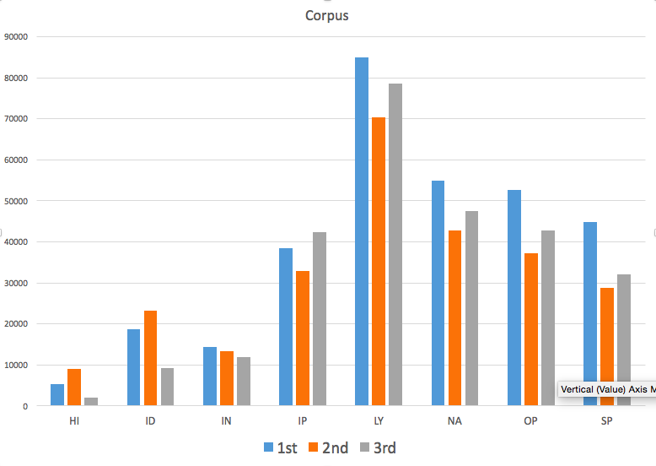 **Hypothesis:** I hypothesized that 1st person pronouns will be more common among song lyrics, opinion blogs and interactive discussion while 2nd person pronouns will be found in informational persuasion, how-to/instructional and interview transcripts. Lastly, I believed that 3rd person pronouns will have the highest frequency among informational and news reports.

**Results:** As we can see pronouns in general, especially 1st pronouns, are most common in song lyrics. Pronouns are least found in how-to/instructional texts. Within news reports and opinion blogs 1st pronouns are also very common. Only within how-to/instructional and interactive discussion are 2nd pronouns not the least common of all three.