Netflix User Ratings

Michael J Murray
Colorado State University Global
MIS581 - Capstone
Dr. Kimberly Ford
November 7th 2021

Table of Contents

Dataset 3

Company Background 4
Company Utilization of the Dataset 5

Tools………………………………………………………………………………………………6

Variables………………………………………………………………………………………….7

Data Dictionary…………………………………………………………………………………..7

Future Plans……………………………………………………………………………………...8

Importance of the hypothesis……………………………………………………………………8

Hypothesis………………………………………………………………………………………...9

Ethical Concerns………………………………………………………………………………..15

Objectives……………………………………………………………………………………….18

Overview of the Study………………………………………………………………………….18

Research Hypothesis……………………………………………………………………………19

Review of Literature ……………………………………………………………………………19

Methods………………………………………………………………………………………….23

Methodology…………………………………………………………………………………….23

Limitations………………………………………………………………………………………23

Ethical Considerations…………………………………………………………………………24
References 25

Netflix User Ratings

Dataset
The dataset of ratings of movies and TV shows on Netflix by viewers of the program was chosen (Willden, 2017). The data within the dataset are title, rating, rating level, rating description, release year, user rating score, and user rating size. The dataset has information on one thousand movies and TV shows but needs to be cleaned as there are some duplicates. Once the duplicates were removed from the dataset there is still data on over 500 movies and TV shows.
It has been said that during peak internet times in the United States Netflix accounts for one third of all of the traffic (Marr, 2017). The dataset gives a glimpse into the viewing preferences of their subscribers by showcasing what content is being added.

Company Background
The world is currently at the peak consumption of streaming television. There are numerous companies offering video on demand services in the recent years. Some of the newcomers in the streaming service is Peacock, HBO max, Disney+, Hulu, and Paramount plus. These services have significantly altered the way in which television is watched and the way in which it is produced. (Hidalgo, et. al, 2021).
Netflix is an entertainment company that has its headquarters in Los Gatos, California. Netflix offers monthly subscriptions to customers who in turn are able to stream unlimited movie and TV shows. The company started out as a rent by mail service for DVDs where fee structures were tied to how many movies were allowed out at one time. Customers could choose what movies they wanted online and they were mailed to them in red envelopes which included a postage paid envelope to mail the move back once they were done (Mahtani, 2021).
In 2000 the creator of Netflix, Reed Hastings, scheduled a meeting with the CEO of Blockbuster to pitch a partnership that would lead the two companies into the future together. The pitch was that Netflix would run Blockbuster’s online presence and in turn, Blockbuster would promote Netflix within their stores. Blockbuster ultimately rejected the proposal which led to the demise (Satell, 2014). Flash forward ten years and Blockbuster went bankrupt while Netflix is now a household name.
The company has 9,400 fulltime employees and approximately 204 million paid members in 190 countries. Netflix, Inc. was founded in 1997 and is headquartered in Los Gatos, California. (Yahoo Finance, 2021).
Netflix generates a lot of data on their viewers and utilize that data to improve the platform by making better suggestions based upon algorithms setup based upon how you rate previous shows that have been viewed. These ratings are also used to determine what content to add in the future so that the company can maintain their current customer base and add more customers.
In a streaming market where competition is growing a rapid pace generating and understanding the data coming in is important to stay ahead of the competition. Netflix’s model itself is easily copied, offer tv shows and movies on demand for a nominal cost. The ability to cut costs by determining exactly what viewers are looking for coupled with the ability to make meaningful suggestions of what to watch next is what sets Netflix apart from the competition.
Utilization of the Datasets
The company can use the dataset to determine any gaps in genres that may be missing from the streaming service. This will lead to a well-rounded library which includes something for everyone in the family. The dataset can also be utilized to determine the genres that are rated the best by their viewers to determine what content to add to their streaming service. Based upon past ratings it will be determined what the likelihood of the user rating will be. Within the rating level it will be determined if any keywords trigger a better rating from the viewers
This knowledge will assist the company in making informed business decisions that will boost the profitability of the company. When creating knew content it could be determined if spending extra money to bring in certain actors would be beneficial based upon prior ratings of movies with the same actors. The data can also tell the story of what genres are enjoyed most by the viewers so the company can focus on adding and creating content that aligns with what their customers are looking for.
These combined datasets can also be used to determine what content has been added over the years with a prediction of what content will be added in the future. This projection could be used as a baseline to ensure that the company is staying on a path that aligns to what the consumer wants.
Tools

For the analysis of the data R and SAS will be utilized. R Studio will be used for the statistical analytics portion as R performs very well with statistical analytics and has an abundance of resources in case of any unforeseen nuances.
Having a well-connected and supportive community is critical in helping you solve problems, and the R community is fully supportive of people who are learning R as their first programming language. R was written by statisticians for statisticians thus is the choice for someone looking for statistical correctness. Machine learning and statistics are two tightly related fields of study. So much so that statisticians refer to machine learning as “applied statistics” or “statistical learning” rather than the computer-science-centric name (Brownlee 2019).
SAS Studio will be utilized for the descriptive analytics portion of the research project. SAS outperforms many of the other programs in terms of visualizations. The SAS system is a powerful software program designed to give researchers a wide variety of both data management and data analysis capabilities (Elliott & Woodward, 2016).

Variables
The variables that will be analyzed in this dataset are interval and categorical variables. For the user ratings based data the differences between the values are meaningful as a movie that is rated a 99 is better in the eyes of the viewers than one that is rated a 66. The data for what the movie is rated for based upon content the data is categorical as it is string based and can be broken down into categories based upon the rating.
Data Dictionary
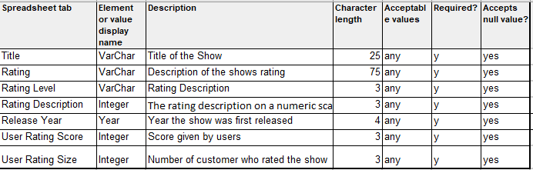

Future Plans

For the descriptive part of the research visualizations will be utilized to show how customer ratings are broken down by release year, rating, and rating level. This will provide the decision makers withing the organization a clear picture of the direction the company should go with for new content. For the predictive part of the research the likelihood of movies that have yet to be added being rated highly will be determined to ascertain if Netflix should add the movie ton their library. Adding new movies to the library costs a significant amount of money and provides a decrease in profitability if the wrong movies are added.
Importance of the Hypothesis
A hypothesis presents the research question and proposes what the expected outcome should be. This is an important part of the scientific method and forms a basis of the experiments. The researcher will need to be cautious and methodical when proposing the hypothesis. A slight error in the development of the hypothesis could have disastrous effects on the experiment (Enago Academy, 2020).
A road map with what the business question is and the hypothesis of what the outcome should be needs to be established. It is only once the scientist fully understands what the business is trying to accomplish that the map can be followed. There may be times that the data scientist may not be familiar with the field and some research may need to be performed before taking on the project. Success within data projects do not stem solely from technical knowledge but come from softer skills such as an understanding of the nature of the business problems, the ability to explain results in a way that is simple, gaining the trust of the stakeholders, and addressing concerns that management may have (Redman, 2019).
It is important to resist the temptation to find, build, and deploy resolutions without first understanding what the context is in which the problem exists (Nelson, 2018). Combing through the Netflix dataset it can be determined that there are many null values that need to be removed before performing any descriptive statistics. Before performing any predictive statistics the data has to be fully understood. For the descriptive statistics SAS Studio was utilized to provide snapshots of the data as well as visualizations.

Hypothesis
H0: Rating has no effect on the way a user rates the show.
H1: Shows with a mature rating have a higher user rating.
As can be seen in the box plot in Figure 3 Movies and TV shows have higher user ratings with TV shows having a few outliers with low ratings. This would cause the null hypothesis to be rejected and the alternate hypothesis to be accepted. It is with this data that a recommendation should be made to put an emphasis on mature rated content. There should not be an exclusive focus on mature content as the main goal is to provide content for people of all ages and background but there should be a slight emphasis on adding mature content. The pie chart in Figure 3 shows that TV-14 shows make up a majority of the content on Netflix. While they are rated in the higher spectrum there are other ratings that are rated higher by users that are underserved.
The time series modeling that is being used in Figure 4 is an Arima (3,1,1). The time series model shows that movies are being added at a more rapid pace than that tv shows. As can be seen by the time series chart, both Movies and TV shows are being added at a rapid pace. Movies are being added at a greater frequency and this is projected to be continued into 2022.
Figure 5 provides insight int user ratings based upon the release date of the show. As can be seen in the scatterplot movies and tv shows that are newer have a tendency to be rated higher by users than older movies. The plot also shows that Netflix understands this as there are a lot more dots closer to 2020.
Figure 6 provides statistical insight into the data, from this chart we learn that the minimum user rating score is a 55, the max user rating is 99, the oldest show on Netflix is from 1940 and the newest is from 2017. This glimpse into the data provides helpful insights into understanding the data.

Figure 1. Statistical Analysis of Ratings vs User Score
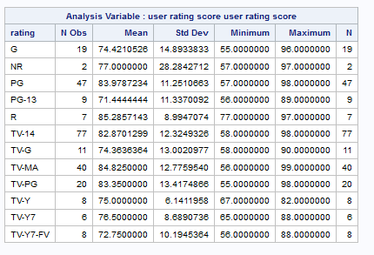

Figure 2. Pie Chart of Ratings Distributions
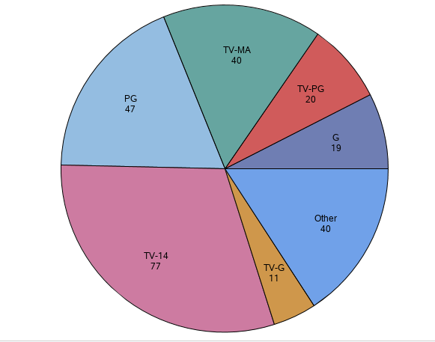

Figure 3. Box Plot of Rating by User rating score
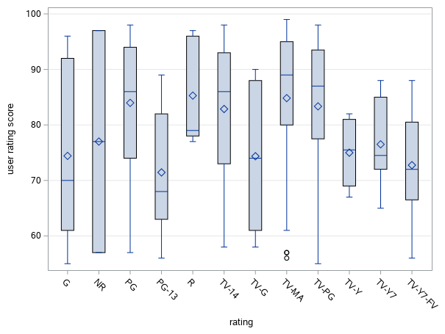

Figure 4. Arima (3,1,1) Time Series Forecast
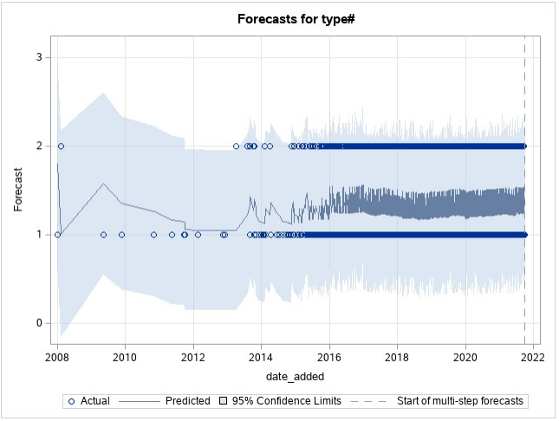

Figure 5. User rating by release year
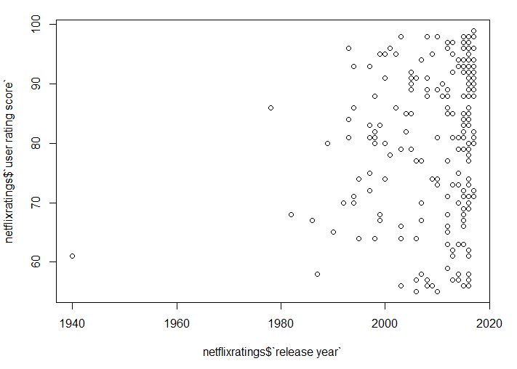
Figure 6. Statistical analysis in R
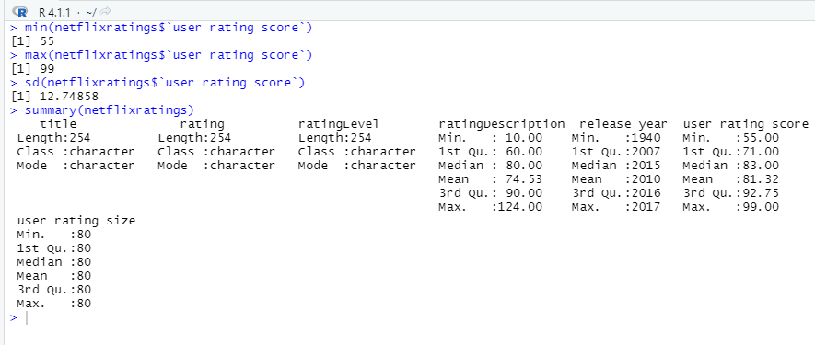

Ethical Concerns
As a society we value the privacy and the protection of our way of life. Most people would like to have at least some control over what information is available on them. They certainly do not want their personal information to be accessible to just anyone no matter how menial it may seem (Hoven et al, 2019).
Collecting and utilizing data to improve user experience is a necessity as product overload could be enough to cause many users to give up searching for what show to watch next out of frustration. Netflix utilizes data based upon customer viewer preferences to deliver a seamless experience to their users. Having over 15,000 titles on their streaming service provides a great selection but makes figuring out what to watch difficult at times.
The greater the time spent watching movies on Netflix decreases the likelihood of the user cancelling their service. Users can set up profiles that can filter out adult rated content as well as keep track of the shows you watch and if you enjoyed them to recommend other titles that you might like. In order to remain profitable companies need to rely on data to make informed business decisions. Making original content or purchasing content that is not in line with what viewers prefer could waste millions of dollars that would be difficult for Netflix to make up.
Knowledge of the target customer for a business is an essential aspect of profitability. Without knowing customer preferences it would be extremely difficult to satisfy their demands as the business would not fully understand what those demands are. The more a business knows about their customer the easier it would be to service them (Neira, et al, 2019).
On a small scale this seems like a wonderful idea that many would not think twice about but once the data is combined to make business decisions is when a whole new territory is entered. There is an enormous amount of data collected that is only privy to the company. The gray area comes in deciding if the data collected belongs to the company or to the person the data is collected from. As long as the data collected is used for the benefit of the person within the company that collected it, everything is fine. It is when the company tries to sell the data to make a profit that ethical lines are crossed.
Big Data remains a new concept, developing across scientific, social, and business backgrounds genuinely only related by the enormous size of the datasets being considered. As is the case with any cutting edge technology or scientific progress, understanding the ethical aspects trail behind (Mittelstadt, 2016). Some data, such as addresses and phone numbers, are not as sensitive as bank account numbers and passwords, but a truly ethical company will secure both confidential and non-confidential data the same. When combining data from many customers into one source it is important to scrub all personally identifiable information.
Different countries, and even the territories withing them, treat the usage of data differently. There are two different options when it comes to consumer choice, opt in and opt out. The side that the country or territory enforces has far reaching effects on the businesses within. Typically, the option pre-selected is the option that the customer is mostly likely to choose. Status quo bias states that whatever option is pre-selected for the consumer is the option that is stuck with most of the time. Having a ruling that a customer must opt in to have their data collected could have a negative impact on the data value exchange between consumers and companies, user experience on the web, and ultimately, the true level of privacy available to the consumer (Kaufman, 2020). The opt in vs opt out discussion boils down to choice vs. economic impact and user experience vs. consumer privacy issues.
. When companies are ethical with the data they collect both the consumer and the company benefit greatly. Before gathering data on customers they should be informed of the companies intentions for the data. A short paragraph long explanation should be provided so that the likelihood of the customer reading it is higher than the usual multipage disclaimer full of legal jargon.
The Netflix dataset that is being worked with has all user information scrubbed and gives a general description of how users rated the show. The unprecedented integration of digital technologies in the economic and social spheres has led to strong concerns regarding the ethical use of data collected by such technologies. In response to these concerns, several intergovernmental and multistakeholder bodies as well as individual governments have started devising data ethics compliance frameworks. These frameworks integrate certain core principles such as human rights protection, ethical design, algorithmic accountability, and data privacy and security (MISHRA, 2021).
It is important for companies to utilize data ethically and to ensure all customers know what their data is being used for. Maintaining high ethical standards will ensure that government regulators will stay away. If a governmental agency had to step in regulations would be much stricter than if the industries applied ethical standards themselves.
Database security for any data is f the utmost importance. Data breaches cause not only monetary damages but reputational damages as well. Any data breach has the repercussions of lost customers and the possibility of customers on the fence about starting a new subscription to maybe choose another platform.
The security of any database much address at a minimum:
- The data contained within the database
- The database management system (DBMS)
- Applications that are associated with the database
- The physical database server and/or the virtual database server and the underlying hardware
- The computing and/or network infrastructure used to access the database
Database security is a complicated and challenging task that includes all aspects of information security technology. The security of a database is naturally in opposition of accessibility. Think of the dreaded password that must contain exactly eight characters with one symbol and a capital letter than has to be changed every 90 days and can never be repeated!
The easier it is to access the database the more vulnerable the database is to security threats, the more difficult it is to access the more secure the database is. Anderson's rule states that systems that handle sensitive personal information involve a trilemma of security, functionality and scale, of which you can choose any two. It is very important that security is made a priority (IBM Cloud Education, 2019). In conclusions while there is no personally identifiable information contained in the dataset the same ethical standards and security measures should be taken to protect the data.
OBJECTIVES
The objective of this research paper is to determine what type of content is preferred by Netflix’s customer base. Analyzing the data on current user ratings will determine where funding should be spent to add and create content that customers will like. Predictive analytics will be used to determine the what the ratings will be on the shows that have a current rating on N/A based upon similar shows.
Overview of the Study
User ratings were taken from a subset of all available content available on Netflix. The dataset contains the title, rating, rating level, rating description, release year, user rating score and user rating size. The dataset contains 497 unique shows available on Netflix and includes content ranging from G to R.
The study will provide insight into the viewing preferences of Netflix subscribers. With a firm grasp on the preferences of the current members greater profitability will be achieved based upon the cost savings of knowing what shows to purchase to add to the platform.
Research Hypothesis
H0: Rating has no effect on the way a user rates the show.
H1: Shows with a mature rating have a higher user rating.
H0: Future ratings cannot be predicted by current ratings
H1: Future ratings can be predicted by current ratings

Review of Literature
New audience dimensions in streaming platforms: the second life of Money heist on Netflix as a case study
Without knowing customer preferences it would be extremely difficult to satisfy their demands as the business would not fully understand what those demands are. The more a business knows about their customer the easier it would be to service them (Neira, et al, 2019). With more and more competitors entering the streaming video service business it is now more important than ever to fully understand the customer base. Without knowing what the user’s preference is it would be costly to add shows that may not provide anything of value to the customer base.
The Ethics of Big Data: Current and Foreseeable Issues in Biomedical Contexts.
Big Data remains a new concept, developing across scientific, social, and business backgrounds genuinely only related by the enormous size of the datasets being considered. As is the case with any cutting edge technology or scientific progress, understanding the ethical aspects trail behind (Mittelstadt, 2016). When compiling data on customers it is important to only utilize that data internally to provide a better user experience for the consumer. While regulations have not yet been put into place it is important for a truly ethical company to do the right thing ethically.
To Opt-In or Opt-Out?
Typically, the option pre-selected is the option that the customer is mostly likely to choose. Status quo bias states that whatever option is pre-selected for the consumer is the option that is stuck with most of the time. Having a ruling that a customer must opt in to have their data collected could have a negative impact on data exchange between consumers and companies. This could in turn negatively affect the user’s experience on the web and ultimately have a negative impact on the consumer company relationship. Accepting cookies could provide the company the permission to retain your zip code which would in turn save the hassle of having to put it in every time when looking for restaurants (Kaufman, 2020). The opt in vs opt out discussion boils down to choice vs. economic impact and user experience vs. consumer privacy issues.
International Trade Law Meets Data Ethics: A Brave New World
The Netflix dataset that is being worked with has all user information scrubbed and gives a general description of how users rated the show. The ethical use of such collected data has come under scrutiny and raised many concerns. In order to respond to these concerns, several agencies have developed data ethics compliance frameworks. Within these frameworks, certain core principles, including the protection of human rights, ethical design, algorithmic accountability, as well as data privacy and security++, are upheld and integrated. (MISHRA, 2021)
The unprecedented integration of digital technologies in the economic and social spheres has led to strong concerns regarding the ethical use of data collected by such technologies. In response to these concerns, several intergovernmental and multistakeholder bodies as well as individual governments have started devising data ethics compliance frameworks. These frameworks integrate certain core principles such as human rights protection, ethical design, algorithmic accountability, and data privacy and security (MISHRA, 2021).
Database Security: An Essential Guide.
Database security for any data is of the utmost importance. Data breaches cause not only monetary damages but reputational damages as well. Any data breach has the repercussions of lost customers and the possibility of customers on the fence about starting a new subscription to maybe choose another platform.
The security of any database much address at a minimum:
- The data contained within the database
- The database management system (DBMS)
- Applications that are associated with the database
- The physical database server and/or the virtual database server and the underlying hardware
- The computing and/or network infrastructure used to access the database
Database security is a complicated and challenging task that includes all aspects of information security technology. The security of a database is naturally in opposition of accessibility. Think of the dreaded password that must contain exactly eight characters with one symbol and a capital letter than has to be changed every 90 days and can never be repeated!
The easier it is to access the database the more vulnerable the database is to security threats, the more difficult it is to access the more secure the database is. Anderson's rule states that systems that handle sensitive personal information involve a trilemma of security, functionality and scale, of which you can choose any two. It is very important that security is made a priority. (IBM Cloud Education, 2019). While all personally identifiable information is scrubbed from the dataset it is still important to secure the database as if there was. This data is important and could be considered a trade secret. With the influx of streaming services available access to this data assists in keeping Netflix in the forefront.
Privacy and Information Technology
As a society we value the privacy and the protection of our way of life. Most people would like to have at least some control over what information is available on them. They certainly do not want their personal information to be accessible to just anyone no matter how menial it may seem (Hoven et al, 2019).

Methods
Statistical analysis of the dataset will be performed to determine what the driving factor is behind the way titles are rated by users. Once the determination is made as to what the decisive factors are for highly rated shows recommendations can be made on what content should be added. The data being analyzed in this study is Quantitative in nature. Quantitative data is information about quantities, and therefore numbers, and qualitative data is descriptive, and regards phenomenon which can be observed but not measured, such as language (Mcleod, 2019). The ratings of the shows are given a numerical value, while this does not provide an in depth reasoning behind the score it does provide enough data to understand user preferences.

Methodology
SAS Studio will be utilized for the descriptive analytics portion of the research project. SAS will be used to understand the data and what is being done currently. SAS will be utilized to garner the percent of titles rated highly by users that fall into each rating. Data will be compiled and made into graphs to determine the percentage of TV Shows to Movies currently on the platform. SAS will be used for the predictive analytics portion as SAS performs very well with predictive analytics. Pythion will be used to make predictions about future ratings to guide the company in the direction of greater profitability.
Limitations
The limitations of the dataset is the amount of data that Netflix generates. Netflix has roughly 210 million users worldwide with over 15,000 titles available on their streaming service. The dataset being utilized is a subsection of all of the available data for this behemoth of a company. When sampling a portion of all of the data available it is important to ensure that the conclusions drawn will be scalable.
Ethical considerations
There is an enormous amount of data collected that is only privy to the company. The gray area comes in deciding if the data collected belongs to the company or to the person the data is collected from. As long as the data collected is used for the benefit of the person within the company that collected it, everything is fine. It is when the company tries to sell the data to make a profit that ethical lines are crossed. It is important for companies to utilize data ethically and to ensure all customers know what their data is being used for. Maintaining high ethical standards will ensure that government regulators will stay away. If a governmental agency had to step in regulations would be much stricter than if the industries applied ethical standards themselves. . When companies are ethical with the data they collect both the consumer and the company benefit greatly. Before gathering data on customers they should be informed of the companies intentions for the data. A short paragraph long explanation should be provided so that the likelihood of the customer reading it is higher than the usual multipage disclaimer full of legal jargon.

References

Bansal, S. (2021, January 18). Netflix Movies and TV Shows. Retrieved from
https://www.kaggle.com/shivamb/netflix-shows/discussion/241645
Brownlee, J. (2019, August 8). What is Statistics (and why is it important in machine learning)?
Retrieved from https://machinelearningmastery.com/what-is-statistics/
Elliott, A. C., & Woodward, W. A. (2016). SAS essentials: Mastering SAS for data analytics
(Second ed.). Hoboken, NJ: John Wiley and Sons.
Enago Academy. (2020, September). How to Develop a Good Research Hypothesis. Retrieved
from https://www.enago.com/academy/how-to-develop-a-good-research-hypothesis/
Hidalgo-Marí, T., Segarra-Saavedra, J., & Palomares-Sánchez, P. (2021). In-depth study of
Netflix’s original content of fictional series. Forms, styles and trends in the new
streaming scene. Communication & Society, 34(3), 1–13.
IBM Cloud Education. (2019). Database Security: An Essential Guide. Retrieved from
https://www.ibm.com/cloud/learn/database-security
Kaufman, Lauren. “To Opt-In or Opt-Out?” Medium, Medium, 6 Mar. 2020,
lolokaufman.medium.com/to-opt-in-or-opt-out-5f14a10bae24.
Mahtani, S. M. (2021). Netflix, Inc. Salem Press Encyclopedia.
Marr, B. (2017). Big data in practice: How 45 successful companies used big data analytics to
deliver extraordinary results. Chichester, West Sussex: Wiley.
Mcleod, S. (2019, July). Qualitative vs Quantitative Research: Simply Psychology. Retrieved
from https://www.simplypsychology.org/qualitative-quantitative.html
MISHRA, N. (2021). International trade law meets data ethics: A brave new world. New
York University Journal of International Law & Politics, 53(2), 303–379.

Mittelstadt, B. D., & Floridi, L. (2016). The ethics of big data: Current and foreseeable issues
in biomedical contexts. Law, governance and technology series the ethics of
biomedical big data, 445–480. doi: 10.1007/978-3-319-33525-4_19
Neira, E., Clares-Gavilán, J., & Sánchez-Navarro, J. (2021). New audience dimensions in
streaming platforms: the second life of Money heist on Netflix as a case study. El
Profesional de La Información, 30(1), 1–17. https://doi.org/10.3145/epi.2021.ene.13
Nelson, G. S. (2018). The analytics lifecycle toolkit: A practical guide for an effective analytics
capability. Hoboken, NJ: John Wiley & Sons.
Redman, T. C. (2019, May 16). Do your data scientists know the 'why' behind their work?
Retrieved from https://hbr.org/2019/05/do-your-data-scientists-know-the-why-behind-
their-work
Satell, G. (2014, September 21). A look back at why blockbuster really failed and why it
didn't have to. Retrieved from https://www.forbes.com/sites/gregsatell/2014/09/05/a-
look-back-at-why-blockbuster-really-failed-and-why-it-didnt-have-to/?sh=758dd6d11d64
Retrieved from https://finance.yahoo.com/quote/nflx/profile/
Van Den Hoven, J., Blaauw, M., Pieters, W., & Warnier, M. (2019, October 30). Privacy and
information technology. Retrieved from https://plato.stanford.edu/entries/it-privacy/
Willden, C. (2017, June 02). Netflix Shows - Dataset by chasewillden. Retrieved from
https://data.world/chasewillden/netflix-shows
Yahoo Finance. (2021, September 22). Netflix, Inc. (NFLX) Company Profile & Facts.

