Market Breadth · Michael J. Stevenson, CAIA
Beneath the Index
The S&P 500 sits 1.4% from its record high. Three out of five of its members are more than 20% below theirs.
As of close, 09/24/2026
Drawdown from ATH | Members | Share of index
10% or more | 428 | 85.1%
20% or more | 304 | 60.4%
50% or more | 87 | 17.3%

304 of the 503 members of the S&P 500 are in an individual bear market when measured against each company's own all-time high.
I. The Shape of the Damage
Exhibit 1
Distribution of drawdowns from all-time highs
Number of S&P 500 members in each range. The single largest cohort sits between 10% and 20% below its high, within correction territory, just short of bear territory. The right side of the 20% line is what the index level conceals.
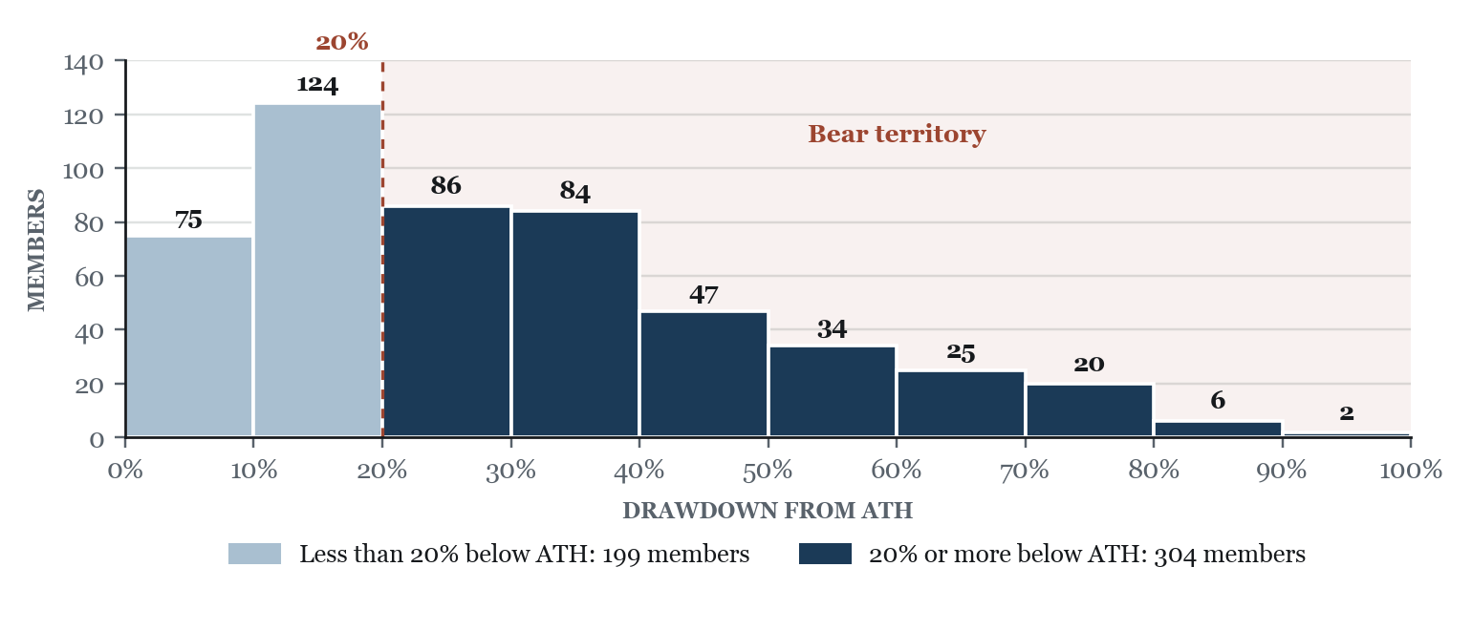
The S&P 500 is market cap-weighted, meaning a small number of large companies near their all-time high can hold the index up while hundreds of smaller members are not. Notable names that have contributed significant growth over the last four years and still sit in the 0-10% below ATHs range include CRWD (−0.5%), AAPL (−2.4%), AMD (−2.6%), NVDA (−4.7%), META (−6.6%), PLTR (−7.6%) and MSFT (−9.9%).
Exhibit 2
Two reference highs, two different markets
Share of the index at or beyond each drawdown threshold, measured against ATHs and against 52-week highs. The gap widens as the threshold deepens. At the 50% mark, the ATH lens finds five times as many names.
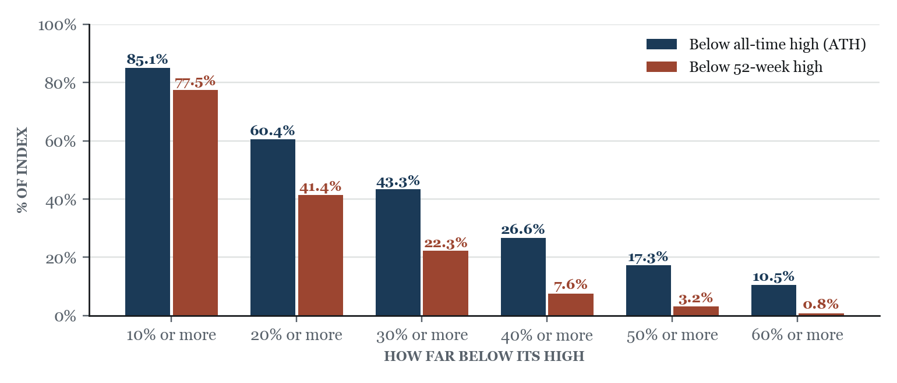
The 52-week view understates the damage because it resets every year. A stock that peaked years ago and has traded sideways since looks fine against a 52-week high but is still far below its ATH. That is why 41.4% of members are 20% or more below a 52-week high and 60.4% are below their ATH. The gap widens at deeper thresholds (87 members are 50% or more below their ATH vs. 16 on a 52-week basis), which points to stocks that have stopped falling but never recovered.
Exhibit 3
Every member, ranked
All 503 constituents ordered from smallest drawdown to largest. The curve crosses the 20% line at rank 199 — and keeps falling for another three hundred names.
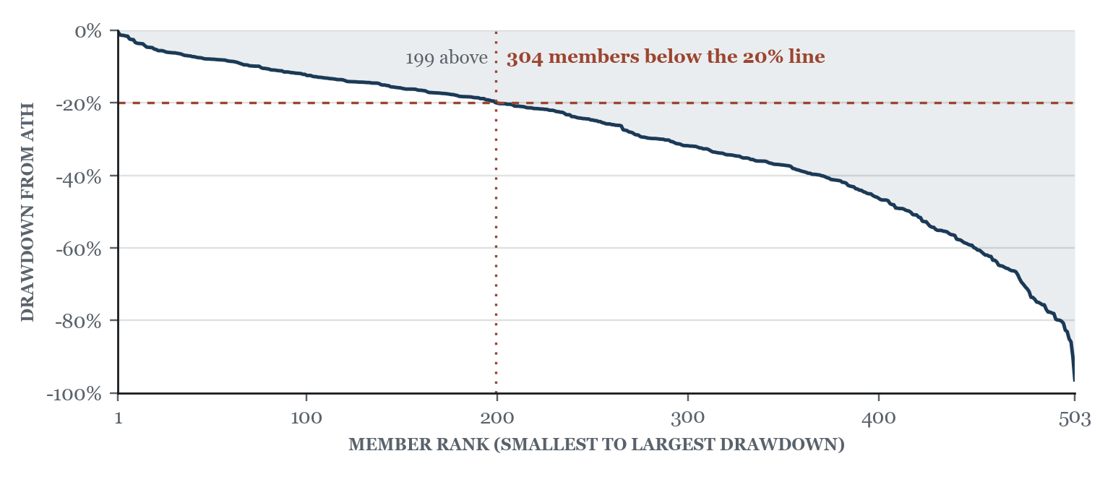
The curve crosses the 20% line at member 199, so 304 members are past it. The median member is 24.9% below its ATH. The slope is gradual through the middle and steepens at the far end, where 28 members are more than 70% below. This is broad weakness with a tail, not a market split between a few winners and a few disasters.
II. Where It Sits
Exhibit 4
Sector breadth against all-time highs
Share of each sector's members more than 20% below their ATH, with member count and sector median drawdown.
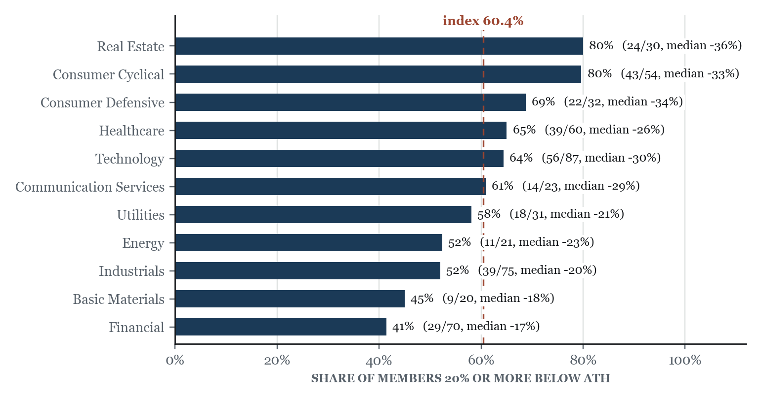
Real estate and consumer cyclical are the worst at 80% each, and financials are the best at 41% (median −17%). Real estate is rate sensitive, and the higher rate environment since 2022 pushed valuations down across the sector (median member 36% below ATH). 13 of 54 consumer cyclical members are 50% or more below their ATH, so those names have not recovered from earlier peaks. Technology is split. Chip and hardware names are near their highs (NVDA −4.7%, AMD −2.6%, AAPL −2.4%), while software and services are deep in drawdowns (ADBE −65.6%, INTU −64.8%, ACN −56.0%).
Exhibit 5
The reference high changes the ranking
Same sectors, both lenses. Real Estate looks resilient on a 52-week view and worst in the index on an ATH view — the difference between a sector that has stopped falling and one that has recovered.
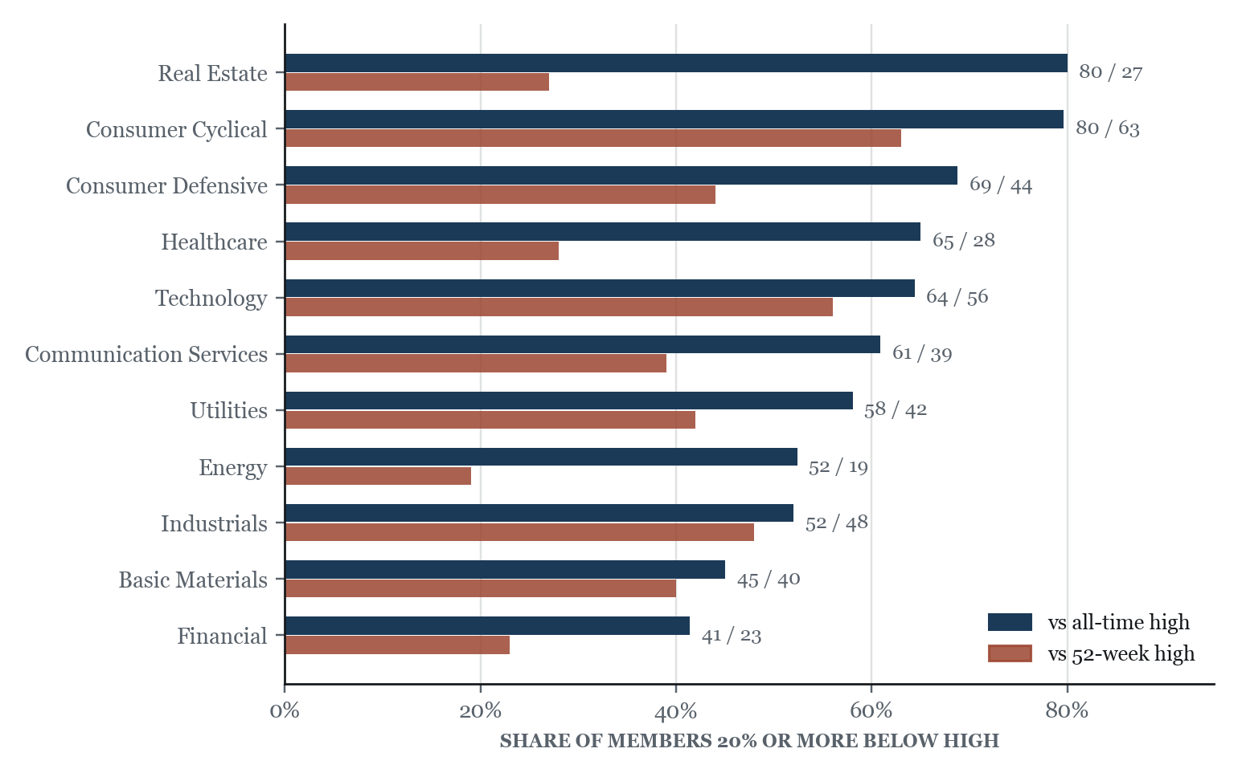
Real estate shows the difference best: 27% of members on a 52-week basis and 80% on an ATH basis. Energy (19% vs. 52%) and health care (28% vs. 65%) show the same pattern. Where the two numbers are close, as in technology (56% vs. 64%) and industrials (48% vs. 52%), the drawdowns are more recent and those sectors are still working through them.
Sector | Members | 20%+ below ATH | Share | Median | 52wk basis
Real Estate | 30 | 24 | 80% | −36% | 27%
Consumer Cyclical | 54 | 43 | 80% | −33% | 63%
Consumer Defensive | 32 | 22 | 69% | −34% | 44%
Health Care | 60 | 39 | 65% | −26% | 28%
Technology | 87 | 56 | 64% | −30% | 56%
Communication Services | 23 | 14 | 61% | −29% | 39%
Utilities | 31 | 18 | 58% | −21% | 42%
Energy | 21 | 11 | 52% | −23% | 19%
Industrials | 75 | 39 | 52% | −20% | 48%
Basic Materials | 20 | 9 | 45% | −19% | 40%
Financials | 70 | 29 | 41% | −17% | 23%
Index | 503 | 304 | 60% | −25% | 41%

III. Concentration
Exhibit 6
Cap-weighted against equal-weighted, since October 2022
The ratio of the market cap-weighted index to its equal-weighted counterpart.
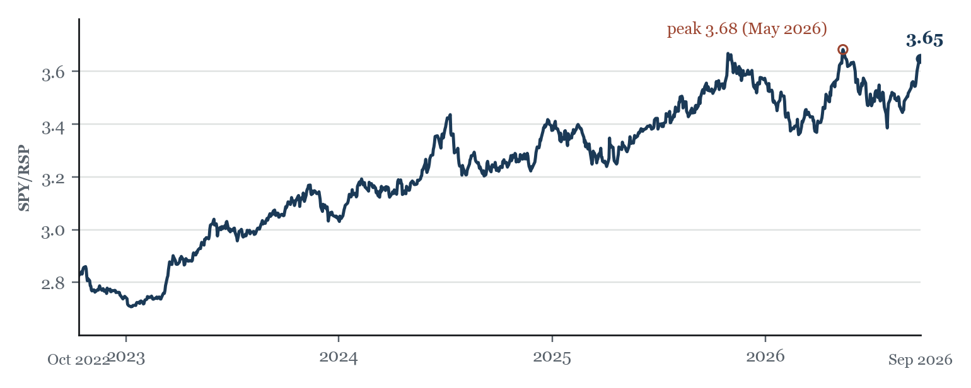
The ratio rose from 2.82 in October 2022 to 3.65 now (+29.2%), so the cap-weighted index has beaten the equal-weighted one by a wide margin in this bull market. YTD, SPY is +12.5% and RSP is +9.8%. This is the same story as Exhibits 1 through 5 from another angle: the largest companies are lifting the index while the average member lags. The ratio is 0.9% below its May 2026 peak, so the concentration has not unwound.
IV. Reads
01 The index level is the least representative number on the page.
A 1.4% drawdown at the index coexists with a 24.9% median drawdown at the member level. Equal-weighting closes part of that gap (the equal-weighted index, RSP, is 5.6% below ATH). Cap-weighting is doing the rest.
index −1.4% · equal-weight −5.6% · median member −24.9% · mean member −30.1%
02 Nothing is at an all-time high.
The closest company in the S&P 500 is just 0.5% below its ATH, and only 19 members are within 5%. The S&P 500 index being within 1.4% of its record is being driven almost entirely by its largest companies.
within 5% of ATH: 19 (3.78%) · best member −0.5%
03 The distribution has a heavy tail.
All-time high vs. 52-week high: 87 members are more than 50% below their ATH and 28 are more than 70% below, against 16 and zero respectively on a 52-week basis.
50%+ below: 87 vs 16 · 60%+: 53 vs 4 · 70%+: 28 vs 0
04 Real estate is the cleanest illustration of the two lenses.
On a 52-week basis, real estate is among the most resilient sectors at 27% of members in drawdown. On an all-time high basis, it is the worst in the index at 80%, with a median member 36% below its record. The sector has been stable for a year and has not recovered from what came before.
Real Estate: ATH basis 24/30 (80%), median −36% · 52wk basis 8/30 (27%)
05 Technology is worse than the index on both measures.
56 of 87 technology members are more than 20% below their ATH, the sector median is −30%, worse than the index median. The sector whose largest constituents are holding the index near its record contains one of the weaker member distributions in it.
Technology: 56/87 (64%) vs index 60% · median −30% vs index −25%
06 Financials are the only sector where most members are intact.
At 41% of members in drawdown and a median of −17%, financials are the sole sector below the index rate on both lenses. Basic Materials and Industrials follow. The spread between the best and worst sector is 39 points on the ATH basis.
Financials 29/70 (41%), median −17% · worst–best spread 39pp
07 Concentration is back near its four-year extreme.
The cap-weighted/equal-weighted ratio has retraced to 3.65, against a peak of 3.68 in May 2026 and a low of 2.71 in January 2023.
ratio 3.65 · peak 3.68 (May 2026) · low 2.71 (Jan 2023) · YTD cap-wt +12.5% vs equal-wt +9.8%
Sources
Exhibit 1: Yahoo Finance
Exhibit 2: Yahoo Finance, Finviz
Exhibit 3: Yahoo Finance
Exhibit 4: Yahoo Finance, Finviz
Exhibit 5: Yahoo Finance, Finviz
Exhibit 6: Alpha Vantage, SPY and RSP adjusted closes
ATH defined as the highest intraday price in each company's full available history.

Appendix: chart data (for rebuilding charts natively in Pages)
In Pages, select a table below, then use Insert > Chart to build an editable chart from it. The pictures above are static images; delete them once your native chart is in place.
Exhibit 1: members by drawdown range
Drawdown range | Members
0-10% | 75
10-20% | 124
20-30% | 86
30-40% | 84
40-50% | 47
50-60% | 34
60-70% | 25
70-80% | 20
80-90% | 6
90-100% | 2

Exhibit 2: share of index at or beyond each threshold
Threshold | ATH members | ATH % | 52-week members | 52-week %
10% or more | 428 | 85.1% | 390 | 77.5%
20% or more | 304 | 60.4% | 208 | 41.4%
30% or more | 218 | 43.3% | 112 | 22.3%
40% or more | 134 | 26.6% | 38 | 7.6%
50% or more | 87 | 17.3% | 16 | 3.2%
60% or more | 53 | 10.5% | 4 | 0.8%

Exhibit 3: every member, ranked
All 503 members (ticker, sector, drawdown from ATH) are in the companion file beneath-the-index-data.csv. Open it in Numbers to sort or chart.
Exhibit 6: SPY/RSP ratio, first trading day of each month
Date | Ratio | Date | Ratio
2022-10-12 | 2.82 | 2024-10-01 | 3.22
2022-11-01 | 2.79 | 2024-11-01 | 3.27
2022-12-01 | 2.77 | 2024-12-02 | 3.26
2023-01-03 | 2.74 | 2025-01-02 | 3.38
2023-02-01 | 2.72 | 2025-02-03 | 3.35
2023-03-01 | 2.74 | 2025-03-03 | 3.31
2023-04-03 | 2.88 | 2025-04-01 | 3.26
2023-05-01 | 2.90 | 2025-05-01 | 3.33
2023-06-01 | 3.04 | 2025-06-02 | 3.38
2023-07-03 | 3.00 | 2025-07-01 | 3.38
2023-08-01 | 3.00 | 2025-08-01 | 3.45
2023-09-01 | 3.04 | 2025-09-02 | 3.44
2023-10-02 | 3.09 | 2025-10-01 | 3.53
2023-11-01 | 3.14 | 2025-11-03 | 3.66
2023-12-01 | 3.09 | 2025-12-01 | 3.59
2024-01-02 | 3.03 | 2026-01-02 | 3.56
2024-02-01 | 3.13 | 2026-02-02 | 3.51
2024-03-01 | 3.17 | 2026-03-02 | 3.37
2024-04-01 | 3.14 | 2026-04-01 | 3.41
2024-05-01 | 3.15 | 2026-05-01 | 3.56
2024-06-03 | 3.24 | 2026-06-01 | 3.64
2024-07-01 | 3.38 | 2026-07-01 | 3.50
2024-08-01 | 3.23 | 2026-08-03 | 3.49
2024-09-03 | 3.21 | 2026-09-01 | 3.51

Template notes (delete this page before using)
Styles: every element uses a named paragraph style (Series, Report Title, Deck, Byline, Section Heading, Exhibit Label, Exhibit Title, Exhibit Description, Analysis, Read Heading, Read Body, Evidence, Sources Heading, Source Item, Table Text). Change a style once in the Pages Format sidebar (Paragraph Styles) and every use updates.
Font: set to Georgia, which every Mac has. Swap it in the style definitions to try another face.
Colors: ink 16191C, navy 1B3A57, brick 9C4530, muted 59626B, highlight DDE7F0.
Charts: the pictures are static. Build native charts from the appendix tables (Insert > Chart), or replace a picture by dragging in a new image over it.
To save as a reusable template: File > Save as Template.

