**SEAIT SCMS: SEAIT SCHOOL CLINIC MANAGEMENT SYSTEM**

A project study presented to the faculty of

South East Asian Institute of Technology

College of Information and Communication Technology

In partial Fulfillment

of the requirement for the subject

IT 228: System Analysis and Design

**By:**

**CASIANO, JACK LESTER T.**

**LIGAYA, IAN VINCENT C.**

**OLIVA, KATHLEEN NICOLE D.**

MAY 2024

**CHAPTER I**

**INTRODUCTION**

**Rationale of the Study**

The rise of technology has transformed how we manage information, making its adoption crucial for our generation to improve efficiency and service quality across various sectors, inducing offices. For clinics seeking to simplify workflows and enhance patient care, clinic management systems offer a technological solution. A School Clinic Management System (SCMS) is a computer-based system that ensures orderly and systematic access to student medical information through smooth information management and automation of case report generation. A clinic management system aims to improve healthcare operations management in terms of accuracy, efficiency, and general management. focuses on reducing form writing errors through the use of digital platforms instead of manual, conventional approaches. The CMS dramatically lowers errors through the use of intelligent forms that evaluate and correct input, improving patient care and data quality (Nurpathama, 2023).

South East Asian Institute of Technology, Inc. (SEAIT) started its operations in February 2006. The institution has a school clinic with two offices: one in the MST building for high school and college students and another in the RST building for elementary students. Until 2022, there was only one nurse and one nursing assistant to handle patients. Currently, there are two school nurses and two nursing assistants, together with two graduating students who undergo on-the-job training, four part-time working students, and three student volunteer responders. The school has an approximate population of 16 000 students for the school year 2023 - 2024, with an average daily patient count of 10. School nurses document all student visits, with occasional help from nursing assistants, in logbooks. These records include details like the reason for the visit, the student’s concern, and any actions taken. The consultation process involves the nurse asking about symptoms, checking for vitals, and assessing potential causes for the student’s condition. Teachers who are often with the student are asked for additional information. Depending on the situation, the nurse might prescribe medication, send the student home, or refer them to the municipal hospital or the rural health unit. Available medication is provided by the clinic and details are logged as well. The clinic offers basic first aid like managing hyperventilation or treating minor wounds. All of these cases are documented for monitoring purposes. A monthly summary is sent to the students affairs office to track frequent health concerns in the student body where one nurse covers the students in basic education and one nurse covers the college students. Nurses manage student files by category, year level, and course. Nursing assistants keep track of the medication inventory by labeling the medicines on containers containing the medicine’s name and quantity.

The SEAIT School Clinic faces challenges due to the traditional paper-based method, such as: (1) Nursing assistants are sometimes having trouble in understanding patient concerns and giving over-the-counter medication when the school nurses are not around so they sometimes make the patient wait resulting to delayed treatment; (2) Paper-based medical records written by the clinic staff can be lost, misplaced, or illegible which causes incomplete or inaccurate medical history information; (3) Retrieval of medical history is challenging for the clinic staff as they only use logbooks for recording which causes difficulty in identifying the specific patient details and track their health over time; (4) The nurses generate monthly summaries of case reports manually, thus, it is time-consuming and prone to errors which leads to data duplication and possible missing information; and, (5) Manual inventory tracking of medication stocks done by the clinic staff lacks real-time data making it difficult for the clinic staff to anticipate stock needs which leads to wasted resources and unnecessary delays in treatment.

The SEAIT School Clinic Management System aims to address these limitations by offering a comprehensive solution to make clinic operations more efficient and improve student healthcare in South East Asian Institute of Technology, Inc. Storing all processes in a database will simplify record-keeping and report retrieval for the school nurses and clinic staff. This will empower the school clinic to provide more efficient, effective, and secure care for its student population. Implementing this system is not just a technological upgrade, but a commitment to better student healthcare delivery, resource utilization, and data security.

**Objectives of the Study**

**General Objectives**

The researchers aim to study and develop a School Clinic Management System (SCMS) for South East Asian Institute of Technology, Inc. located at National Highway, Crossing Rubber, Tupi, South Cotabato 9505.

**Specific Objectives**

* To be able to develop a system that automatically prescribes medications for a predefined list of common illnesses, reducing errors and wait times.
* To be able to create a system that provides electronic medical record (EMR) for each patient consultation.
* To be able to easily access patient medical history, their previous transactions in the school clinic, their allergies, past medications and illnesses, and family history.
* To be able to automatically generate monthly summaries for case file reports by categories (illnesses).
* To be able to develop a system that monitors stock levels of all medications, automatically notifying the staff when stock levels fall below a predefined threshold.

**Scope and Limitations of the Study**

**Scope of the Study**

The SEAIT School Clinic Management System is capable of the following:

**Automated Prescription Generation**

This automatically prescribes over-the-counter (OTC) medications for a predefined list of common illnesses. With this, the clinic staff will pick an illness on a dropdown list based on the patient’s signs and symptoms, and the system will match it to an appropriate OTC medication. The system does not intend to diagnose or treat complex medical conditions.

**Patient Consultation**

This stores electronic medical record (EMR) for each patient consultation. The system provides a standardized template for storing patient demographics, presenting findings which include complaints, signs, symptoms, and vital signs, and treatment plan, which includes given medication and nursing recommendations. This enables easy retrieval of past medical records for future consultations.

**Medical History Access**

This shows medical history of each patient, containing their check-up records at the clinic. Under this, the system displays a chronological view of all past consultations, diagnoses, medications, and procedures. This allows the clinic staff to view and update patient medical records for continuity of care.

**Case Report Automation**

This automatically generates case reports monthly. The system will then produce a PDF file of the summary of case reports. In the said PDF file, it will show relevant data like patient name, course, findings, treatment, and the exact date they went to the clinic.

**Medical Inventory Management**

This monitors stock levels of all medications and notifies the clinic staff when stock levels are low. The system maintains a centralized database of all medications in the clinic’s inventory. With this, it would be easier for the clinic staff to maintain stock levels for each medicine.

**Limitations of the Study**

The study is only intended for the SEAIT School Clinic. This research project focuses only on prescription automation for a defined list of common illnesses, EMR creation and management, access to patient medical history for authorized personnel, monthly summary of case report generation, and inventory tracking for a defined list of medicines. This system will not include functionalities for managing chronic illnesses or complex medical conditions and will not integrate with external healthcare providers at this stage. The system’s effectiveness depends on the accuracy of data entered by the clinic staff. Technical issues or power outages could disrupt system access. The system will only be available online on desktop computers.

**Significance of the Study**

The system has the potential to significantly impact the school, clinic, staff, and students, leading to improved healthcare delivery. Specifically, this study aims to benefit the following:

**SEAIT School Clinic**

The School Clinic Management System ensures efficient and effective healthcare delivery and accurate and secure medical record management.

**SEAIT School Clinic Staff**

The automation can alleviate the burden of administrative tasks, reducing stress and improving job satisfaction for the School Nurses and Nursing Assistants.

**Students**

The system provides access to their health information through the system which can promote student engagement and health awareness.

**Researchers**

This is an opportunity for the researchers to utilize their skills and knowledge in research, putting what the researchers have learned as Information Technology students into practice.

**Future Researchers**

This study will be of great help to future researchers who plan to design and develop an improved School Clinic Management System as it will provide them 1) documentation that will serve as the literature, and 2) the source code of the system which will guide in the development of a new, enhanced system.

**Flow of the Study**

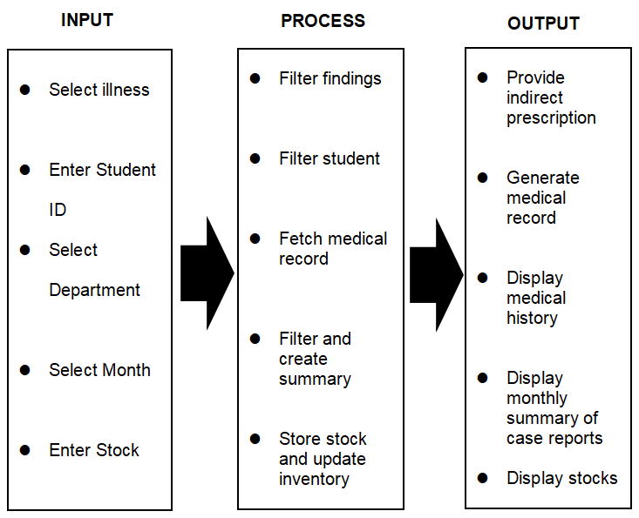

*Figure 1.1: Flow of the Study of SEAIT SCMS: SEAIT School Clinic Management System*

**Definition of Terms**

**Assessment –** a comprehensive evaluation of the patient’s health status.

**Automation –** reduces the tasks the clinic staff have to do manually.

**Case Report –** document relating to the incident regarding the patient’s situation.

**Consultation –** a conversation between the school nurse and the patient that aims to understand the patient’s concerns, assess the patient, develop a treatment plan, and answer the patient’s questions.

**Emergency Inpatient –** a patient needing urgent medical attention who is brought by their classmates or rescued by the volunteer responders from their rooms to the school clinic.

**Emergency Outpatient –** a patient needing urgent medical attention who is automatically referred to the municipal hospital or the rural health unit.

**EMR (Electronic Medical Record) –** a digital version of the patient’s medical history, including diagnoses, medications, allergies, and past illnesses.

**First Aid Treatment** **–** initial care given to a sick or injured person, with minor injuries and illnesses, until professional medical help is available or needed.

**Inventory Management –** tracking stock levels of medications supplies.

**Medical History –** how frequently a student visits or is brought to the clinic.

**Monitoring –** keeping track and checking the stock levels of medicine in the SEAIT School Clinic.

**Over-the-counter (OTC) Medication –** approved medications which can be provided to patients without a prescription.

**Recommendation –** a course of action suggested by the school nurse based on their assessment of the patient’s condition.

**SEAIT School Clinic –** the area of investigation and where patients are brought to be given first aid treatment.

**Walk-in Inpatient –** a patient who visits the school clinic for a non-life-threatening issue and stays there to rest for a while after treatment.

**Walk-in Outpatient –** a patient who visits the school clinic for a non-critical issue and is released after treatment.

**CHAPTER II**

**REVIEW OF RELATED LITERATURE AND STUDIES**

To address many concepts, ideas, and understandings involving both local and foreign literature of the studies, a review of connected literature and studies is established. The information from the past to the present is analyzed and provided in this study, which aids the researcher in creating project proposals. The various studies and publications related to the clinic management system.

**Review of Related Literature**

**Foreign Literature**

**MediChain: Medical Record Management System**

There's a gap between the current limitations of Electronic Health Records (EHRs) and the potential of a blockchain-based system. Traditional EHRs, managed by healthcare providers, suffer from security breaches, data fragmentation, and limited access for patients. Blockchain, a secure and tamper-proof distributed ledger technology, addresses these issues. Research suggests that a blockchain-based system like MediChain can create a secure and reliable platform for storing medical records, while also empowering patients to control access and share information seamlessly with healthcare providers and researchers. This improved data exchange could lead to better diagnoses, faster treatment, and more efficient healthcare delivery (Katile, 2023).

**School Clinic Management Module in the Pioneers E-School System**

While the Pioneers E-School system offers a comprehensive suite of tools for managing student medical records and clinic logistics (medications, doctor information, scheduling examinations), there appears to be a gap in functionalities specifically addressing the needs of students with chronic health conditions (Salah, 2023). The system excels at storing past medical information and facilitating communication between healthcare providers, but it lacks features to support daily management plans or medication adherence tracking for these students. This highlights a potential need for additional functionalities within the School Clinic Management module to ensure students with chronic conditions receive the most effective care during school hours.

**Local Literature**

**Medicine Management System: Its Design and Development**

There's a gap between the current situation and the desired outcome. Currently, residents need to physically visit the health center to request refills for their medication, which can be inconvenient, especially during a pandemic. The researchers addressed this gap by developing a "Medicine Management System," an online platform accessible anytime, anywhere. This system aims to expedite the medicine requisition process by eliminating the need for in-person visits and long queues The system offers an assurance that the file will be protected and safe for it will also require authorization before someone can access the system (Luciano et al., 2023).

**MediCord: A Web-Based Health Record Management System**

In response to the challenges of the COVID-19 pandemic, which necessitates secure and efficient data sharing, this study developed MediCord, a web-based health record management system using a developmental research approach. In order to handle the files and data in the community health centers effectively, this project aimed to offer an information technology-based solution. It also seeked to record and evaluate data necessary for decision-making correctly. Additionally, it aimed to raise the standard of procedures followed while obtaining and issuing medical records and approvals. The project successfully designed and implemented the system following the Software Development Life Cycle (SDLC), which resulted in valuable diagrams for construction. While further stages of SDLC and industry standard assessments are recommended, this project opens doors for future studies to evaluate its effectiveness in a real-world healthcare setting (Olipas et al., 2022).

**Review of Related Studies**

**Foreign Studies**

**Web-based Clinic Management System (CMS)**

A gap exists in healthcare services where managing patient records is complex due to their size and the lack of a unified system for exchanging information like prescriptions and appointments. This inefficiency stems from paper-based approaches and limited access to electronic records. The Clinic Management System (CMS) was developed to automate Sule Lamido University Clinic's manual processes, specifically record-keeping (Muhammad & Garba, 2020). While the system improves efficiency for practitioners and patients by replacing manual tasks, it currently only focuses on interactions between receptionists, doctors, pharmacists, and patients. Future plans aim to expand functionality in two key areas: 1) integrating with laboratory systems to include test results and analysis, and 2) exploring interfaces with pharmaceutical company applications for medication information and potentially linking the Clinic and Pharmacy modules.

**Patient Management System** This study identified limitations in both manual and existing computer-based systems used by small clinics to manage patient information (Gomes, 2020). Currently, accessing past medical history can be inconvenient, and transferring records to new doctors can be slow, posing a critical challenge in emergencies. A cloud-based patient management system (PMS) addresses these issues by storing data centrally with secure access levels for doctors, patients, staff, and administrators. The implemented system prioritizes data reliability, security, efficiency, and user experience. Built on a client-server architecture with Spring Boot and Angular, the application leverages Docker containers for portability and easier deployment. Recognizing the importance of patient information security, the system uses Spring Security, JWT tokens, and a REDIS server (token blacklist) for robust authentication and authorization. By streamlining workflows for doctors, staff, and patients, the cloud-based PMS improves overall clinic operations and patient care. Additionally, automation of daily tasks contributes to a potentially effective and efficient business model for small healthcare practices.

**Local Studies**

**Computerized Medical Record and Monitoring System of Saint Michael College of Caraga, Philippines**

A study investigating the implementation of a computerized medical record system at Saint Michael College Caraga (SMCC) aimed to address the limitations of the current paper-based system. While paper charts offer some advantages, they lack the efficiency and security of a digital solution. The research found that the computerized system improved medical record management for both students and staff at the SMCC clinic. It securely stores and updates patient data, streamlining clinic operations and allowing for easier report generation. However, the study doesn't explore the potential drawbacks of the system, such as user adoption challenges or cybersecurity risks. This gap in research highlights the need for further investigation into the long-term impact and potential hurdles associated with implementing computerized medical records in school clinics (Bergado et al., 2020).

**A Web-Based Clinic Records Management and Inventory System for St. Paul University Quezon City**

A web-based records management system was developed for St. Paul University Quezon City to improve efficiency for doctors, nurses, and students. While the system aimed to address general workload and record-keeping needs, the research focused on functionalities relevant to medical staff, including patient records, inventory management, and potentially appointment scheduling. The evaluation using ISO 25000 standards confirmed software quality, but the detailed functionalities for student appointment scheduling and the impact on student experience are not explicitly mentioned in this excerpt (Calucin et al., 2020). There might be a gap between the system's intended purpose and the reported research focus.

**CHAPTER III**

**RESEARCH METHODOLOGY AND DESIGN**

This chapter presents theories associated with obtaining necessary to be used in this study, software methodology, research design, and system development phases which include the planning, design, development, testing, deployment, and review.

**Environment**

The study took place at the SEAIT School Clinic, National Highway, Crossing Rubber, Tupi, South Cotabato.

**Software Methodology**

The Rapid Application Methodology (RAD) will be the model used for the software development of SEAIT School Clinic Management System. According to Team Kissflow (2024), Rapid Application Development (RAD) methodology focuses on developing applications rapidly through frequent iterations and continuous feedback. The model comprises of four (4) phases, which include:

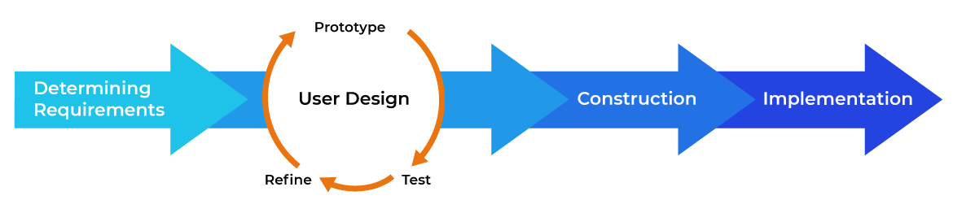

*Figure 3.1: Software Model: RAD Model for SEAIT SCMS that illustrates the System Development Process.*

**System Development Phases**

**Determining Requirements**

The requirements for SEAIT School Clinic Management System were determined by interviewing the target users. First, they were asked how the processes in SEAIT School Clinic are done. Second, they were asked about what part of their processes they find to require improvements/streamlining. The researchers summarized their findings; prescription, patient documentation, case reports, and inventory management. The prescription requires the help of the nurse to identify the illness and what medicine to prescribe. The patient documentation is written in a records book which takes the third finding, case reports, considerable time in summarizing. The inventory is manually checked by the nurse and assistants for stock levels.

**User Design**

**Prototype**

The prototype was created according to the findings of the researchers. First, the prescription was designed with easy processing in mind by having prescribed medicine be associated with common illnesses to streamline the prescription process. Second, the patient documentation was planned to be retrievable via student-id. Third, the case reports were designed to be separated by month. and Fourth, the inventory was planned to be tracked via the system the researchers will make.

**Test**

The testing of the prototype was conducted with the help of the nurse and assistants of SEAIT School Clinic. The prototype of the system was shown and demonstrated to the target users and their suggestions were integrated into the system.

**Refine**

The refining of the system was based on the initial prototype and the suggestions of the target users during testing. The refined prescription was integrated with the inventory of the system, having the prescription deduct from the stock levels in the inventory. The patient documentation has an addition of separating the patient entries by college department and patient history. And the case reports are to be generated into a PDF file.

**Construction**

Construction of the system started when the prototype was approved. Construction was separated into sections, mainly the prescription section, documentation section, case reports section, and inventory section. The prescription section was created first, integrating the findings from the user design phase, while keeping in mind its connection to the inventory section. The patient documentation was constructed second, as patient documentation is directly connected to the prescription method. The documentation section is divided into two; Patient record and Patient History. Patient record is the initial documentation of a patient transaction and Patient history is part of documentation wherein the user can retrieve medical history of the patient.

The case reports section follows as its data is from patient documentation. And lastly, the inventory section was built connected to the prescription section.

**Implementation**

In the implementation phase, the system is to be handed over to the target user. The system will streamline the processes in SEAIT School Clinic

**Business Model Canvas**

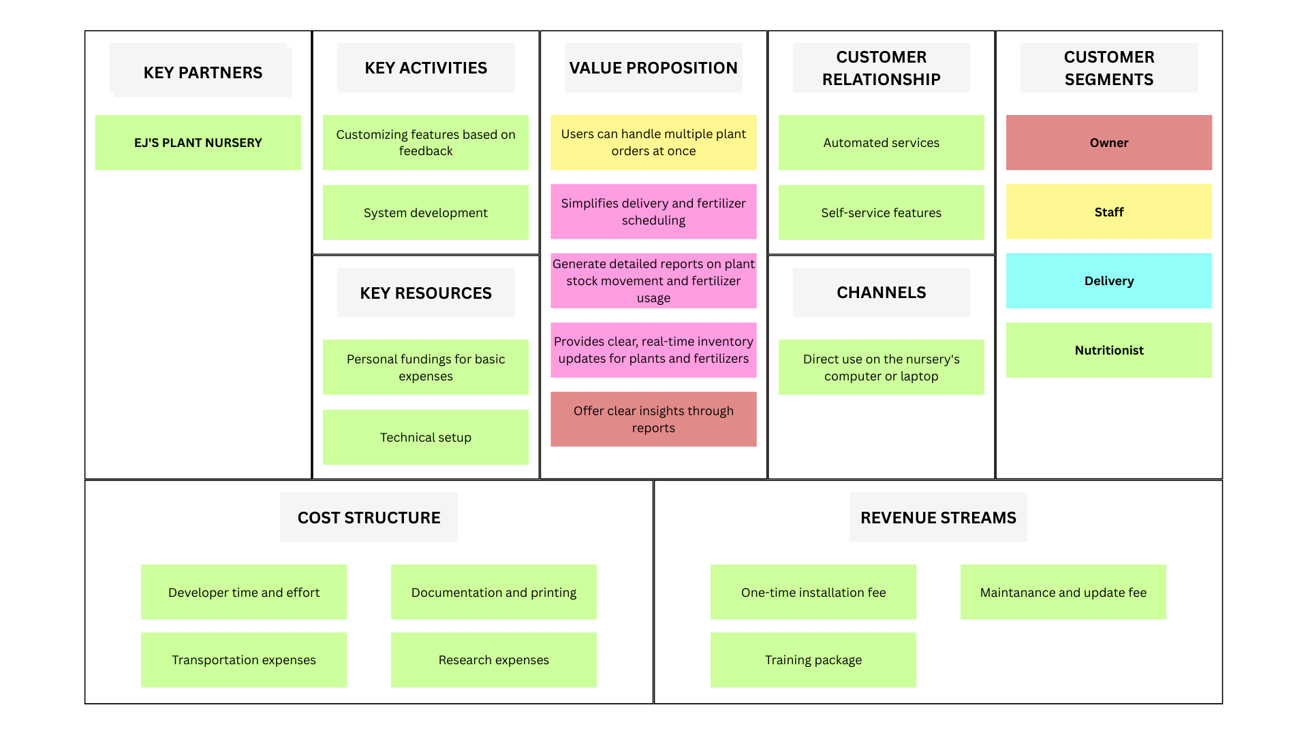

*Figure 3.2 SEAIT SCMS Business Model Canvas*

*This is the strategic management and lean startup template for the development of the SEAIT SCMS: School Clinic Management System. This is the overview that lays out both what is the system for and how it will run.*

**Gantt Chart**

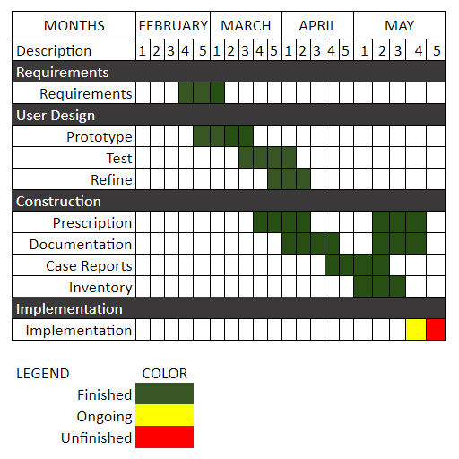

*Figure 3.3: Gantt Chart*

*This chart illustrates this project’s schedule. This illustrates the start and ending week of the terminal elements and summary elements of the project. Terminal elements and summary elements comprise the work breakdown structure of the development of the system.*

**Functional Decomposition Diagram**

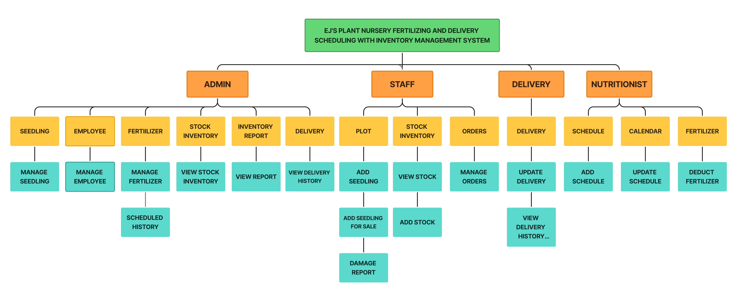

*Figure 3.4: Functional Decomposition Diagram*

*This figure shows the flow of the EJS’s Plant Nursery Fertilizing and Delivery Scheduling With Inventory Management.*

**Use Case Design Phase**

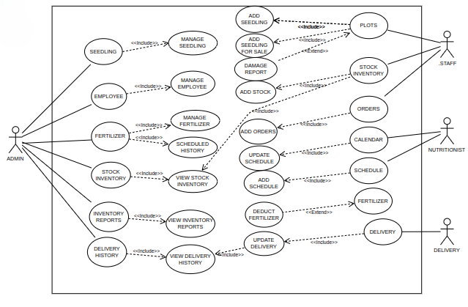

*Figure 3.5: EJ’s Plant Nursery Use Case Design*

*A use case diagram is a graphical depiction of a user's possible interactions with a system.*

**Use Case Matrix**

| **General Characteristics** | |
| --- | --- |
| **Intent** | To identify the purpose of the features that SEAIT School Clinic Management System has |
| **Scope** | The scope of this Use Case is Nurse(Admin) and Assistant(User) Only |
| **Level** | 2nd Level |
| **Author** | Oliva, Kathleen Nicole, Ligaya, Ian Vincent, and Casiano, Jack Lester |
| **Last Update** | May 16, 2024 |
| **Status** | Ongoing |
| **Primary Actor** | Nurse(Admin), who has access to all system functions |
| **Secondary Actor** | Assistant(User). Can add and view but cannot update and delete |
| **Precondition** | The developer must assist the admin and user for using this system |
| **<Dynamic Precondition>** | The admin and user must explore the system to familiarize with the functions that run without encountering problems |
| **Assumptions** | All the Dynamic Preconditions are running successfully |
| **Trigger** | When the admin and user login and start to add new patient records and details to the system |
| **Success Post Condition** | After login, all the functions and features that are based on the current problem was running successfully with little precondition |
| **Failed Post Condition** | Other modules are still on progress |
| **<Model>** | Use Case Matrix |
| **Operation Concepts** | In implementing this system, the system must run according to the feature that the developers created in observing the current problems of the respondents. The functions will help in managing the SEAIT School Clinic in day-to-day operations and monthly case reports. |
| **Overview** | Several Modules are not fully functional and are still in progress. Analyzing and correcting the errors will ensure smooth use before full implementation. |

*Table 3.1: SEAIT SCMS Use Case Matrix*

**Database Design**

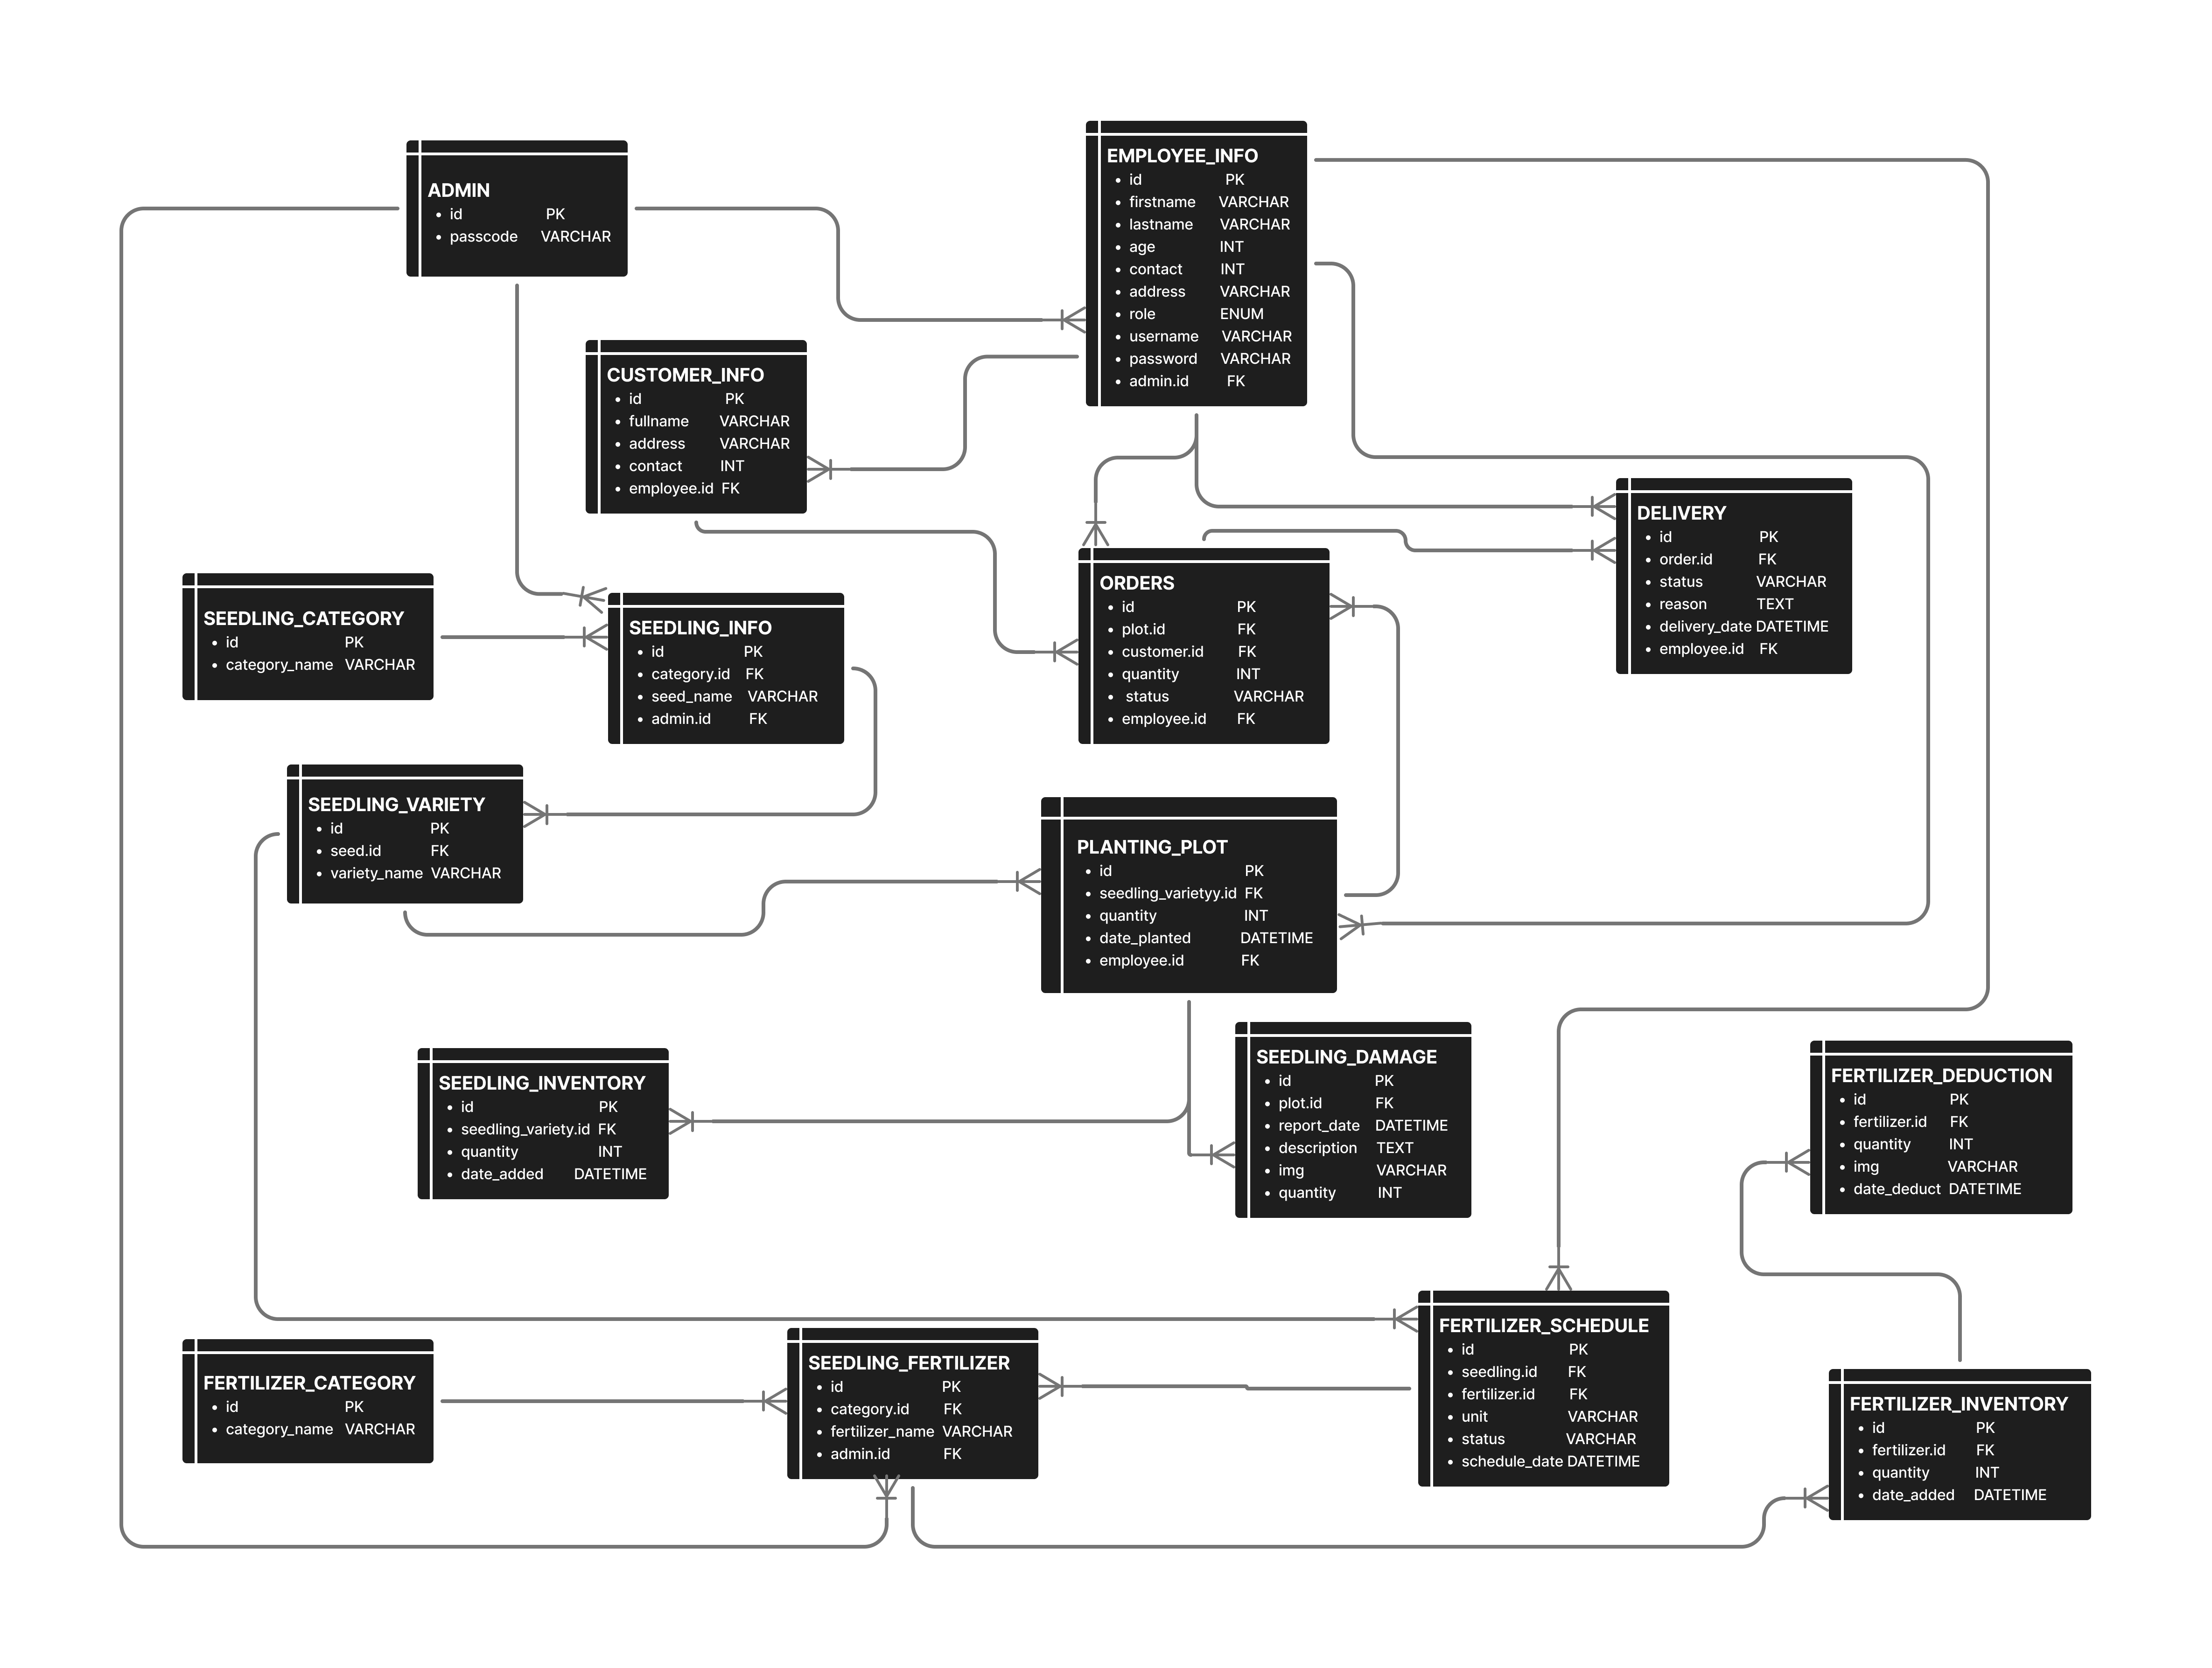

*Figure 3.9: SEAIT SCMS Database design.*

*This figure will determine what data is stored and managed.*

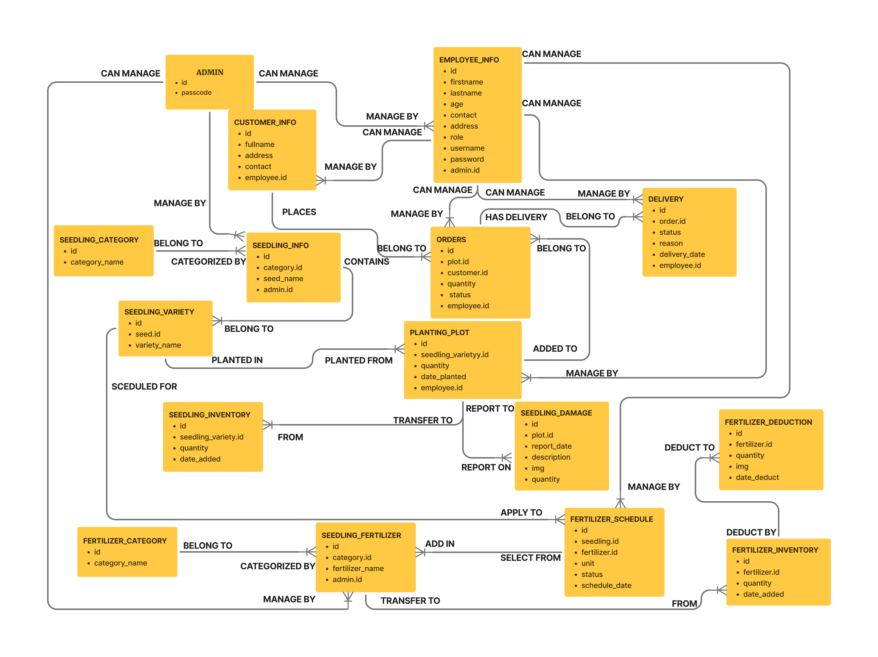

**Entity Relationship Diagram**

*Figure 3.10: Entity Relationship Diagram to depict relationships among the users, objects, or events within the SEAIT SCMS.*

**Data Dictionary**

|  |  |  |  |  |
| --- | --- | --- | --- | --- |
| **ADMIN** |  |  |  |  |
| **Attribute** | **Type** | **Null** | **Default** | **Description** |
| id | vnt(11) | No | PK | ID of admin |
| passcode | varchar(255) | No |  | Admin password |

*Table 3.2.1: Data Dictionary Admin Table.*

|  |  |  |  |  |
| --- | --- | --- | --- | --- |
| **EMPLOYEE_INFO**  **Attribute** | **Type** | **Null** | **Default** | Description |
| id | int(11) | No | PK | ID of employee |
| firstname | varchar(255) | No |  | Employee name |
| lastname | varchar(255) | No |  | Employee name |
| age | Int(11) | No |  | Employee age |
| contact | Int(50) | No |  | Contact number |
| address | text | No |  | location of employee |
| role | enum | No |  | Role of employee |
| username | varchar(255) | No |  | Username of employee |
| password | varchar(255) | No |  | Password of employee |
| admin.id | Int(11) | No | FK | Admin ID |

*Table 3.2.2: Data Dictionary Employee Table.*

|  |  |  |  |  |
| --- | --- | --- | --- | --- |
| **CUSTOMER_INFO**  **Attribute** | **Type** | **Null** | **Default** | Description |
| id | int(11) | No | PK | ID of customer |
| fullname | varchar(255) | No |  | customer name |
| address | varchar(255) | No |  | Location of customer |
| contact | Int(50) | No |  | Contact number |
| employee.id | Int(11) | No | FK | Employee ID |

*Table 3.2.3: Data Dictionary Medical Records Table of SEAIT SCMS.*

|  |  |  |  |  |
| --- | --- | --- | --- | --- |
| **SEEDLING_INFO**  **Attribute** | **Type** | **Null** | **Default** | Description |
| id | int(11) | No | PK | ID of seedling |
| category_id | Int(11) | No | FK | Category of seedling |
| Seed_name | varchar(255) | No |  | Name of seedling |
| admin.id | Int(11) | No | FK | ID of admin |

*Table 3.2.4: Data Dictionary Student Table of SEAIT SCMS.*

|  |  |  |  |  |
| --- | --- | --- | --- | --- |
| **SEEDLING_CATEGORY**  **Attribute** | **Type** | **Null** | **Default** | Description |
| id | int(11) | No | PK | ID category of seedling |
| category_name | varchar(255) | No |  | Name of category |

*Table 3.2.5: Data Dictionary Case Table of SEAIT SCMS.*

|  |  |  |  |  |
| --- | --- | --- | --- | --- |
| **SEEDLING_VARIETY**  **Attribute** | **Type** | **Null** | **Default** | Description |
| id | int(11) | No | PK | ID variety of seedling |
| seed_id | int(11) | No | FK | ID of seedling |
| variety_name | varchar(255) | No |  | Name of seedling variety |
| price | Int(11) | No |  | Price of seedling variety |

*Table 3.2.6: Data Dictionary Inventory Table of SEAIT SCMS.*

|  |  |  |  |  |
| --- | --- | --- | --- | --- |
| **SEEDLING_FETILIZER**  **Attribute** | **Type** | **Null** | **Default** | Description |
| id | int(11) | No | PK | ID of fertilizer |
| fertilizer_name | varchar(255) | No |  | Name of fertilizer |
| category_id | int(11) | No | FK | Category id of fertilizer |
| admin.id | Int(11) | No | FK | Admin ID |

|  |  |  |  |  |
| --- | --- | --- | --- | --- |
| **FERTIIZER_SCHEDULE**  **Attribute** | **Type** | **Null** | **Default** | Description |
| id | int(11) | No | PK | ID of fertilizer schedule |
| seedling_id | int(11) | No | FK | ID of seedling to fertilized |
| Fertilizer_id | INT(11) | NO | FK | ID of fertilizer to use |
| unit | varchar(255) | No |  | Unit to use |
| scheduled_date | datetime | No |  | Time of schedule |
| status | varchar(255) | No |  | Status of fertilizing result |
| employee.id | Int(11) | No | FK | Employyee ID |

|  |  |  |  |  |
| --- | --- | --- | --- | --- |
| **FERTILIZER_DEDUCTION**  **Attribute** | **Type** | **Null** | **Default** | Description |
| id | int(11) | No | PK | ID of fertilizer deduction |
| fertilizer.id | int(11) | No | FK | Fertilizer ID |
| quantity | int(11) | No |  | Total to deduct |
| img | varchar(255) | No |  | Photo to deduct |
| date_deduct | datetime | No |  | Date of deduction |

|  |  |  |  |  |
| --- | --- | --- | --- | --- |
| **SEEDLING_INVENTORY**  **Attribute** | **Type** | **Null** | **Default** | Description |
| id | int(11) | No | PK | ID of inventory |
| seedling_variety.id | int(11) | No | FK | Seedling variety ID |
| quantity | int(11) | No |  | Total to inventory |
| date_added | datetime | No |  | Date of added to inventory |

|  |  |  |  |  |
| --- | --- | --- | --- | --- |
| **SEEDLING_DAMAGE**  **Attribute** | **Type** | **Null** | **Default** | Description |
| id | int(11) | No | PK | ID of inventory |
| plot.id | int(11) | No | FK | Plot ID |
| report_date | datetime | No |  | Date damage reported |
| description | text | No |  | Description of damage |
| img | varchar(255) | No |  | Photo of damage |
| quantity | INT(11) | NO |  | Total of damage |

|  |  |  |  |  |
| --- | --- | --- | --- | --- |
| **FERTILIZER_CATEGORY**  **Attribute** | **Type** | **Null** | **Default** | Description |
| id | int(11) | No | PK | ID of fertilizer category |
| category_name | varchar(255) | No |  | Name of category |

|  |  |  |  |  |
| --- | --- | --- | --- | --- |
| **FERTILIZER_INVENTORY**  **Attribute** | **Type** | **Null** | **Default** | Description |
| id | int(11) | No | PK | ID of fertilizer Iinventory |
| fertilizer_id | int(11) | No | FK | Fertilizer ID |
| quantity | Int(11) | No |  | Total stock |
| date_added | datetime | no |  | Date added in inventory |

|  |  |  |  |  |
| --- | --- | --- | --- | --- |
| **PLANTING_PLOT**  **Attribute** | **Type** | **Null** | **Default** | Description |
| id | int(11) | No | PK | ID of plot |
| seedling_variety.id | int(11) | No | FK | Seedling variety ID |
| quantity | int(11) | No |  | Total planted |
| date_added | Int(11) | No |  | Date added in plot |
| employee.id | Int(11) | No | FK | Employee ID |

|  |  |  |  |  |
| --- | --- | --- | --- | --- |
| **ORDERS**  **Attribute** | **Type** | **Null** | **Default** | Description |
| id | int(11) | No | PK | ID of orders |
| plot.id | int(11) | No | FK | Plot ID |
| customer.id | Int(11) | No | FK | Customer ID |
| quantity | Int(11) | No | FK | Total orders |
| status | varchar(255) | No |  | Status of orders |
| employee.id | Int(11) | No | FK | Employee ID |

|  |  |  |  |  |
| --- | --- | --- | --- | --- |
| **DELIVERY**  **Attribute** | **Type** | **Null** | **Default** | Description |
| id | int(11) | No | PK | ID of delivery |
| order.id | int(11) | No | FK | Order ID |
| status | varchar(255) | No |  | Status of Delivery |
| reason | text | No |  | Reason if canseled |
| employee.id | Int(11) | No | FK | Employee ID |

**Network Design**

Network design is the integration of the connection type of the devices to achieve end-to-end communication between the devices in the network, which helps to identify the type of topology the SEAIT School Clinic Management System is going to use.

*Figure 3.11: SEAIT School Clinic Management System Network Design*



**Network Topology**

The Network model that will be used is the Stand Alone topology model. In this model, the network is independent of any other node in the network and is often for an offline system. The system is designed to be offline and house its functions and data in the storage of the computer of the user.

*Figure 3.12: SEAIT School Clinic Management System Network Topology*



**Development/Construction/Build Phase**

**Technological Stack**

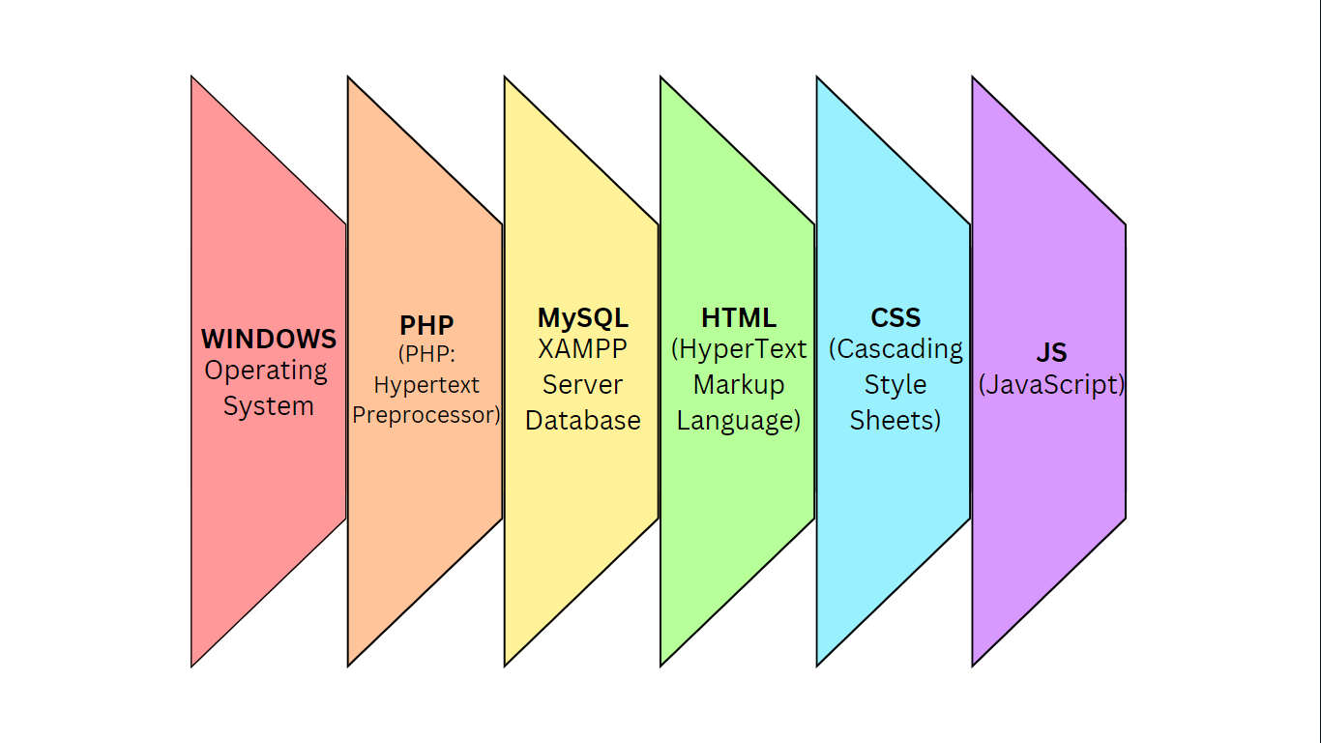

*Figure 3.13: SEAIT School Clinic Management System Technology Stack*

**Software Specification**

Language: PHP

Technology: HTML, CSS Framework, JS, PHP

Database: MySQL XAMPP Server

IDE: Visual Studio Code

Operating System: Microsoft Windows 11

**Hardware Specification**

Processor: Intel Core i5 12th gen

Hard Disk: 512 GB

RAM: 8.00 GB

**Program Specification**

Language: PHP

Database: MySQL

IDE: Visual Studio Code

**List of Modules**

**Automated Prescription Generator Module**

This module automatically prescribes over-the-counter (OTC) medications for a predefined list of common illnesses.

**Electronic Medical Record Module**

This module stores electronic medical record (EMR) for each patient consultation.

**Medical History Access Module**

This module shows medical history of each patient, containing their check-up records at the clinic.

**Case Report Automation Module**

This automatically generates case reports monthly in a PDF file.

**Medical Inventory Management Module**

This module monitors stock levels of all medications and notifies the clinic staff when stock levels are low, under a predefined threshold. It automatically reduces stock when a prescription is done.

**References**

Bergado, T. M., Esclamado, J. D., Godínez, M., Isaga, R., & Magallen, K. (2020). Computerized Medical Record and Monitoring System of Saint Michael College of Caraga, Philippines. *SMCC Interdisciplinary Journal*, *1*(1). https://doi.org/10.18868/SHERJIN1.01.100120.03

Calucin, R. A., Hapa, J. P., & Benito, J. P. (2020). The Web-Based Records Management for St. Paul University of Quezon City. *Cognoscere: SPUQC Student Research Journal*, *13*(1). https://ejournals.ph/article.php?id=14161

Gomes, J. P. L. (2020). *Patient Management System*. UCSC Digital Library. https://dl.ucsc.cmb.ac.lk/jspui/bitstream/123456789/4487/1/2017%20MIT%20019.pdf

Katile, U. (2023). MediChain: Medical Record Management System. *{International Journal for Research in Applied Science and Engineering Technology*. https://doi.org/10.22214/ijraset.2023.52365

Luciano, R., Torres, R. A., Gomez, E., Nacino, H. J., & Ramirez, R. (2023). Medicine Management System: Its Design and Development. *I. J. Education and Management Engineering*, *13*(3), 11-18. 10.5815/ijeme.2023.03.02

Muhammad, J., & Garba, S. (2020). *International Journal of Science and Engineering Applications*, *8*(5), 131-135,. https://ijsea.com/archive/volume8/volume8issue5.pdf

Nurpathama, M.D. (2023). *CLINIC MANAGEMENT SYSTEM FINAL PROJECT (Doctoral dissertation, Politeknik Negeri Sriwijaya)*. http://eprints.polsri.ac.id/14743/

Olipas, C. N., . Viloria, J., Mateo, S., Sta. Maria, S. A., Bisnar, E., & Vallecera, M. L. (2022, September). MediCord: A Web-Based Health Record Management System. *Journal Healthcare Treatment Development*, *2*(5). https://www.researchgate.net/profile/Cris-Norman-Olipas/publication/364324883_MediCord_A_Web-Based_Health_Record_Management_System/links/6348710076e39959d6be4f2e/MediCord-A-Web-Based-Health-Record-Management-System.pdf?origin=journalDetail&_tp=eyJwYWdlIjoi

Salah, I. (2023, March 26). *School Clinic Management Module in the Pioneers E-School System*. Pioneers E-School. https://pioneerseschool.com/en/school-clinic-management

Team Kissflow. (2024, April 5). *Understanding the Phases of Rapid Application Development (RAD)*. Kissflow. https://kissflow.com/application-development/rad/rapid-application-development-rad-phases/

**CURRICULUM VITAE**



**JACK LESTER T. CASIANO**

Purok 1-A, Palian, Tupi, South Cotabato 9505

jackcasiano6761@gmail.com

+63 916 618 0706

**PERSONAL DATA**

**Civil Status :** Single

**Date of Birth :** April 29, 2001

**Sex :** Male

**Nationality :** Filipino

**Languages Spoken :** Tagalog, English

**Religion :** Roman Catholic

**Father :** Rolly P. Casiano

**Mother :** Epifania T. Casiano

**EDUCATIONAL BACKGROUND**

**Tertiary :** South East Asian Institute of Technology, Inc.

Bachelor of Science in Information Technology

2022 - present

**Secondary :** Tupi National High School

2014 - 2022

**Primary :** Tupi Central Elementary School

2011 - 2014



**MICHAEL JUDE C. GARDE**

Rizal 3, Banga, South Cotabato 9511

gardemichaeljude12@gmail.com

+63 993 392 0678

**PERSONAL DATA**

**Civil Status :** Single

**Date of Birth :** February 15, 2005

**Sex :** Male

**Nationality :** Filipino

**Languages Spoken :** Tagalog, Bisaya, Hiligaynon

**Religion :** Catholic

**Father :** Judy L. Garde

**Mother :** Arlene A. Garde

**EDUCATIONAL BACKGROUND**

**Tertiary :** South East Asian Institute of Technology, Inc.

Bachelor of Science in Information Technology

2022 - present

**Secondary :** Rizal 3 National High Schoool

2016 - 2023

**Primary :** Rizal Elementary School

2009 - 2016



**KATHLEEN NICOLE D. OLIVA**

Purok 3, Crossing Rubber, Tupi, South Cotabato 9505

olivakndi@gmail.com

+63 926 419 2959

**PERSONAL DATA**

**Civil Status :** Single

**Date of Birth :** September 29, 2004

**Sex :** Female

**Nationality :** Filipino

**Languages Spoken :** Tagalog, English

**Religion :** Born Again Christian

**Father :** Harly P. Oliva

**Mother :** Kathleen D. Oliva, RN

**EDUCATIONAL BACKGROUND**

**Tertiary :** South East Asian Institute of Technology, Inc.

Bachelor of Science in Information Technology

2022 - present

**Secondary :** Tupi National High School

2019 - 2022

**Primary :** Golden Pond School

2013 - 2016

**APPENDICES**

**APPENDIX A**

**(Transmittal Letter)**

March 20, 2024

**KATHLEEN D. OLIVA, RN**

School Nurse

Salutations!

We, the undersigned, are a group of second-year Bachelor of Science in Information Technology students of the South East Asian Institute of Technology Inc. (SEAIT). As part of our System Analysis and Design course, we are currently developing a research project titled “**SEAIT SCMS: School Clinic Management System**.”

We kindly request your approval to conduct this research project within the school clinic. Your cooperation will be instrumental in allowing us to gather valuable data and complete our project successfully.

We have attached a more detailed proposal outlining the project objectives, methodology, and timeline for your reference. We are available to meet with you at your earliest convenience to discuss the project further.

Thank you for your time and consideration. We look forward to your positive response.

Respectfully yours,

CASIANO, JACK LESTER T.

LIGAYA, IAN VINCENT C.

OLIVA, KATHLEEN NICOLE D.

Approved by:

**KATHLEEN D. OLIVA, RN**

School Nurse

**APPENDIX B**

**(Project Proposal)**

**Project Proposal**

**Name of Proponents:** Casiano, Jack Lester T.

Ligaya, Ian Vincent C.

Oliva, Kathleen Nicole D.

1. **Proposed Case Study Title:**

SEAIT CMS: SEAIT School Clinic Management System

1. **Area of Investigation**

School Clinic, South East Asian Institute of Technology, Inc.

National Highway, Crossing Rubber,

Tupi, South Cotabato 9505

1. **Cited Problems**

* Incomplete or inaccurate medical history information due to paper-based records can be lost, misplaced, or illegible which may cause delays in student diagnosis and treatment.
* Nurses spend time manually filling out student’s medical information forms to papers which are prone to misplacement and damage. This might lead to potential medical errors.
* Manual inventory tracking of medical supplies done by the clinic staff is time consuming and lacks of real-time data makes it difficult for the clinic staff to anticipate stock needs which can pose safety risks to expired medications.
* There are limited insights into student health trends as nurses manually write and format case reports which may lead to data duplication and possible missing information.
* Lack of secure and centralized data storage in the school clinic restricts access which could cause delays in referrals and potential inconsistencies in care for the student.

1. **Function of the Proposed System**

This system is designed to reduce the time nurses spend on administrative tasks and optimize patient care through streamlined information management and automation of case report generation. The system functions as a comprehensive solution to improve the quality and efficiency of student healthcare in the school clinic.

1. **Features of the Proposed System**

* Medical History Access
* Student Information Management
* Inventory Management
* Case Report Automation
* Case File Management

1. **Programming Language and Database**
   1. **Front End:** HTML, CSS, JS
   2. **Back End:** PHP, MySQL
2. **Reason for the Choice**

* To be able to create a system that stores the patient’s profile, their allergies, immunizations, past medications and illnesses, and family history.
* To be able to develop a system that automatically integrates with the school’s databases with regards to basic student information, like their name, year, contact details, and emergency contact.
* To be able to develop a system that monitors stock levels of all medications and medical supplies, automatically notifying the staff when stock levels fall below a predefined threshold.
* To be able to automate case reporting and generate monthly summaries for case file reports.
* To be able to securely store and manage all case file reports, enabling easy search of reports based on various criteria (student name, date, diagnosis).

1. **Importance of the Study**

The system has the potential to significantly impact the school, clinic, staff, and students, leading to improved healthcare delivery. Specifically, this study aims to benefit the following:

* **South East Asian Institute of Technology, Inc.**

The School Clinic Management System ensures efficient and effective healthcare delivery and accurate and secure medical record management.

* **School Clinic**

With this system, the School Clinic would have minimized manual data entry errors and ensure consistent and accurate documentation.

* **School Clinic Staff**

The automation can alleviate the burden of administrative tasks, reducing stress and improving job satisfaction for the School Nurses and Nursing Assistants.

* **Students**

The system provides access to their health information through the system which can promote student engagement and health awareness.

* **Researchers**

This is an opportunity for the researchers to utilize their skills and knowledge in research, putting what the researchers have learned as Information Technology students into practice.

* **Future Researchers**

This study will be of great help to future researchers who plan to design and develop an improved School Clinic Management System as it will provide them 1) a documentation which will serve as the literature, and 2) the source code of the system which will guide in the development of a new, enhanced system.

1. **Target Users**

* School Nurses
* Clinic Staff

**APPENDIX C**

**(Map of Research Environment)**

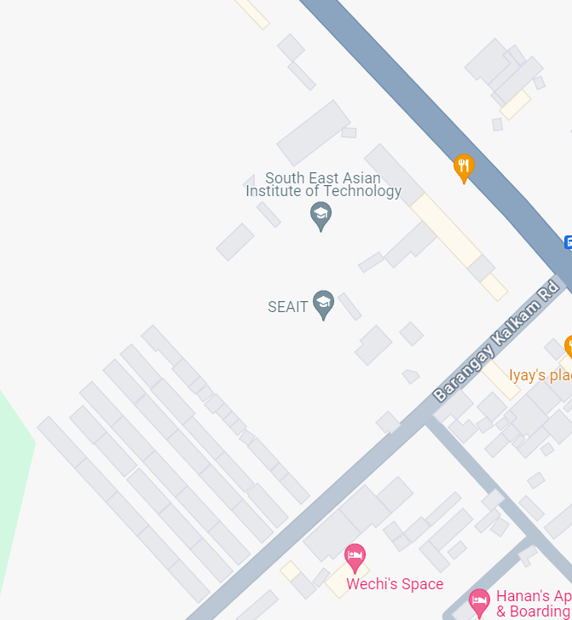

**South East Asian Institute of Technology, Inc. — School Clinic,**

National Highway, Crossing Rubber, Tupi, South Cotabato 9505