**Team 5: Iteration 2**

Project: Movie searching and rating tool for multiple users.  
  
**Diagram:**

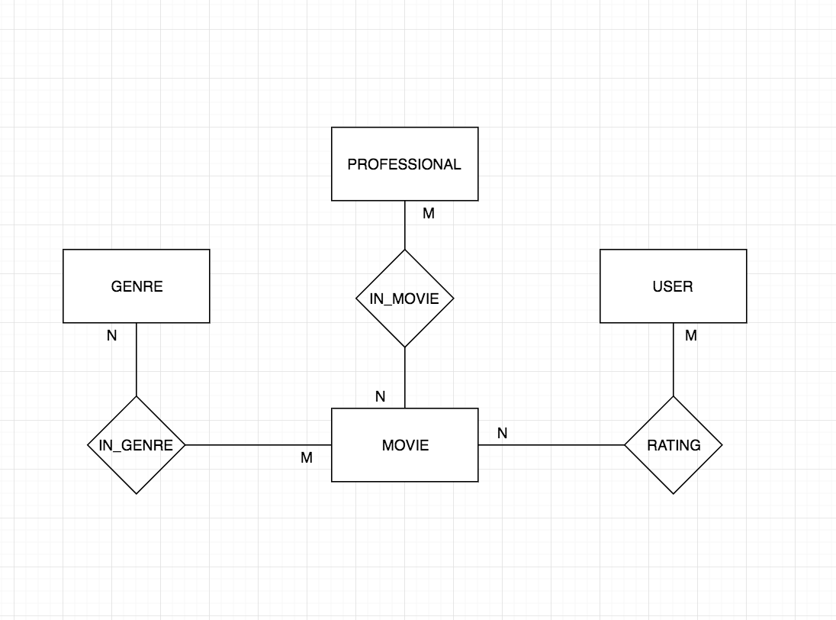

**Attributes:**

USER: ID, FIRST_NAME, LAST_NAME, **!Syntax Error, X**

RATING: {MOVIE_ID, USER_ID }, RATING, DATE

MOVIE: ID, NAME, MPAA_RATING, PLOT_SUMMARY, RELEASE_DATE, RUNTIME, POSTER

IN_MOVIE: {MOVIE_ID, PROFESSIONAL_ID}, ROLE, ROLE_PRIORITY

PROFESSIONAL: ID, FIRST_NAME, LAST_NAME

GENRE: ID, NAME

IN_GENRE: {MOVIE_ID, GENRE_ID}