**Team 5: Iteration 1**

Project: Movie searching and rating tool for multiple users.  
  
**Diagram:**

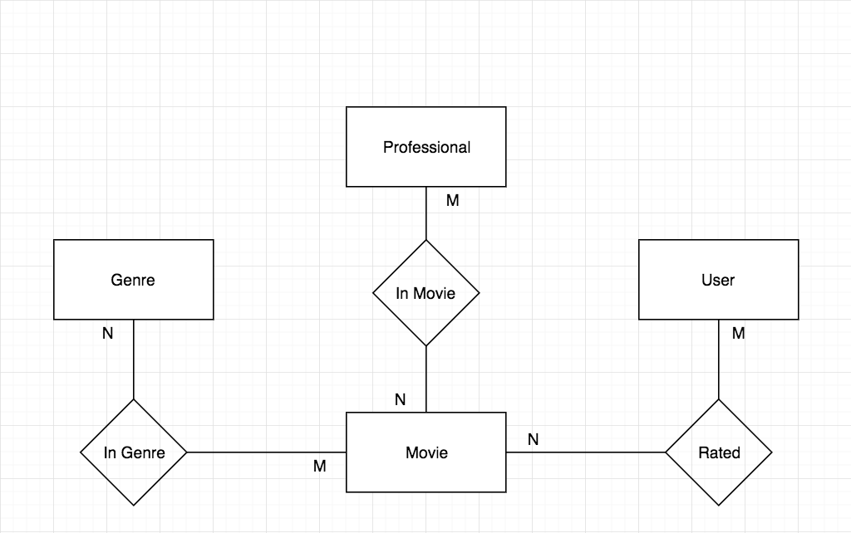

**Attributes:**

User: Id, FirstName, LastName, **!Syntax Error, X**

Rated: Id, Rating, DateRated

Movie: Id, Name, MPAA_Rating, Plot, ReleaseDate

In Movie: Id, Role, RolePriority

Professional: Id, FirstName, LastName

Genre: Id, **!Syntax Error, X**