IST 1025: INTRODUCTION TO PROGRAMMING

END-SEMESTER EXAM

**12th August 2021, 9:00 – 11:00 (2 hours)**

**Instructions Total Marks: 30**

1. Answer Question One on Blackboard.
2. Answer Questions Two and Three in this document and submit in **PDF**.
3. Paste screenshots of your programs and output in the spaces indicated.

**Question One [14 Marks]**

This question will be done as a test on Blackboard.

**Question Two [8 Marks]**

Consider the following program.

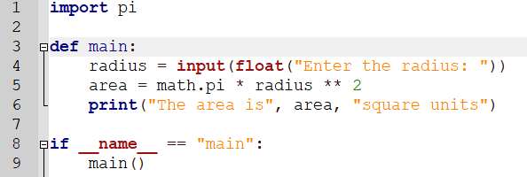

1. Identify the line number where there are errors and write down the correction. [4 Marks]

**Line 1:** import pi **Correction:** from math import math

**Line 4:** input(float(“Enter the radius”). **Correction:** float(input(“Enter the radius”)

**Line 3:** def main **Correction:** def main ()

**Line 8:** if __name__ == “main” **Correction:** if __name__ == “__main__”

1. Explain the purpose of lines 8 and 9. [2 Marks]

Is used to execute some code only if the file was run directly, and not imported

1. Write down a modified line 6 so that it uses an f-string and rounds the output to two decimal places. [2 Marks]

print( “The area is”, f’{area: .2f}’, “square units”)

**Question Three [8 Marks]**

1. Using the lists **mark_ranges = ['90-100', '80-89', '70-79', '60-69', '0-59']** and **grades = ['A', 'B', 'C', 'D', 'F']**, write a program that uses a **for loop** to create a dictionary where each key comes from the **mark_ranges** list and its value comes from the same position in the **grades** list. Your dictionary might start out like this: **{'90-100': 'A', …}**. [4 Marks]
2. Add code to your program for part (a) to print out the contents of the dictionary so that the output looks like this: [4 Marks]

MARK GRADE

90-100 A

80-89 B

70-79 C

60-69 D

0-59 F

