Name: Koo Tsz Kit

SID: 17225965

1. A: T(n) = 7(b/2)+n^2 A’ T’(n)= aT’(n/4)+n^2 a=a b= 4 f(n)=n^2

a=7, b=2, f(n)=n^2

∴ A= Θ(n^(lg7)) ∴ A= Θ(n^(lg4,a)) if a>16

For A’ to be asymptotically faster than A, log(4,a) need to <log7, which mean the largest integer for a must be smaller than 49, Therefore, the answer is 48.

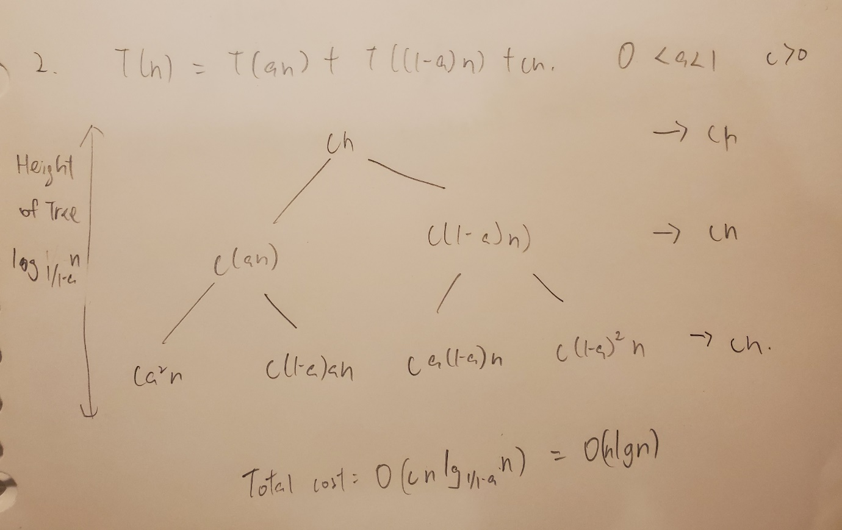

3.

Assume c large enough for T(n)<= cn for all n<= 140

Pick constant a so the function takes O(n) in the recurrence is <=an for all n>0

By induction hypothesis

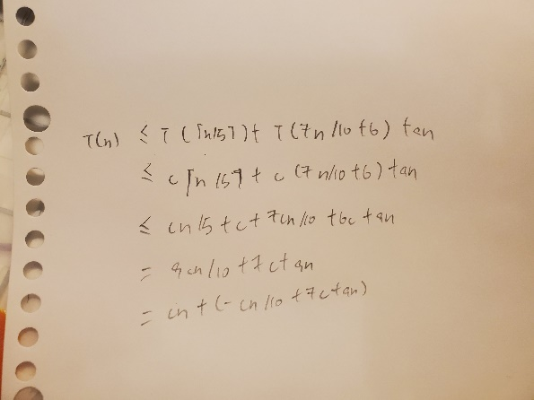

Therefore, T(n)<= cn+(-cn/10+7c+an)

T(n)<= cn if

0>= -cn+70c +10an

c<= 10a(n/n-70)

As n >=140, n/(n-70) <=2 , therefore this will be true for c>=20, and it shown that T(n)=O(n)

4. We can use counting sort, as we already known the range of number and all the number already. However, it should be processed in order to make all the number change to integer and restore to the original value after sorting. The algorithm take O(n) as it is a linear time sorting

5.

6. Create an array A to stores the absolute difference between each element and the median.

First, Use linear time selection to find the median.

1.For i =1 to n

2.A[i]=|S[i]-median|

3.Use linear time selection to select the kth smallest element in A

4.the first k elements in the partition of A is the k numbers in S are closet to the median.

As it is linear time selection therefore It is O(n).

7. merge and insertion sort are stable. To make sorting algorithm stable. We can pre-process which mean replacing each element of an array with an order pair. The first element in each element in the pair is the value and the second one is the index. This scheme takes no extra time but Θ(n) space