User Guide

A Strenuous And Detailed Description On Using The Application

Functionality One: Display all members of an organizing sub-committee.

A. Click the Subcommittees link on the Sidebar.

B. Click the dropdown box and select the desired user.

C. Click the ‘List Members’ button to display members.

C.

B.

A.

Functionality Two: For a hotel room, list all the students housed in this room.

A. Click the Students link on the Sidebar.

B. Click the dropdown titled ‘205A’ box and select the desired user.

C. Click the ‘List Students’ button to display information.

C.

B.

A.

Functionality Three: Display the conference schedule for a day.

A. Click the Schedule link on the Sidebar.

B. Operate the radio buttons to choose the appropriate day.

C. Click the ‘Get Schedule’ button to display information.

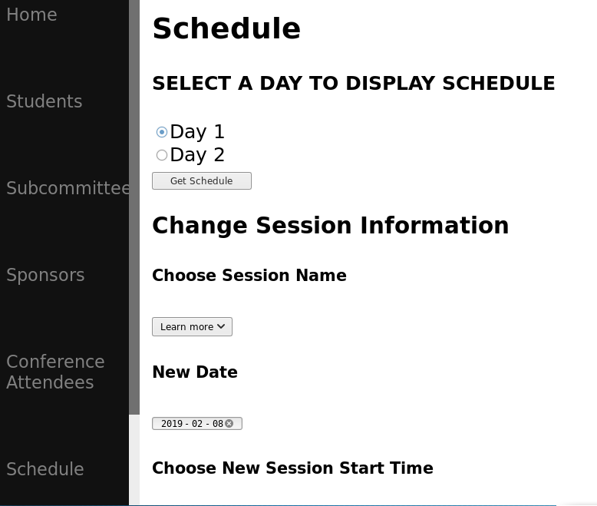

C.

B.

A.

Functionality Four: List the sponsors (company name) and their level of sponsorship.

A. Click the Sponsors link on the Sidebar.

B. The desired list will be the first thing displayed to the web page.

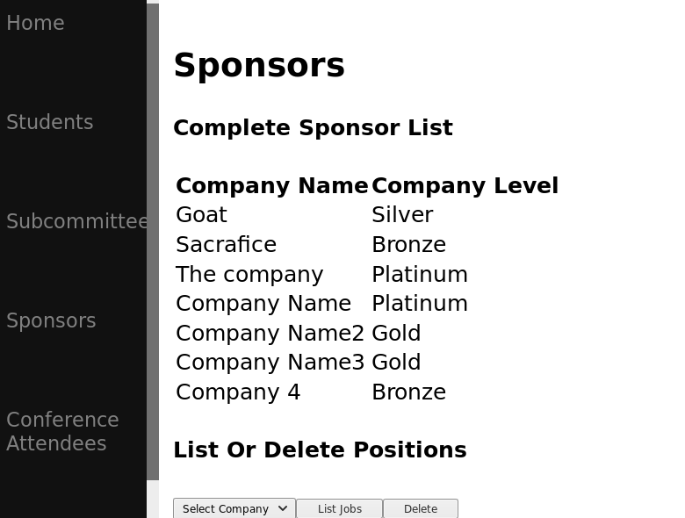

B.

B.

A.

Functionality Five: For a company, list the jobs that they have available.

A. Click the Sponsors link on the Sidebar.

B. Click the dropdown titled ‘Select Company’ box and select the desired sponsor.

C. Click the ‘List Jobs’ button to display information.

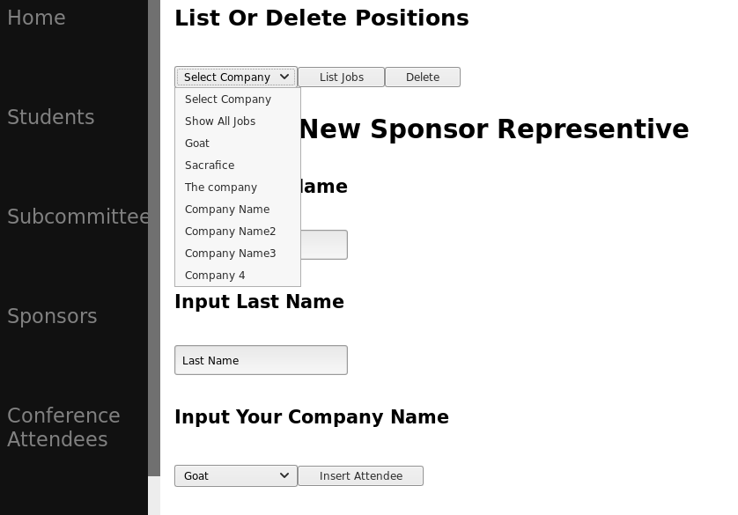

C.

B.

A.

Functionality Six: List all jobs available.

A. Click the Sponsors link on the Sidebar.

B. Click the dropdown titled ‘Select Company’ box and select ‘Show All Jobs’ button.

C. Click the ‘List Jobs’ button to display information.

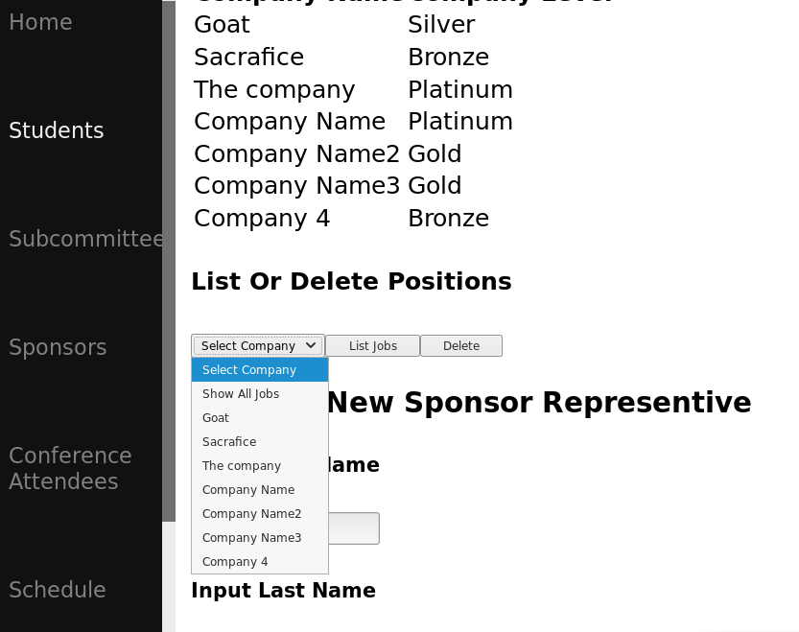

C.

B.

A.

Functionality Seven: Show the list of conference attendees as 3 lists: students, professionals, sponsors.

A. Click the Conference Attendees link on the Sidebar.

B. The desired lists will be the first thing displayed to the web page.

B.

A.

B.

Functionality Eight: Add a new attendee.  If the attendee is a student, add them to a hotel room.

For Students:

A. Click the Students link on the Sidebar.

B. Fill on the necessary fields (First Name and Last Name).

C. Click the ‘Insert Attendee’ button to insert attendee.

C.

B.

A.

B.

For Sponsor:

A. Click the Sponsors link on the Sidebar.

B. Fill on the necessary fields (First Name and Last Name).

C. Click the dropdown under ‘Input Your Company Name’ and select your desired company.

D. Click the ‘Insert Attendee’ button to insert attendee.

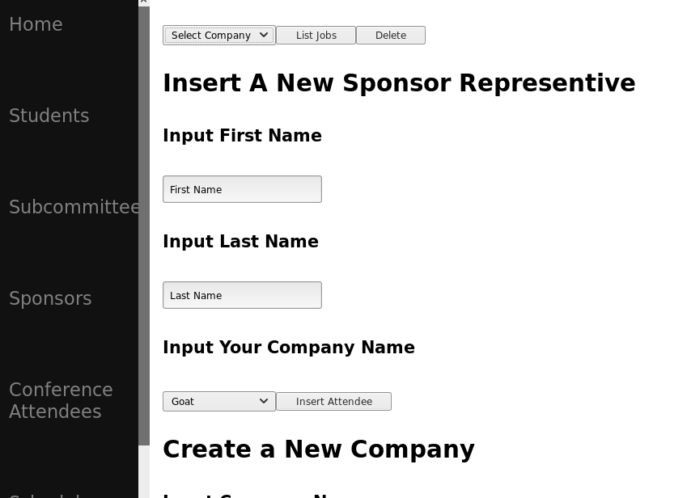

D.

C.

B.

A.

B.

For Professional:

A. Click the Professional link on the Sidebar.

B. Fill on the necessary fields (First Name and Last Name).

C. Click the ‘Insert Attendee’ button to insert attendee.

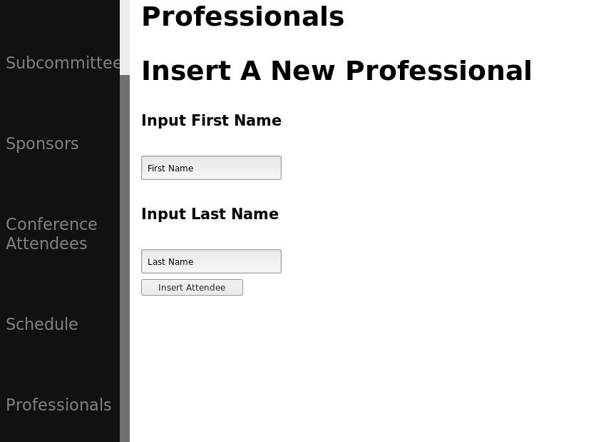

Functionality Nine: Show the total intake of the conference broken down by total registration

amounts and total sponsorship amounts.

A. Click the Conference Attendees link on the Sidebar.

B. The desired lists will be located at the bottom of the page.

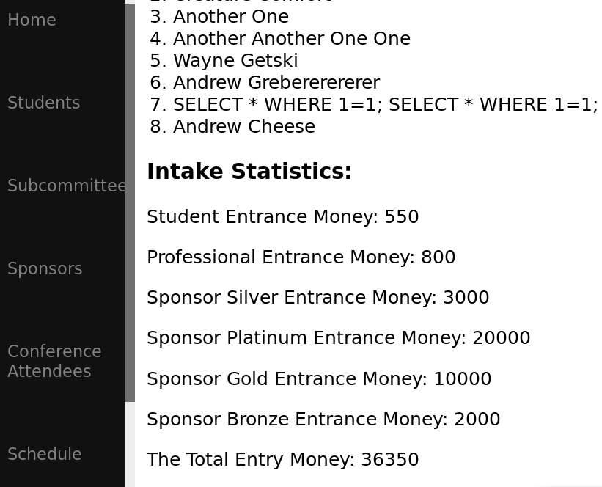

B.

A.

B.

Functionality Ten: Add a new sponsoring company.

A. Click the Sponsors link on the Sidebar and scroll to the bottom of the page.

B. Fill on the necessary fields (Company Name).

C. Operate the radio buttons to choose the correct sponsor type.

D. Click on ‘Insert New Company’ to insert the new company.

Functionality Eleven: Delete a sponsoring company and its associated attendees.

A. Click the Sponsors link on the Sidebar.

B. Click the dropdown titled ‘Select Company’ box and select the desired sponsor.

C. Click the ‘Delete’ button to delete the company.



C.

B.

A.

Functionality Twelve: Switch a session's day/time and/or location.

A. Click the Schedule link on the Sidebar.

B. Fill on the necessary fields including: (Session Name, New Date, Session Start Time, Session End Time, Room Name).

C. Click the ‘Change Session Information’ button to change information.

