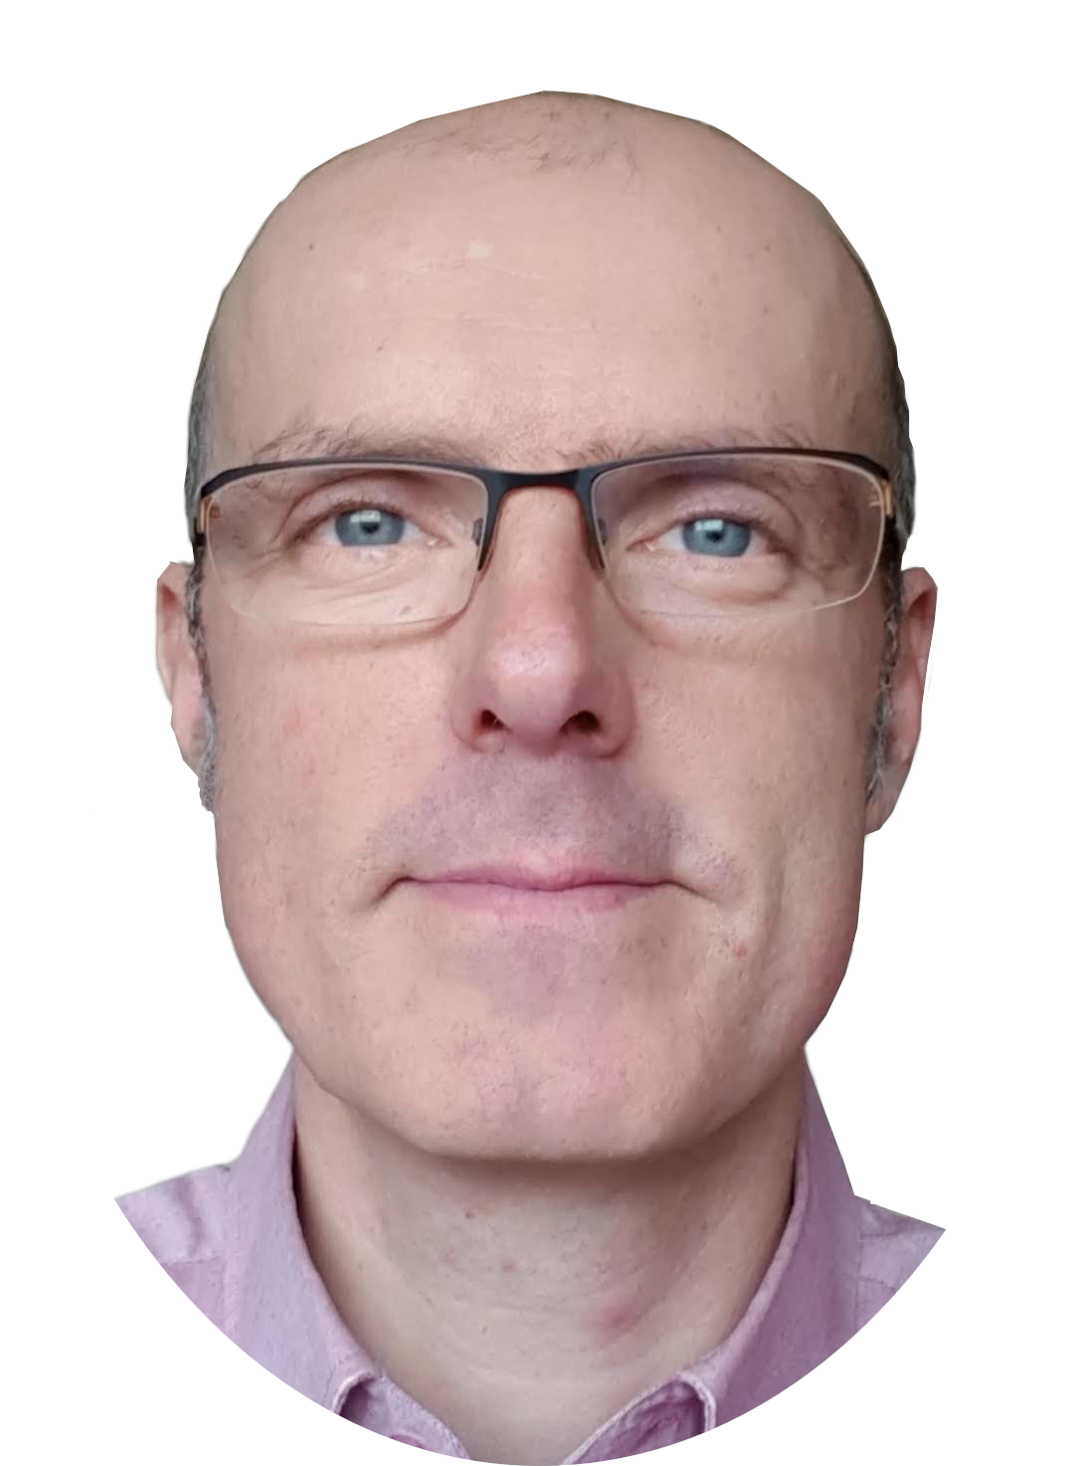
Michaël LAUNAY
Entrepreneur & Senior Software Architect
IA – Collaborative Systems - Open Source
Former founder and manager of an innovative company with €3M turnover, 4 FTEs, and an average of €1M in R&D tax credits and innovation tax credits over twenty years.
Born 19 January 1973, married, 2 children

Expertise, Innovation & Knowledge Sharing

Senior Software Architect & Entrepreneur
Founder of Ecréall SARL in 2005, then Logikascium in 2023, I have 25 years of experience in software engineering, including 15 years dedicated to managing innovative projects involving R&D.
I support organisations from needs analysis to the deployment of complex collaborative systems, ensuring that technical choices remain aligned with business strategy.

Technical Expertise & AI
Specialised in distributed systems and GNU/Linux environments, including DevOps and open source technologies, I have strong expertise in Python and C++ architectures.
My current focus is on AI applied to document processing and business workflows: OCR, RAG, augmented workflows and semantic search.
Passionate about knowledge management, I experiment with the concept of a “second brain” assisted by local LLMs, deployed via Docker and OpenClaw, within the Obsidian environment.

R&D Management
With solid experience as a business manager, notably within Ecréall SARL, a four-person company, I master the full contractual cycle: from negotiation and intellectual property to operational maintenance.
I have supervised several DevOps and R&D teams, including CIFRE PhD projects. I have also prepared ANRT funding applications and obtained JEI status.

Teaching & Knowledge Transfer
Since 2019, I have worked as a part-time lecturer at ENSAM, Polytech Lille and the University of Lille, teaching the fundamentals of software engineering and Python programming.
I supervise experimental Master’s-level projects based on a rigorous engineering approach, including UML, Agile UP and Design Patterns, while integrating a reasoned, ethical and traceable use of AI.
Contact
35 rue Gambetta, 59273 Fretin
 +33 6 16 85 91 12  michaellaunay@logikascium.com  http://www.logikascium.com
 https://github.com/michaellaunay  https://www.linkedin.com/in/michaellaunay1973011

https://github.com/michaellaunay/NotesPubliques https://github.com/michaellaunay/alirpunkto
Professional Experience
Since 2023
Founder and Manager, EURL Logikascium.
- Design and development of Alirpunkto, an open-source identity verification solution intended to support the admission of new members into a European participatory network.
- Writing of technical documentation and computer science courses.
- Meetups and training sessions on the use of generative AI for software development.
- Biblioteko: educational project for transforming scanned documents into usable content through a hybrid local/cloud OCR pipeline, using Mistral OCR and Gemini, with intelligent document segmentation.
2005-2023
Founder and Manager, SARL Ecréall.
- Methodology for developing collaborative portals using UML and BPMN.
- Obtained JEI (startup) status in 2010; prepared ANRT and tax ruling applications.
- Conference presentations and publication of an article in Linux Pratique.
- Writing of documentation and delivery of training courses on GNU/Linux Ubuntu administration, Python development and Plone (see my github).
- Client relationship management for collaborative portal projects for HDFID, Bonduelle, CRT Hauts-de-France, MESHS and Bluenove.
- Security : Iptables, fail2ban, postfix (spf, dkim, dmarc), nmap, tcpdump, wireshark.
2001-2004

Software Developer – Sofrelog / EADS
Development in C++ of a cartography editor.
1997-2000

Software Developer – Thomson-CSF / Thales
Development in C++ of a simulator.
Education
Since 2016 Various MOOCs on Fun-MOOC, Udemy and Elephorm.
1997 Engineering degree in Computer Science, Measurement and Automation
École Universitaire d’Ingénieurs de Lille Now Polytech Lille.
1994 DUT in Electrical Engineering and Industrial Computing
IUT de Cachan.
1992 Baccalauréat F2, with honours.
Languages
English: reading, speaking and writing.
Esperanto: reading, limited speaking and writing.
Languages, Methods, Technologies & Communication
Areas of Expertise
Collaborative portals, workflows, Linux, Python, Docker.
Methodologies
Agile methods, model-driven engineering, TOGAF.
Documentation
Obsidian, Markdown, Mermaid and PlantUML.
Programming and Modelling Languages
C++, Bash, Python, JavaScript, XML, UML, BPMN.
Frameworks
Bootstrap, React.
3D Modelling
SketchUp, Blender, Sweet Home 3D, FreeCAD.
Prototyping
Electronics, Raspberry Pi.
Personal Interests
Reading, walking, French boxing instructor, and self-building of a bioclimatic house.

