DATASET LINK:

https://www.kaggle.com/uciml/mushroom-classification

A. Describe the dataset in your own words.

**Objective**

Classify whether if a mushroom is safe to eat or poisonous?

**Overview**

23 species of gilled mushrooms from the Agaricus and Lepiota family are observed in the dataset. The dataset contains 23 features of mushroom and the first feature is whether the mushroom is edible or poisonous.

**Attributes and observations**

The dataset contains 23 features and 8124 observations, all are categorical (factor) data.

**Missing values**

There are 2480 missing values in the dataset, where the missing values is denoted as “?” and are found in “stalk-root”, the 11th column.

**Distribution of edible/poisonous mushroom**

-- edible : 4208 observations (51.8%)

-- poisonous : 3916 observations (48.2%)

-- total : 8124 observations (100.0%)

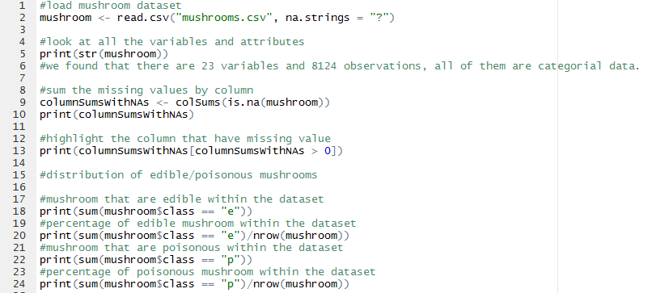

Figure 1. Code we used for describing the mushroom dataset.

B. What possible insights can be obtained from mining the chosen dataset?

To obtain common features that are found in edible and poisonous mushrooms for building a prediction model.

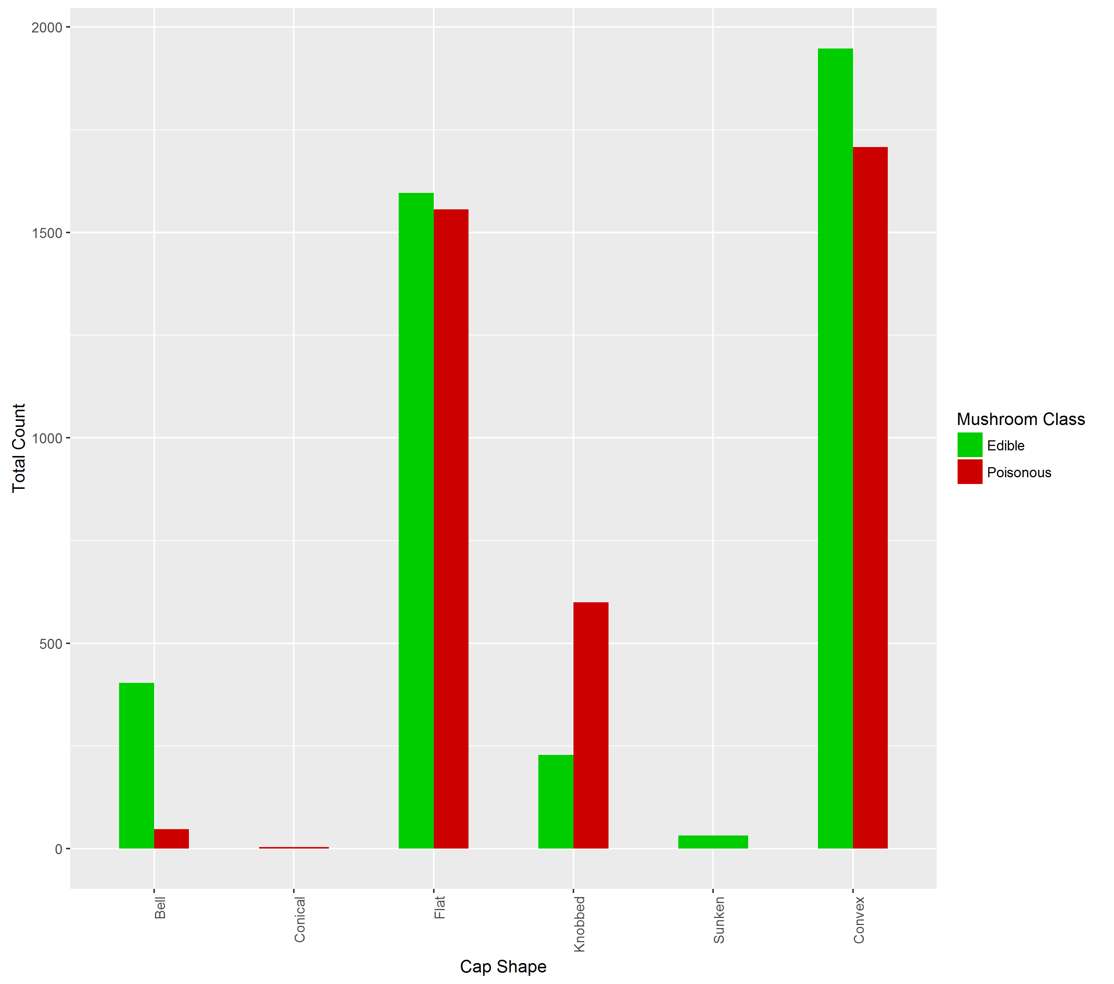

What we found from mushroom’s cap shape:

* Bell shaped mushroom are very likely (89~%) to be edible
* Knobbed shaped mushroom are very likely (72~%) to be poisonous
* Conical shaped mushroom are poisonous based on this dataset
* Sunken shaped mushroom are edible based on this dataset
* Flat and Convex are close to 50/50 % edible and poisonous

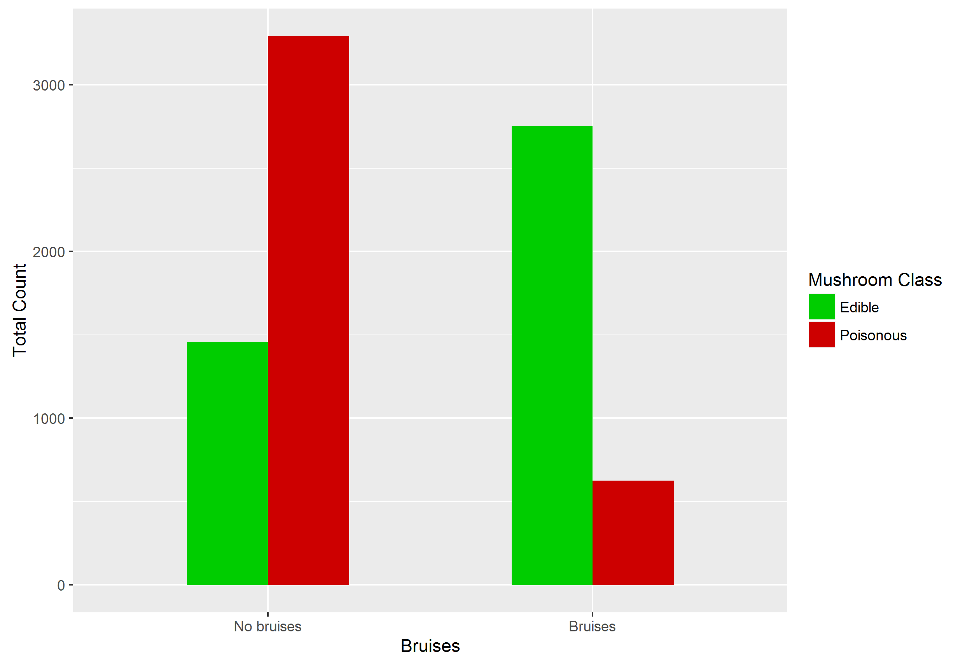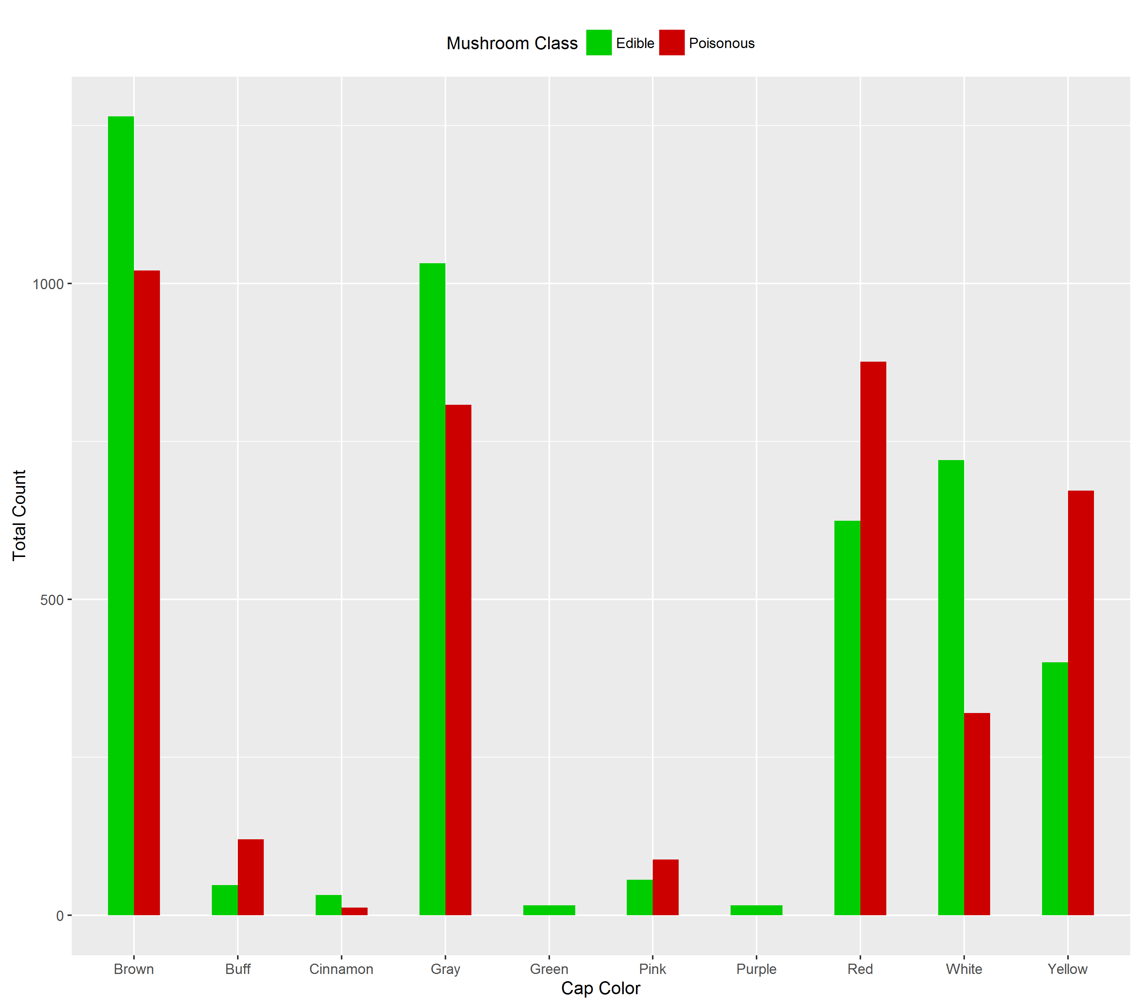

## C. What type of data mining technique (association rule mining, classification or clustering) would be relevant? Give an example, for example, if you think classification is suitable, describe what will be classified and what the possible classes are.

Association mining rule can be used to assist the classification process, to describe the common and pattern of poisonous or edible mushroom. Classes/Attributes that may be used for association mining rule are cap shape, bruises and color. “arules” and “arulesViz” in R can both be used for generating association mining rule and plotting the mining rules.

Classification - Classify whether a mushroom is poisonous or edible based on the association mining rule. Multiple or more association mining rule can be used to improve the accuracy of the classification model. “randomForest” library in R can be used for creating a classification model.

**Discovered disjunctive rules for mushroom datasets**

odor=NOT(almond.OR.anise.OR.none)

result: 120 poisonous cases missed, 98.52% accuracy

spore-print-color=green

result: 48 cases missed, 99.41% accuracy

odor=none.AND.stalk-surface-below-ring=scaly.AND.(stalk-color-above-ring=NOT.brown)

result: 8 cases missed, 99.90% accuracy

habitat=leaves.AND.cap-color=white

result: 100% accuracy

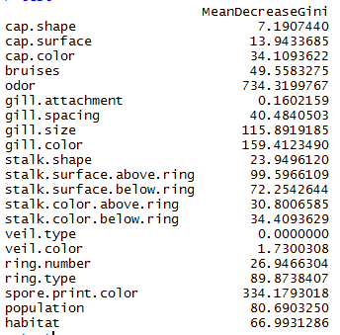We are planning to use random forest as one of our classification model to predict if a mushroom is poisonous or not. The code below shows a **SIMPLE SAMPLE** that we may be using for part 2. Accuracy we got from random forest is pretty decent, out of few runs (4 different executions with different seed) our prediction model got 0.00 ~ 0.05% error rate. We also extracted which variable/attribute influences the model the most.

Figure 2. Importance (function) of randomForest package, to show which column influences the outcome of the prediction model the most.

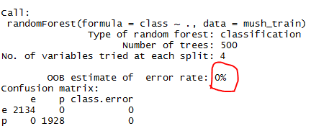

Figure . Result of the model

D.  Describe data quality issues, and be specific. Identify which attribute (column) has issues, or if the structure of the data has problems.

A dataset is said to be tidy if it satisfies all of the condition:

1. Observations are in rows
2. Variables are in columns
3. Contained in a single dataset for each type of observations

Mushroom dataset:

1. Each row is an observation of a single mushroom
2. Each column describes a variable of the mushroom
3. Each dataset contains each type of observation, where our type of observation is whether if the mushroom is edible or poisonous

Column 11 (stalk-root) has issues, it contains 2480 missing values and 5644 non-missing values.

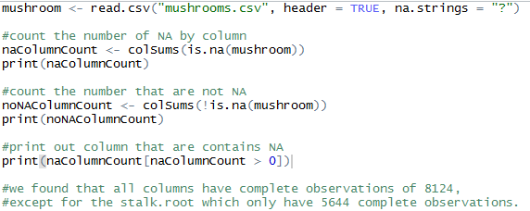

Figure . Script used to find whether if any column contains any missing values.

## E. Perform a pre-processing task on the dataset chosen.

“Editrules” one of the library that allows reading, manipulating and impose a set of rules (edit rules) on numerical and categorical data. We will be using this library along with our “pre-defined” rules for the mushroom dataset. This step ensure that we will know if there is any unknown values that isn’t specified in the mushroom’s data codebook. If there is any we can use library “deducorrect” to correct those unknown values.

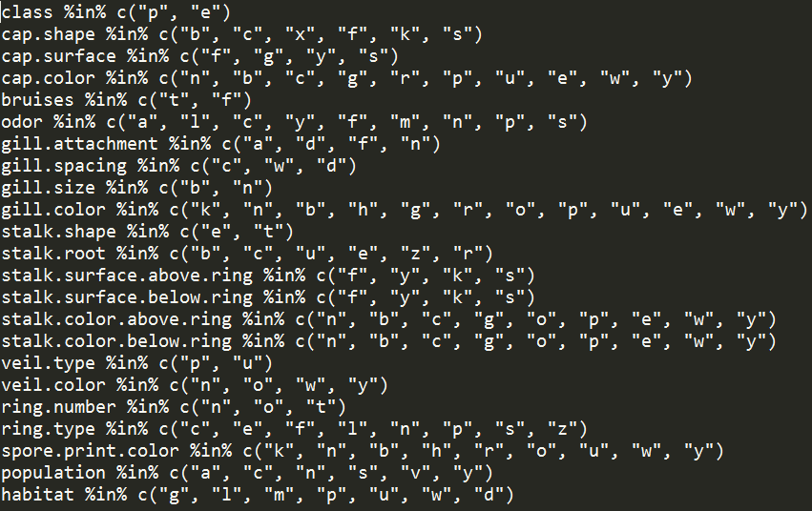

Figure . Rules of the mushroom dataset to check if there are any violation of rules (undefined values).



Figure 6. No violation found in the mushroom dataset

We found that the mushroom dataset does not have any violation of rules.