1. Command Line Usage.
To perform OCR on an image.
TestImage.png
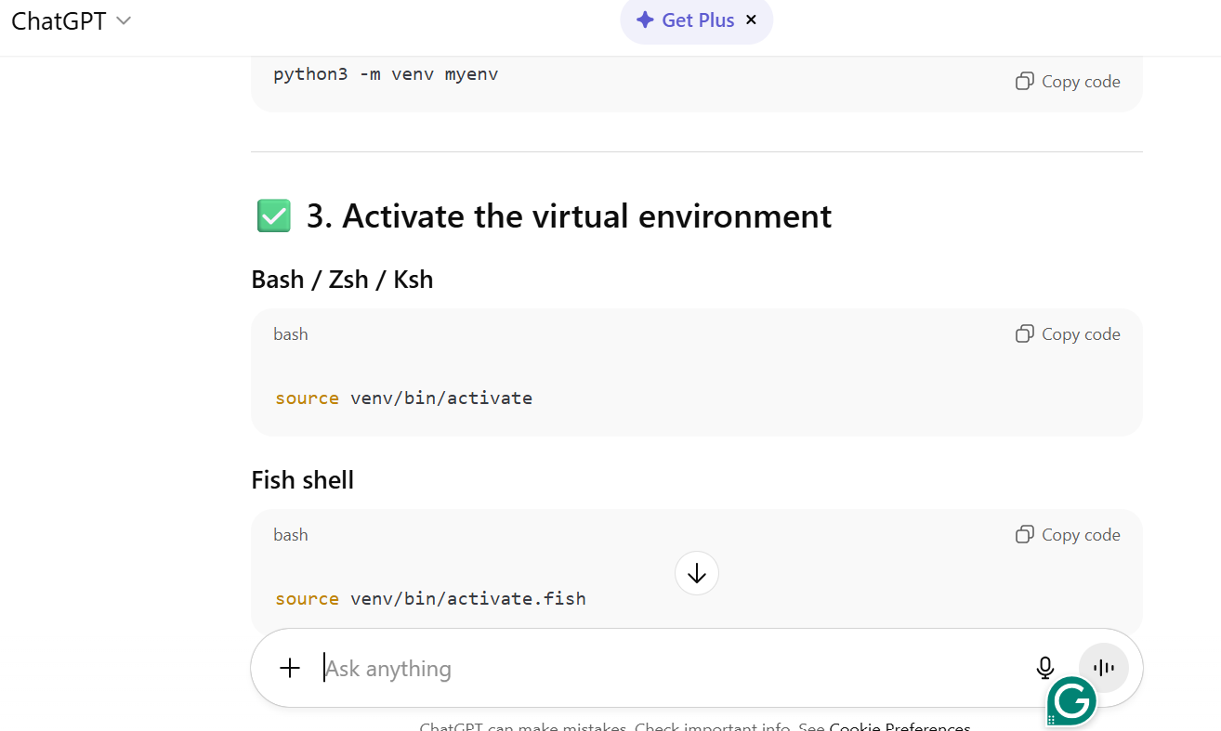

(venv) icha@LAPTOP-OJPRFSNJ:~/Dev/AI/Prjs/cls2$ nano testOut.txt.txt

(venv) icha@LAPTOP-OJPRFSNJ:~/Dev/AI/Prjs/cls2$ tesseract TestImage.png testOut.txt
Nano to view testOut.txt.txt

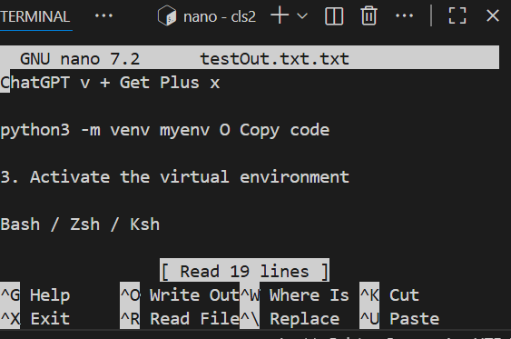
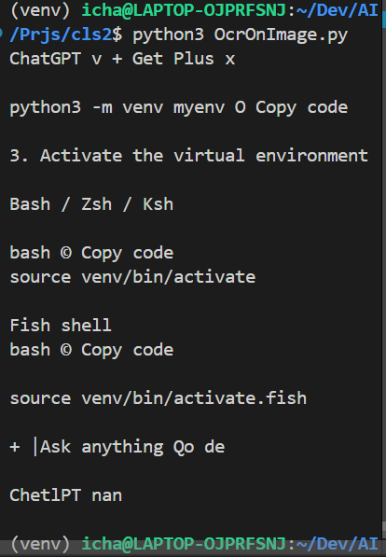

2. Use Tesseract with python
(venv) icha@LAPTOP-OJPRFSNJ:~/Dev/AI/Prjs/cls2$ python3 OcrOnImage.py

output:

