Project 3 – Angrybird

F74046145廖允誠

開始畫面

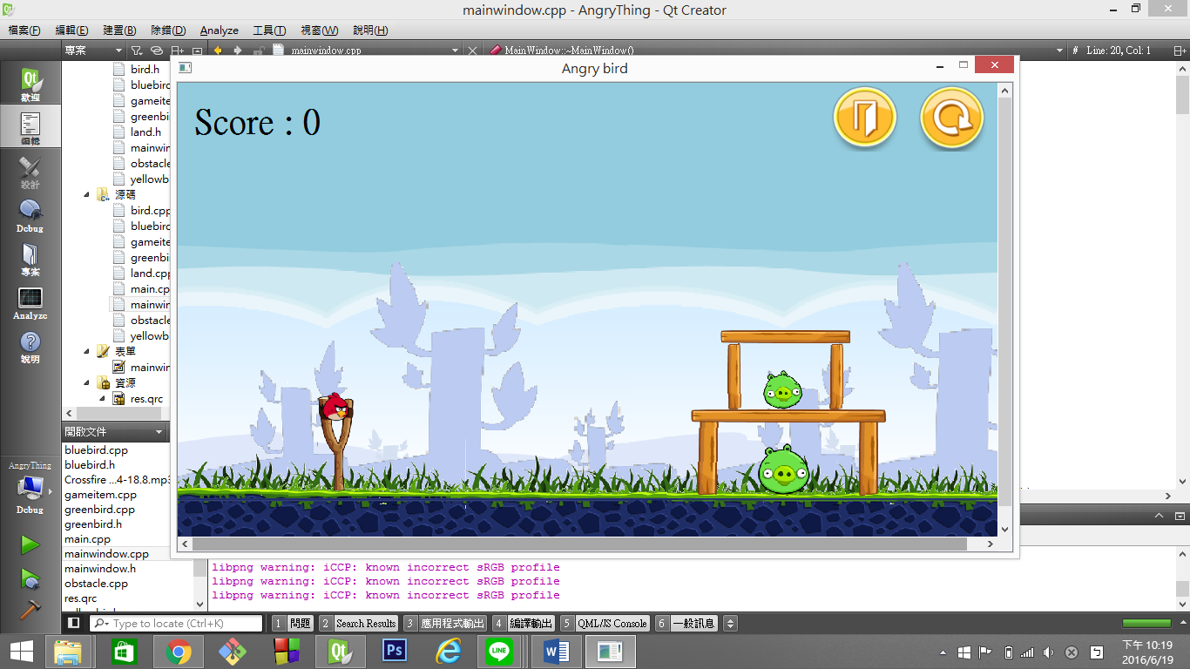右上角有exit和restart鍵，左上角顯示分數

畫面上已經有第一隻鳥和我們的關卡

豬豬x2和一堆木頭

豬來了～

另外有下邊界跟右邊界會反彈(怕飛到右邊不見= =)

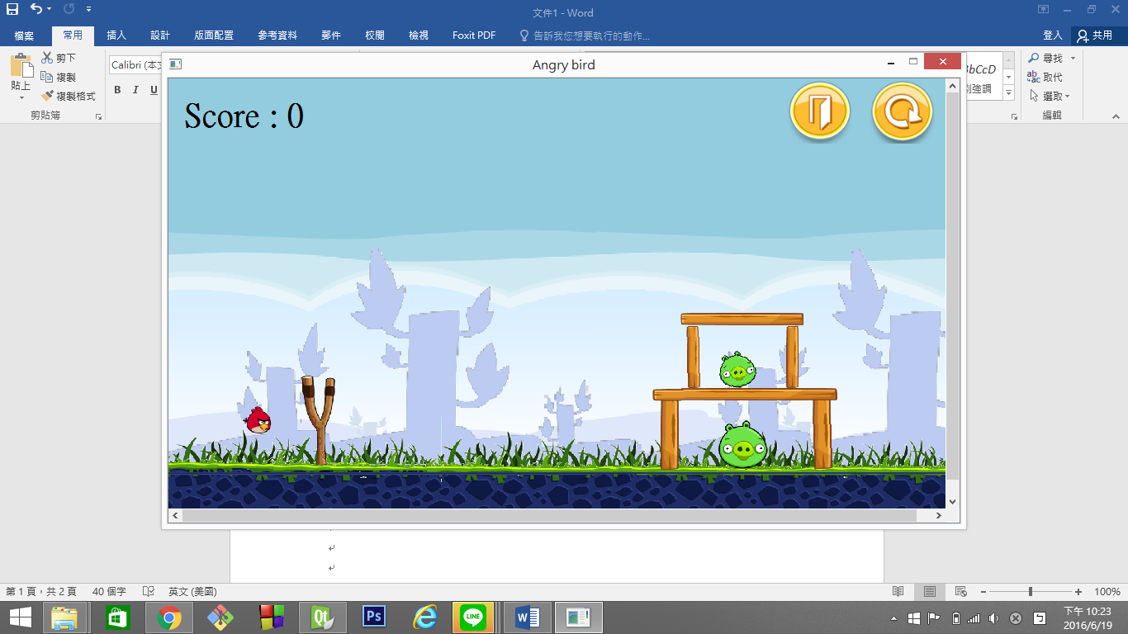 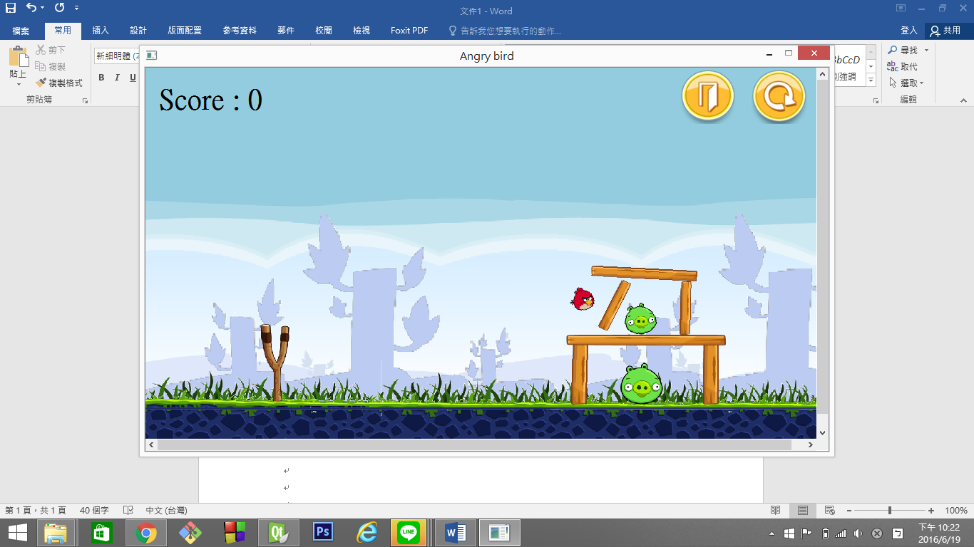

拉弓 射出

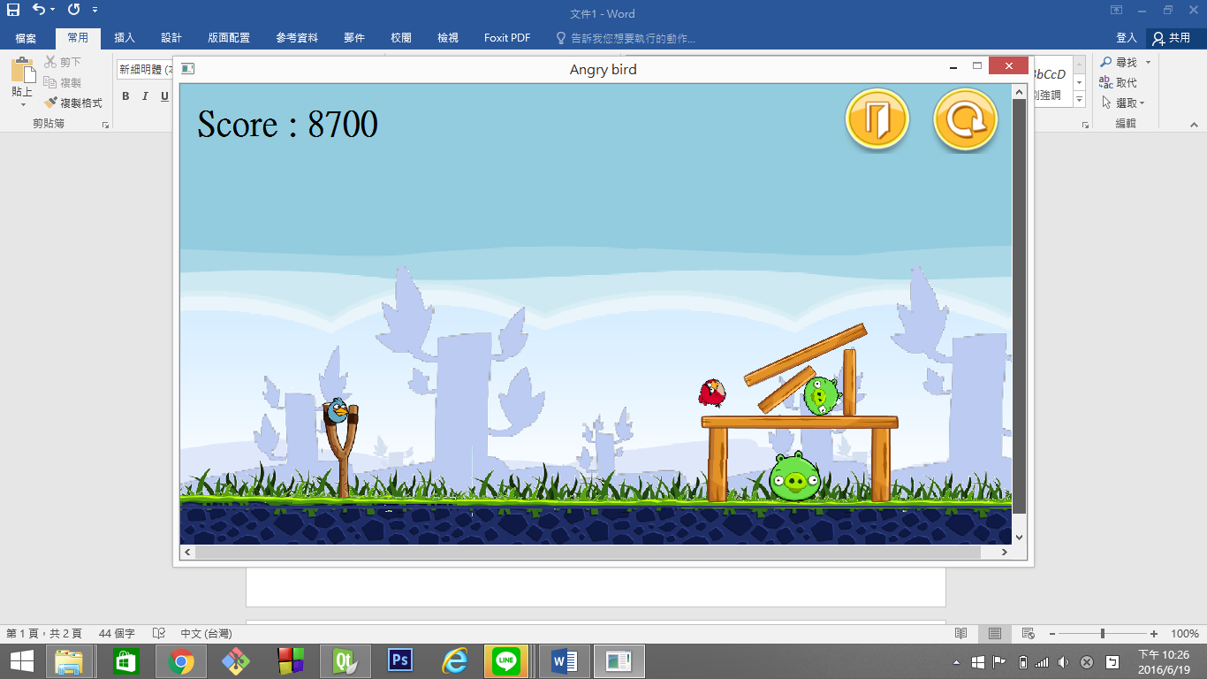

豬不會消失，但是只要讓他移動就會計分

按一下右鍵叫出下一隻鳥><

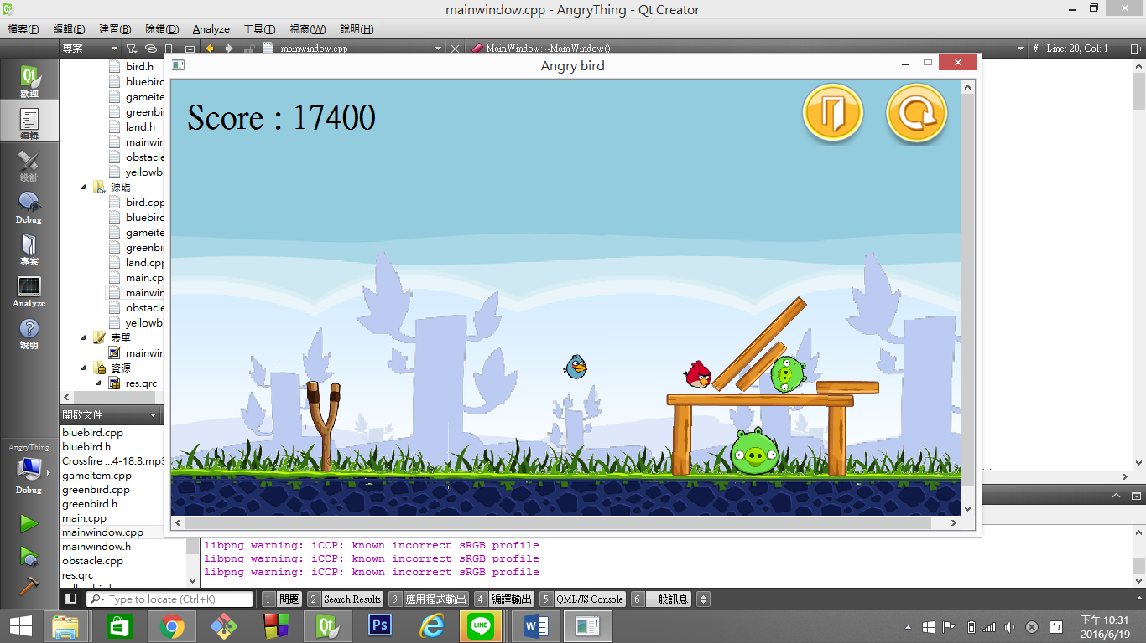 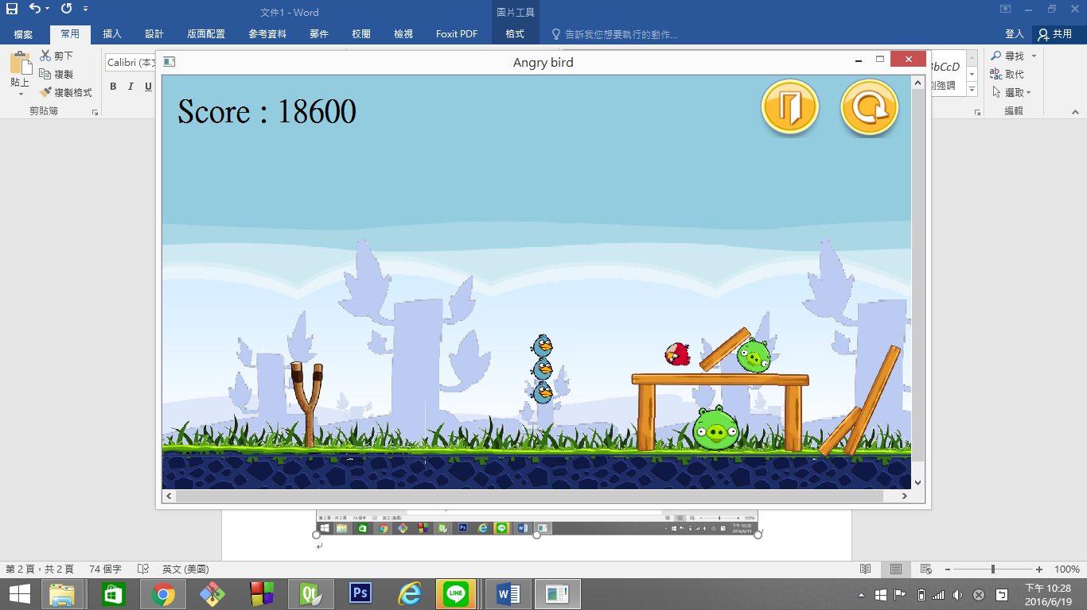

一隻藍鳥 影分身!!x3

在飛行途中按一下左鍵就會分裂成三隻

威力x3!!!!!!!!或許吧

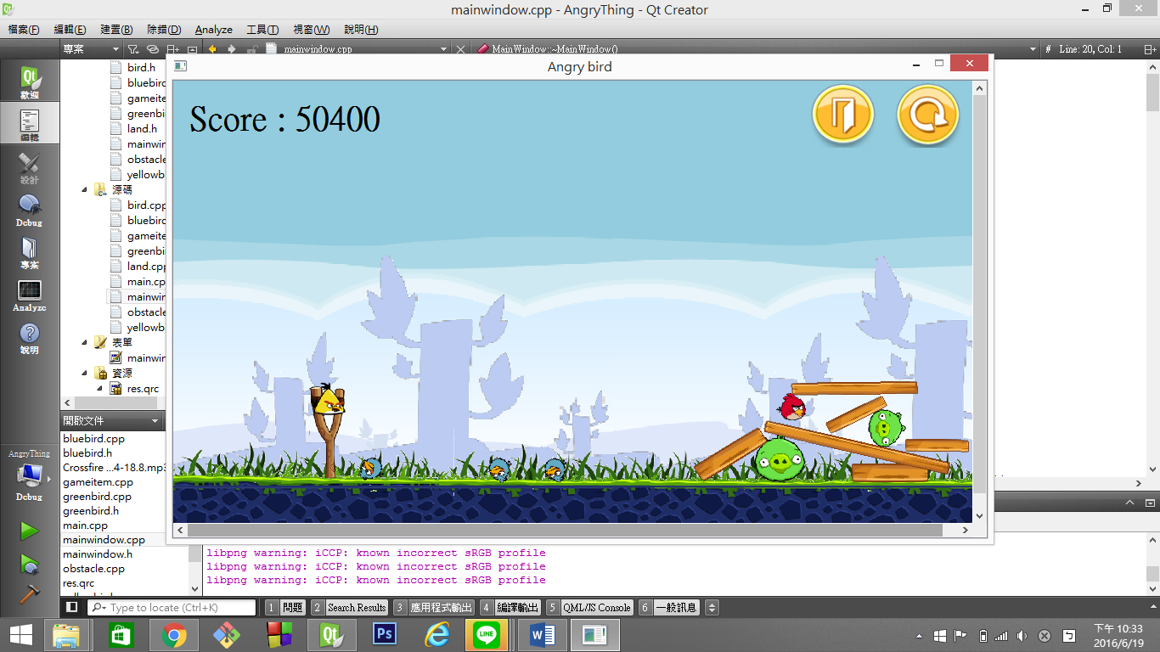

黃鳥okgogooo

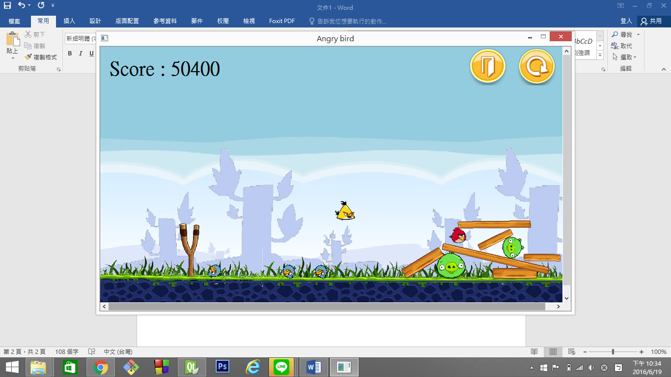 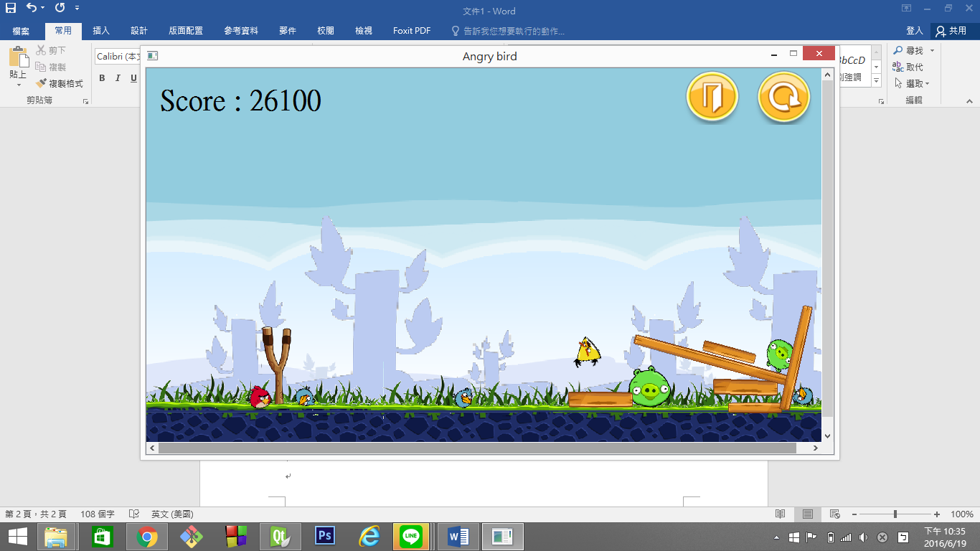

Fly fly fly 碰!

按一下左鍵變快衝擊，用力碰撞飛出，刺激快感的好選擇

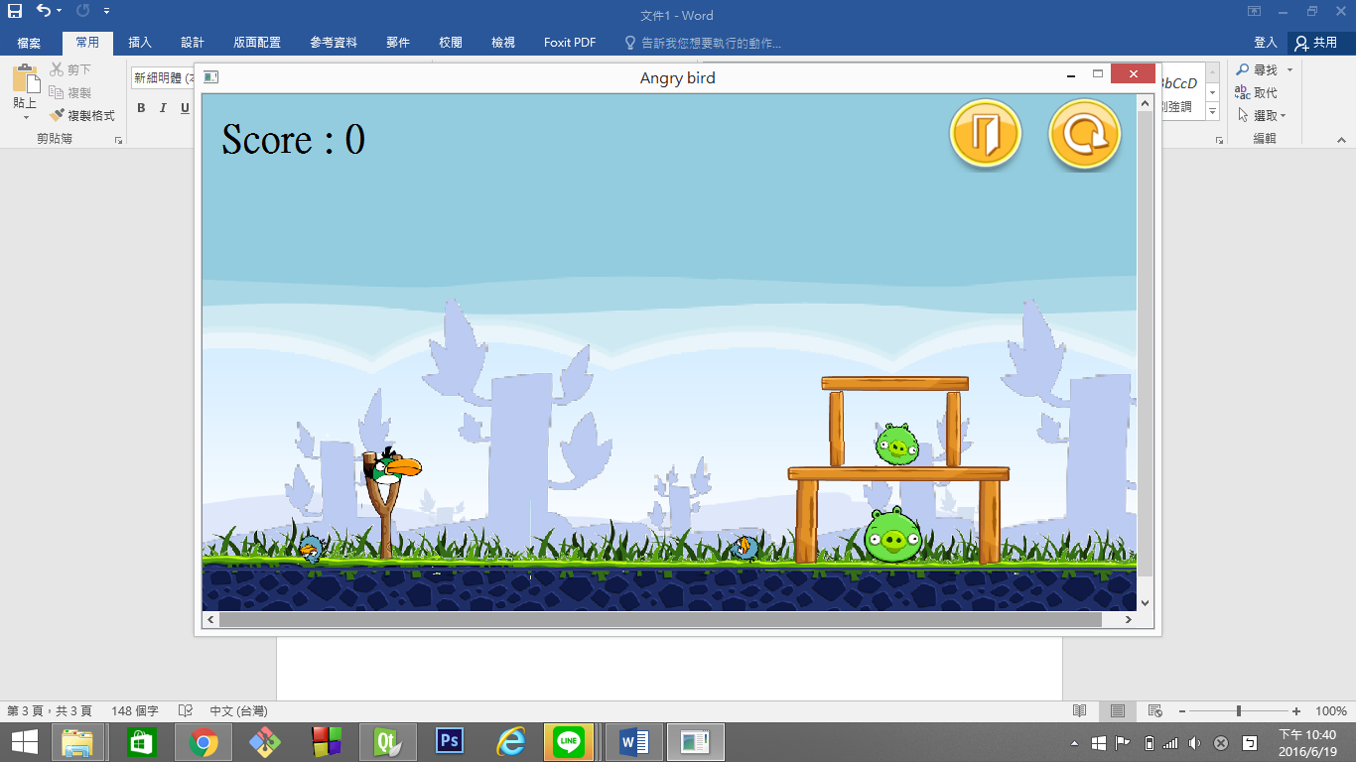

最後登場綠綠迴旋鳥

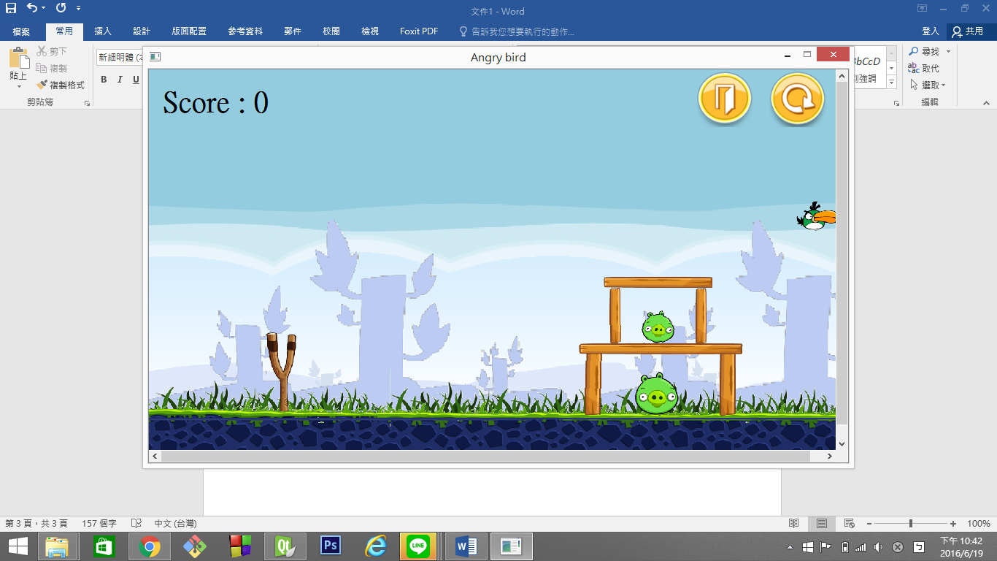 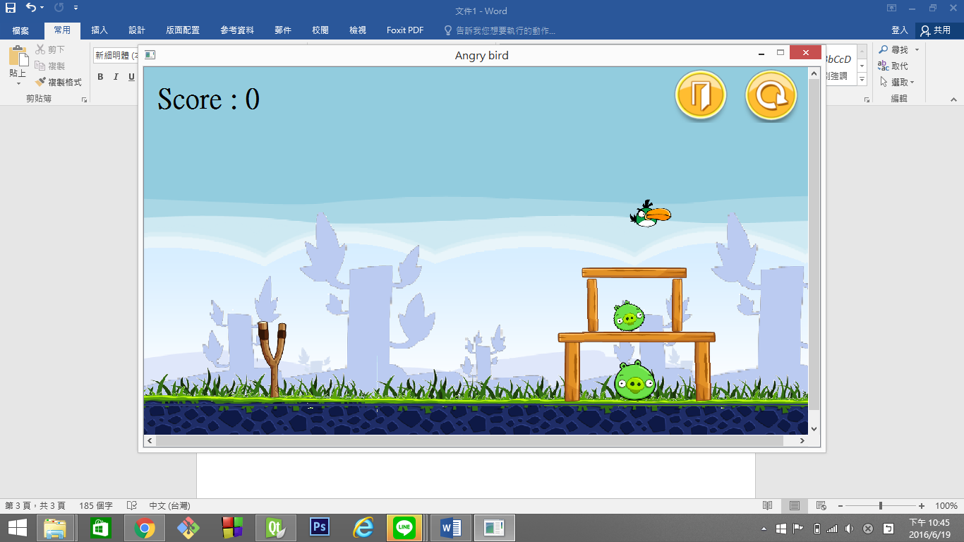

準備~~!! 沒打到QQ

其實迴旋好難寫喔T_T

我讓他往後飛而已

沒關係相信前面的鳥大家已經很高分了XD

之後就按exit按鈕離開或restart鍵重來吧!!!!!

*UML Diagram

|  |
| --- |
| MainWindow: inherit QMainWindow |
| -scene: QGraphicsScene * |
| -world: b2World * |
| -itemList: QList<GameItem *> |
| -timer: QTimer |
| -gameBg: QGraphicsPixmapItem,* |
| -gameCatapult: QGraphicsPixmapItem * |
| -restart: QPushButton * |
| -exit: QPushButton * |
| -scoreBoard: QLabel * |
| -bgm: QMediaPlayer * |
| -wee: QMediaPlayer * |
| -bird[4]: Bird * |
| -pig[2]: Bird * |
| -building[6]: Obstacle * |
| -birdType: int |
| -scene: QGraphicsScene * |
| -world: b2World * |
| -itemList: QList<GameItem *> |
| -timer: QTimer |
| -gameBg: QGraphicsPixmapItem,* |
| -gameCatapult: QGraphicsPixmapItem * |
| -restart: QPushButton * |
| -exit: QPushButton * |
| -scoreBoard: QLabel * |
| -bgm: QMediaPlayer * |
| -wee: QMediaPlayer * |
| -bird[4]: Bird * |
| -pig[2]: Bird * |
| -building[6]: Obstacle * |
| -birdType: int |
| -score: int |
| -timecount: int |
| -x: double |
| -y: double |
| -pressX: double |
| -pressY: double |
| -r: double |
| -pig1_vx: float |
| -pig1_vy: float |
| -pig1_angle: float |
| -pig2_vx: float |
| -pig2_vy: float |
| -pig2_angle: float |
| -playGame: bool |
| +<<explicit>> MainWindow(QWidget *parent = 0): void |
| +~MainWindow() |
| +showEvent(QShowEvent *): void |
| +eventFilter(QObject *,event: QObject): bool |
| +closeEvent(QCloseEvent *): void |
| +<<signals>>quitGame(): void |
| +startGame(): void |
| +restartGame(): void |
| -<<slots>>tick(): void |
| -<<slots>>QUITSLOT(): void |

|  |
| --- |
| GameItem: inherit QObject |
| +g_body: b2Body * |
| +g_pixmap: QGraphicsPixmapItem |
| +g_size: QSizeF |
| +g_world: b2World * |
| +g_worldsize: static QSizeF |
| +g_windowsize: static QSizeF |
| +GameItem(world: b2World *) |
| +~GameItem() |
| +setGlobalSize(worldsize:QSizeF, windowsize: QSizeF): static void |
| +<<slots>>paint(): void |

|  |
| --- |
| Obstacle: inherit GameItem |
| +Obstacle(x: float, y: float, w: float, h: float, timer: QTimer *, pixmap: QPixmap, world: b2World *, scene: QGraphicsScene *) |

|  |
| --- |
| Bird: inherit GameItem |
| +Bird(x: float, y: float, radius: float, timer: QTimer *, pixmap: QPixmap, world: b2World *, scene: QGraphicsScene *) |
| +setLinearVelocity(velocity: b2Vec2):void |
| +skill(): virtual void |
| -startx: float |
| -starty: float |
| -useTimes: int |
| -clicked: bool |
| -bodydef: b2BodyDef |

|  |
| --- |
| BlueBird: inherit GameItem |
| +BlueBird(x: float, y: float, radius: float, timer: QTimer *, pixmap: QPixmap, world: b2World *, scene: QGraphicsScene *) |
| +~Bluebird() |
| +skill(): void |
| -t: Qtimer * |
| -image: QPixmap |
| -w: b2World * |
| -s: QGraphicsScene * |
| -blue[2]: Bird |

|  |
| --- |
| YellowBird: inherit GameItem |
| +YellowBird(x: float, y: float, radius: float, timer: QTimer *, pixmap: QPixmap, world: b2World *, scene: QGraphicsScene *) |
| +skill(): void |

|  |
| --- |
| GreenBird: inherit GameItem |
| +GreenBird(x: float, y: float, radius: float, timer: QTimer *, pixmap: QPixmap, world: b2World *, scene: QGraphicsScene *) |
| +skill(): void |

|  |
| --- |
| Land: inherit GameItem |
| +Land(x: float, y: float, w: float, h: float, timer: QTimer *, pixmap: QPixmap, world: b2World *, scene: QGraphicsScene *) |

*Inheritance Relationship

**MainWindow**

**YellowBird**

**BlueBird**

**GameItem**

**Bird**

**GreenBird**

**Obstacle**

Land