**1.** See attached image for derivation.

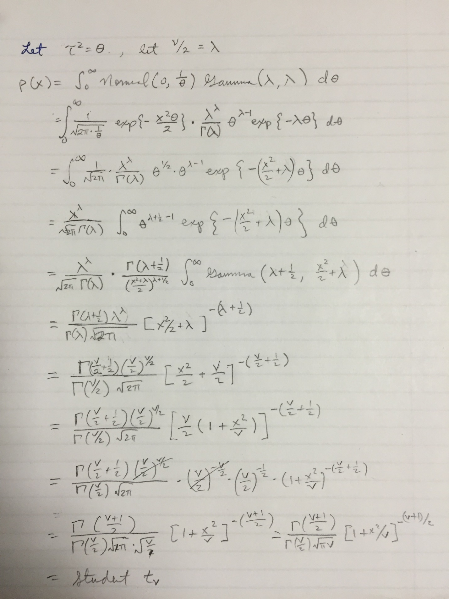

**2.** The histogram of X:

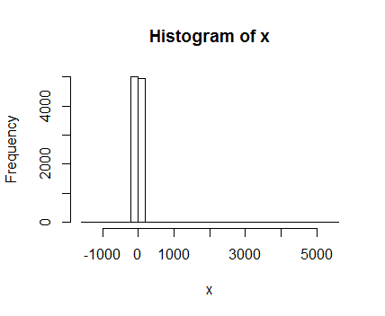

The actual marginal distribution of f(X) when $ν=1$ is called the t distribution with df=1, which is alternatively named the Cauchy distribution.

**3.** Using the ks.test function where null hypothesis is that the distributions are equal, the p-value is 0.5444. We conclude that the observed distribution is equal to a t distribution with df=1 because the p-value suggests that we don’t have enough evidence to reject the null hypothesis.

**4.** The distribution is beta(1,1), which is the uniform distribution.

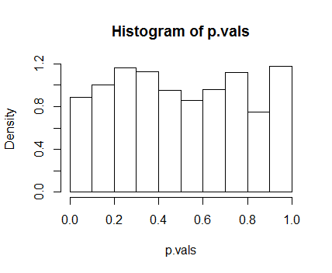

**5.** When $ν=1$, the t distribution with df=1 has undefined variance, thus the distribution of the mean is undefined; central limit theorem does not apply. For $ν=2$, the variance is infinity, so distribution of mean is again undefined and central limit theorem does not hold. However, for $ν≥3$, variance is well-defined and mean is 0, so CLT does hold.

**R code:**

size = 10000;

x = rep(0,size);

tausq = rgamma(size, shape=0.5, rate=0.5);

for(i in 1:size){

x[i] = rnorm(1, 0, sqrt(1/(tausq[i])));

}

hist(x, breaks=35);

ks.test(x, "pt", 1);

probs = rep(0, 1000)

for (i in 1:1000) {

y = rt(50, df = 1);

probs[i] = ks.test(y, 'pt', 1)$p;

}

hist(probs, freq = FALSE);