mips_building_blocks.vhd

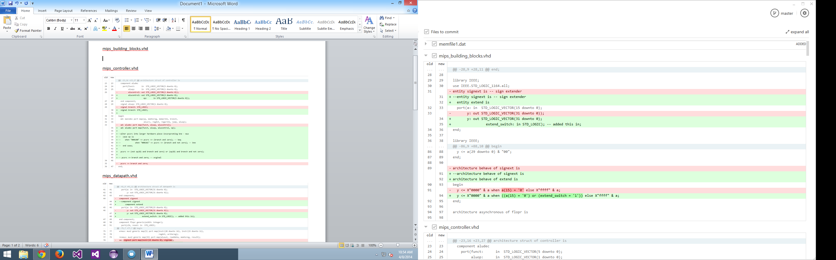

mips_controller.vhd

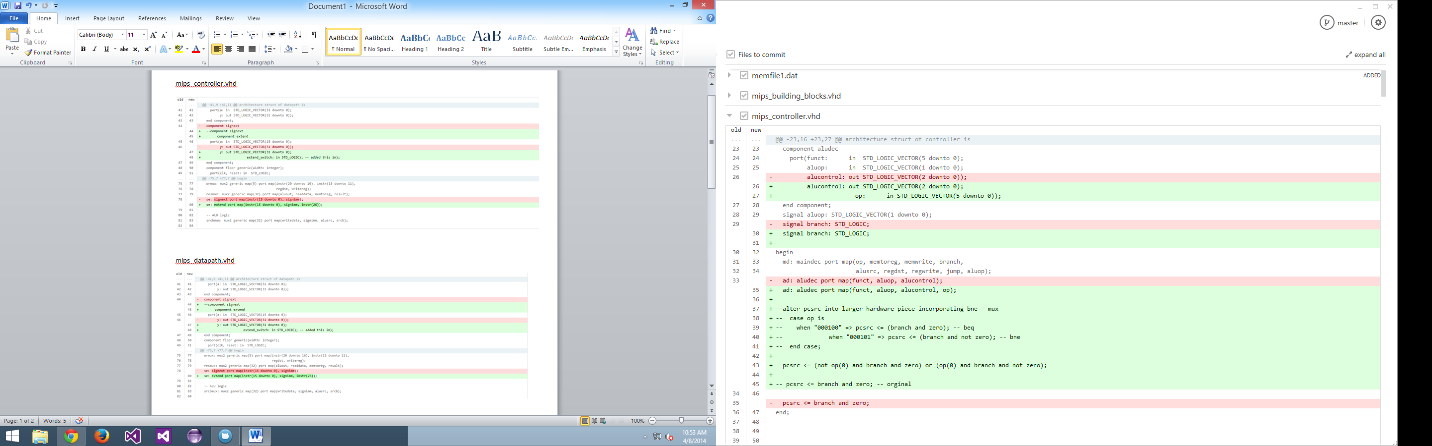

mips_decoder_main.vhd

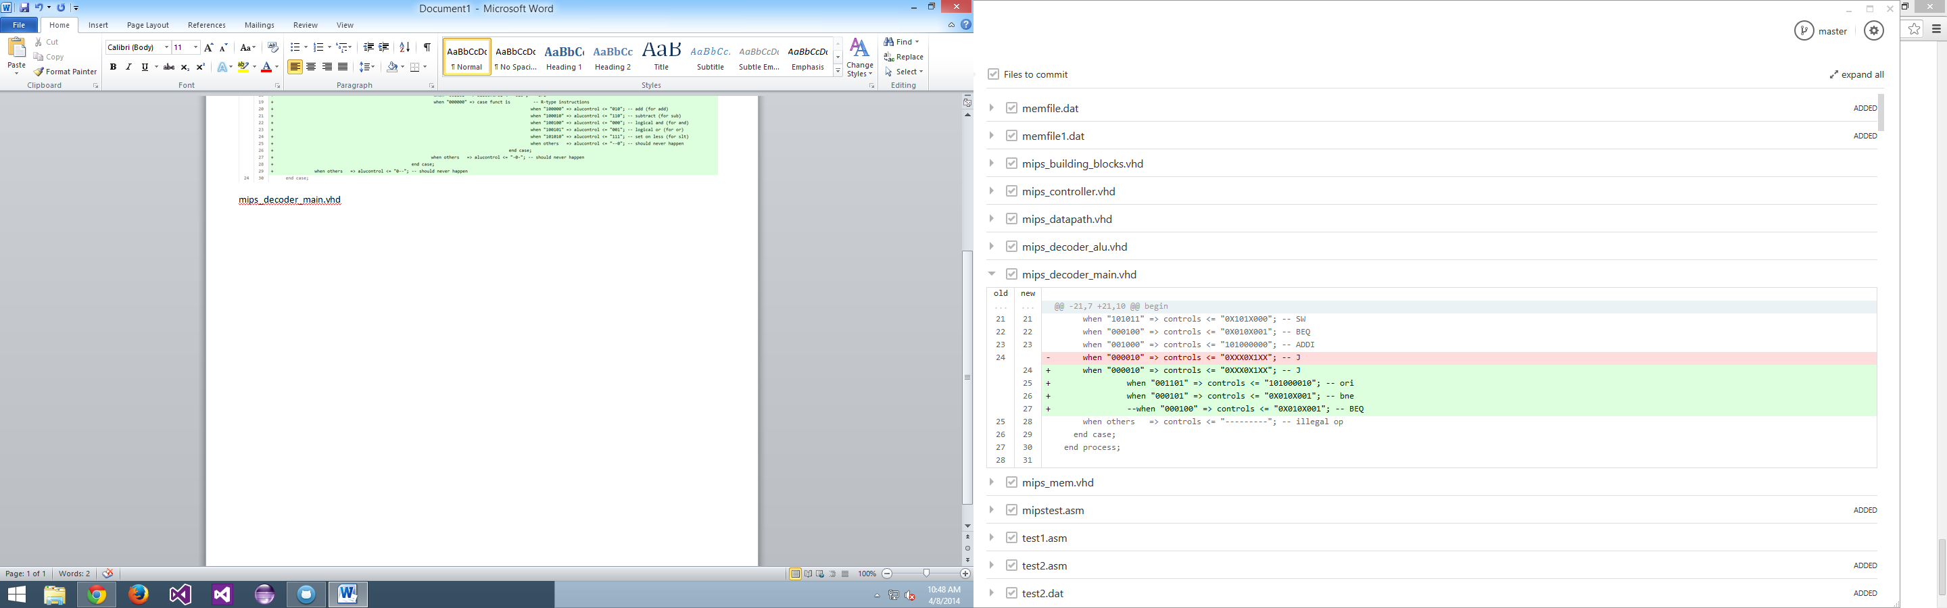

mips_datapath.vhd

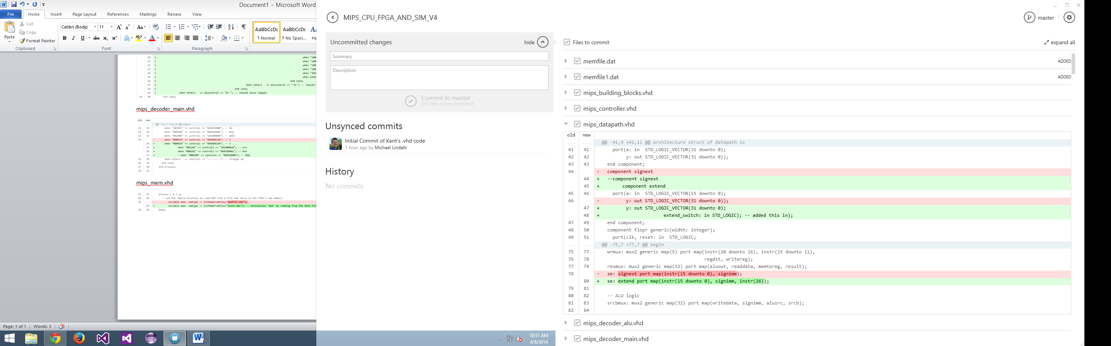

mips_decoder_alu.vhd

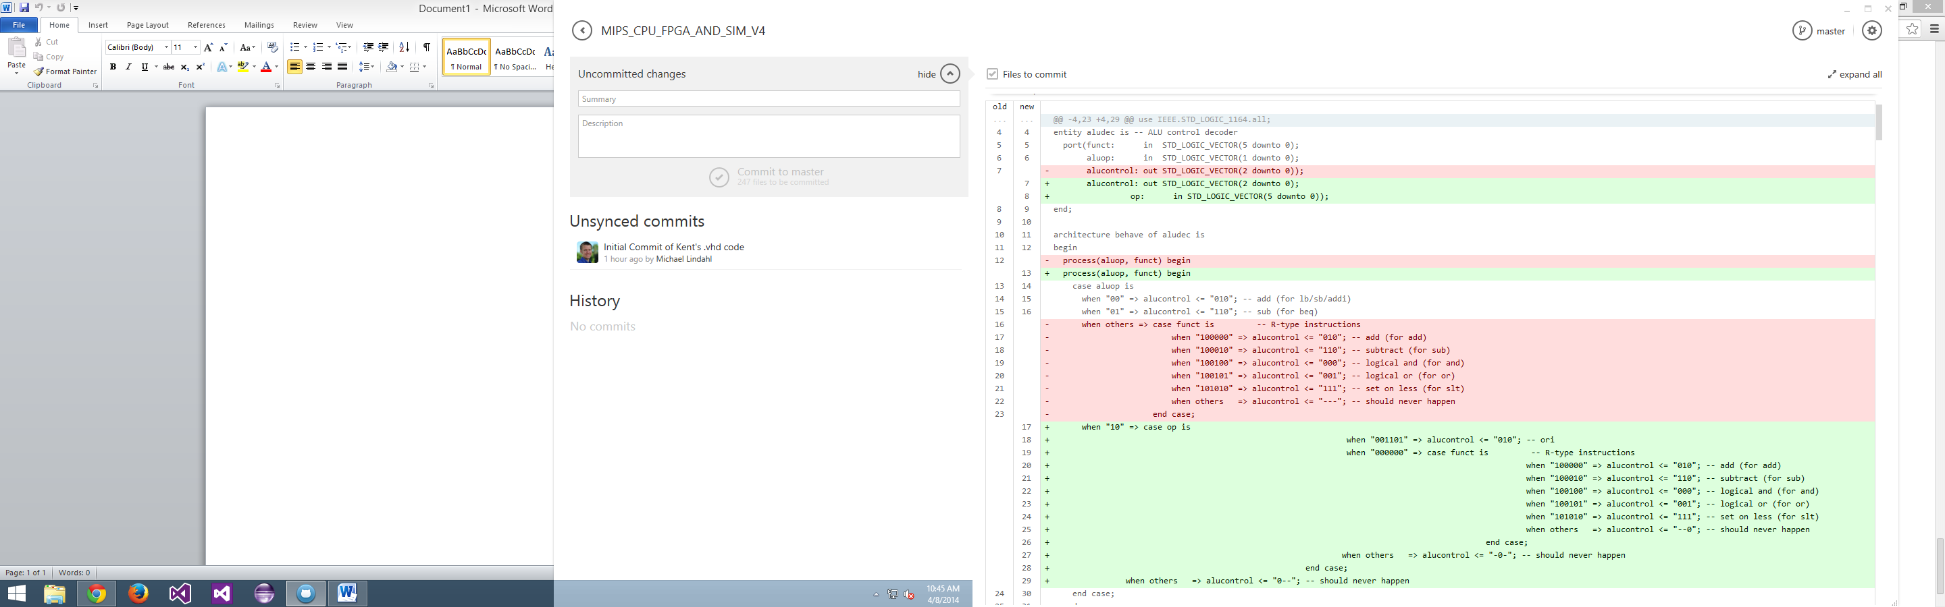

mips_mem.vhd

