**OPERATING SYSTEMS**

**UCCD 2103**

**JAN 2020**

**ASSIGNMENT REPORT**

**PART A**

|  |  |  |  |  |
| --- | --- | --- | --- | --- |
| No. | Student ID | Name | Programme (CN/CS/CT/IA) | Email |
| 1. | 1806352 | Ewe Chun Kit(L) | CS | jackzewe120@1utar.my |
| 2. | 1806718 | Tai Jia Wei | CS | - |
| 3. | 1806623 | Wan Jia Xing | CS | - |

**VMWare Specification**

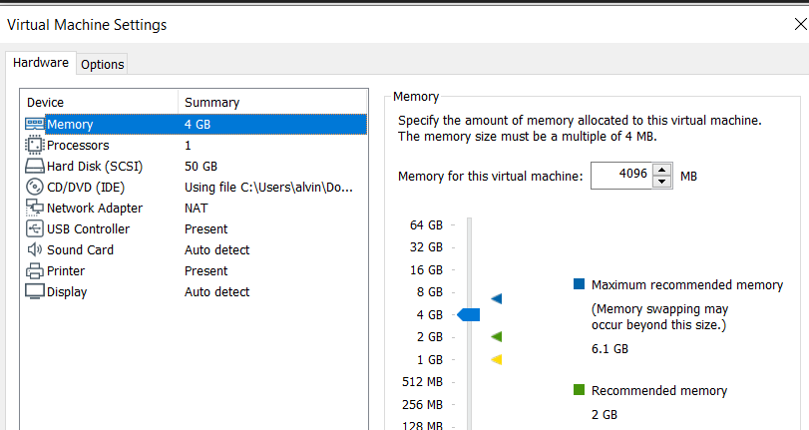

Processor: Uni Core

OS: Fedora

RAM allocated: 4GB

**Question 1**

|  |  |  |
| --- | --- | --- |
| t | thread_t0() | thread_t1() |
| 0 |  |  |
| 1 |  | printf(“\nChef 1 is using Pan B to prepare fry 1 egg.\n");  sleep(2); |
| 2 | printf(“\nChef 0 is using Pan B to prepare fry 1 ham.\n");  sleep(2); |  |
| 3 |  | printf("\nChef 1 finished using Pan B.\n");  sleep(1); |
| 4 | printf("\nChef 0 finished using Pan B.\n");  sleep(1); |  |
| 5 |  | printf(“\nChef 1 is using Pan B to prepare fry 1 egg.\n");  sleep(2); |
| 6 | printf(“\nChef 0 is using Pan B to prepare fry 1 ham.\n");  sleep(2); |  |

Timing Diagram

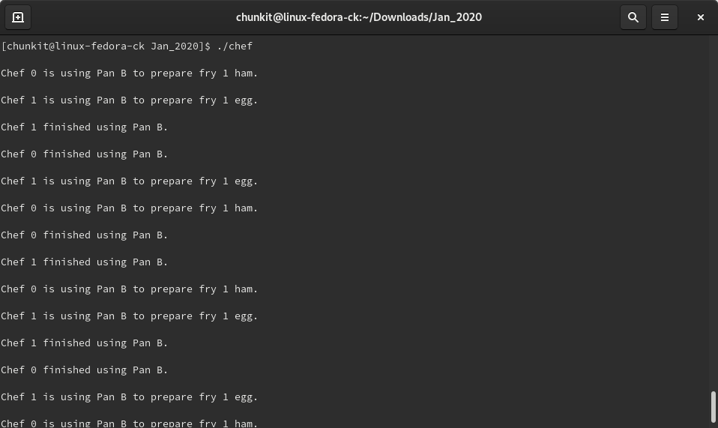

Output Diagram

As we can observe from the timing diagram above, Chef 1 and Chef 2 are doing the same activity at the same time. When the system execute thread 1 first output, the time slice coincidentally finished before it can finish its execution and it proceed to run thread 0. This is not the ideal output that we need and the reason is due to the lack of implementing semaphore in this system. Both thread is having collision of critical section and thus executing the same line. The output can be seen from the picture above.

**Question 2**

|  |  |  |  |  |  |  |
| --- | --- | --- | --- | --- | --- | --- |
| t | thread A( ) | thread B( ) | A.count | B.count | var_A | var_B |
| 0 |  |  | 0 | 0 | 0 | 0 |
| 1 |  | var_B=4321; sem_post(&A); sem_wait(&B); | 1 | -1 | 0 | 4321 |
| 2 | var_A=1234; sem_post(&B); sem_wait(&A); buf_A = var_A; var_A = buf_B; printf(var_A); sleep(1); |  | 0 | 0 | 1234 > 0 | 4321 |
| 3 |  | buf_B = var_B; var_B = buf_A; printf (var_B);  sleep(1); | 0 | 0 | 0 | 1234 |
| 4 | var_A=1234; sem_post(&B); sem_wait(&A); |  | -1 | 1 | 1234 | 1234 |
| 5 |  | var_B=4321; sem_post(&A); sem_wait(&B); buf_B = var_B; var_B = buf_A; printf(var_B);  sleep(1); | 0 | 0 | 1234 | 4321 > 1234 |
| 6 | buf_A = var_A; var_A = buf_B; printf(Var_A); sleep(1); |  | 0 | 0 | 4321 | 1234 |

Timing Diagram

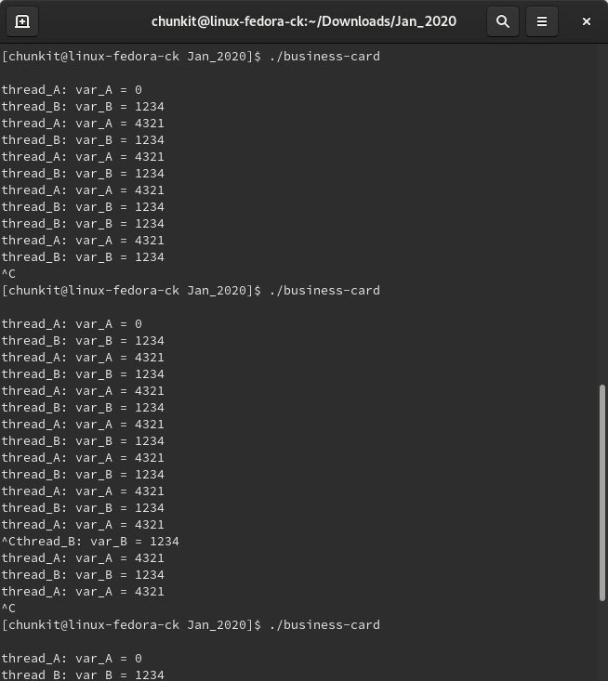

Output Diagram

Regardless of which thread is running first. During the first iteration, the output of the second thread that execute will always be zero. Referring to the timing diagram above, thread A() will be the one facing this problem. This is due to the arrangement of code (buf_B = var_B) in t=3 being placed wrongly and thus the buf_B couldn’t able to run because semaphore wait has already run. Therefore, it went to block queue and in t=2 var_A couldn’t take in any value because buf_B haven’t initiate yet.

**Question 2 (Solution)**

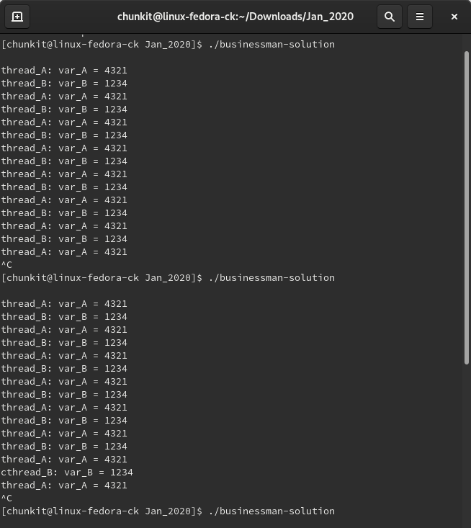

Output Diagram

|  |  |  |  |  |  |  |
| --- | --- | --- | --- | --- | --- | --- |
| t | thread A( ) | thread B( ) | A.count | B.count | var_A | var_B |
| 0 |  |  | 0 | 0 | 0 | 0 |
| 1 |  | var_B=4321; buf_B = var_B; sem_post(&A); sem_wait(&B); | 1 | -1 | 0 | 4321 |
| 2 | var_A=1234; sem_post(&B); sem_wait(&A); buf_A = var_A; var_A = buf_B; printf(Var_A); sleep(1); |  | 0 | 0 | 1234 > 4321 | 4321 |
| 3 |  | var_B = buf_A; printf(var_B);  sleep(1); | 0 | 0 | 4321 | 1234 |
| 4 | var_A=1234; buf_A = var_A; sem_post(&B); sem_wait(&A); |  | -1 | 1 | 1234 | 1234 |
| 5 |  | var_B=4321; sem_post(&A); sem_wait(&B); buf_B = var_B; var_B = buf_A; printf (var_B);  sleep(1); | 0 | 0 | 1234 | 4321 > 1234 |
| 6 | var_A = buf_B; printf(var_A); sleep(1); |  | 0 | 0 | 4321 | 1234 |

Timing Diagram

**Appendix A (chef-solution.c)**

// Reference: https://www.geeksforgeeks.org/use-posix-semaphores-c/

// C program to demonstrate a simple multi-threaded process using two threads.

#include <stdio.h>

#include <pthread.h>

#include <unistd.h>

#include <semaphore.h>

sem_t s0;

//thread t0 represents Chef 0

void* thread_t0(void* arg)

{

int i = 10;

while(i > 0){

sem_wait(&s0);

printf("\nChef 0 is using Pan B to prepare fry 1 ham.\n"); //in Critical Section

sleep(2); //simulate frying 1 ham in 2 seconds

sem_post(&s0);

i--;

printf("\nChef 0 finished using Pan B.\n"); //exit Critical Section

sleep(1); //transition taking 1 second

}

}

//thread t1 represents Chef 1

void* thread_t1(void* arg)

{

int j = 10;

while(j > 0){

sem_wait(&s0);

printf("\nChef 1 is using Pan B to prepare fry 1 egg.\n"); //in Critical Section

sleep(2); //simulate frying 1 egg in 2 seconds

sem_post(&s0);

j--;

printf("\nChef 1 finished using Pan B.\n"); //exit Critical Section

sleep(1); //transition taking 1 second

}

}

int main()

{

//these values are used to identify thread number

int thread0_id=0, thread1_id=1;

sem_init(&s0, 0, 1);

//intialize two variables type pthread_t called t0 and t1

pthread_t t0,t1;

//create two threads, passing thread number as the forth argument

pthread_create(&t0,NULL,thread_t0,&thread0_id);

pthread_create(&t1,NULL,thread_t1,&thread1_id);

//join two threads after they finished running

pthread_join(t0,NULL);

pthread_join(t1,NULL);

sem_destroy(&s0);

return 0;

}

**Appendix B (businessman-solution.c)**

// C program to demonstrate a simple multi-threaded process using two threads.

#include <stdio.h>

#include <pthread.h>

#include <unistd.h>

#include <semaphore.h>

sem_t A; //semaphore variable called A is declared

sem_t B; //semaphore variable called B is declared

int buf_A, buf_B; //declare global variables buf_A and buf_B

//thread A does the following

void* thread_A(void* arg)

{

int var_A;

while(1){

var_A = 1234;

buf_A = var_A; //Jot down own contact number to buf_A so that thread_B can

copy

sem_post(&B); //Here is my card

sem_wait(&A); //Waiting for yours

var_A = buf_B; //Copy thread_B's contact number to var_A

printf("\nthread_A: var_A = %d", var_A); //print var_A on screen

sleep(1);

}

}

//thread B does the following

void* thread_B(void* arg)

{

int var_B;

while(1){

var_B = 4321;

buf_B = var_B; //Jot down own contact number to buf_B so that thread_A can

copy

sem_post(&A); //Here is my card

sem_wait(&B); //Waiting for yours

var_B = buf_A; //Copy thread_A's contact number to var_B

printf("\nthread_B: var_B = %d", var_B); //print var_B on screen

sleep(1);

}

}

int main()

{

//these values are used to identify thread number

int threadA_id=0, threadB_id=1;

//initialize semaphore A and B values as 0 (3rd argument)

sem_init(&A, 0, 0);

sem_init(&B, 0, 0);

//intialize two variables type pthread_t called t0 and t1

pthread_t tA,tB;

//create two threads, passing thread number as the forth argument

pthread_create(&tA,NULL,thread_A,&threadA_id);

pthread_create(&tB,NULL,thread_B,&threadB_id);

//join two threads after they finished running

pthread_join(tA,NULL);

pthread_join(tB,NULL);

//print the value of x and y after threads finished running

printf("The final value of buf_A is %d\n", buf_A);

printf("The final value of buf_B is %d\n", buf_B);

//destroy the semaphore after finished using it

sem_destroy(&A);

sem_destroy(&B);

return 0;

}