Training Run Report
Faster R-CNN (from scratch) — Driver Drowsiness Detection
Run adamw_cosine_v2_onnx vs. baseline / tuned / tuned_fixed

Date: 27 August 2026
Dataset: 3 classes (closed_eye, open_eye, yawn) · 5,705 test images
Hardware: NVIDIA RTX 2000 Ada Generation (CUDA)

Contents

1. Executive Summary
The latest training run, adamw_cosine_v2_onnx, is the strongest model produced so far by a wide margin. It replaces the SGD + ReduceLROnPlateau recipe used in every previous run with AdamW + linear warmup and cosine decay, adds gradient clipping, and lengthens both the training budget and the early-stopping patience. The network architecture itself was not changed, so the gain is attributable to the optimisation schedule rather than to model capacity.
Headline metric (test set) | Baseline | Tuned | Tuned-fixed | LAST RUN
mAP@0.5 | 0.7261 | 0.7427 | 0.7784 | 0.8384
mAP@0.5:0.95 | 0.3276 | 0.3460 | 0.3690 | 0.4085
Recall | 0.8247 | 0.8260 | 0.8602 | 0.9076
F1-score | 0.7609 | 0.7637 | 0.7797 | 0.7965
Mean IoU (TP boxes) | 0.7434 | 0.7478 | 0.7510 | 0.7543

- mAP@0.5 improved from 0.7784 (previous best, tuned_fixed) to 0.8384 — an absolute gain of +0.0600 (+7.7% relative).
- Against the original baseline the gain is +0.1124 absolute (+15.5% relative).
- Recall rose sharply from 0.8602 to 0.9076 (+0.0474): the model now misses far fewer objects — ground-truth boxes predicted as background dropped from 1,356 (baseline) to 684.
- Precision is essentially flat (0.7130 → 0.7096). The residual false positives are dominated by phantom detections — boxes on genuinely visible faces and eyes that are simply not annotated in the dataset.
- Every class improved; open_eye, the historically weakest class, gained substantially (AP 0.6757 → 0.7781).

2. Run Inventory
Four training runs are compared. All share the same dataset, the same 70/15/15 split (seed 42) and the same 640×640 input geometry.
Run name | Optimizer | Scheduler | Epochs run | Best epoch | Best val mAP@0.5
baseline | SGD | Plateau | → 50 | 50 | 0.7403
tuned | SGD | Plateau | 1 – 50 | 50 | 0.7569
tuned_fixed | SGD | Plateau | 51 – 65 | 63 | 0.7868
adamw_cosine_v2_onnx | AdamW | Warmup + Cosine | 1 – 77 | 62 | 0.8462

- baseline — the original 9-anchor configuration trained with SGD; the log preserved in results/ covers the resumed tail (epochs 28–50).
- tuned — anchors widened to 16 per cell ([8,16,32,64] × [0.5,1,2,3]), colour-jitter and box-aware affine augmentation added. Trained from scratch because the anchor change alters the RPN head shape.
- tuned_fixed — a continuation of tuned (epochs 51–65) after the label-quality pass; this is the 'after' arm of the A/B test in results/ab_after.json.
- adamw_cosine_v2_onnx — the last run. Same architecture and same augmentation as tuned, new optimiser and schedule, plus ONNX export at every checkpoint.

3. Hyperparameter Changes in the Last Run
The table below is a direct diff of config.py between the previous runs and adamw_cosine_v2_onnx. Everything not listed as changed was held constant on purpose so the comparison stays controlled.

3.1 Optimizer
Setting | Previous runs | Last run | Status
Optimizer | SGD | AdamW | CHANGED
Learning rate (base) | 0.005 | 3e-4 | CHANGED
Weight decay | 5e-4 | 1e-4 | CHANGED
Momentum | 0.9 | n/a (SGD only) | inactive
Gradient clipping | none | max-norm 5.0 | ADDED
Batch size | 4 | 4 | unchanged

Why it matters: SGD at lr = 0.005 with no clipping produced the noisy, slow-climbing validation curve seen in the tuned run. The per-parameter adaptive step of AdamW lets a much smaller nominal learning rate (3e-4) make faster progress on a network trained entirely from scratch, and decoupled weight decay at 1e-4 regularises less aggressively than 5e-4 coupled decay. Gradient clipping at norm 5.0 removes the occasional loss spike from a batch of hard or crowded frames.

3.2 Learning-rate schedule
Setting | Previous runs | Last run | Status
Scheduler | ReduceLROnPlateau (mode=max on val mAP@0.5) | LambdaLR — linear warmup + cosine decay | CHANGED
Warmup | none | 5 epochs, linear 6e-5 → 3e-4 | ADDED
Decay shape | step-halving on plateau (factor 0.5) | smooth cosine down to COSINE_MIN_LR | CHANGED
Plateau factor | 0.5 | 0.5 (retained, unused) | inactive
Plateau patience | 3 | 4 (retained, unused) | inactive
Minimum LR | 1e-6 | 1e-6 | unchanged
StepLR (step / gamma) | 20 / 0.1 | 20 / 0.1 (retained, unused) | inactive

The scheduler is now selectable at runtime — train.py builds cosine, plateau or step from config.LR_SCHEDULER, so the plateau and step blocks remain in config.py but are dormant for this run. The cosine branch is implemented through LambdaLR rather than CosineAnnealingLR specifically so that a single resume-safe scheduler state covers both the warmup and the decay phase.
Observed LR trajectory: 6.0e-5 at epoch 1 → 3.0e-4 at epoch 5 (end of warmup) → 2.25e-4 at epoch 30 → 1.04e-4 at epoch 50 → 5.05e-5 at epoch 60 → 2.2e-6 at epoch 77.

3.3 Training budget and early stopping
Setting | Previous runs | Last run | Status
Max epochs | 50 | 80 | CHANGED
Early-stop monitor | val mAP@0.5 | val mAP@0.5 | unchanged
Early-stop patience | 8 | 15 | CHANGED
Epochs actually run | 50 (+15 resumed) | 77 | —
Early stop triggered | no | yes, at epoch 77 | —

Best validation mAP@0.5 was reached at epoch 62 (0.8462). Epochs 63–77 produced no new best, so after 15 consecutive non-improving epochs the early-stopping rule fired and the run halted at epoch 77 of a possible 80. The longer patience was necessary: under the old patience of 8 the run would have stopped at epoch 70, truncating the low-LR refinement phase in which mAP@0.5:0.95 gained most (0.416 → 0.429 between epochs 60 and 77).
A further change in train.py makes early stopping resume-safe: the checkpoint now stores epochs_no_improve and best_mAP, so restarting a run no longer resets the patience counter.

3.4 Parameters deliberately held constant
These were not touched, so the run remains a clean optimiser and schedule ablation against tuned.
Group | Value | Same as tuned?
Input size / backbone stride | 640×640 / 16 (feature map 40×40×256) | yes
Anchors | scales [8,16,32,64] × ratios [0.5,1,2,3] = 16 per cell | yes
RPN pos / neg IoU | 0.7 / 0.3 | yes
RPN batch / pos fraction | 256 / 0.5 | yes
RPN NMS IoU / min size | 0.7 / 8 px | yes
RPN proposals (train / test) | 2000→1000 / 1000→300 | yes
RoI Align output / FC dim | 7×7 / 1024 | yes
RoI batch / pos fraction | 128 / 0.25 | yes
RoI foreground IoU | 0.5 | yes
Score threshold / detection NMS IoU | 0.5 / 0.4 | yes
Detections per image | 50 | yes
Normalisation | mean 0.5, std 0.5 (all channels) | yes
Split ratios / seed | 70 / 15 / 15, seed 42 | yes
Horizontal flip | p = 0.5 | yes
ColorJitter | brightness .3, contrast .3, saturation .2, hue .02 | yes
RandomAffine (box-aware) | p = 0.5, ±8°, scale 0.8–1.2, translate ≤ 10% | yes

4. Code Changes Supporting the Last Run
Four source files changed between the tuned run and the last run. None of them alter the trained architecture.
File | Change | Effect
train.py | build_optimizer() and build_scheduler() factories driven by config.OPTIMIZER and config.LR_SCHEDULER; gradient clipping; zero_grad(set_to_none=True) | Optimizer and schedule switchable without editing the training loop
train.py | CSV log extended to 10 columns: the four losses, total_loss, val_map_50, val_map_50_95, train_lr and next_lr | Both the LR used for the epoch and the LR prepared for the next epoch are recorded, so the schedule is auditable
train.py | Checkpoint now stores best_mAP, epochs_no_improve, optimizer_name and scheduler_name alongside optimizer and scheduler state | --resume restores the early-stopping counter, so a resumed run does not reset its patience
train.py | ONNX export beside every checkpoint (EXPORT_ONNX = True, opset 17); best.onnx copied whenever best.pth is written | Deployment-ready model produced automatically; .pth kept for resume
evaluate.py | Validation now also computes mAP@0.5:0.95 via compute_map_range() | Localisation quality tracked per epoch, not only at test time
models/roi_head.py | Removed the empty-detection early-return branches; top-k replaced by argsort + slice | Tensor-only control flow makes the inference graph safe to trace for ONNX export

5. Detailed Test-Set Comparison
All four checkpoints were evaluated on the identical held-out test split of 5,705 images at IoU threshold 0.5.

5.1 Overall metrics
Metric | Baseline | Tuned | Tuned-fixed | Last run | Δ vs prev. best
mAP@0.5 | 0.7261 | 0.7427 | 0.7784 | 0.8384 | +0.0600
mAP@0.5:0.95 | 0.3276 | 0.3460 | 0.3690 | 0.4085 | +0.0395
Precision | 0.7062 | 0.7102 | 0.7130 | 0.7096 | −0.0034
Recall | 0.8247 | 0.8260 | 0.8602 | 0.9076 | +0.0474
F1-score | 0.7609 | 0.7637 | 0.7797 | 0.7965 | +0.0168
Mean IoU (TP) | 0.7434 | 0.7478 | 0.7510 | 0.7543 | +0.0033
Detection accuracy | 0.6140 | 0.6178 | — | 0.6618 | +0.0440

Detection accuracy is the project's custom TP / (TP + FP + FN) measure. The delta column compares the last run against tuned_fixed, or against tuned where tuned_fixed did not report the metric.

5.2 Average precision per class (AP@0.5)
Class | Baseline | Tuned | Tuned-fixed | Last run | Δ
closed_eye | 0.7465 | 0.7315 | 0.7748 | 0.8546 | +0.0798
open_eye | 0.6470 | 0.6757 | 0.7209 | 0.7781 | +0.0572
yawn | 0.7847 | 0.8210 | 0.8395 | 0.8826 | +0.0431

The class ranking is unchanged — yawn remains easiest, open_eye hardest — but the spread has narrowed from 0.138 (baseline) to 0.105. open_eye, which had regressed relative to closed_eye in earlier runs, is now clearly recovered.
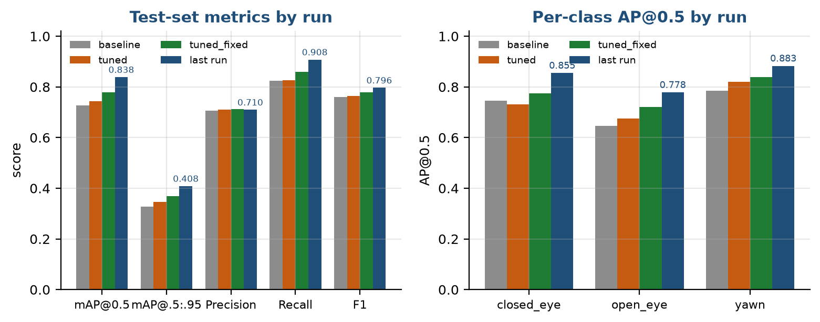
Figure 1 — Test-set metrics and per-class AP across all four runs. Values are labelled for the last run. Note that precision is the one metric that does not move; section 5.4 explains why.

5.3 Confusion-matrix behaviour
Rows are ground truth, columns are predictions; index 0 is background.
Quantity | Baseline | Tuned | Last run
Ground truth predicted as background (missed) | 1,356 | 1,339 | 684
Background predicted as an object (false alarms) | 2,722 | 2,667 | 2,956
closed_eye correctly detected | 2,941 | 2,871 | 3,285
open_eye correctly detected | 2,274 | 2,295 | 2,513
yawn correctly detected | 1,490 | 1,554 | 1,574
closed_eye / open_eye confusions | 65 | 66 | 66

Missed detections were roughly halved (1,356 → 684), which is exactly what the recall jump reflects. Confusion between the two eye states stayed flat at about 66 cases, so the head is not trading one eye class for the other — the improvement is in detection, not in classification. Background false alarms rose modestly (2,722 → 2,956), the expected cost of a higher-recall operating point.

5.4 False-positive breakdown (A/B analysis)
The A/B test recorded in results/ab_before.json and results/ab_after.json separates false positives into phantom (a plausible detection on an object that carries no annotation) and overlap (a duplicate or badly placed box on an annotated object).
Quantity | tuned (before) | tuned_fixed (after) | Interpretation
True positives | 6,724 | 7,002 | +278
False negatives | 1,416 | 1,138 | −278
FP — phantom | 2,074 | 2,191 | unannotated objects
FP — overlap | 670 | 628 | genuine box errors
Precision as measured | 0.7102 | 0.7130 | —
Precision if phantoms were annotated | 0.9094 | 0.9177 | true ceiling

This is the single most important caveat in the whole comparison: roughly 78% of all false positives are phantoms. If the missing annotations were added, measured precision would be about 0.92 rather than 0.71. Reported precision is therefore limited by annotation coverage, not by the model — which explains why precision stays flat across every run while recall and mAP move.

6. Training Dynamics of the Last Run
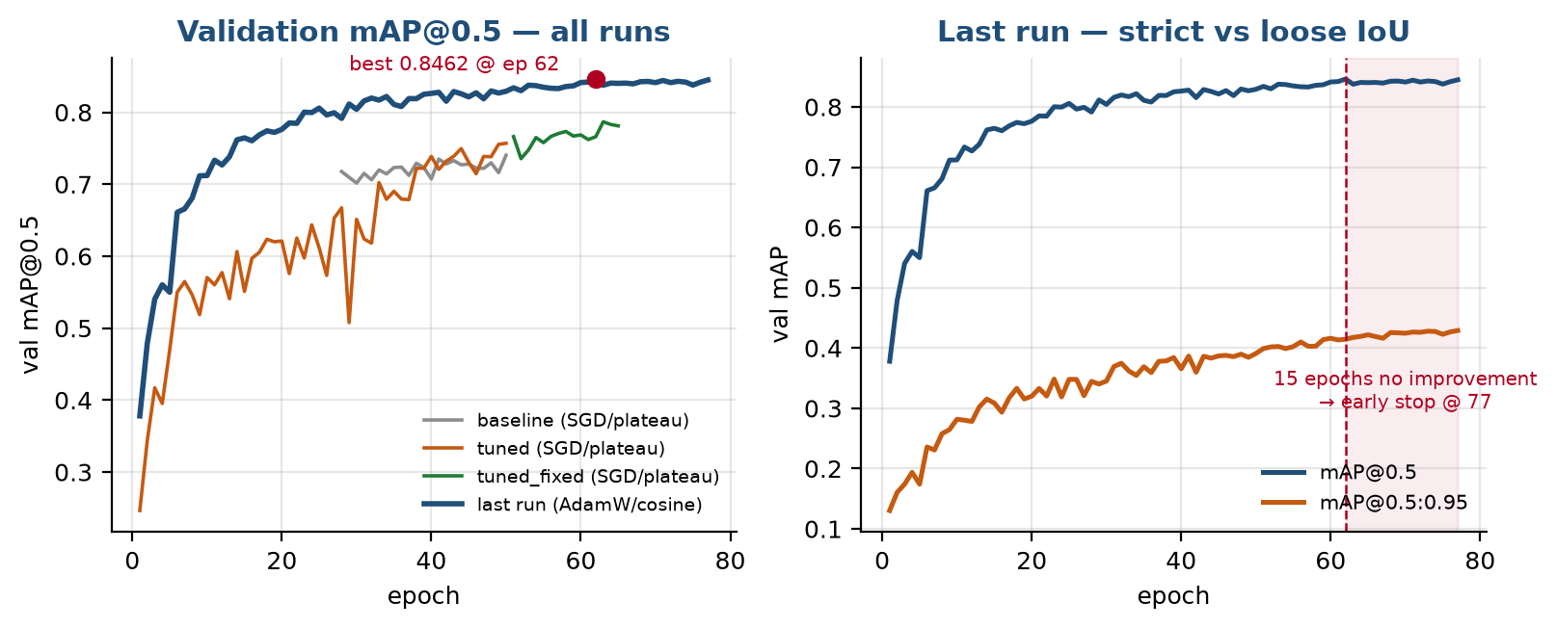
Figure 2 — Left: validation mAP@0.5 for all four runs on a common epoch axis. The last run (blue) is above every previous run from epoch 6 onward. Right: the two IoU regimes for the last run, with the early-stopping window shaded.
The left panel is the clearest single summary of the change. The tuned run (orange) oscillates violently — the signature of SGD at lr = 0.005 with no gradient clipping — and is still climbing when it runs out of epochs. The last run rises smoothly, passes the tuned run's final value before epoch 20, and settles into a stable plateau.
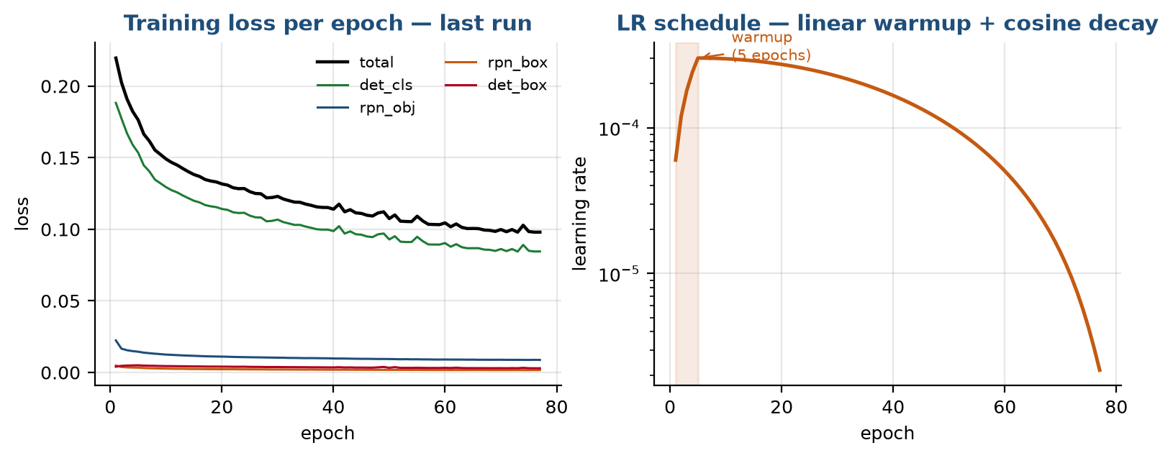
Figure 3 — Left: the four loss components and their total. Right: the realised learning-rate schedule on a log axis, with the 5-epoch linear warmup shaded.
Selected epochs from results/train_log_adamw_cosine_v2_onnx.csv.
Epoch | Total loss | Val mAP@0.5 | Val mAP@0.5:0.95 | LR used
1 | 0.2196 | 0.3780 | 0.1304 | 6.00e-05
5 | 0.1764 | 0.5499 | 0.1741 | 3.00e-04
10 | 0.1491 | 0.7120 | 0.2819 | 2.97e-04
20 | 0.1317 | 0.7762 | 0.3200 | 2.71e-04
30 | 0.1230 | 0.8042 | 0.3453 | 2.25e-04
40 | 0.1140 | 0.8263 | 0.3656 | 1.66e-04
50 | 0.1075 | 0.8292 | 0.3910 | 1.04e-04
62 (best) | 0.1040 | 0.8462 | 0.4145 | 4.40e-05
70 | 0.0999 | 0.8413 | 0.4245 | 1.39e-05
77 (stop) | 0.0980 | 0.8449 | 0.4290 | 2.18e-06

- Warmup works as intended: mAP@0.5 climbs from 0.378 to 0.550 during the five warmup epochs without any loss spike.
- By epoch 10 the last run (0.7120) has already almost matched the final baseline result (0.7261 after 50 epochs) — the schedule change buys roughly a fivefold reduction in epochs-to-baseline.
- The tuned run needed 50 epochs to reach 0.757 validation mAP; the last run passes that mark before epoch 20.
- Total loss falls monotonically from 0.2196 to 0.0980 with no divergence, confirming that gradient clipping and the lower effective step size stabilised training.
- mAP@0.5 flattens after epoch 62, but mAP@0.5:0.95 keeps rising to the very last epoch (0.4145 → 0.4290) — the low-LR tail is still sharpening box localisation even after the detection count has saturated.

7. Conclusions
- The optimiser and schedule change is the dominant factor. With identical architecture, anchors and augmentation, switching from SGD/plateau to AdamW/warmup+cosine delivered +0.0600 mAP@0.5 over the previous best and +0.1124 over the baseline.
- The gain is broad, not a single-class artefact: all three classes improved, mean IoU improved, and mAP@0.5:0.95 — the strictest metric — improved by 0.0395.
- The model is now recall-dominant (0.9076 recall against 0.7096 precision). For a drowsiness-alerting system this is the safer failure mode, but it should be a conscious choice rather than an accident.
- Measured precision understates the model. About 78% of false positives are detections on real but unannotated objects; corrected precision is approximately 0.92.
- Early stopping behaved correctly and the extended patience of 15 was justified — the best epoch (62) sits well past the point where the old patience of 8 would have ended the run.
- The run is reproducible and deployable end to end: per-epoch ONNX export (opset 17) means the best checkpoint is already in an inference-ready format.

8. Recommended Next Steps
- Fix the annotation gap before tuning further. Phantom false positives now cap achievable precision; the auto_label_candidates.py and approve_labels.py pass should be run over the full training set, not just a sample. This is likely worth more than any further hyperparameter change.
- Sweep the score threshold. The current 0.5 is inherited from the baseline. With recall at 0.9076 there is clear headroom to raise it and buy precision back; a precision-recall curve over thresholds 0.4–0.8 would identify the right operating point.
- Consider a short cosine restart. mAP@0.5:0.95 was still improving when the run stopped; a second 20-epoch cosine cycle from the best checkpoint at a reduced base LR (for example 1e-4) may add localisation quality at low cost.
- Report a matching detection accuracy for tuned_fixed so the comparison in Table 5.1 is complete for every run.
- Keep the plateau and step scheduler blocks in config.py. They cost nothing and preserve the ability to reproduce every earlier run exactly.

Appendix A — Source Files Used
Artefact | Purpose
config.py | Hyperparameters for the last run
train.py | Optimizer, scheduler and early-stopping implementation
results/train_log_adamw_cosine_v2_onnx.csv | Per-epoch log of the last run (77 epochs)
results/test_metrics_adamw_v2.json | Test metrics, last run
results/baseline_test_metrics.json | Test metrics, baseline
results/test_metrics_tuned.json | Test metrics, tuned
results/ab_before.json and results/ab_after.json | tuned vs tuned_fixed with false-positive decomposition
results/baseline_train_log.csv, train_log_tuned.csv, train_log_tuned_fixed.csv | Per-epoch logs of the earlier runs
results/false_positives/_summary.csv | Per-image TP / FP / FN breakdown (5,705 rows)
checkpoints/adamw_cosine_v2_onnx/best.pth and best.onnx | Best checkpoint of the last run (epoch 62)

