Bananarama: The Quest for Colour-blind Fruit-based Equality

From the beginning of time there have been one group marginalised against. Derided and beaten down. I am of course talking about the colour-blind. What kind of all powerful, merciful creator would rob a subset of their creation of the ability to see lilac? A total bastard, that’s who. So I hope that you will join me in creating an unholy artificial intelligence in defiance of this so-called ‘God’ person.

Having watched Terminator at least twice I already have the know-how to build the AI but what I don’t have is the most important part: data. This is where you guys come in. I need a database of, ideally, thousands of images of bananas of the Cavendish species. I choose this species because it is the most sold in the UK. After reading multiple papers on banana classification and ripening (it’s a lock-down, keep your judgements to yourself) I have found that there is a distinct lack of this. I know, it seems like a huge oversight from the data community but they were probably too busy making ageify apps or something.

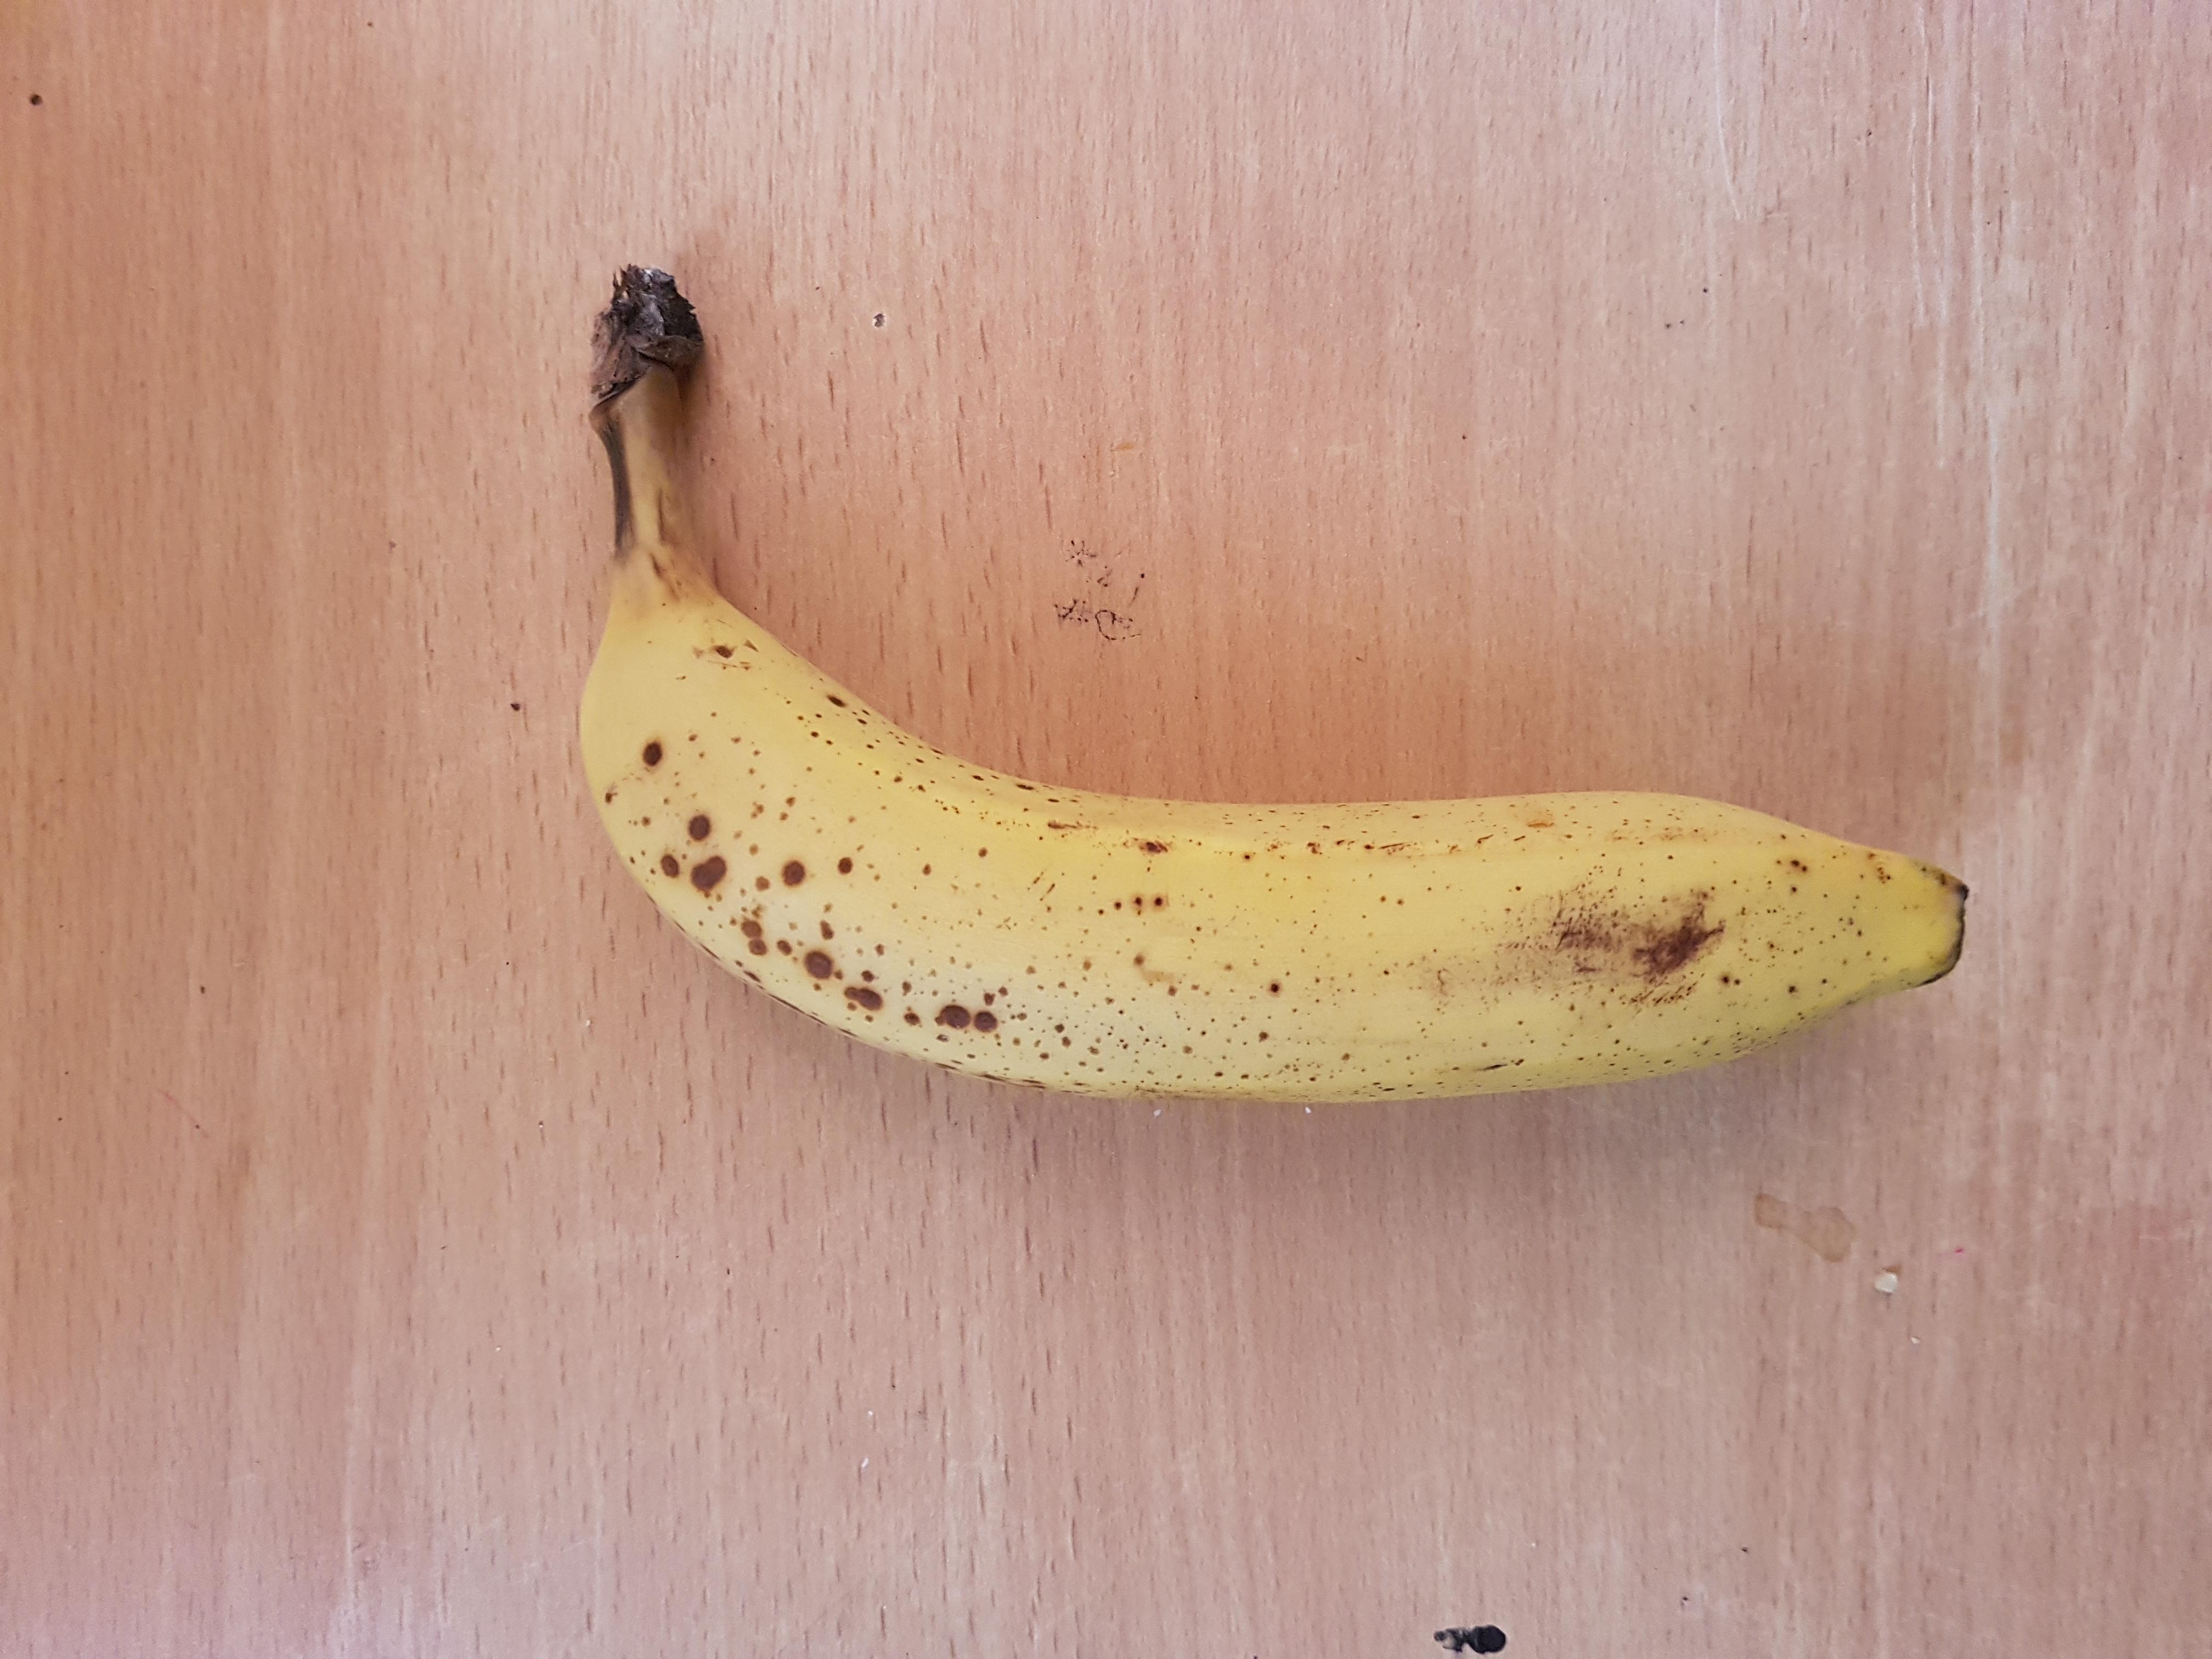
Here’s what you can do for me. When buying a banana, take a picture of it on a neutral background with nothing else in the shot. White backgrounds are better but as long as it is one colour (or as close as possible) that’s fine as well. Send me a description of whether the banana was ripe, under-ripe or over-ripe as well and I’ll take it from there. The images should be taken on either android or ios phones, preferably with a 4:3 aspect ratio and ideally at least 480p resolution. Your phones are set to these settings as standard so don’t worry. If you are concerned about your phone because you have played the system and kept a non-smartphone (h*ck you NSA) let me know. An example of one of these images is below.

Is there is a reward? Yes. When I think of one. Until then, your names will be saved somewhere and if I manage to make an application using this AI and release it, your names will be in the acknowledgements. This may not actually happen and most of this is a learning process for me, but I am bloody sick of not being able to tell even with my glasses on, so I am hoping to turn it into an app somehow. First we take the pictures, then we take the world. Viva la Colour-blind Revolution!

