HW2: Digital Signal Processing

1. Using the sample code, I was able to import sigA.csv, sigB.csv, and sigC.csv into Python as lists. My python code is below:

1. Next, using the sample code provided to us, I plotted signals A, B and C. The code and plot are shown below:

1. Now we can find the sample rate of the data using the formula

sample rate = number of data points / total time of samples. The code is listed below:

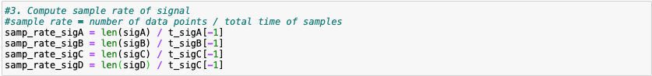

1. Using the example code, I can compute the FFTs of each CSV and plot the results. The code and plots are shown below:

1. I implemented the moving average filter and found that with x = 200 samples I obtained a noticeable lowpass effect. My code and plots are below:

1. Next, I coded an IIR LPF as instructed. I found that A = 0.99 and B = 1-A = 0.01 produced a good frequency response with significantly less noise. My code and plots are below:

1. Finally, using the filter designer on <https://fiiir.com> I found the filter coefficients necessary to implement a LPF. I chose a filter with cutoff frequency of 10 Hz and bandwidth of 50 Hz and found that it did a good job removing the high frequency noise in each signal. Instead of manually copying coefficients, I chose to use the algorithm linked on the filter designer site to come up with parameters for the sinc filter with blackman window. The code I used is available on this site: <https://tomroelandts.com/articles/how-to-create-a-simple-low-pass-filter>.

My code and plots are shown below.

In summary, I have implemented several filters including FIR and IIR LPFs in Python. I used Jupyter Notebook to complete my python coding and have included the notebook and an equivalent python file in my submission as HW2.ipynb and HW2.py respectively.