Enterprise Review

Business Requirements

**Perficient**

Prepared By: Ellie Huss and David Otto

Contents

Enterprise Review 1

Business Requirements 1

1. Business Goal 4

2. Enterprise Review Author and Approval Process 4

3. Authoring and Security 5

4. Annual Review 7

5. Project Review 15

6. Three Month Review 21

7. 360/Peer Review Process 28

8. ** Missing section on how the system allows the user to interact with reviews during and after review process ** 31

9. Glossary 32

**Version History**

|  |  |  |
| --- | --- | --- |
| **Version** | **Author** | **Notes** |
| 1.0 | Ellie Huss | Initial draft |
| 2.0 | Ellie Huss | Updated based on peer review comments – David Brooks and John Spyers |
| 3.0 | Ellie Huss | Added section 8.0 – User Notifications and Interactions |
| 4.0 | Ellie Huss | Updated based on team and GM feedback |
| 5.0 | Ellie Huss | New requirements based on Iterations 1 and 2. |
| 6.0 | Ellie Huss | Added the following requirements on 12.11.13  10.0  10.2.5  10.3.5  10.3.6  10.3.7 |
| 7.0 | Ellie Huss | Added the following Figures on 12.11.13  Figure 8.0  Figure 9.0  Figure 10.0 |

# Business Goal

Replicate the current manual review process (a.k.a “CareerBook”- Excel file based) into an enterprise review solution (“Enterprise Review”) to allow for ease of use and communication among the leadership, managers, and counselees.

# Enterprise Review Author and Approval Process

* 1. All stakeholders should have workflow visibility to where the review is in the process at any given time per figure 2.0 in the Addendum.
  2. The system shall allow a Counselor or the Counselee to initiate any review type mentioned in this document.
     1. If a Counselee starts a review, a notification should be sent to the Career Counselor.
     2. If a Counselor starts a review, a notification should be sent to the Counselee
  3. The system shall allow a counselee to fill out/edit the counselee fields (specific to each review type) and submit to Career Counselor. A notification will be sent to the Career Counselor.
  4. They system should allow for the Counselor and / or counselee to choose peers of the counselees for peer review/360 Review feedback.
  5. The Counselor should be notified when the peer reviews /360 reviews are complete.
  6. The Counselor should be able to see the peer reviews but the counselee should not be able to view the peer reviews until the Counselor has completed the review with the counselee.
     1. Peer comments are only visible by the counselor -- ** flag certain comments to be seen by counselee – See requirement 9.5
  7. The Counselor should have access to the peer reviews/360 Reviews during the annual review, project review, or the 3-month review processes with the counselee.
  8. The system shall allow the Career Counselor to specify that more work is needed on the review. A notification will be sent to the Counselee.
  9. During the Counselor review, the Counselor is allowed to edit only the Reviewer’s eligible fields and add texts in Comments Fields.
  10. Upon agreement of an approved Enterprise Review between the Career Counselor and the Counselee. The Counselor has control of the document in order to provide signature and forward to the General Manager (GM). The form is read only at this time (aside from signature field).
  11. If the GM has changes, the Enterprise Review must be set to a non-approved state with notification sent to the Career Counselor for modifications. At this time the Enterprise Review is changed to an editable state (per requirements in “Authoring and Security”).

# Authoring and Security

* 1. The following requirements are applicable to 3 Month Review, Annual Performance Review, and the Project Review – see Figure 3.0 in Addendum A.
  2. The Counselee has access to author and update the Enterprise Review only during the Counselee draft and review portion of the process. If during the review, updates are required, the counselee or the counselor has the ability to make those updates, depending on which fields need to be updated.
     1. The Counselee can update the Self Rating
        1. If rating is not equal to a 3, a comment is required.
     2. The counselor can update the Reviewer Rating
        1. If rating is not equal to a 3, a comment is required.
     3. Comments and ratings fields to be separated and tracked by the original author
        1. Counselee Comments
        2. Career Counselor Comments
        3. Peer Comments (to be added by Career Counselor)
     4. The comments field should be automatically notated with the login credentials to capture who is making the comment.
     5. The comments field is not editable by anyone other than the original author of the comment.
     6. There needs to be a “help the user” section for all reviews that includes the following:
        1. As seen in Figure 4.0 In Addendum A – Annual Checklist
        2. As seem in Figure 4.3 In Addendum A - Overall rating, the description under the arrow
        3. As seen in Figure 4.6 In Addendum A - Performance Evaluation is an explanatory field compacting the Counselee Rating Scale and the definition of each rating.
        4. Frequently Asked Questions – FQAs.
           1. Contents to be supplied at a later date.
  3. Once an Enterprise Review form is saved or submitted, all are not editable.
     1. Once submitted and GM approved or disapproved, If any change is required, the Career Counselor should be able to change the status to draft mode, with notification to the counselee and the GM.
  4. When the counselee, peer or counselor is completing a review, need to be able to save Enterprise Review in draft state.
  5. The counselee and counselor should be able to see/know the status of a review at all times.
  6. The review should remain in draft state until it has been approved by the Counselor. There is no required timeframe for starting and completing a review.

# Annual Review

* 1. Replicate the current Annual Review excel form. – see figure 4.6 in Addendum A.
  2. The following fields as seen in Figure 4.0 In Addendum A are required to begin the Annual Review Process and is completed by the Counselor:
     1. Colleague Name
  3. The following fields as seen in Figure 4.0 in Addendum A are required to begin all Review Processes and should be auto-populated. (NOTE: if any of these fields cannot be auto-populated, the counselor should be required to complete). This serves as a Counselor management screen needed to start a review process.
     1. Colleague Counselor
     2. Colleague Current Title
     3. Next Target Title
     4. Review Year
     5. Anniversary Month
     6. Business Unit Practice
     7. Review Period - Start Date
     8. Review Period - End Date
     9. Perficient Start Date
     10. Today’s Date - updated each time the form is began or updated.
  4. The header information for the Counselee’s reviews should populate from the information in Figure 4.0 in Addendum A.
  5. Include a free form field to capture the following information in each of the following sections. NOTE: auto-populate from previous reviews if available.
     1. Client Dates, Roles and Responsibilities
     2. Goals
     3. Achievements
        1. List goals from prior APR or PDP
  6. In figure 4.1 – Core Competencies section - the Categories and contents should be copied exactly as they appear and the Self Rating and Reviewer Rating field should contain a numeral 1, 2, 3, 4 or 5 or an NA.
     1. NA is defined as Non-applicable, meaning that field does not apply to the counselee being reviewed and is not taken into consideration in the composite score.
  7. The score from the Core Competencies section in Figure 4.1 in Addendum A is equal to the Reviewer Composite Score for both the Self Rating and the Reviewer Rating. See figure 4.2 in Addendum A.
  8. Need a free form comments field that is tracked by the user. Similar to what is seen is Figure 4.1 in Addendum A.
  9. In figure 4.3, in Addendum A, – Internal Contributions section - the Categories and contents should be copied exactly as they appear and the Self Rating and Reviewer Rating field should contain a numeral 1, 2, 3, 4 or 5 or an NA.
     1. NA is defined as Non-applicable, meaning that field does not apply to the counselee being reviewed and is not taken into consideration in the composite score.
     2. The score from the Internal Contributions section in Figure 4.3 in Addendum A, should be included in the calculations within the Reviewer Composite Score for both the Self Rating and the Reviewer Rating. See figure 4.4. Calculations for the ALL section as indicated by the Red Arrow, - calculated by the following equation: ALL = Avg (Core Competencies AND Avg (Internal Contributions)).
     3. As seen in figure 4.5, in Addendum A, there needs to be an alpha/numeric free form field for the following sections:
        1. Strengths, Areas for Improvement, Goals, Development Opportunities, Longer Term Goals and
           1. These fields are not mandatory.
     4. As seen in figure 4.5, in Addendum A, there needs to be a submit field that submits the form.

# Project Review

* 1. Replicate the current Project Review form - See Figure 5.3, in Addendum A.
  2. The following fields as seen in figure 5.0, in Addendum A, are required to begin the Project Review and should be auto-populated. (NOTE: if any of these fields cannot be auto-populated, the counselor should be required to complete). This serves as a Counselor management screen needed to start a review process.
     1. Colleague
     2. Colleague’s Counselor
     3. Review Date
     4. Engagement Summary
        1. Include static instruction for Engagement Summary as seen in figure 5.0, in Addendum A.
     5. Client
     6. Project
     7. Project Role(s) and Responsibilities
     8. Review Period
  3. Calculations for the Performance Evaluation Section (figure 5.1, in Addendum A) consist of the following Core Competencies:
     1. Provide definition for each Header below as seen in figure 5.1, in Addendum A.
        1. Technical Abilities
           1. P roductivity
           2. Quality
           3. R esults
           4. Technical Skills
        2. Consulting Skills
           1. Adaptability
           2. Communication
           3. Interpersonal Skills
           4. Core Consulting Skills
        3. Professionalism
           1. Attitude
           2. Dependability
           3. Initiative
           4. Professionalism
        4. Leadership
           1. Decision Making
           2. Leadership
        5. Teamwork
           1. Teamwork
           2. Customer Focus
  4. Carry Score from the Core Competencies section, an average of the scores entered, to the fields of Self and Reviewer within the Reviewer Composite Score for both the Self Rating and the Reviewer.
  5. If Self Rating or Reviewer Rating is not equal to a 3, a comment is required. Comments field must be completed.
  6. The calculations seen in the red box above in figure 5.2, in Addendum A. are an average of the scores carried down from the Composite Score averages in figure 5.1, in Addendum A.
  7. Under the Heading “Overall Evaluation,” provide free form fields for the following as referenced in figure 5.3, in Addendum A:
     1. Differentiators
     2. Opportunities for Improvement
     3. Summary
  8. Overall Rating (Yellow Box as seen in figure 5.2, in Addendum A.) is a numeric only field requiring manual entry.
     1. Include instruction provided in figure 5.2, in Addendum A, under arrow.
  9. Provide field for current date for Colleague and Reviewer as seen in figure 5.3, in Addendum A.
  10. Provide “Submit Final Form” button.
  11. Include signature fields for Colleague and Reviewer as seen in figure 5.3, in Addendum A.

# Three Month Review

* 1. Replicate the current three month Review form. See Figure 6.3, in Addendum A.
  2. The following fields as seen in figure 6.0, in Addendum A, are required to begin the Three Month Review Process and are completed by the Counselor:
     1. Colleague
     2. Colleague’s Counselor
     3. Reviewer
     4. Perficient Start Date
     5. Review Date
     6. Include a free form comments field for the following;
        1. Perficient Assessment (Colleague)
        2. Project Performance Assessment (Reviewer and Colleague “Both”)
           1. Provide instruction for Project Performance Assessment.
           2. Include free form comments section.
        3. Overall Short-Term Performance Evaluation (Static content providing definition of the performance rating scale, comments not required.
           1. Include a free form comments, comments not required.
  3. The Reviewer Composite Scores Section consists of the following Core Competencies, the Categories and contents should be copied exactly as they appear and the Self Rating and Reviewer Rating field should contain a numeral 1, 2, 3, 4 or 5 or an NA.
     1. NA is defined as Non-applicable, meaning that field does not apply to the counselee being reviewed and is not taken into consideration in the composite score.
  4. The Composite score, see red oval in figure 6.1, is an average of the scores within each evaluation section. This average is required for all Core Competencies listed below (ex. 3.0.4.1, 3.0.4.2).
  5. Provide definition for each below as seen in figure 6.1, see Addendum A:
     1. Technical Abilities
        1. Productivity
        2. Quality
        3. Results
        4. Technical Skills
     2. Consulting Skills
        1. Adaptability
        2. Communication
        3. Interpersonal Skills
        4. Core Consulting Skills
     3. Professionalism
        1. Attitude
        2. Dependability
        3. Initiative
        4. Professionalism
     4. Leadership
     5. Teamwork
  6. Carry this average from the Core Competencies sections to the fields of “Self” and “Reviewer” within the Reviewer Composite Score for both the Self Rating and the Reviewer.
  7. The All section, see green oval, is an average of the scores carried down from the Core Competencies sections.
  8. Overall Rating (Yellow Box as seen in figure 6.1, in Addendum A.) is a numeric only field requiring manual entry.
     1. Include instruction provided in figure 6.1, in Addendum A, under the arrow.
  9. Provide field for current date.
     1. Provide “Submit Final Form” button.
  10. Include signature fields as seen in figure 6.1, in Addendum A.
  11. Calculation in the red box is an average of the Core Competencies averages carried down from above.

# 360/Peer Review Process

* 1. Replicate the current form in Drupal. See figure 7.0, in Addendum A.
  2. The following fields are completed by the Counselor
     1. Colleague
     2. Colleague’s Counselor
     3. Date
     4. Project
     5. Reviewer’s Role on Project.
  3. The following field is completed by the reviewer and can be left blank -- not seen by the counselee – only visible by the counselor
     1. Reviewer
  4. The Reviewer is responsible for scoring the colleague’s Technical Abilities, Consulting Skills, Professionalism, Leadership and Teamwork score.
     1. Categories and contents should be copied exactly as they appear in the Reviewer Rating field and should contain a numeral 1, 2, 3, 4 or 5 or an NA.
     2. A comment is requited if anything other than a three is selected by the Reviewer, the comment is required.
  5. Carry the score from the Composite Score sections, an average of the scores entered directly above, to the field called Reviewer Composite Score. As seen in the red circle below in figure 7.0, in Addendum A.
  6. The calculations in the red box within then red circle in figure 7.0, in Addendum A, are an average of the scores directly above, or an average of the scores from the Composite Scores.
  7. The overall rating field, seen in yellow in Figure 7.0, in Addendum A, is a numeric free form field and must be completed by the Reviewer.
  8. The form needs to have free form field for Reviewer comments

The form needs to have a non-required signature and date field for the Reviewer.

# Users Notifications and Interactions

* 1. When a Counselor or Counselee begins a new review the status = New Review Started and a notification is sent to both the counselor and counselee.
     1. Content for notification:
        1. Subject Line: Enterprise Review Notification
        2. Body: This is automatically generated email to notify you that a new review has been started <for> and is currently in New Review Stated status.
  2. When the reviews are being edited by the counselee, counselor or the peers the status = Review in Draft
  3. When the review has been submitted to the counselor by the peer or the counselee the status = Review by Counselor
  4. When the counselor has approved the review the status = Approved by Counselor
     1. At this time a notification should be sent to the counselee of the status so he/she can expect a meeting notification from the counselor.
     2. Content for notification:
        1. Subject Line: Enterprise Review Notification
        2. Body: This is automatically generated email to notify you that the review <for> has been approved by your career counselor.
     3. Upon the counselor and counselee meeting and reviewing the review, counselor submits to the GM.
  5. When the counselor has submitted to the GM for review status = GM Review.
     1. At this time a notification is sent to the counselor and counselee.
     2. Content for notification:
        1. Subject Line: Enterprise Review Notification
        2. Body: This is automatically generated email to notify you that the review <for> and is currently in GM Review status.
  6. When the GM has reviewed and approved the review status = GM Approve
     1. At this time a notification is sent to the counselee and counselor.
     2. Content for notification:
        1. Subject Line: Enterprise Review Notification
        2. Body: This is automatically generated email to notify you that the <for> and is currently approved by the GM.
  7. If the GM has reviewed the review and has NOT accepted the review, the status is changed to Review by Counselor.
     1. Content for notification:
        1. Subject Line: Enterprise Review Notification
        2. Body: This is automatically generated email to notify you that the review <for> and is currently requiring more work and is in the Review by Counselor status.

# General System Requirements

* 1. The system shall have a login in screen
  2. The system shall have a drop down menu listing the variety of reviews, as seen in Figure, 4.0, in Addendum A.
  3. The system shall allow the counselor, counselee or General Manager to view historical reviews.
  4. When a user, a counselor or counselee begins a review, the system should save the review in draft mode, until approved, so the user can access the review throughout the year.
     1. The system shall have an approve button for the counselor and counselee to use one a review has been completed and is ready for the next part of the process. See figure 2.0, in Addendum A.
  5. The system should allow for certain comments to be flagged, resulting in only the counselor being able to see those comments
  6. The system to allow the counselor to select multiple counselees on their anniversary dates for reviews
  7. No one has the ability to delete reviews.

# Additional Requirements based on Iteration Reviews.

* 1. During the peer review selection process – See Figure 8.0
     1. Change the section from the right side of the box to the left side of the box.
     2. The user should be able to see the entire list of peers in the left side of the box.
     3. They system should hinder the user from deleting a peer after selecting them and choosing the submit button.
     4. If the user wants to add additional peers after the submit butter has been selected, the follow requirements are needed:
        1. Any peers already selected do not show in the peer selection box on the left.
        2. Any peers not already selected can be added, requiring the user to hit the submit button.
  2. During the Annual Review
     1. Project information from the project reviews completed thru the year should auto populate
        1. Need to include Name of the client and Start and End date on the form
     2. The user should have the ability to add additional projects manually
     3. The Yellow Box – Overall Rating as seen in Figure 4.2 - should be auto-populated in the Rating field of the Annual review. This must be a whole number and cannot be changed and is for display purposes only.
     4. The Row(s) containing the project information should link to the project review within the enterprise review.
     5. Add the Rating field back into the Annual Review. (Manual Entry Field) See Figure 10.0
  3. Additional Requirements – pertaining to all reviews
     1. When a user chooses a rating other than a”3”, the user is required to fill in a comment
        1. When the system errors bc a comment has not been added, the error needs to tell the user where a comment is needed.
     2. Add the following messaging under the Submit button to make it clear that, once the form is submitted, no additional changes can be made
        1. Please note, upon selecting the Submit button, the form is locked and un-editable.
     3. Thank you message once the self assessment has been completed. This messaging can be used anytime someone uses the submit button
        1. Your work has been submitted successfully, thank you.
     4. The Yellow Box – Overall Rating as seen in Figure 4.2 must be a whole number when entered by the counselor.
     5. Eliminate the Start and End Date on all reviews within the Basic Information Tab. – See Figure 9.0
     6. Add a “page” or location on the site for an admin to maintain the Counselor / Counselee / GM relationships
     7. Add a “page” or location on the site for the user to update his / her personal information
        1. Name
        2. GM
        3. Counselor
        4. These fields should auto-populate from Ldap if possible

# Glossary

|  |  |
| --- | --- |
| Career Counselor (CC) | The person initiating and completing the “reviewer” sections of a review. |
| Counselee (Cee) | The person for whom the review is being completed. |
| Peer | Any person (Perficient or Client) that can provide feedback for a Cee. |
| APR | Annual Performance Review |
| PDP | Personal Development Plan |
|  |  |
|  |  |
|  |  |

# Addendum A

Figure 2.0

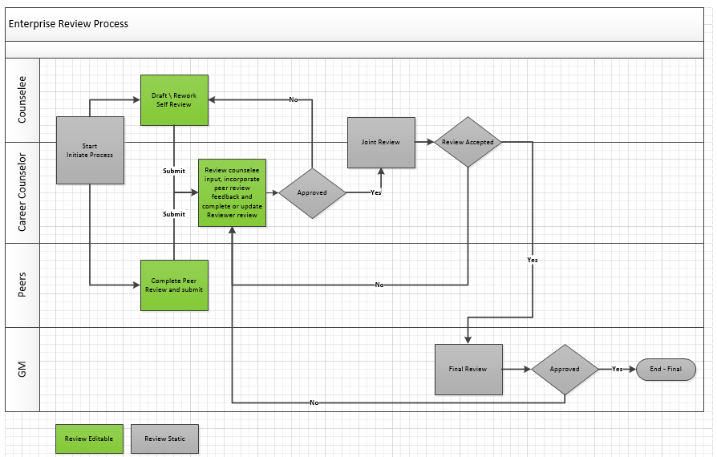

**Figure 3.0**

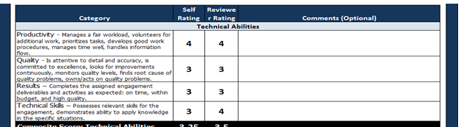

**Figure 4.0**

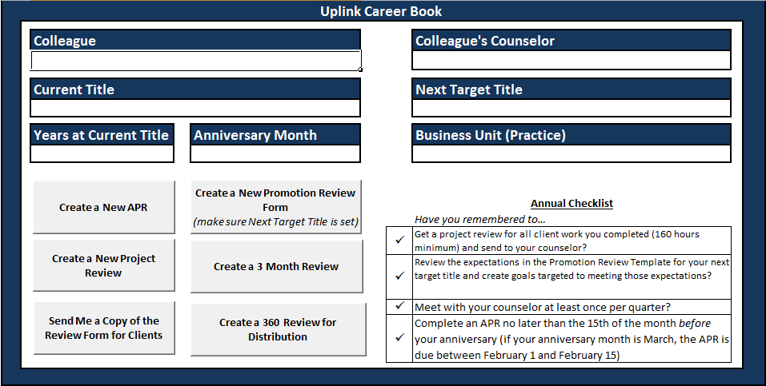

**Figure 4.1**

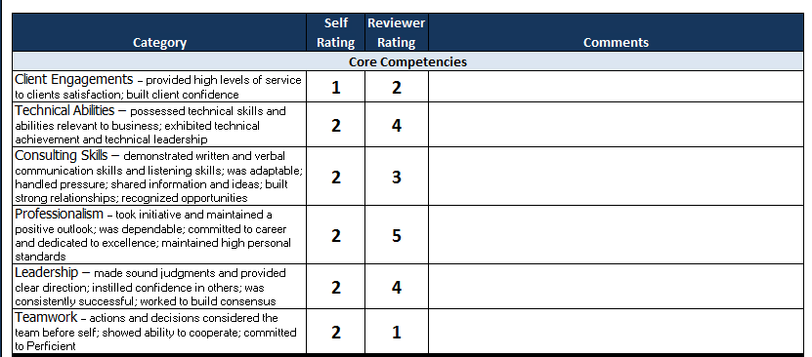

**Figure 4.2**

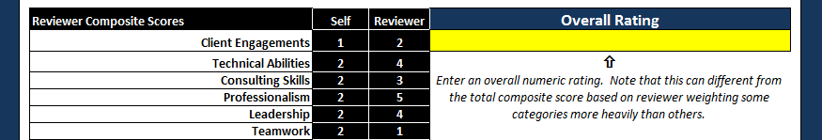

**Figure 4.3**

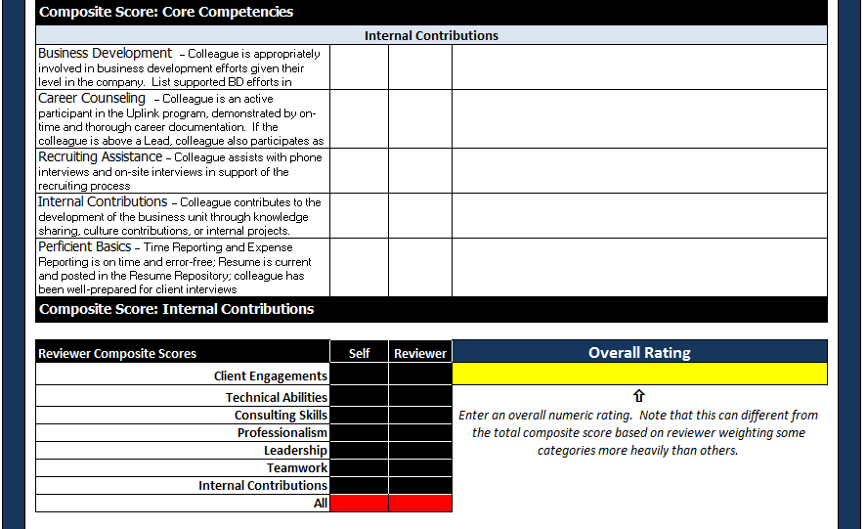

**Figure 4.4**

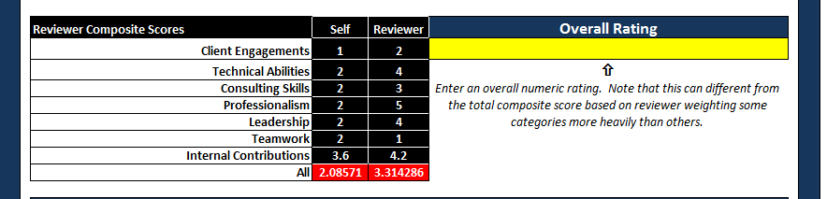

**Figure 4.5**

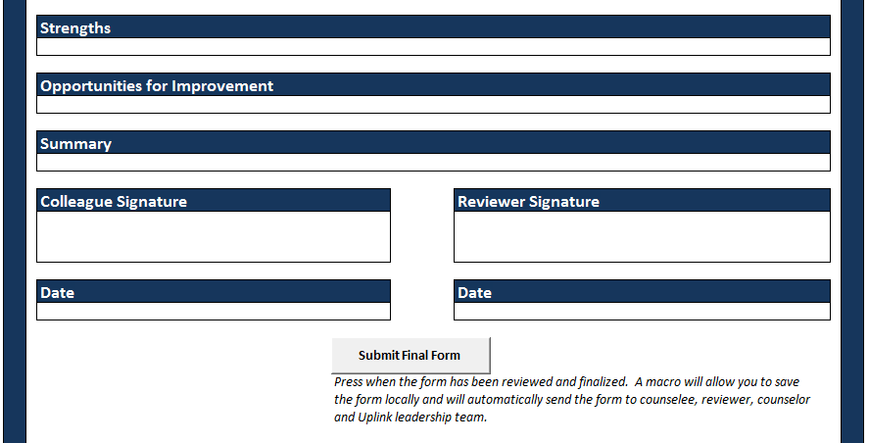

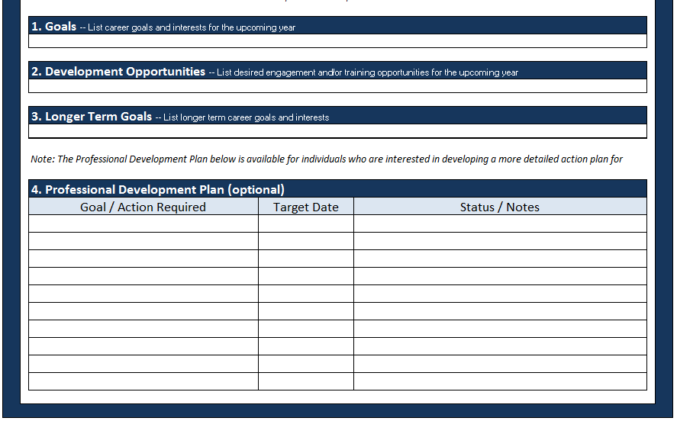

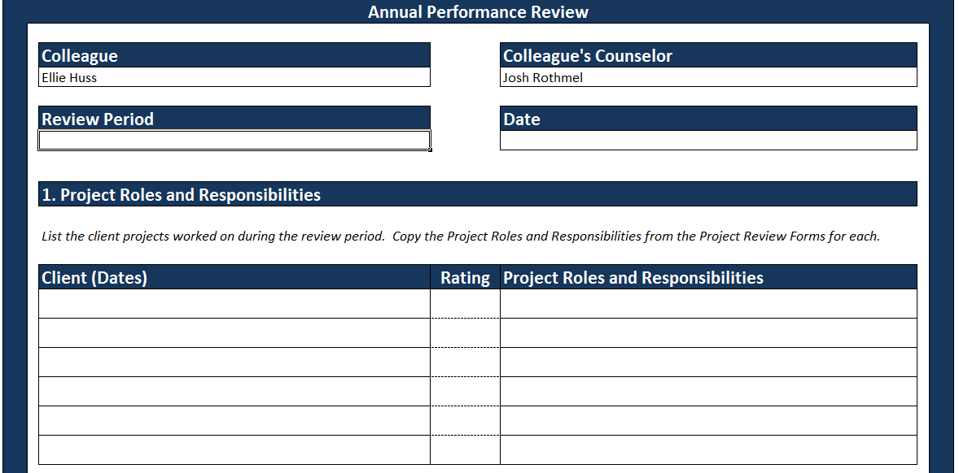

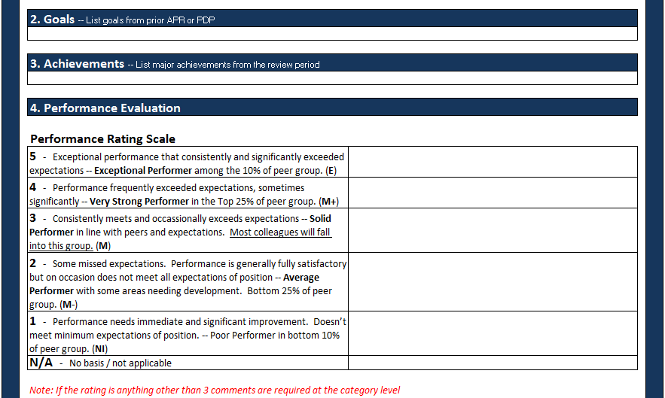

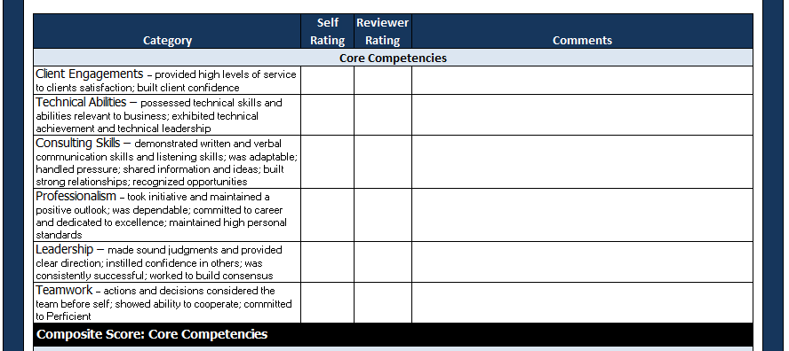



**Figure 4.6**

 

**Figure 5.0**

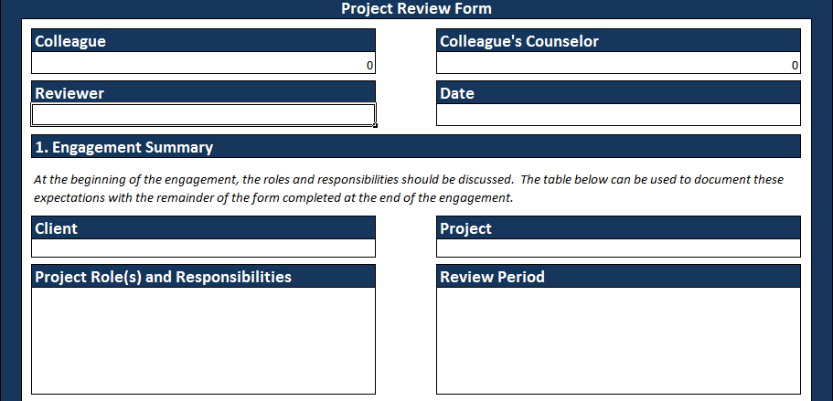

**Figure 5.1**

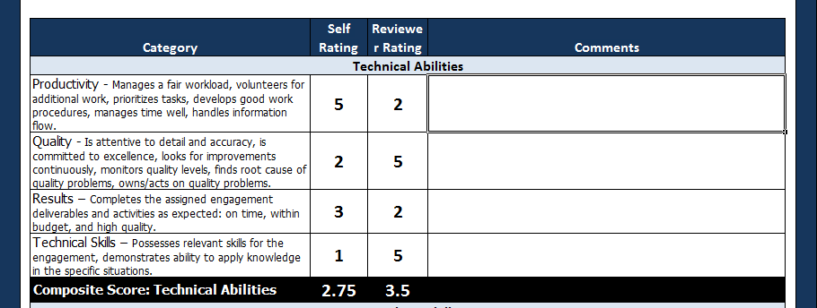

**Figure 5.2**

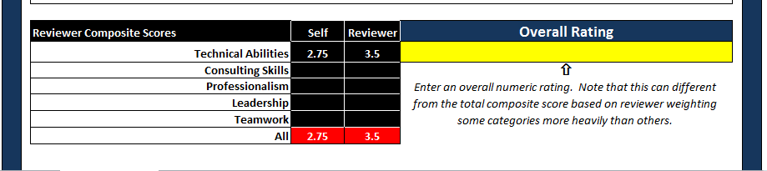

**Figure 5.3**

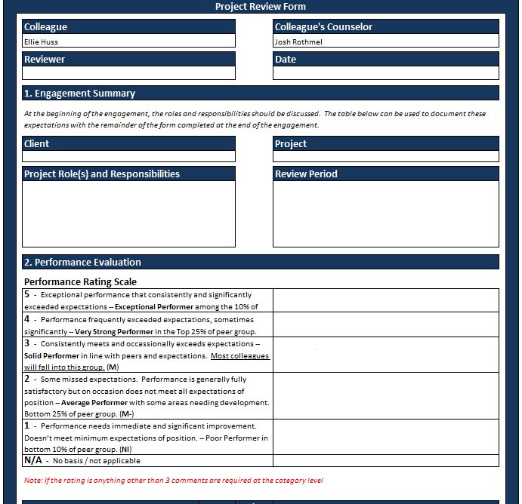

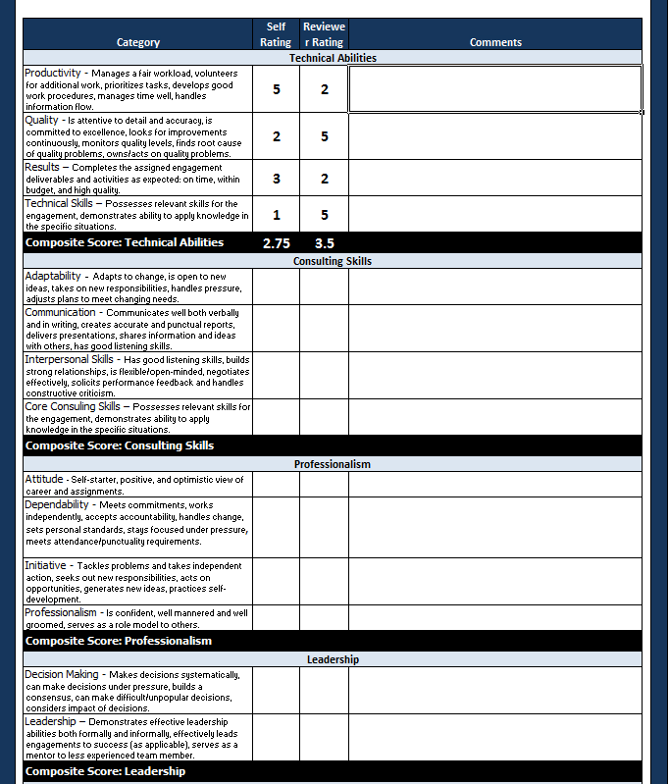

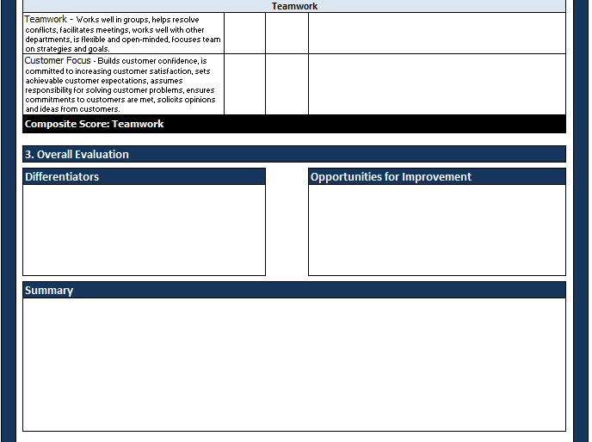

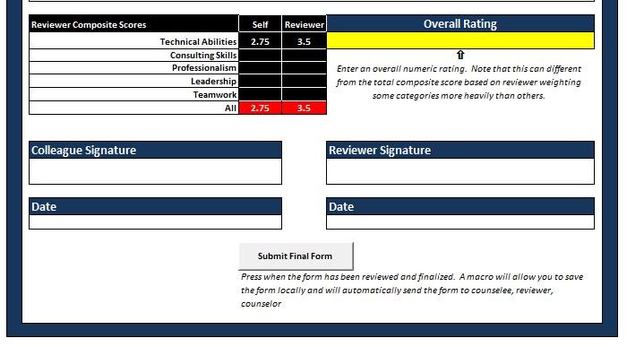

**Figure 6.0**

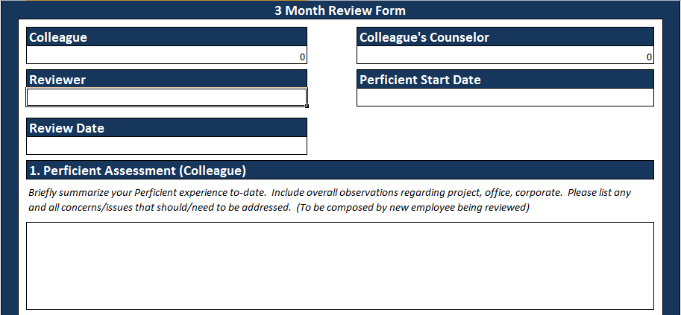

**Figure 6.1**

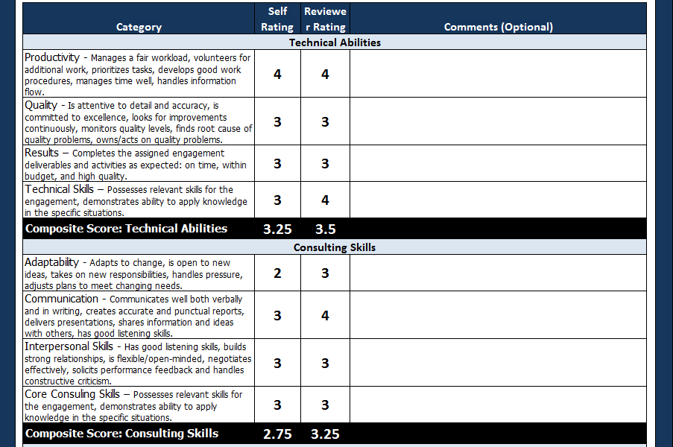

**Figure 6.2**

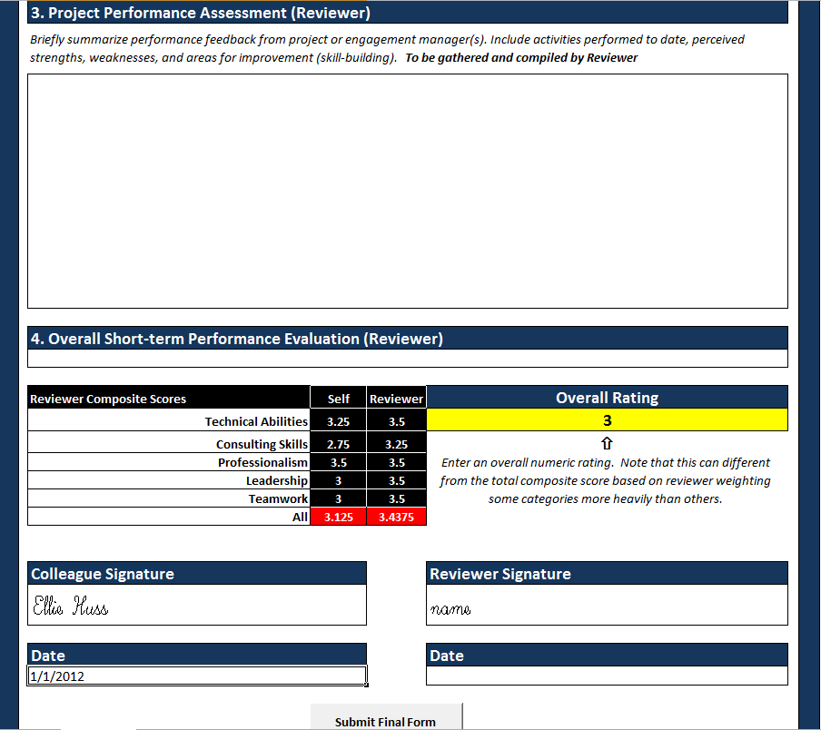

**Figure 6.3**

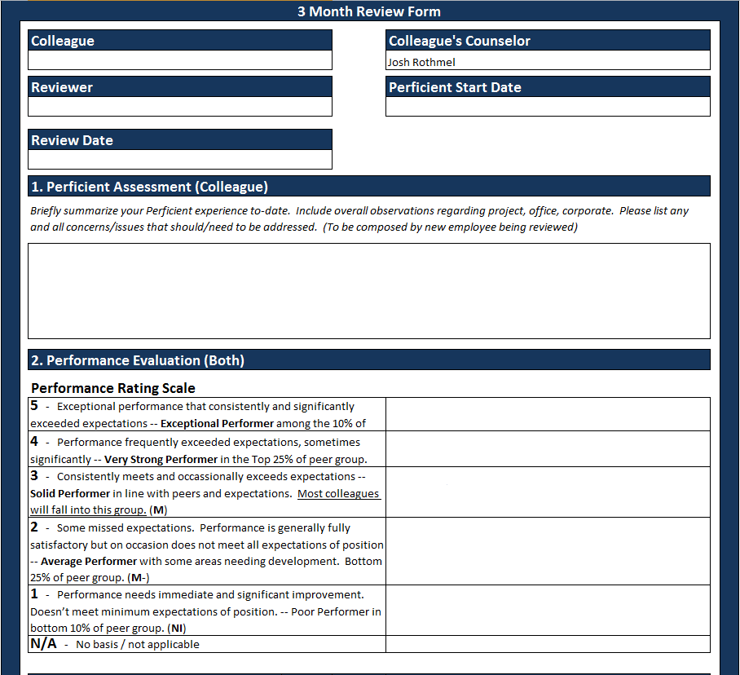



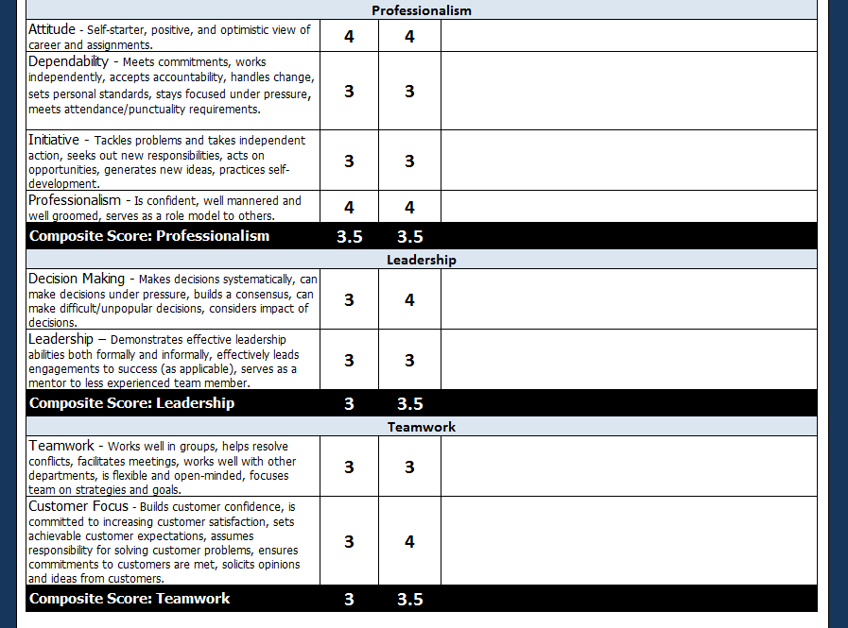



**Figure 7.0**

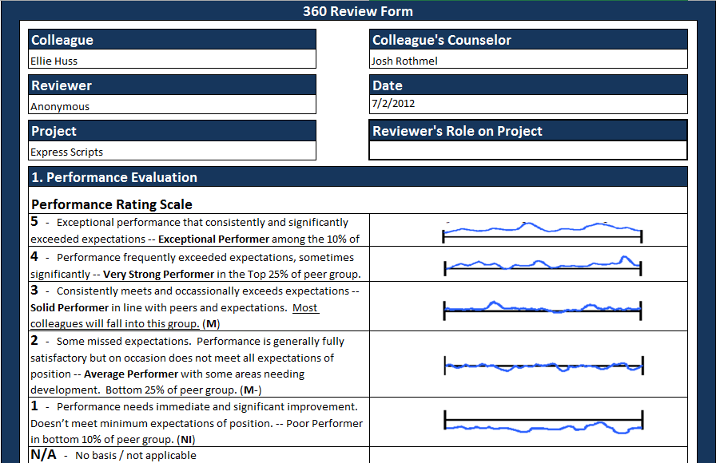

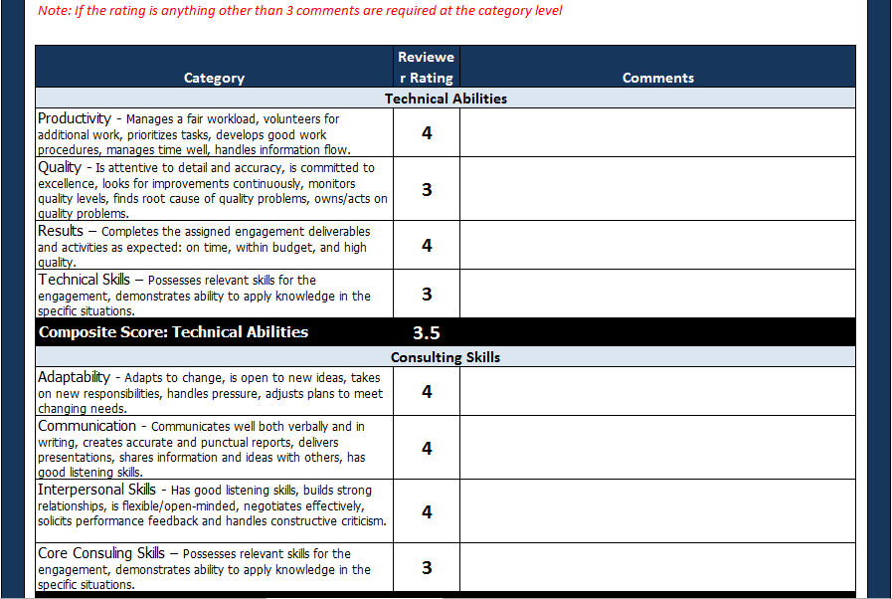

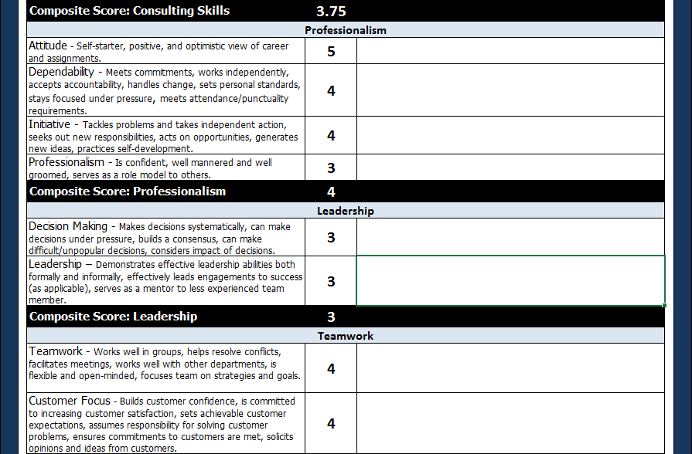

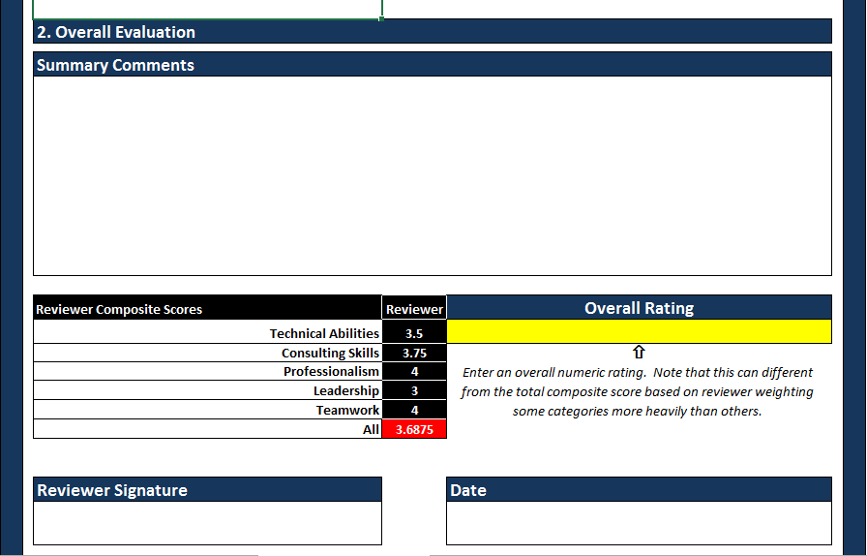

**Figure 8.0 – Reference for requirements 8.1 – 8.7**

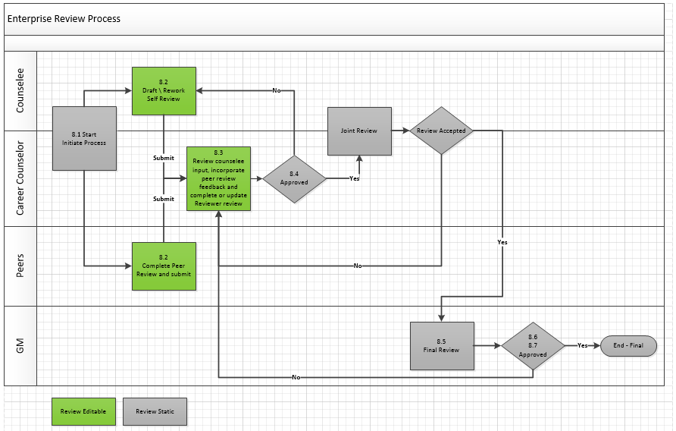

**Figure 8.0 – Reference for requirement 10.0**

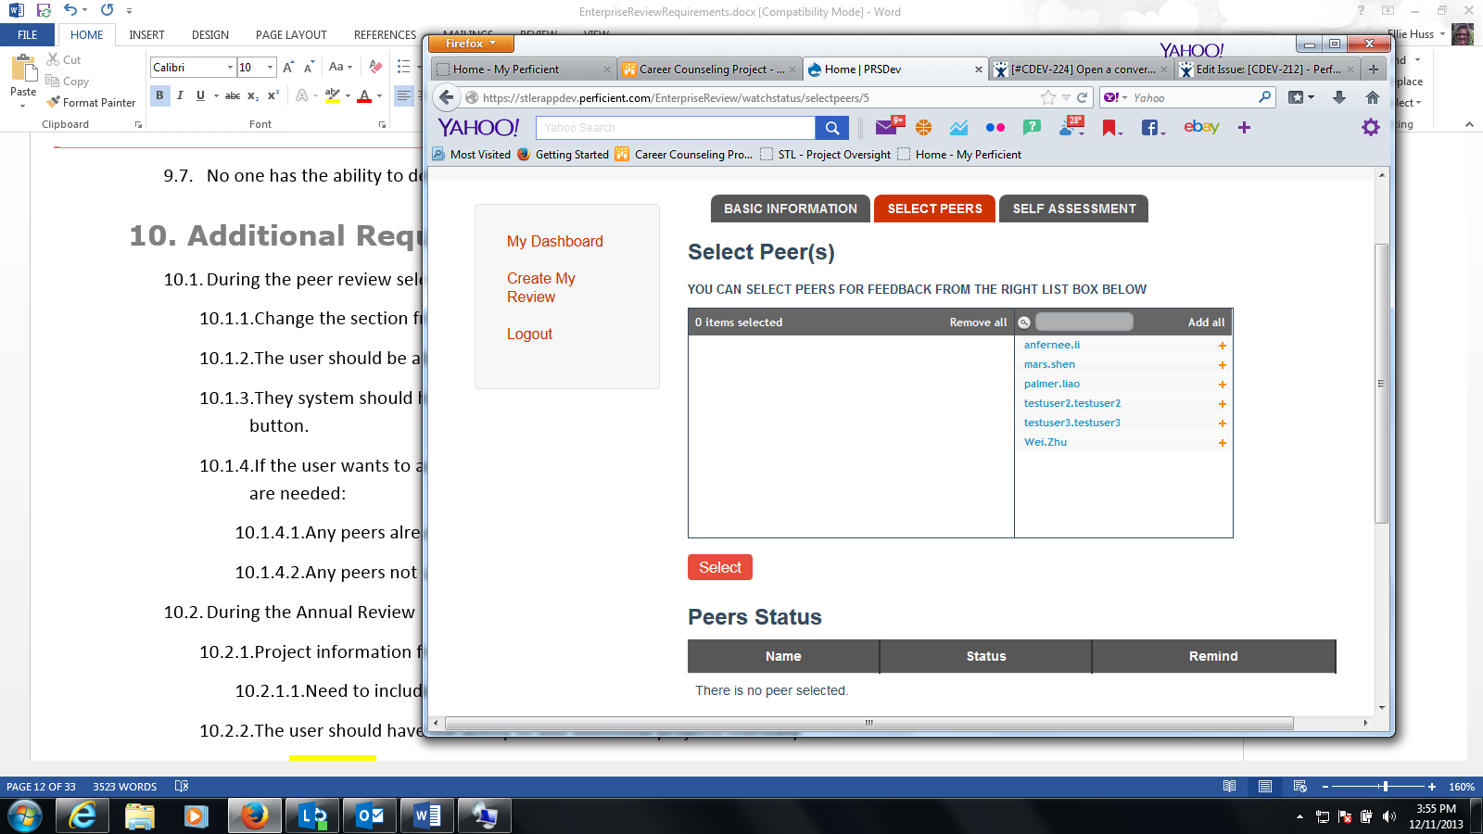

**Figure 9.0 – Reference for requirements 10.3.5**

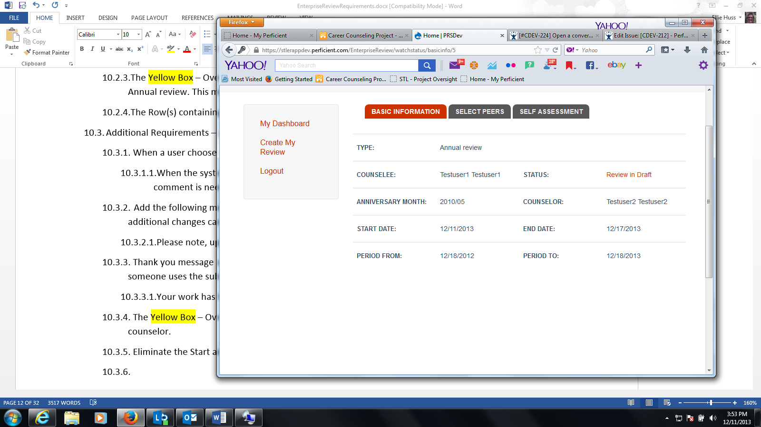

**Figure 10.0 – Reference for requirement 10.2.5**

