perficient.gif360 DEGREE ASSESSMENT System

User GUIDE

# Reviewers

## STEP-1

Login the 360DAS system using ldap account. <http://10.2.1.76/361review/>

## STEP-2

In **My Work List**, you can find your task.

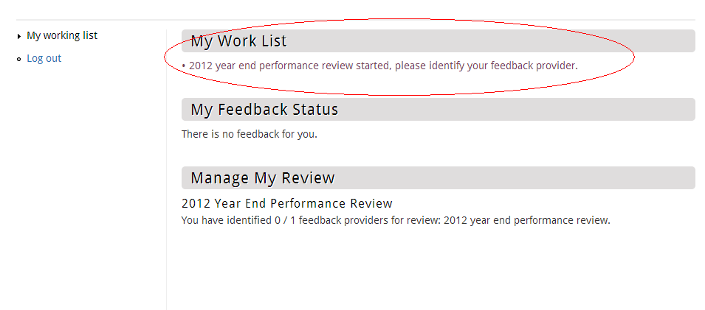

## STEP-3

Click on that link and go to selecting page. You can select your feedback providers. 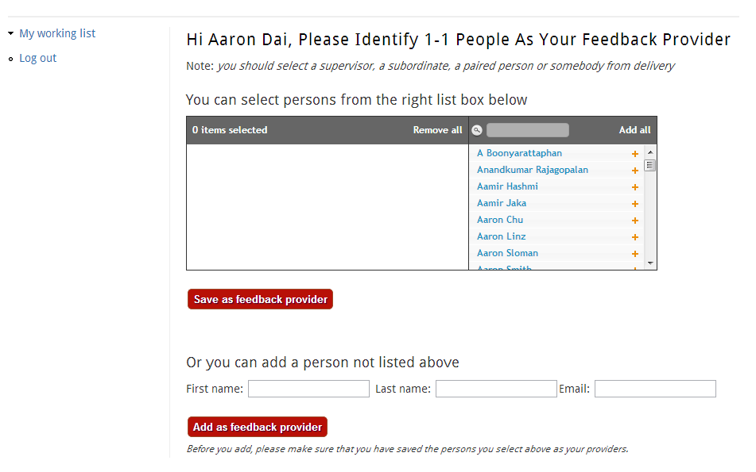

## STEP-4

After save the providers, system brings you back to work stage page. You can find your feedback status and manage your review.

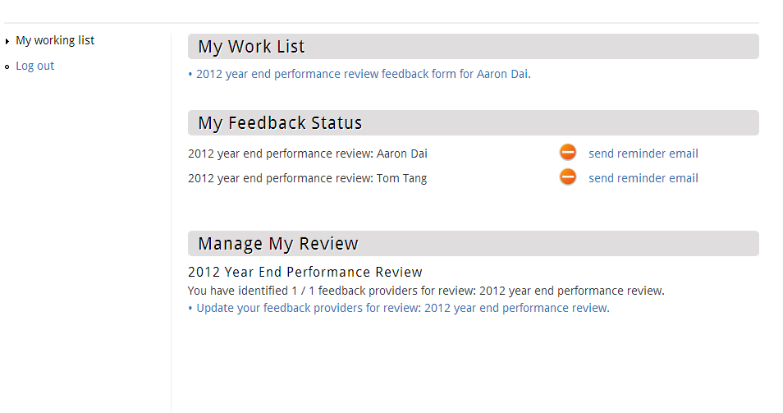

You can send reminder email to provider

Somebody ask you to provide feedback.

Only if you give yourself assessment, can you see the self-assessment result under section **Manage My Review**.

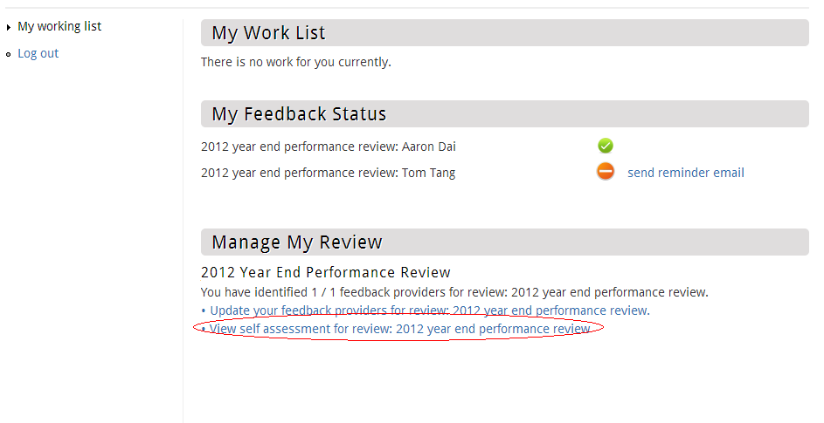

Only if all your providers give back the feedbacks, can you see the summary-assessment result under section **Manage My Review**.

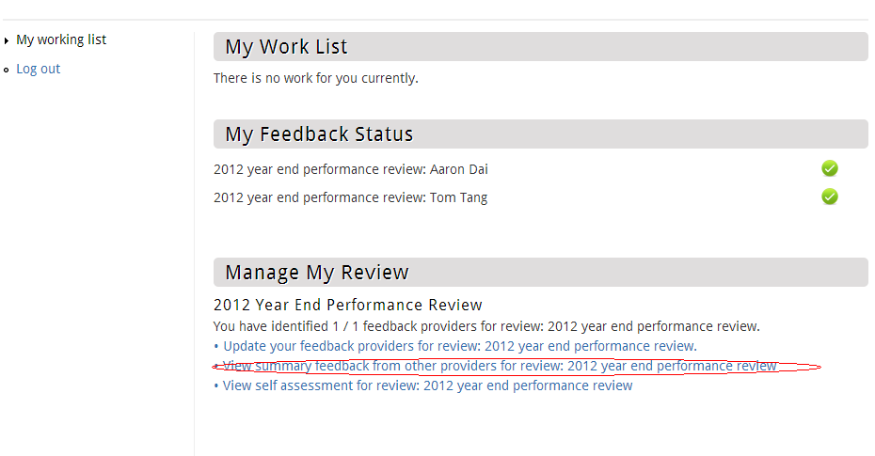

# Feedback Providers

If anybody selects you as feedback provider, you will see there is a task to fill in feedback for that person in your work stage. At the same time, you will receive reminder email.

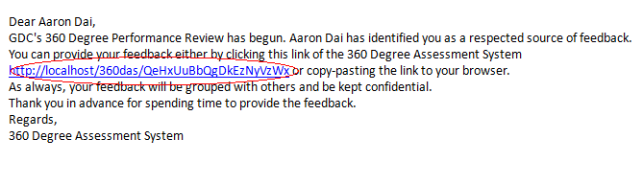

The only thing you need to do is clicking on that link and filling in all required field in the feedback form.

