**FAQs**

1. How do I know who my Counselor is?
   1. Ask your GM
2. How do the calculations work?

For the Annual Review -

* 1. Calculations for the Reviewer Composite Scores Section consists of the following Core Competencies
     1. Client Engagement, Technical Abilities, Consulting Skills, Professionalism, Leadership, Teamwork
  2. Carry score from the Core Competencies section to the fields of Self and Reviewer within the Reviewer Composite Score for both the Self Rating and the Reviewer.

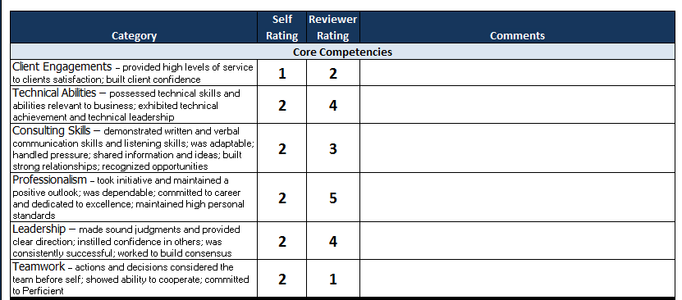

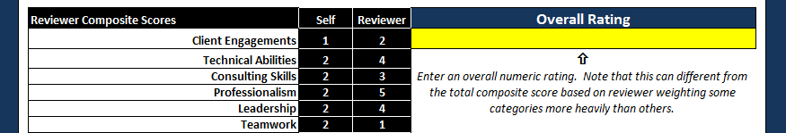

* 1. Calculations for the ‘Internal Contributions’ section of the Reviewer Composite Scores Section consists of the roll up scores from the Composite Score: Internal Contributions

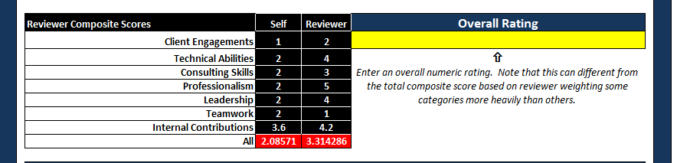

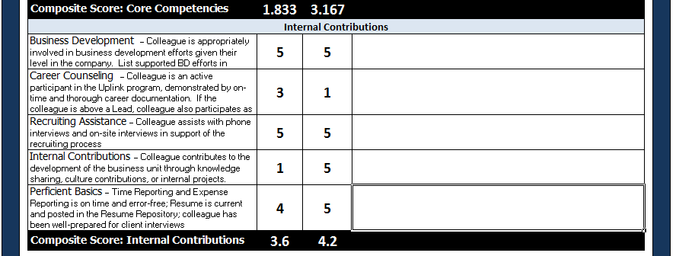

* 1. Calculations for the ALL section as seen in Red is given by the following equation: ALL = Avg (ALL Core Competencies AND Avg (Internal contributions)



For the Three Month Review

1. The Composite score, see red oval, is an average of the scores within the evaluation section. This average is required for all Core Competencies listed above 1-5.
2. Carry this average from the Core Competencies sections to the fields of Self and Reviewer within the Reviewer Composite Score for both the Self Rating and the Reviewer.
3. The All section, see green oval, is an average of the scores carried down from the Core Competencies sections.

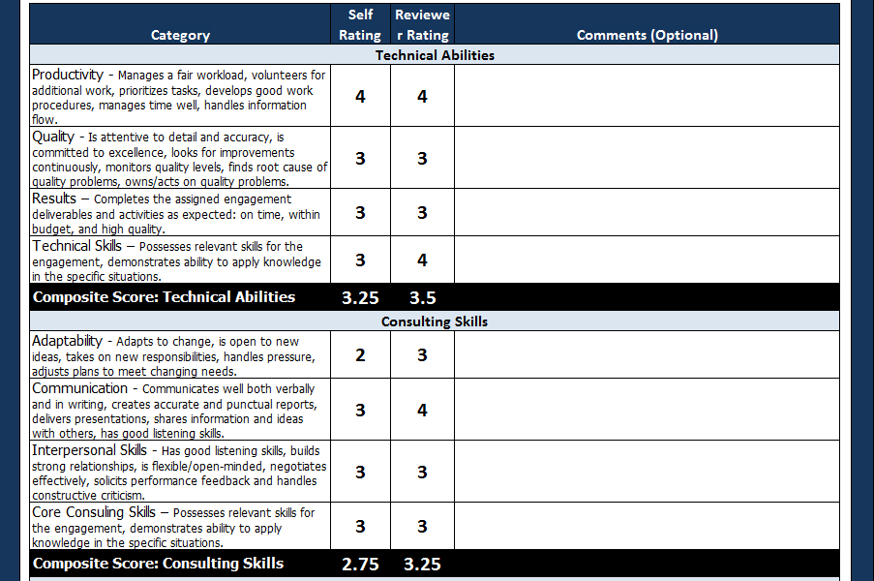

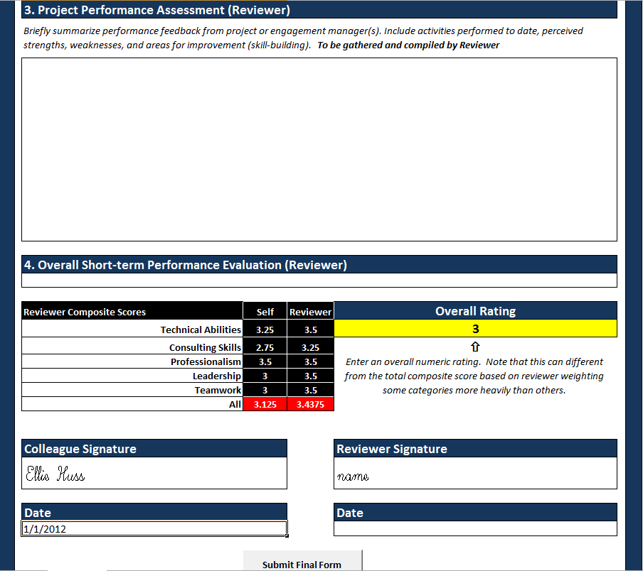

1. Calculation in the red box is an average of the Core Competencies averages carried down from above.