Phagosome Maturation with LAMP1 and THP-1 cells

THP-1 cells are usually spilt with 10 ml of cells and 20 ml MEDIUM during the week (Monday and Wednesday) and with 10 ml of cells and 30 ml MEDIUM on Friday

Split cells: Day -8
- 15 ml of cells and 30 ml MEDIUM (in 75 cm² flasks)

Split cells: Day -6
- 40 ml of cells and 70 ml MEDIUM (in 150 cm² flasks)

Seed cells for differentiation: Day -4
- Centrifuge 100 ml of cell culture in two 50 ml centrifuge tubes at 1000 rpm for 5 min
- Keep at least 15 ml supernatant for later use
- Resuspend pellets in 1 ml MEDIUM each
- Pool the two centrifuge tubes to one centrifuge tube
- Final volume for the centrifuge tube:
35 ml MEDIUM + 15 ml supernatant + 50 µl PMA (100 µg/ml)
- Seed THP-1 cells into two petri dishes (2 x 25 ml)
- Incubate the two petri dishes containing 100 ng/ml PMA at 37° C and 5% CO₂

Day -1:
Coat coverslips with Poly-D-lysine Hydrobromide (Sigma, P7280-5MG):
- Add 50 ml of sterile tissue culture grade water to 5 mg of poly-D-lysine.
- Aseptically coat culture surface with 0.5-1.0 ml of solution per 25 cm² (100µl per well). Rock gently to ensure even coating of the culture surface.
- After 5 minutes, remove solution by aspiration and thoroughly rinse surface with sterile tissue culture grade water.
- Allow to dry at least two hours before introducing cells and medium.
Seed cells:
- Wash the two petri dishes 2 times with 10ml PBS per petri dish
- Add 5 ml accutase per petri dish, incubate at 37°C for up to 30 minutes. Shake from time to time until cells are detached.
- For each petri dish add 5 ml MEDIUM and transfer cells to a 50 ml centrifuge tube
- Wash each petri dish with 10 ml MEDIUM and transfer cells to the 50 ml centrifuge tube
- Centrifuge the two centrifuge tubes at 1000 rpm for 5 minutes
- Resuspend each pellet in 1 ml MEDIUM, pool to one centrifuge tube and wash the other with 8ml MEDIUM to have a final volume of 10 ml with cells from the 2 petri dishes.
- Mix 50 µl of cell suspension with 50 µl of Trypan Blue solution
- Pipette 10 µl of the mix into a Neubauer improved cell counting chamber
- Count the cells in the 4 x 16 squares under 10x microscope, do not count blue (dead) cells
- Number of cells in the mix with trypan blue: (A+B+C+D) / 4 x 10⁴/ml
- Cell suspension is 2x the number of cells counted (dilution with trypan blue)
- e.g.: (32 + 41 + 35 + 37) / 4 * 2 * 10⁴ = 72.5 * 10⁴ cells/ml
- Seed 1ml of 2.5 * 10⁵ cells/ml
Day 0:
Labelling of Mycobacterium bovis BCG with Alexa 488:

- Measure OD₆₀₀ of cultures.
- Spin down 50ml of BCG culture (rolling at 37C) (30 min at 4400 RPM).
- Meanwhile turn on the thermomixer (90°C).
- Resuspend in 1ml of sterile PBS (wash away Tween 80) and transfer to screw cap.
- Spin down 15 min at 8000 RPM.
- Resuspend in 200ul of PBS pH 7.2.
- Kill “dead” 10 min 90°C (Heat-block without shaking)
- Add 10ul Alexa 488 succimidyl ester (Molecular Probes #A20000, 1mg/ml in DMSO) in each eppendorf (final concentration 50μg/ml)
- Incubate 1 hour, RT, in dark, on shaking table, 800rpm.
- Add 1ml of PBS
- 1. Spin bacteria 15 min at 8000 RPM (Heraeus Biofuge Pico).
- Resusped in 1ml PBS.
- 2. Spin bacteria 15 min at 8000 RPM (Heraeus Biofuge Pico).
- Resuspend in 800µl MEDIUM.
- Homogenize bacteria with needle (1 ml syringe) 10 times.
- Resuspend in 6ml MEDIUM.
- Dilute to OD₆₀₀ = 0.05 (5 * 10⁷ Bac/ml would result in a MOI of 1:100).
Infection:
- Remove media and add 1ml of bacteria suspension
- Spin down 5min at 800 RPM at RT.
- Incubate 15min at 37°C, 5% CO₂.
- Wash 3x with MEDIUM.
- Add 1ml of MEDIUM.
- Incubate for 105 min at 37°C, 5% CO₂.
- Wash 2x with PBS.
- Fix 10min with 4% paraformaldehyde at RT (1ml/well)
- Wash 3x with PBS.
- Incubate in 1% BSA / 10% normal goat serum / 0.3M glycine in 0.1% PBS-Tween for 50 min at room temperature to permeabilise the cells and block non-specific protein-protein interactions.
- Dilute primary antibody (Anti-CD63 antibody #68) 1:100 with 1% BSA / 10% normal goat serum / 0.3M glycine. (8.5μl in 850μl, CD63 #68)
- Wash 1x with PBS
- Incubate with primary antibody in 70μl on parafilm 60min at RT.
- Wash 3x with PBS.
- Incubate with secondary antibody (Goat Anti-Rabbit IgG H&L #W) 1:300, 70μl, diluted with 1% BSA / 10% normal goat serum / 0.3M glycine, 50 minutes at RT. (3μl in 900μl)
- Wash 3x with PBS.
- Mount cover slip with ProLong Gold Antifade Mountant with DAPI, cure for 24h at room temperature in the dark.

Materials:

- Poly-D-lysine hydrobromide, Sigma-Aldrich: P7280-5MG
- Cover glasses, (Deckgläser, Rund, Stärke 1.5, 12mm Ø), Karl-Hecht,
- VWR: HECH1001/12/1.5, Deckglas-Dicke 0,17mm+-0,01mm
- RPMI 1640 Medium, no glutamine, ThermoFisher Scientific: 31870-074
- PBS, pH 7.4, ThermoFisher Scientific: 10010-056
- FBS gamma-irradiated, ThermoFisher Scientific: 10499-044
- MEDIUM: RPMI 1640 Medium, no glutamine + 10% FBS gamma-irradiated
- PMA (Phorbol 12-myristate 13-acetate), Sigma-Aldrich: P1585-1MG
- Trypan Blue Solution, 0.4%, ThermoFisher Scientific: 15250-061

- Alexa Fluor® 488 NHS Ester (Succinimidyl Ester), ThermoFisher Scientific: A-20000
- Anti-CD63 antibody (ab118307), abcam: ab118307 / #68
- Goat Anti-Rabbit IgG H&L (Alexa Fluor® 594) (ab150080), abcam: ab150080 / #W
- Normal Goat Serum (10%), ThermoFisher Scientific: 50197Z
- Bovine Serum Albumin, Sigma: A6003
- Glycine, Biosolve: 0007132391BS
- Tween 20, Sigma: P2287
- Pierce™ 16% Formaldehyde (w/v), Methanol-free, ThermoFisher Scientific: 28908
- ProLong® Gold Antifade Mountant with DAPI, ThermoFisher Scientific: P36941

- Neubauer improved cell counting chamber
- Disposable hollow needle,
B BRAUN STERICAN (Einmalkanülen) 0,45x12 mm 26G x 1/2", REF: 4665457
- Tissue Culture Dishes, 100mm, sterile, VWR: 10062-880
- Centrifuge Tubes, 50ml, TPP: 91050
- Tissue Culture Dishes, VWR: 734-2321
- Tissue culture flasks 75 cm², TPP: 90076
- Tissue culture flasks 150 cm², TPP: 90151
- Heraeus Biofuge Pico, 24 Place Microlitre centrifuge

- Bacteria cultures in Roller bottles
- 48-well plates with adherent THP-1 cells
- COS plates

Solutions:

4% paraformaldehyde: Dilute 10 ml 16% Formaldehyde (28908) in 30 ml PBS (1:4)
Store 4% Paraformaldehyde at -20ºC

NBG: 1% BSA / 10% normal goat serum / 0.3M glycine:

For 10ml: 100 mg BSA
225.2 mg glycine
10 ml normal goat serum (10%)

For 30ml: 300 mg BSA
675.6 mg glycine
30 ml normal goat serum (10%)

NBG-T: 1% BSA / 10% normal goat serum / 0.3M glycine in 0.1% PBS-Tween:

For 2ml: add 2μl Tween-20 to master mix

Confocal Microscopy:

CLSM Leica SP8 gated STED
Inverse CLSM (Leica DMI6000B,Model SP8, manufactured 2012).

Magnification 63
ObjectiveName HC PL APO CS2 63x/1.40 OIL
Immersion OIL (Typ F)
NumericalAperture 1.40
RefractionIndex 1.518
Pinhole 95.6 µm
PinholeAiry 1.00 AU
ProLong® Gold Antifade Mountant with DAPI: Refractive index: 1.46

Fluorochrome | Excitation (nm) | Emission (nm)
DAPI | 358 | 461
Alexa Fluor® 488 NHS Ester | 499 | 519
Goat Anti-Rat IgG H&L (Alexa Fluor® 594) (ab150160) | 590 | 617

Dimensions

Dimension Logical Size Pixel Size / Voxel Size
X 512 0.0450498 µm
Y 512 0.0450498 µm
Z ca. 30 0.1502039 µm

Channels

LUT Resolution Min Max
Green 12 0 4095
Red 12 0 4095
Blue 12 0 4095

Ideal Nyquist sampling distances:
X ideal sampling rate (nm) 36.2
Y ideal sampling rate (nm) 36.2
Z ideal sampling rate (nm) 109

For Confocal Microscope images recorded with pinholes of around 1 Airy disk diameter, lateral sampling distances may be up to 1.6 times of the recommended Nyquist values without significantly compromising image quality.
Software:

Images first have to be renamed (using bactelize-renamer.sh) such that first number indicates coverslip and second number enumerates the images. The first three coverslips are used for the first condition (e.g.: wild type is: 1-1.tiff to 1-10.tiff / 2-1.tiff to 2-10.tiff), the coverslips 4 to 6 are used for the next condition and coverslips 7 to 8 are used for the last condition.

Workflow: (see folder RC-bactelize for macros.)
Huygens Professional
LAMP1-merge-decon-3D.ijm
LAMP1-crop-3D.ijm
LAMP1-seg.ijm
LAMP1-bactelize.ijm

Region Competition Parameters:
E data: e_PC
E length: Sphere_Regularization
Intitialization: LocalMax
Yes for Fusion, Fission and Handles
Lambda E length: 0.04
Theta E merge: 0.1
Max Iteration: 300
Oscillation threshold (Convergence): 0.02

Local Max Initialization:
Radius: 10
Sigma: 3
Tolerance: 0.4
Region Tol: 20

Supplementary:

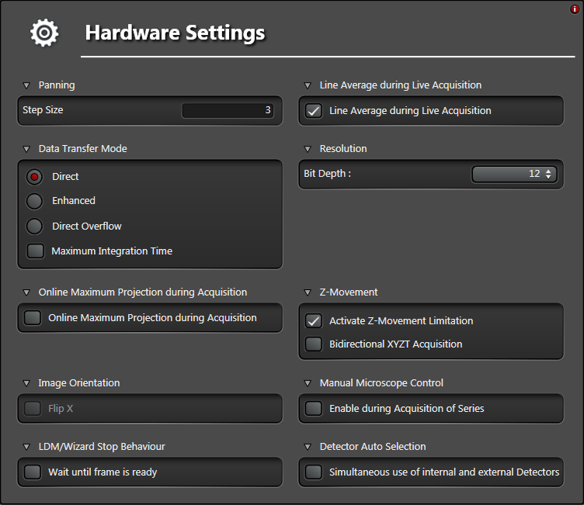

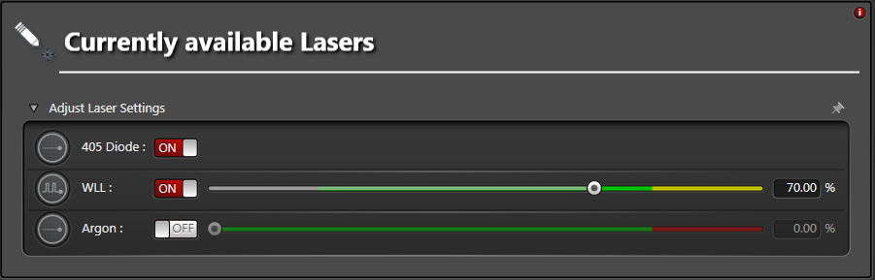

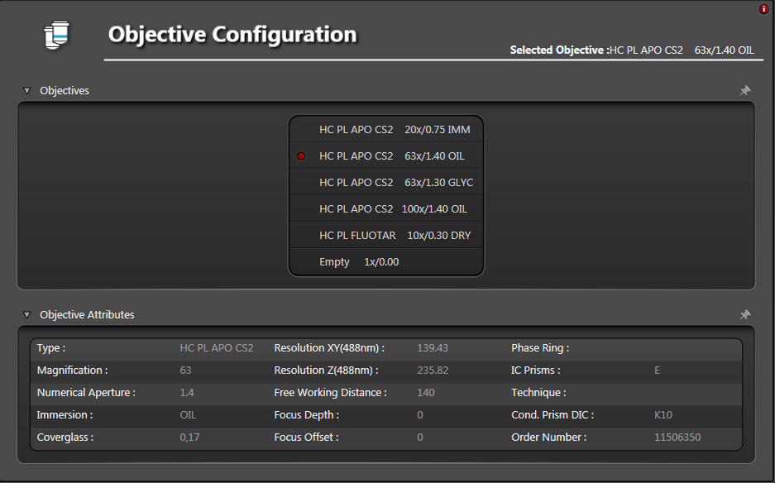

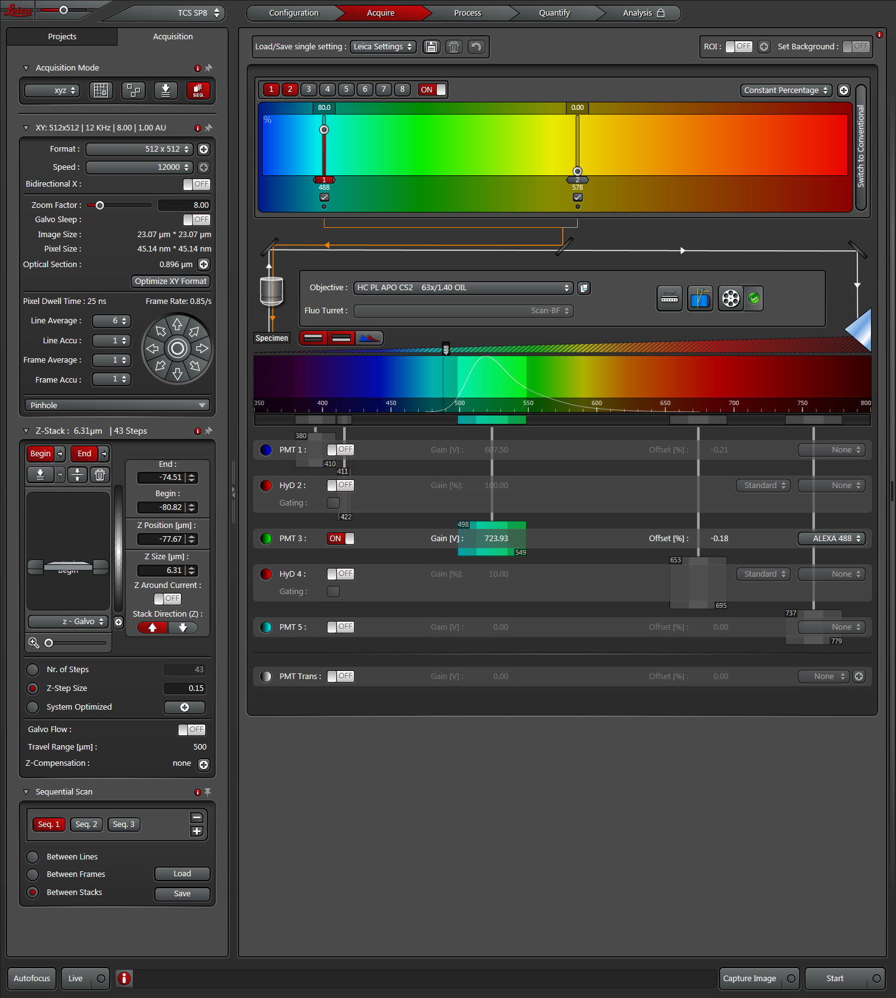

Huygens Professional:
Deconvolve images with Huygens Professional:
http://www.zmb.uzh.ch/en/Instruments-and-tools/Image-processing-tools/Software/Huygens-Professional.html
To use Hygens Professional use the Citrix Reiceiver to log onto a Virtual machine (VM) of the Center for Microscopy and Images Analysis of the University of Zurich:
http://www.zmb.uzh.ch/en/Howtos/How-to-use-an-image-processing-virtual-machine.html
You need to reserve the virtual machine first in the reservation system using your Artologik login which your received when you registered as a ZMB user. For this use the “Reservation system” link below the “Quick Links” on http://www.zmb.uzh.ch

Fiji:
Fiji is an image processing package. It can be described as a "batteries-included" distribution of ImageJ (and ImageJ2), bundling Java, Java3D and a lot of plugins organized into a coherent menu structure:
http://fiji.sc/Fiji

Region Competition:
J. Cardinale, G. Paul, and I. F. Sbalzarini. Discrete region competition for unknown numbers of connected regions. IEEE Trans. Image Process., 21(8):3531–3545, 2012.
http://mosaic.mpi-cbg.de/?q=downloads/RCITK

Region Competition is also available as plugin for Fiji:
http://mosaic.mpi-cbg.de/?q=downloads/imageJ
http://mosaic.mpi-cbg.de/MosaicToolboxSuite/MosaicToolsuiteTutorials.html

Lif_extractor.ijm is to be used with Fiji and is taken from Supplementary Data to:
A. Rizk, G. Paul, P. Incardona, M. Bugarski, M. Mansouri, A. Niemann, U. Ziegler, P. Berger, and I. F. Sbalzarini. Segmentation and quantification of subcellular structures in fluorescence microscopy images using Squassh. Nature Protocols, 9(3):586–596, 2014.
http://mosaic.mpi-cbg.de/?q=downloads/imageJ

3D ImageJ Suite:
This “suite” is composed of :
- 3D Filters (mean, median, max, min, tophat, max local, …) and edge and symmetry filter
- 3D Segmentation (hysteresis thresholding, spots segmentation, watershed, …)
- 3D Mathematical Morphology tools (fill holes, binary closing, distance map, …)
- 3D RoiManager (3D display and analysis of 3D objects)
- 3D Analysis (Geometrical measurements, Mesh measurements, Convex hull, …)
- 3D MereoTopology (Relationship between objects)
- 3D Tools (Drawing ellipsoids and lines, cropping, …)
A 2D/3D spatial statistics plugin is also available.
http://imagejdocu.tudor.lu/doku.php?id=plugin:stacks:3d_ij_suite:start#d_imagej_suite

