Phagosome Maturation LysoTracker (2h post infection)

Day -1:

Coat coverslips with Poly-D-lysine Hydrobromide (Sigma, P7280-5MG):

- Add 50 ml of sterile tissue culture grade water to 5 mg of poly-D-lysine.
- Aseptically coat culture surface with 0.5-1.0 ml of solution per 25 cm² (100µl per well). Rock gently to ensure even coating of the culture surface.
- After 5 minutes, remove solution by aspiration and thoroughly rinse surface with sterile tissue culture grade water.
- Allow to dry at least two hours before introducing cells and medium.

Seed cells:

- Remove media from Cell Culture Flask flask 75cm² containing RAW cells (80% confluent).
- Add 10ml of MEDIUM (DMEM + 10% FBS gamma-irradiated) and scrape cells
- Mix this 10ml with 20ml MEDIUM in 50ml TPP falcon tube
- Mix 50ul of cell suspension with 50ul of Trypan Blue solution
- Pipette 10ul of the mix into a Neubauer improved cell counting chamber
- Count cells in 4 x 16 squares under 10x microscope (A+B+C+D calculate the mean.)
Do not count blue (dead) cells
- Cell suspension is: 2x number of cells (mean =A+B+C+D/4) x 10⁴/ml
e.g.: 104 : 4 * 2 * 10⁴ = 52 *10⁴ cells/ml
- Seed 2.5 * 10⁵ cells/m, 1ml per well

Day 0:

Labelling of Mycobacterium bovis BCG with Alexa 488:

- Measure OD₆₀₀ of cultures.
- Spin down 50ml of BCG culture (rolling at 37C) (30 min at 4400 RPM).
- Meanwhile turn on the thermomixer (90°C) if needed.
- Resuspend in 10ml of sterile PBS (wash away Tween 80) and add another 25ml PBS.
- Spin down 30 min at 4400 RPM.
- Resuspend in 200ul of PBS pH 7.2.
- Kill “dead” 10 min 90°C (Heat-block without shaking)
- Add 10ul Alexa 488 succimidyl ester (Molecular Probes #A20000, 1mg/ml in DMSO) in each eppendorf (final concentration 50μg/ml)
- Incubate 1 hour, RT, in dark, on shaking table, 800rpm.
- Add 1ml of PBS
- 1. Spin bacteria 15 min at 8000 RPM (Heraeus Biofuge Pico).
- Resusped in 1ml PBS.
- 2. Spin bacteria 15 min at 8000 RPM (Heraeus Biofuge Pico).
- Resuspend in 800µl MEDIUM.
- Homogenize bacteria with needle (1 ml syringe) 20 times.
- Resuspend in 6ml MEDIUM
- Dilute to OD₆₀₀ = 0.062 (5 * 10⁷ Bac/ml would result in a MOI of 1:100)
Infection:

- Remove media and add 1ml of bacteria suspension
- Spin down 5min at 800 RPM at RT.
- Incubate 15min at 37°C, 5% CO₂.
- Wash 3times with MEDIUM.
- Add 1ml of MEDIUM containing 1/10,000 LysoTracker® Red DND-99
(LysoTracker can be prediluted 1:10 in PBS).
- Incubate for 1 1/2 hours at 37°C, 5% CO₂.
- Wash 2times with MEDIUM
- Incubate with MEDIUM for 5 min at 37°C, 5% CO₂ (to chase LysoTracker).
- Wash 1x with PBS.
- Fix 15min with 4% paraformaldehyde (1ml/well)
- Wash 2x with PBS
- Add 0.4 ml Whole Cell staining to each well.
- Incubate 30min at room temperature
- Wash 1x with PBS.
- Remove 1x PBS and incubate in 50 mM NH₄Cl for 5 min (quenching).
- Wash 1x time with 1x PBS.
- Mount cover slip with ProLong Diamond Antifade Mountant, cure for 24h at room temperature in the dark.

Materials:

- RAW 264.7 (ATCC Number: TIB-71)
- Poly-D-lysine hydrobromide, Sigma-Aldrich: P7280-5MG
- Cover glasses, (Deckgläser, Rund, Stärke 1.5, 12mm Ø), Karl-Hecht,
VWR: HECH1001/12/1.5, Deckglas-Dicke 0,17mm+-0,01mm
- DMEM, high glucose, pyruvate, ThermoFisher Scientific: 41966-029
- FBS gamma-irradiated, ThermoFisher Scientific: 10499-044
- MEDIUM: DMEM + 10% FBS gamma-irradiated
- PBS, pH 7.2, ThermoFisher Scientific: 20012-019
- Cell Culture Flask, 75cm², TPP: 90076
- Centrifuge Tubes, 50ml, TPP: 91050
- Heraeus Biofuge Pico, 24 Place Microlitre centrifuge
- Disposable hollow needle,
B BRAUN STERICAN (Einmalkanülen) 0,45x12 mm 26G x 1/2", REF: 4665457
- Alexa Fluor® 488 NHS Ester (Succinimidyl Ester), ThermoFisher Scientific: A-20000
- LysoTracker® Red DND-99, ThermoFisher Scientific: L-7528
- Whole Cell Stain Blue, ThermoFisher Scientific: 8403501
- ProLong® Diamond Antifade Mountant, ThermoFisher Scientific: P36965
- Neubauer improved cell counting chamber
- Trypan Blue Solution, 0.4%, ThermoFisher Scientific: 15250-061
Confocal Microscopy:

CLSM Leica SP8 gated STED
Inverse CLSM (Leica DMI6000B,Model SP8, manufactured 2012).

Magnification 63
ObjectiveName HC PL APO CS2 63x/1.40 OIL
Immersion OIL
NumericalAperture 1.40
RefractionIndex 1.518
Pinhole 95.6 µm
PinholeAiry 1.00 AU
ProLong® Diamond Antifade Mountant: Refractive index of cured mountant: 1.47

Fluorochrome | Excitation (nm) | Emission (nm)
Whole Cell Stain Blue | 350 | 450
Alexa Fluor® 488 NHS Ester | 499 | 519
LysoTracker® Red DND-99 | 577 | 590

Dimensions

Dimension Logical Size Physical Length Pixel Size / Voxel Size
X 832 41.52 µm 0.04990134615384615 µm
Y 832 41.52 µm 0.04990134615384615 µm
Z 46 6.76 µm 0.15020385714285714 µm

Channels

LUT Resolution Min Max
Green 12 0 4095
Red 12 0 4095
Blue 12 0 4095

Ideal Nyquist sampling distances:
X ideal sampling rate (nm) 36.2
Y ideal sampling rate (nm) 36.2
Z ideal sampling rate (nm) 109

For Confocal Microscope images recorded with pinholes of around 1 Airy disk diameter, lateral sampling distances may be up to 1.6 times of the recommended Nyquist values without significantly compromising image quality.

Software:

Huygens Professional:
Deconvolve images with Huygens Professional:
http://www.zmb.uzh.ch/en/Instruments-and-tools/Image-processing-tools/Software/Huygens-Professional.html
To use Hygens Professional use the Citrix Reiceiver to log onto a Virtual machine (VM) of the Center for Microscopy and Images Analysis of the University of Zurich:
http://www.zmb.uzh.ch/en/Howtos/How-to-use-an-image-processing-virtual-machine.html
You need to reserve the virtual machine first in the reservation system using your Artologik login which your received when you registered as a ZMB user. For this use the “Reservation system” link below the “Quick Links” on http://www.zmb.uzh.ch

bactelize.ijm:
Images first have to be renamed (using bactelize-renamer.sh) such that first number indicates coverslip and second number enumerates the images. The first three coverslips are used for the first condition (e.g.: wild type is: 1-1.h5 to 1-15.h5 / 2-1.h5 to 2-15.h5 / 3-1.h5 to 3-15.h5), the coverslips 4 to 6 are used for the next condition (e.g.: dead is: 4-x.h5 to 6-x.h5) and coverslips 7 to 8 are used for the last condition (e.g.: ko is: 7-x.h5 to 9-x.h5).
Open the bactelize.ijm macro with Fiji to process deconvolved images of HDF5 (.h5) file format.
Press Run in the Fiji Script Editor to start the macro.
The script uses the HDF5 Plugin for ImageJ and Fiji, the Region Competition plugin and the 3D ImageJ Suite plugins described below.

Fiji:
Fiji is an image processing package. It can be described as a "batteries-included" distribution of ImageJ (and ImageJ2), bundling Java, Java3D and a lot of plugins organized into a coherent menu structure:
http://fiji.sc/Fiji

HDF5 Plugin for ImageJ and Fiji:

HDF5 is a data format for storing extremely large and complex data collections. For more information see the official website http://hdf.ncsa.uiuc.edu/HDF5/. The plugin uses the jhdf5 library from ETH SIS for reading and writing HDF5 files:
http://lmb.informatik.uni-freiburg.de/resources/opensource/imagej_plugins/hdf5.html

Region Competition:
J. Cardinale, G. Paul, and I. F. Sbalzarini. Discrete region competition for unknown numbers of connected regions. IEEE Trans. Image Process., 21(8):3531–3545, 2012.
http://mosaic.mpi-cbg.de/?q=downloads/RCITK

Region Competition is also available as plugin for Fiji:
http://mosaic.mpi-cbg.de/?q=downloads/imageJ
http://mosaic.mpi-cbg.de/MosaicToolboxSuite/MosaicToolsuiteTutorials.html

Lif_extractor.ijm is to be used with Fiji and is taken from Supplementary Data to:
A. Rizk, G. Paul, P. Incardona, M. Bugarski, M. Mansouri, A. Niemann, U. Ziegler, P. Berger, and I. F. Sbalzarini. Segmentation and quantification of subcellular structures in fluorescence microscopy images using Squassh. Nature Protocols, 9(3):586–596, 2014.
http://mosaic.mpi-cbg.de/?q=downloads/imageJ

3D ImageJ Suite:
This “suite” is composed of :
- 3D Filters (mean, median, max, min, tophat, max local, …) and edge and symmetry filter
- 3D Segmentation (hysteresis thresholding, spots segmentation, watershed, …)
- 3D Mathematical Morphology tools (fill holes, binary closing, distance map, …)
- 3D RoiManager (3D display and analysis of 3D objects)
- 3D Analysis (Geometrical measurements, Mesh measurements, Convex hull, …)
- 3D MereoTopology (Relationship between objects)
- 3D Tools (Drawing ellipsoids and lines, cropping, …)
A 2D/3D spatial statistics plugin is also available.
http://imagejdocu.tudor.lu/doku.php?id=plugin:stacks:3d_ij_suite:start#d_imagej_suite

Supplementary:

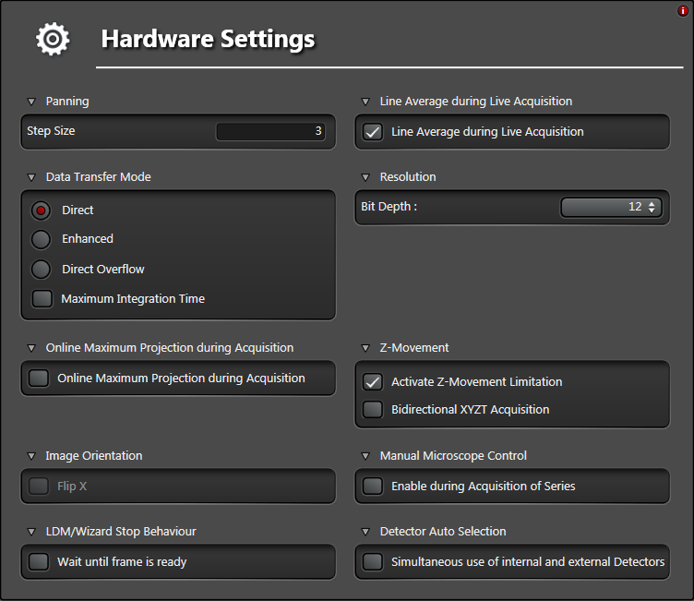

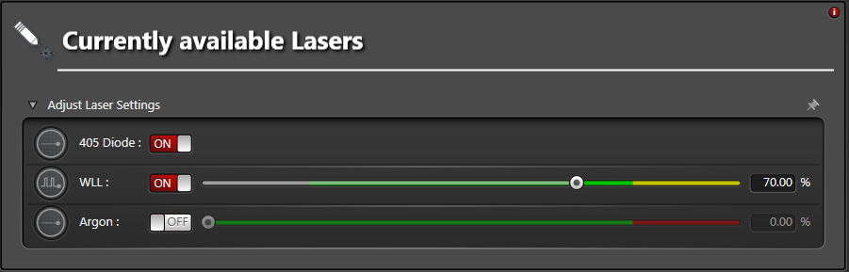

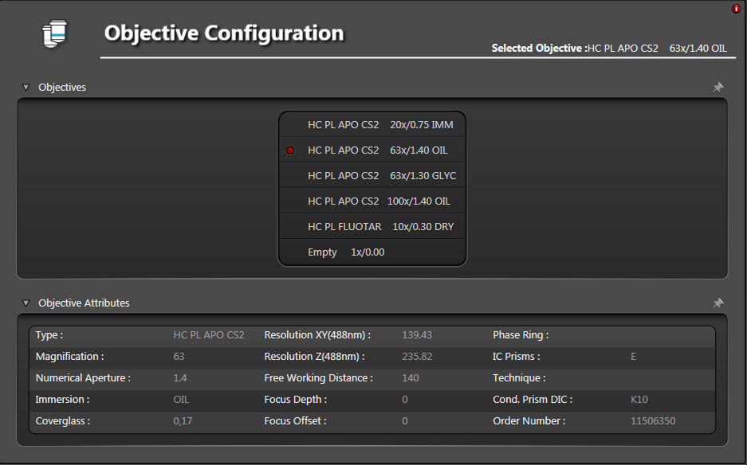

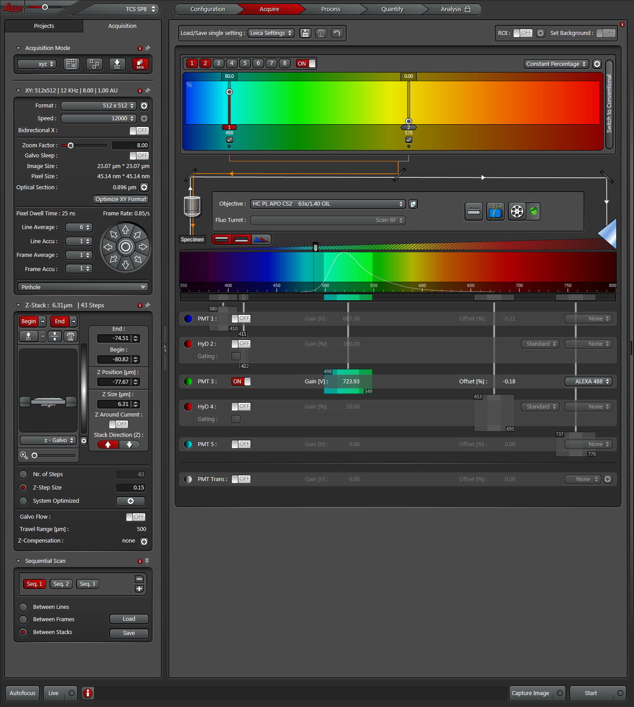

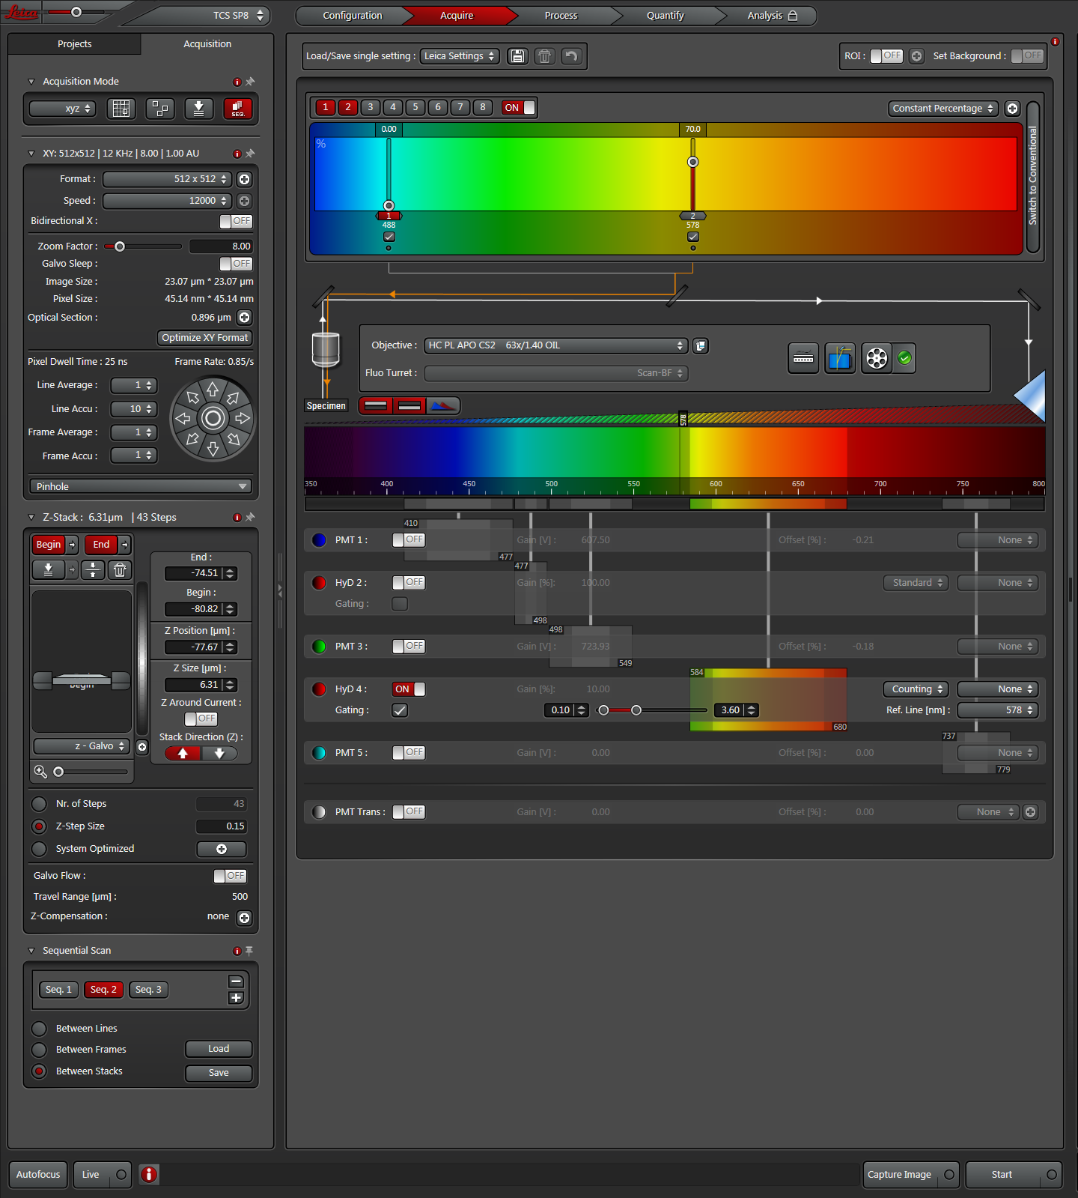

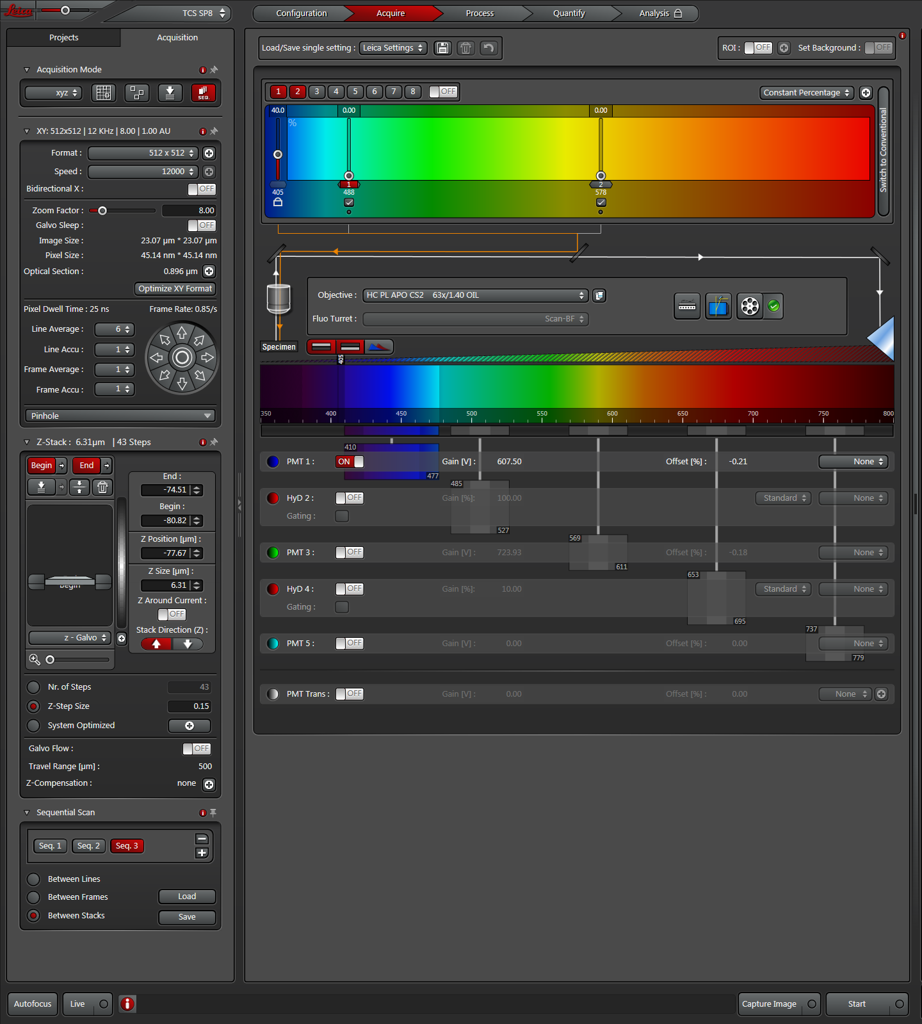

Obsolete:
RC-bactelize C++/ITK:
The program RC-bactelize is based on Region Competition and requires ITK (Insight Segmentation and Registration Toolkit) and the Boost C++ Libraries .
Region Competition (main.cxx) was modified by Michael Meuli to get object properties of objects and mean intensity values within objects but measured in the channels of “LysoTracker® Red DND-99” staining the lysosomes and of “Whole Cell Stain Blue” staining the macrophages.

--channels arg assignment of channels: bacteria, lysosomes, cells (default: 0 1 2)

"channels":
{
"bacteria": "0",
"lysosomes": "1",
"cells": "2"
}

bacteria: “Alexa Fluor® 488 NHS Ester (Succinimidyl Ester)”
lysosomes: “LysoTracker® Red DND-99” “Alexa Fluor® 488 NHS Ester (Succinimidyl Ester)”
cells: “Whole Cell Stain Blue”

Executables are added to PATH in /etc/environment
PATH is an environmental variable in Linux and other Unix-like operating systems that tells the shell which directories to search for executable files (i.e., ready-to-run programs) in response to commands issued by a user. It increases both the convenience and the safety of such operating systems and is widely considered to be the single most important environmental variable.
The file /etc/environment is specifically meant for system-wide environment variable settings. It is not a script file, but rather consists of assignment expressions, one per line.
File content:
PATH="/usr/local/sbin:/usr/local/bin:/usr/sbin:/usr/bin:/sbin:/bin:/usr/games:/usr/local/games:/home/mmeuli/Bioimage/RC-bactelize/RC-bactelize:/home/mmeuli/Bioimage/RC-bactelize/build-20150806"

ITK: /home/mmeuli/Bioimage/ITK/itk-4.8.0/build-20150806
RC-bactelize: /home/mmeuli/Bioimage/RC-bactelize/build-20150806/RC-bactelize

ITK (Insight Segmentation and Registration Toolkit)
http://www.itk.org
ITK needs to be compiled with:
Module_ITKReview=ON
Module_LesionSizingToolkit=ON
Module_SCIFIO=ON

Boost C++ Libraries
boost_1_49_0 needs to be installed:
http://www.boost.org/users/history/version_1_49_0.html

To avoid SCIFIO throwhing exeption because of memory limits:
export JAVA_FLAGS=-Xmx5400m
To have it permanently add the following line to /etc/environment:
JAVA_FLAGS=-Xmx5400m

Use of itkSCIFIOImageIOTest with ome-tiff files:
./SCIFIOTestDriver itkSCIFIOImageIOTest /path/to/dead-A.ome.tiff /path/to/dead-A.ome.tiff -w -a -d 5

