Michael O’Connell

Dr. Gary Thai

CMSC 203

10/6/2023

Project 2

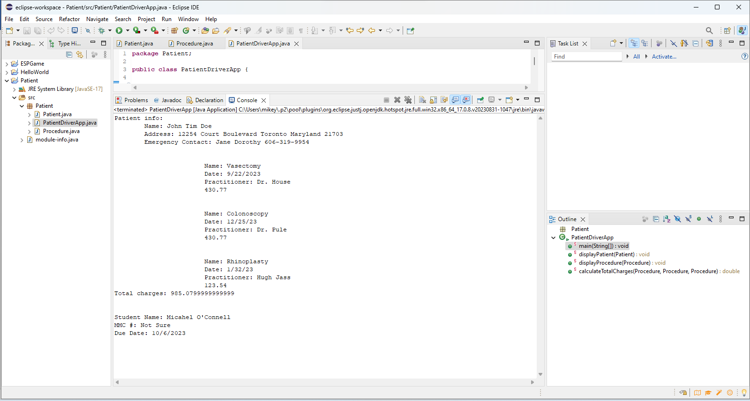

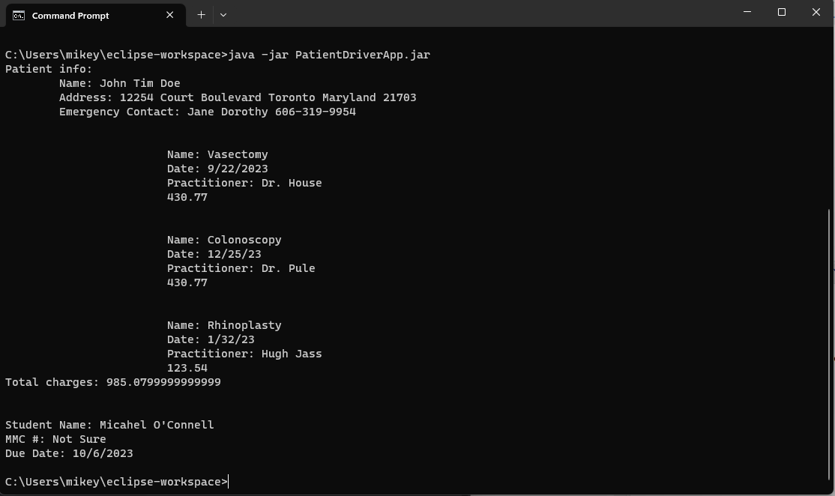

|  |  |  |  |  |  |
| --- | --- | --- | --- | --- | --- |
| **Test Case #** | **Input** |  | **Expected Output** | **Actual Output** | **Did the test pass?** |
| 1 | patientName=  int |  | error | error | yes |
| 2 | Address = double or other besides string |  | crash | crash | yes |
| 3 | City = data type besides String |  | Validation prints “Wrong data type, try again.” | Validation prints “Wrong data type, try again.” | yes |
|  |  |  |  |  |  |

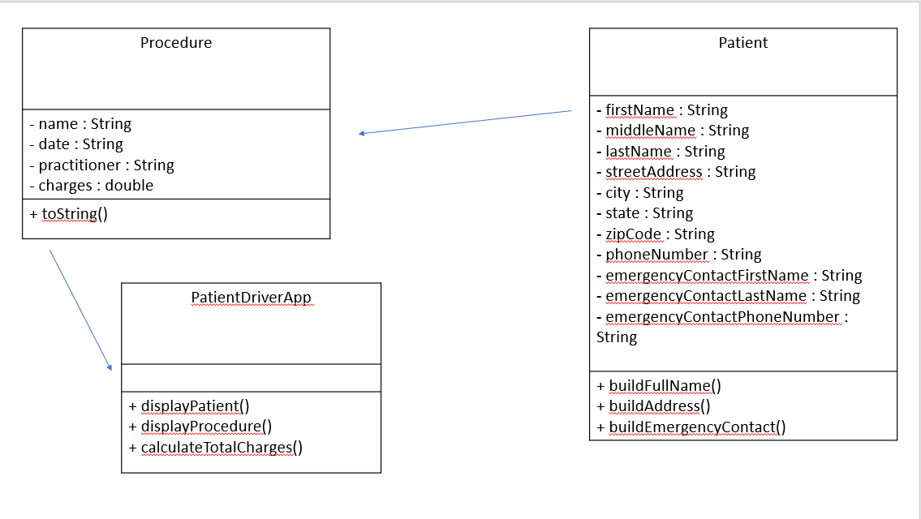

What did I learn:

I learned a LOT about classes and time management, and I have to work on the testing more, as well as the UML diagrams. I loved doing this project, however.