CS 340 Project Two - Client/Server Development
Michael Miller
Grazioso Salvare Dashboard

About the Project
This project is a full-stack web application dashboard built for Grazioso Salvare, a rescue-animal training company. The dashboard connects to a MongoDB database holding the Austin Animal Center (AAC) Outcomes data set and lets the client identify dogs that are good candidates for search-and-rescue training. It follows the Model-View-Controller (MVC) pattern: MongoDB is the model, the Dash widgets are the view, and the CRUD Python module plus the dashboard callbacks form the controller.
Required Functionality
The dashboard provides a branded, interactive interface with the following components:
- The Grazioso Salvare logo and a unique identifier (the developer’s name) for branding.
- Interactive radio-button filter options: Water Rescue, Mountain or Wilderness Rescue, Disaster or Individual Tracking, and Reset.
- An interactive data table that responds to the filter selection, with sorting, filtering, pagination, and single-row selection.
- A pie chart that shows the breed distribution of the currently displayed animals and updates with each filter.
- A geolocation chart (Leaflet map) that shows the location of the selected animal and updates with the filter and row selection.
When a filter is selected, the radio option runs a MongoDB query through the CRUD Python module (using breed, sex, and age criteria from the Rescue Type and Preferred Dog Breeds table), and the data table, pie chart, and map all update to reflect the returned data. Reset returns every widget to its original, unfiltered state.

Functionality Screenshots
The screenshots below demonstrate the dashboard in its starting state and after each required filter is applied. Each screenshot shows the Grazioso Salvare logo and the unique identifier.
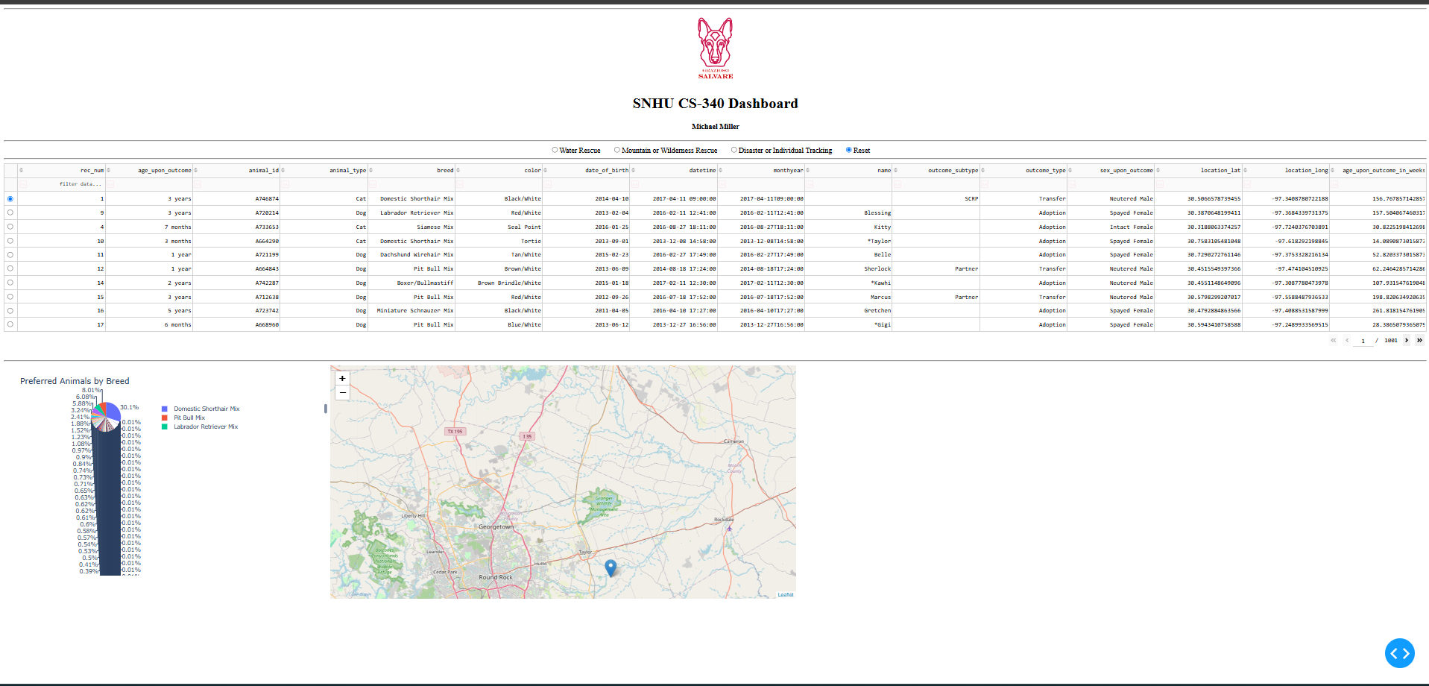
Screenshot 1: Starting (unfiltered) state with Reset selected.
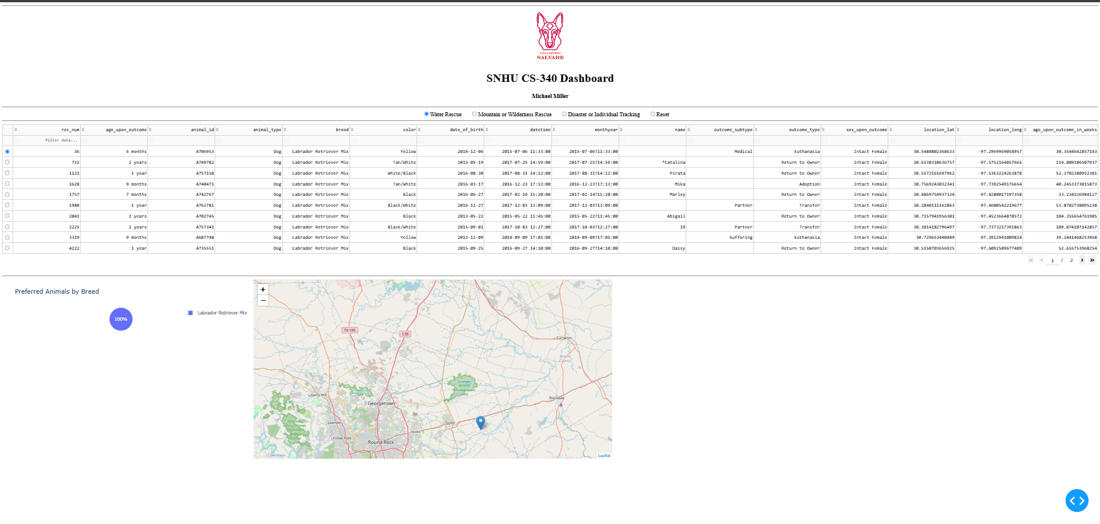
Screenshot 2: Water Rescue filter applied (Intact Female, ages 26-156 weeks).
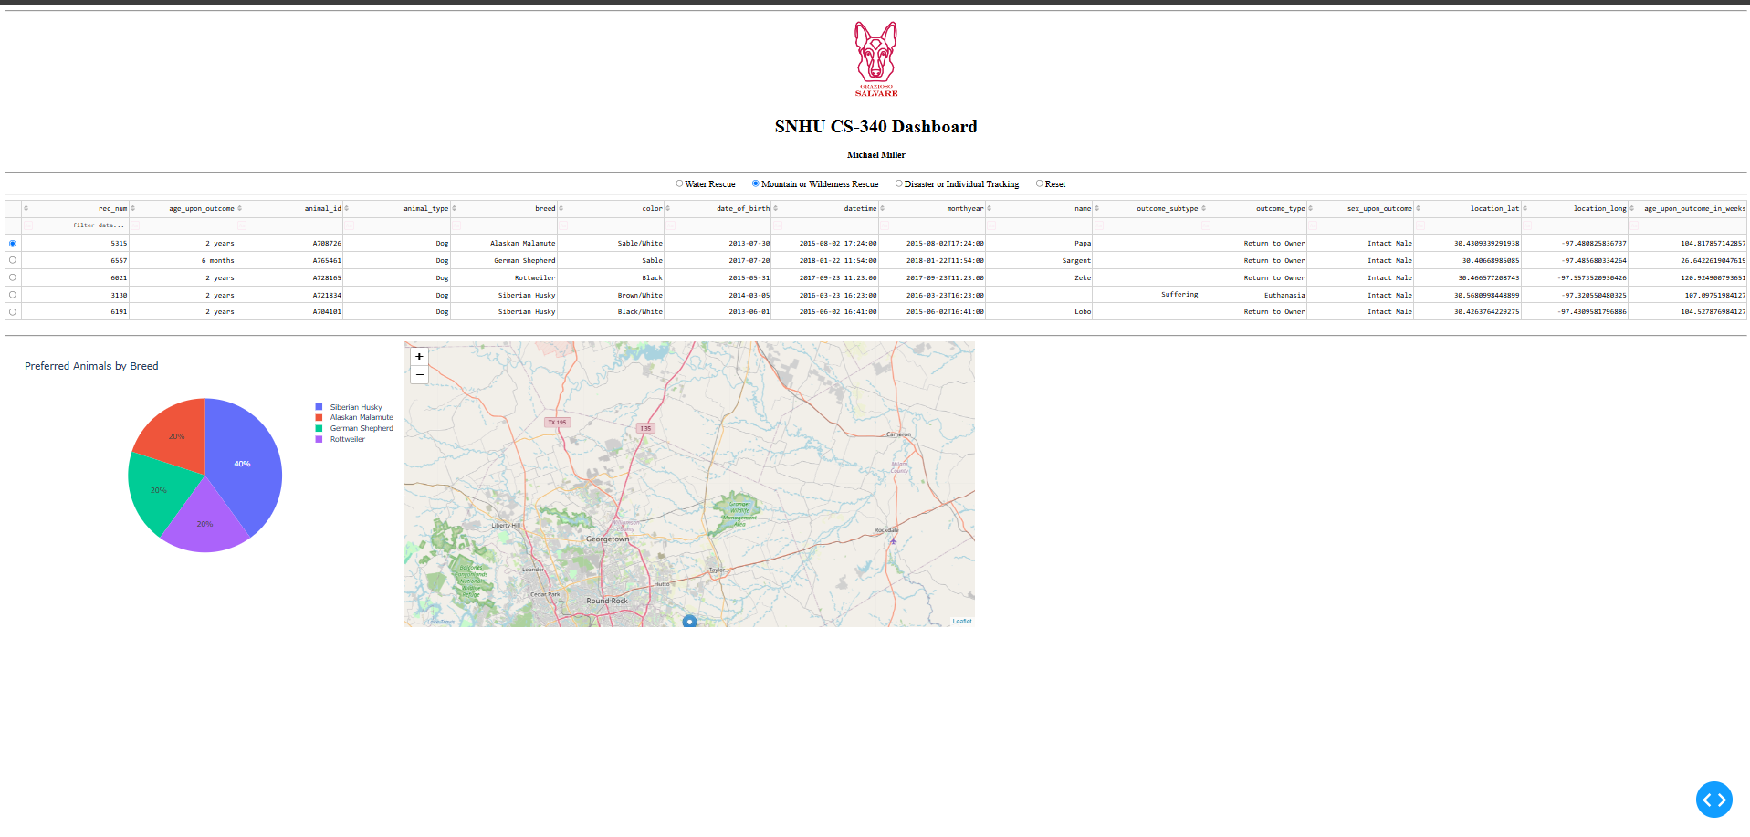
Screenshot 3: Mountain or Wilderness Rescue filter applied (Intact Male, ages 26-156 weeks).
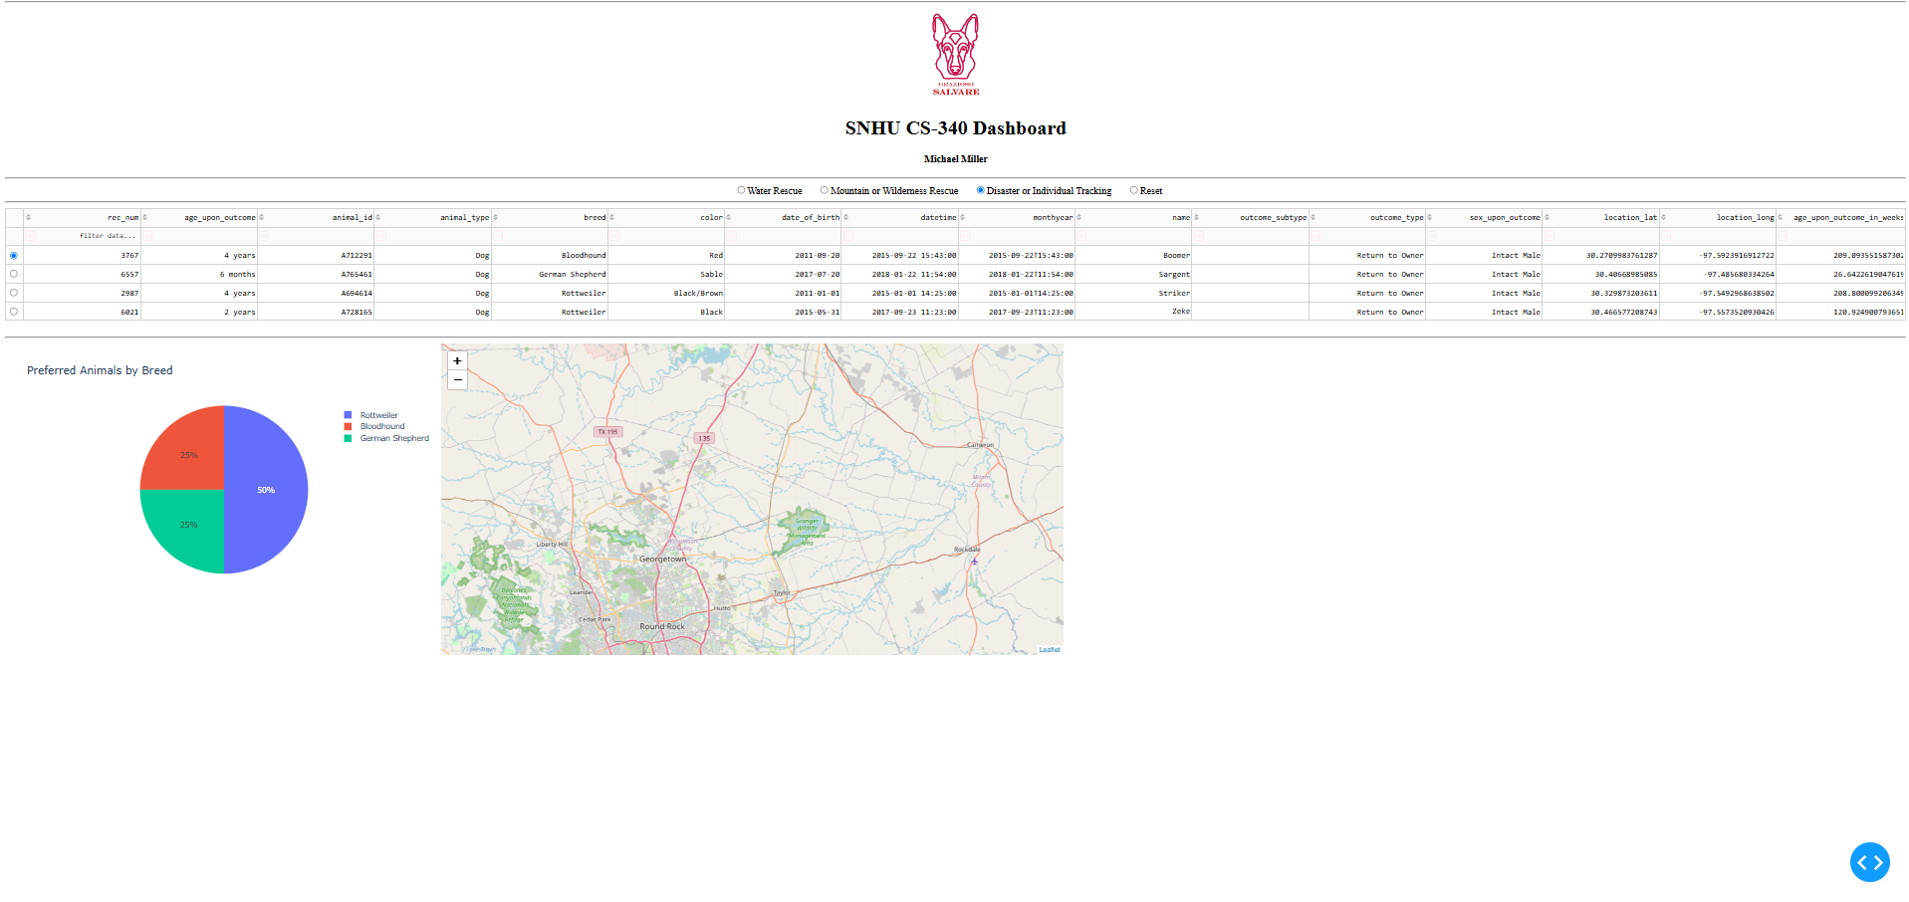
Screenshot 4: Disaster or Individual Tracking filter applied (Intact Male, ages 20-300 weeks).
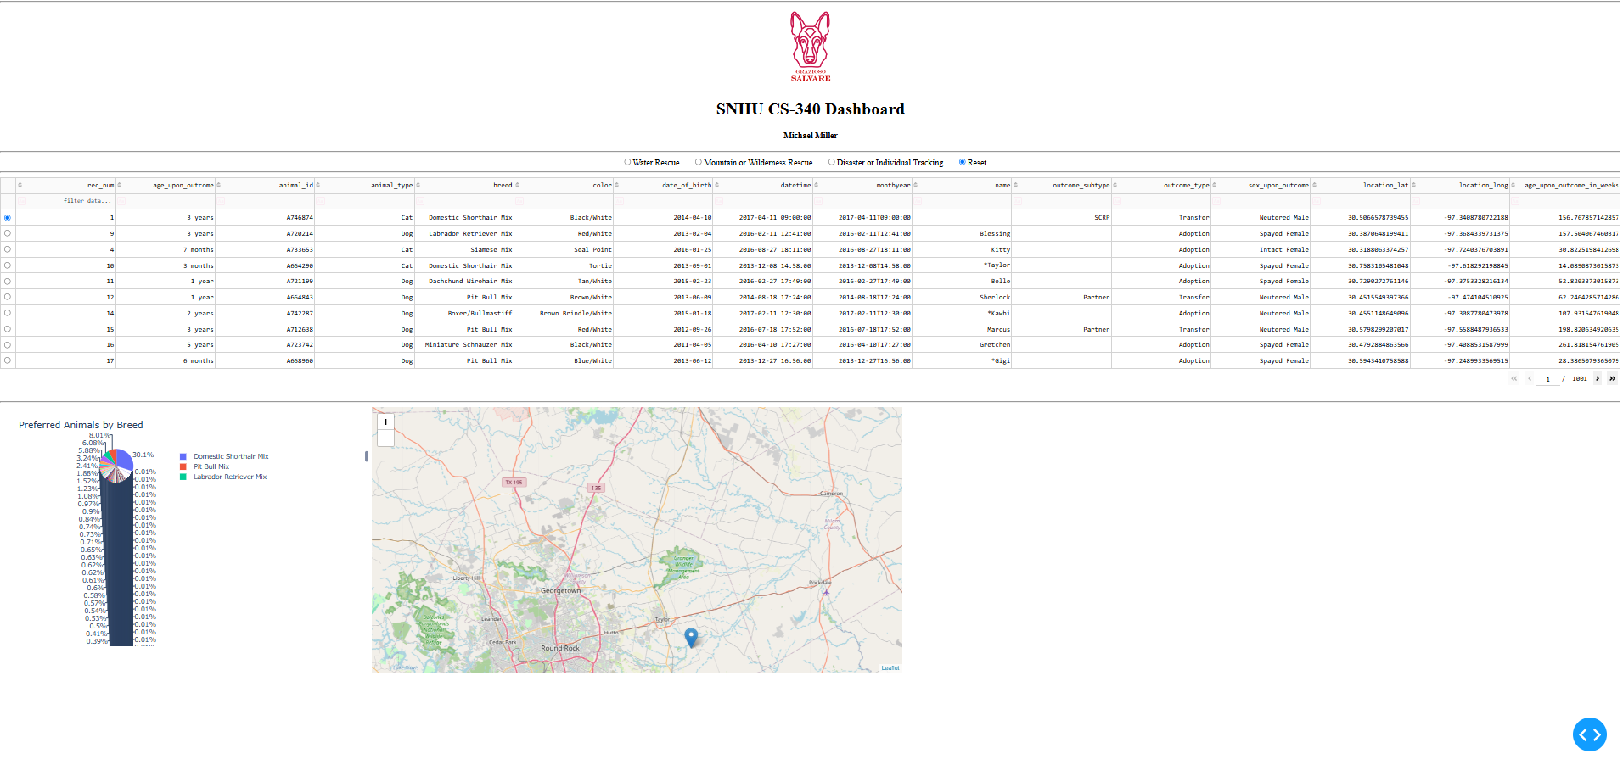
Screenshot 5: Reset returns all widgets to the original, unfiltered state.
Tools Used and Rationale
MongoDB (model). MongoDB was chosen as the database because its flexible, document-oriented model fits the varied fields of the shelter data and does not require a fixed schema. It stores records as JSON-like (BSON) documents, which map naturally to Python dictionaries, so query inputs and results move between the database and the application with little conversion. It also supports indexing for fast queries and scales horizontally, which suits a growing data set. MongoDB interfaces with Python through the PyMongo driver, the official MongoDB driver, which returns query results as native Python objects that pandas can load directly into a DataFrame.
Dash (view and controller). The Dash framework provides both the view and the controller structure for the web application. Dash builds the interface from Python components (the view) such as the data table, radio items, pie chart, and map, and connects them with callbacks (the controller) that react to user input and update the widgets. Because Dash is written in Python, it works directly with the CRUD module and pandas, so the same language runs the whole stack. Dash Leaflet supplies the geolocation map, and Plotly Express renders the pie chart.
CRUD Python module. The AnimalShelter class developed in Project One provides the create, read, update, and delete methods used for all database access. The dashboard uses its read method to run the “retrieve all” and filter queries, keeping the database logic separate from the interface.
Resources and links:
- MongoDB: https://www.mongodb.com/
- PyMongo driver: https://pymongo.readthedocs.io/
- Dash: https://dash.plotly.com/
- Dash Leaflet: https://www.dash-leaflet.com/
- Plotly Express: https://plotly.com/python/plotly-express/
- pandas: https://pandas.pydata.org/
- Austin Animal Center Outcomes data set: https://data.austintexas.gov/
- PEP 8 Style Guide for Python Code: https://peps.python.org/pep-0008/

Steps Taken to Complete the Project
The project was completed in stages across the course milestones and Project Two:
- Imported the AAC Outcomes CSV into MongoDB and created the authenticated aacuser account with readWrite access to the aac database.
- Built single and compound indexes to optimize the breed and outcome_type queries.
- Developed the CRUD Python module (AnimalShelter class) with create, read, update, and delete methods, using PyMongo and exception handling.
- Created the interactive data table in Dash and populated it with a “retrieve all” query through the CRUD module.
- Added the geolocation (Leaflet) chart tied to the selected table row.
- Added the radio-button filter options and a callback that runs the matching MongoDB query for each rescue type, updating the table.
- Added the pie chart that displays the breed distribution of the filtered data.
- Embedded the Grazioso Salvare logo and the unique identifier for branding.
- Tested each filter (Water, Mountain/Wilderness, Disaster/Individual Tracking, Reset) and captured screenshots as proof of functionality.
Challenges Encountered and How They Were Overcome
Authentication from the dashboard. The CRUD module originally hardcoded the account credentials, but the dashboard needed to supply them at instantiation. The __init__ method was updated to accept a username and password, so the same module works whether credentials are hardcoded (as in this dashboard) or passed from a login form.
Callback error at load. The column-highlight callback failed at startup because no column was selected yet, producing an error badge. A guard clause was added to return an empty list when the selected-columns input is None, which cleared the error.
Fitting the whole dashboard in one screenshot. The dashboard is taller than the screen, so the logo, table, and both charts would not fit together. Zooming the browser out brought the logo, identifier, filter options, table, pie chart, and map into a single frame for each required screenshot.
Getting Started (Reproduction Instructions)
To reproduce this project in the Codio (or an equivalent) environment:
- Import the data set: run mongoimport with the --type csv and --headerline options to load aac_shelter_outcomes.csv into the aac database and animals collection.
- Create the user: in mongosh, switch to the admin database and run db.createUser to create aacuser with a readWrite role on the aac database.
- Ensure the files are together: place CRUD_Python_Module.py, ProjectTwoDashboard.ipynb, and the Grazioso Salvare Logo.png in the same directory.
- Install dependencies: jupyter-dash, dash, dash-leaflet, pymongo, pandas, plotly (for example, pip install jupyter-dash dash-leaflet).
- Open ProjectTwoDashboard.ipynb in Jupyter Lab, confirm the username and password in the notebook match the aacuser account, and run the cell.
- Open the dashboard at the proxy URL that Dash prints, then use the radio options to filter the data.

Contact
Michael Miller
Email: michaelfmiller5@gmail.com

