**CHAPTER I**

**INTRODUCTION**

**Background of the Study**

Palmistry is popular since ancient age, the remains of stone-age shows samples of the human interest in palmistry. Practitioners of the art of palm reading are the only one who can read of every person’s palm in an accurate way. They study for years to gain experience and results from anyone who is interested to know their fate. However, science does not believe in prediction of the future but in a logical deduction of events that affects the occurrence of an event. The technology is an applied science, it can help to modernize the teaching in palmistry by making systematized and applied it through science. These two opposing knowledge can be combined to work as one functional system that will provide the user information, education and entertainment.

In this fast paced modern life, the ever increasing demand on powerful computing devices is what the trend is tracking on and information is now everywhere through the use of the internet. Handheld devices such as smartphones, tablets and personal assistant devices are attracting every one of us to facilitate and plan some of our task but it’s not just as simple like that. Developing mobile applications on these devices are what the manufacturers are racing to gain a competitive advantage on the market. Now that the once simple search engine is now a giant company, the Google, develop an open-source

platform wherein various mobile applications can be run and developed by anyone who has their own interest in doing a project, paved the way of production of devices offering the massive number of apps. But deployment and development of these apps requires skills and motivation to complete a necessary purpose. Studying algorithms is the best way to help a programmer achieve the desired results in a project, depending on the complexity of the problem needed to be solved by a team of developers.

Since every smartphones especially Android-powered smartphones have camera have that have a good resolution, it can be used for study and application of some of the image processing algorithms. Capturing images have never been as an instant as before, with just one touch to the icon of your app of your choice, viewing and sharing of photo is just fast, fun and easy. Editing of photos are included in some of the features of every app like Instagram which is popular for its filters and sharing it to the community. While other camera-apps where made to educate, entertain and solve a specific problem combined with other principles, it may be either in arts or sciences, like palmistry or palm reading using an image processing algorithm.

Image processing is an operation wherein images are taken as input and produces these images as an output. Certain algorithms were derived as a way of manipulation of data to draw the desired results and findings to solve a problem. At this study, image processing algorithms were applied to examine a person’s palm and give his/her characteristics according to the art of reading palms, the palmistry.

Through the computing power of devices provided the tools for development of this mobile application, we can pursue this study with enough resources and skill set with ease, however, challenges may interfere to hone the researchers.

**Statement of the Problem**

In every research and study, problems will be always present. In our part, the main question is how we will do this mobile application and the possible constraints ahead of us. The study aims to develop a mobile android application that will read the person’s palm through the use of an image processing algorithm.

To comply with the study, the following questions should be answered.

1. How will the application detect the lines in a palm image?
2. How will the application determine and obtain the results based on some of the teaching in palmistry?

3. How large is the database needed in providing results to the user of the application?

**Significance of the Study**

The development of the application will prove to be beneficial to the different groups in the following aspects:

To the students who are conducting their research, this may be related to their particular study especially in image processing through the use of open-source technologies like Linux and Android.

This study can also contribute to the researcher’s field, knowing the principles, convention, theories in computing will improve their decision-making and problem-solving skills.

The project will contribute to the achievement of the Computer Science Department in the University. This will pave a way for a deeper study about line and edge detection for future reference or use.

**Scope and Limitations of the Study­­­­­­­**

**­­­­­­­**The development of a mobile application for android devices always carries a particular purpose, with the purpose attached, certain conditions should be considered.

The researchers will apply some basic knowledge in palmistry to provide results to the users through the use of an image processing algorithm. The development of the application requires appropriate tools and mobile devices to test the functionality of the project.

The captured palm image which is composed of lines and curves is to be detected by the Hough transform algorithm. The Canny Algorithm will help the Hough-Algorithm to work better to detect edges accurately on an image. The values of the lines detected in the image will be used in obtaining results in the database.

The background of the captured image of the palm should be contrasting to the skin color, may be white or gray and preferably it should be the left palm. It makes the detection of the lines and edges in the palm easy. Internet connection is required to fetch results in the database. On the web database there are range of values which are the start and the end values, reading name and the corresponding description or reading. Those were mentioned are the fields under the web management system’s database.

The application will not use pattern matching or template matching because it will take time and computing resources to produce results that may cause the termination of the application, instead native codes were implemented to replace the codes to be able to use the algorithm.

**Definition of Terms**

Through referencing the existing researches in the development of the application, various terms should be understand and stated clearly to help other researchers for future use.

**Algorithm.** It is a procedure to accomplish a specific task and the idea behind any reasonable computer program [13].

**Android.** It is an open mobile phone platform that was developed by Google and defines as “software stack” for mobile phones [1].

**Eclipse IDE.** It is a Java-based open source that allows a software developer to create a customized development environment (IDE) from plug-in components [11].

**Image Processing.** A technique in which the data from an image are digitized and various mathematical operations are applied to the data, generally with a digital computer, in order to create an enhanced image that is more useful or pleasing to a human observer, or to perform some of the interpretation and recognition tasks usually performed by humans [7].

**JNI (Java Native Interface).** A high pass filter sharpens an image. This program analyses every pixel in an image in relation to the neighbouring pixels to sharpen the image [9].

**NDK(Native Development Kit).** The NDK is a toolset that allows to implement parts of an app using native-code languages such as C and C++.

**HTML (HyperText Mark-Up Language).** A language that is used to build web pages and viewed by software called a web browser. It uses a mark-up tags and designed in hierarchy.

**CSS(Cascading Style Sheet).** Is a style sheet that is used to style web pages to have an attractive look and an additional formatting.

**JavaScript.** It is a scripting language which runs in most web browsers specifically client-side to interact with the user and determine the behaviour of a web page.

**Java.** It is an object oriented programming language which is extensively used for developing open-source projects like an Android Application.

**Database.** It is a collection of tables containing data , organized and relative to each other.

**SIMD.** A kind of computing architecture which aims in executing single instruction across multiple data [7].

**Hough Transform.** It can be used to detect lines, circles or other parametric curves. It was introduced in 1962 and first used to fine lines in images a decade later. The goal of the algorithm is to find the location of lines on an image [14].

**Canny Edge Detection.** One of the commonly used operation in image analysis providing strong visual cues that can help the recognition process developed by John F. Canny.

**CHAPTER II**

**REVIEW OF RELATED LITERATURE**

In this chapter, the relevant studies and researches are being used as a resource for the researchers to have enough knowledge on the project.

**Research Literature**

A digital image is an image *f*(*x, y*) that has been discretised both in spatial coordinates and in brightness. It is represented by a 2D integer array, or a series of 2D arrays, one for each colour band. The digitised brightness value is called grey level.

Each element of the array is called pixel or pel, derived from the term “picture element”. Usually, the size of such an array is a few hundred pixels by a few hundred pixels and there are several dozens of possible different grey levels as shown in Figure 1. Thus, a digital image looks like this [8]

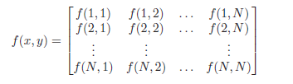

**Figure 1. An Array of Pixels in Different Possible Grey Levels**

The project is concerned in developing an android mobile application that will capture the person’s palm image and tell a person’s characteristics based from the basic knowledge in palmistry. It is important to know why image processing plays a role on the project and what are the existing data and developments particular to our research.

Image Processing has been developed in response to three major problems concerned with pictures:

* Picture digitisation and coding to facilitate transmission, printing and storage of pictures;
* Picture enhancement and restoration in order, for example, to interpret more easily pictures of the other planets taken by various probes;
* Picture segmentation and description as an early stage of Machine Vision.

In the problem, we process an image to have an analysis on the data by measurement and detection pixel by pixel.

Image processing algorithms can be classified as low-level, intermediate-level and high-level operations [7].

Low-level image processing operations work on an entire image to generate a single value, a vector or an image from. Due the involved computations’ local nature, where they work on individual pixels and input image data is spatial. Figurally, localized low-level operations offer fine grain parallelism. This property of low-level image processing operations can be tapped using SIMD (Single Instruction across multiple data) parallel architectures or techniques. Smoothing, sharpening, filtering, convolution, histogram-generation are few examples of low level image processing operations. Intermediate-level image processing operations produce compact data structures like lists from input images. As these computations work only on segments of and not on a whole image, intermediate-level image processing operations offer only medium grain parallelism. They are more restrictive from data-level parallelism aspect (DLP) when compared to low-level operations. Hough transform, object labelling, motion analysis are examples of intermediate-level image processing operations.

High-level image processing operations are characterized as symbolic processing where they work on data structures as input to return other data structures as output that lead to decisions in an application. Also, they usually have irregular access patterns. Due to these properties, high-level operations offer coarse grain parallelism and are difficult to run data-parallel. Position estimation and object recognition are examples of high-level image processing operations.

Image Processing nowadays refers mainly to the processing of digital images. Many image processing algorithms were formulated to solve one specific problem; it may come with another algorithm to solve a more complex one. The deployment of the application on the Android Mobile Platform requires software tools to provide a more comprehensive environment for the programmers and implement the necessary solutions on constraints carried by the study. Later on, the technical details on these topics will be discussed in Theoretical Background.

**Related Studies**

In this section, we include studies that are closest to the topic or research. Some of our findings come from journals and other researches.

According to the study of Navpat et al.[4] , Palmistry is the art of foretelling the future through the study of the palm lines. Palmistry consists of the practice of reviewing and analysing a person’s past potentials and the justice that the person has done to those potentials. Palmistry is not just an art but it is a science. Research says that the various patterns of fingerprints and the fine lines on the palm` are established by the fourth month of life in the womb. In other words, the behavioural pattern (i.e. the way in which the foetus curls his/her palm) of the foetus in the womb is reflected on the palm lines. This paper discusses the design of a system that helps in predicting the palmistry details by scanning an image of the palm and then applying the concepts of image processing so as to predict the palmistry based details of the user. The system will provide the user an automated analysis of person’s palm. The output produced by system will be unbiased as it will use image processing for the extraction of lines. Hence the proposed system is an unbiased and reliable system.

Patel and Dubey [6] discussed in their study a method of palm print recognition which there is no chance of forgetting password and even no can theft his/her password used by the only intended human being. They developed system software where palm images are used for authentication purpose. The palm print provides better security for identification purpose as compared to other method and services where person need to prove their identity. In the same purpose of study of Ahmed et. al [7], the palm vein authentication has high level of accuracy because it is located inside the body and does not change over the life and cannot be stolen. The paper presents an analysis of palm vein pattern recognition algorithms, techniques, methodologies and systems.

Human palms have some common characteristics in the form of mountains known as planets according to Nigam et. al [8]. The finger’s length corresponding to the planet represents the strength of that planet for that person. The help of image processing and ratio based algorithms; one can characterize people and may know their personality type as well.

For the need of implementation of different image processing algorithms, the implemented operations are basic and starting steps to extract useful information according to application, in the research of Miss Jagtap R.S. and Mrs. Sadalage J.A. [9]. For tasks related to images, OpenCV is used. It is compatible with android platform, with open cv manager the same results can be checked on windows operating system. OpenCV stands for Open Source Computer Vision. This is open source computer vision library written in C and C++. The Open CV library contains over 500 functions that span many areas in vision and useful in real time applications. After developing environment it is necessary to add this library in the editor to support its functions and algorithms. Though the use of these libraries requires an adequate amount of resources such as the processor and time to do the necessary operations on the image which the researchers consider.

**Theoretical Background**

This section includes the comprehensive discussion on theorems, definitions, fundamental algorithms, mathematical models/formulas and tools in the applicability to the study.

The system developed in this work mainly focuses on the algorithm that will be used to analyse a person’s palm image and generate results based on basic knowledge in palmistry, making the practical art systematized and automated. Earlier researchers have done work in detection of lines and edges from images and we are using these to take help in formulating our approach in the study.

The most efficient algorithm for curve and line detection is the Hough Transform. With the help of Hough Transform we extract outlines of hand and line on palm from the given hand print and then system will analyse those lines in our database. The use of Canny Edge Detection Algorithm will help the Hough Transform to detect the edges in the image of palm.

Through the use of JNI (Java Native Interface) and NDK (Native Development Kit) installed in Eclipse , enables the interaction between native code languages such as C/C++, and Java which are essential for the development of the mobile application. Meanwhile, the NDK , is a toolset which overcomes the limitation of Java, such as performance and memory management and supports native development.

**CANNY EDGE DETECTION**

Edge detection is one of the most commonly used operations in image analysis providing strong visual clues that can help the recognition process. Edges are local variations in an image function defined by a discontinuity in gray level values and have strong intensity contrasts. It’s also a point in image where intensities are changing rapidly.

The purpose of edge detection in general is to significantly reduce the amount of data in an image, while preserving the structural properties to be used for further image processing. Several algorithms exists, and this worksheet focuses on a particular one developed by John F. Canny (JFC) in 1986. Even though it is quite old, it has become one of the standard edge detection methods and it is still used in research. Some of its application is for security, defense like face detection or human detection.

In layman’s term, the algorithm is consist of the following stages [7] :

1. The removal of noise in an image through convolution mask in a grayscale image with Gaussian Mask. Convolution involves averaging a pixel with surrounding pixels followed by the Gaussian that is used to smooth and blurring the image. For a pixel, the intensity is replaced with the sum of the product between the intensity values within a neighbouring area centered at the pixel and the coefficients of the kernel.

In Figure 2, the surrounding pixels, the violets, are the overlapping pixels with masks and the cyan is the current pixel. After convolution, the current pixel was replaced with a different intensity value.

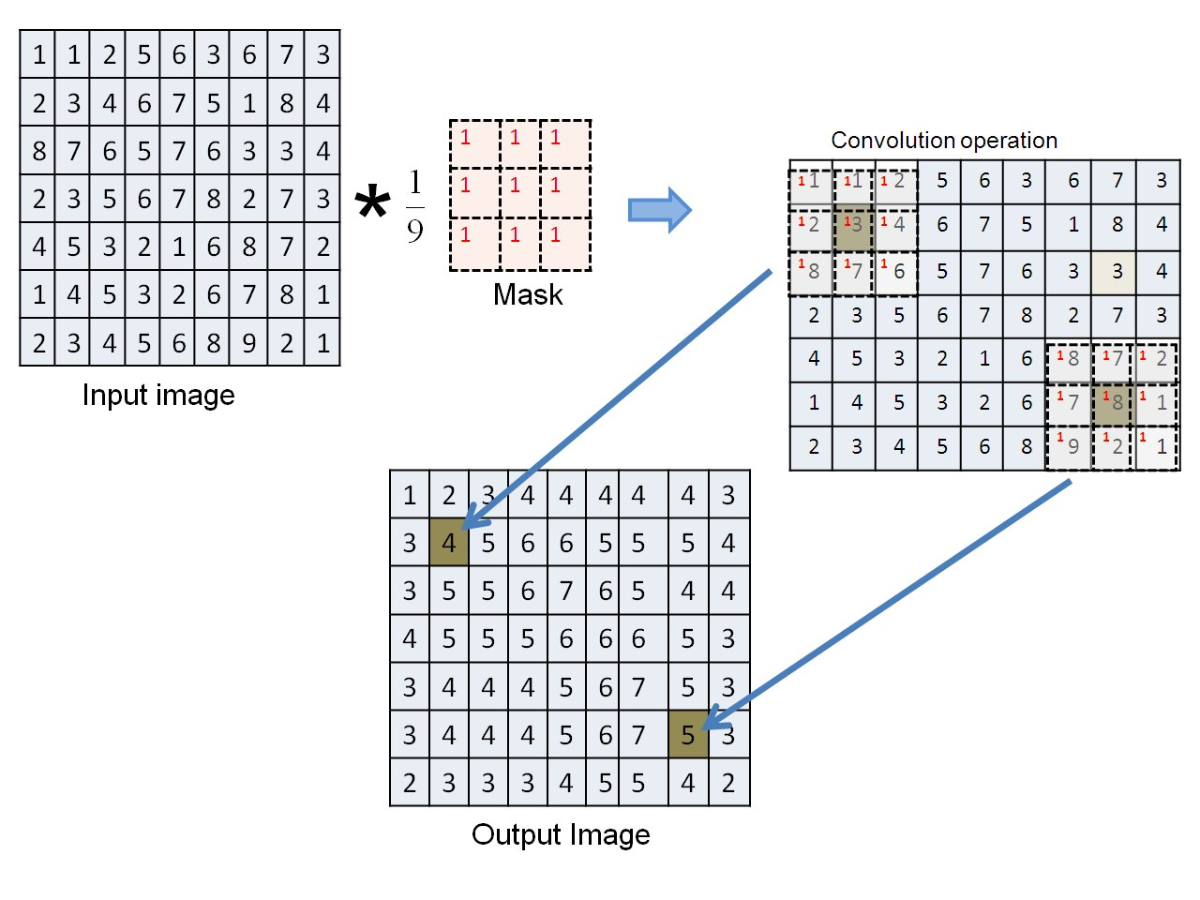

**Figure 2. Application of Convolution to the Matrix**

2. After the removal of noise and smoothing the image, finding the edges on the image where the grayscale intensity changes the most is the next one. These areas in the image are found by determining the gradient magnitude in the image.

*|G| = |Gx| + |Gy|*

*where: Gx and Gy are the gradients in the x and y directions respectively.*

3. Getting the peaks in the matrix of determined gradients. Peak is represented as Boolean matrix for each pixel of the image. If the peak is true, then the gradient magnitude is considered to be a part of the edge. If not, it is supressed as shown in Figure 3 in the next page.

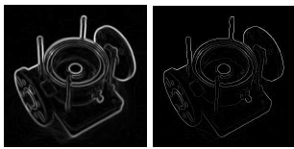

(a)Gradient Values (b) Edges after getting Peaks

**Figure 3. Finding the Peak of Gradient Magnitude**

4. The edge-pixels remaining after the suppression are still marked with their irrelevant pixels. Many of these will probably will the true edges but some may be caused by noise or color variation. To solve these, threshold must be use so that only edges stronger with a stronger value would be preserved as shown in Figure 4.

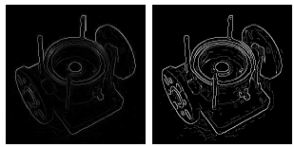

(a)Edges after getting Peaks (b) Double Thresholding

**Figure 4. Double Thresholding**

5. The final step is to track the edges which are strong edges and can be included in the final edge image. Weak edges are included if and only if they are connected to strong edges as shown in Figure 5.

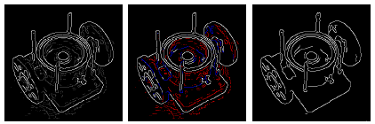

(a) Double Threshold (b) Edge Tracking (c) Final Edge Image

**Figure 5. Final Edge Image**

**HOUGH TRANSFORM FOR LINES AND CURVES**

It can be used to detect lines, circles or other parametric curves. It was introduced in 1962 and first used to find lines in images a decade later. The goal of the algorithm is to find the location of lines in images [14].

**Basic Ideas**

Assume that we have performed some edge detection like the Canny Edge, thus pixels *n* may partially describe the boundary of some objects. Finding those pixels will make up a straight line. Let say that point *(x, y)* and a straight line *y = mx + b.* There are many lines passing through that point and common to them is that they satisfy the equation for some set of (*m, b)* as parameters as shown in Figure 6.

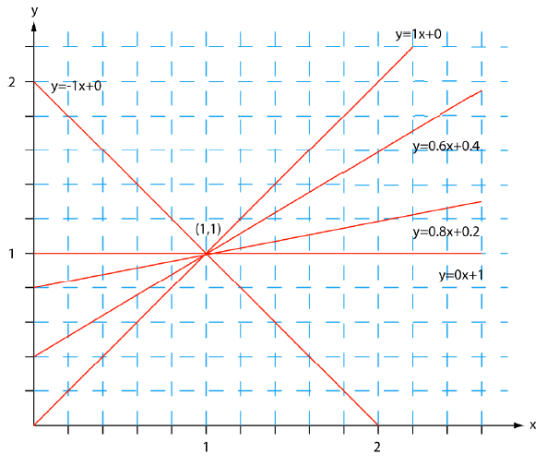

**Figure 6. Basic Idea of Hough Transform**

All points on line in an image space represented by a coordinate plane, yields lines in parameter space which they intersect.

1. It has an accumulator array which is a set of containers that have minimum and maximum possible values of m and b respectively. Then initialize it to zero.

2. For each edge element (x,y), increment all cells that satisfy the equation *b = -x m + y.*

3. Find the highest peak that corresponds to a point that the lines intersect in the parameter space. The incrementing function indicates the possible point of the line, then go to the next edge point. We use the polar (normal) representation of lines as *x cos Ɵ + y sin Ɵ = p.*

**Conceptual Framework**

This study used the systems approach with three elements: input, process and output.

The input for the mobile android application comes from the user’s palm image then it will be processed to generate the results. In terms of development, the researchers include the required knowledge in palmistry, database management, programming and image processing algorithm. The system will read and match the data into the database then a result will be displayed on the screen. The output phase will show what kind of person are you and describe the user’s palm. The following figure supports the above mentioned conceptual framework.

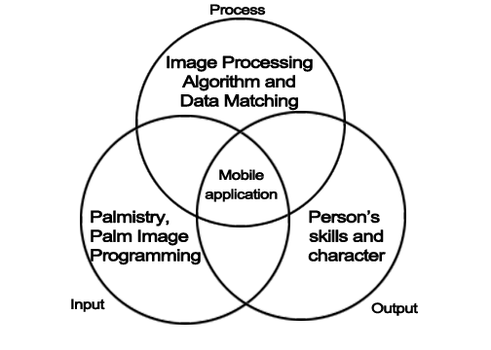

**Figure 7. Conceptual Paradigm of the Project**

**CHAPTER III**

**DESIGN AND METHODOLOGY**

This chapter will discuss the methods of gathering of data and how those data contributes for the development of the project. It includes design and tools used in both hardware and software.

**Project Concepts**

The researchers aim to develop a mobile android application which utilizes the camera as capture device. The input coming from the person’s palm image will be processed by the program and generate readings or results according to the database of basic palmistry. This section will discuss the data needed in the application, operations, interfaces and deliverables in the project.

After the installation of the app on the smartphone, the user can access it in his menu as an icon. The app was started, then a series of menu will show up. In recognition mode, where the user will capture the subject’s palm-image, a yellow-indicator will be present on the screen, this yellow rectangle indicator will changes it size to fit-in with the region of interest. The user needs to tap the screen to capture the image then the screen will prompt the reading from the web database. The web database will be managed by an administrator which contains the table for the readings. The table is composed of these fields: Reading Name, Description, Start Value, End Value. The lines detected by the application are color-coded to indicate its values. The lines are red, green and blue and based on those values, a reading will be displayed on the screen.

With the use of Canny Edge Algorithm and Hough Algorithm, edges and boundaries in the palm-image can be calculated and match in the database by taking its value then output the corresponding reading in the display of the mobile device.

**Functional Requirements**

The mobile application’s core function is to analyse the input, the palm image and calculate the values of the lines, the application will generate the person’s characteristics and skills based on the approach in palmistry that the researchers used.

1. When the application icon is tapped in the menu of the smartphone, the application should be launched.
2. The application must show the menu at the start-up.
3. Every time the user touches a button, the application must respond correctly.
4. The application must capture the palm image as an input as the user wants to do so.
5. Detection of lines in the palm-image must be done by the application after the capturing the palm image.
6. It must calculate the values of the lines and indicate colors in those lines.
7. The application must output readings from the web database that is matching the range of values declared.
8. The web management system must allow administrators to add, delete and edit records in the table containing readings.

**Non – functional Requirements**

These are non-behavioural requirements that the application will exhibit and the constraints on the services or functions offered by the application.

1. Speed

The mobile application should process user’s input in an immediate response time for about 0.4 seconds.

2. Compatibility

The mobile application should be compatible in higher version of Android OS. It would run in most of the devices running the Android OS or platform because some open source applications are being developed based on Android.

3. Ease of Use

It is designed to be user-friendly and comprehensible with high operability, thus requiring technical knowledge for the user is not too much.

**Software Requirements**

Android OS is the only required software or platform for running and testing the mobile application. When installing the application the user should allow permissions in accessing the hardware of the smartphone for the software to run smoothly.

**Hardware Requirements**

The following is required by the mobile application in terms of hardware to provide the functionality and usability of it.

* An Android Mobile Device which is touch-screen to be specific, with at least 1GHz dual-core processor, 4 GB of storage, 5 MP auto-focus camera, Bluetooth or Wi-Fi enabled.

**End User Requirements**

The end user should have an Android Mobile Device running at least in version 2.3.6 of the Android Operating System or in higher version of the operating system, having at least 512 MB of RAM, 3G or Wi-Fi connectivity.

**Development Model**

In Figure 8, the proponents intended to use Spiral Model. This development model’ iteration in every level gives more flexibility for storing changes in the project. It involves analysis and design of the problem which the researchers should keep on reviewing prior to palm reading through an image processing algorithm which should be develop for android devices The same with

the remaining steps in the model. If there are problems in the development, we can review and evaluate it for testing and implementation.

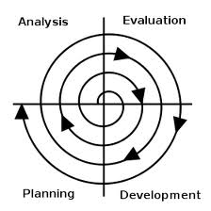

**Figure 8. Spiral Development Model**

**Development Approach**

Through the use of software tools and hardware devices that are required to develop the mobile application, the researchers can do the task according to the plan for the development. However, problems may arise on the middle of the development, thus the researchers must analyse and design a plan to cope with it. Since, the application is for Android mobile devices, the use Java among other programming languages is suited for this. Software Development tool such Eclipse IDE is the most appropriate for building this project which allows software development kit, plug-ins and device emulator for the developers. While the algorithm is expected to be complex as the development goes on, the researchers will be open with references and personal consultations. Testing of the application should be frequent as long as the validity of results passed the evaluation, if not further improvement must be done.

**Software Development Tools**

The Eclipse IDE for Java Developers contains what is needed to build Java applications. Considered by many to be the best Java Development tool available, it provides superior, Java editing with validation, incremental compilation, cross-referencing, code assist and XML Editor.

Eclipse IDE for java Developers (Indigo and Juno) is a multi-language software development environment comprising integrated development environment (IDE) and an extensible plug – in system. It is written mostly in Java, it can be used to develop applications in Java and by means of various plug-ins, other programming languages including Ada, C, C++, COBOL, Haskell, Perl, PHP, Python, R, Ruby, Scala, Clojure, Groovy, Android and Scheme. It can also be used to develop packages for the software Mathematica. Development environments include the Eclipse Java Development Tools (JDT) for Java, Eclipse CDT for C++ and Eclipse PDT for PHP among others.

In order to develop the application using this IDE, software development kits and a runtime environment are required for testing and debugging such as the Android Software Development Kit and Java Runtime. Native Development Kit is also one of the important components for implementing image processing in the application, such toolset to implement native codes like C/C++ to run on android mobile devices through the help of Java Native Interface which defines a way to interact java codes to native libraries. These tools need the help of appropriate hardware such as a personal computer for programming and an android mobile device. A personal computer must have at least a 2gb of RAM, 2GHz of processor speed, the system type can be in 32-bit and preferably running on Windows OS.

**Algorithm Used in the Application**

Android Based Palm Reading Application talks about line and edge detection. Through the concept of Canny Edge Detection and Hough – Transform which are the most used algorithm in providing visual clues, the researchers decided to implement these algorithms in setting boundaries, detecting edges, indicating lines and calculation of values.

With the use of a Palm API which can be utilized through the Java Native Interface, the researchers arrive with this algorithm.

1. Prepare the Native API. It involves the declaration of a class that involves these methods: Preparing, Labeling, Reading. The “prepare” method is used for determining the width, height and the scale of the image. The ‘label’ method is for determining the source and destination frame to be used by the “read” method.

2. After the preparation for the API, an instance of the Camera hardware should be made. Setup, callbacks, capture and the view itself is constructed under this object.

3. While the camera view is running, another class is running and this is the recognition of an image under the view. This is where the Native API and Android OS do the work. The Android OS is the one responsible for the hardware and views used by the application while the Native API loads the libraries for reading, labelling the frame and producing the result in a bitmap format with the detected lines.

4. The value calculated from the image will be used as a parameter for pairing with the values in the database.

5. After the value was calculated, the argument passed on the server of the web database will be matched for the declared ranges of values with its corresponding reading to be returned to the client-side.

6. The application will now have the reading displayed on the user’s screen.

**CHAPTER IV**

**RESULTS AND DISCUSSION**

This chapter presents the scientific generalization of the conducted study. It also summarizes the analysis of the result through interpretation of the researchers.

**Detection of Lines on a Palm Image.**

The application accesses the device’s hardware for capturing and recognizing the palm image. At this point, image processing will take place in order to detect and mark the lines on the image.

By using the Native API and Palm Detection library, the application will assist the user to set and capture the palm-image by a guiding yellow-line which indicates the boundaries and region of interest. Then, after the image was captured, another screen with an image of the palm with color-coded lines will appear, such as red, blue and green.

The operations or procedures said above were done using the methods in the library. The Palm Detection Library compromises labelling, marking and detection of the line. The detection involves the preparation of the phone’s camera which uses the hardware’s width, height and scale as its parameters. These values will be used as part of the recognition of the palm. When the user is sure about the guiding lines in the camera view, he or she can tap the screen in order to process the image. In the labelling process, the image that was captured within the region of interest will be prepared for labelling by resizing the images using the image’s width and height. After resizing the images, a function will be called to find the central area of the image because this is where the palm lines can be found and labelled.

**Obtaining and Determining Results Based On A Palm Image.**

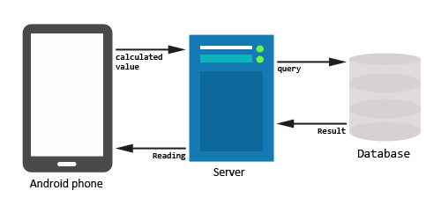After the recognition of the palm lines, markings on the palm image will be made by the application. The markings are in the color of red, green and blue to separate the lines in each other. The application was designed to use a calculated value from all of the lines marked in the image then using this as a parameter for querying the results from a web database. The database contains a table which provides the readings to the user. ­­­­­

**Figure x. Obtaining and Determing Results**

lowest to highest then after that, ranges where declared to suit the basic palm reading studies and conditions.

In obtaining and determining the results, reading could change every time because the marking on the image also changes so as the calculated value.

**Database Used in the Application.**

The size of the database that is needed in the project is small since the study did not pursue the use grayscale image for pattern matching, instead, the researchers used the calculated values of the lines to query the readings in the web database, certainly string values where fetched and printed in the users display.

**VALIDATION AND TESTING**

In the operation of the mobile application, the researchers tested the functionalities of it.

The mobile seems to running on hardware with a minimum requirement unless the device has difficulties in interfacing with the application or damaged and malfunctioning. On testing the buttons in the menu, it seems to be functioning correctly according to its purpose. It also recognizes images as in general, the application was designed to be capturing images of palm but it can also captures any other images without the main subject as the palm. As long as the internet connectivity of the smartphone is working, the application can fetch the data intended for the user.

The detection of the lines and indication of color-coded lines at the captured palm-image was a success in some times. The researchers noticed that the a poor-lighted image shows the inability of the application to do the function. In addition, when the researchers have captured a non-palm image the yellow-guiding line was not working then the image reading is abnormal or not in the range of values declared in the database. The calculation of lines in a palm-image is working fine though there are readings that were too high and out of range.

**INTERPRETATION AND DISCUSSION OF RESULTS**

The mobile application is intended to be used by most of the people who want to use it, the researchers will show the interfaces at least in some of the menu of the application and interpret it as well as for discussion.

As shown in Figure 9. , the mobile application has five buttons with each corresponding functions, the first button which is the settings. In the settings, there’s an only option and that is to change the server’s address where the database is managed and maintained.

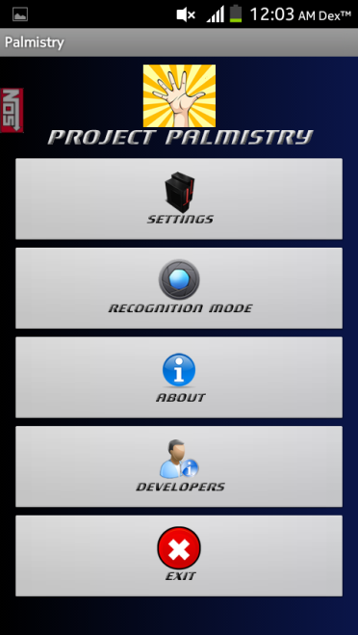

**Figure 9. Main Menu**

In recognition mode, the second function of the application, this where the user needs to use the hardware of the camera to capture the subject’s palm-image. Through the help of the self-adjusting rectangle the area of the user’s interest closes-in to the palm. When the palm is enclosed by the yellow rectangle, this is the time where the user should tap the screen to capture the image, this is shown in Figure 10.

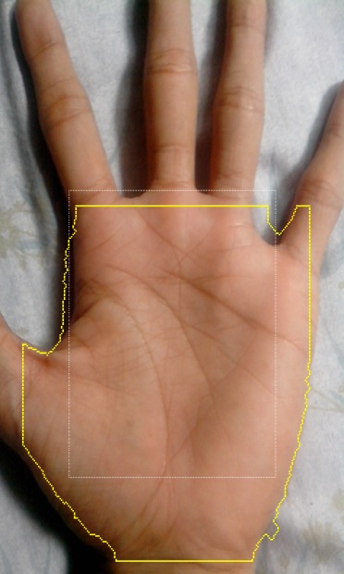

**Figure 10. Recognition Mode**

Notice that there’s another rectangle inside the yellow rectangle. The white rectangle is being used as another guide for the user to decide the region of interest. If the user pointed out the camera to a subject that is not a palm, the application still functions and continues to search for boundaries but the values were either high or zero, this will result to no available readings. Another observation is, when the image is blurry, the lines were short and color-coded lines were not complete resulting to a low reading. Despite of these, the database still provides readings according to the values that were sent into it.

In this Figure 11, there are three color-coded lines. Namely, red, green and blue. The red line indicates a higher value, then followed by the green and the blue. Notice that the lines are not solid lines but there are broken and branching lines. Those lines contribute largely to the calculated value of a line. The more the broken and branching lines the higher the value the application will output. Through the use of sample readings, the red is always at the top followed by either green or blue which indicates the level of dominancy of the lines in a palm. The administrators of the database decided to research the dominant lines in the palm and where it is positioned on a person’s palm. Through this, the researchers provided a database for fetching the readings.

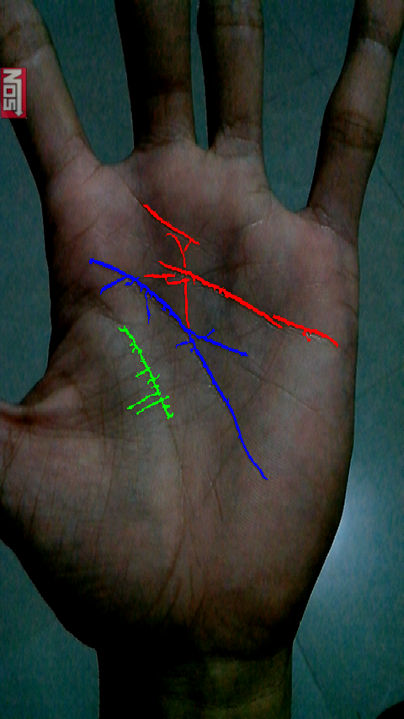

**Figure 11. Color-coded Lines Detected**

After the lines were detected by the mobile application, the user should tap the screen to view the reading, this requires internet connectivity to be able to download the reading from the server. Figure 12 shows the value of the line and its reading.

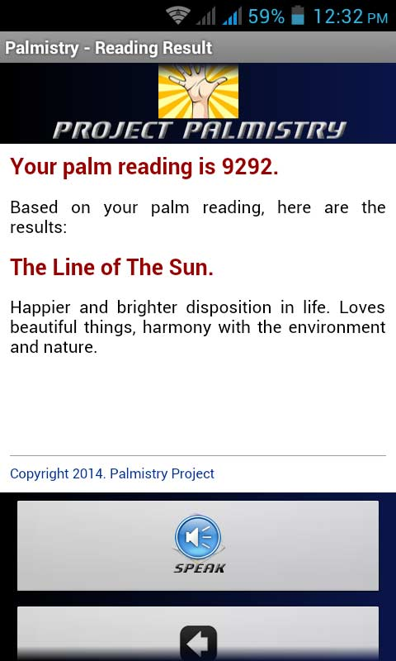

**Figure 12. Palm Reading**

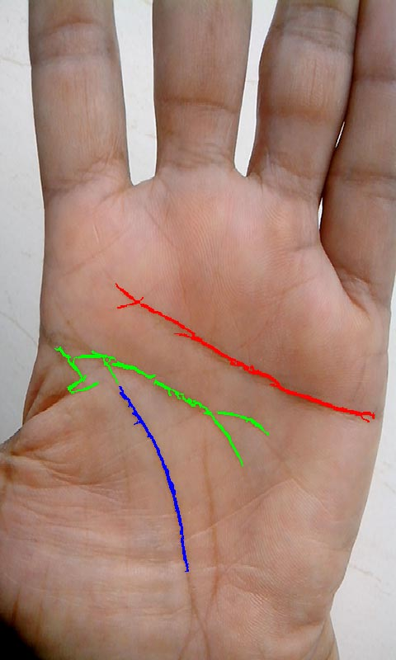 As we can see from the figure, there’s a value indicating the palm reading. The application will use it to determine the reading on the web database. If no matching case that was agree to the calculated value, the application will have the no output on the screen.

**Figure X. Palm Image Used For Comparison of Results**

Using this sample image, the researchers try to compare the reading of a fortune teller to the result given by the application. The figure below is the result given by the application.

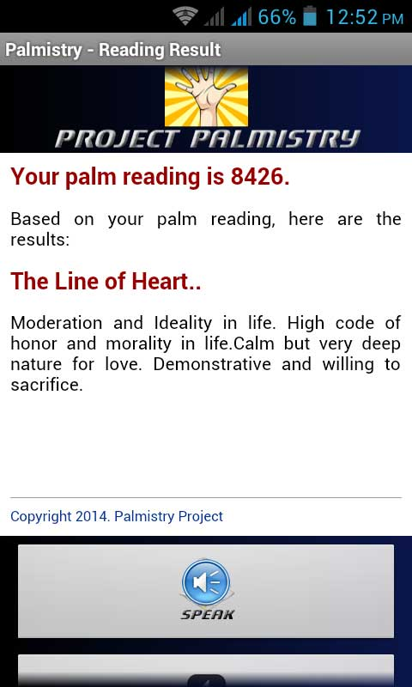

**Figure X. Palm Reading For Comparison of Results**

The palm reading says that the subject has the line heart which corresponds to a moderate and ideal life and so on. On the quote below is the fortune teller’s own interpretation of the subject’s palm.

*“She is a woman of integrity. She uses all his ability to make all*

*things work according to his plans and a generous person she is”.*

*-Manang Minera, Quiapo*

The fortune teller’s interpretation or reading of the subject’s palm sound’s conflicting with the result of the application, because of certain factors, like the principles used and reading methodology used by the fortune teller.

**CHAPTER V**

**SUMMARY, CONCLUSIONS AND RECOMMENDATIONS**

**Findings**

Through the efforts of the developers the following were attained as per testing the application functionalities and performance.

1. The application was successful in detecting lines on palm image through the use of a Palm Detection Library. A Java Native Interface was used for this library which is written in C++ for optimal use of memory and hardware resources of the android device.
2. Obtaining and determining result based on some teachings of palmistry was successfully implemented through the use of a calculated value queried into a web database and returning the reading to the client’s device. Providing the same reading for a particular palm image was not achieved by the developers.
3. The size of the database was not large for storing readings and description for the application. It only amounts up to 1.5 megabytes of memory.

**Conclusions**

Based on the findings and the results of the testing of the application the following conclusions have been drawn:

1. The Palm Detection Library worked well in developing and implementing the main functionality of the application in the detection of the lines on a palm image.

2. The use of ranges of value for a reading stored on a web database and queried by the client’s device is suited for obtaining and determining the results to the user.

3. The database size is small because the number of readings are few which the application used for obtaining and providing the results to the users.

**Recommendations**

The proceeding statements were recommendations to the future researchers and readers that the present researchers want to convey for the improvement of the present study.

1. The application will provide a better and more accurate result if the images are well lit and positioned accordingly.
2. The application’s functionality can be improved by using an artificial intelligence on reading lines on a subject’s palm in a real-time manner.
3. The application’s scope can be widen in the future since computing power is increasing through the years in the era of information, the researchers can add another functionality or eve another application for the user’s security and privacy of his or her information.