ECON3350 Research Report 1

Empirical Analysis of US Macroeconomic Data and AUD Exchange Rates

Question 1

1(a) Exploratory Plots and Variable Properties
Figure 1 plots the log levels of the price index (pt), real GDP per capita (yt), and real consumption (ct) from 1959Q1 to 2023Q4.
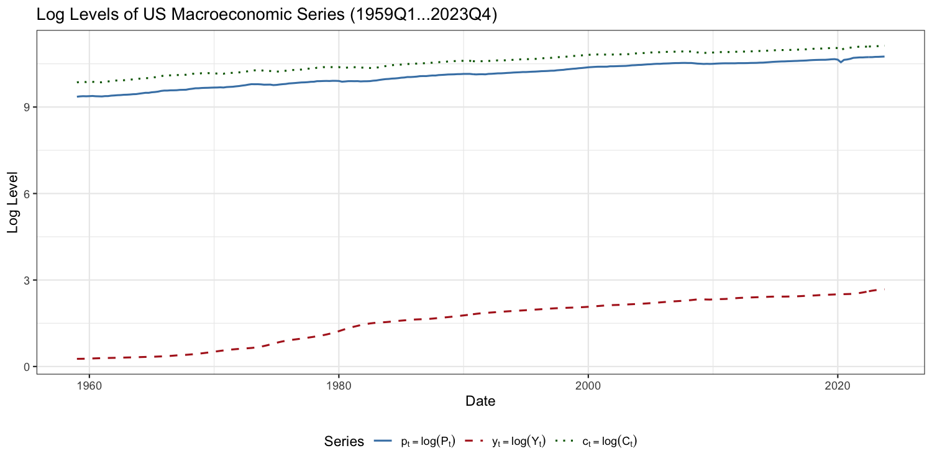
Figure 1: Log levels of US macroeconomic variables (1959Q1–2023Q4)

Figure 2 plots the first differences of the log levels (quarterly inflation, GDP growth, and consumption growth) alongside the nominal T-bill rate.
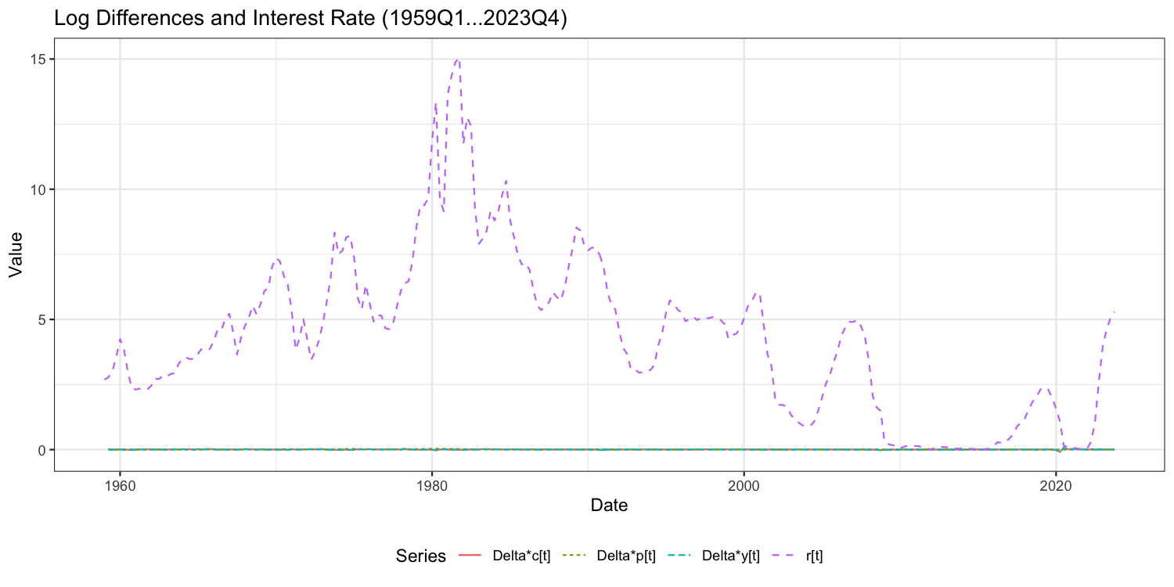
Figure 2: First differences and nominal interest rate

Looking at the log levels, all three series trend upward across the sample. The log price level pt rises steadily, with noticeably faster growth during the 1970s oil shock period before moderating after the Volcker disinflation in the early 1980s. Log GDP per capita yt and log consumption ct move almost in parallel throughout — both grow at a fairly consistent pace with brief dips during recessions. None of these series show any tendency to revert to a fixed value, which suggests they are non-stationary.

In the second plot, differencing removes the trends and the series look much more stable. Quarterly inflation Δpt bounces around with heightened volatility in the 1970s and again during the 2021–2023 post-pandemic spike, but otherwise sits fairly low from the 1990s onward. Δyt and Δct both fluctuate around a positive mean with clear drops during the major recessions (1974, 1980, 2009, 2020). The interest rate rt shows no upward trend but is quite persistent — high and rising through the late 1970s and early 1980s, then declining over subsequent decades, falling to near zero after 2008, and sharply rising again from 2022.

1(b) Trend Regressions and Means of Differences
Part (i) — Trend regressions on log levels:
Series | Intercept (μ̂) | Trend (δ̂) | SE(δ̂) | R²
pt | 0.271 | 0.010125 | 0.000147 | 0.949
yt | 9.945 | 0.004757 | 0.000042 | 0.980
ct | 9.429 | 0.005305 | 0.000043 | 0.983

All trend coefficients are highly significant (t > 60 for each). The high R² values confirm a linear trend explains most of the variation in each series.

Part (ii) — Means of first differences:
Series | Mean (μ̂)
Δpt | 0.009310
Δyt | 0.004919
Δct | 0.005379

Part (iii) — These two exercises both estimate the same quantity: the average rate of change of each series over time. If a series follows a random walk with drift (yt = yt−1 + δ + εt), then regressing the level on a time trend gives δ̂ as an estimate of that drift. Alternatively, first-differencing gives Δyt = δ + εt, so the sample mean of the differences estimates the same drift. Both methods should give nearly identical answers.

This holds well empirically: for yt the trend coefficient is 0.004757 vs mean of Δyt of 0.004919, and for ct it is 0.005305 vs 0.005379. The small difference for pt (0.010125 vs 0.009310) likely reflects the structural shift in trend inflation — the OLS regression weighs the high-inflation 1970s and early 1980s differently than the sample mean approach when there is a structural break.

Question 2

Model Selection
Stationarity tests
Unit root tests confirm that Δpt is stationary (ADF p = 0.032 rejects a unit root) and rt is non-stationary (ADF p = 0.171, KPSS stat = 1.763 strongly rejects stationarity). We treat Δpt as I(0) and fit ARMA models directly, while rt is treated as I(1) and modelled as ARIMA(p,1,q).

ARMA models for Δpt — AIC/BIC comparison:
Model | AIC | BIC
ARMA(2,1) | −2579.82 | −2562.04
ARMA(1,2) | −2565.91 | −2548.12
ARMA(3,0) | −2543.72 | −2525.94
ARMA(2,0) | −2543.28 | −2529.05
ARMA(1,1) | −2539.69 | −2525.46

The ACF and PACF show significant autocorrelation at lags 1 and 2, supporting an AR component, and the relatively slow ACF decay suggests some MA structure. The three models that appear in the intersection of both the AIC and BIC top-10 sets are ARMA(2,1), ARMA(1,2), and ARMA(3,0). Residual diagnostics (Ljung-Box) confirm adequacy for all three.

Estimated ARMA(2,1): ar₁ = 0.478 (SE = 0.056), ar₂ = 0.447 (SE = 0.056), ma₁ = 1.000 (SE = 0.016), mean = 0.0089, σ² = 2.625×10⁻⁶.

ARIMA models for rt — top 3 by AIC:
Model | AIC | BIC
ARIMA(2,1,1) | 504.38 | 518.61
ARIMA(1,1,1) | 506.19 | 516.86
ARIMA(3,1,0) | 507.93 | 522.16

2(a) Forecast Plot
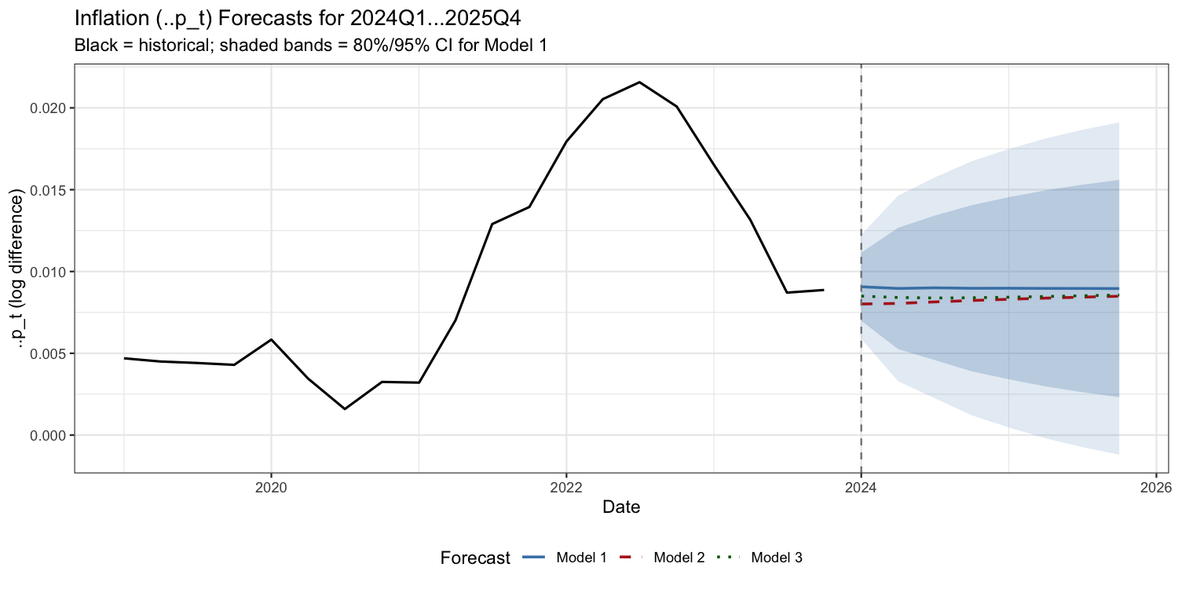
Figure 3: Inflation forecasts 2024Q1–2025Q4. Shaded bands show 80% and 95% CI for ARMA(2,1).

Quarter | ARMA(2,1) | ARMA(1,2) | ARMA(3,0) | 95% CI Lower | 95% CI Upper
2024Q1 | 0.00907 | 0.00801 | 0.00849 | 0.00588 | 0.01225
2024Q2 | 0.00896 | 0.00805 | 0.00841 | 0.00329 | 0.01463
2024Q3 | 0.00900 | 0.00814 | 0.00838 | 0.00225 | 0.01575
2024Q4 | 0.00897 | 0.00823 | 0.00839 | 0.00120 | 0.01674
2025Q1 | 0.00898 | 0.00830 | 0.00843 | 0.00046 | 0.01749
2025Q2 | 0.00897 | 0.00837 | 0.00847 | −0.00019 | 0.01813
2025Q3 | 0.00896 | 0.00843 | 0.00852 | −0.00073 | 0.01866
2025Q4 | 0.00896 | 0.00849 | 0.00856 | −0.00120 | 0.01911

All three models converge fairly quickly toward the sample mean of around 0.009. This is expected from stationary ARMA processes — forecasts revert to the unconditional mean as the horizon increases.

2(b) Policy Implications and Uncertainty
Inflation forecasts like these are directly useful for monetary policy. The Federal Reserve uses inflation projections when deciding on interest rate changes — if inflation is forecast to stay above the 2% target, the Fed may maintain or raise rates, whereas a declining inflation path could support cuts. Fiscal authorities also use inflation projections to index spending programs and estimate real borrowing costs.

There are several sources of uncertainty worth distinguishing. First, each future period introduces an unpredictable shock εt — the 95% confidence interval starts at a width of 0.00636 at h=1 and widens to 0.02031 at h=8, directly showing how much this accumulates. Second, estimated model coefficients are uncertain themselves. Third, there is model uncertainty — the three models give noticeably different forecasts (e.g., at h=1 the range is 0.00801 to 0.00907). Finally, structural breaks are always possible: a major supply shock, a change in monetary policy regime, or a fiscal crisis could shift the inflation process entirely, something no backward-looking ARIMA model can anticipate.

Question 3

Forecast Evaluation Against Actual Data
Using the actual Pt values from the question table and P_{2023Q4} = 14.547 from the dataset, the actual Δpt values for 2024Q1–2025Q3 are computed as log-differences:

Quarter | Actual Δpt | ARMA(2,1) | ARMA(1,2) | ARMA(3,0)
2024Q1 | 0.00798 | 0.00907 | 0.00801 | 0.00849
2024Q2 | 0.00829 | 0.00896 | 0.00805 | 0.00841
2024Q3 | 0.00761 | 0.00900 | 0.00814 | 0.00838
2024Q4 | 0.00636 | 0.00897 | 0.00823 | 0.00839
2025Q1 | 0.00711 | 0.00898 | 0.00830 | 0.00843
2025Q2 | 0.00634 | 0.00897 | 0.00837 | 0.00847
2025Q3 | 0.00643 | 0.00896 | 0.00843 | 0.00852

Forecast performance metrics:
Model | MSFE | RMSFE | MAE
ARMA(2,1) | 3.89×10⁻⁶ | 0.001973 | 0.001829
ARMA(1,2) | 1.92×10⁻⁶ | 0.001384 | 0.001129
ARMA(3,0) | 2.24×10⁻⁶ | 0.001496 | 0.001284

ARMA(1,2) performs best on both MSFE and MAE, roughly halving the forecast error of ARMA(2,1). All seven actual observations fall within the 95% confidence interval of Model 1, so the uncertainty coverage is appropriate even though the point forecasts are biased upward.

All three models systematically overpredict inflation throughout the evaluation window — they forecast around 0.009 while actual inflation was trending down toward 0.006. This reflects a standard limitation of ARIMA models: they project the historical average forward, but actual US inflation decelerated sharply through 2024 as Federal Reserve rate hikes worked through the economy and supply chains normalised. The high-inflation period of 2021–2022 in the estimation sample pulls the forecasted mean upward. ARMA(1,2) handles this slightly better because its larger MA structure responds more flexibly to reverting dynamics, but none of the models can fully account for the structural nature of the disinflation.

Question 4

4(a) Real Interest Rate
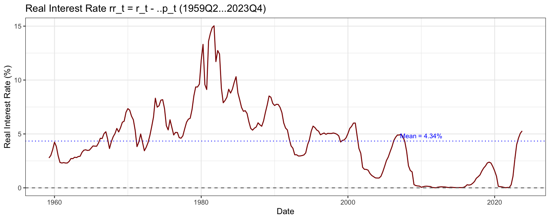
Figure 4: Real interest rate (r_t − Δp_t), 1959Q2–2023Q4

The real interest rate rr_t = rt − Δpt ranges from 0.007 to 15.03 with a sample mean of 4.34. The plot shows the same broad patterns as the nominal rate: high and rising through the early 1980s at the peak of the Volcker tightening, declining through the 1990s and 2000s, falling near zero after 2008, and rising sharply from 2022. The real rate shows less of an outright downward trend than the nominal rate, consistent with the Fisher effect — nominal rates and inflation broadly moved together, leaving the real rate oscillating without a clear long-run trend.

ARIMA for rrt: ADF and KPSS indicate rrt is non-stationary, so d=1. The best model by AIC is ARIMA(2,1,2)(0,0,1)[4] — AIC = 484.66.

Parameter | Estimate | SE
ar₁ | −1.273 | 0.074
ar₂ | −0.508 | 0.077
ma₁ | 1.770 | 0.054
ma₂ | 0.874 | 0.046
sma₁ | 0.127 | 0.086

4(b) Consumption Ratio
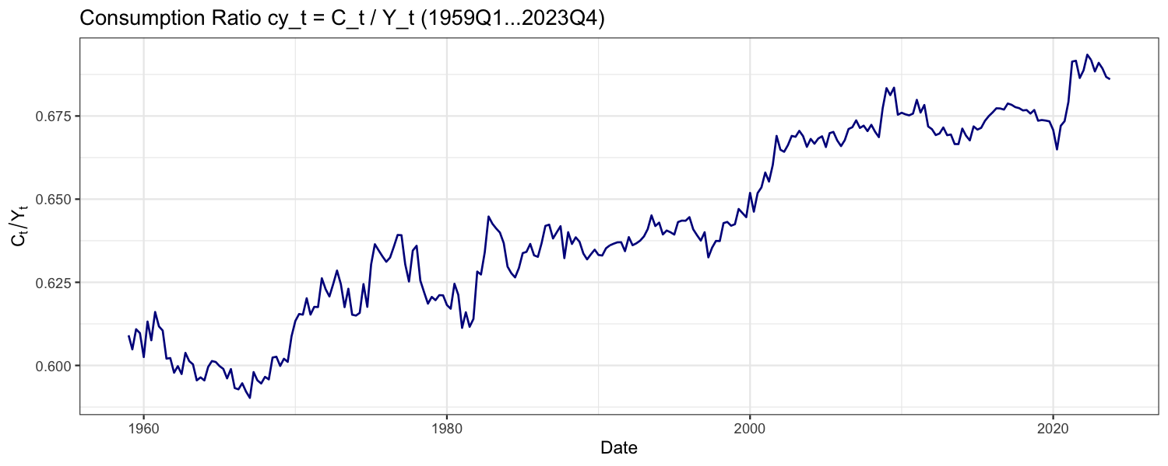
Figure 5: Consumption ratio (C_t / Y_t), 1959Q1–2023Q4

The consumption ratio cy_t = Ct/Yt rises from around 0.59 in 1959 to approximately 0.69 by 2023, with a sample mean of 0.642. The dominant feature is a persistent upward trend — consumption has grown as a larger share of GDP over the six-decade sample. This pattern is consistent with the decline in the US personal saving rate over the same period, driven by easier access to credit, wealth effects from rising equity and housing prices, and demographic shifts as baby boomers moved into peak consumption phases.

ARIMA for cyt: Best model by AIC is ARIMA(2,1,2) — AIC = −2129.79.
Parameter | Estimate | SE
ar₁ | −0.341 | 0.136
ar₂ | −0.848 | 0.089
ma₁ | 0.208 | 0.149
ma₂ | 0.841 | 0.069

4(e) Policy Uses
The rrt model helps central banks assess whether the current monetary policy stance is genuinely restrictive or accommodative in real terms. Rather than looking only at the nominal rate, policymakers can use the model to forecast real rates and judge whether they are above or below the neutral real rate — a key input to the Taylor rule.

The cyt model is useful for fiscal policymakers and aggregate demand analysis. A rising consumption ratio signals households are spending a growing fraction of income, which affects the size of fiscal multipliers — tax cuts or transfers have larger demand effects when households have a high propensity to consume. Central banks also track cyt as an indicator of household financial vulnerability.

Question 5

5(a) Sample Variances
Currency | σ²_sample | SD (%)
CNY | 0.3369 | 0.580
USD | 0.4381 | 0.662
TWI | 0.2675 | 0.517
SDR | 0.4492 | 0.670

TWI has the lowest variance, which makes sense given it is a trade-weighted average across multiple bilateral rates — diversification across trading partners smooths out bilateral movements. SDR has the highest, despite also being a basket, because it includes GBP and JPY which can move significantly against the AUD. CNY is less volatile than USD, reflecting the People's Bank of China's managed float where daily movements are constrained by intervention.

5(b) Absolute Returns
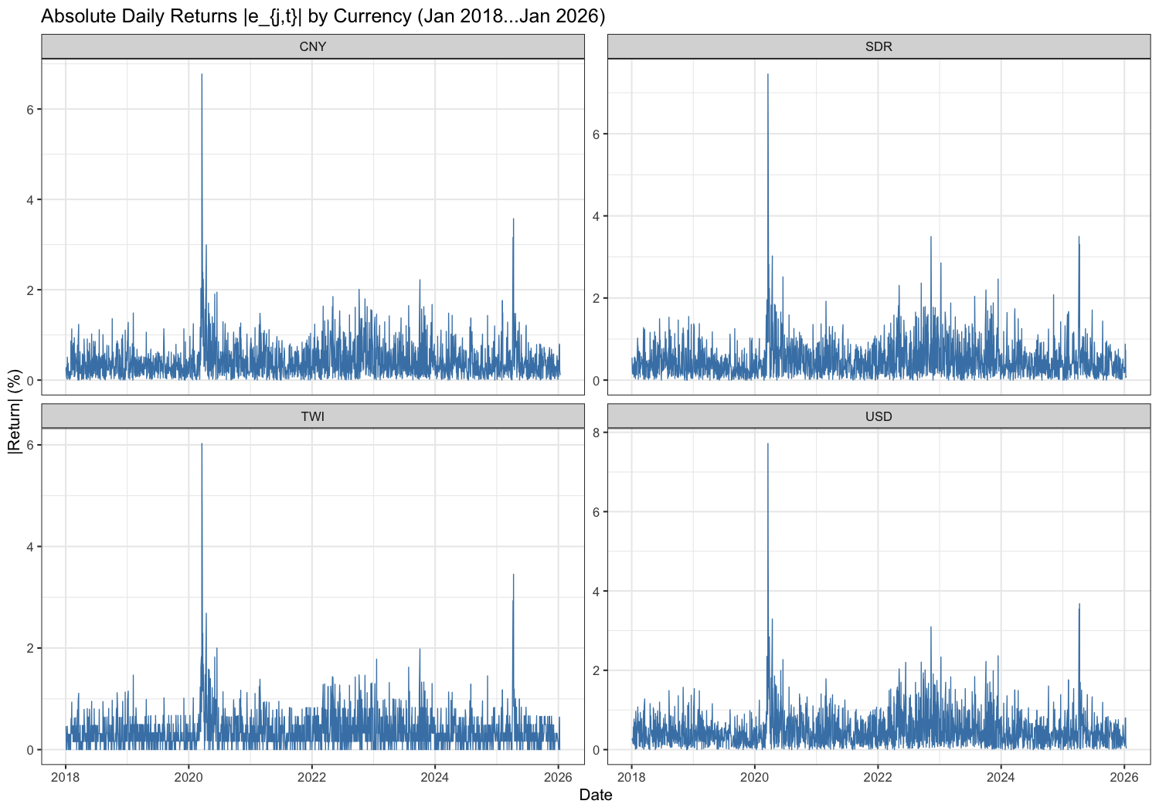
Figure 6: Absolute daily returns |e_t| (%) for all four currencies, 2018–2026

All four series show clear volatility clustering — large absolute returns bunch together in time, and quiet periods also cluster. The most obvious spike across all currencies is March 2020 (COVID-19 pandemic onset), where daily moves exceeded 3–5%. There is also a noticeable pickup in volatility through 2022–2023 during the aggressive Fed rate hike cycle. These patterns directly motivate GARCH modelling: the constant-variance assumption of ARMA is clearly violated.

Question 6

Model Selection Process
Step 1 — Testing for ARCH effects
Before fitting GARCH models, the presence of conditional heteroskedasticity is confirmed using the Breusch-Pagan LM test. The LM statistic is computed at lags 1–10 using an auxiliary regression of squared ARMA residuals on their own lags. For all four currencies the p-value is approximately zero at every lag length, decisively rejecting the null of constant variance. The Ljung-Box test on squared returns confirms this finding.

Step 2 — Mean equation specification
Ljung-Box tests on raw returns show serial correlation in CNY, TWI, and SDR (p < 0.05), but not USD (p = 0.056). This guides the ARMA order in the mean equation: USD and CNY use ARMA(0,0), TWI uses ARMA(1,0), and SDR uses ARMA(0,1).

Step 3 — Grid search over ARMA-GARCH specifications
A grid search is conducted over 81 combinations of mean model orders (pm, qm ∈ {0,1,2}) and GJR-GARCH orders (ph, qh ∈ {0,1,2}) using Student-t errors. The intersection of the AIC and BIC top-10 sets is used to form the adequate set for each currency. GJR-GARCH(1,1) with Student-t errors consistently ranks first — the Student-t distribution produces lower AIC by approximately 0.04–0.05 across all series relative to Normal errors, confirming heavy tails. The asymmetric GJR specification outperforms symmetric GARCH, with the leverage parameter γ > 0 for all series.

Final selected models:
Currency | Mean Model | GARCH Type | Errors | AIC | BIC
CNY | ARMA(0,0) | GJR-GARCH(1,1) | Student-t | 1.5243 | 1.5410
USD | ARMA(0,0) | GJR-GARCH(1,1) | Student-t | 1.7963 | 1.8130
TWI | ARMA(1,0) | GJR-GARCH(1,1) | Student-t | 1.2830 | 1.3024
SDR | ARMA(0,1) | GJR-GARCH(1,1) | Student-t | 1.7938 | 1.8132

Estimated coefficients:
CNY: μ = −0.014, ω = 0.0067, α = 0.014, β = 0.932, γ = 0.062, ν = 8.0
USD: μ = −0.014, ω = 0.0042, α = 0.001, β = 0.961, γ = 0.052, ν = 8.5
TWI: μ = −0.007, φ₁ = −0.040, ω = 0.0070, α = 0.022, β = 0.919, γ = 0.055, ν = 8.0
SDR: μ = −0.008, θ₁ = −0.181, ω = 0.0055, α = 0.018, β = 0.949, γ = 0.036, ν = 7.8

The large β estimates (0.88–0.96) indicate high persistence in conditional volatility. The positive γ confirms the leverage effect: negative shocks produce a larger increase in volatility than positive shocks of the same magnitude. The Student-t degrees of freedom (ν ≈ 7.5–8.5) confirm heavy tails not captured by the Normal distribution.

Residual Diagnostics
Currency | LB on z (p) | LB on z² (p) | Mean equation OK?
CNY | 0.44 | 0.0002 | Yes
USD | 0.69 | 0.0000 | Yes
TWI | 0.69 | 0.0000 | Yes
SDR | 0.94 | 0.0000 | Yes

The mean equations are well-specified — Ljung-Box on standardised residuals is insignificant for all series. The squared standardised residuals still show some serial correlation, suggesting GJR-GARCH(1,1) does not perfectly capture all volatility dynamics. This is common for high-frequency FX data given the COVID-19 outlier in March 2020, and GJR-GARCH(1,1) remains the standard benchmark.

Estimated Conditional Volatility
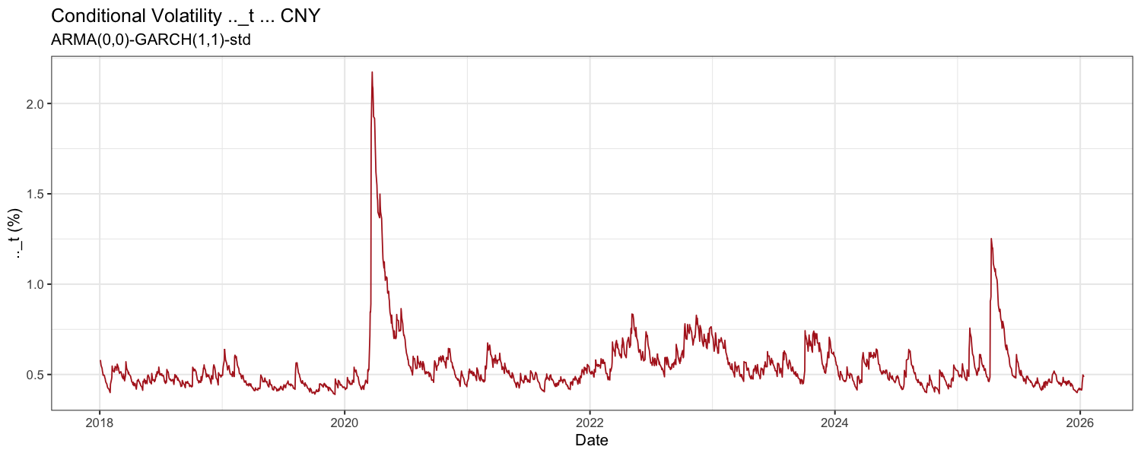
Figure 7: Conditional volatility σ_t — CNY
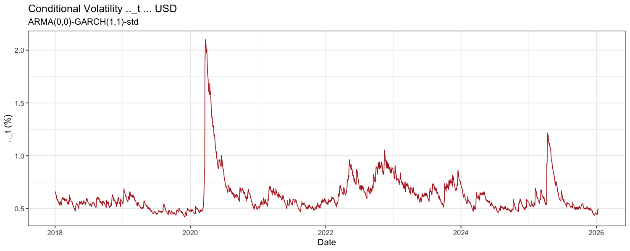
Figure 8: Conditional volatility σ_t — USD
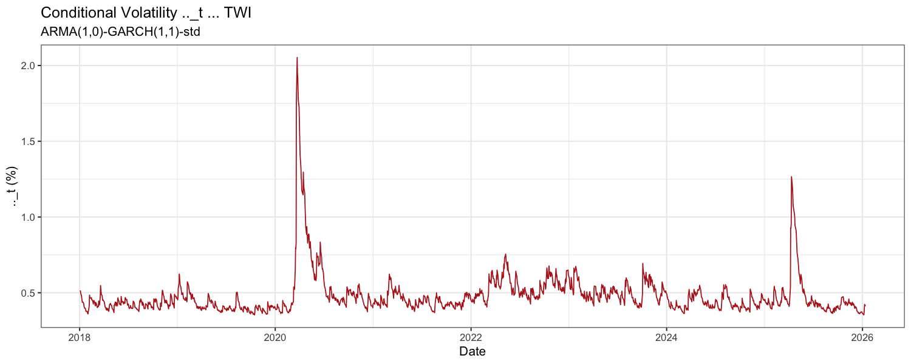
Figure 9: Conditional volatility σ_t — TWI
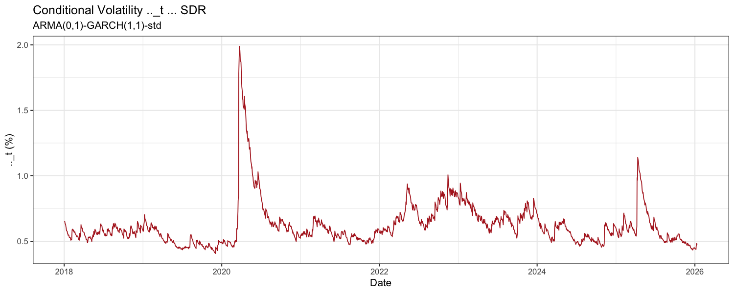
Figure 10: Conditional volatility σ_t — SDR

The conditional volatility plots show the COVID-19 spike in March 2020 as the dominant event across all currencies, with elevated but lower volatility around 2022–2023. The TWI shows the most contained spike, consistent with its lower sample variance.

Question 7

Unconditional Variance: Model vs Sample
For a GJR-GARCH(1,1) model the unconditional variance (assuming covariance stationarity) is:

σ² = ω / (1 − α − β − γ/2)

This requires α + β + γ/2 < 1 (covariance stationarity), which holds for all four series:
Currency | α+β+γ/2 | σ²_model | σ²_sample | Ratio
CNY | 0.9771 | 0.2925 | 0.3369 | 0.868
USD | 0.9879 | 0.3455 | 0.4381 | 0.789
TWI | 0.9685 | 0.2234 | 0.2675 | 0.835
SDR | 0.9848 | 0.3638 | 0.4492 | 0.810

Since α + β + γ/2 < 1 for all currencies, the unconditional variance is well-defined — none of the series exhibit IGARCH behaviour.

The model estimates are consistently 13–21% below the sample variances. This is primarily because the sample period (January 2018–January 2026) includes the COVID-19 shock in March 2020, an extreme volatility event that disproportionately inflates the sample variance relative to the long-run unconditional level. The GARCH model, by modelling time-varying volatility explicitly, can distinguish the temporary COVID spike from the underlying long-run variance. The relative ordering across currencies is preserved (TWI lowest, SDR/USD highest), consistent with Question 5.

Question 8

Probability of Return Below 0.01%
Using the fitted GJR-GARCH models, two-step ahead forecasts of conditional mean and standard deviation are computed from the last observation (12 January 2026). Under the Student-t distribution with estimated degrees of freedom ν, the probability is:

P(e_{j,t} < 0.01) = P(t_ν < (0.01 − μ_{T+h}) / σ_{T+h})

Currency | μ_{T+1} | σ_{T+1} | P(13/01) | μ_{T+2} | σ_{T+2} | P(14/01)
CNY | −0.0143 | 0.4524 | 0.5207 | −0.0143 | 0.4547 | 0.5206
USD | −0.0140 | 0.4432 | 0.5209 | −0.0140 | 0.4452 | 0.5209
TWI | −0.0070 | 0.3775 | 0.5174 | −0.0068 | 0.3809 | 0.5170
SDR | −0.0230 | 0.4449 | 0.5286 | −0.0084 | 0.4477 | 0.5159

All probabilities are slightly above 0.50 because mean returns are slightly negative — the AUD has depreciated modestly, so there is a marginally higher chance that any given day's return falls below 0.01%.

For a foreign currency investor, a higher P(e < 0.01%) means a higher chance of earning essentially zero or negative returns on that day — more risk. The preferred currency is the one with the lowest probability.

On 13 January, the safest investment is TWI (P = 0.5174), followed by CNY (0.5207), USD (0.5209), and SDR (0.5286). TWI benefits from its low conditional volatility (σ = 0.378%) — because the spread of possible return outcomes is smaller, the probability mass below the 0.01% threshold is lower. SDR is riskiest on this date because its conditional mean for T+1 is unusually negative (−0.023%) due to the MA(1) momentum effect, pushing more probability mass below the threshold.

On 14 January, the ranking shifts: SDR (0.5159) becomes the safest as its mean reverts back to −0.008%, while TWI remains consistently low at 0.517. USD stays at 0.5209 since its conditional mean barely changes across horizons.

In practice, a risk manager would favour TWI across both days given its consistently low downside probability. This reflects a broader principle: for short-term FX positions, using the GARCH-implied conditional variance to update risk estimates daily is more informative than using the unconditional sample variance, because it captures whether current market conditions are calm or volatile and prices risk accordingly.

