101459108 COMP3123 Assignment 1 Test Case Screenshots – Michael Mocioiu:

MongoDB ss at bottom!!

**POSTMAN:**

1) POST /api/v1/user/signup  
Invalid email format:

Invalid password:  
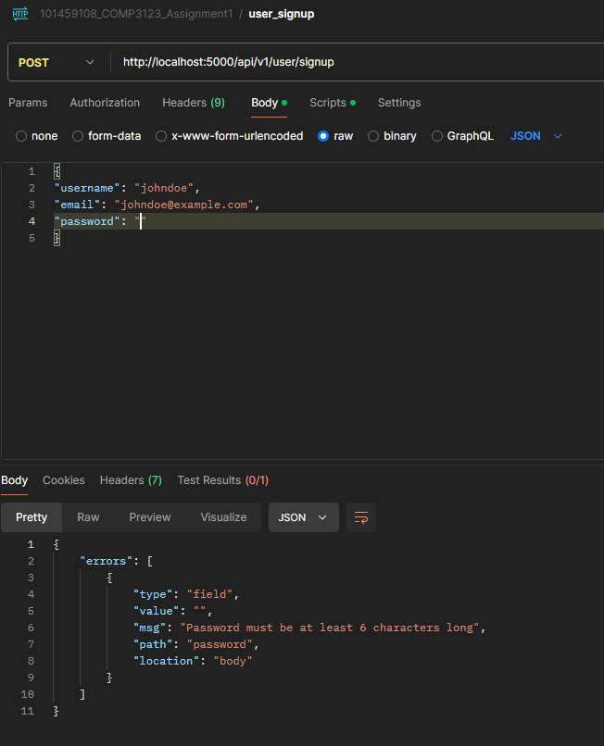

Invalid username Input:  
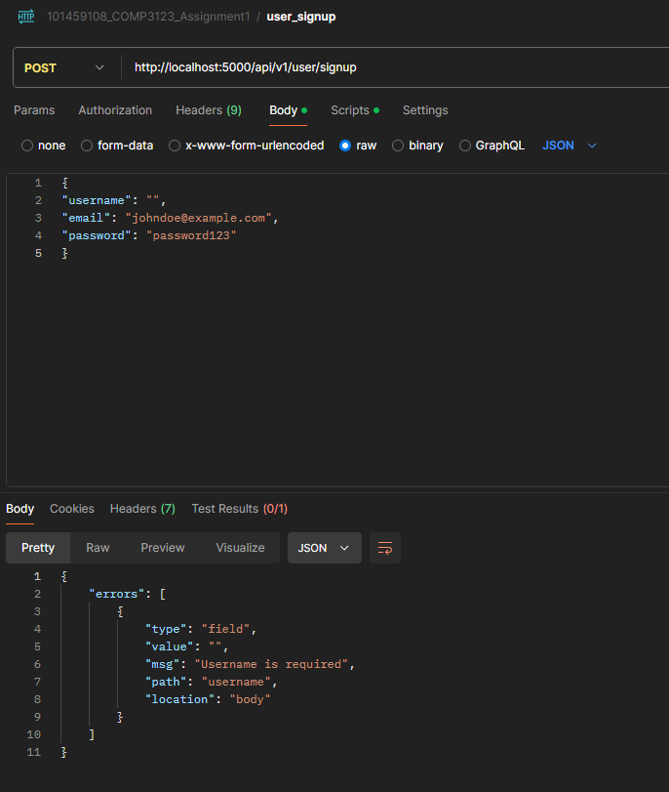  
Valid attempt:  
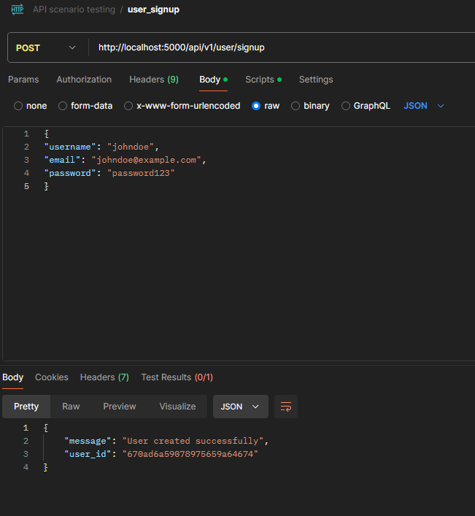

2) POST /api/v1/user/login

Invalid email:

Invalid email format:  
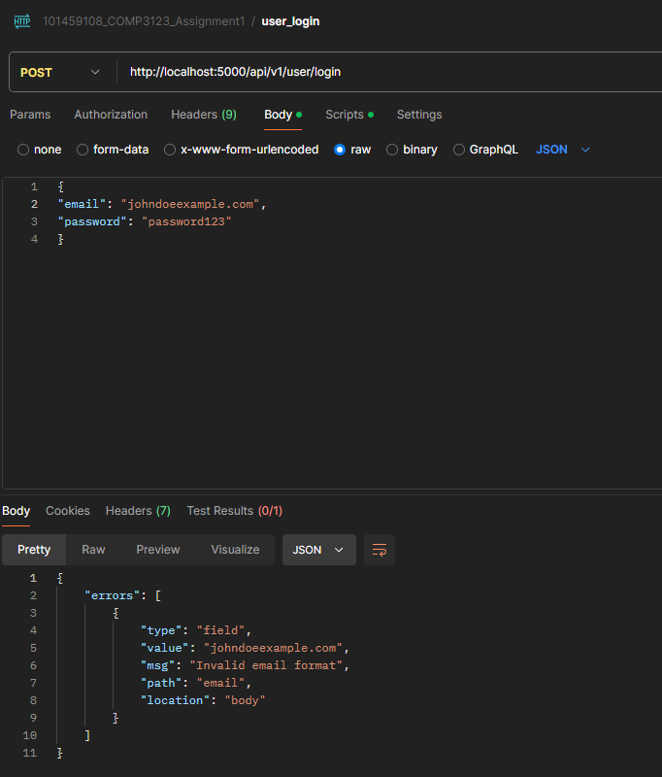

Invalid password format:  
  
Valid Login:  
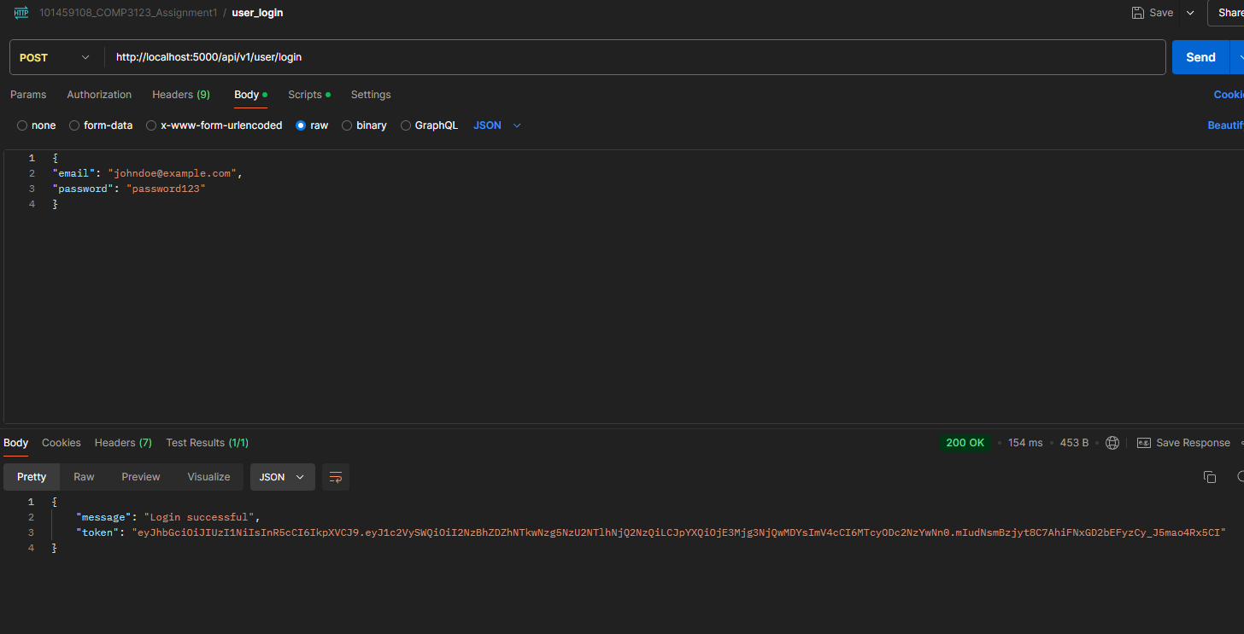

3) GET /api/v1/emp/employees

Valid auth:

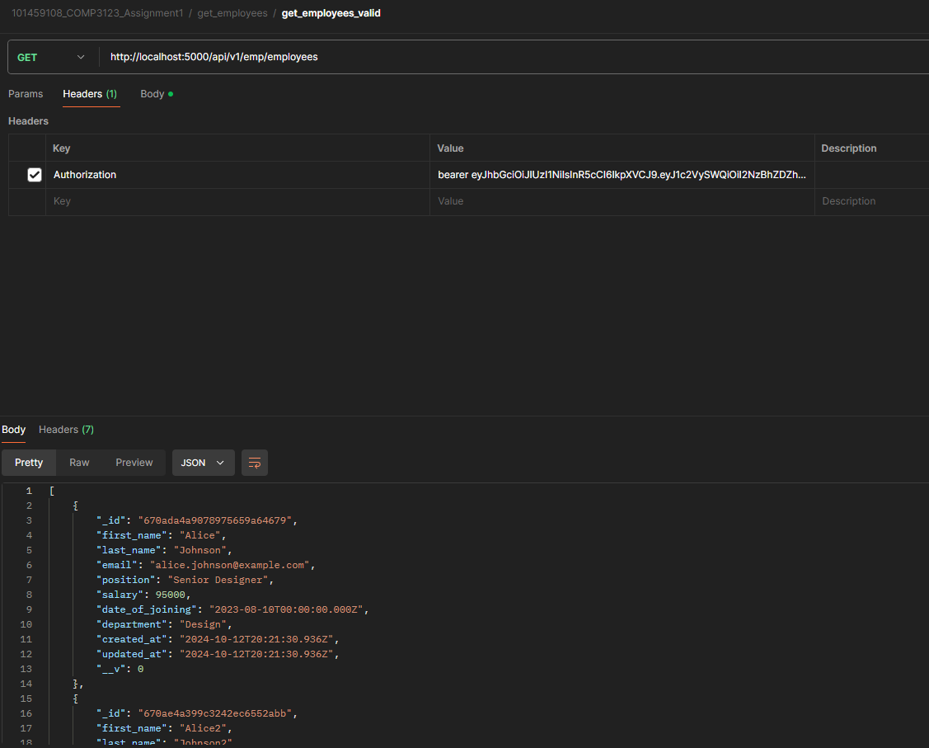  
Invalid auth:  
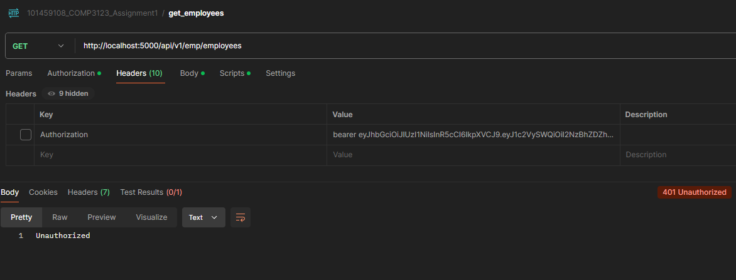

4) POST /api/v1/emp/employees  
Email in use:  
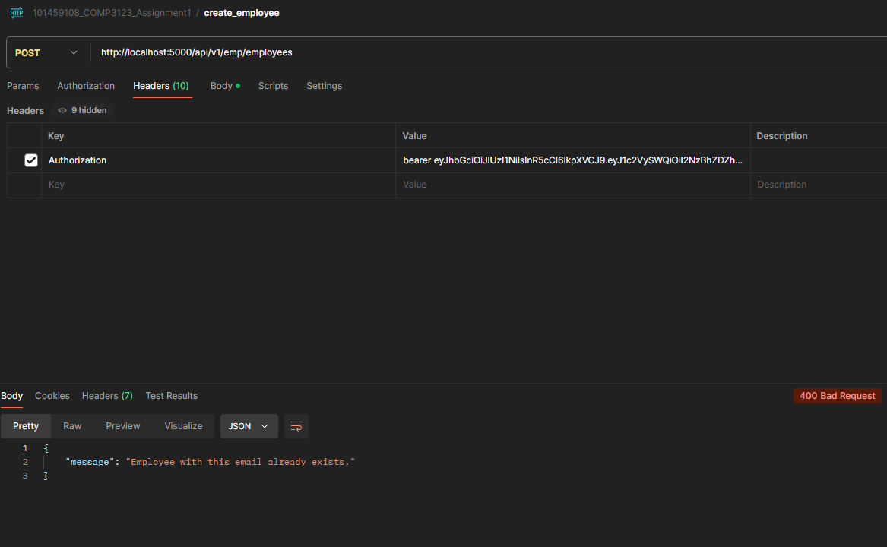

Invalid email format:  
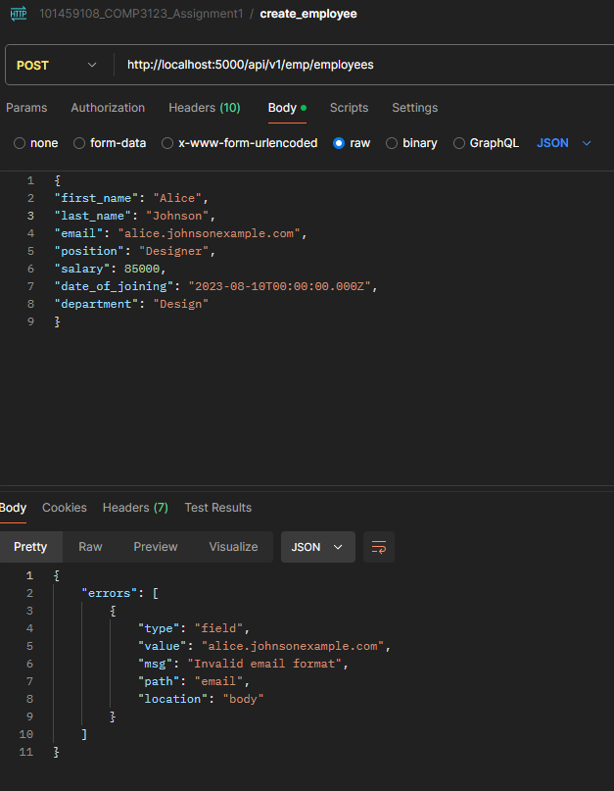

Invalid auth:  
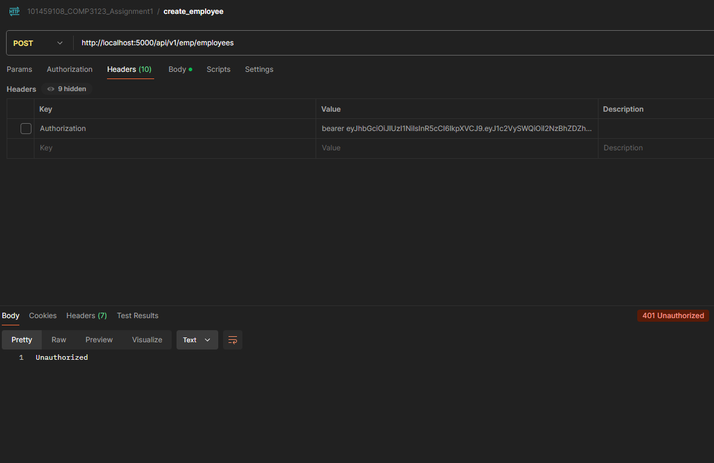

Valid attempt:

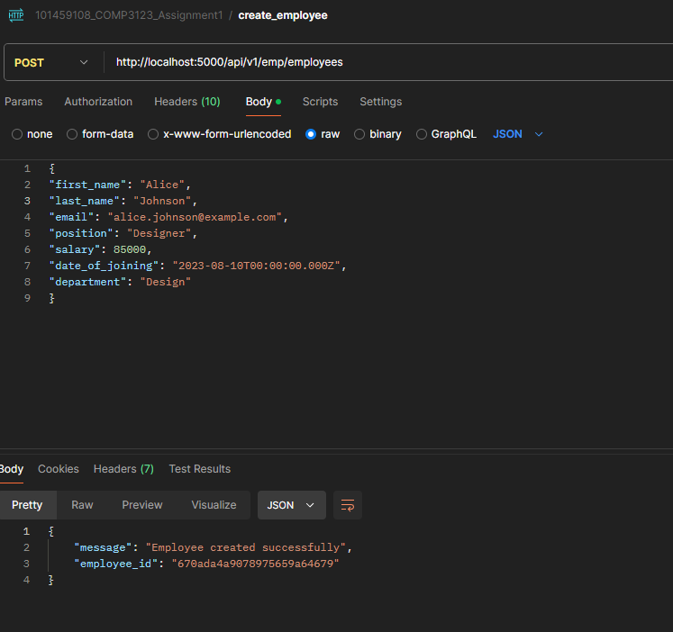

5) GET /api/v1/emp/employees/{eid}  
Valid attempt:  
invalid auth:

Not found:  
Invalid id format:

6) PUT /api/v1/emp/employees/{eid}  
Valid attempt:

Bad request:

Not found:  
invalid id format:

7) DELETE /api/v1/emp/employees?eid={eid}  
valid attempt  
Not found:  
**

**MONGO:**

Employee data:  
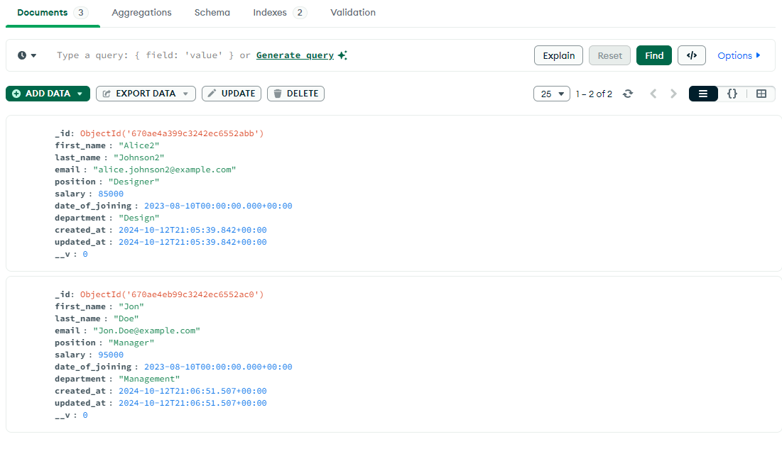

User data:  
  
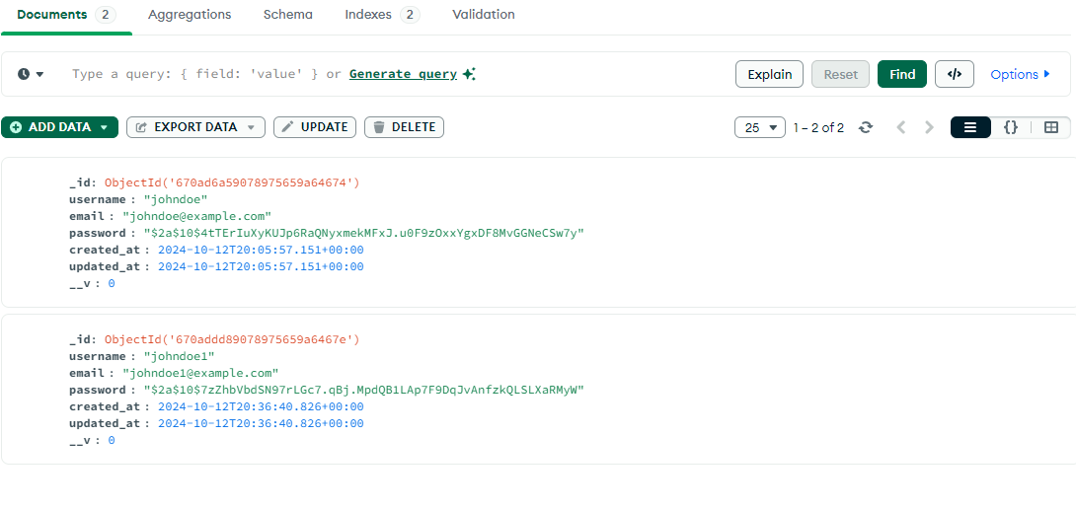  
Tables:  
